**DBMS Assignment 2**

**PESUVariance - Learn, Grow & Challenge Yourself!**

**Team ID: H1**

**Names and respective SRN’s:**

**Shrikar Madhu: PES1UG19CS470**

**Sravya Yepuri: PES1UG19CS502**

**Sri Ramya Priya Vedula: PES1UG19CS504**

**Yousha Mahamuni: PES2UG19CS468**

**Semester: 5, Section: H**

**List of reasons/constraints to justify the choice of DBMS:**

The DBMS type chosen for our project is RDBMS. Below are the reasons behind our choice.

• Relational data is well known to be useful for simple data types, whereas NoSQL and other types of DBMS may be preferred for complex modeling. Since our data is relatively simple, we have chosen RDBMS

• Since we would require real time query management in terms of hosting competitions, quizzes and comments and posts, we would prefer RDBMS. • RDBMS solves the ACID requirement with good durability and performance which is required for our project.

• RDBMS also allows for complicated queries like joins and other types that would be useful for our project.

Specifically, we are planning on using POSTGRESQL.

**About the files:**

The creation of all tables and database is done in pesuvariance_create.sql file, insertion of values which are not clob/blob types are done in

pesuvariance_insert.sql file and the respective files are used to insert the values of tables in which there are blob/clob types.

user.py - user_profile table values insertion.

dataset.py - dataset table values insertion.

c_images.py - c_images table values insertion.

p_images.py - p_images table values insertion.

**Link to the relational schema file:** Relational Schema

**Relational Schema:**

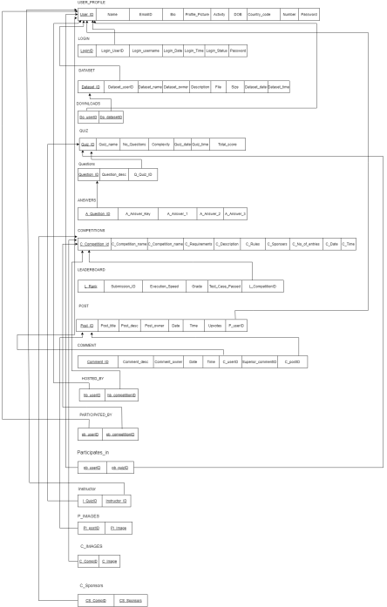

**OUTPUT SCREENSHOTS:**

The below screenshot shows the output of running the pesuvariance_create.sql file. 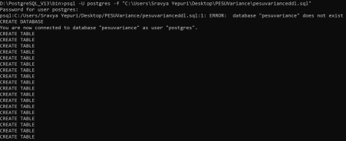

Below screenshot shows the output which displays the pesuvariance database.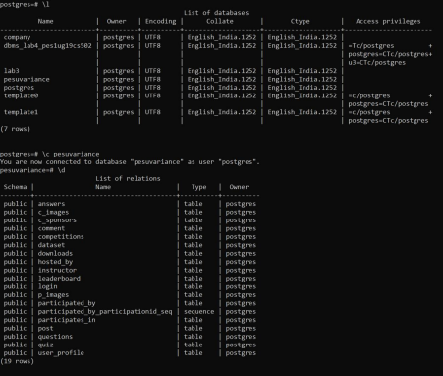

Below screenshot shows the USER_PROFILE Relation.

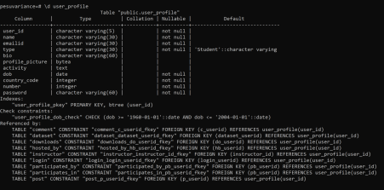

Below Screenshot displays the LOGIN Relation.

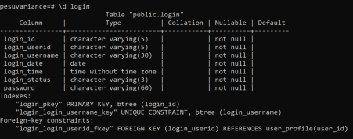

Below Screenshot Displays the Dataset Relation.

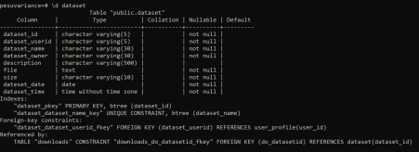

Below Screenshot Displays the Downloads Relation.

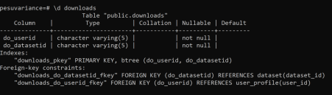

Below Screenshot displays the Quiz Relation.

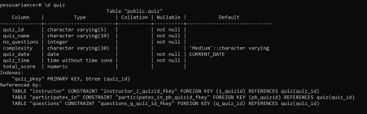

Below is the screenshot of the Questions Relation.

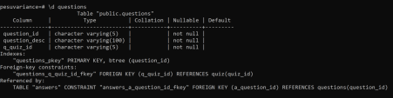

Below is the screenshot of the Answers Relation.

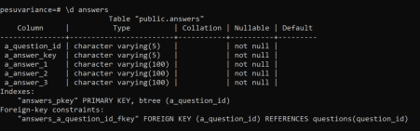

Below is the screenshot of the Competitions Relation.

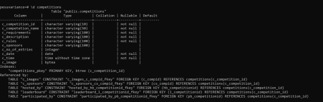

Below is the screenshot of the Leaderboard Relation.

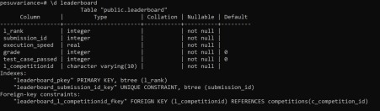

Below is the screenshot of the Post Relation.

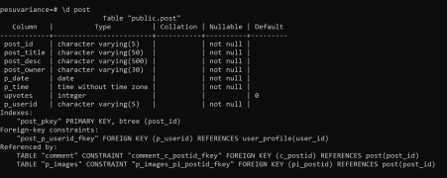Below is the screenshot of the Comment Relation.

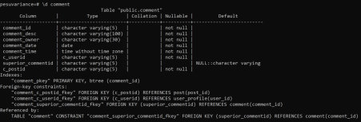

Below is the screenshot of the Hosted_BY relation.

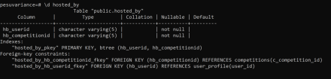

Below is the screenshot of the PARTICIPATED_BY Relation.



Below is the screenshot of the Participates_IN Relation.



Below is the screenshot of the Instructor Relation.



Below is the screenshot of the C_Sponsors Relation.



Below is the screenshot of the P_Images Relation.



Below is the screenshot of the C_Images Relation.



Below is the screenshot of insertion of user_profile table values.



Below is the screenshot of insertion of dataset table values.



Below is the screenshot of insertion from pesuvariance_insert.sql file.

Below is the screenshot of insertion of c_images table values.



Below is the screenshot of insertion of p_images table values.



**Contribution of each member:**

Shrikar Madhu - Worked on pesuvariance_create.py, blob/clob data and report. Sravya Yepuri - Worked on pesuvariance_insert.py, blob/clob data and report. Sri Ramya Priya Vedula -Worked on pesuvariance_create.py, blob/clob data and report.

Yousha Mahamuni - Worked on pesuvariance_insert.py, blob/clob data and report.

**Time spent to complete assignment 2:**

Creation statements - 3 Hours

Insert statements - 4 Hours

Exploring and inserting images and files (blob/clob data) - 4 Hours Making Final Report - 4 Hours

Google Drive Link:

https://drive.google.com/drive/folders/1w

UWcaEjJO51bETl1a7BGpEGCYos6vSR?usp=sharing