ICP3

K SRI SAI NIKHIL (10)

Inheritance (Bank Account)

python program to create an employee class and do the corresponding tasks such as avg salary of the employees

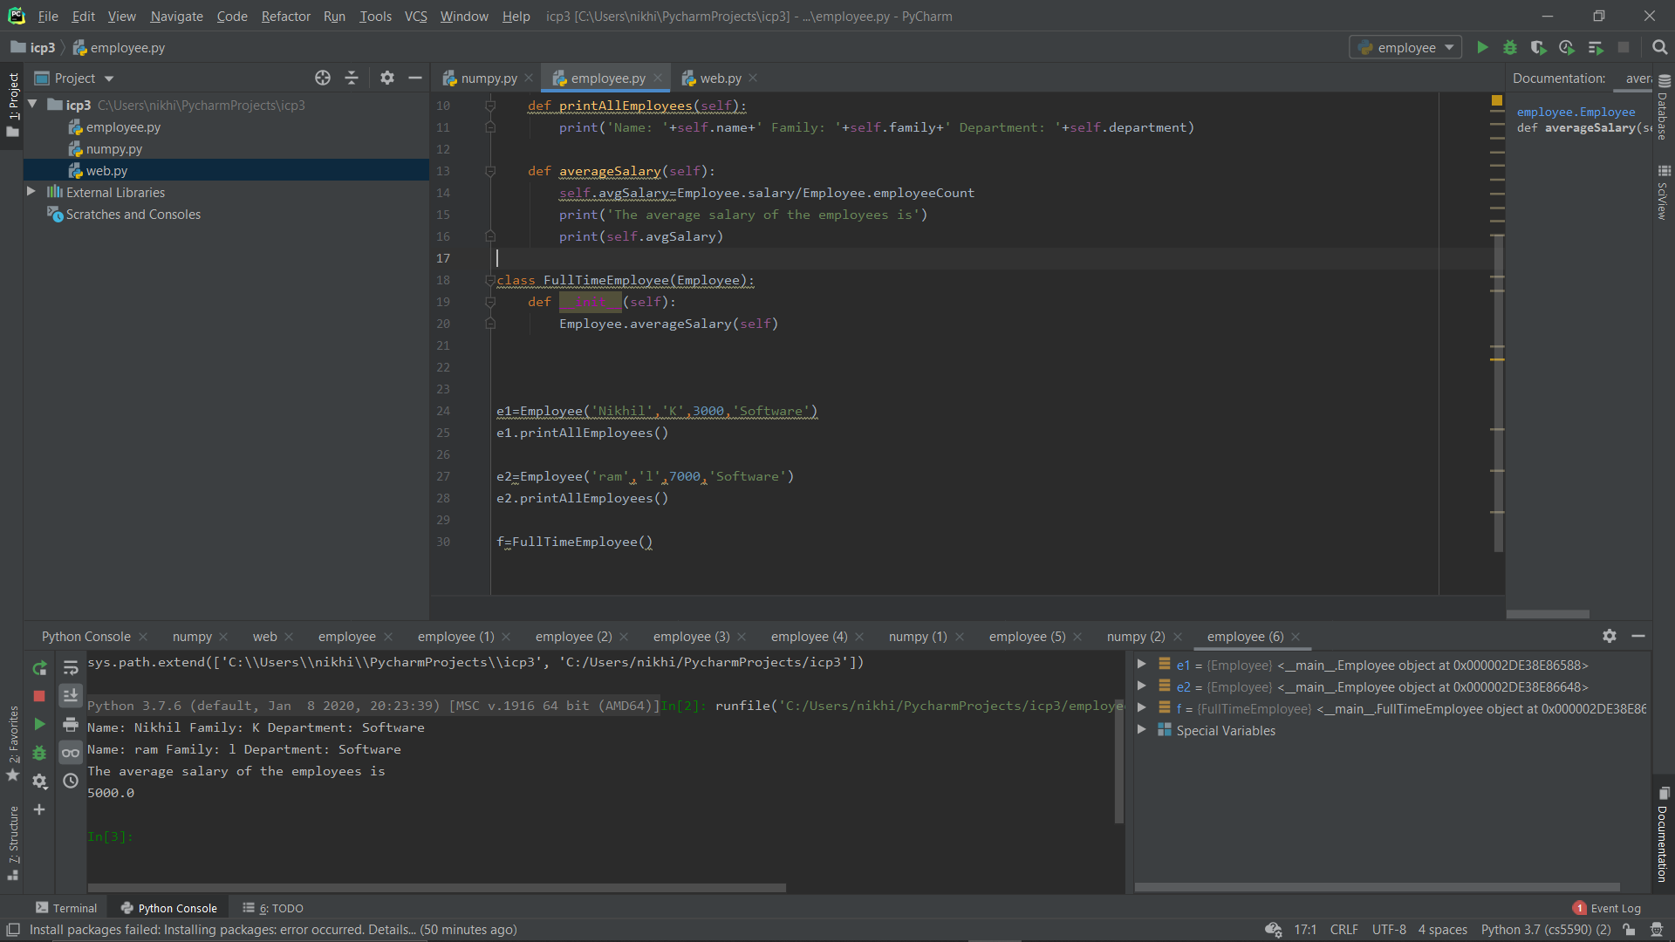

program that parse a Wiki page and Print out the title of the page and find all the links in the page (‘a’ tag) and Iterate over each tag(above) then return the link using attribute "href" using get

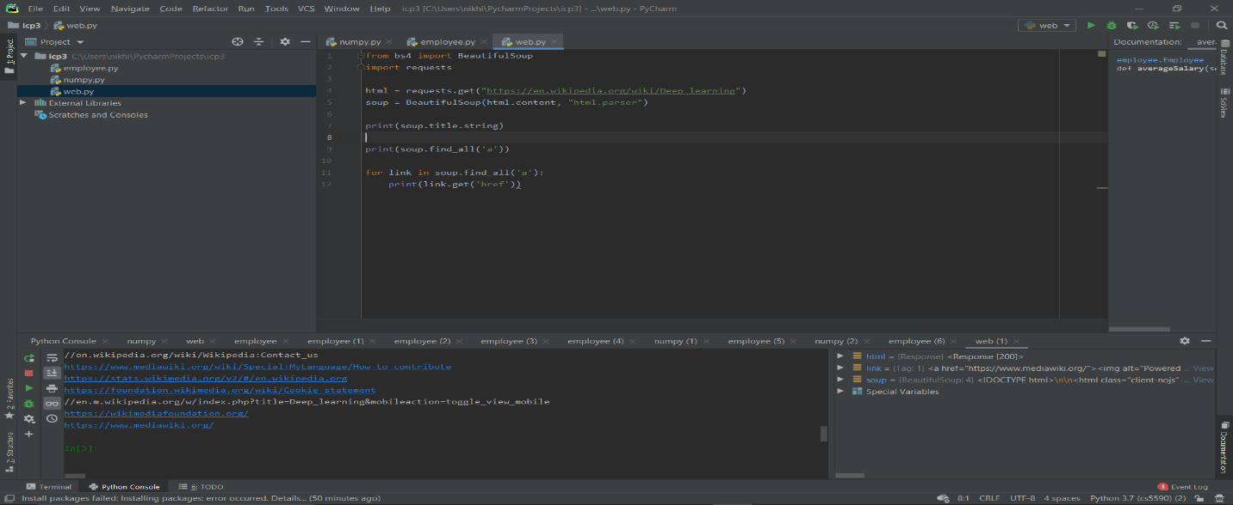

Numpy package using

