**Assignment - 2**

**1.Write a java program for matrix addition.**

**Source Code :**

import java.util.Scanner;

class AddMatrix{

public static void main(String args[]){

Scanner sc = new Scanner(System.in);

int m,n,i,j;

System.out.print("Enter the number of rows of a matrix : ");

m=sc.nextInt();

System.out.print("Enter the number of columns of a matrix : ");

n=sc.nextInt();

int first[][] = new int[m][n];

int second[][] = new int[m][n];

int sum[][] = new int[m][n];

System.out.print("Enter the elements of first matrix : ");

for(i=0;i<m;i++)

for(j=0;j<n;j++)

first[i][j]=sc.nextInt();

System.out.print("Enter the elements of second matrix : ");

for(i=0;i<m;i++)

for(j=0;j<n;j++)

second[i][j]=sc.nextInt();

for(i=0;i<m;i++)

for(j=0;j<n;j++)

sum[i][j]=first[i][j]+second[i][j];

System.out.println("Sum of given matrices is : ");

for(i=0;i<m;i++){

for(j=0;j<n;j++)

System.out.print(sum[i][j]+"\t");

System.out.println();

}

}

}

**Output :**

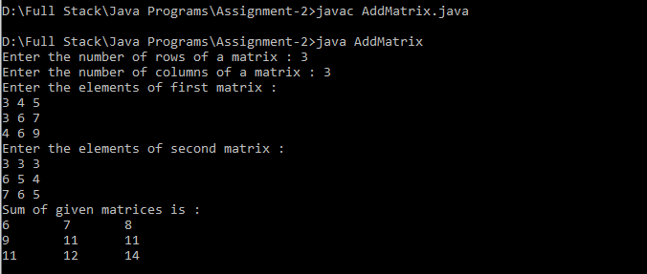

**2.Write a java aprogram for matrix multiplication**

**Source Code :**

import java.util.Scanner;

class MulMatrix{

public static void main(String args[]){

Scanner sc = new Scanner(System.in);

int m,n,i,j,a,b,k,sum=0;

System.out.print("Enter the number of rows of a first matrix : ");

m=sc.nextInt();

System.out.print("Enter the number of columns of a first matrix : ");

n=sc.nextInt();

int first[][] = new int[m][n];

System.out.print("Enter the elements of first matrix : ");

for(i=0;i<m;i++)

for(j=0;j<n;j++)

first[i][j]=sc.nextInt();

System.out.print("Enter the number of rows of a second matrix : ");

a=sc.nextInt();

System.out.print("Enter the number of columns of a second matrix :");

b=sc.nextInt();

if(n!=a)

System.out.println("The matrices can't be multiplied.");

else{

int second[][] = new int[a][b];

int multiply[][]=new int[m][b];

System.out.print("Enter the elements of second matrix : ");

for(i=0;i<m;i++)

for(j=0;j<n;j++)

second[i][j]=sc.nextInt();

for(i=0;i<m;i++){

for(j=0;j<b;j++){

for(k=0;k<a;k++)

sum=sum+first[i][k]*second[k][j];

multiply[i][j]=sum;

sum=0;

}

}System.out.println("Product of given matrices is : ");

for(i=0;i<m;i++){

for(j=0;j<b;j++)

System.out.print(multiply[i][j]+"\t");

System.out.print("\n");

} } }

}

O**utput :** 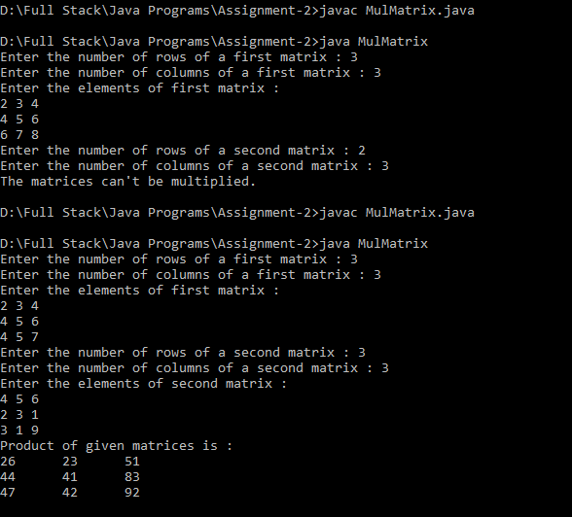

**3.Write a java program to demostrate method overloading**

**Source Code:**

import java.util.Scanner;

class Shape{

void area(double l,double h){

System.out.print("Area of rectangle is : "+(l*h));

}

void area(double a){

System.out.print("Area of square is : "+(a*a));

}

public static void main(String args[]){

Shape mo = new Shape();

Scanner sc =new Scanner(System.in);

System.out.println("-----Demostration of Overloading-----");

System.out.print("Enter number of inputs (1/2) : ");

int n = sc.nextInt();

if(n==2){

System.out.print("Enter length of rectangle : ");

double l = sc.nextDouble();

System.out.print("Enter height of rectangle : ");

double h = sc.nextDouble();

mo.area(l,h);

}

else{

System.out.print("Enter a value : ");

double s = sc.nextDouble();

mo.area(s);

}

}

}

**Output :**

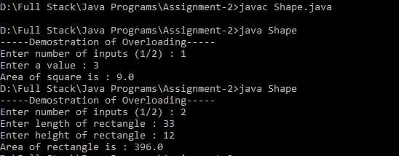

**4. Write a java program to create a class Point with two data members x & y. Include constructors and display().**

**Source Code :**

import java.util.Scanner;

class Point{

int x,y;

Point (){

System.out.println("---Default Constructor---");

x=33;

y=99;

System.out.println(x+" - "+y+" = "+(x-y));

}

Point(int a,int b){

x=a;

y=b;

System.out.println("---Parameterizied Constructor---");

System.out.println(x+" - "+y+" = "+(x-y));

}

Point(double a,double b){

System.out.println("---Constructor Overloading---");

System.out.println("a+b="+(a+b));

}

void display(){

System.out.println("This is display Method!!");

}

public static void main(String args[]){

Point p = new Point();

Point p1= new Point(3,5);

Point p2= new Point(12.5,23.6);

p.display();

}

}

**Output :**

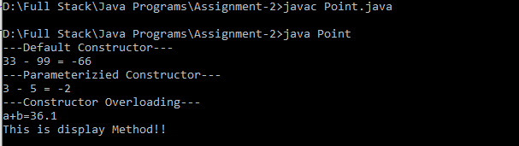

**5. Write a java program using static method.**

**Source Code :**

class StaticMethod{

static void printString(){

System.out.println(" This is Static Method!");

}

static void myStaticMethod(){

printString();

}

public static void main(String args[]){

myStaticMethod();

}

}

**Output :**

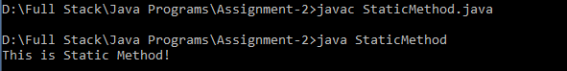

**1.What is conditional statement?**

Conditional statements are used to specify the which block of code should be executed based on the given conditions. if the condition is true it goes with that specified block otherwise another block of code will be executed.

Conditional statements in java are:

* if statement
* if - else statement
* nested-if statement
* if-else ladder
* switch case statement

**2.Write the syntax of switch..case statement.**

switch(variable){

case value1:

//statements

break;

case value2:

//statements

break;

.

.

.

case value n:

//statements

break;

default :

//statements

break;

}

**3.Write the difference between break and continue statement.**

|  |  |
| --- | --- |
| **break** | **continue** |
| 1.It is used to terminate the flow of execution. | 1.It is used to skip the current iteration. |
| 2.It resumes the control of program to end of the loop. | 2.It resumes the control of the program to the next iteration. |
| 3.break statement can be used with 'switch' and 'label'. | 3.continue statement cannot be used with 'switch' and 'label'. |

**4.What is looping statement?**

Looping statement is also called as iterative statements which is used execute the statements multiple times.

Looping statements are :

* for loop
* while loop
* do-while loop

**5. Write the difference between while and do..while statement.**

|  |  |
| --- | --- |
| **While** | **do-while** |
| 1.Condition is checked first then statements are executed. | 1.Statements is executed atleast once, thereafter condition is checked. |
| 2.while loop is entry controlled loop. | 2.do-while loop is exit controlled loop. |
| 3.No semicolon at the end of the while. | 3.semicolon at the end of the loop. |
| 4.Syntax:  While(condition){  //statements;  } | 4.Syntax:  do{  //statements;  }while(condition); |

**6. What is array? How it is created?**

An array is a group of similar typed variables that are referred by a common name.

Arrays of any type can be created and may have one or more dimensions. A specific element in an array is accessed by its index.

**Declaration Example:**

dataType var_name[]; int myList[];

or or

dataType[] var_name; int[] myList[];

**creating an array using new operator:**

arrayRefVar = new dataType[size]; myarr=new int[10];

or or

dataType[] arrayRefVar = new dataType[size]; int[] myarr = new int[10];

or or

dataType[] arrayRefVar = [value0,value1,......,valuen]; int[] my=[10,20,30,40];

**7. What is class?**

The process of binding data members and associated methods in a single unit is known as class. A class is a collection of data members and methods.

Syntax:

class <class_name>{

variable declaration(data members)

method definition

}

**8. What is constructor?**

A constructor is one of the special member method and it is automatically (or) implicitly called by JVM during object creation.

Name of the constructor must be similar to class name.

**9. What is the use of copy constructor?**

A copy constructor is a constructor that creates a new object using an existing object of the same class

And initializes each instance variable of newly created object with corresponding instance variables of the existing object passed as argument.

**10. What is the use of this keyword?**

* + this keyword is used to refer current class instance variable.
  + it is used to invokes the current class constructor and current class method.
  + this can be passes as an argument in the method call and argument in constructor call.
  + this can be used to return the current class instance from the method.

**11. What is method overloading?**

Method overloading is declaring two or more methods of same name within same class with different method signature by changing number of arguments and type of arguments.

**12. What is static variable?**

static variables are initialized only once, at the start of the execution. These variables will be initialized first, before the initialization of any instance variables.

A static variable can be accessed directly by the class name and does not need any object.

**13. What is access modifier?**

Access modifiers is to set access levels for classes, variables, methods and constructors. Java provides four levels of access they are:

* No modifiers(the default) visible to the package.
* public (visible to the world)
* protected(visible to the package and all the subclasses).
* private (visible to the class only).

**14. Write the difference between instance and static methods.**

|  |  |
| --- | --- |
| **Instance methods** | **Static methods** |
| 1.Instance method are methods which require an object of its class to be created before it can be called. | 1.Static methods are methods that can be called without creating an object of class. |
| 2.Instance method is declared without a keyword | 2.Static methods are declared witha a keyword 'static'. |
| 3.It exists as multiple copies depending on the number of instances created for that class. | 3.Static method means which will exist as a single copy for a class. |
| 4.It can access static variables and methods directly. | 4.It can't access instance methods and variables directly. |
| 5.These are invoked by using object reference | 5.These methods can be invoked by using class reference. |

**15. What is object? How it is created?**

Instance of a class is known as an object (Instance is nothing but allocating sufficient amount of memory space for data members and member functions)

**Syntax:**

<class_name> <object_name> = new <class_name>();

**eg:**

MyClass mc = new MyClass();