INFO 102
Sri
HW#1: Information Systems

Explanation
As a triathlete training for an Ironman 70.3, I rely every day on wearable Internet of Things (IoT) devices such as WHOOP and Strava to guide my training decisions. This context interests me because these devices sit exactly at the intersection of data, information, and knowledge: raw sensor readings (heart rate, motion, GPS) are only useful once an information system combines and interprets them into something actionable, such as a recovery score or a suggested pace. I see information systems impacting endurance sports training because wearable IoT platforms convert continuous biometric signals into coaching decisions in near real time, while simultaneously creating a data trail that extends far beyond the athlete’s original intent. To understand this, it helps to know that consumer wearables are not medical devices; they operate outside HIPAA regulation, which covers only hospitals, insurers, and their business associates (Livity, 2025). That distinction matters because it determines who actually controls the data these devices generate.
Engagement
The people involved in this system extend well past the individual athlete. Coaches and training partners use shared data to plan workouts, while engineers and data scientists at Strava and WHOOP build the models that turn raw signals into scores such as “Strain” or “Fitness.” Less visibly, third-party advertisers such as Meta and Google are also participants: a 2025 investigation of popular fitness apps found that 78% shared user data with these companies even when accounts were set to private (TechRadar, 2025). The technology layer includes optical heart-rate and heart-rate-variability sensors, GPS receivers, accelerometers, and cloud-based machine learning pipelines that estimate recovery and training load. The process begins with continuous sensor capture on the wrist or chest strap, which syncs to the cloud, where proprietary algorithms combine it with sleep data and historical baselines before pushing a recommendation back to the athlete’s phone. The data that matter most are heart-rate variability, sleep stages, and GPS location history, because these three inputs drive both the coaching value of the app and, as it turns out, most of its privacy risk.
Reflection
Mindmap
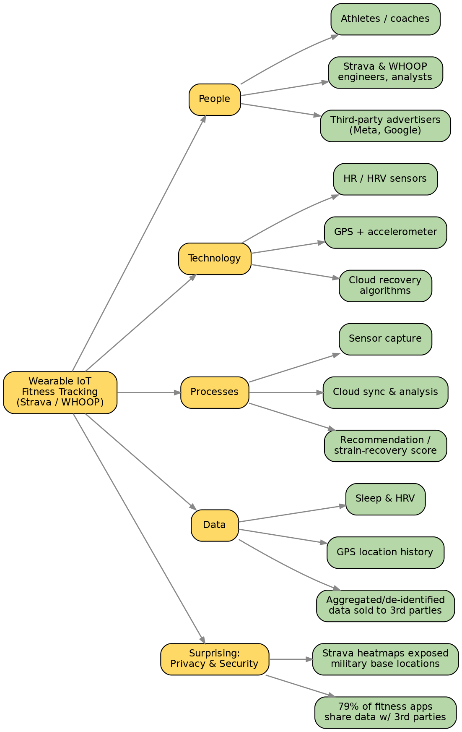
Building the mindmap made clear how tightly the four elements, people, technology, process, and data, depend on one another: removing GPS data, for instance, would not just remove a feature, it would break route-based training analysis and route-sharing with training partners. My argument matters because millions of amateur athletes treat these apps as harmless motivation tools without realizing how much of their data leaves their control. The most surprising discovery was how consequential a jogging app can become outside the fitness context: Strava’s public heatmaps of aggregated user routes have been used to locate secret military bases, and in 2026 a sailor aboard the French aircraft carrier Charles de Gaulle revealed the ship’s location simply by logging a run on deck (GhostVault, 2026). Learning that the same information system I use to track my own Ironman training has, in other contexts, exposed classified military positions reframed how I think about the “process” step of syncing data to the cloud: it is never just a training log, it is a live feed of my location and physiology to a company, and by extension, to whoever that company shares it with.

References
GhostVault. (2026, March). Is your fitness tracker selling your health data? Whoop, Strava, Garmin & more. https://www.ghostvault.live/blog/fitness-tracker-selling-health-data
Livity. (2025). Health data privacy: Who has your fitness tracker data? https://livity-app.com/en/blog/health-data-privacy-fitness-trackers
TechRadar. (2025). Fitbit, Strava and Nike Training Club are the most data-hungry fitness apps according to a new report. https://www.techradar.com/health-fitness/fitness-apps/fitbit-strava-and-nike-training-club-are-the-most-data-hungry-fitness-apps-according-to-a-new-report-here-are-4-ways-to-protect-your-privacy

