Architecture of the App
Study of Nykaa's Design and Architecture
Mini Project — Distributed Systems
Application studied: Nykaa
Registration No.: 23MCCE28

1. Introduction
Nykaa (operated by FSN E-Commerce Ventures) is an Indian omnichannel retailer of beauty, fashion and wellness products. It was founded in 2012 by Falguni Nayar and began as one of the country's first beauty e-commerce platforms. It has since added Nykaa Fashion, Nykaa Man and Superstore by Nykaa, and sells through websites, mobile apps and a network of physical stores.
According to AWS's published case study, Nykaa offers products from over 6,000 brands, serves over 40 million active users monthly and operates more than 165 physical stores. At this scale the platform has to handle heavy read traffic (browsing and search), spiky write traffic (sale events), large volumes of behavioural data, and consistency-sensitive operations such as inventory and payments.
This document summarises what I learned about how Nykaa's system is designed, based on publicly available material. It is the foundation for the next two deliverables (distributed paradigms and algorithms, and the simplified MiniNykaa app).

1.1 A note on sources and certainty
Nykaa is a private company and, unlike Netflix or Uber, does not publish a detailed engineering blog describing its internals. The most authoritative material available comes from (a) an AWS customer case study and re:Invent-style session write-up, (b) a technology interview with Nykaa's CTO, and (c) public professional profiles of Nykaa engineers describing services they built. Where a statement below comes directly from these sources I say so. Where I infer a component from common practice for an e-commerce system of this scale, it is explicitly marked as inferred. The architecture diagram is therefore an informed reconstruction, not Nykaa's confidential design.

2. Sources Consulted
- AWS Case Study — "Nykaa Builds Unified Data Platform for Insights Generation Using AWS" (aws.amazon.com/solutions/case-studies/nykaa).
- YourStory webinar summary — "How AWS empowers Nykaa's data revolution" (session by Nykaa engineers on the clickstream data lake and AdTech platform).
- Analytics India Magazine — "Deep Dive: At A Valuation Of $724 Million, Nykaa's Path To Profitability..." (interview covering Nykaa's technology stack and engineering culture).
- Public engineer profiles (e.g. Codementor, Nykaa Distinguished Engineer profile) describing the microservices they built for Nykaa.

3. High-Level Architecture
Nykaa's platform is described by its CTO as a multi-tenant web services platform that can power multiple businesses (Nykaa, Nykaa Fashion, and others) on the same underlying stack. This lets new business models be launched without rebuilding the core. Around this platform sit dedicated microservices, a caching tier, several databases, and a separate analytics/data platform on AWS.
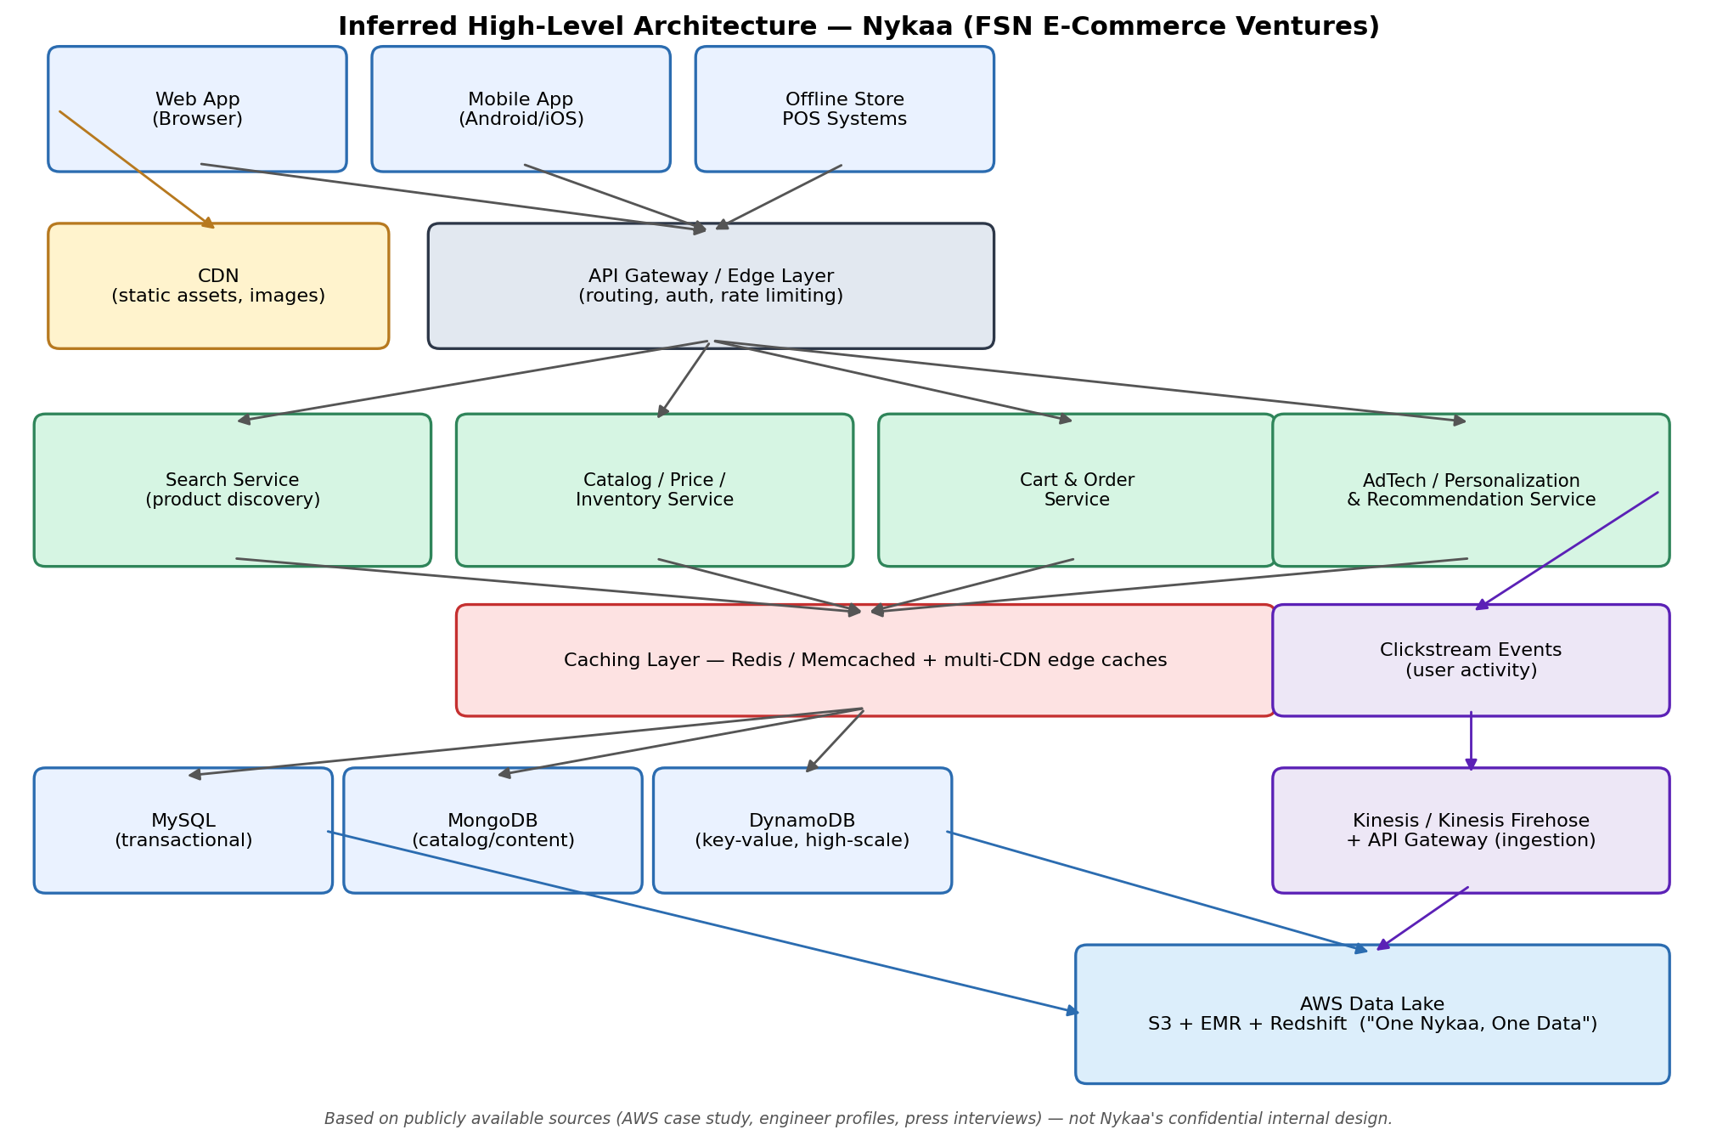
Figure 1: Inferred high-level architecture of Nykaa (reconstructed from public sources).

3.1 Layers of the system
Layer | What it does | Evidence / status
Clients | Website, Android/iOS apps, and in-store systems. | Stated (web, apps and stores are public facts).
Edge: CDN + gateway | Serves static assets/images from CDNs; routes, authenticates and throttles API calls. | CDN use is stated; a gateway layer is inferred.
Microservices | Independent services: Search, Price Management, Inventory Management, AdTech, and others. | Stated by engineers who built them.
Cache tier | Multi-level caching from CDNs down to Memcached (and Redis). | Stated in CTO interview.
Databases | MySQL, MongoDB and DynamoDB. | Stated in CTO interview.
Data platform | Clickstream ingestion (API Gateway, Kinesis, Firehose) into an S3/EMR/Redshift data lake. | Stated in AWS material.

4. Technology Stack

4.1 Backend
- Languages: Python and Java are the main technologies for API development (CTO interview). Engineer profiles mention Flask, Django and Celery in Python services.
- Service style: microservices built by product-aligned teams; one engineer reports designing services with core API response times under 15 ms.
- Team structure: inspired by the Spotify model — small, empowered teams with clear success metrics.

4.2 Data storage
- MySQL — relational, transactional data (orders, payments, inventory records are typical fits; inferred mapping).
- MongoDB — flexible-schema documents such as product/catalog and content (inferred mapping).
- DynamoDB — key-value workloads needing very high throughput and predictable latency (inferred mapping).

4.3 Caching and content delivery
The CTO interview highlights "massive use of caching strategies" with multiple CDNs all the way down to Memcached (and, per the article, an in-memory store such as Redis). In practice this forms a hierarchy: browser cache, CDN edge, application cache, and finally the database. Product images, category pages and other read-heavy content are natural candidates for the outer layers.

4.4 Search (inferred design)
Nykaa engineers list "Search" as one of the microservices they built from scratch. Product discovery at this scale is normally implemented with a distributed inverted-index engine such as Elasticsearch/OpenSearch, sharded and replicated across nodes; I could not find Nykaa confirming a specific engine, so this is inferred. The pattern (index shards queried in parallel and merged) is what I model in MiniNykaa's scatter-gather search.

5. Microservices Identified
Service | Role
Search | Query understanding and product discovery over the catalog.
Price Management | Maintains prices, offers and discounts consistently across channels.
Inventory Management | Tracks stock levels; must be accurate to avoid overselling.
AdTech / Display Network | Manages ads across Nykaa's business units; engineers describe a booking (ad) engine and a profiling service for performance attribution.
Real-time Clickstream Pipeline | Collects user-activity events for personalisation, targeted advertising and real-time ad optimisation.

Splitting these concerns into separate services lets each scale independently (search and browsing scale far more than checkout), be deployed by different teams, and fail without taking down everything else.

6. Data Platform Architecture
A major, well-documented part of Nykaa's architecture is its data platform on AWS, built around the goal "One Nykaa, One Data".
- Ingestion: for clickstream data, Nykaa uses API Gateway, Amazon Kinesis and Kinesis Data Firehose to absorb large volumes of events in real time.
- Storage and processing: in 2023 Nykaa began building the data lake's ingestion layer using Amazon EMR, Amazon S3 and Amazon Redshift, consolidating over 400 TB of unarchived data from many sources.
- Cost and elasticity: a proof of concept in September 2022 showed about 30% lower core software cost thanks to EMR's elastic scaling and pay-as-you-go pricing.
- Outcomes reported: a 48x increase in daily data refreshes, and report configuration time cut from weeks to 4–5 hours.
- Future direction: using the consolidated lake for machine learning to improve search, recommendations and inventory management.

7. How a Typical Request Likely Flows (inferred)
- The user opens the app; static assets and images come from the nearest CDN edge.
- An API call (e.g. "search for serum") reaches the gateway, which authenticates and routes it to the Search service.
- The Search service consults caches first; on a miss it queries the search index (sharded across nodes) and merges results.
- Price and inventory for the results are fetched from their services (often via cache) and combined.
- When the user checks out, the Order service validates stock with Inventory, records the order in a transactional store, and triggers payment.
- Every interaction is emitted as a clickstream event through Kinesis into the data lake, feeding recommendations and ads.

8. Key Design Observations
- Scalability through decomposition: independent microservices and a multi-tenant core.
- Performance through caching: several cache layers protect databases and cut latency.
- Polyglot persistence: the right database (SQL, document, key-value) for each workload.
- Decoupled analytics: heavy analytics run on a separate data lake so they never slow the transactional path.
- Cloud elasticity: managed AWS services scale up for sale events and down afterwards.

9. Limitations of this Study
Nykaa's exact service topology, database-to-service mapping, search engine, and deployment details are not public. Items marked inferred are reasoned from the public facts and standard e-commerce architecture. Figures (users, brands, TB of data) are as reported in the cited sources at the time and may have changed.

10. References
- AWS. Nykaa Builds Unified Data Platform for Insights Generation Using AWS. https://aws.amazon.com/solutions/case-studies/nykaa/
- YourStory. How AWS empowers Nykaa's data revolution. https://yourstory.com/webinar/how-aws-empowers-nykaas-data-revolution
- Analytics India Magazine. Deep Dive: At A Valuation Of $724 Million, Nykaa's Path To Profitability Is Driven By Its Entrepreneurial Culture. https://analyticsindiamag.com/deep-dive-at-a-valuation-of-724-million-nykaas-path-to-profitability-is-driven-by-its-entrepreneurial-culture/
- Codementor. Profile of a Senior Engineer at Nykaa (Display Network team). https://www.codementor.io/@shashankaryan

