Software Requirement Specification
MiniNykaa — A Simplified Nykaa-Style Distributed Shopping System
Mini Project — Distributed Systems
Application studied: Nykaa
Registration No.: 23MCCE28

1. Introduction

1.1 Purpose
This document specifies the requirements of MiniNykaa, a simplified version of the Nykaa shopping app. Its purpose is to demonstrate, at small scale, the distributed-systems ideas identified in the study of Nykaa: microservices, an API gateway, data sharding with consistent hashing, replication, heartbeat-based failure detection and failover.

1.2 Scope
MiniNykaa lets several users browse a beauty-product catalog, search it, add items to a cart, check out, and view order history. It runs as a set of cooperating processes communicating over TCP sockets on one machine (or several machines on a network). It is a teaching prototype: it has no real payments, persistent database, authentication or web/mobile UI.

1.3 Definitions
Term | Meaning
Gateway | A stateless server behind the load balancer (two run: gateway-1, gateway-2); it routes requests to internal services, caches catalog reads and orchestrates checkout and cancellation.
Catalog shard | A catalog service instance holding one partition of the products.
Load balancer | The front door (port 5000): every client request lands here first and is forwarded to a healthy gateway using round-robin or least-connections.
Order cluster / leader | Three order-service replicas (order-1..3). The Bully algorithm elects the alive node with the highest id as leader; only the leader serves requests and it replicates writes to the followers.
LRU cache with TTL | A gateway-local cache of catalog reads: the least recently used entry is evicted when full, and every entry expires after a time-to-live.
Heartbeat | A periodic PING used to check whether a node is alive.
Consistent hashing | A technique that maps keys (product IDs) to shards with minimal re-mapping when shards change.

2. Overall Description

2.1 Simplification relative to Nykaa
Aspect | Real Nykaa (as far as public) | MiniNykaa
Clients | Web, Android, iOS, stores | Website only
Catalog size | Very large (an app-store listing cites 130,000+ products) | 20 sample products
Services | Many microservices (search, price, inventory, ads...) | Catalog and Order services, two gateways and a load balancer
Storage | MySQL, MongoDB, DynamoDB, data lake | In-memory Python dictionaries
Caching / CDN | Multi-layer | Not included
Payments, login, recommendations | Yes | Not included (user id only)
Distribution | Cloud, many nodes | Multiple local processes on different ports, Docker Compose containers

2.2 Architecture
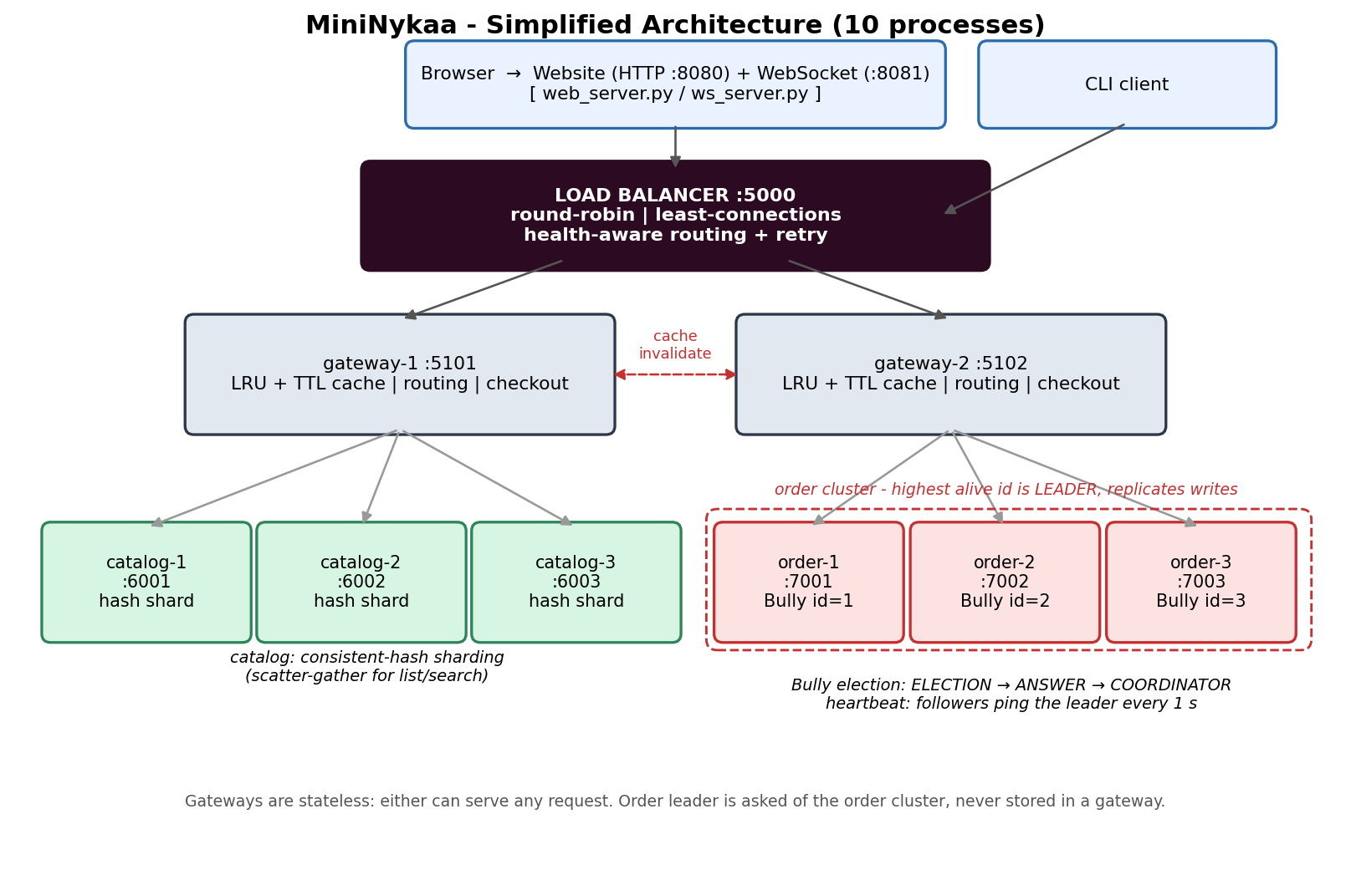
Figure 1: MiniNykaa architecture.

2.3 Components
Component | Port(s) | Responsibility
Load balancer | 5000 | Front door. Picks a gateway per request (round-robin or least-connections), skips DOWN gateways, retries a failed forward on another gateway, reports gateway statistics.
Gateways (2) | 5101, 5102 | Stateless. Route to shards (consistent hashing), fan out and merge searches, hold an LRU+TTL cache, find the order leader, orchestrate checkout and cancellation, run heartbeat monitors.
Catalog shards (3) | 6001–6003 | Each stores its hash-assigned products; supports GET, LIST, SEARCH, DECREMENT_STOCK, PING.
Order cluster (3) | 7001–7003 | Replicas that elect a leader with the Bully algorithm. The leader handles carts and orders and replicates each write (with a version number) to followers; followers answer NOT_LEADER.
Website (the only client) | 8080 | Nykaa-styled storefront served by a stdlib HTTP server (web_server.py) that bridges each REST call to the same gateway socket protocol; no shopping logic lives in the web layer.
WebSocket server | 8081 | Hand-written RFC 6455 server on raw sockets (ws_server.py). Polls the gateway and pushes health/stock changes to every connected browser.

2.4 User classes
- Shopper: browses, searches, adds to cart, checks out, views orders.
- Operator/tester: starts and stops nodes, checks node health, triggers failures to observe recovery.

2.5 Assumptions and constraints
- The system runs in Docker (Python 3.12 image); the backend uses only the Python standard library (socket, threading, json, struct, hashlib, http.server). Python with pytest in a virtual environment is needed only to run the automated tests.
- All state is in memory and is lost when a process stops.
- Nodes are trusted; there is no encryption or authentication.
- The load balancer is a single instance (a known single point of failure; production would use a pair behind a virtual IP).
- Ports 5000, 6001–6003 and 7001–7002 must be free.

3. Functional Requirements
ID | Requirement | Component | Priority
FR-1 | The system shall let a client list all products, gathered from all healthy catalog shards. | Gateway, Catalog | High
FR-2 | The system shall let a client search by keyword (name or brand) and/or category across all shards. | Gateway, Catalog | High
FR-3 | The system shall return a single product by ID, routing to the shard chosen by consistent hashing. | Gateway | High
FR-4 | The system shall let a user add a product with quantity to a personal cart. | Order | High
FR-5 | The system shall let a user view their cart. | Order | High
FR-6 | The system shall perform checkout: read the cart, verify price and stock, decrement stock on each owning shard, create the order and clear the cart. | Gateway, Catalog, Order | High
FR-7 | The system shall reject checkout with a message when the cart is empty or stock is insufficient. | Gateway | High
FR-8 | The system shall let a user view their past orders. | Order | Medium
FR-9 | The system shall generate globally unique order IDs that cannot collide across order replicas. | Order | High
FR-10 | The gateway shall ping every backend node periodically and mark a node DOWN after consecutive missed heartbeats. | Gateway | High
FR-11 | The gateway shall not send requests to catalog shards marked DOWN. | Gateway | Medium
FR-12 | The order leader shall replicate each cart and order write, with a version number, to every follower; a follower that detects a missed write shall pull a full snapshot from the leader. | Order | High
FR-13 | The order replicas shall elect a leader with the Bully algorithm (highest alive id wins), detect a dead leader by missed pings, elect a new one automatically, and let a recovered higher-id node resync its data and reclaim leadership. Gateways shall discover the leader by asking the cluster, not by storing it. | Order, Gateway | High
FR-14 | The website shall provide a status view of node health and the active order node. | Website, Gateway | Medium
FR-15 | The system shall serve many clients concurrently. | All servers | High
FR-17 | The system shall let a user change a cart line item to an exact quantity, or remove it, without re-adding from scratch. | Gateway, Order | High
FR-18 | The gateway shall reject an add-to-cart or quantity-update that would exceed current stock (counting what is already in the cart) at the moment of the request, not only at checkout, and shall report how many units remain. | Gateway | High
FR-19 | The system shall provide a browser-based website as the only client, showing live stock status (in-stock, low-stock, out-of-stock) on every product and disabling Add to Cart for out-of-stock items. | Website | High
FR-21 | A user shall be able to cancel a CONFIRMED order. Cancelling shall mark it CANCELLED on the order service (replicated to the followers) and return every line item's units to the shard that owns the product. A second cancel of the same order shall be rejected so stock is never restored twice. | Gateway, Order, Catalog | High
FR-25 | A load balancer shall be the single entry point for clients. It shall distribute requests over the gateway instances using round-robin or least-connections, never select a gateway marked DOWN, and retry a failed forward on another gateway so a gateway crash causes no failed request. | Load balancer | High
FR-26 | Each gateway shall cache catalog list, search and single-product reads in an LRU cache with a TTL; stock decisions (add-to-cart, update, checkout, cart view) shall bypass the cache; any stock change shall clear the cache on the gateway that made it and on its peer gateways. | Gateway | High
FR-28 | The website server shall print a READY banner containing the browser URL (localhost:8080), the WebSocket URL and the load-balancer address once the load balancer, all gateways, all shards and an elected order leader are available, and shall print what is still missing until then. | Website | Medium
FR-27 | The website shall show, live, the load balancer and its algorithm, each gateway's request count and cache hit rate, shard health, and the order nodes with the current leader. | Website | Medium
FR-22 | Every product shall have an image shown on the catalog card and in the cart. | Website | Medium
FR-23 | The Get App, Store & Events, Gift Card and Help links in the top bar shall each open a working panel (demo content; Help is a static FAQ, no AI assistant). | Website | Low
FR-24 | The website shall keep a WebSocket connection to the backend and receive pushed updates when node health or product stock changes, updating the page without polling or refresh. | Website, WebSocket server | Medium
FR-20 | The system shall be deployable as a set of Docker containers, one per node, started with a single command, with no change to application code. | Docker | Medium

4. Non-Functional Requirements
ID | Category | Requirement
NFR-1 | Scalability | Adding a catalog shard shall re-map only a fraction (about 1/N) of products, not the full catalog.
NFR-2 | Availability | Order operations shall continue after the loss of the order leader: a new leader shall be elected and serving within about 3 seconds (2 missed 1 s pings plus election); and after the loss of one gateway with no failed client request.
NFR-3 | Fault tolerance | Failure of one catalog shard shall not crash the gateway; other shards continue serving.
NFR-4 | Performance | Typical local requests should complete in well under one second; 25 concurrent checkouts should complete within a few seconds.
NFR-5 | Consistency | Concurrent stock decrements on one shard shall not oversell (protected by locks).
NFR-6 | Usability | The website shall show node state visually (green UP / red DOWN, LEADER badge) and stock state on every product.
NFR-7 | Portability | Runs on Windows, Linux and macOS with Python only.
NFR-8 | Observability | Each node shall log key events (startup, DOWN, elections, leader changes, state-changing requests) to the console without being flooded by routine read traffic (VERBOSE=1 enables full logging).
NFR-9 | Testability | An automated pytest suite shall exercise every component, including crash and recovery of nodes, using a private copy of the system, and shall also be able to target an already-running deployment.

5. External Interface: Wire Protocol
All nodes exchange JSON messages over TCP. Each message is preceded by a 4-byte big-endian length so that the receiver can reconstruct message boundaries.

5.1 Client to load balancer actions (forwarded unchanged to a gateway)
Action | Request fields | Reply fields
LIST_CATALOG | — | status, products, shards_used
SEARCH_CATALOG | keyword, category (optional) | status, products, shards_used
GET_PRODUCT | product_id | status, product, shard
ADD_TO_CART | user_id, product_id, qty | status, cart, served_by (or OUT_OF_STOCK + message)
UPDATE_CART | user_id, product_id, qty | status, cart, served_by (qty<=0 removes; OUT_OF_STOCK if qty exceeds stock)
REMOVE_FROM_CART | user_id, product_id | status, cart, served_by
VIEW_CART | user_id | status, cart, items (enriched with name/price/stock), total, served_by
CHECKOUT | user_id | status, order or message
CANCEL_ORDER | user_id, order_id | status, order (now CANCELLED), restocked, restock_failed
VIEW_ORDERS | user_id | status, orders, served_by
STATUS | — | status, nodes (UP/DOWN), active_order_node (the leader), lb (algorithm), gateways (state, requests, cache stats)

5.2 Internal actions
PING (all nodes); GATEWAY_INFO, CACHE_INVALIDATE (gateway); GET, LIST, SEARCH, DECREMENT_STOCK, INCREMENT_STOCK (catalog); ADD_TO_CART, UPDATE_CART, REMOVE_FROM_CART, VIEW_CART, PLACE_ORDER, CANCEL_ORDER, VIEW_ORDERS (order, leader only); WHO_LEADER, ELECTION, COORDINATOR, SNAPSHOT, REPLICATE (order cluster internals).

6. Use Cases

UC-1 Shopper places an order
- User opens the website and signs in with a name.
- User searches for a product (fan-out across shards).
- User adds products to the cart (served by the order leader).
- User chooses checkout; gateway verifies stock and price, decrements stock, creates the order.
- Client shows the order ID and total.

UC-2 Order leader fails during operation
- Operator stops the order leader (order-3).
- Followers miss two pings and presume it dead; the highest alive id (order-2) wins the Bully election and announces COORDINATOR.
- The gateway's next order request finds the old leader unreachable, re-discovers the new leader and retries.
- Shopper continues; carts and orders replicated earlier are intact. When order-3 restarts it resyncs and reclaims leadership.

7. Acceptance Tests
Test | Procedure | Expected result
T1 | Start all nodes; run STATUS. | All eight backend nodes UP (3 catalog, 3 order, 2 gateways); load balancer reports its algorithm; order-3 is leader.
T2 | LIST_CATALOG. | 20 products from shards catalog-1, -2, -3.
T3 | SEARCH_CATALOG with keyword serum. | Three serum products.
T4 | GET_PRODUCT P002. | Served by one deterministic shard (catalog-2 in the test run).
T5 | Add P002 x2 and P006 x1, then CHECKOUT. | Order confirmed, total Rs.2047, stock reduced.
T6 | Kill the order leader (order-3), wait ~3 s, ADD_TO_CART. | served_by order-2 (newly elected); VIEW_ORDERS still shows earlier orders.
T6b | Restart order-3. | It installs the latest snapshot, wins the election and is leader again, with data written while it was down.
T6c | Send 10 LIST_CATALOG requests through the load balancer. | They alternate gateway-1, gateway-2 (round-robin).
T6d | Kill gateway-1 and send 8 requests. | All 8 succeed on gateway-2; the failed forward is retried; gateway-1 shown DOWN.
T6e | Read a product repeatedly, check out 5 units through one gateway, read through both gateways. | Cache hit rate rises; every read after checkout shows the new stock (no stale value).
T7 | 20 shoppers check out at the same moment (automated test). | All 20 succeed with 20 unique order IDs and stock reduced by exactly 20.
T9 | On the website, add a product, raise its quantity past available stock with the + button. | Request rejected immediately with an 'only N left' message; quantity does not change.
T10 | On the website, reduce a cart item to 0 with the − button / press Remove. | Item disappears from the cart and the total updates, without a page reload.
T12 | Order 3 units of a product, note stock, press Cancel order, then try cancelling again. | Stock returns to its original value; order shows CANCELLED; the second cancel is rejected.
T13 | Open a raw-socket WebSocket client on port 8081, then buy a product via the website API. | Handshake returns 101; a pushed message arrives with the reduced stock, with no polling.
T14 | Open Get App, Store & Events, Gift Card and Help from the top bar. | Each opens its panel; Gift Card generates a code; Help FAQ items expand.
T11 | docker compose up --build, then open http://localhost:8080. | All ten containers start; the website loads and behaves identically to the non-Docker run.

Tests T1-T7 (incl. T6b-T6e), T9, T10 and T12-T14 were run against the implementation and passed (see screenshots in the submission). T11 (Docker) was carried out by the student on their own computer: the containers started and their logs were observed. The sandbox used to prepare this submission had no Docker daemon, so it is not part of the automated checks.

7.1 Automated tests
The acceptance tests above are automated as 65 pytest tests in the tests/ folder (see the tutorial, section 13): 25 fast unit tests (LRU cache, consistent hashing, wire protocol, load-balancer logic) and 40 integration tests that run a private copy of all ten processes and, where needed, kill and restart nodes. All 65 pass in about 30 seconds.

8. Out of Scope and Future Work
- Authentication, payments, real database persistence.
- A replicated pair of load balancers (virtual IP), and Raft-style terms/quorum so a network partition cannot create two leaders.
- Saga-style compensation if checkout fails midway.
- Dynamic addition of catalog shards with data migration.
- Using cloud

