MiniNykaa Tutorial
Installation, Usage Manual and Demo Guide
Mini Project — Distributed Systems
Application studied: Nykaa
Registration No.: 23MCCE28

1. What is MiniNykaa?
MiniNykaa is a small distributed shopping website written in Python using raw TCP sockets, modelled on Nykaa. Ten processes cooperate: a load balancer (the front door), two stateless gateways (each with an LRU+TTL cache), three sharded catalog services, three order replicas that elect a leader with the Bully algorithm, and the website itself. It runs entirely in Docker on your own computer, so you can stop containers on purpose and watch the system recover.

2. Requirements
- Docker Desktop (Windows/macOS) or Docker Engine with the Compose plugin (Linux). This is all you need to run the website.
- A modern web browser (Chrome, Firefox, Edge, Safari).
- Free ports: 8080 (website), 8081 (WebSocket), 5000 (load balancer). The backend ports 5101-5102, 6001-6003 and 7001-7003 are also published so the tests can reach them.
- Only for the automated tests (Section 10): Python 3.8 or newer on your computer, used inside a virtual environment (venv). The application itself needs no Python on your computer and no packages: it runs inside the Docker image.

3. Installation
- Unzip the submission. You will find a folder named MiniNykaa.
- Open a terminal (PowerShell, Command Prompt, Terminal) and go into it: cd MiniNykaa.
- Check Docker works: docker --version and docker compose version.
- That is the whole installation: Docker builds everything else on first start.

3.1 Folder structure
MiniNykaa/
common/ protocol.py, consistent_hash.py, lru_cache.py, config.py
catalog_service/ catalog_server.py, products_data.py
order_service/ order_server.py (Bully election + replication)
gateway/ load_balancer.py, gateway_server.py, health_monitor.py
web/ web_server.py, ws_server.py, static/ (html, css, js, img/)
tests/ 65 pytest tests
Dockerfile, docker-compose.yml, .dockerignore
pytest.ini, requirements-dev.txt (tests only)

4. Running with Docker
Docker packages each node as a container, so the whole system starts with one command.

4.1 Start everything
cd MiniNykaa
docker compose up --build
The first run downloads Python and builds one shared image, then starts ten containers from it: catalog-1..3, order-1..3, gateway-1..2, lb and web. They run on a private network and find each other by name (the gateways connect to "catalog-1", not 127.0.0.1).
How do I know it is ready? The web container waits until the load balancer answers, both gateways and all shards are UP and the order cluster has elected a leader, then prints this banner in the docker compose up output:
==============================================================
MiniNykaa is READY
Website (open in your browser) : http://localhost:8080
Live-update WebSocket : ws://localhost:8081
Load balancer (front door) : localhost:5000 [round_robin]
Gateways: gateway-1, gateway-2 Order leader: order-3
==============================================================
Open http://localhost:8080 in your browser. (The banner says localhost because 0.0.0.0, which the container binds to, is not an address you can type into a browser. If you run Docker on another machine, set PUBLIC_HOST to its name or IP.) Until the system is ready it prints [web] starting up... waiting for: ... lines naming what is still missing.
To stop: press Ctrl+C, then run docker compose down.

4.2 Useful Docker commands
Command | What it does
docker compose up --build -d | Start everything in the background.
docker compose ps | List the ten containers and their status.
docker compose down | Stop and remove all containers.

4.3 How the containers find each other
Every node's address table is in common/config.py and is read from environment variables. In docker-compose.yml each variable is set to the service name (for example ORDER_3_HOST=order-3), and every server binds its listening socket to 0.0.0.0 (BIND_HOST) so other containers can reach it.

5. The Website
Open http://localhost:8080. The page is plain HTML/CSS/JavaScript served by web/web_server.py. It contains no shopping logic: every click becomes a request over the socket protocol to the load balancer, so all the distributed behaviour happens in the backend containers.
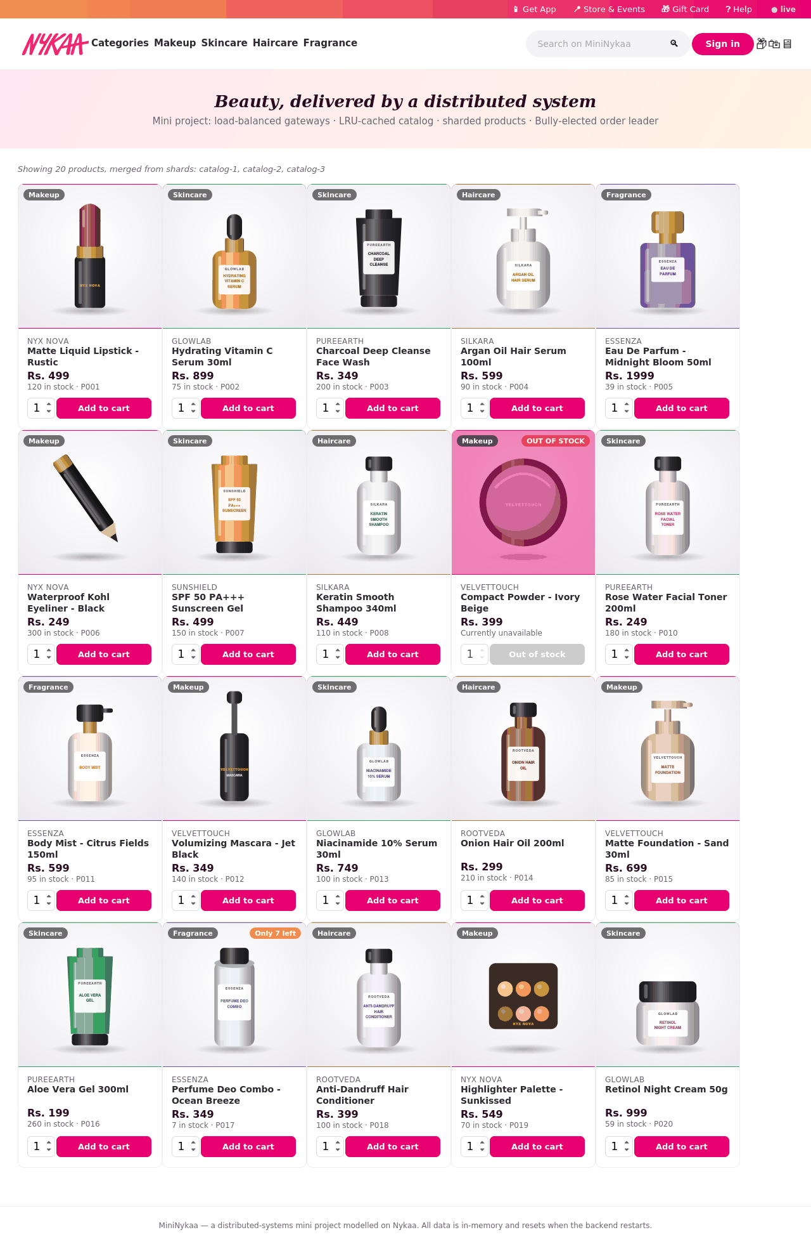
Figure 1: The storefront — Nykaa logo, product images, live stock badges, catalog merged from three shards.

5.1 Signing in
Click Sign in and type any name. There is no password (authentication is out of scope). The name is remembered in the browser. Use different names in different browser windows to act as different shoppers.

5.2 Browsing, search and stock badges
The category links and the search box query all catalog shards and merge the results (the line above the products names the shards used). Each card shows live stock: a red OUT OF STOCK badge and disabled button at 0, and an orange Only N left badge at 10 or fewer. Product images are illustrations generated by tools_gen_images.py, not photographs.
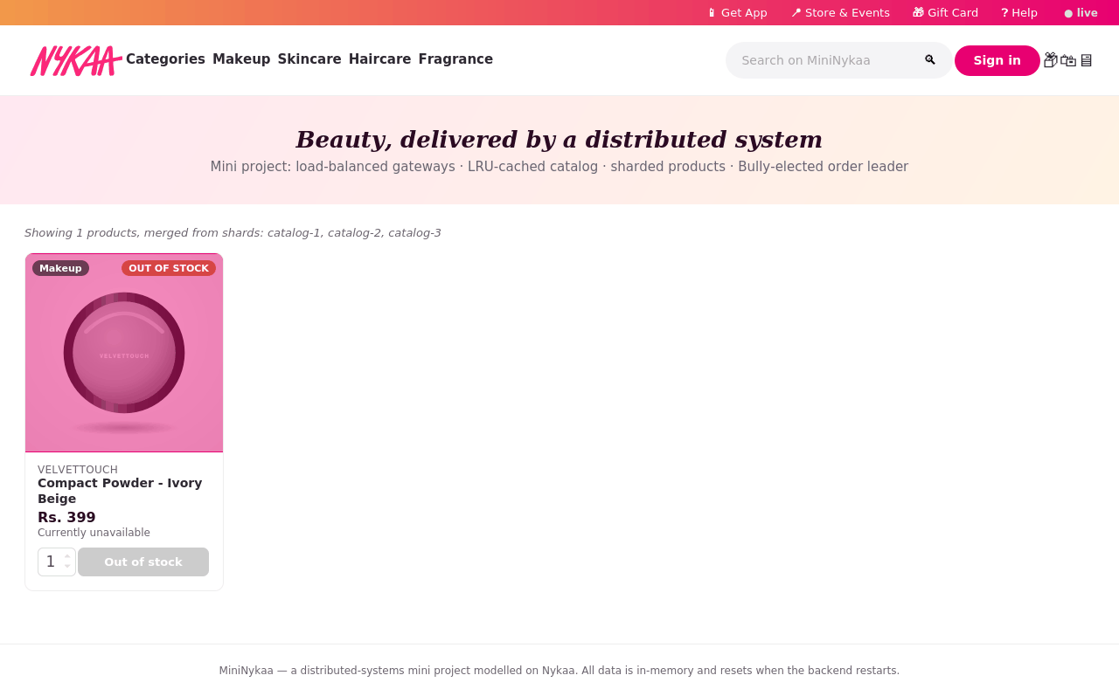
Figure 2: An out-of-stock product — disabled button.

5.3 Cart: change quantity or remove an item
Open the cart (bag icon). − and + set an exact quantity, Remove deletes the line. Raising the quantity past stock is rejected immediately (counting what is already in your cart) with an "only N left" message.
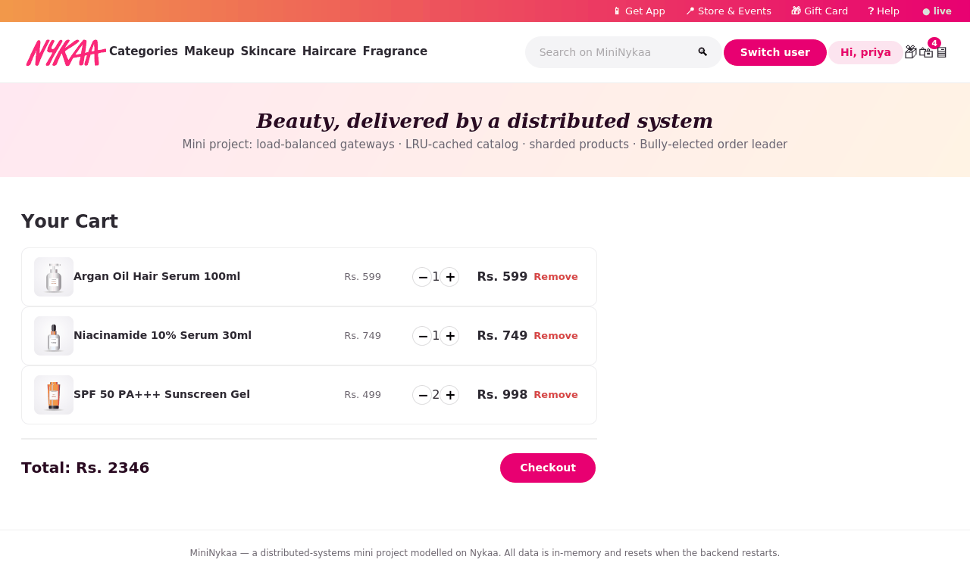
Figure 3: Cart with +/− and Remove.

5.4 Checkout, orders and cancellation
Checkout re-validates stock, decrements it on the owning shard and creates the order on the order leader (replicated to the followers). On the Orders page (box icon) each confirmed order has a Cancel order button: it marks the order CANCELLED and returns the items to stock; a second cancel is rejected.
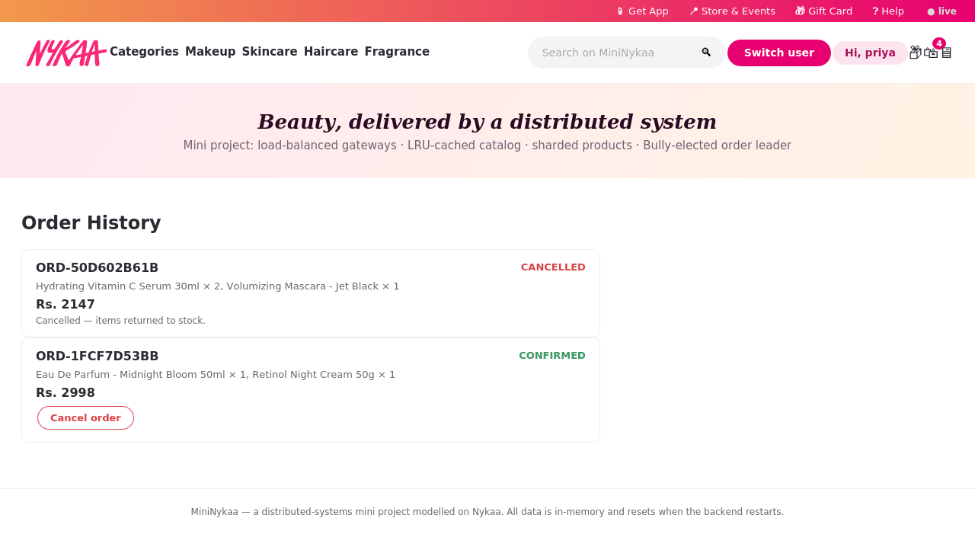
Figure 4: A cancelled order (stock restored) and a confirmed one with a Cancel order button.

5.5 Get App, Store & Events, Gift Card, Help
The four links in the pink bar open panels with demo content: Get App (placeholder, no real app, decorative QR pattern), Store & Events (sample data), Gift Card (generates a demo code, no payment) and Help (a plain FAQ). There is no AI/LLM assistant anywhere in the project.
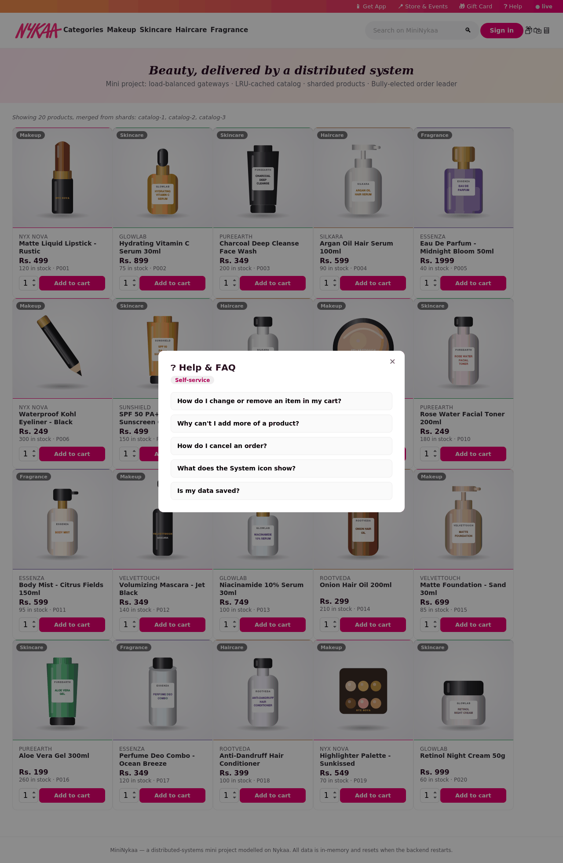
Figure 5: The Help panel.

5.6 The System tab (monitor icon)
A live picture of the whole cluster, refreshed every 2 seconds, in four groups: (1) the load balancer and its algorithm; (2) the gateways with requests handled, in-flight count, failures and cache statistics (hits, misses, hit rate, size, TTL, evictions); (3) the catalog shards; (4) the order replicas with the elected LEADER badge. A small log lists state changes. Every demonstration below is watched here.
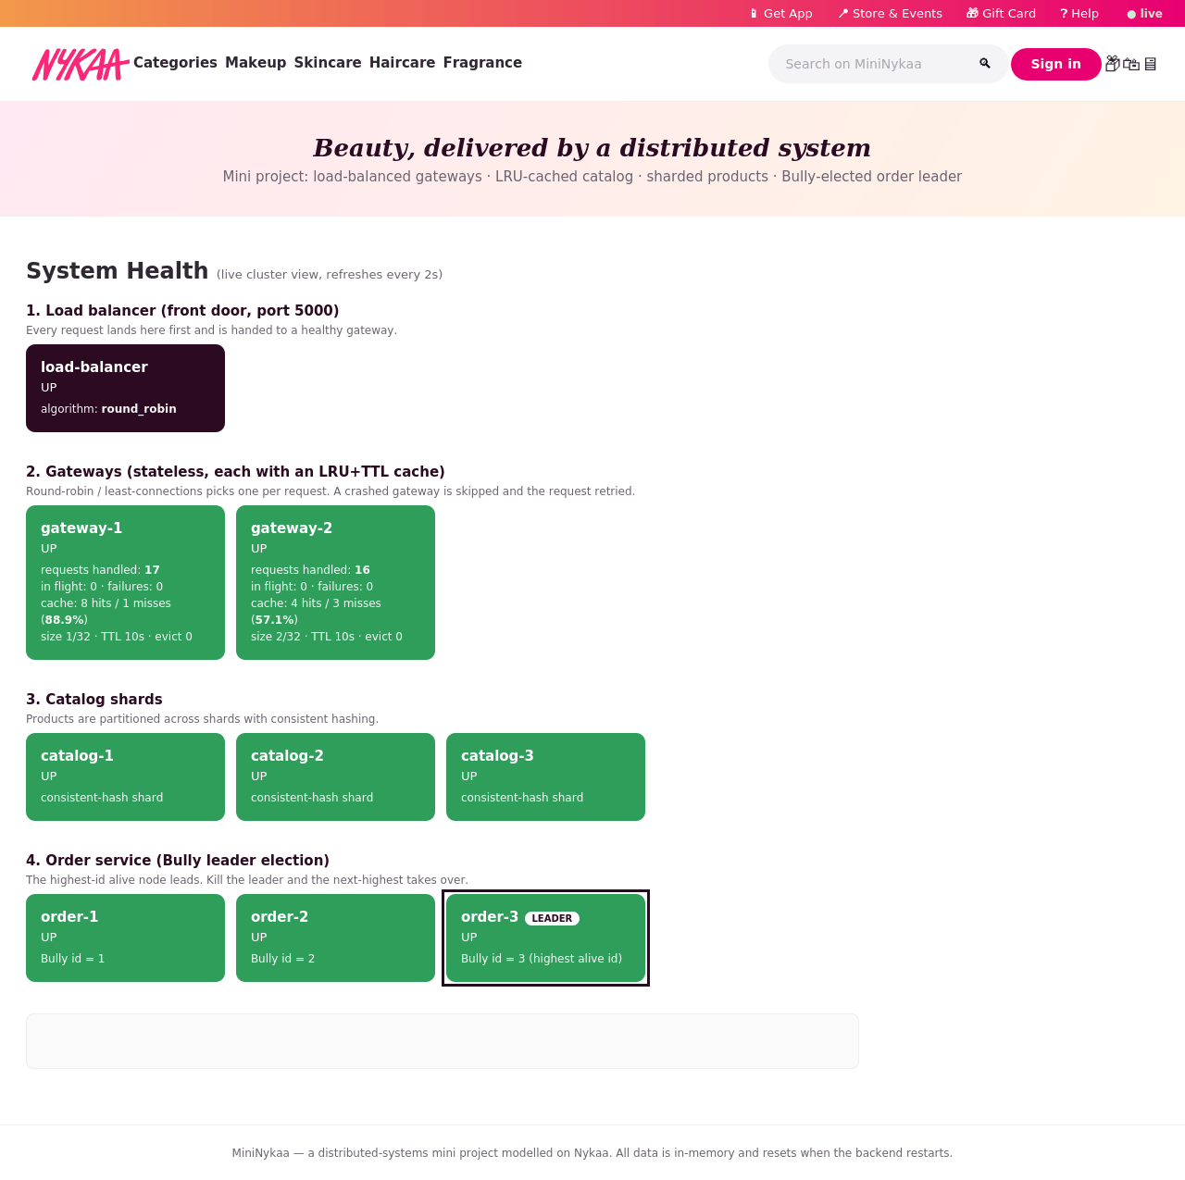
Figure 6: System tab, everything healthy; order-3 is leader.

6. Demonstrations

6.1 Sharding
The line above the products says which shards the list was merged from. To see which products each shard owns, run docker compose logs catalog-1 catalog-2 catalog-3: the three shards own 8, 5 and 7 of the 20 products, chosen by consistent hashing. A product always lives on the same shard.

6.2 Load balancing
Sign in, open the System tab, then click around the store (browse, search, add to cart). Watch gateway-1 and gateway-2 under "requests handled": the counts rise in turn because the load balancer uses round-robin. Background refreshes by the page itself are deliberately not counted.

6.3 Bully leader election
- Open the System tab: order-3 carries the LEADER badge.
- Stop it: docker compose stop order-3.
- Within about 3 seconds order-1 and order-2 miss two pings, presume the leader dead and start an election. order-2 hears no answer from a higher id, wins, and announces COORDINATOR. The System tab shows order-3 DOWN and order-2 LEADER.
- Add an item to your cart: it still works, served by order-2, and earlier carts and orders are intact (they were replicated).
- Run docker compose start order-3: it first copies the latest data from its peers, then starts an election, wins (highest id) and takes leadership back.
To see the election messages, run docker compose logs -f order-1 order-2 order-3 while you do this. The two figures below show the log and the System tab.

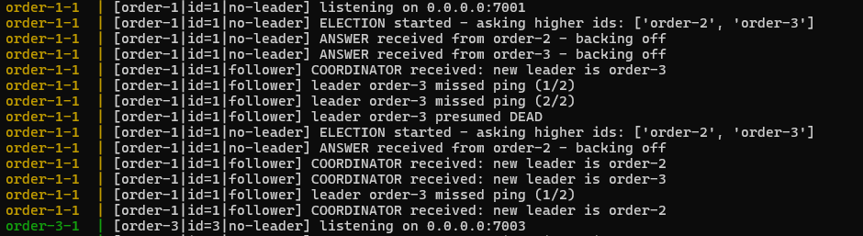
Figure 7: Election log after the leader stops.
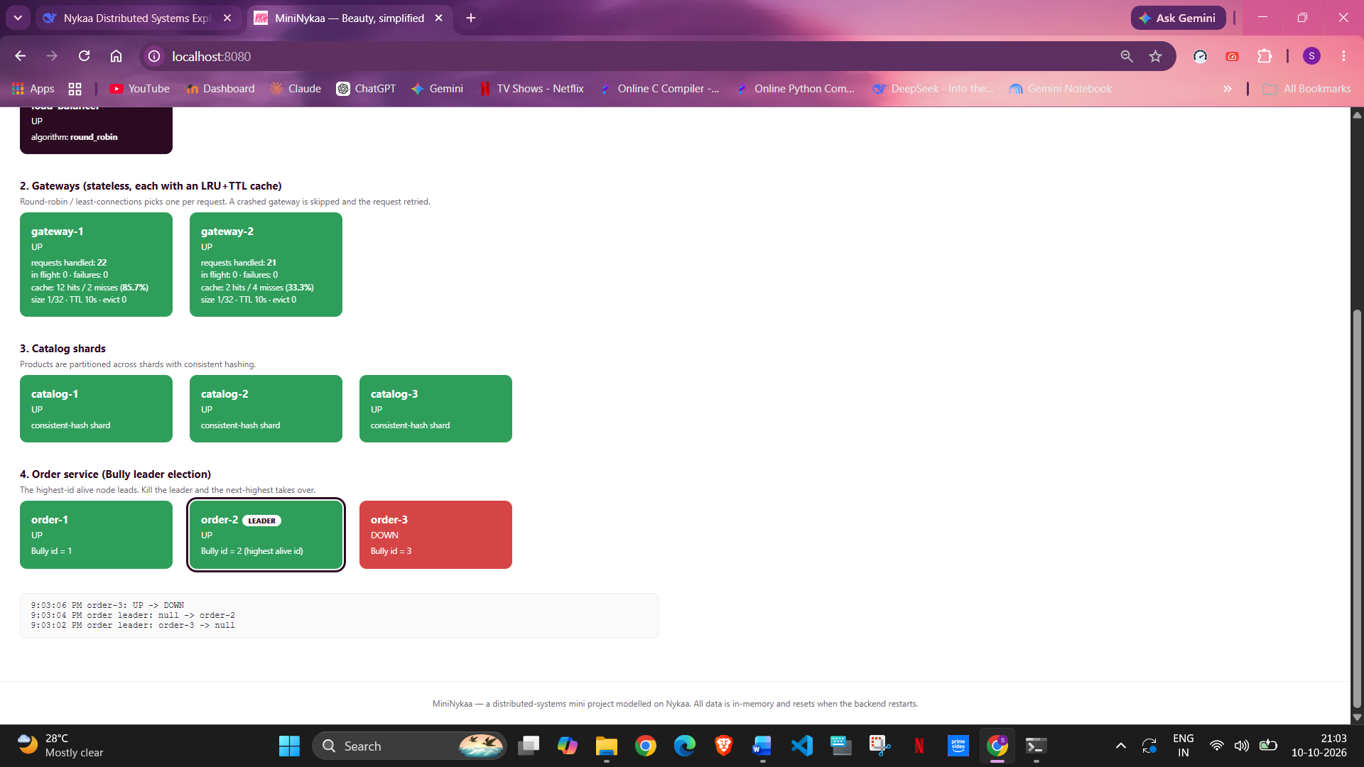
Figure 8: order-3 DOWN, order-2 elected LEADER.

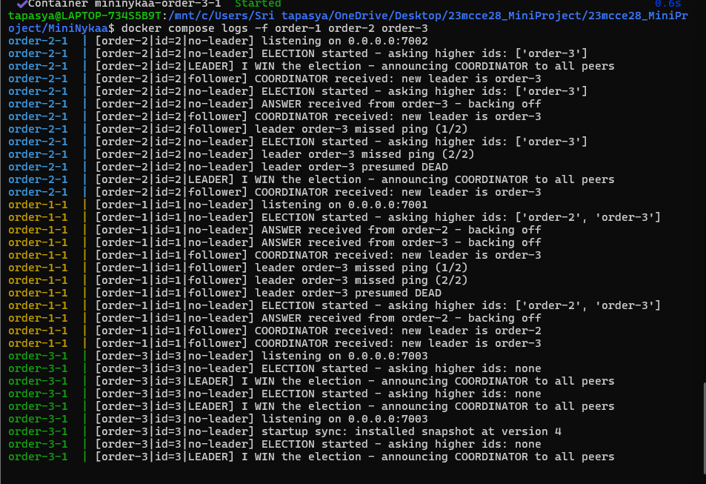
Figure 9: order-3 restarts, syncs, and reclaims leadership.

6.4 Gateway failure
Run docker compose stop gateway-1 and keep using the store. The load balancer's first failed forward marks gateway-1 DOWN and re-sends the request to gateway-2, so nothing fails. The System tab shows gateway-1 DOWN and gateway-2 carrying all the traffic. docker compose start gateway-1 returns it to rotation within a few seconds.
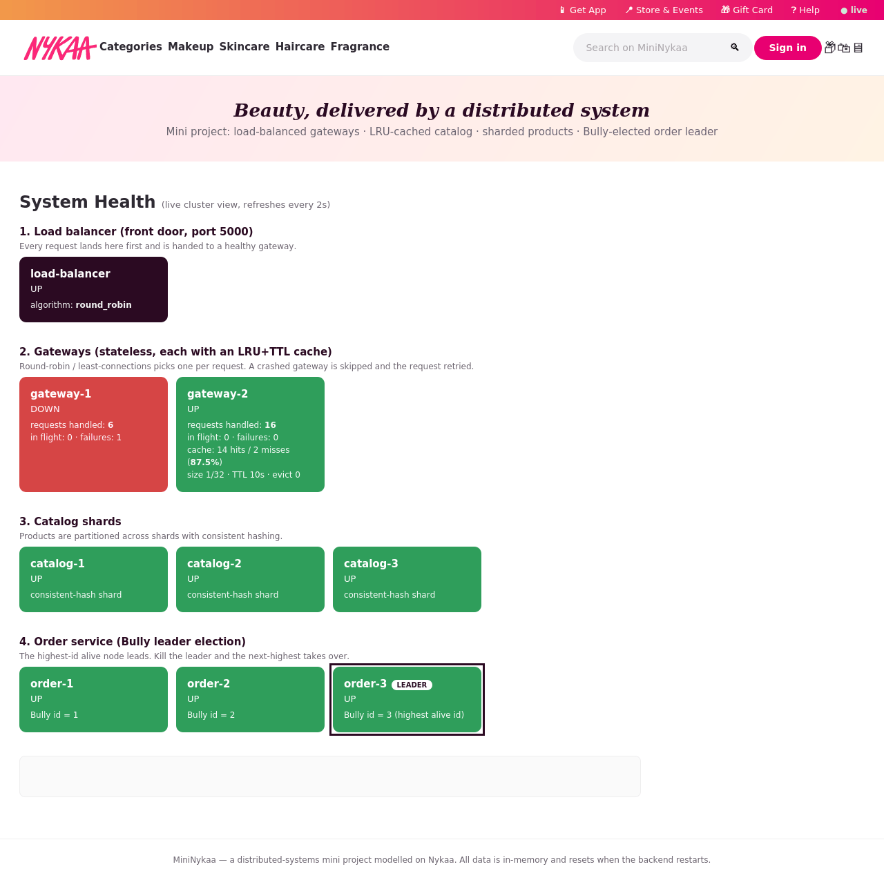
Figure 10: gateway-1 DOWN, gateway-2 carries all traffic.

6.5 Concurrency
Many shoppers at once are tested automatically: the test test_concurrent_checkouts_give_unique_ids_and_exact_stock runs 20 shoppers checking out simultaneously and verifies that every order ID is unique and the stock fell by exactly 20. See Section 10.

6.6 Catalog shard failure
Run docker compose stop catalog-1. After a few seconds the catalog shows only the remaining shards' products, and a product on the stopped shard cannot be added to the cart (the shard is down). The catalog has no replicas in this version, so this is partial availability. docker compose start catalog-1 brings it back (its stock numbers reset, because data is in memory).

7. Automated Tests (pytest)
The tests/ folder holds 65 automated tests. They check the load balancer, the cache, the Bully election and the rest of the system, including stopping nodes on purpose. The tests run on your computer inside a Python virtual environment (venv), which keeps pytest separate from the rest of your Python installation.

7.1 One-time setup: create and activate a virtual environment
Run these in the MiniNykaa folder. Use python on Windows and python3 on Linux/macOS if python is not found.

Windows (PowerShell)
cd MiniNykaa
python -m venv .venv
.venv\Scripts\Activate.ps1
pip install -r requirements-dev.txt

Windows (Command Prompt)
cd MiniNykaa
python -m venv .venv
.venv\Scripts\activate.bat
pip install -r requirements-dev.txt

Linux / macOS
cd MiniNykaa
python3 -m venv .venv
source .venv/bin/activate
pip install -r requirements-dev.txt
When the venv is active, your prompt starts with (.venv). requirements-dev.txt contains just pytest; the application itself needs no packages. Next time you only need to activate the venv again (the line that starts with .venv/source). To leave it, run deactivate. The .venv folder is excluded from the Docker image (see .dockerignore).

7.2 Running the tests
pytest # all 65 tests, about 30 seconds

By default the tests start their own private copy of all ten processes on a separate port range (15000-18081) and stop it afterwards. You do not need Docker running for this, and it cannot clash with the website you may have open on port 8080.
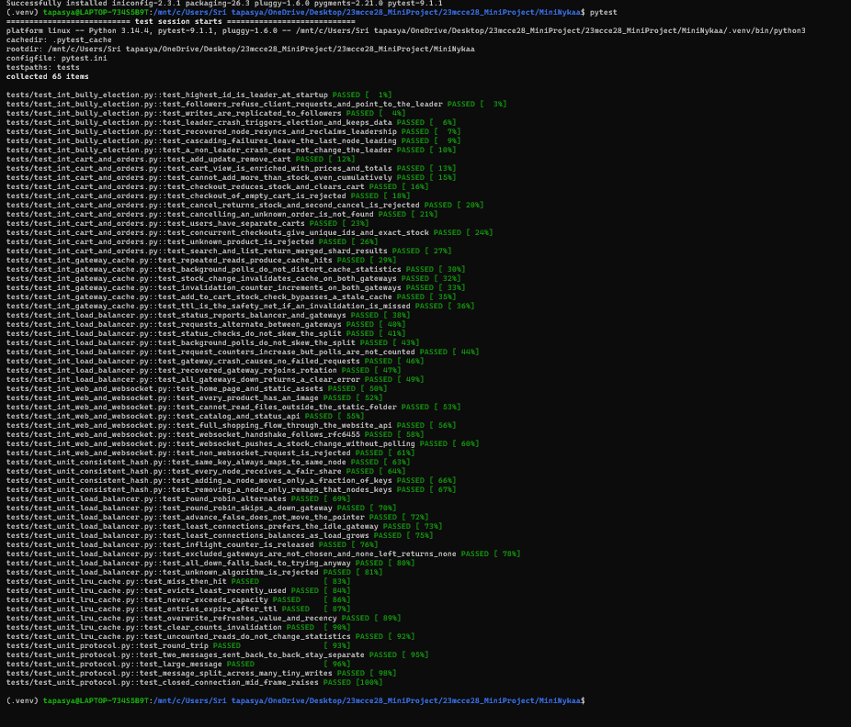
Figure 11: A pytest run: 65 passed.

7.3 What is tested
File | Tests | What it proves
test_unit_lru_cache.py | 7 | Hit/miss counting, least-recently-used eviction, TTL expiry, capacity limit, invalidation, uncounted background reads.
test_unit_consistent_hash.py | 4 | Same key, same shard; fair spread; adding a node moves only about a quarter of keys, all to the new node.
test_unit_protocol.py | 5 | Message framing: round trip, back-to-back messages, 500 KB message, one-byte-at-a-time delivery, truncated message.
test_unit_load_balancer.py | 9 | Round-robin alternates; skips DOWN gateways; least-connections picks the idle one; polls do not move the pointer; invalid algorithm rejected.
test_int_load_balancer.py | 8 | Real balancer: strict alternation, no skew from status checks or polls, counters, a gateway crash causes zero failed requests, a recovered gateway rejoins, all-down gives a clear error.
test_int_gateway_cache.py | 6 | Hits on repeated reads; a purchase invalidates BOTH gateways (never a stale value); add-to-cart bypasses a stale cache; the TTL heals a missed invalidation.
test_int_bully_election.py | 7 | Highest id leads at start; followers refuse requests (NOT_LEADER); writes replicate; leader crash elects order-2 with data intact; the recovered node resyncs and reclaims leadership; cascading crashes; a follower crash changes nothing.
test_int_cart_and_orders.py | 11 | Add/update/remove, cumulative stock limit, checkout, cancel restores stock exactly once, per-user carts, 20 concurrent checkouts give unique IDs and exact stock.
test_int_web_and_websocket.py | 8 | Website pages and images, path traversal blocked, full shopping flow over HTTP, WebSocket handshake matches RFC 6455, a purchase is pushed live.

