Week4 Assessment Screenshots

Week 4 and Final Assessment Devops(Maven,Junit, Git,Sonarqube,Docker,Jenkins) implementation for Microservice Customer Producer application

- Push the code through IDE (STS or Eclipse) into github remote repository backend.

https://github.com/SriTejaKunchapu/week4assessment/tree/main

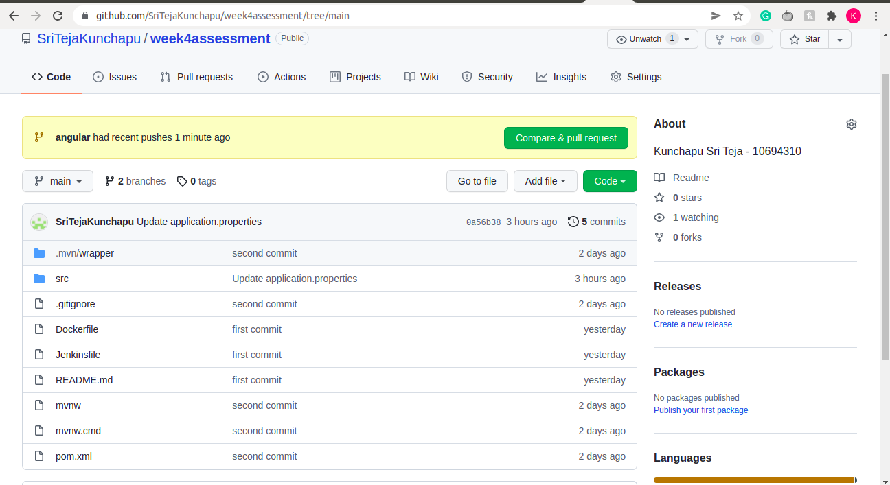
- Push Frontend code also into git command line

https://github.com/SriTejaKunchapu/week4assessment/tree/angular
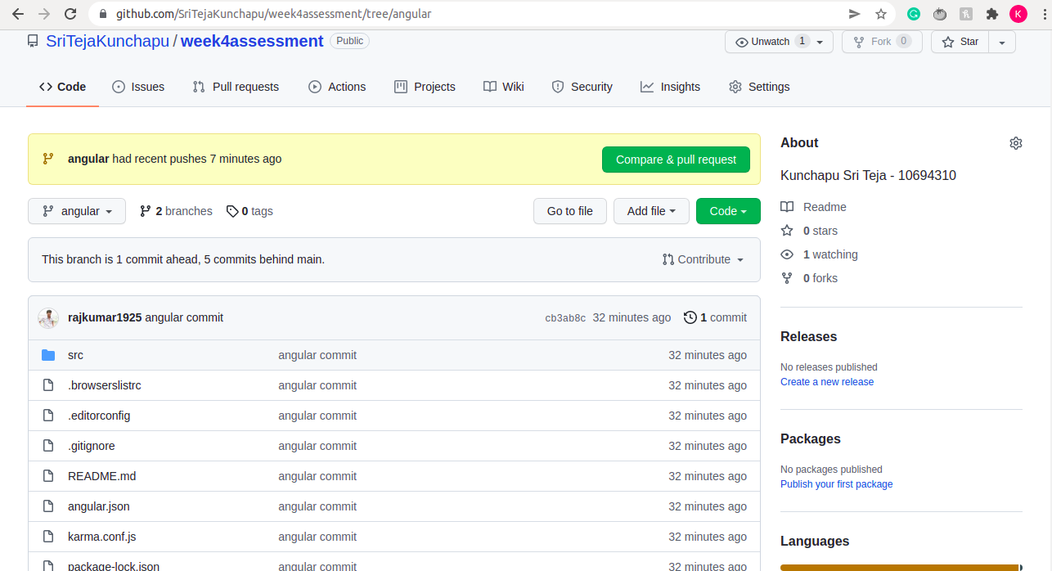

- Run the possible number of Junit test case ( positive+ negative )-
JNUIT TEST CASES AND COVERAGE:
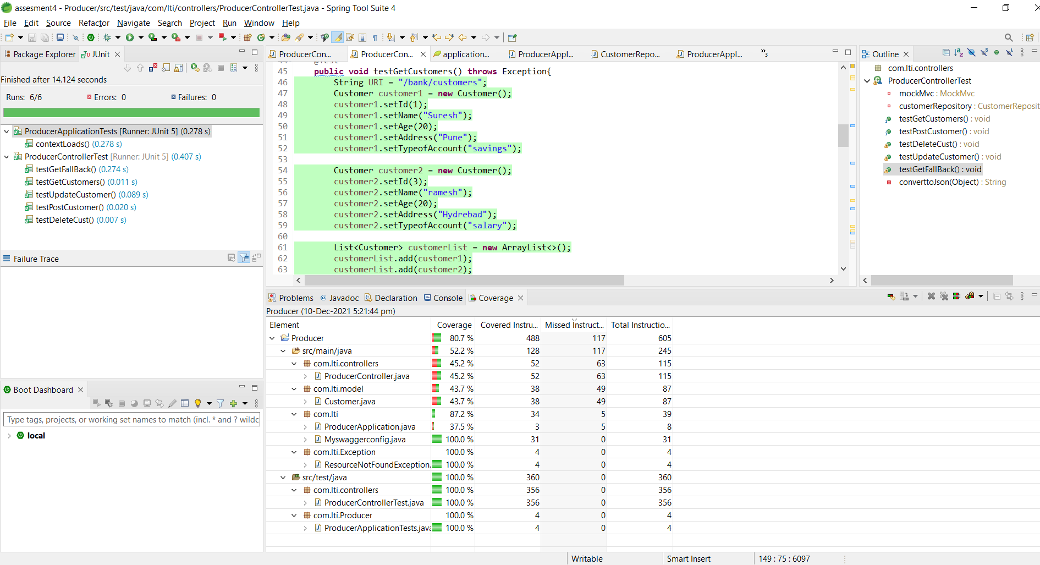

H2 CONSOLE:
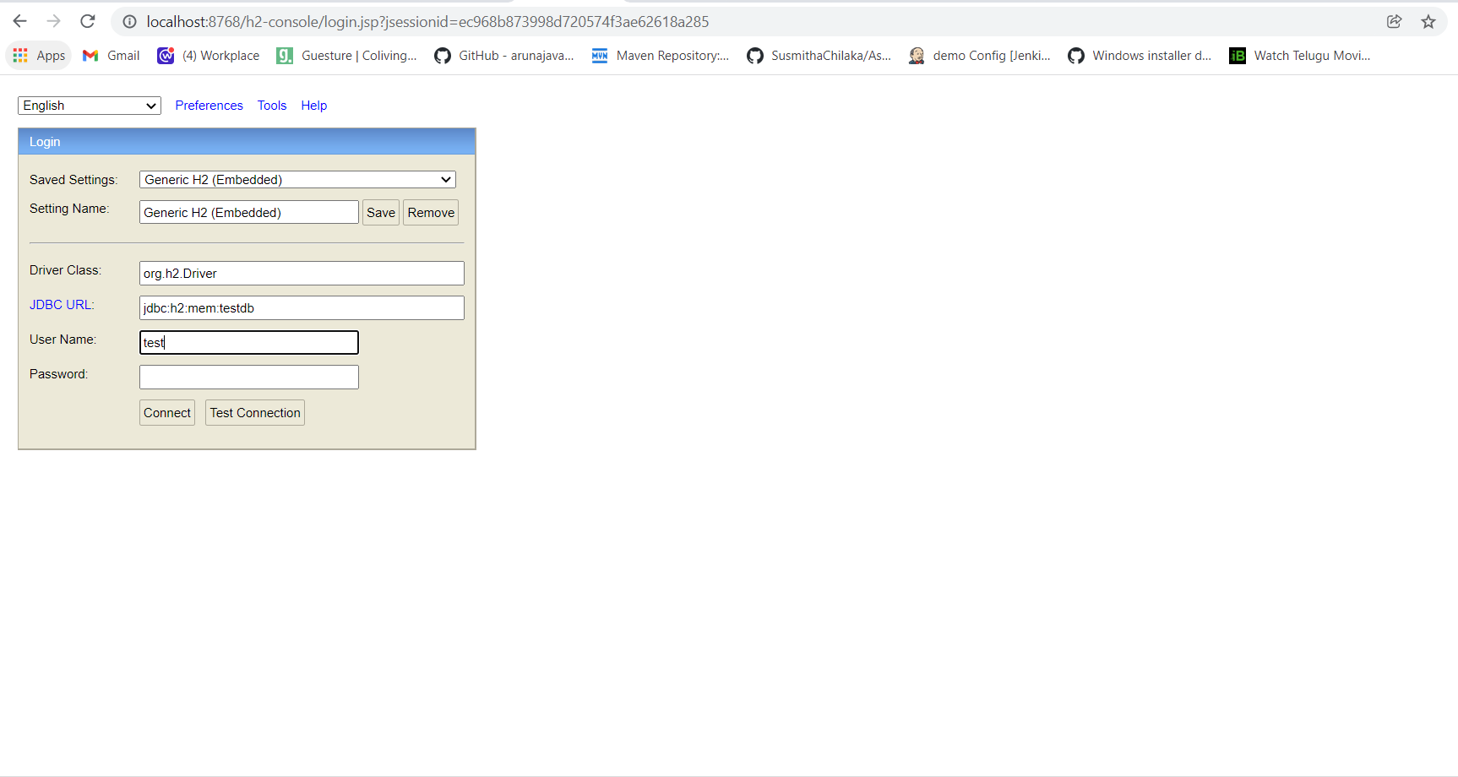

Devops
- Code quality can be checked for backend code-SonlarLint /Checkstyle -
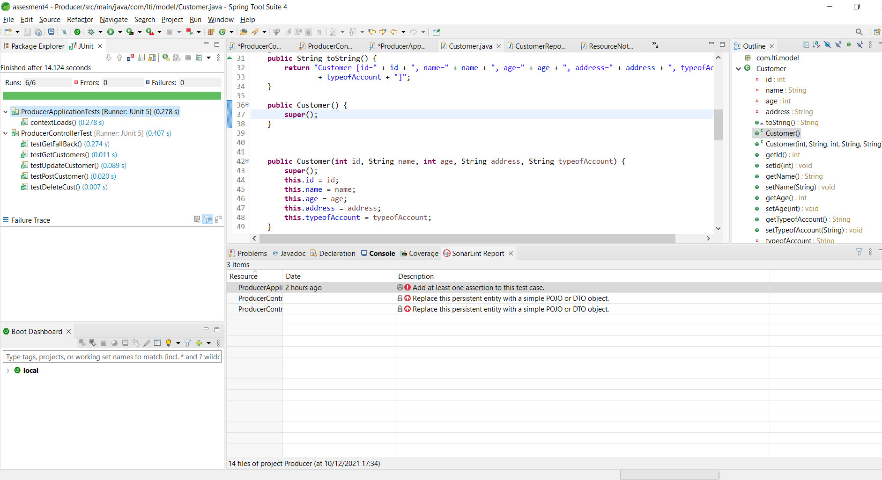

- Project can be imported in Sonarqube for bugs and vulnerabilities-

PROJECT IMPORTED TO SONARQUBE
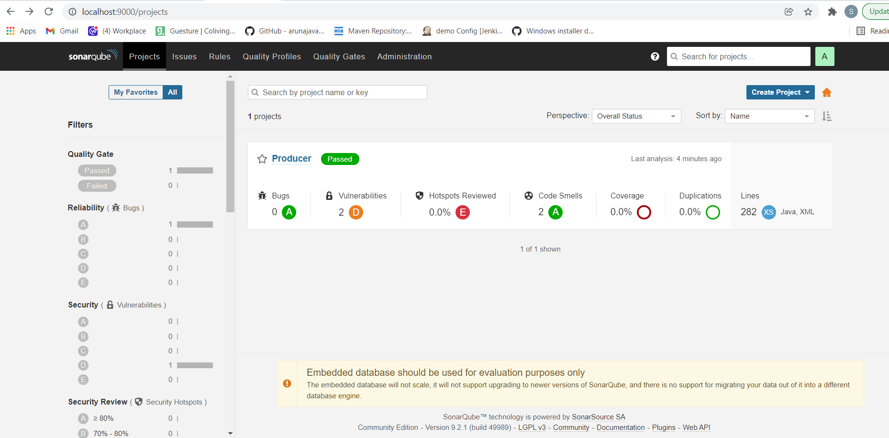

BUGS AND VULNERABILITIES IN SONARQUBE
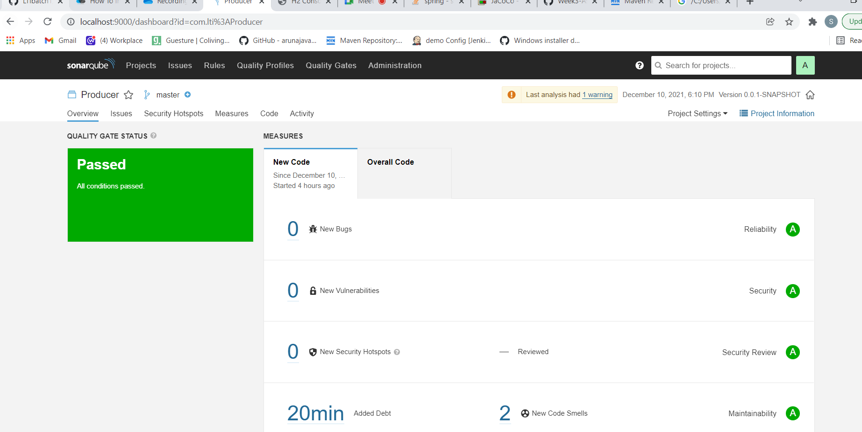

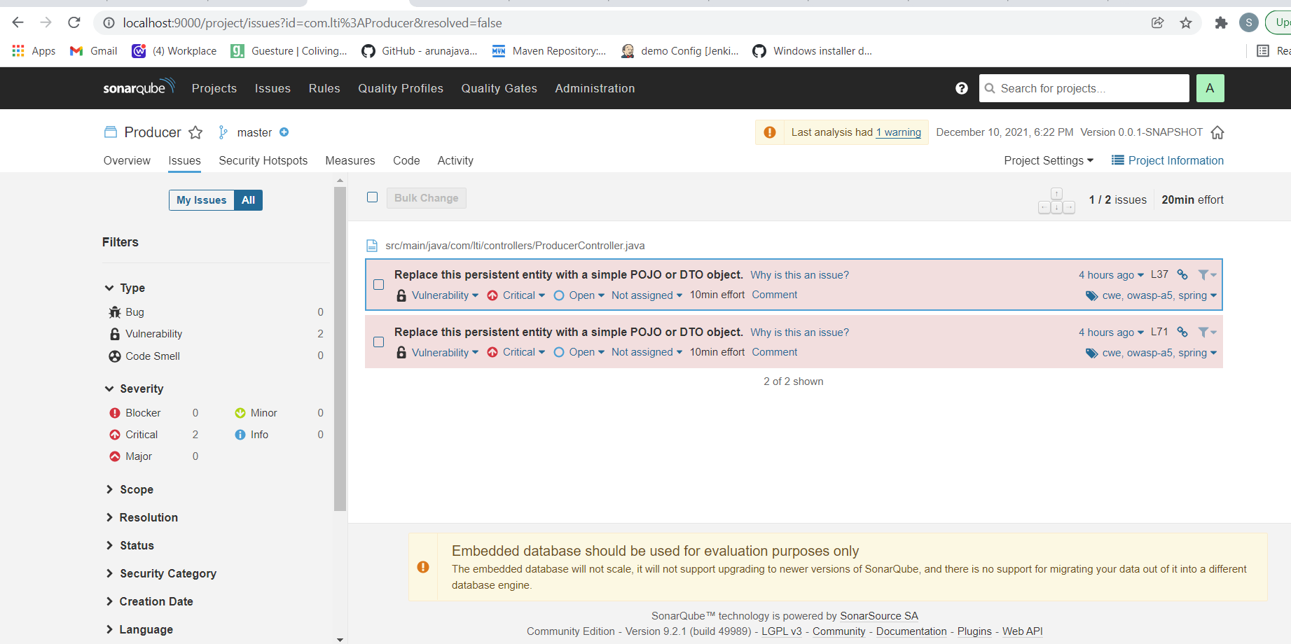

- Docker image and container creation and deployment in Dockerhub -

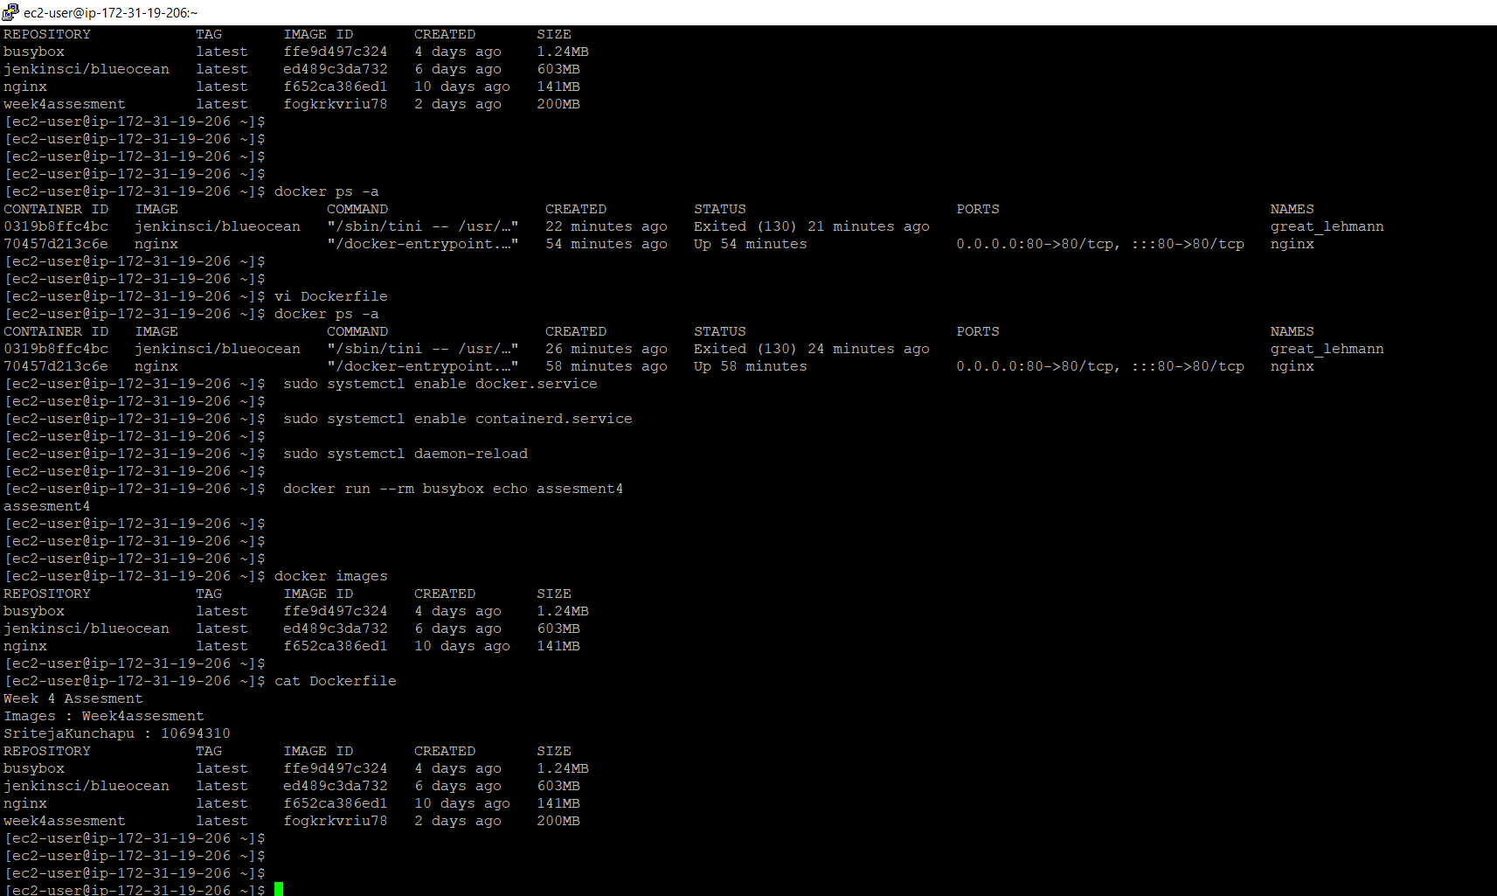
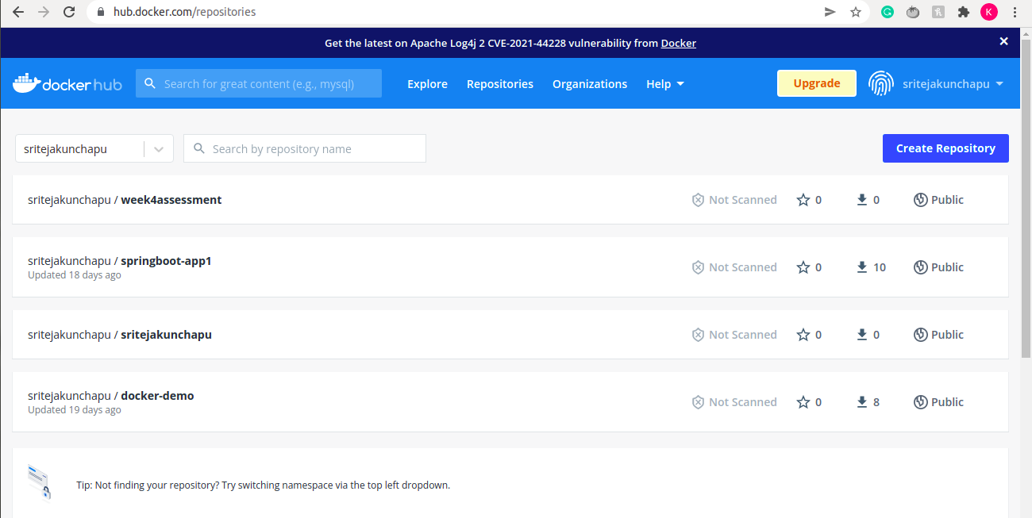

- Jenkins code pipeline can be created with minimum 3 stages -

Docker Running from EC2-INSTANCE
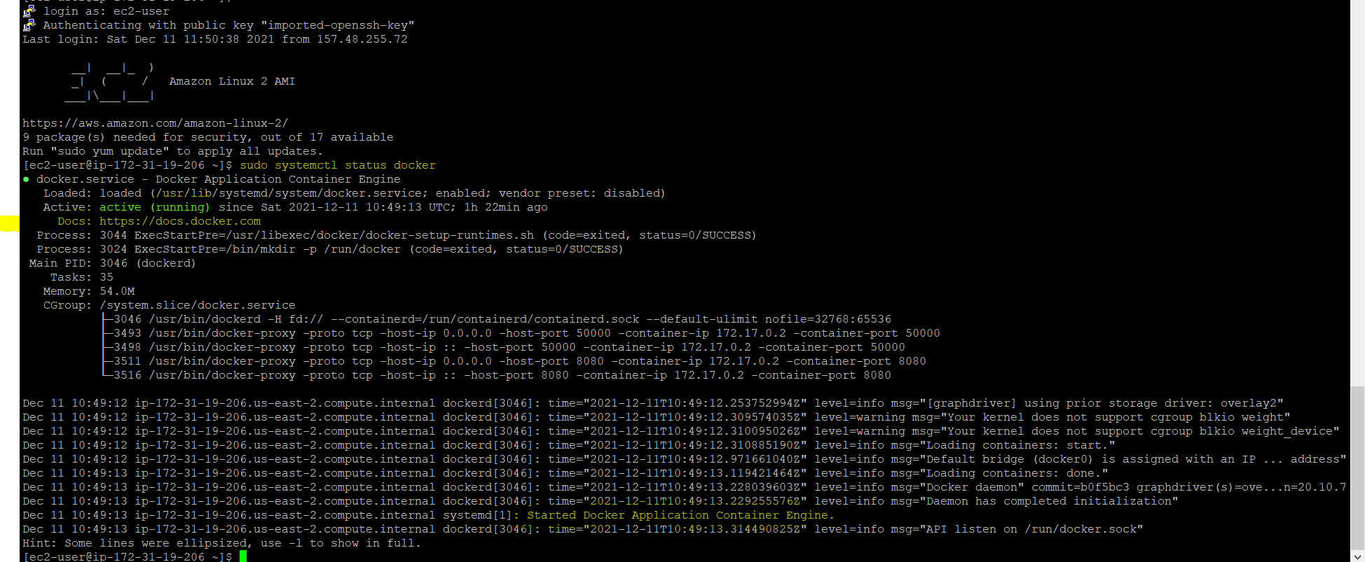

JENKINS FRUNNING FROM EC2 INSTANCE
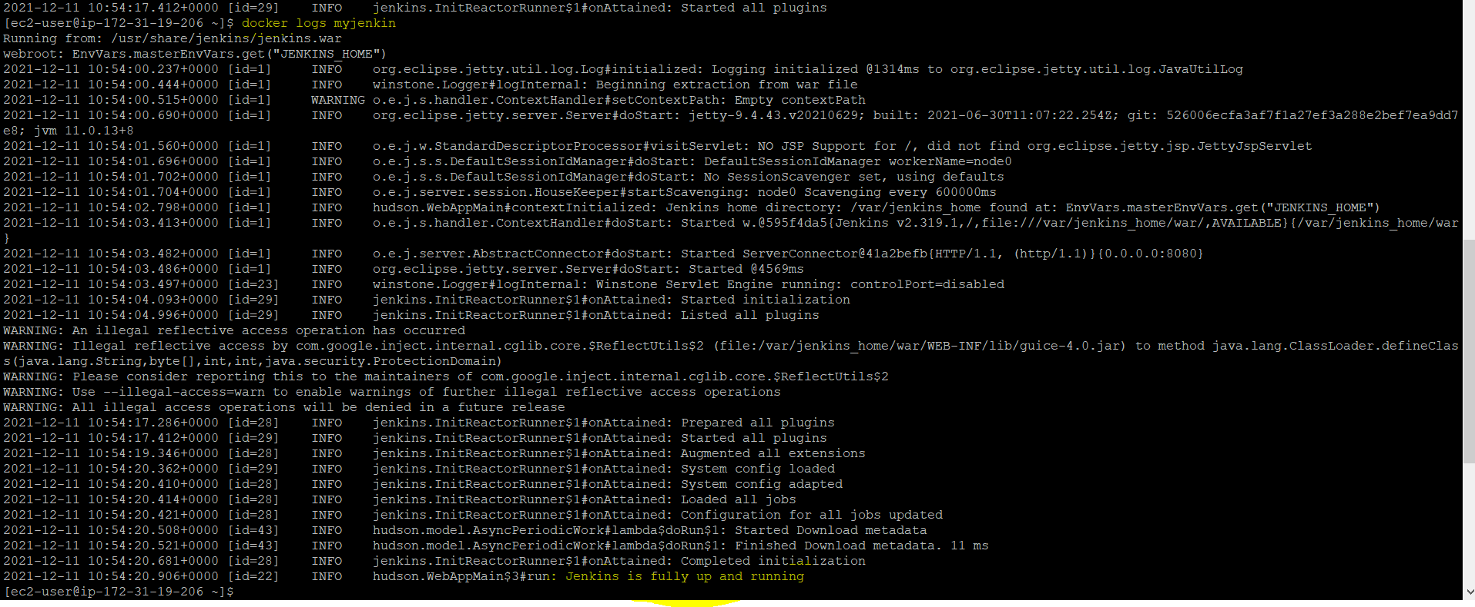

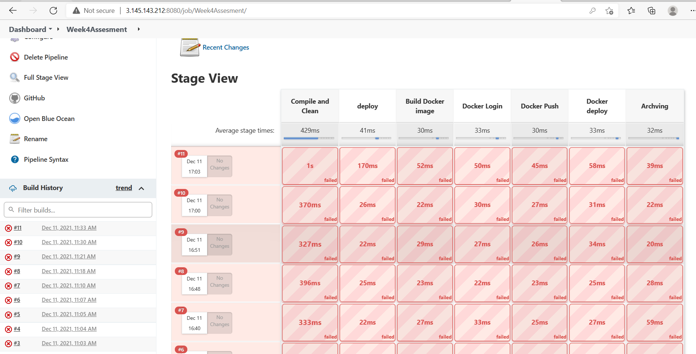

AWS:

- Use S3 bucket to deploy Frontendcode

S3 Bucket : arn:aws:s3:::week4assessmentfrontend

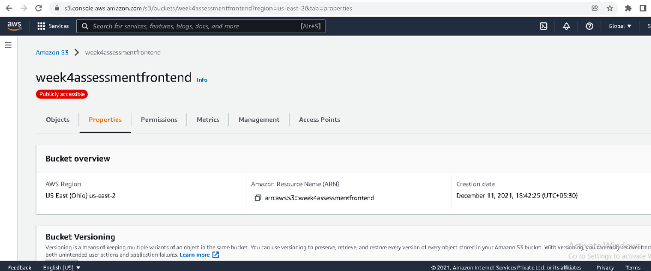
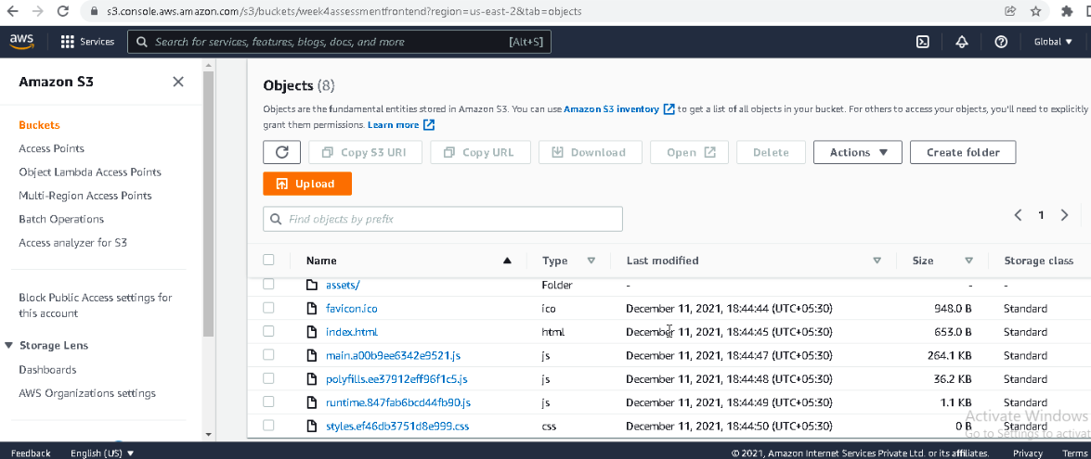
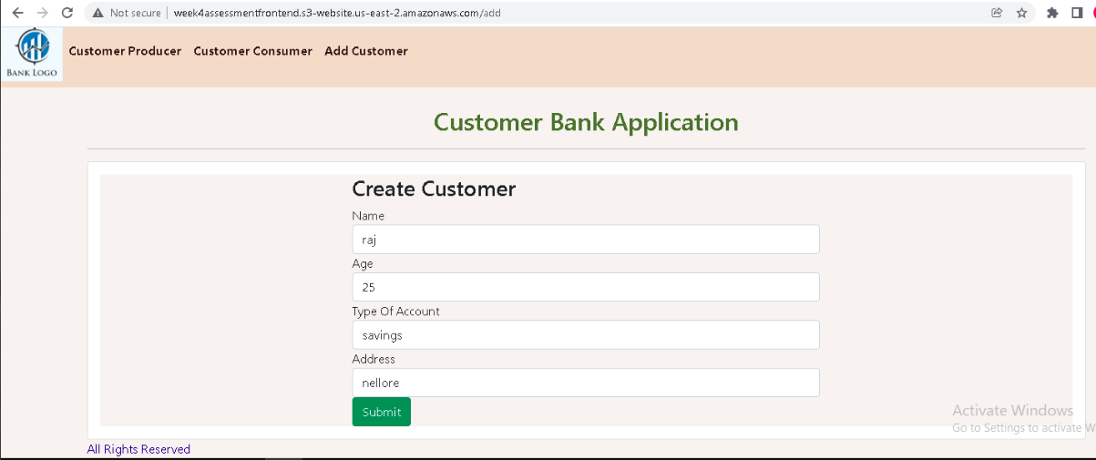

- Use RDS instance to connect to Mysql instance.

