**Day 2:**

Ls ccommand:

The ls command in Linux is used to list the contents of a directory.

It displays information about the files and directories within the specified directory.

ls -l: Lists files and directories in a long format, showing detailed information such as permissions, number of links, owner, group, size, and modification time.

ls -a: Lists all files, including hidden files (those starting with a dot .).

ls -h: When used with -l, displays file sizes in human-readable format (e.g., KB, MB).

ls -R: Recursively lists subdirectories.

ls -t: Sorts files by modification time, with the newest files listed first.

ls -S: Sorts files by size, with the largest files listed first.

ls -r: Reverses the order of the sort.

CD command:

The cd (change directory) command in Linux is used to change the current working directory.

It allows you to navigate through the filesystem and switch to different directories.

Using cd with Relative and Absolute Paths

Relative path: A path relative to the current directory.

By using the cd command effectively, It can navigate through the Linux filesystem and access various directories to manage files and perform tasks

CP command:

The cp command in Linux is used to copy files and directories.

It allows you to duplicate files and directories from one location to another.

MV command:

The mv command in Linux is used to move or rename files and directories.

The mv command is versatile for both moving and renaming files and directories,

making it a fundamental tool for managing files in the Linux filesystem.

Rm command:

The rm command in Linux is used to remove files and directories.

It is a powerful command that permanently deletes files and directories, so it should be used with caution.

pwd command:

The pwd command in Linux stands for "print working directory." It displays the full path of the current directory you are in.

This command is helpful when you need to know your exact location within the filesystem,

especially when navigating through multiple directories.

mkdir command:

The mkdir command is used to create new directories.

mkdir directory_name

mkdir -p: Creates parent directories as needed.

mkdir -v: Verbose mode; shows a message for each created directory.

rmdir:

The rmdir command is used to remove empty directories.

rmdir -p: Removes parent directories as well, if they become empty.

rmdir -v: Verbose mode; shows a message for each removed directory.

man mkdir

man rmdir

These commands will display the manuals for mkdir and rmdir, providing comprehensive information on all available options and their usage.

**Question 1:**

Navigation:

cd (change directory): Moves you between directories.

Exercise: Navigate to your home directory (cd ~), then explore subdirectories like Documents (cd Documents). Use pwd (print working directory) to confirm your location. Try going back a directory with cd ...

pwd (print working directory): Shows your current directory path.

cd ~: Changes the current directory to your home directory.

pwd: Prints the current working directory.

cd Documents: Changes the current directory to the Documents directory.

cd ..: Changes the current directory to the parent directory of the current directory.

**Question 2:**

Exercise: After navigating using cd, use pwd to verify the path.

ls (list): Lists files and directories in the current directory.

Exercise: Use ls in your home directory and note the listed items. Try ls -l (long format) for detailed information like permissions, owner, and size.

cd ~: Changes directory to your home directory.

pwd: Prints the current working directory.

ls: Lists files and directories in the current directory.

ls -l: Lists files and directories in long format, displaying detailed information.

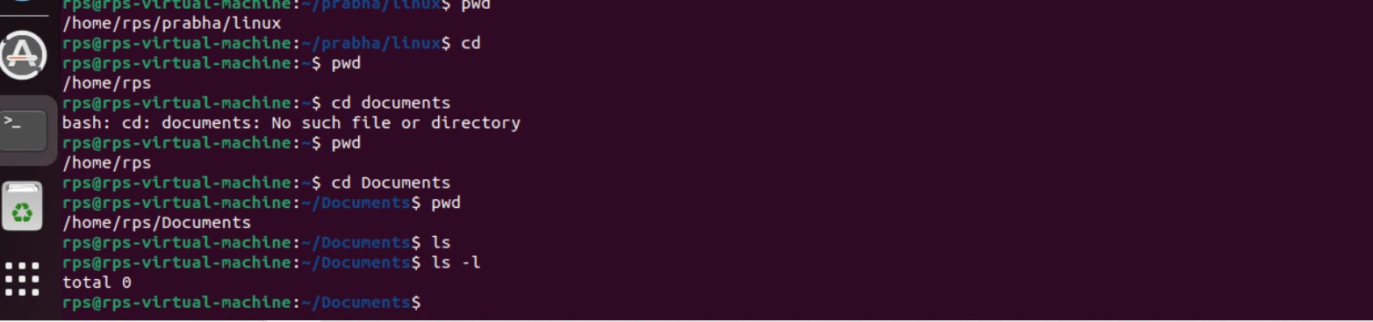

**Question3:**

File and Directory Management:

mkdir (make directory): Creates a new directory.

Exercise: Create a new directory called "Projects" (mkdir Projects). Use ls to confirm its existence.

rmdir (remove directory): Deletes an empty directory.

Exercise: Make a directory named "temp" (mkdir temp). Delete it after verifying its existence with ls (rmdir temp).

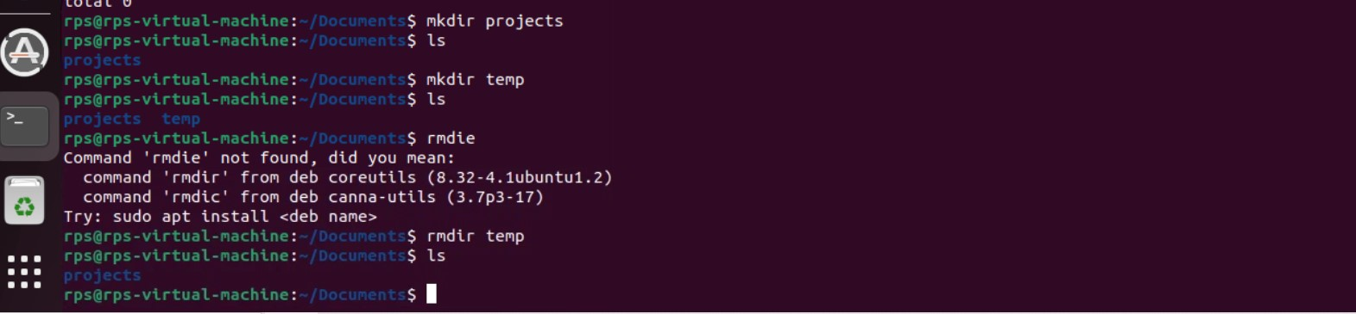

**Question 4:**

touch (create file): Creates an empty file.

Exercise: Create a file called "test.txt" (touch test.txt). Use ls to see it listed.

cp (copy): Copies a file or directory to another location.

Exercise: Copy "test.txt" to your Documents directory (cp test.txt Documents). Verify the copy with ls Documents.

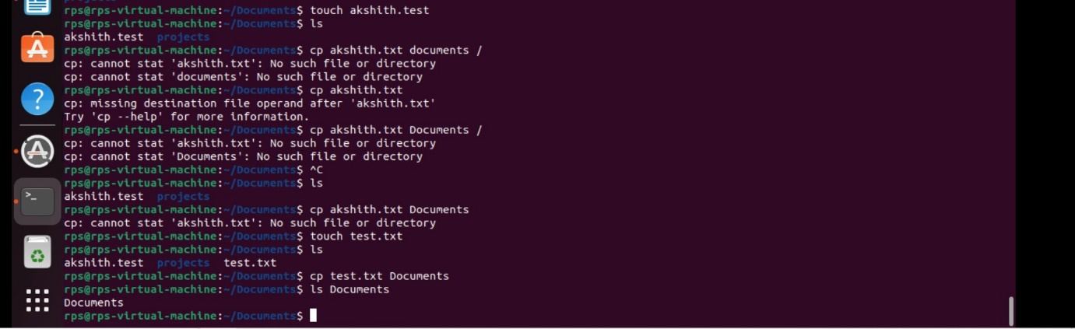

touch test.txt: Creates an empty file named test.txt.

ls: Lists files and directories in the current directory.

cp test.txt Documents/: Copies test.txt to the Documents directory.

ls Documents: Lists files and directories in the Documents directory to verify the presence of test.txt.

**Question5:**

mv (move/rename): Moves or renames a file or directory.

Exercise: Rename "test.txt" to "data.txt" (mv test.txt data.txt). Use ls to confirm the change. You can also move files to a different directory (e.g., mv data.txt Documents).

rm (remove): Deletes files or directories (use with caution!).

Exercise: Important: Only use this after creating a test file (e.g., touch temp.txt). Delete "temp.txt" with rm temp.txt. Never use rm -rf without understanding the risks!

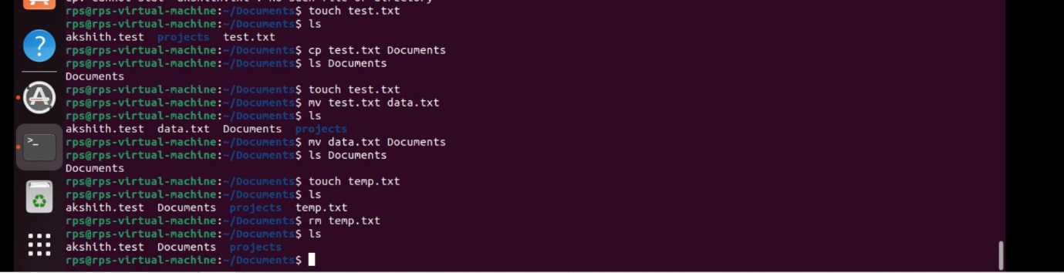

**Question 6:**

File Viewing and Permissions:

cat (concatenate): Displays the contents of a text file.

Exercise: Create a text file named "message.txt" with some content (e.g., using a text editor). Then, use cat message.txt to view its contents.

more (pager): Displays a file's contents one screen at a time (useful for long files).

Exercise: Create a larger text file (e.g., "long_text.txt") and use more long_text.txt to navigate through its content page by page.

less (pager): Similar to more, but allows you to move backward in the file.

Exercise: Use less with "long_text.txt" to try moving backward using the Up arrow key.

chmod (change mode): Modifies file permissions (owner, group, others) for read, write, and execute access.

Exercise: This requires understanding permissions. Refer to the man chmod page for details. Proceed with caution when modifying permissions.

Getting Help and Information:

**Question 6:**

man (manual): Provides detailed information about a command.

Exercise: Use man ls or man cd to learn more about these commands.

info (information): Another source of documentation for some commands, often more user-friendly than man.

Exercise: Try info ls or info cd if available on your system.

--help or -h (help flag): Provides a brief overview of a command's usage.

Exercise: Use ls --help or ls -h to see the basic usage options for ls.