Sample IRJASH Template, Bold, Times New Roman Font, Size 16, 1.0 Line spacing (Maximum - 100 characters)
First Author^{1*}, Second Author², Third Author³, (Times New Roman Font Size 10 & Italic)
¹First Author Affiliation & Address (Times New Roman Font Size 10 & Italic)
²Second Author Affiliation & Address
³Example: Professor, Department of abc Engineering, abc college, state, country (Times New Roman Font Size 10 & Italic)
Article history | Abstract
Received: XX june 201X  Accepted: XX December 201X (Times New Roman Font Size 10 & Italic)  Keywords:  Key word1;  Key word2;  Key word3;  etc (Minimum 4 to 6 key words)(Size 10, Italic & Times new roman font) | An abstract summarizes, in one paragraph (usually), the major aspects of the entire paper in the following prescribed sequence. The abstract of your paper must 250 words or less. This electronic document is a “live” template. The various components of your paper [title, text, heads, etc.] are already defined on the style sheet, as illustrated by the portions given in this document. Do not use special characters, abbreviations, symbols, or math in your title or abstract. The authors must follow the instructions given in the document for the papers to be published. This template, modified in MS Word 2007 and saved as a “Word 97-2003 Document (Size 12, Italic & Times new roman font)

1. Introduction (Bold, Size 12, Times New Roman font)
This document is template. We ask that authors follow some simple guidelines. In essence, we ask you to make your paper look exactly like this document. The easiest way to do this is simply to download the template, and replace (copy-paste) the content with your own material. Number the reference items consecutively in square brackets [1].
However, the authors name can be used along with the reference number [2] in the running text. The order of reference in the running text should match with the list of references at the end of the paper. (Times New Roman Font Size 12)
It is recommended to refer minimum 20 articles, preferably research gap at the end of the section. Articles without novel research gap will summarily get rejected.
It is mandatory to have only these four headings (Introduction, Material & Methods/Methodology, Results and Discussion, Conclusion) without which the article is not

considered for review. Reference should be at the end of the session in MLA format. The minimum resolution for line diagrams is 600Dpi and image diagram is 300Dpi. Use adobe photoshop to increase the clarity, drag the image into the adobe photoshop, click alt+I+I, set the prescribed Dpi in the dialogue box. Don’t drag and drop the JPEG image inside the word document, it reduces the image quality.
Sub Heading 1(Bold, Size 12, Times New Roman font)
Before you begin to format your paper, first write and save the content as a separate text file. Keep your text and graphic files separate until after the text has been formatted and styled. Do not use hard tabs, and limit use of hard returns to only one return at the end of a paragraph. Do not add any kind of pagination anywhere in the paper. Do not number text heads-the template will do that for you.
Finally, complete content and organizational editing before formatting. Please take note of the following items when proofreading spelling and grammar:
Sub Heading 2 (Bold, Size 12, Times New Roman font)
TABLE 1. Sample Table format
Preparation of Manuscript
Margins : Top | 0.5” | Bottom | 0.5”
Left | 0.5” | Right | 0.5”
Margin : Narrow | Font | Times New Roman / 12pt
Title of paper : 16 Point | Heading | 12 Point
Sub Heading :12 Point | Spacing | Single line spacing
Sample paragraph, the entire document should be in Times New Roman font. Type 3 fonts must not be used. Other font types may be used if needed for special purposes.
2. Materials and Methods (Bold, Size 12, Times New Roman font)
The methodology obtained for conducting experiments have to explain elaborately in this section. It includes experimental procedure, equipment’s used, its make and model, specification, material composition, algorithm used, etc..
$A=πr^{2}$ (1)
Equation in image format was not accepted, for writing equation use insert equation option. All the terms in the equation have to notate appropriately.
Sub Heading 1 (Bold, Size 12, Times New Roman font)
Sample paragraph, the entire document should be in Times New Roman font. Type 3 fonts must not be used. Other font types may be used if needed for special purposes.
3. Results and Discussion (Bold, Size 12, Times New Roman font)
Results are the driving force of the publication. Tell a clear and easy-to-understand story The following should be included: the main findings, thus not all findings. Findings from experiments described in the Methods section. Highlight findings that differ from findings in previous publications, and unexpected findings, results of the statistical analysis.
IRJASH sample template format, Define abbreviations and acronyms the first time they are used in the text, even after they have been defined in the abstract. Abbreviations such as IEEE, SI, MKS, CGS, sc, dc, and rms do not have to be defined. Do not use abbreviations in the title or heads unless they are unavoidable.

FIGURE 1. Line diagram (600 dpi)
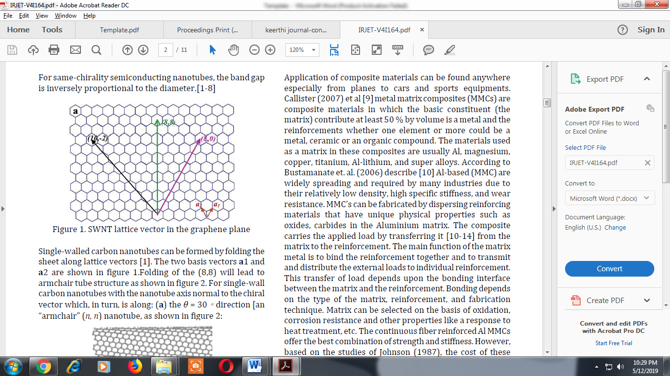
FIGURE 2. Image diagram (300 dpi)
The beginning part: The first sentence of the first paragraph should state the importance and the new findings of your research. The first paragraph may also include answers to your research questions mentioned in your introduction section.
The middle part: The middle should contain the interpretations of the results to defend your answers, the strength of the study, the limitations of the study, and an update literature review that validates your findings.
The end part: The end concludes the study and the significance of your research.
Sub Heading 1 (Bold, Size 12, Times New Roman font)
Sample paragraph Define abbreviations and acronyms the first time they are used in the text, even after they have been defined in the abstract. Abbreviations such as IEEE, SI, MKS, CGS, sc, dc, and rms do not have to be defined. Do not use abbreviations in the title or heads unless they are unavoidable.
After the text edit has been completed, the paper is ready for the template. Duplicate the template file by using the Save As command, and use the naming convention prescribed by your conference for the name of your paper. In this newly created file, highlight all of the contents and import your prepared text file. You are now ready to style your paper.
Conclusion
All the results obtained through the study was concluded here. Do not summarize the paper, the abstract is for that purpose. Present what have you shown and what it means for the field. Suggest future experiments and indicate whether they are underway Avoid bold judgments about impact.
Acknowledgement (Optional)
The authors can acknowledge any person/authorities in this section. This is not mandatory.
Authors’ Note
The authors declare that there is no conflict of interest regarding the publication of this article. Authors confirmed that the pa-per was free of plagiarism.
References
- Kok, Albert. "On the utility of P3 amplitude as a measure of processing capacity." Psychophysiology 38.3 (2001): 557-577.http://dx.doi.org/10.XXXX/j01.xxxxxxx
- Ho, K. H., and S. T. Newman. "State of the art electrical discharge machining (EDM)." International Journal of Machine Tools and Manufacture 43.13 (2003): 1287-1300.http://dx.doi.org/10.XXXX/j01.xxxxxxx
- Kibria, G., et al. "Comparative study of different dielectrics for micro-EDM performance during microhole machining of Ti-6Al-4V alloy." The International Journal of Advanced Manufacturing Technology 48.5-8 (2010): 557-570.http://dx.doi.org/10.XXXX/j01.xxxxxxx
- Lin, Yan-Cherng, et al. "Optimization of machining parameters in magnetic force assisted EDM based on Taguchi method." Journal of materials processingtechnology 209.7 (2009): 3374-3383. http://dx.doi.org/10.XXXX/j01.xxxxxxx
- Khurmi, R. S., and J. K. Gupta. A Textbook of Workshop Technology. S. Chand Publishing, 2008.
- Author's Surname, Given Names. "Title of Chapter or Part." Title: Subtitle of Book. edtion (if not the first), edited by Editor Name, Publisher, Year, pp. pages.
http://dx.doi.org/10.XXXX/j01.xxxxxxx
- Berliner, Marilyn J., and Jan F. Lindberg. Acoustic Particle Velocity Sensors: Design, Performance, and Applications Proceedings. No. CONF-9509298-. American Institutes of Physics, New York, NY (United States), 1996.http://dx.doi.org/10.XXXX/j01.xxxxxxx
- Neustel, Michael S. Patent analyzing system. US 20140200880 A1, United States Patent and Trademark Office, 17 July 2014.

 © Author et al. 2021 Open Access. This article is distributed under the terms of the Creative Commons Attribution 4.0 International License (http://creativecommons.org/licenses/by/4.0/), which permits unrestricted use, distribution, and reproduction in any medium, provided you give appropriate credit to the original author(s) and the source, provide a link to the Creative Commons license, and indicate if changes were made.
Embargo period: The article has no embargo period.
To cite this Article: Author, 1, and Author, 2. "How to cite the article." International Research Journal on Advanced Science Hub 3. 4 (2021): 1287-1300. http://dx.doi.org/10.XXXX/j01.xxxxxxx

