http://localhost:8888/myemsapp/login

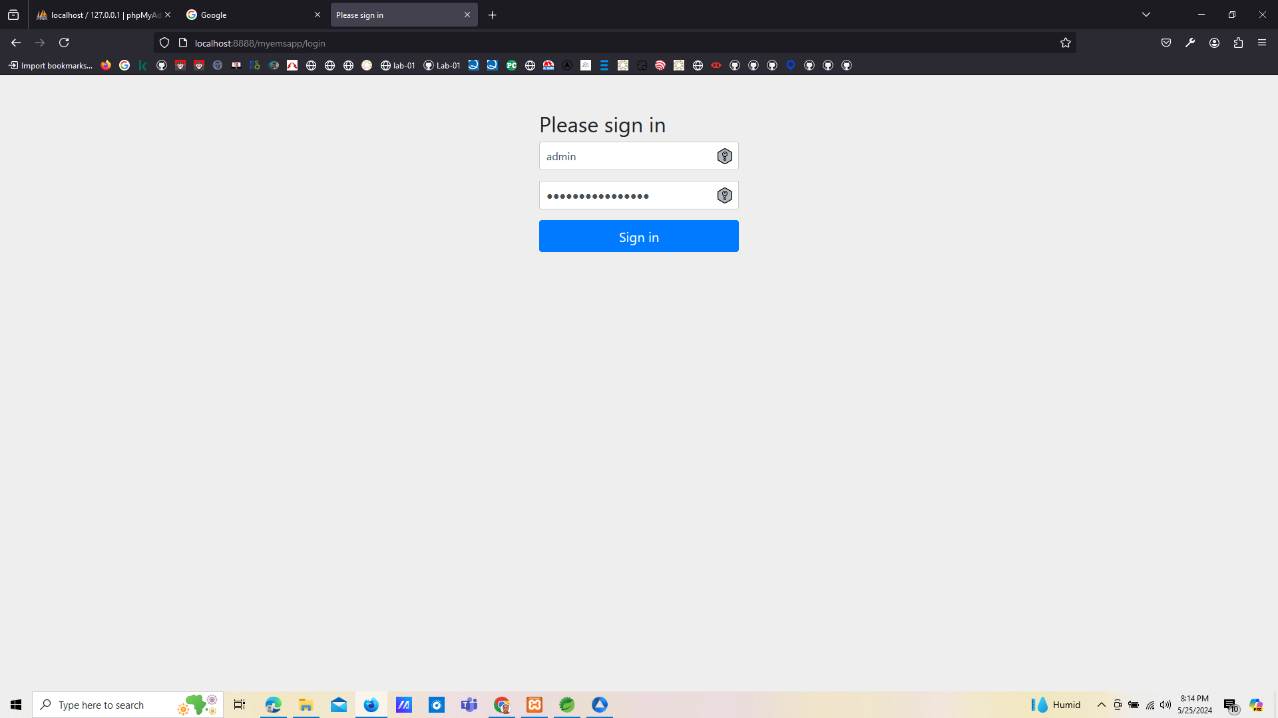

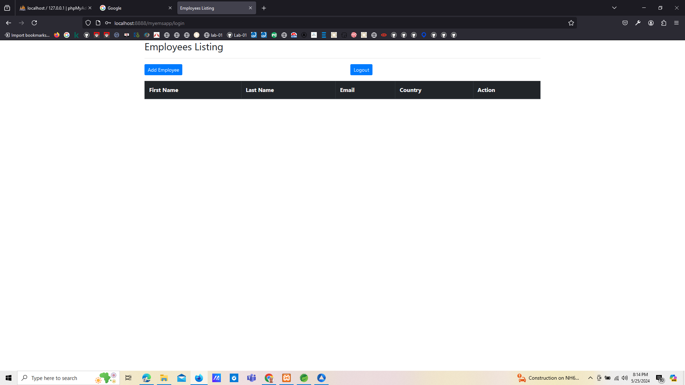

http://localhost:8888/myemsapp/employees/displayEmployeeForm

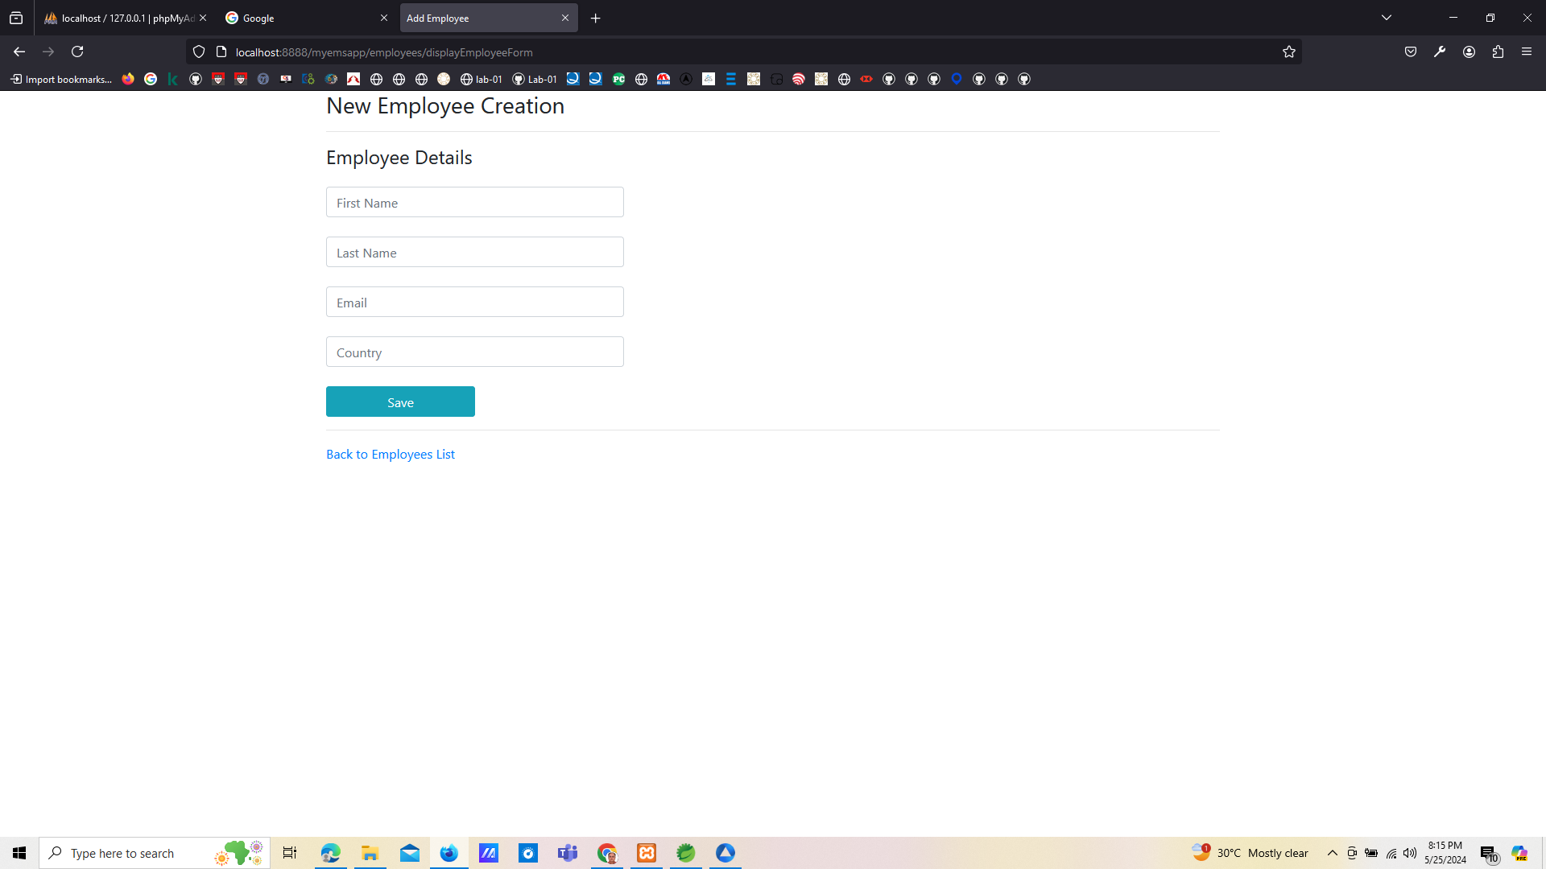

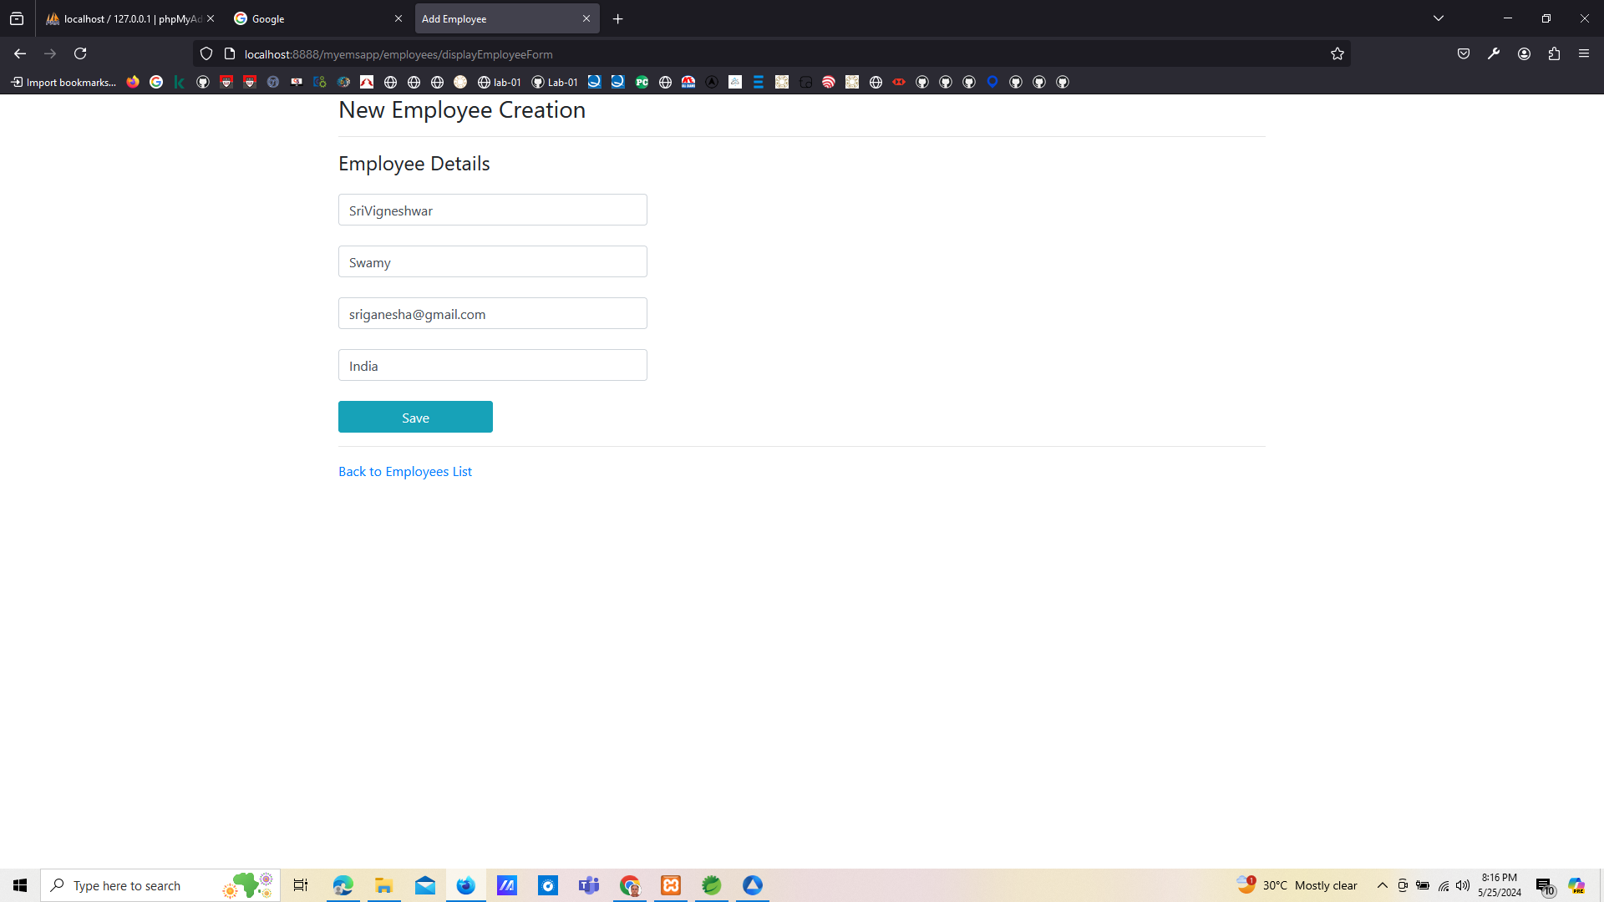

http://localhost:8888/myemsapp/employees/list

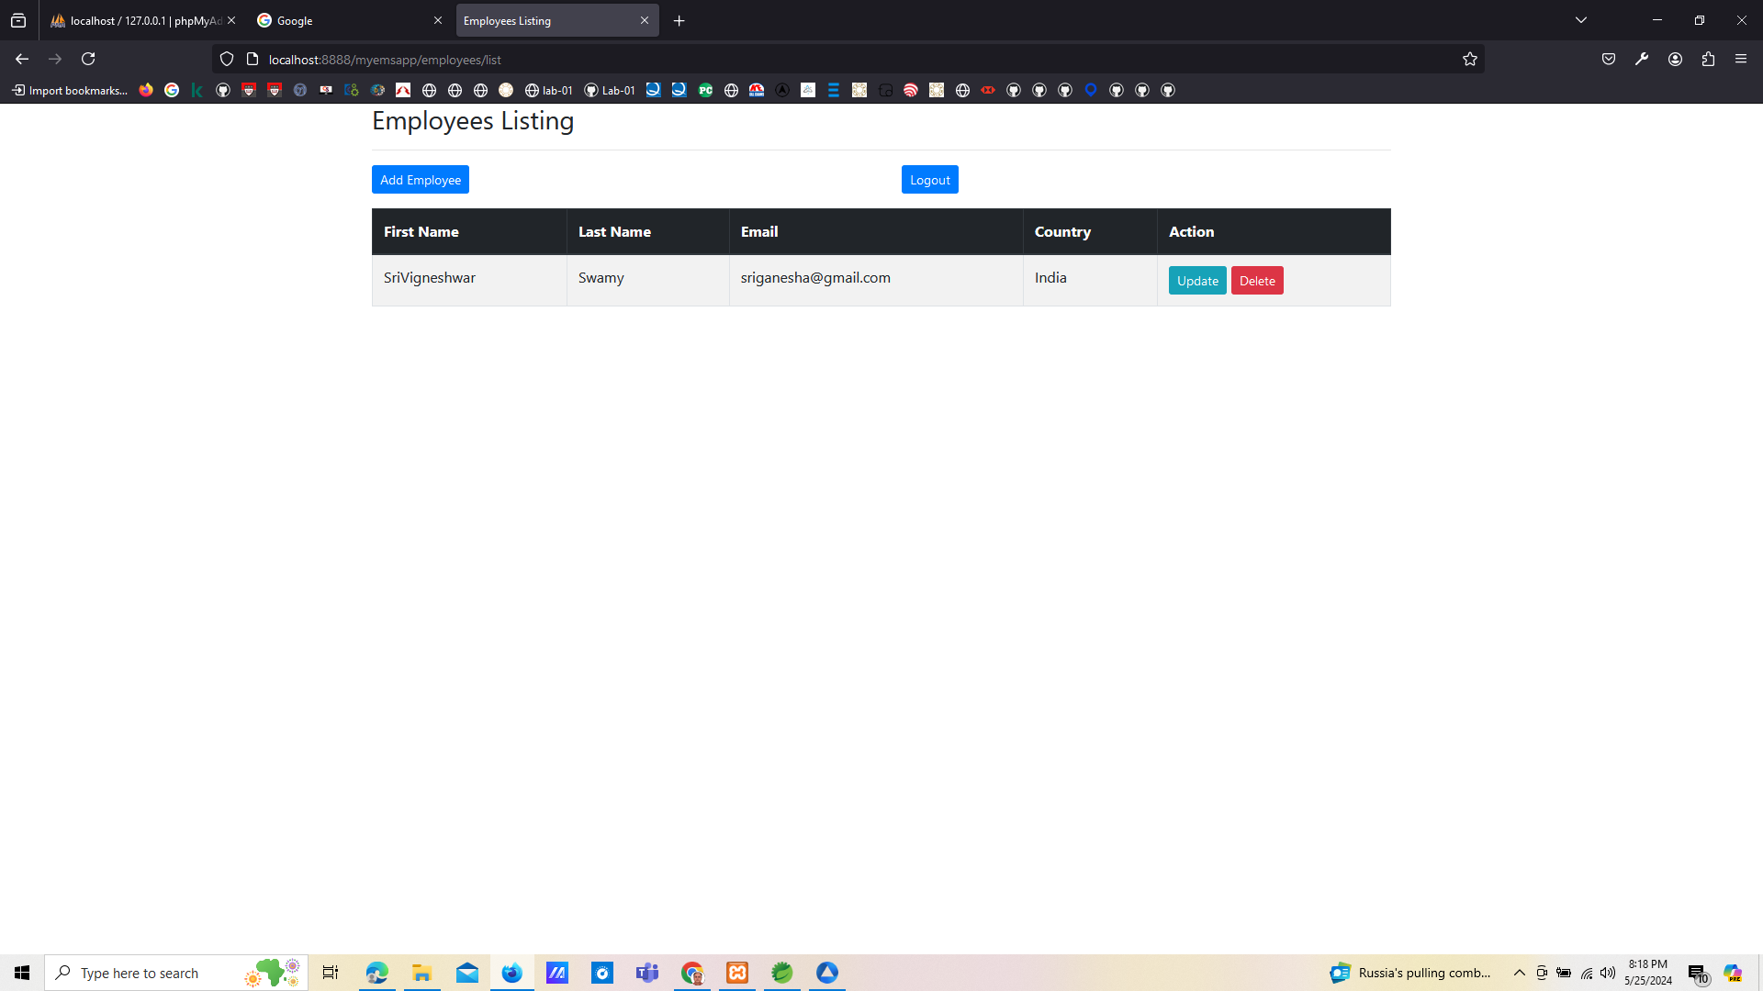

http://localhost:8888/myemsapp/employees/displayEmployeeForm

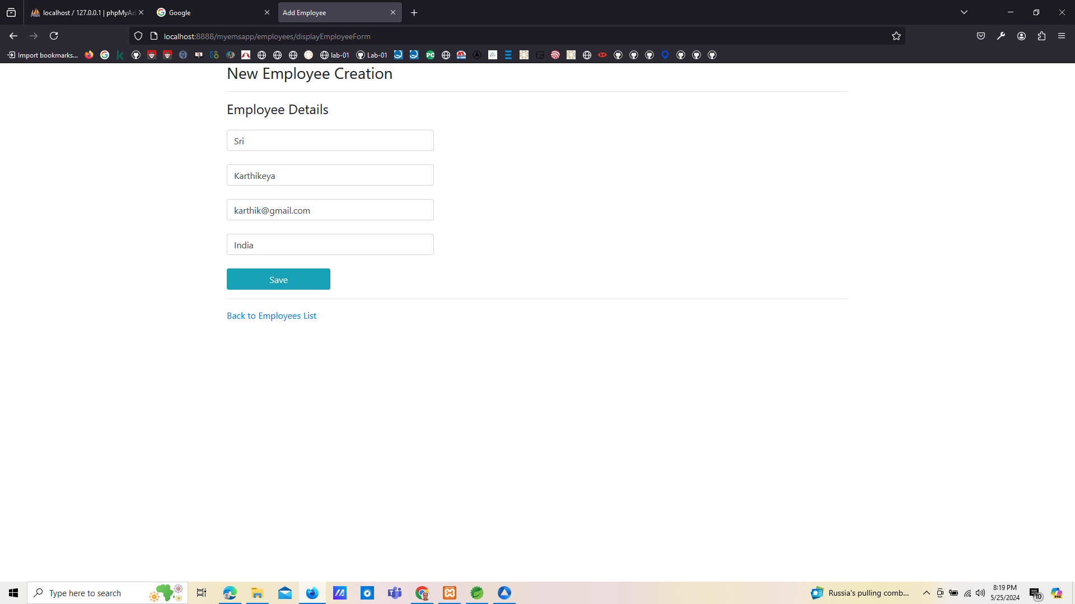

http://localhost:8888/myemsapp/employees/list

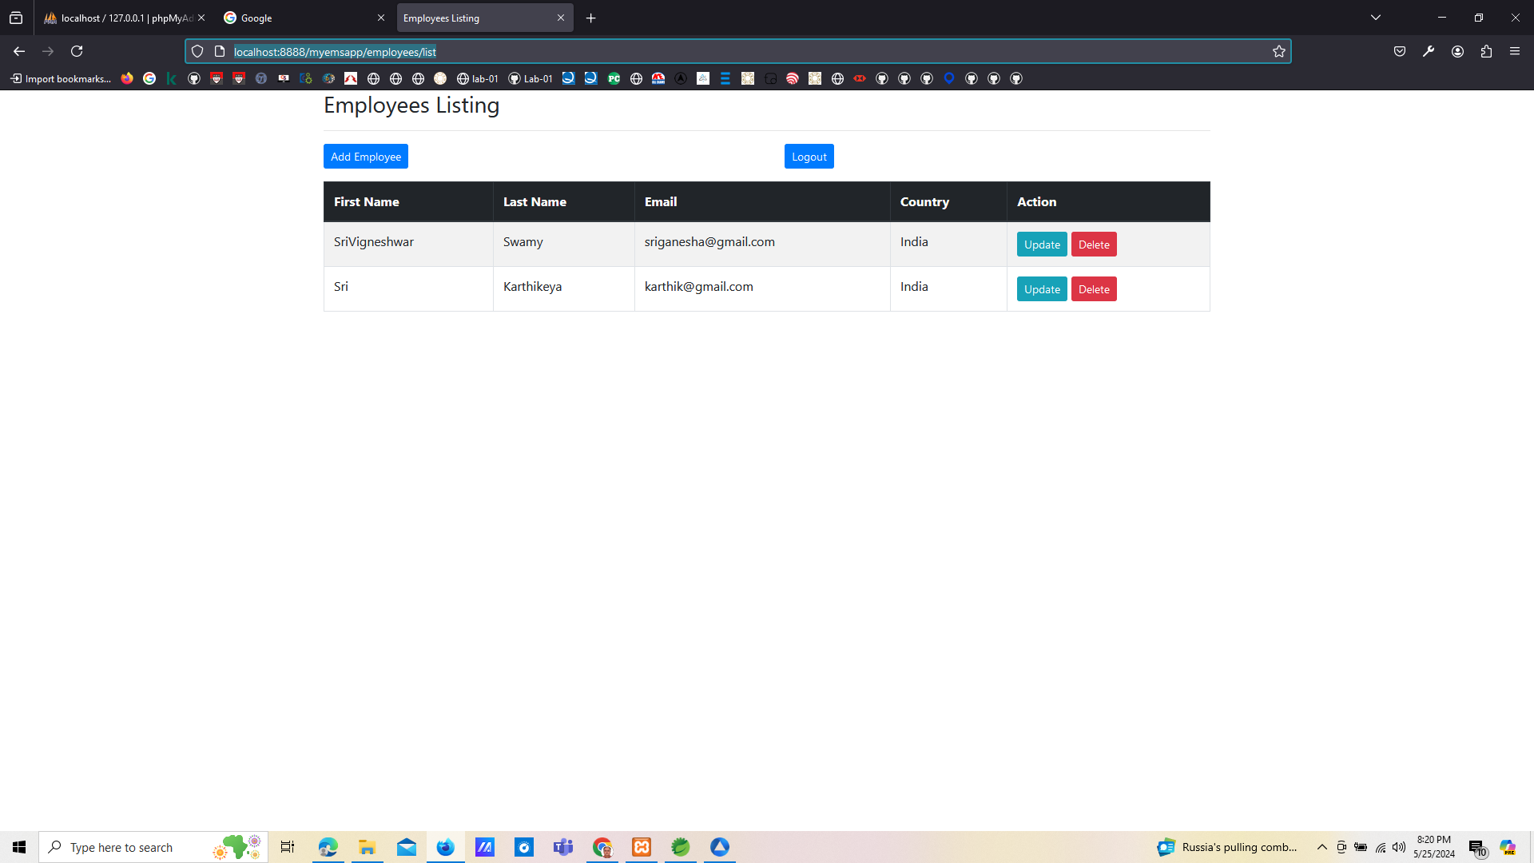

http://localhost:8888/myemsapp/employees/displayEmployeeForm_Update?employeeId=2

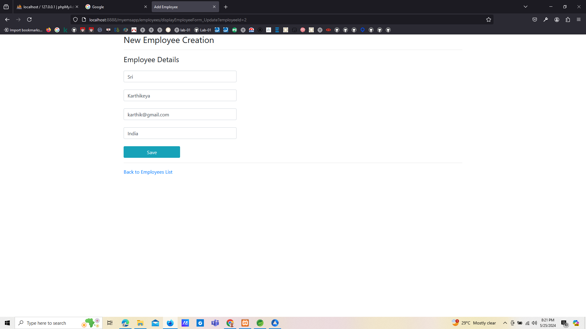

http://localhost:8888/myemsapp/employees/displayEmployeeForm_Update?employeeId=2

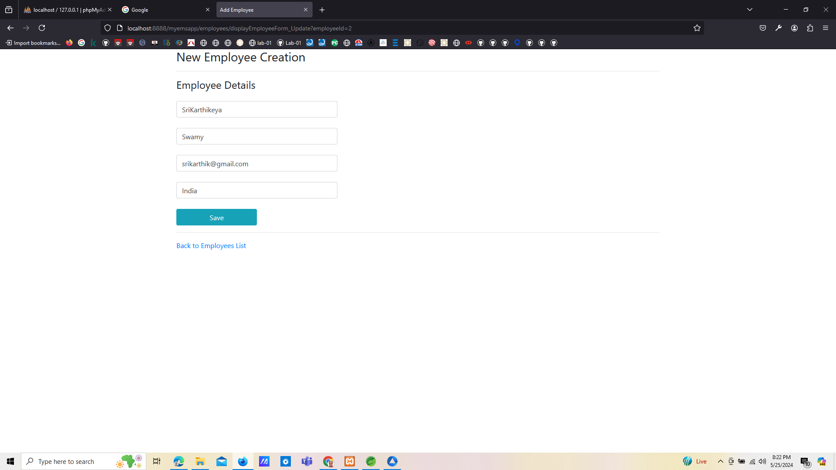

http://localhost:8888/myemsapp/employees/list

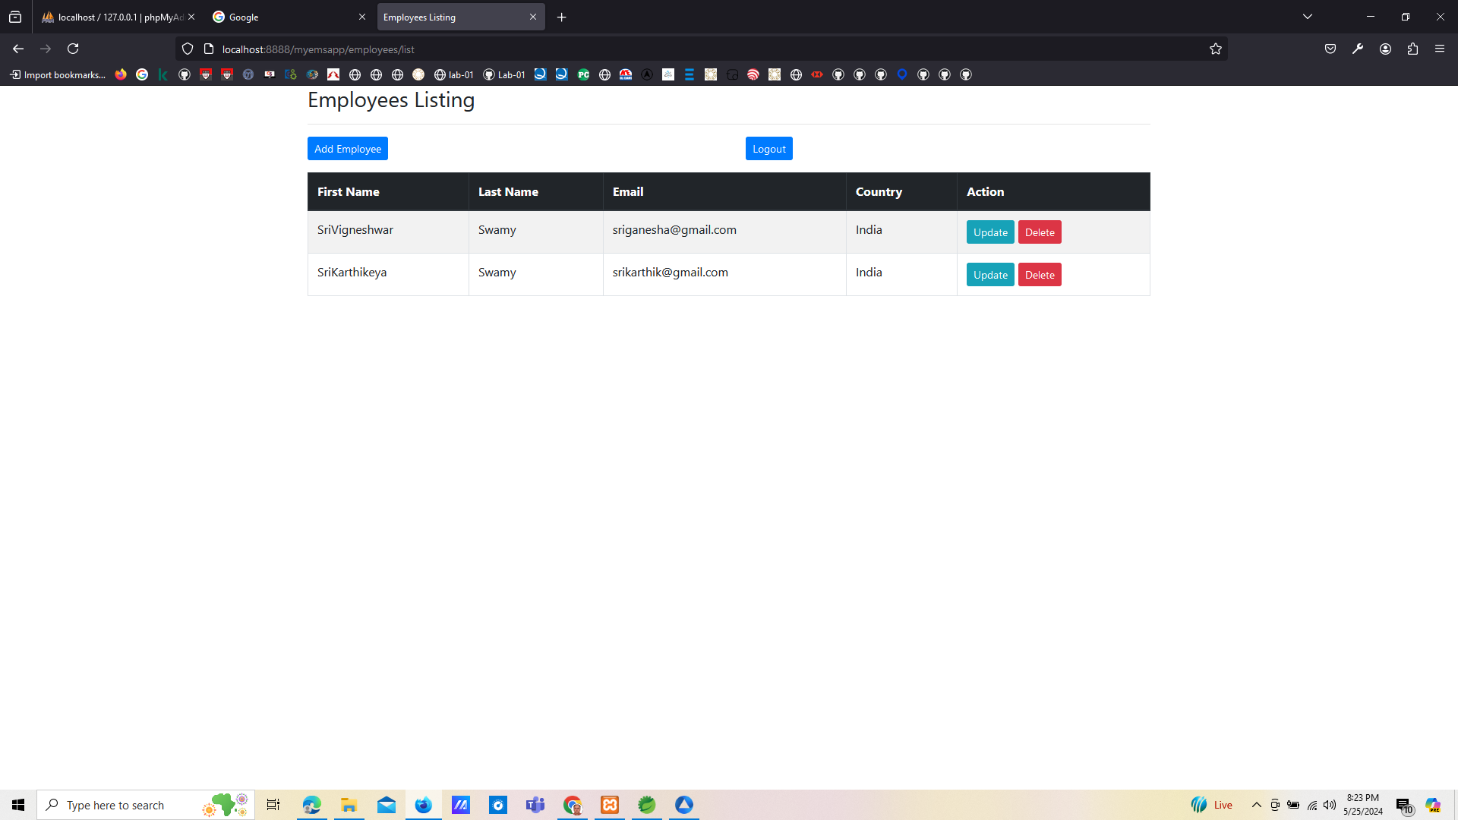

http://localhost:8888/myemsapp/employees/displayEmployeeForm

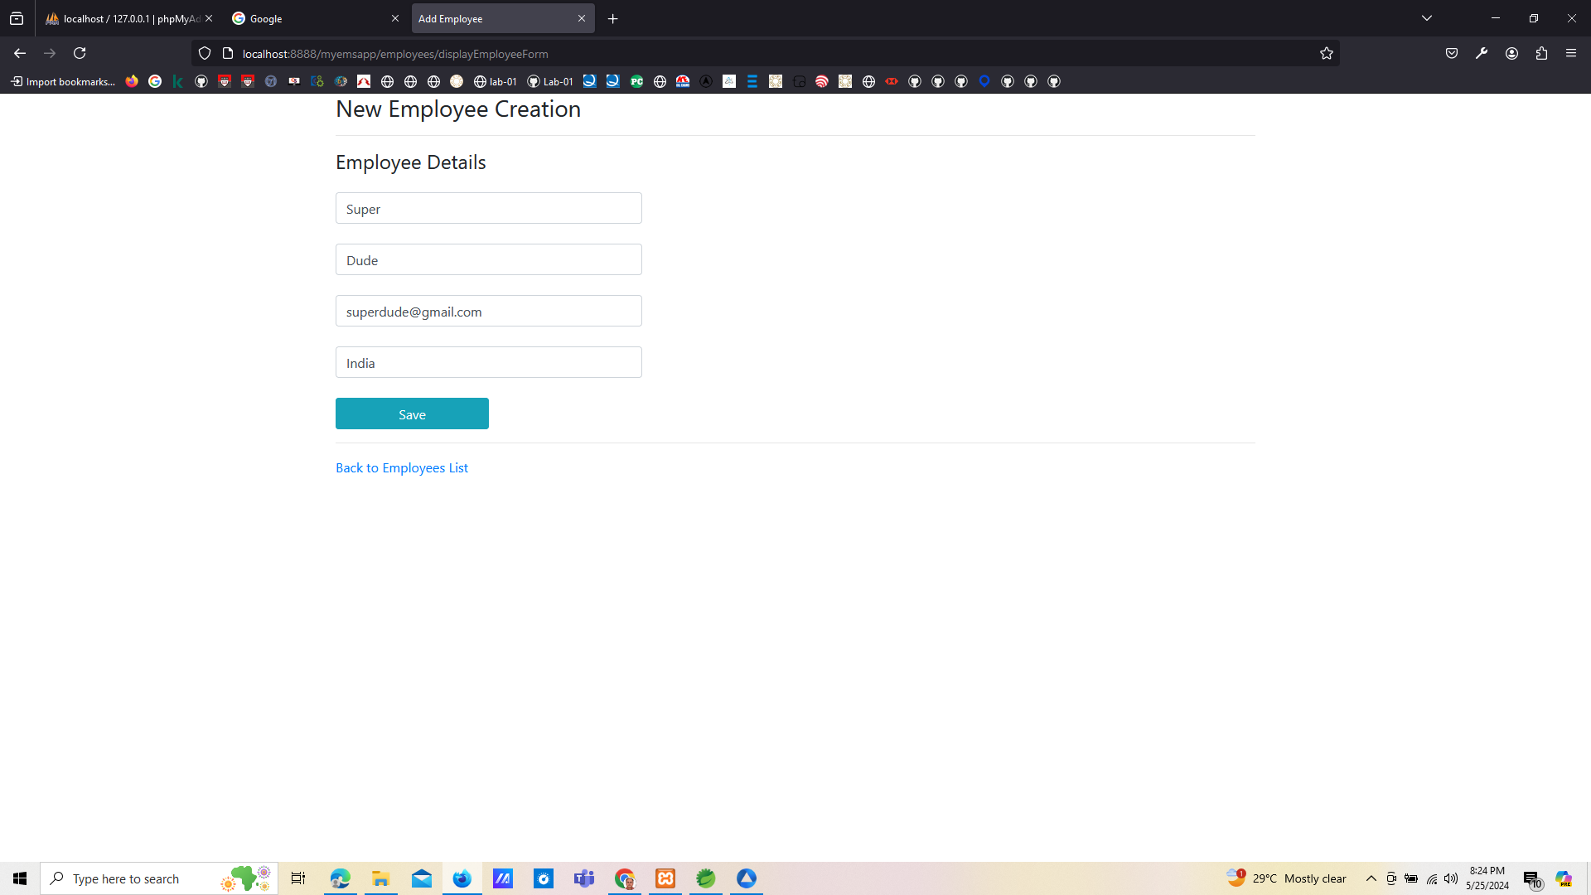

http://localhost:8888/myemsapp/employees/list

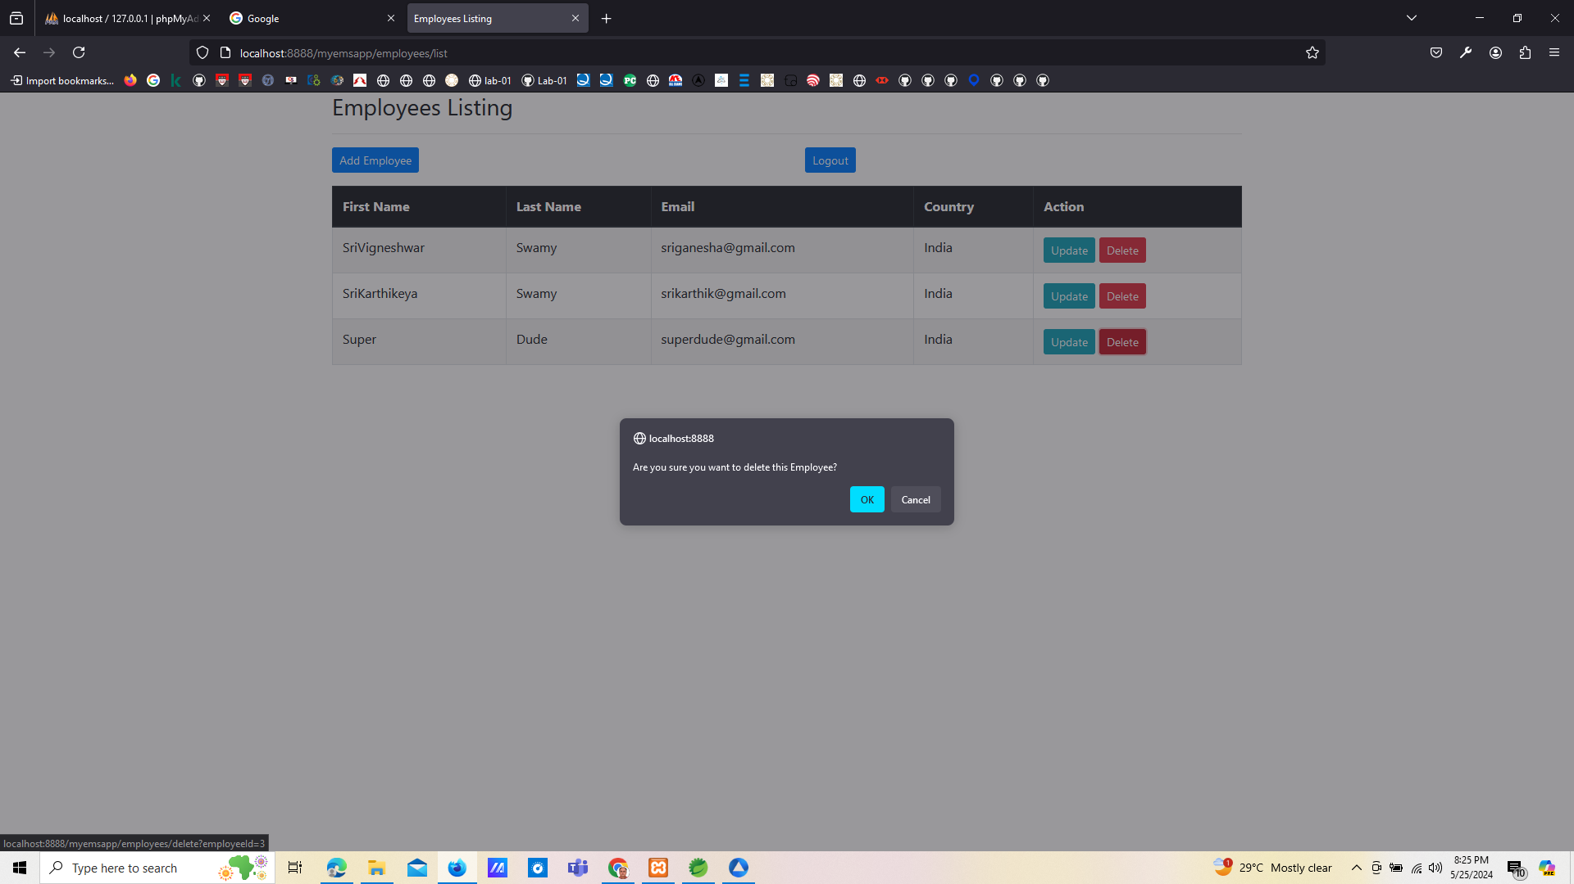

http://localhost:8888/myemsapp/employees/list

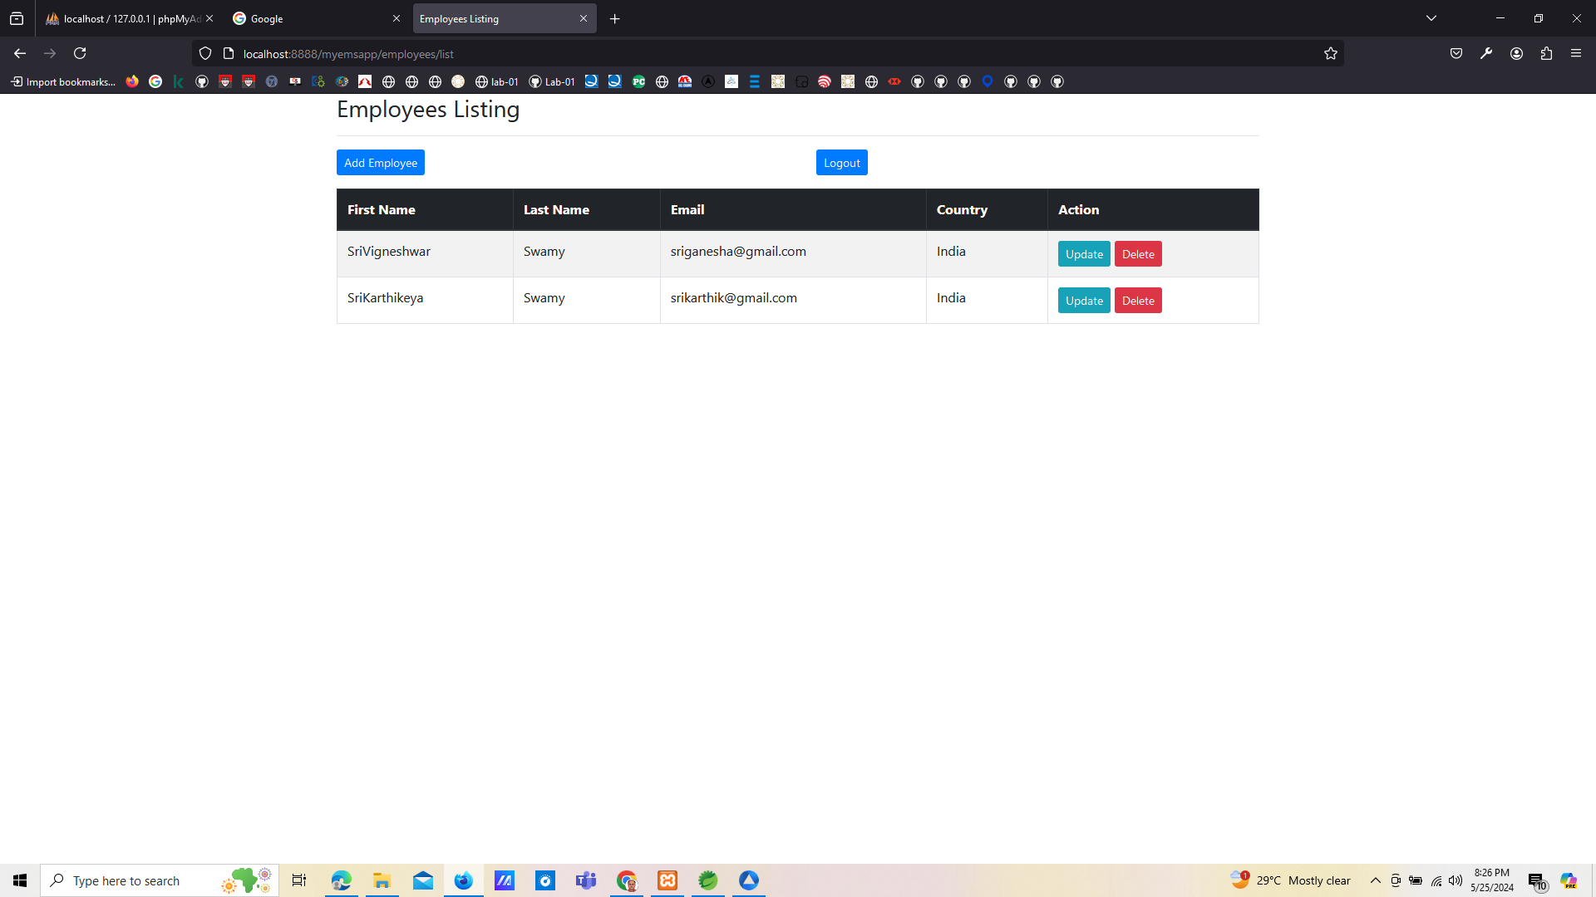

http://localhost:8888/myemsapp/employees/displayEmployeeForm

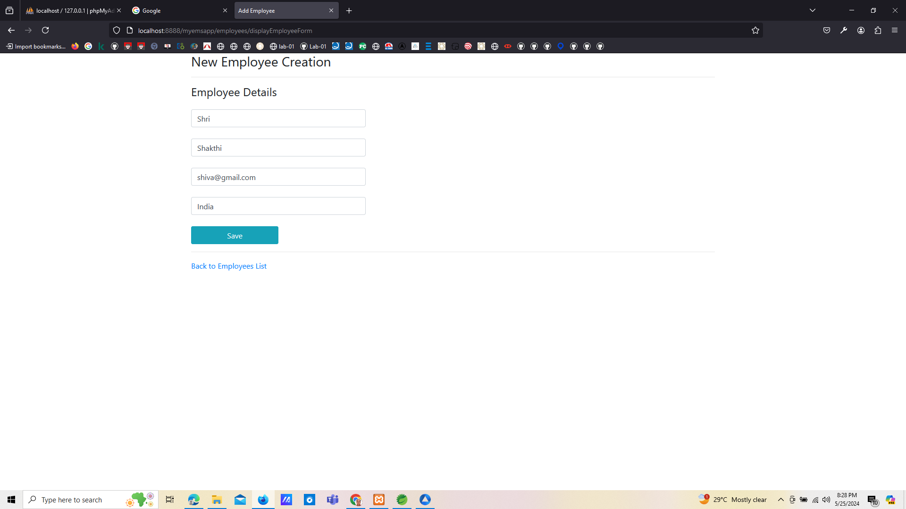

http://localhost:8888/myemsapp/employees/list

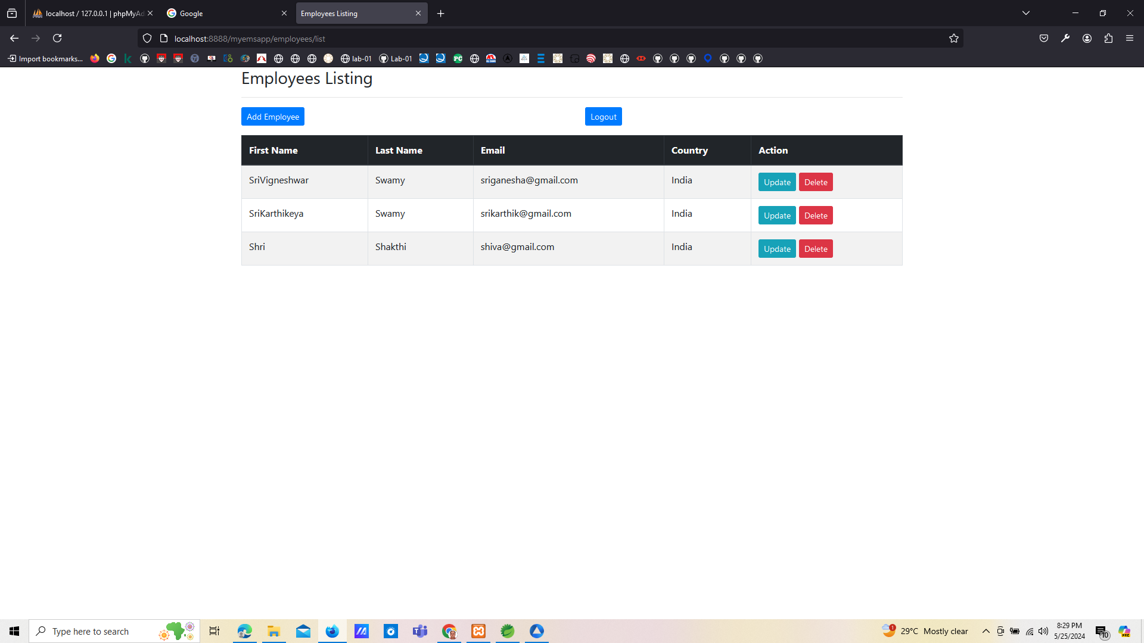

http://localhost:8888/myemsapp/login

