01
Title: “Analysis and Visualization of Hourly Weather Data for NYC Airports (2013)”
Student Name: Vinay Srinivasan
Student Number: “s225447445”
Email: “s225447445@deakin.edu.au; s.vinay.777@gmail.com; srinivasan_vinay@yahoo.com;”
Public Repository: “https://github.com/SriVinayaka/Vinay-Srinivasan-SIG-731-Task-6D/”

02. Data Source
- Dataset: nycflights13_weather.csv.gz
- Extracted file used: weather.csv
- Data description: Hourly meteorological observations for LGA, JFK, EWR during 2013
- Convert the weather.csv to raw_weather.xlsx
- Remove the top 42 rows containing the “R” program markers

03. Load Data into Power BI Desktop
- Open Power BI Desktop
- Home → Get Data → ‘Excel Workbook’
- Select ‘raw_weather.xlsx’
- Click Transform Data (do NOT load directly)
All processing from now on is done in Power Query Editor ✔️

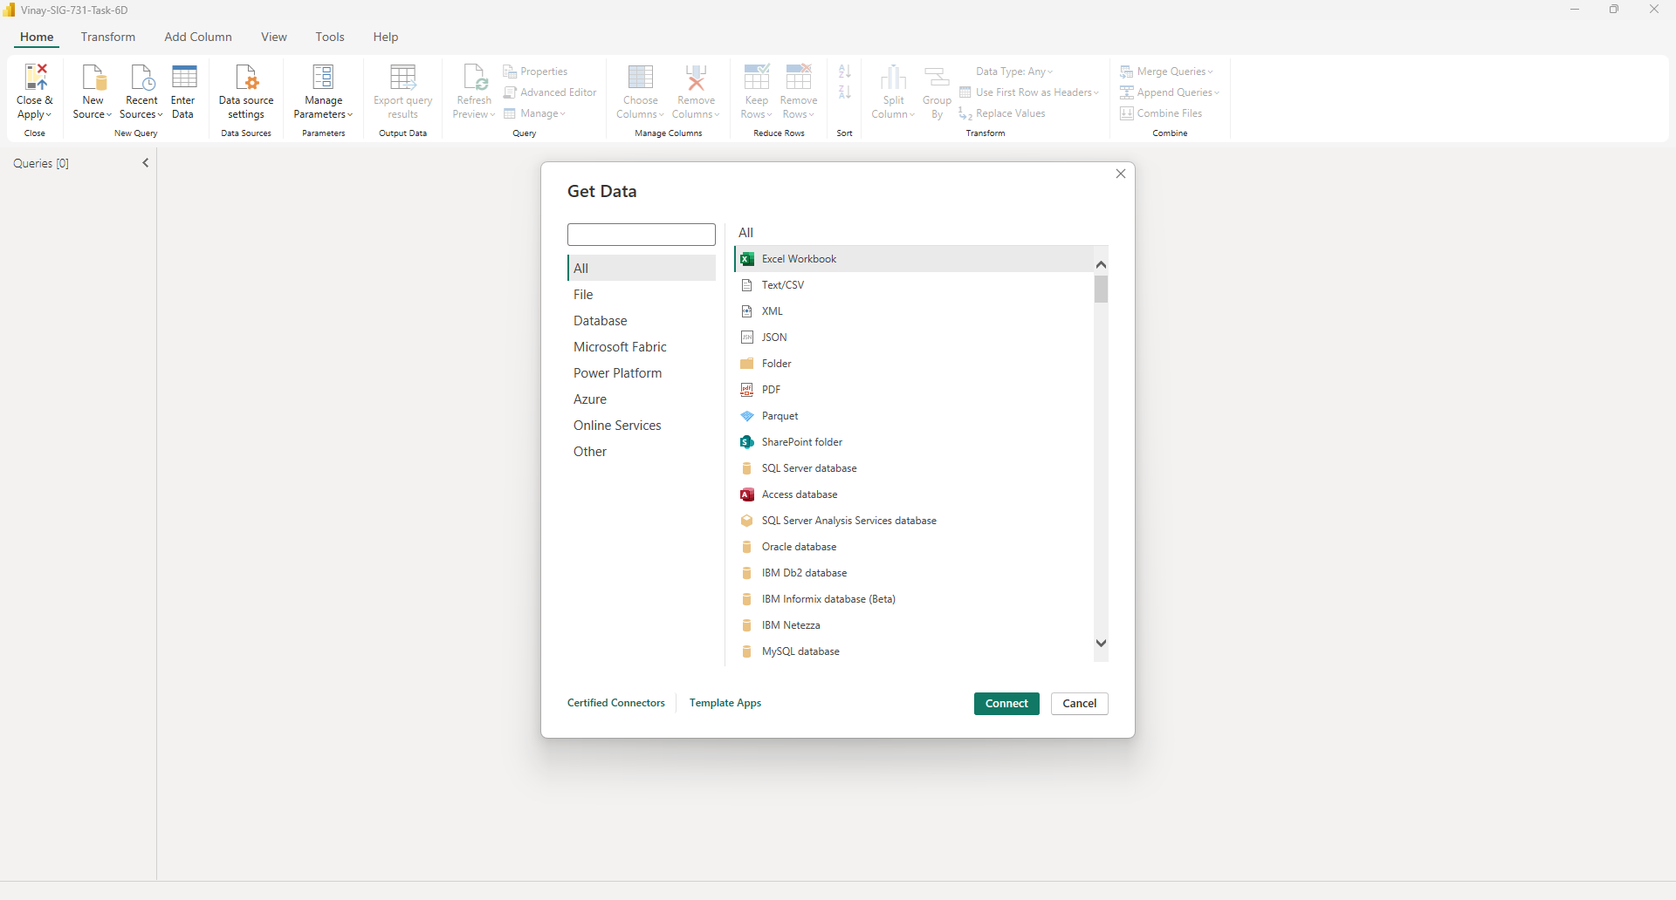

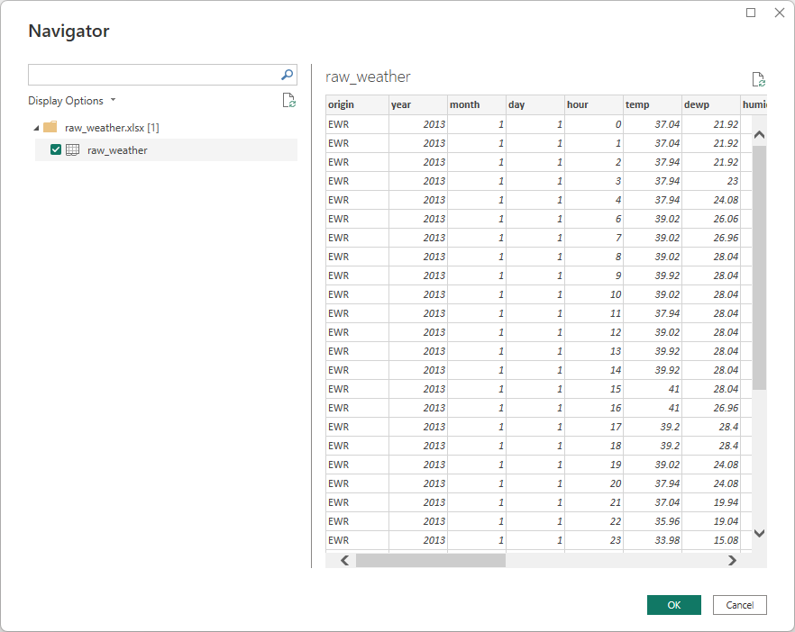

04. Correct the Time Bug (CRITICAL)
The time_hour column is shifted by +1 hour and must NOT be trusted
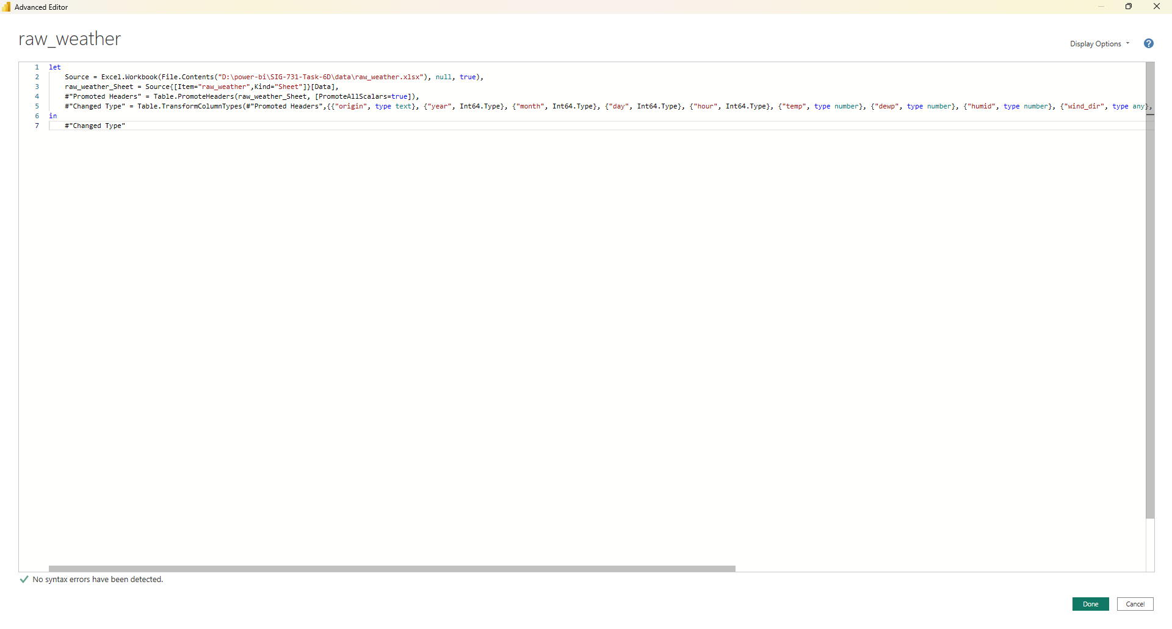
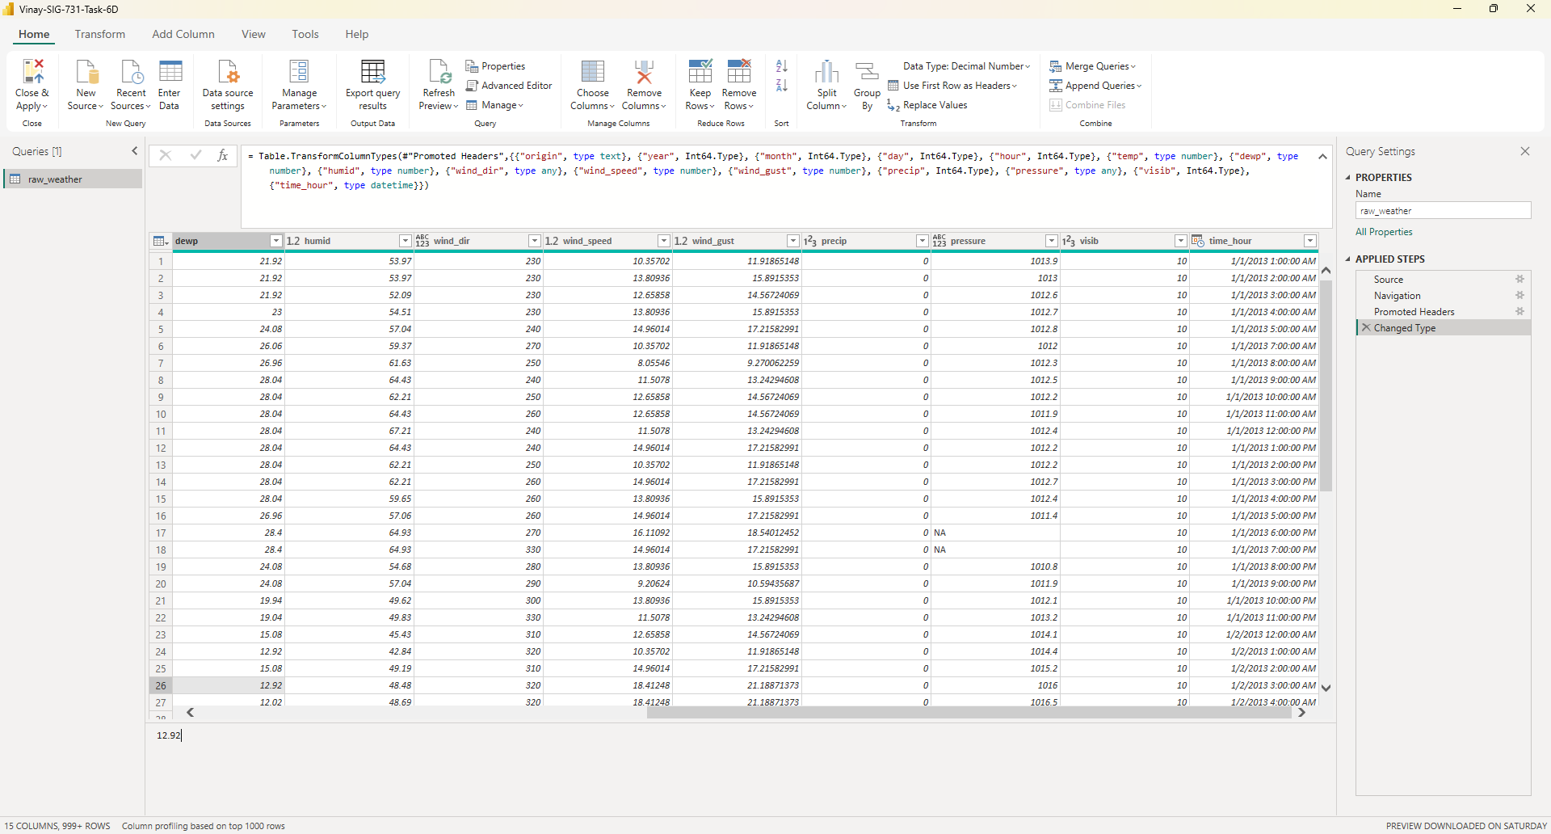

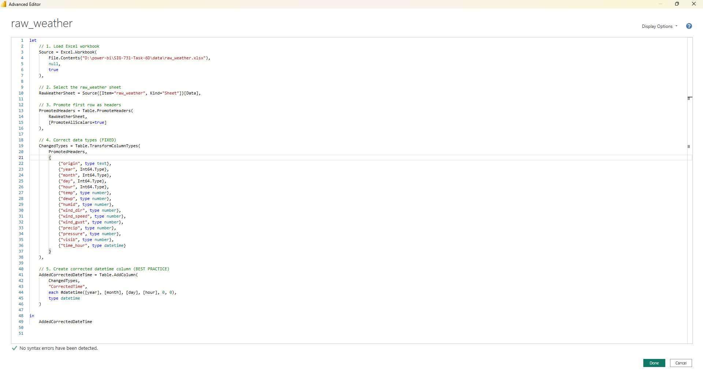
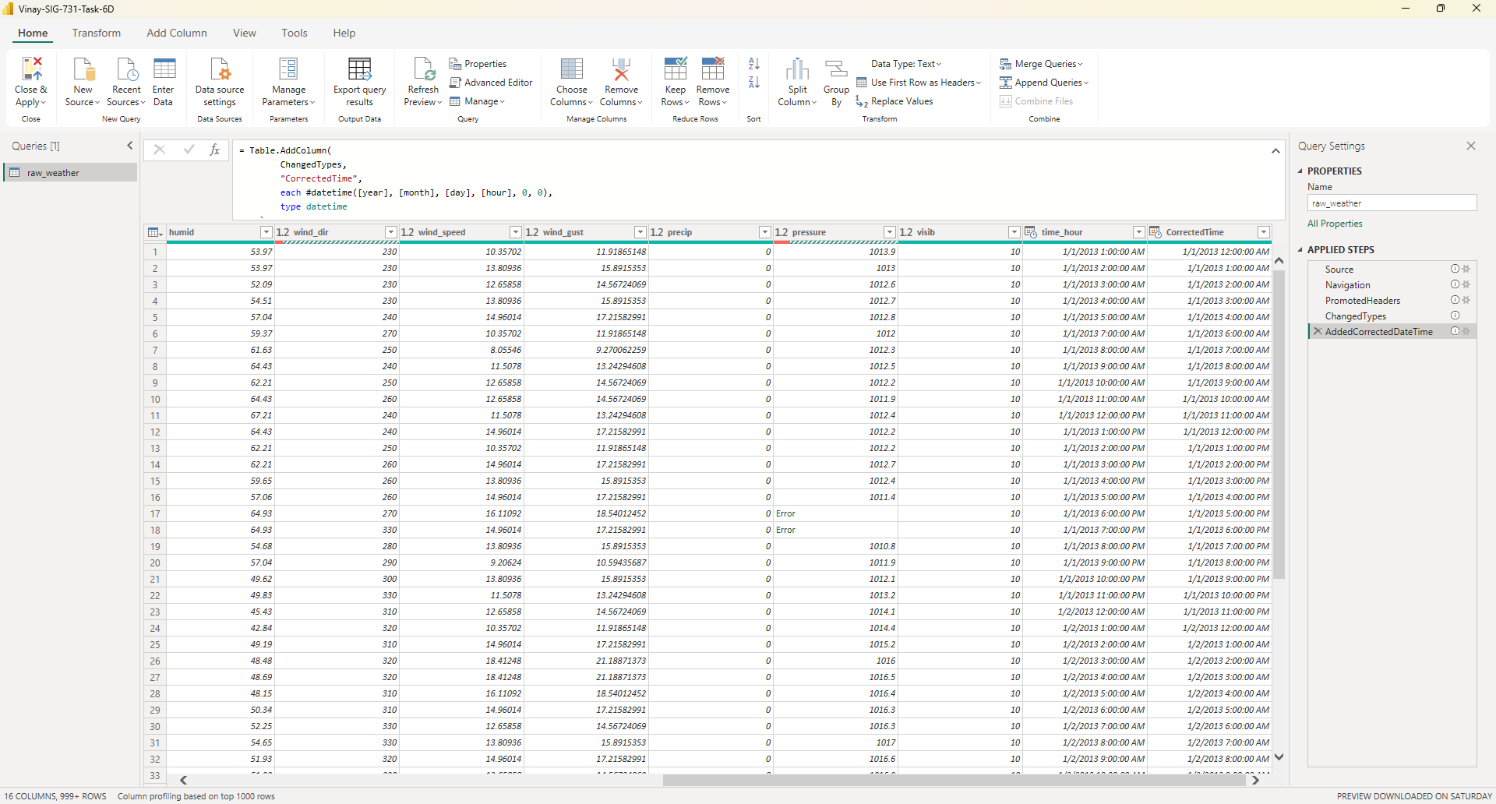

05. Unit Conversion
Converting all columns so that they use International System of Units, SI or derived units metrics, by replacing old or by adding new columns.
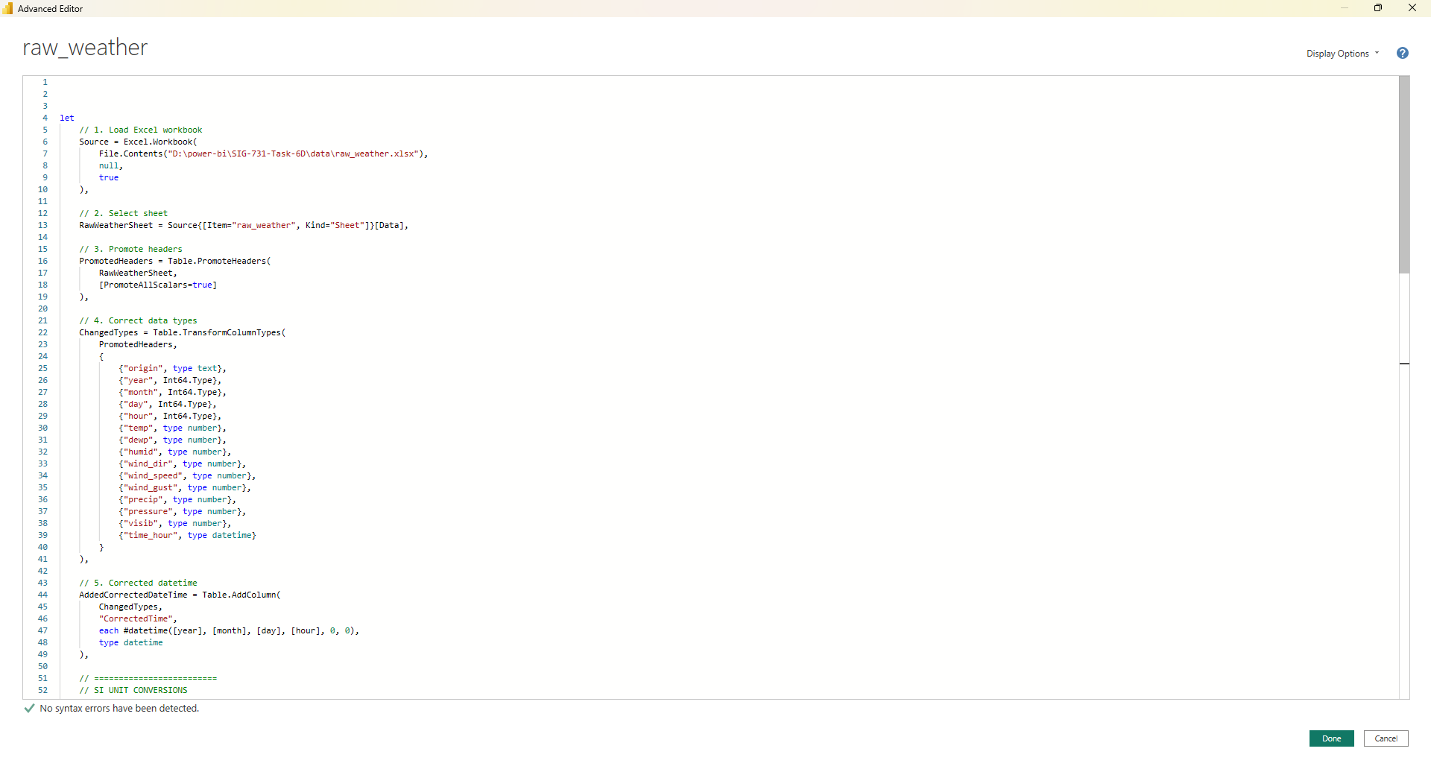
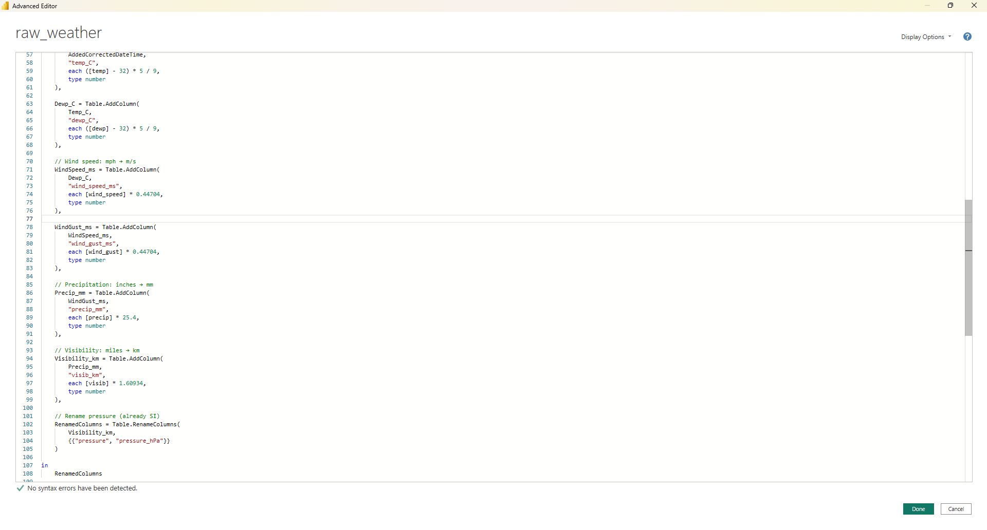

06. Daily Mean Wind Speed Calculation
Hourly observations were aggregated to daily means for each airport
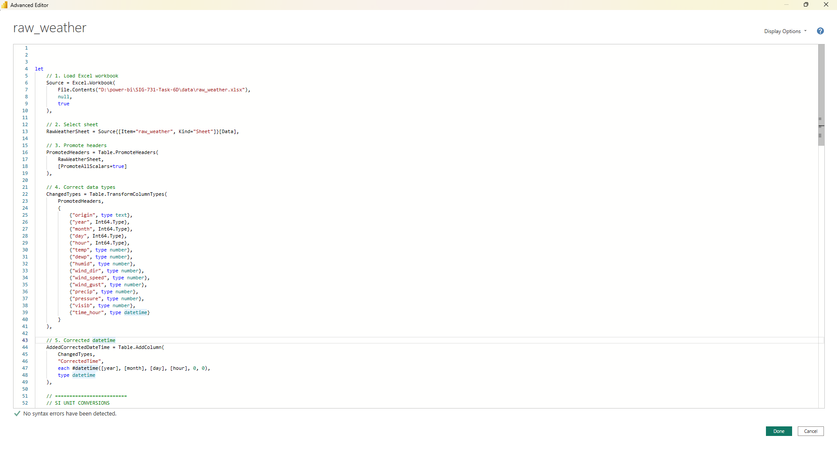
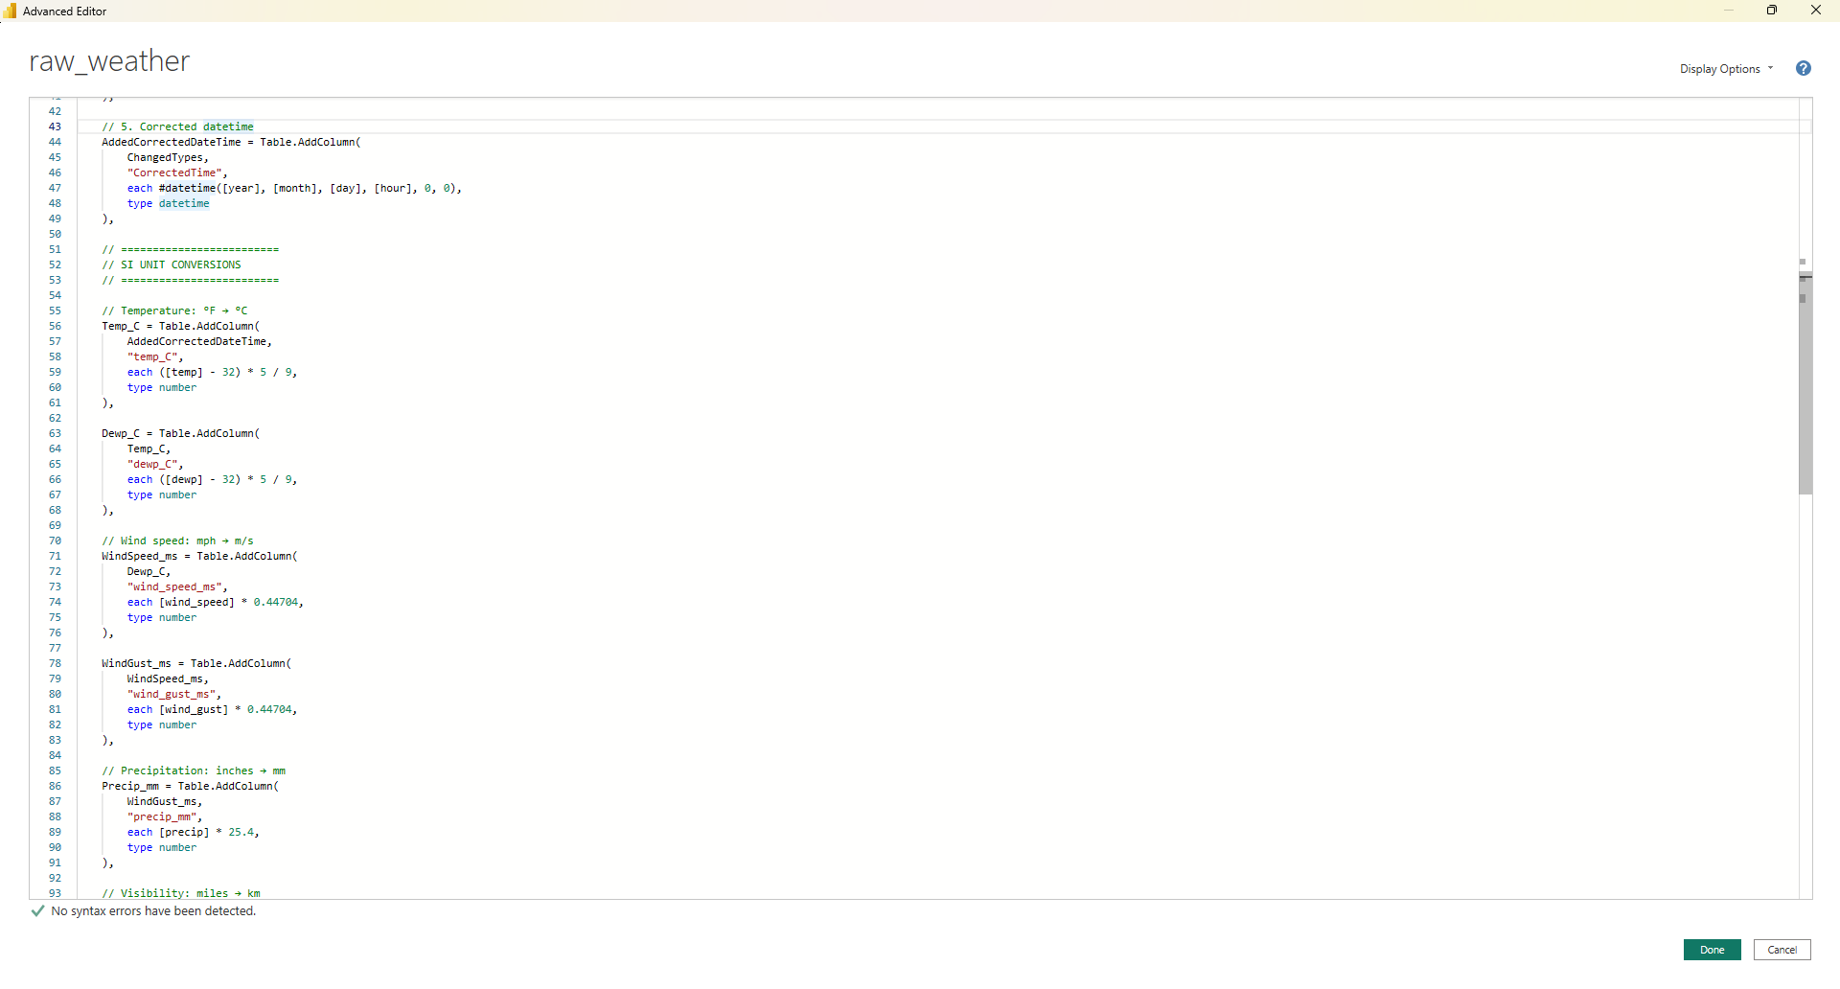

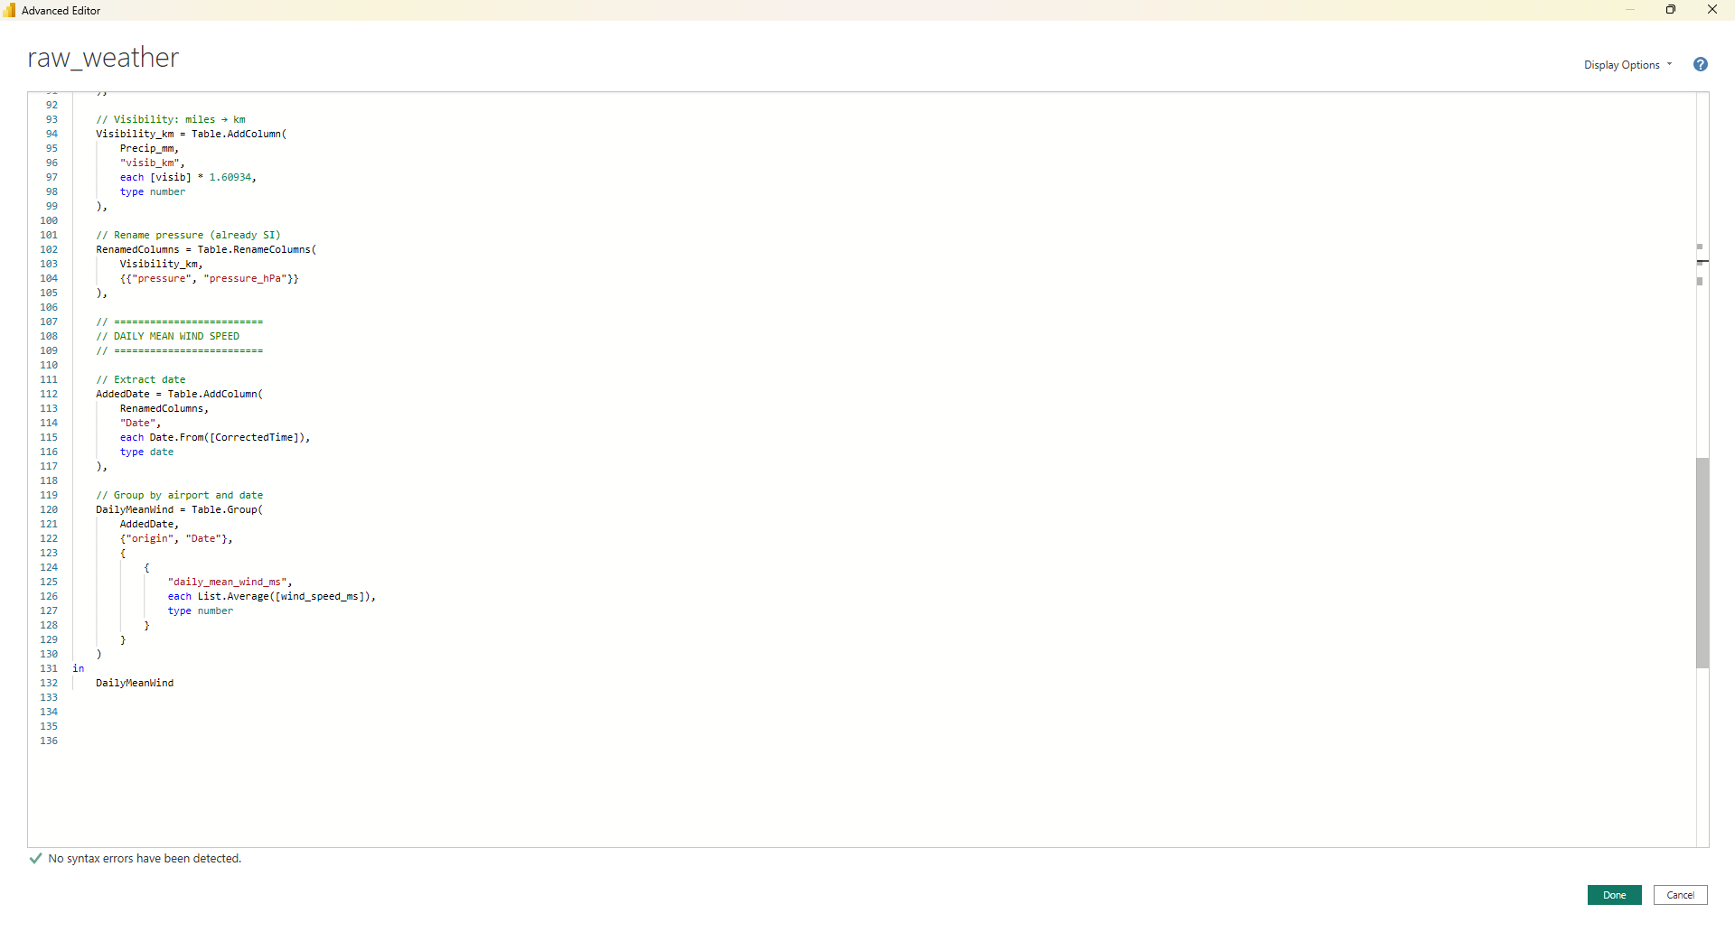
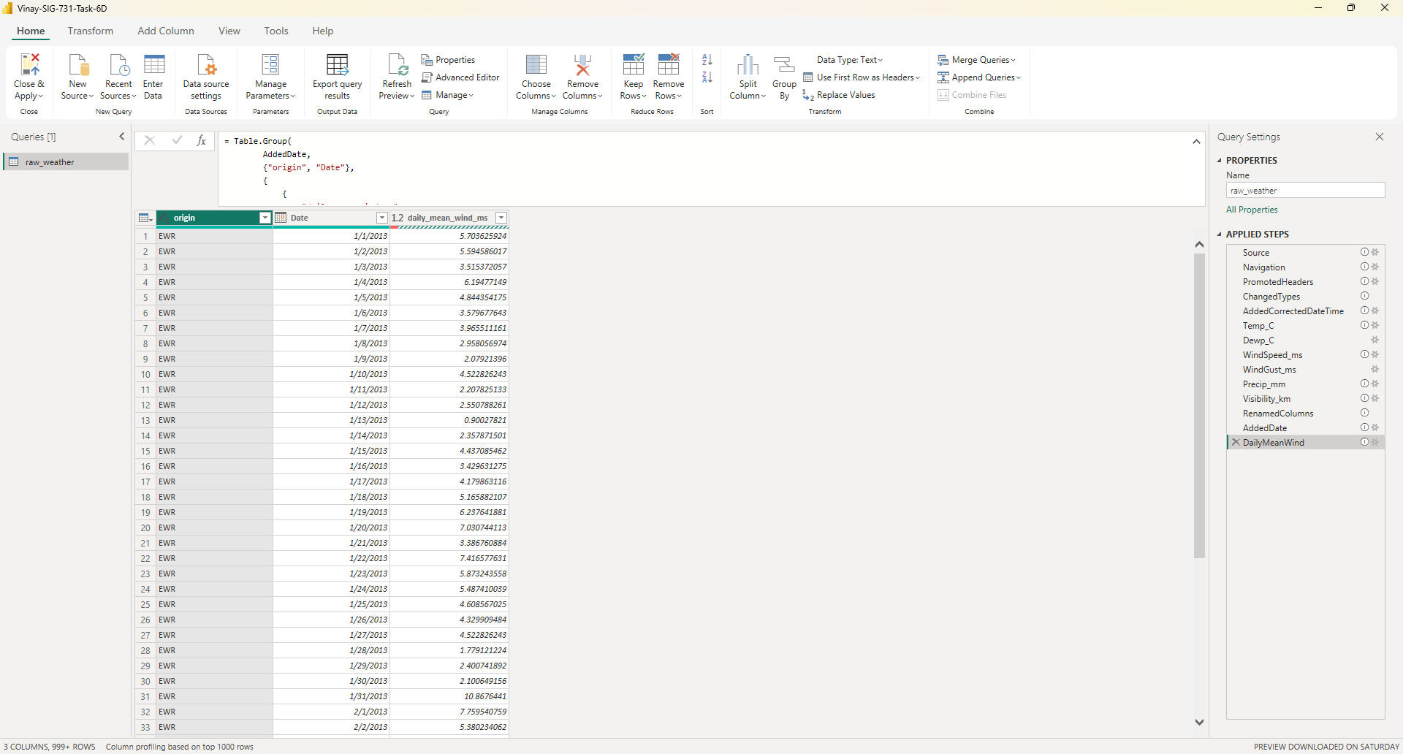

07. Outlier Calculations
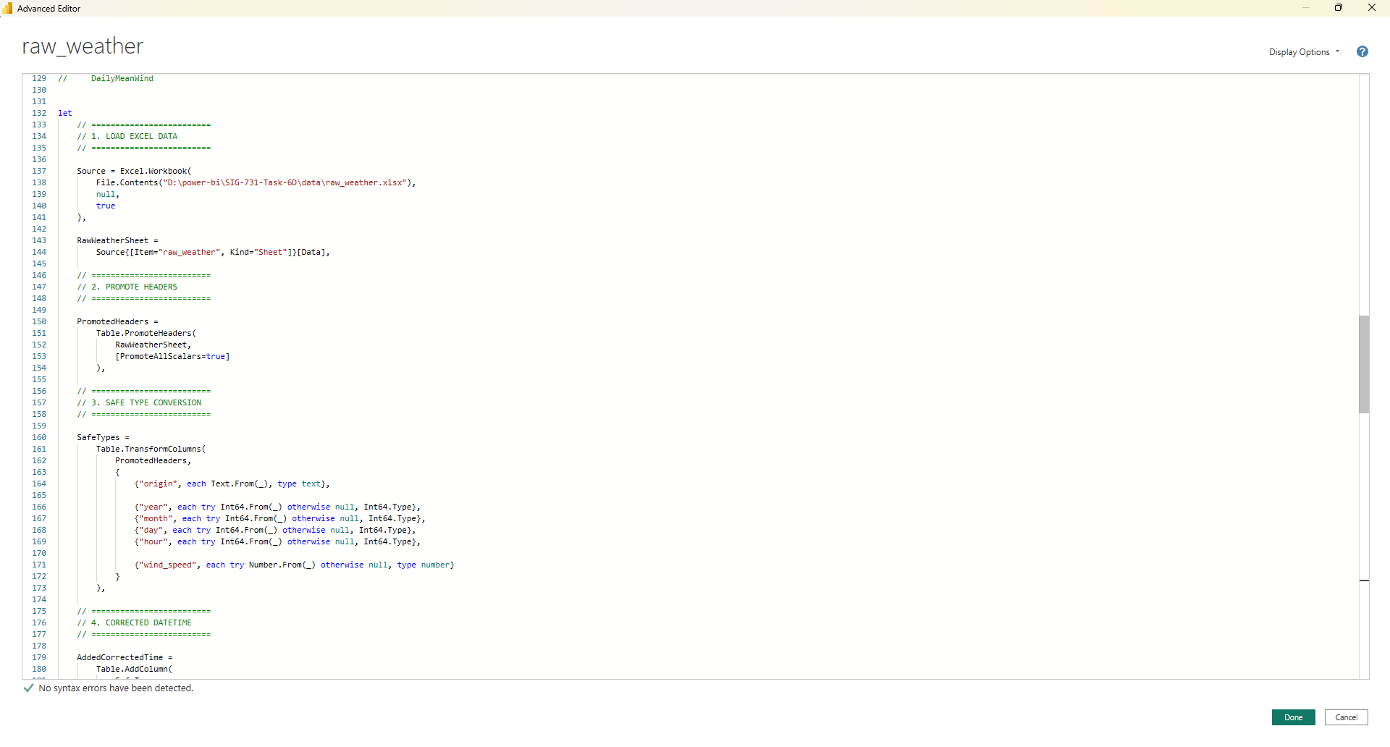
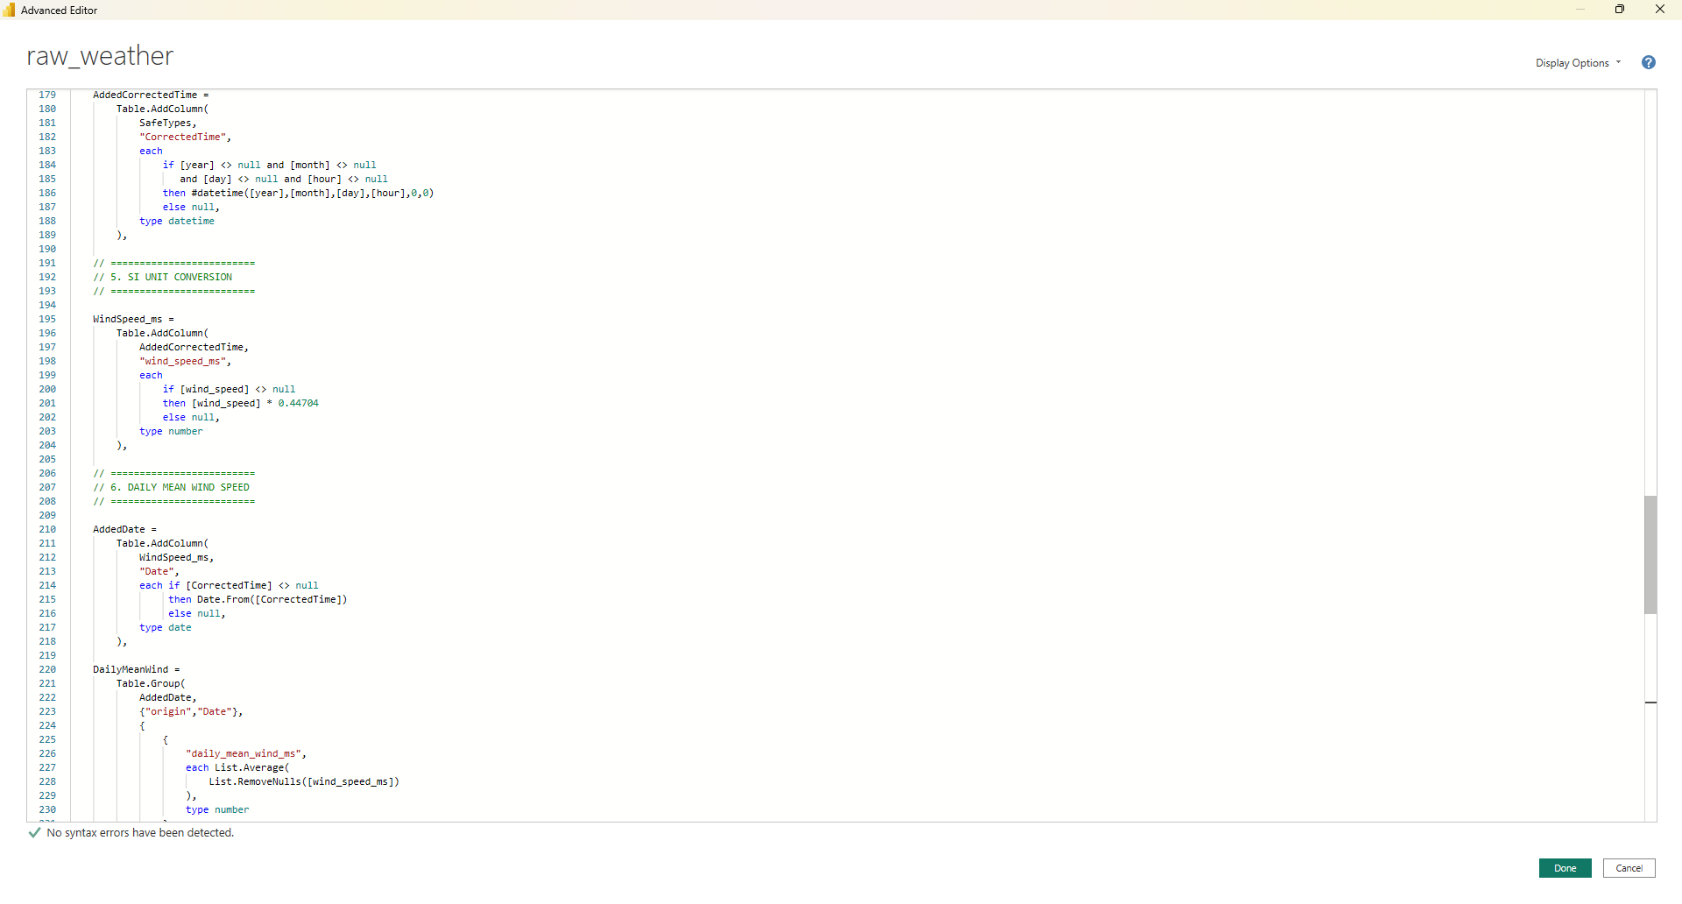

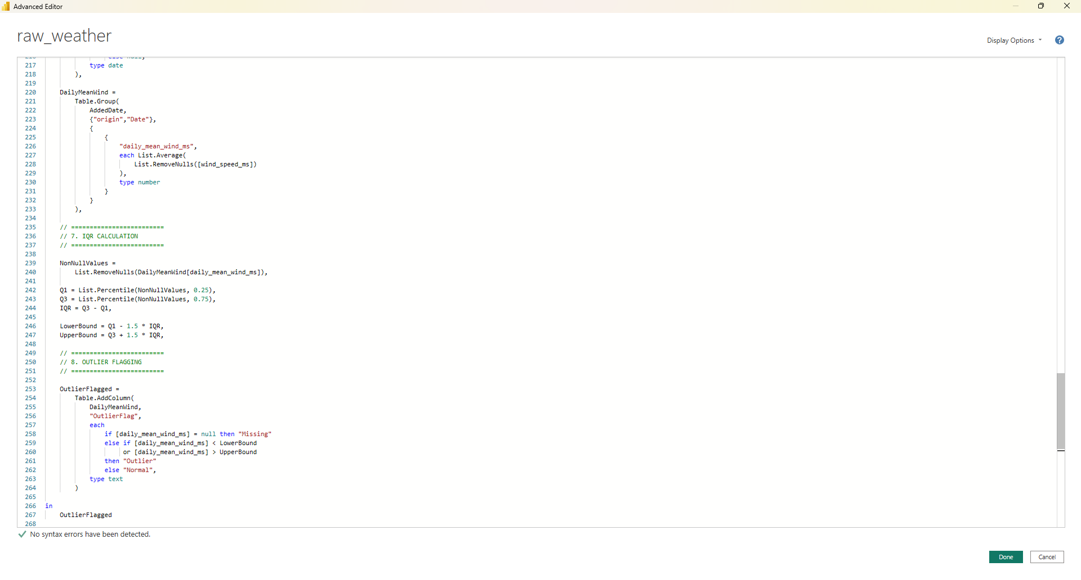
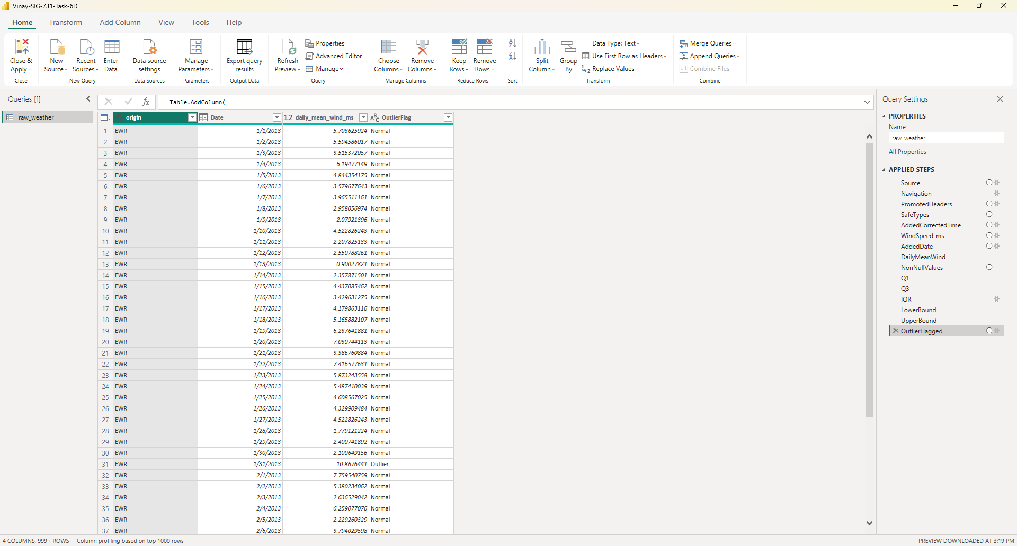

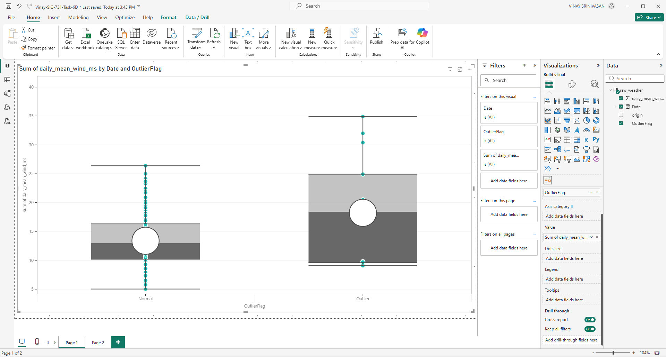

outliers in this analysis represent statistically extreme daily wind speeds identified using the IQR method. Their identification and visualization enhance the robustness and credibility of the analysis, ensuring that reported monthly wind speed trends are both accurate and representative.
Outliers were identified using the Interquartile Range method and represent daily mean wind speeds that deviate substantially from typical conditions. These values were visualized and subsequently excluded from monthly averages to prevent extreme events from biasing seasonal wind speed estimates

07. Calculating Monthly Mean Wind
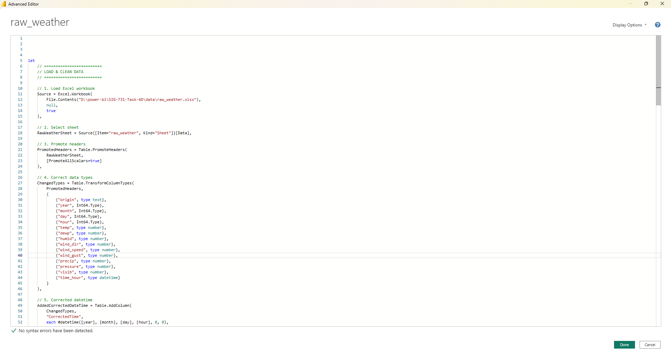
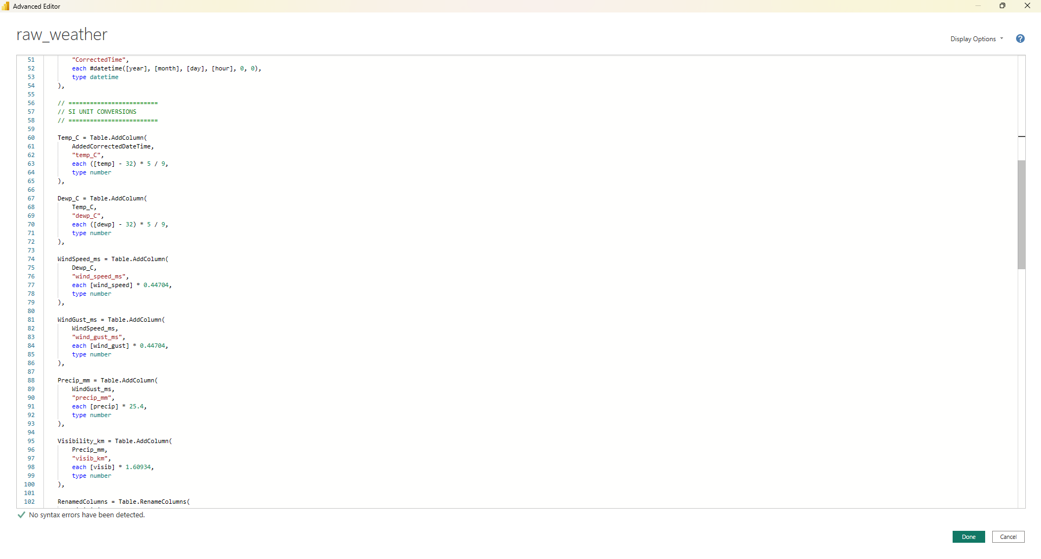

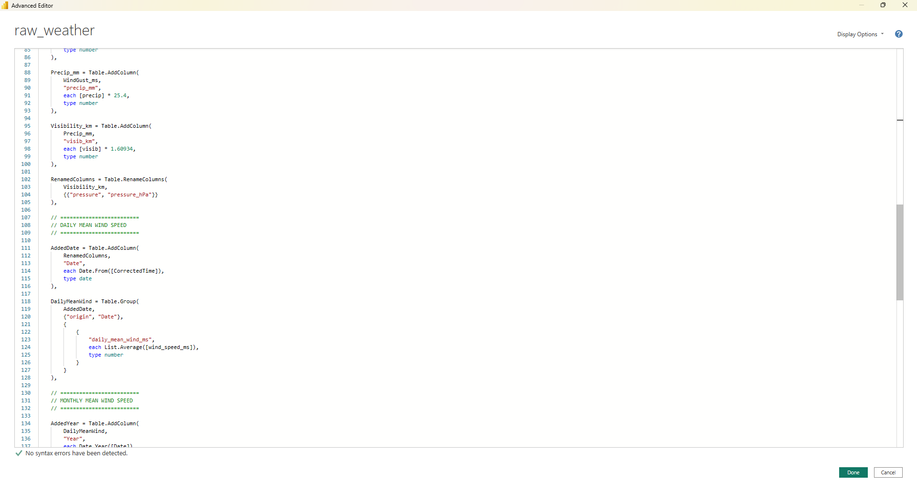
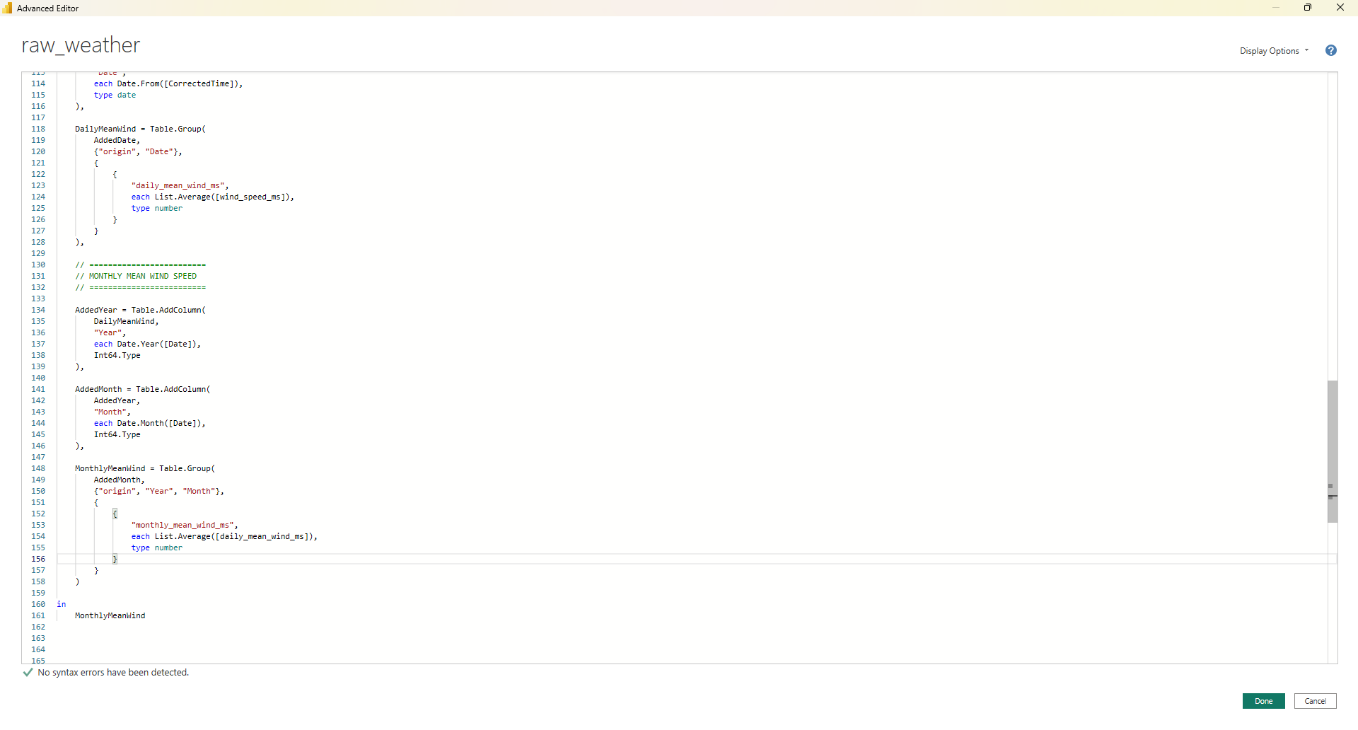

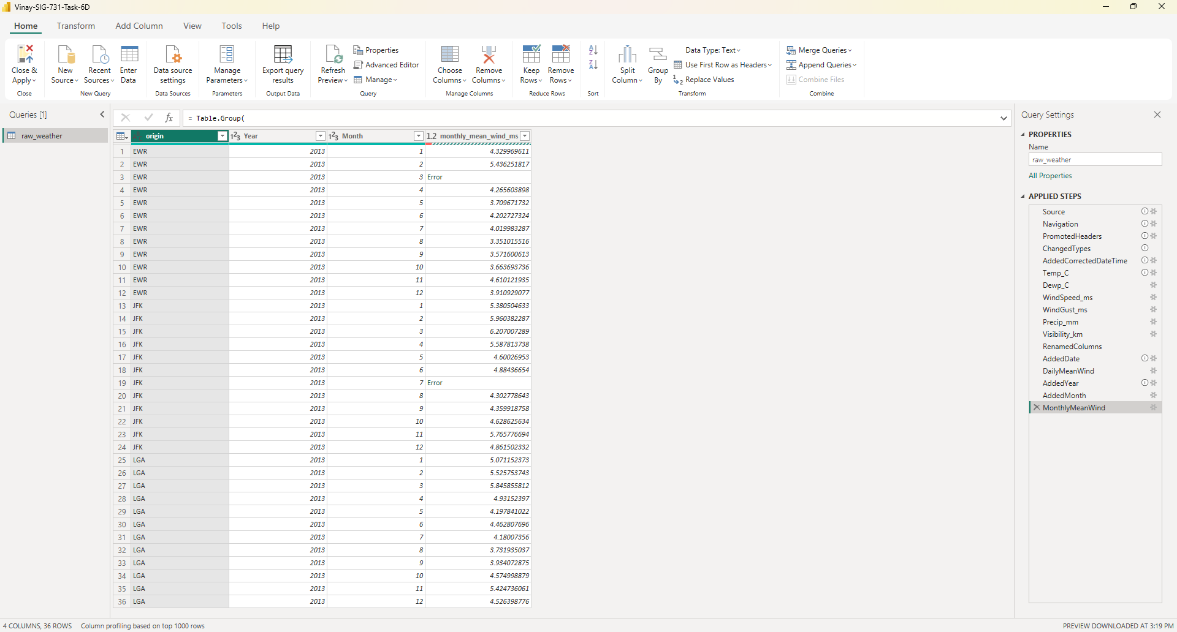

08. Correcting Errors
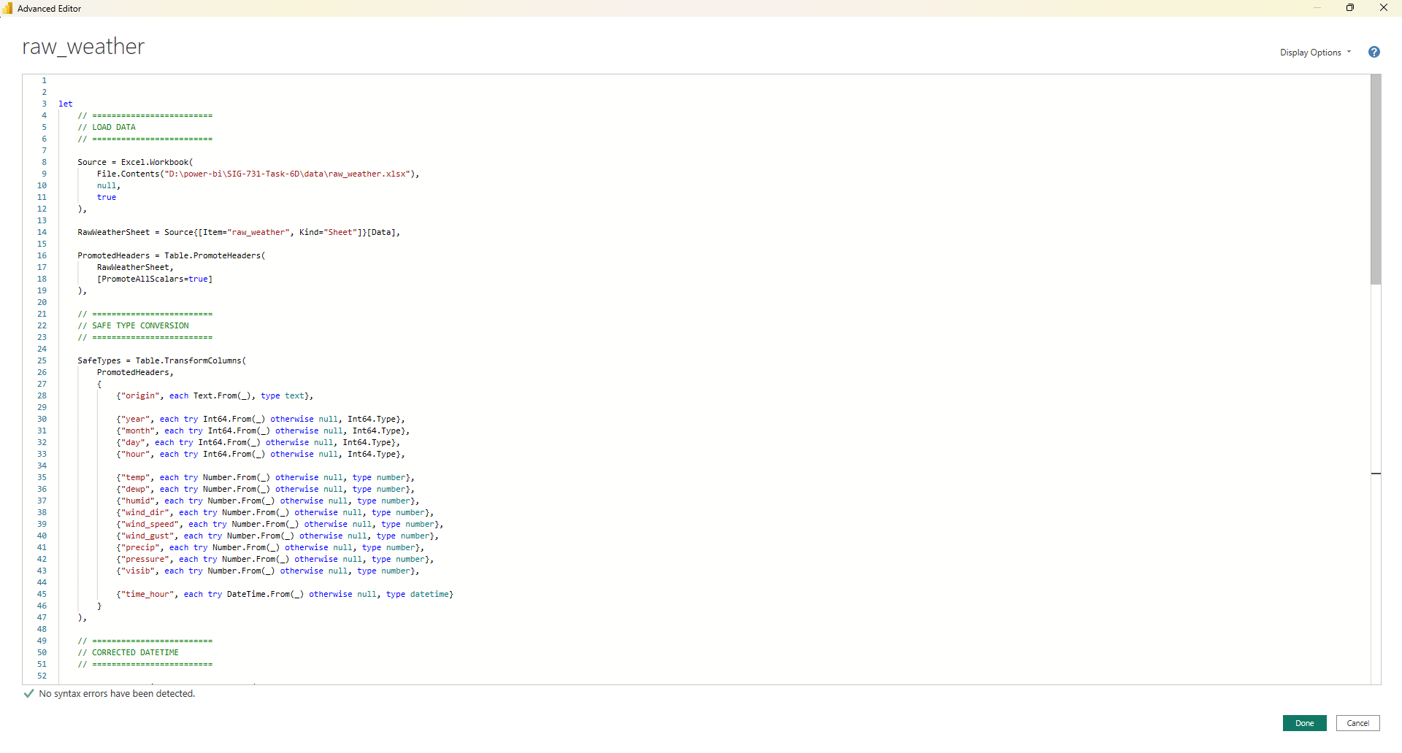

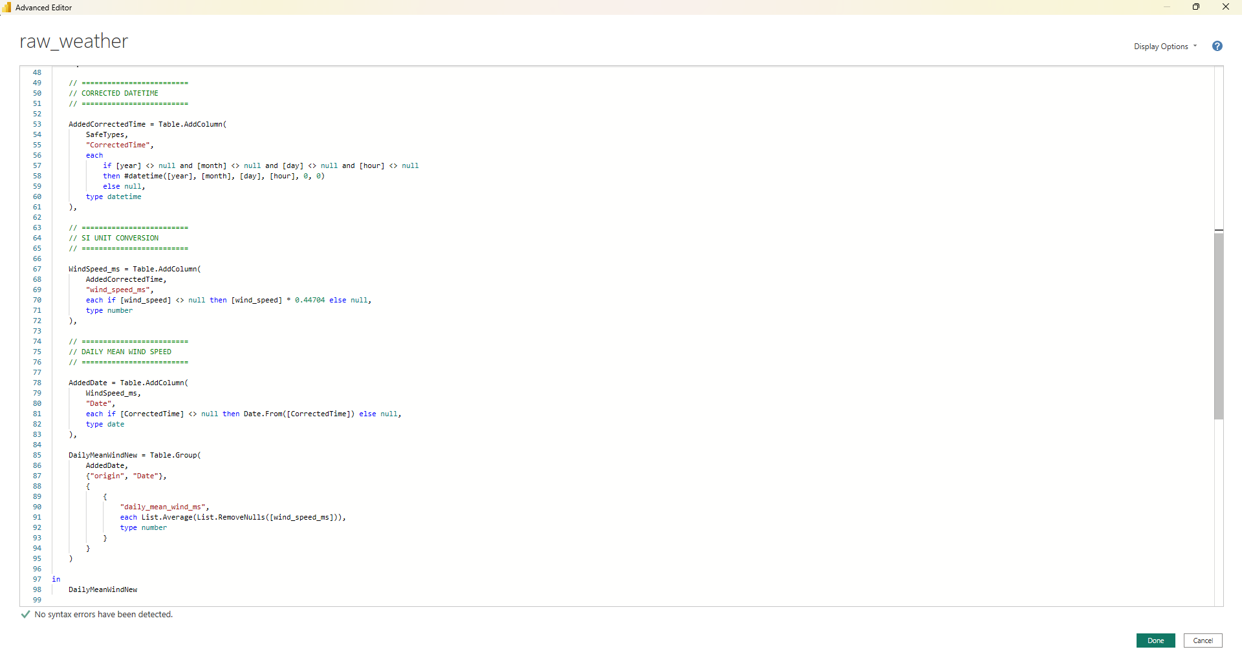
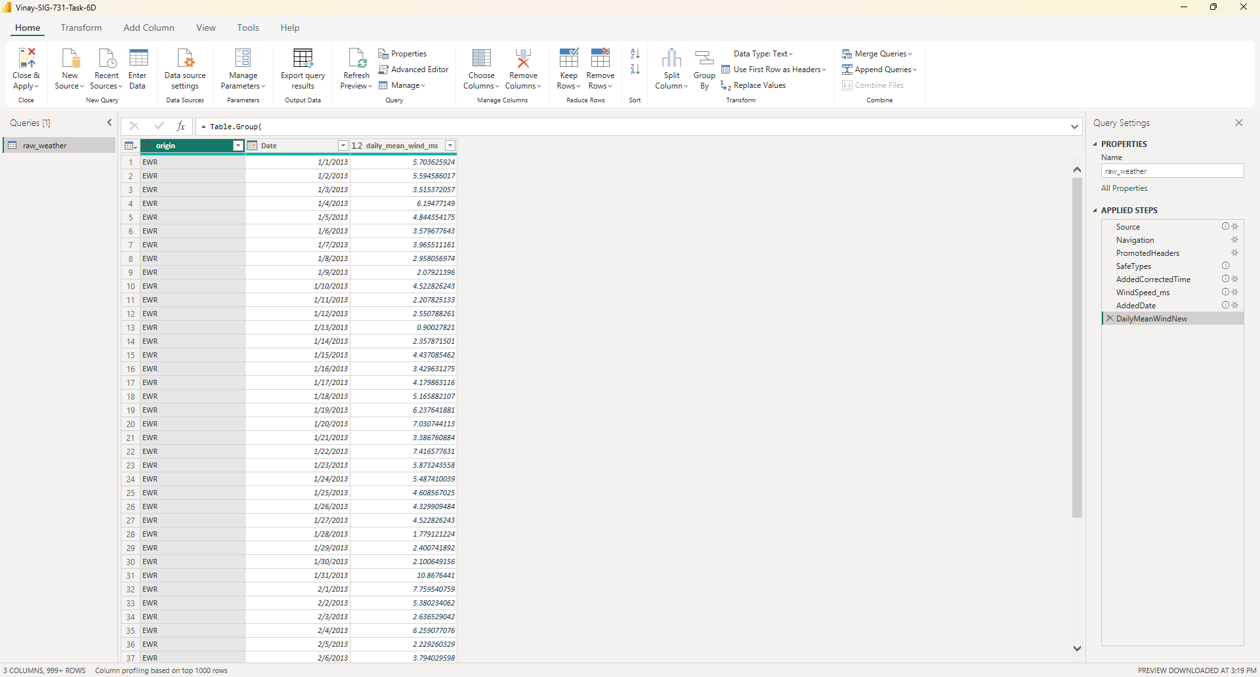

09. Removing Outliers and preparing final required data
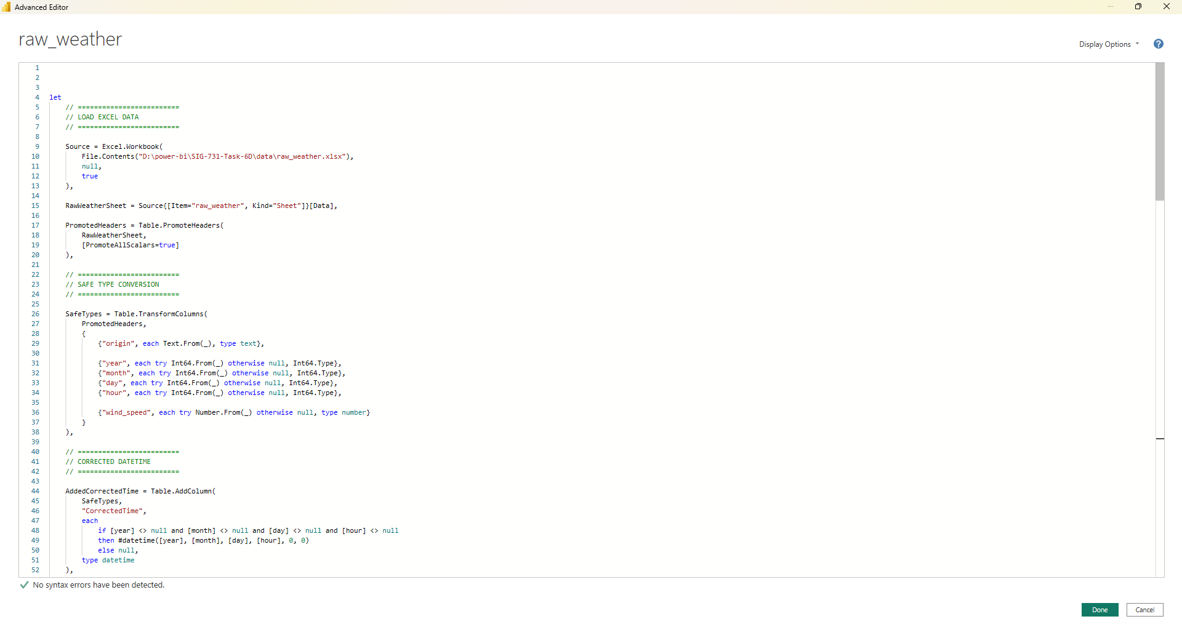
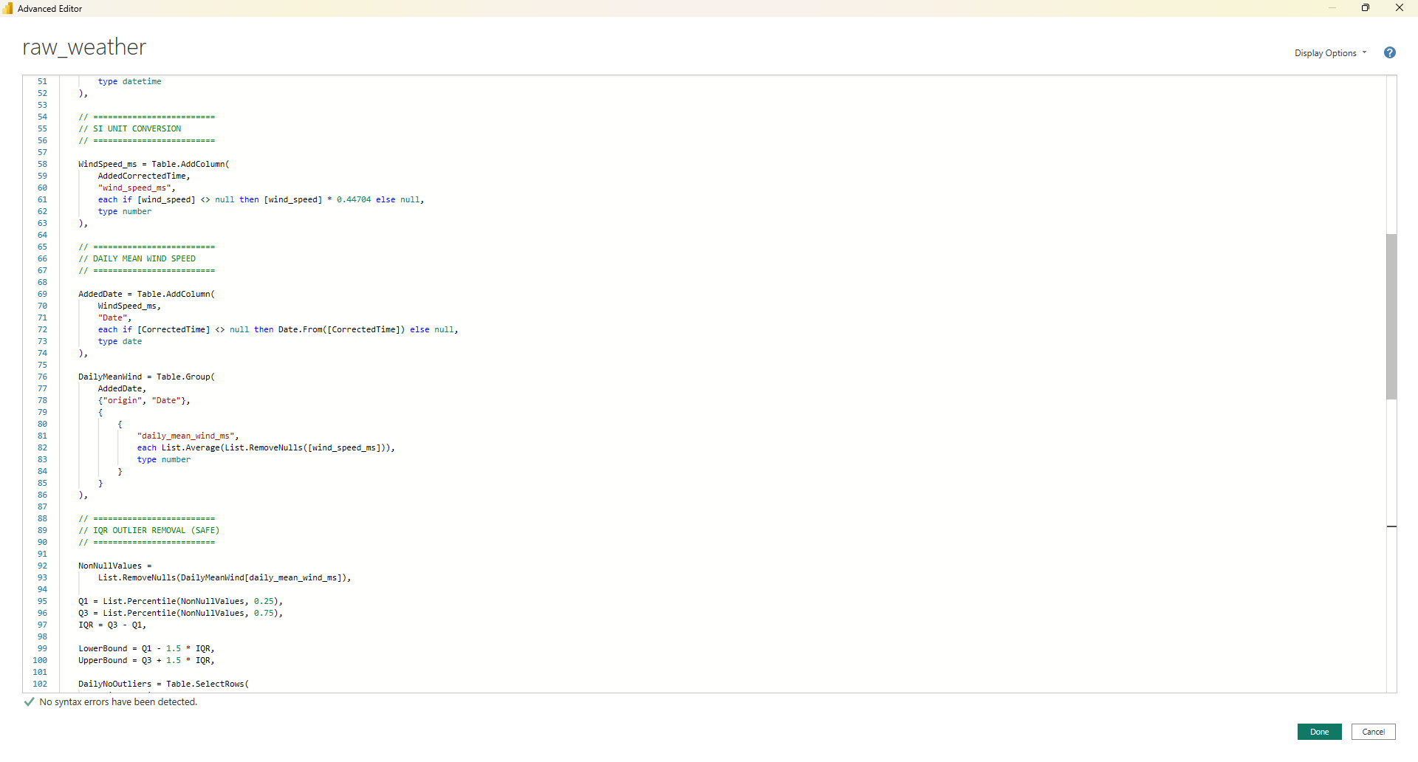
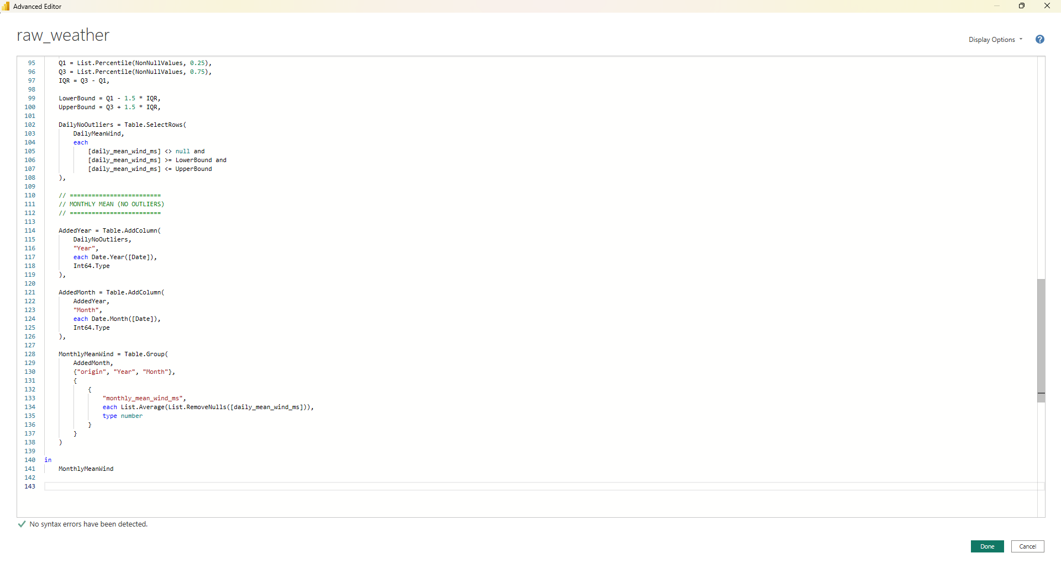
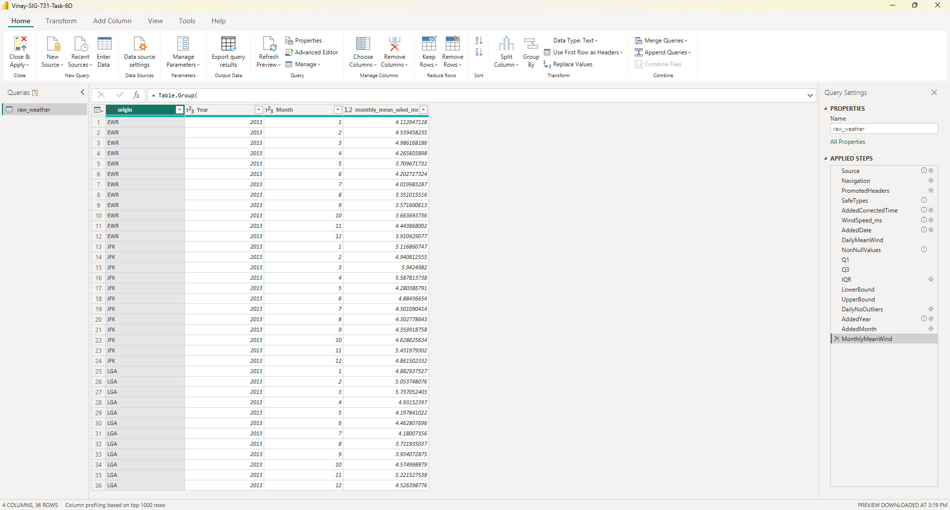

10. Final Dashboard
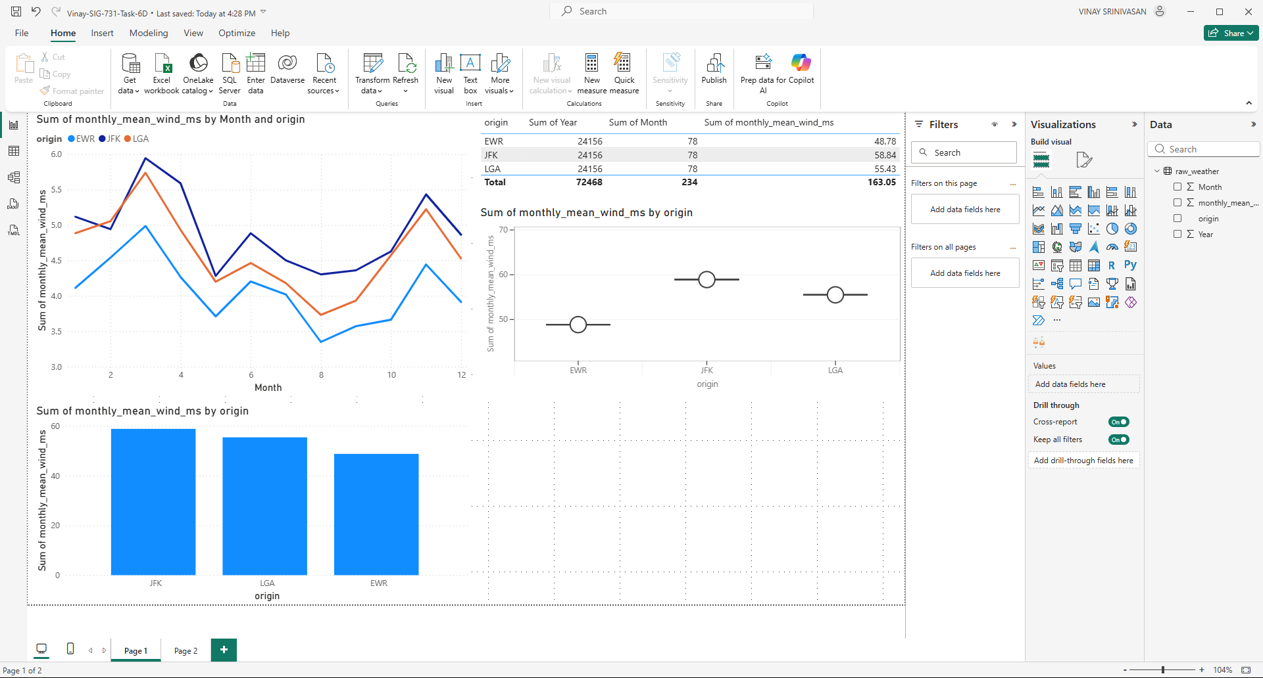
https://app.powerbi.com/groups/me/reports/f2a65ac2-daf8-4fec-a3e3-fcd4ca5311fe/c0f693e5777160b349ed?experience=power-bi

All meteorological variables were converted to International System of Units (SI) or SI-derived units using Power Query. Original measurements were preserved, and new columns were created for temperature (°C), wind speed (m/s), precipitation (mm), visibility (km), pressure (hPa), and relative humidity (fraction). This approach ensures scientific consistency and reproducibility

10.a Line Chart
The line chart shows a strong seasonal cycle in monthly mean wind speed, with higher values during winter and lower values in summer. EWR generally experiences the strongest winds, while LGA records the weakest, although all airports follow similar temporal trends

10.b Column Chart
The column chart shows that EWR has the highest average wind speed, followed by JFK, while LGA consistently records the lowest. This highlights persistent inter-airport differences in wind exposure despite similar seasonal patterns
10.c Table Chart
The table chart displays exact monthly mean wind speed values by airport, supporting transparency and confirming the seasonal and inter-airport patterns observed in the graphical visualizations

10.d Final Outliers Removed
All the Outliers have been removed

Conclusion:
The Final Power-BI Report has been published to:
https://app.powerbi.com/groups/me/reports/f2a65ac2-daf8-4fec-a3e3-fcd4ca5311fe/c0f693e5777160b349ed?experience=power-bi

Artifacts:
Public Repository: “https://github.com/SriVinayaka/Vinay-Srinivasan-SIG-731-Task-6D/”

Final “Power-BI Advanced Query” Model Code:

let
// =========================
// LOAD EXCEL DATA
// =========================

Source = Excel.Workbook(
File.Contents("D:\power-bi\SIG-731-Task-6D\data\raw_weather.xlsx"),
null,
true
),

RawWeatherSheet = Source{[Item="raw_weather", Kind="Sheet"]}[Data],

PromotedHeaders = Table.PromoteHeaders(
RawWeatherSheet,
[PromoteAllScalars=true]
),

// =========================
// SAFE TYPE CONVERSION
// =========================

SafeTypes = Table.TransformColumns(
PromotedHeaders,
{
{"origin", each Text.From(_), type text},

{"year", each try Int64.From(_) otherwise null, Int64.Type},
{"month", each try Int64.From(_) otherwise null, Int64.Type},
{"day", each try Int64.From(_) otherwise null, Int64.Type},
{"hour", each try Int64.From(_) otherwise null, Int64.Type},

{"wind_speed", each try Number.From(_) otherwise null, type number}
}
),

// =========================
// CORRECTED DATETIME
// =========================

AddedCorrectedTime = Table.AddColumn(
SafeTypes,
"CorrectedTime",
each
if [year] <> null and [month] <> null and [day] <> null and [hour] <> null
then #datetime([year], [month], [day], [hour], 0, 0)
else null,
type datetime
),

// =========================
// SI UNIT CONVERSION
// =========================

WindSpeed_ms = Table.AddColumn(
AddedCorrectedTime,
"wind_speed_ms",
each if [wind_speed] <> null then [wind_speed] * 0.44704 else null,
type number
),

// =========================
// DAILY MEAN WIND SPEED
// =========================

AddedDate = Table.AddColumn(
WindSpeed_ms,
"Date",
each if [CorrectedTime] <> null then Date.From([CorrectedTime]) else null,
type date
),

DailyMeanWind = Table.Group(
AddedDate,
{"origin", "Date"},
{
{
"daily_mean_wind_ms",
each List.Average(List.RemoveNulls([wind_speed_ms])),
type number
}
}
),

// =========================
// IQR OUTLIER REMOVAL (SAFE)
// =========================

NonNullValues =
List.RemoveNulls(DailyMeanWind[daily_mean_wind_ms]),

Q1 = List.Percentile(NonNullValues, 0.25),
Q3 = List.Percentile(NonNullValues, 0.75),
IQR = Q3 - Q1,

LowerBound = Q1 - 1.5 * IQR,
UpperBound = Q3 + 1.5 * IQR,

DailyNoOutliers = Table.SelectRows(
DailyMeanWind,
each
[daily_mean_wind_ms] <> null and
[daily_mean_wind_ms] >= LowerBound and
[daily_mean_wind_ms] <= UpperBound
),

// =========================
// MONTHLY MEAN (NO OUTLIERS)
// =========================

AddedYear = Table.AddColumn(
DailyNoOutliers,
"Year",
each Date.Year([Date]),
Int64.Type
),

AddedMonth = Table.AddColumn(
AddedYear,
"Month",
each Date.Month([Date]),
Int64.Type
),

MonthlyMeanWind = Table.Group(
AddedMonth,
{"origin", "Year", "Month"},
{
{
"monthly_mean_wind_ms",
each List.Average(List.RemoveNulls([daily_mean_wind_ms])),
type number
}
}
)

in
MonthlyMeanWind

