**Introduction**

Kubernetes has become the standard tool for managing containerized applications at scale, providing a robust platform for orchestrating and scaling workloads across clusters of machines. AWS Elastic Kubernetes Service (EKS) simplifies the process of deploying, managing, and scaling Kubernetes clusters on AWS infrastructure, offering a seamless integration with other AWS services.

The process of deploying the popular 2048 Game application on an AWS EKS Cluster using Helm Charts. Helm is a package manager for Kubernetes that streamlines the installation and management of applications on Kubernetes clusters.

**Steps Followed:**

**Step 1: Launch an AWS EC2 Medium Instance / use centos VM**

* I used Centos in Virtual machine an installed awls cli

**Step 2: Install and Configure AWS CLI**

* Run "aws configure"
* Enter the IAM user's access key ID, secret access key and set the default region and output format.

**Step 3: Install and setup kubectl**

* Kubectl is a command-line interface (CLI) tool that is used to interact with Kubernetes clusters. It allows users to deploy, inspect, and manage Kubernetes resources such as pods, deployments, services and more.
* Kubectl enables users to perform operations such as creating, updating, deleting, and scaling Kubernetes resources.

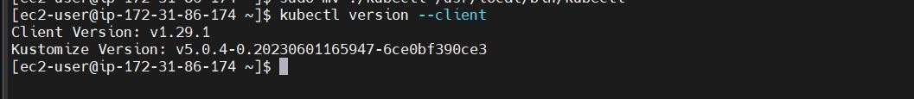

**Step 4: Install and set up eksctl**

* The eksctl is a command line tool for working with EKS clusters that automates many individual tasks.
* eksctl tool uses CloudFormation under the hood, creating one stack for the EKS master control plane and another stack for the worker nodes.



**Step 5: Install Helm Chart**

* Helm is a package manager for Kubernetes, an open-source container orchestration platform.
* Helm helps to manage Kubernetes applications by making it easy to install, update, and delete them.

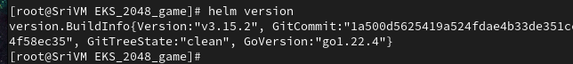

**Step 6: Create an EKS Cluster using EKSCTL**

* Use eksctl to create an EKS cluster, specifying parameters such as region, node instance type, and cluster name.
* eksctl will create an empty cluster, we will host the Kubernetes application on this cluster and see how Ingress Service caters requests from the client.

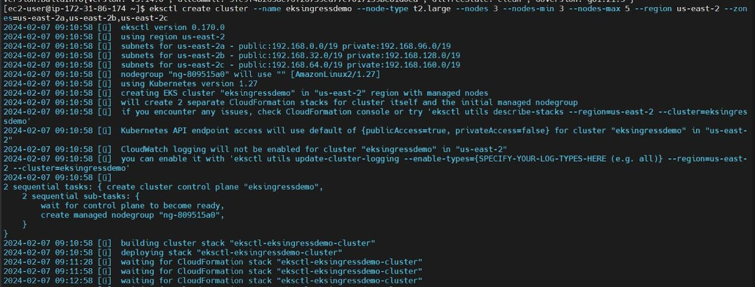

* After some time of execution in your AWS Console, you can able to see the EKS and Worker Nodes created under Compute.

**Step 7: Set up IAM Role for Service Accounts**

* The IAM permissions can either be setup via IAM roles for ServiceAccount or can be attached directly to the worker node IAM roles.
* (a) your AWS account id,

(b) Set your default AWS region,

(c) your EKS cluster name.

**Step 8: Create IAM OIDC provider**

* Create an OIDC identity provider for your AWS account to enable IAM roles for service accounts.

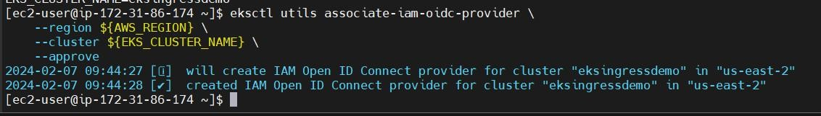

**Step 9: Download IAM Policy for the load balancer using CURL command**

* Ingress configuration requires IAM Policy for certain actions to be allowed.**Step 10: Create an IAM Role and Service Account.**
* Create an IAM service account for your Kubernetes cluster.

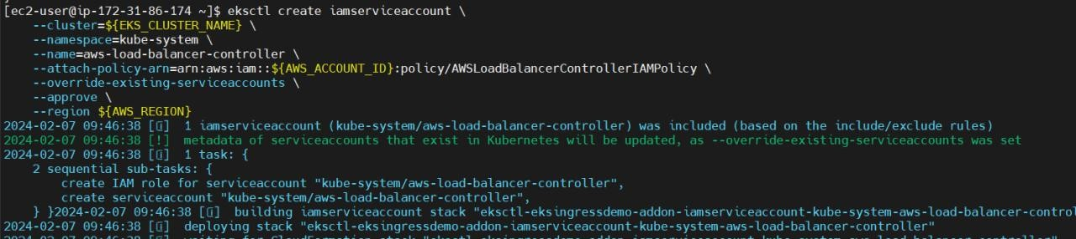

**Step 11: Install the Target Group Binding CRDs**

* Install any necessary Custom Resource Definitions (CRDs) required for target group bindings.

**Step 12: Deploy the Helm chart**

* Deploy the Helm chart for the 2048 Game onto the EKS cluster.



**Step 13: Configure AWS ALB (Application Load Balancer)**

* Configure an AWS Application Load Balancer (ALB) to act as the entry point for incoming traffic to the Kubernetes cluster.

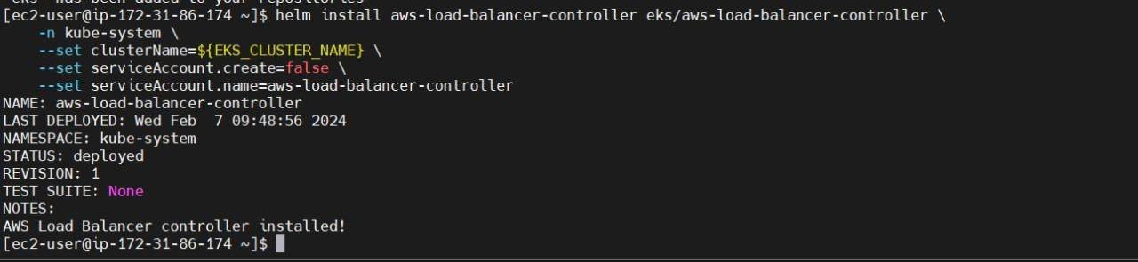

**Step 14: Deploy Sample Application**

* Deploy the 2048 Game application onto the EKS cluster.
* 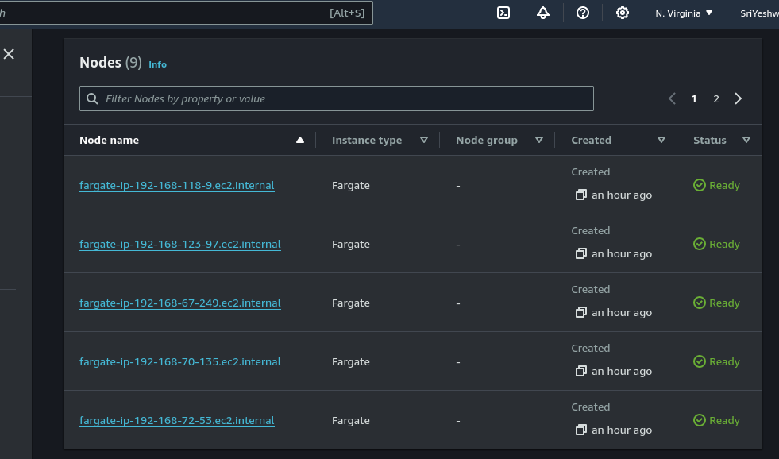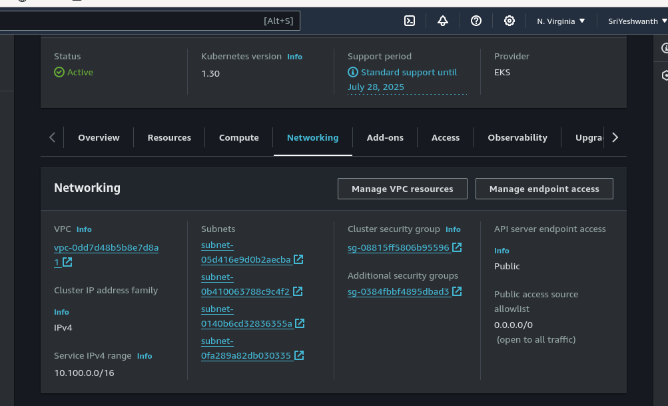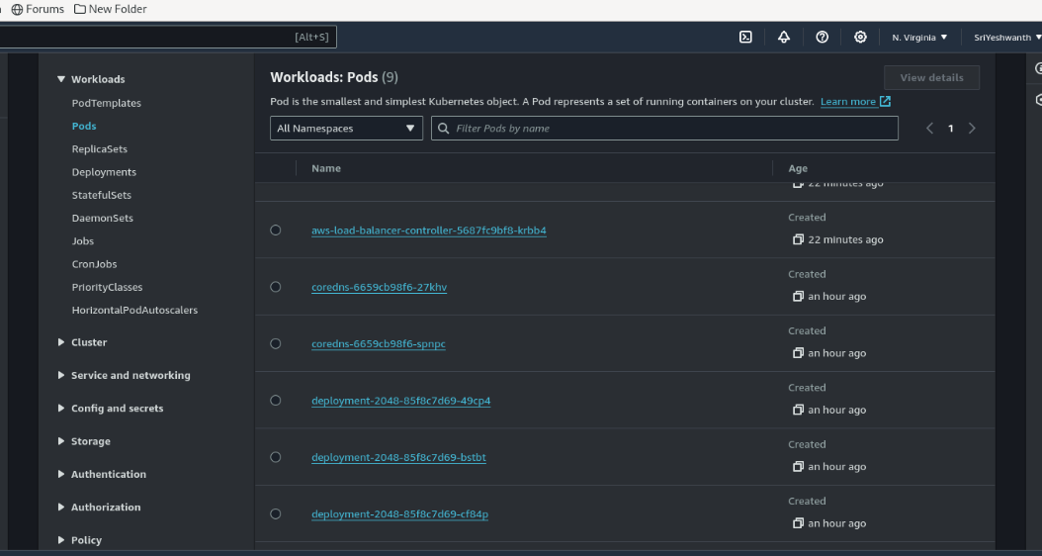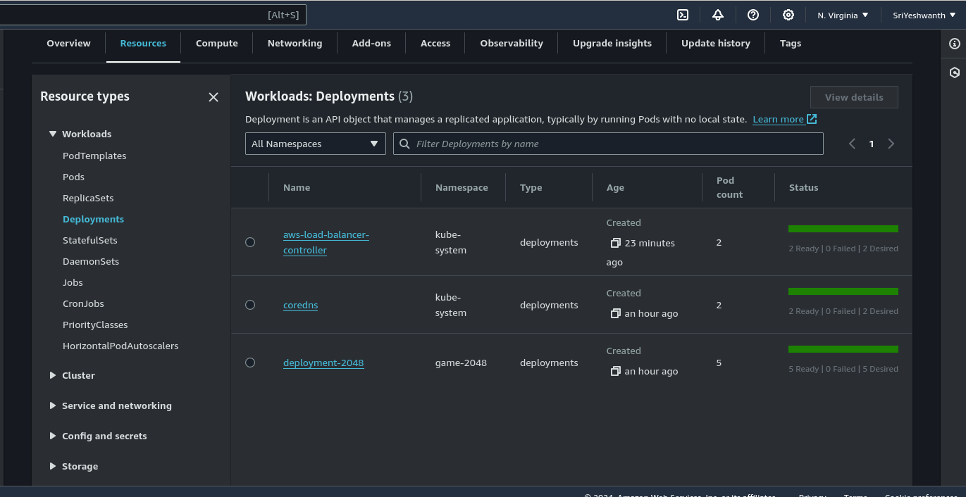

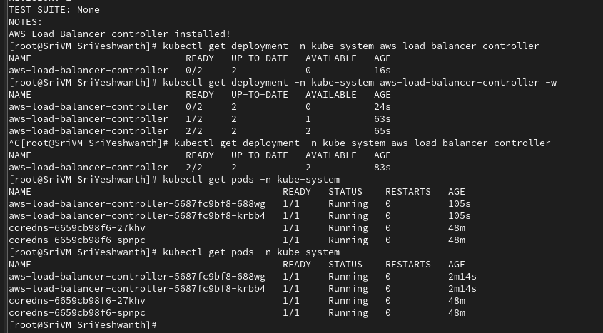

**Step 15: Get Ingress URL and check EKS Pod Data**

* Retrieve the URL exposed by the Ingress resource and test accessing the deployed application.
* Open the URL link in another browser. You can see that our 2048 Game is deployed  and can be accessed.

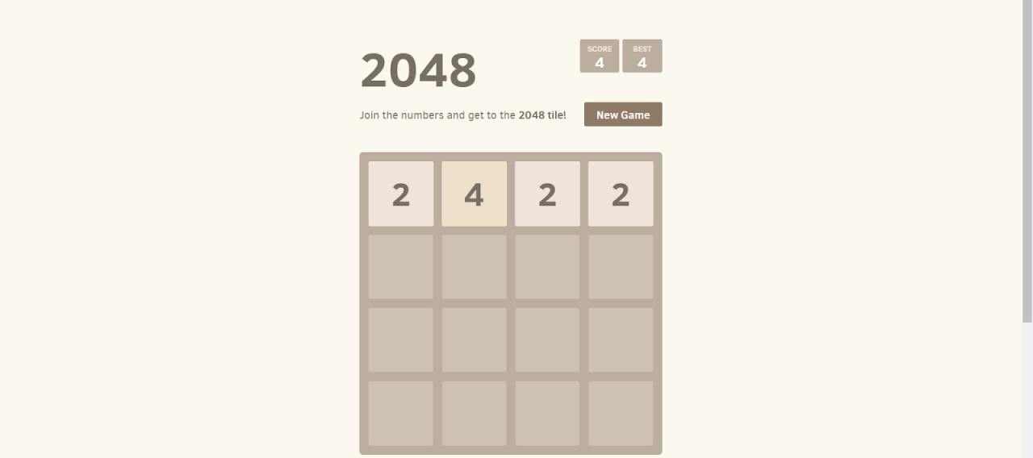

**Step 16: Delete EKS cluster**

* Once testing is complete and the resources are no longer needed, delete the EKS cluster to avoid unnecessary costs.Thank You [Cloudoholic](https://medium.com/@writetoritika?source=post_page-----10d396cdb87--------------------------------)