1. **Provide the list of markets in which customer "Atliq Exclusive" operates its business in the APAC region.**

select distinct market from dim_customer where customer = "Atliq Exclusive" and region = "APAC";

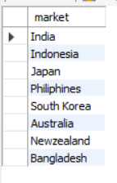

2. **What is the percentage of unique product increase in 2021 vs. 2020? The final output contains these fields, unique_products_2020 unique_products_2021 percentage_chg**

with totalunique_2020 as (

select distinct count(product_code) as unique_products_2020 from fact_gross_price where fiscal_year = 2020 ),

totalunique_2021 as (

select distinct count(product_code) as unique_products_2021 from fact_gross_price where fiscal_year = 2021 )

select *, ( (unique_products_2021 - unique_products_2020 ) * 100 /unique_products_2020) as difference_per from totalunique_2020, totalunique_2021;

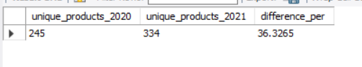

3. **Provide a report with all the unique product counts for each segment and sort them in descending order of product counts.**

**The final output contains 2 fields, segment product_count**

select distinct segment, count(product) as product_count from dim_product group by segment order by product_count desc;

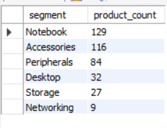

4. **Follow-up: Which segment had the most increase in unique products in 2021 vs 2020?**

**The final output contains these fields, segment product_count_2020 product_count_2021 difference**

with totalunique_2020 as (select p.segment , count(distinct(p.product)) as product_count_2020 from dim_product p join fact_sales_monthly s on s.product_code = p.product_code where fiscal_year = 2020 group by segment ),

totalunique_2021 as (select p.segment , count(distinct(p.product)) as product_count_2021 from fact_sales_monthly s join dim_product p on s.product_code = p.product_code where s.fiscal_year = 2021 group by segment )

select segment, product_count_2020, product_count_2021, ( product_count_2021 - product_count_2020 ) as difference from totalunique_2020 join totalunique_2021 using(segment) group by segment order by difference desc ;

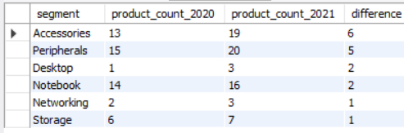

**5. Get the products that have the highest and lowest manufacturing costs.**

**The final output should contain these fields, product_code, product, manufacturing_cost.**

with max_cte as (select p.product as max_product , p.product_code as max_product_code , max(m.manufacturing_cost) as max_cost from dim_product p join fact_manufacturing_cost m on p.product_code = m.product_code group by p.product, p.product_code order by max_cost desc limit 1),

min_cte as (select '\n', p.product as min_product, p.product_code as min_product_code, min(m.manufacturing_cost) as min_cost from dim_product p join fact_manufacturing_cost m on p.product_code = m.product_code group by p.product, p.product_code order by min_cost limit 1 )

select * from max_cte, min_cte



6. **Generate a report which contains the top 5 customers who received an average high pre_invoice_discount_pct for the fiscal year 2021 and in the Indian market.**

**The final output contains these fields, customer_code customer average_discount_percentage**

select distinct c.customer_code , c.customer,p.fiscal_year, round(avg(p.pre_invoice_discount_pct),4) as average_discount_percentage from fact_pre_invoice_deductions p join dim_customer c on c.customer_code = p.customer_code where p.fiscal_year = 2021 and c.market = "India" group by p.fiscal_year, c.customer_code , c.customer order by average_discount_percentage limit 5;

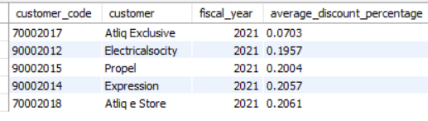

**7. Get the complete report of the Gross sales amount for the customer “Atliq Exclusive” for each month . This analysis helps to get an idea of low and high-performing months and take strategic decisions.**

**The final report contains these columns: Month, Year, Gross sales Amount**

select month(s.date) as Month, s.fiscal_year as Year, Round(sum(g.gross_price * s.sold_quantity),2) as Gross_Sales_Amount from dim_customer c join fact_sales_monthly s on s.customer_code = c.customer_code join fact_gross_price g on g.product_code = s.product_code where c.customer = "Atliq Exclusive" group by month(s.date), s.fiscal_year order by s.fiscal_year

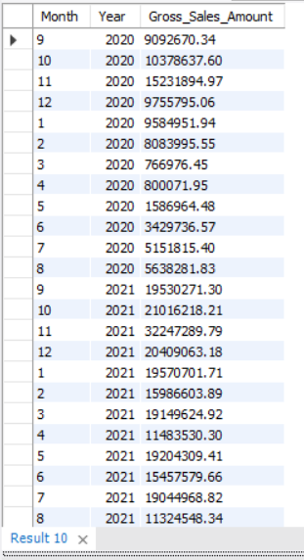

**8. In which quarter of 2020, got the maximum total_sold_quantity?**

**The final output contains these fields sorted by the total_sold_quantity, Quarter total_sold_quantity**

select case when month(date) in (9,10,11) then 'Q1' when month(date) in (12,1,2) then 'Q2' when month(date) in (3,4,5) then 'Q3' when month(date) in (6,7,8) then 'Q4' END AS quarter ,

sum(sold_quantity) as total_sold_quantity from fact_sales_monthly where fiscal_year = 2020

group by quarter order by total_sold_quantity desc limit 1;



**9. Which channel helped to bring more gross sales in the fiscal year 2021 and the percentage of contribution?**

**The final output contains these fields, channel gross_sales_mln percentage**

**// dividing by 1,000,000 is a common way to convert a large value (like total sales in basic currency units) into millions**

with Totalgross as

(select c.channel , round(SUM(g.gross_price * s.sold_quantity)/ 1000000 , 2) as gross_sales_mln from dim_customer c join fact_sales_monthly s on s.customer_code = c.customer_code join fact_gross_price g on g.product_code = s.product_code where s.fiscal_year = 2021 group by c.channel order by gross_sales_mln desc )

select *, round (gross_sales_mln * 100 / SUM(gross_sales_mln) over() ,2) as percentage from Totalgross order by percentage desc ;

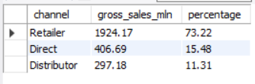

**10. Get the Top 3 products in each division that have a high total_sold_quantity in the fiscal_year 2021?**

**The final output contains these fields, division, product_code, product, total_sold_quantity rank_order**

WITH TOTALSALES as (

select distinct p.division, p.product_code, p.product, sum(s.sold_quantity) as total_sales_quantity from dim_product p join fact_sales_monthly s on

p.product_code = s.product_code where fiscal_year = 2021 group by p.division, p.product_code, p.product ) ,

RANKEDPRODUCTS AS ( select *, RANK() OVER (partition by division ORDER BY total_sales_quantity DESC) AS rank_order from TOTALSALES )

select * from RANKEDPRODUCTS where rank_order<=3;

