**Table of Contents:**

1.Frameowrk

2.Install Maven eclipse plugin

3. Install Cucumber plugin

4.Steps to run the automation scripts.

**1. Framework**

 Framework used to test is built on Selenium jars , cucumber plugin, Maven build  framework in     eclipse editor.chrome driver version

**2. Install maven eclipse plugin**

Most of the time, Maven plug-in is automatically installed in the Eclipse, but if it is not present, we will go to the Eclipse MarketPlace and search for Maven and download the M2E integrated version from there.

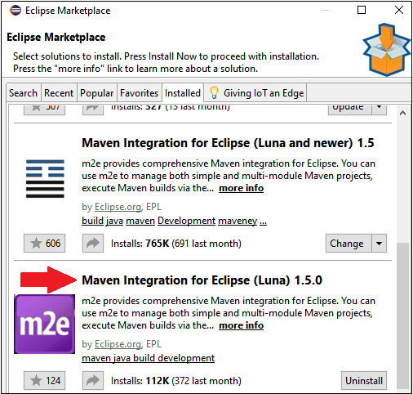

Steps to create Maven project

To create a Maven project, follow the below steps:

* Go to the File → New → Project

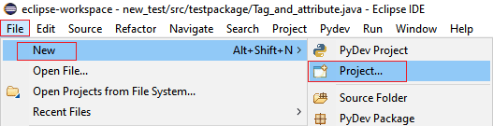

* Then, expand the Maven folder and select the Maven Project options, and click on the Next

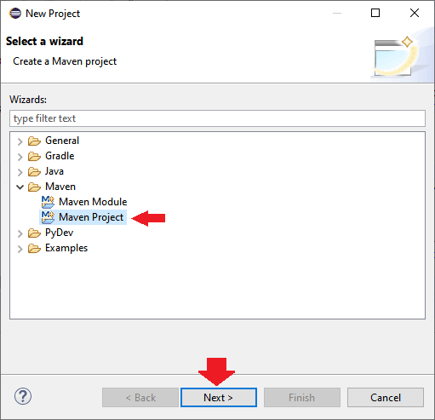

* Again click on the Next button for the further process.

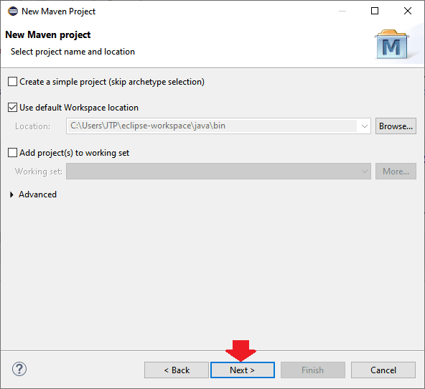

* Click on the Next button without doing anything.

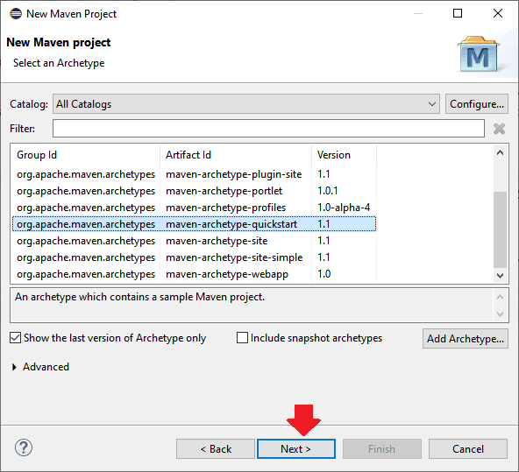

* After click on the Next button, we will provide the Group ID and Artifact ID in our case, and we will give the Group id as MavenProject and Artifact ID as MavenProject, and click on the Finish button as we can see in the below screenshot:

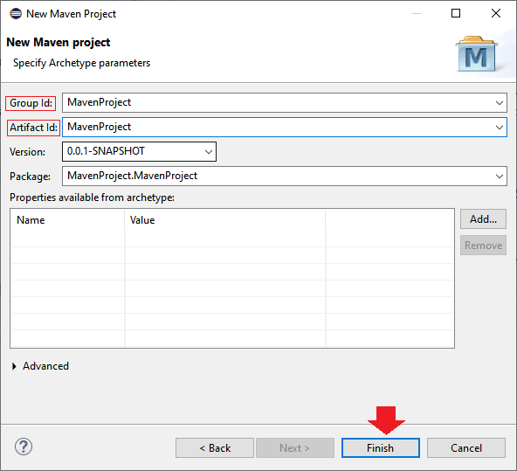

* Once we are done with creating the Maven project, our Maven folder structure will look like this:

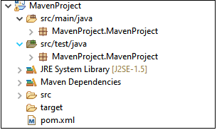

**3. Install Cucumber plugin**

  To install the Cucumber Eclipse Plugin in Eclipse Goto -- Helps->Install New Software->copy paste the link <http://cucumber.github.io/cucumber-eclipse/update-site/> and install.

**4. Project setup**

1. Create a Maven project in Eclipse.
2. Add dependencies to the POM file and update project.Observe all jars are auto populated.
3. Create feature files using new file options in src/test/java
4. Create a java file test with steps to work as glue for the cucumber features it is generally called as step definition file.
5. Create a java file testrunner and add @RunWith() annotation and @CucmberOptions() annotation with location to your feature files and  step definition files.
6. Set up run configurations adding below

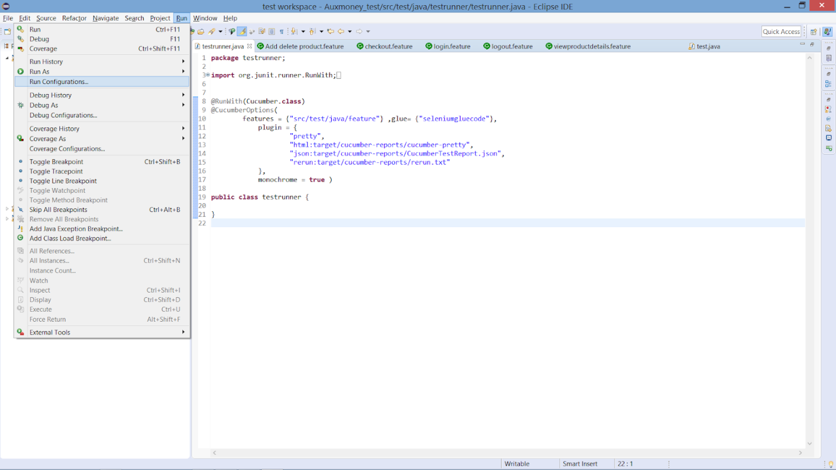

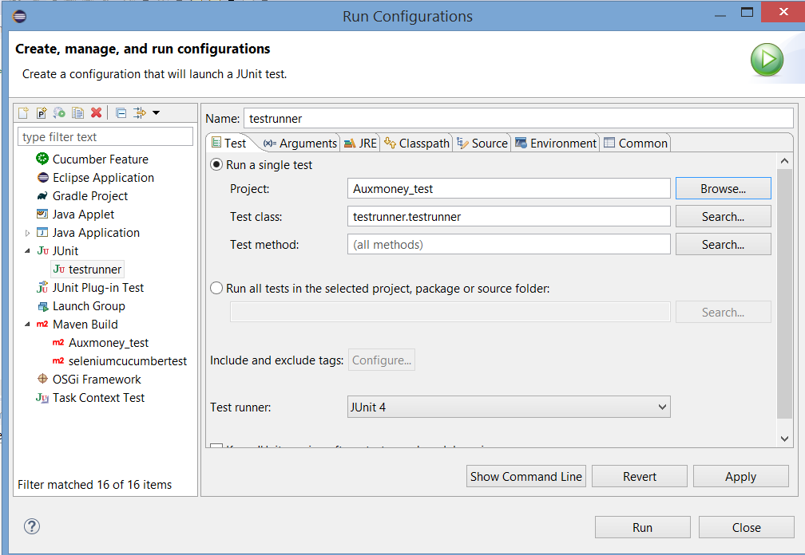

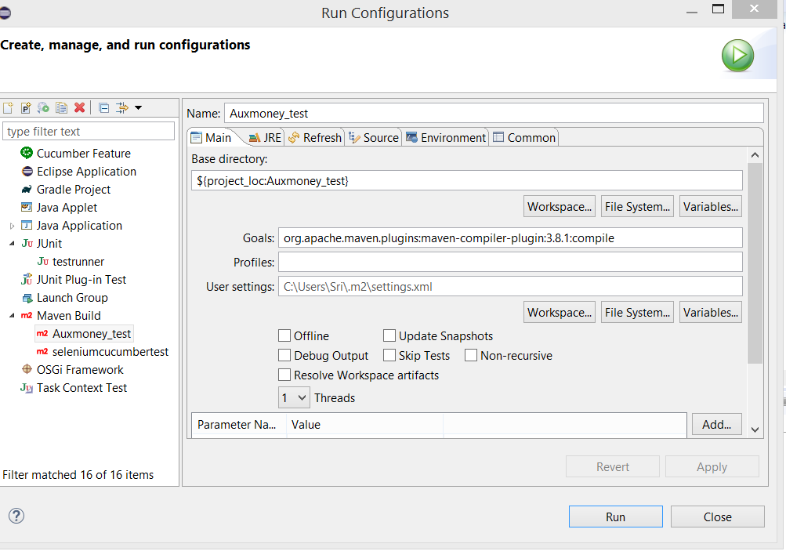

1. Now finally do a Maven Clean and Maven build.

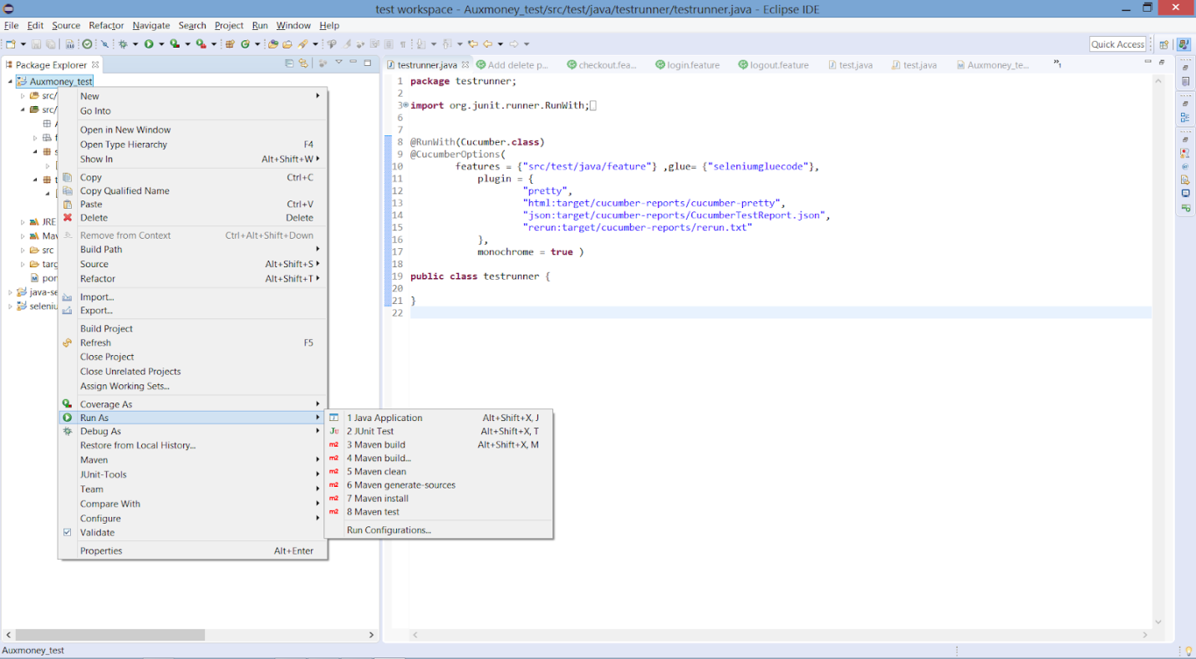

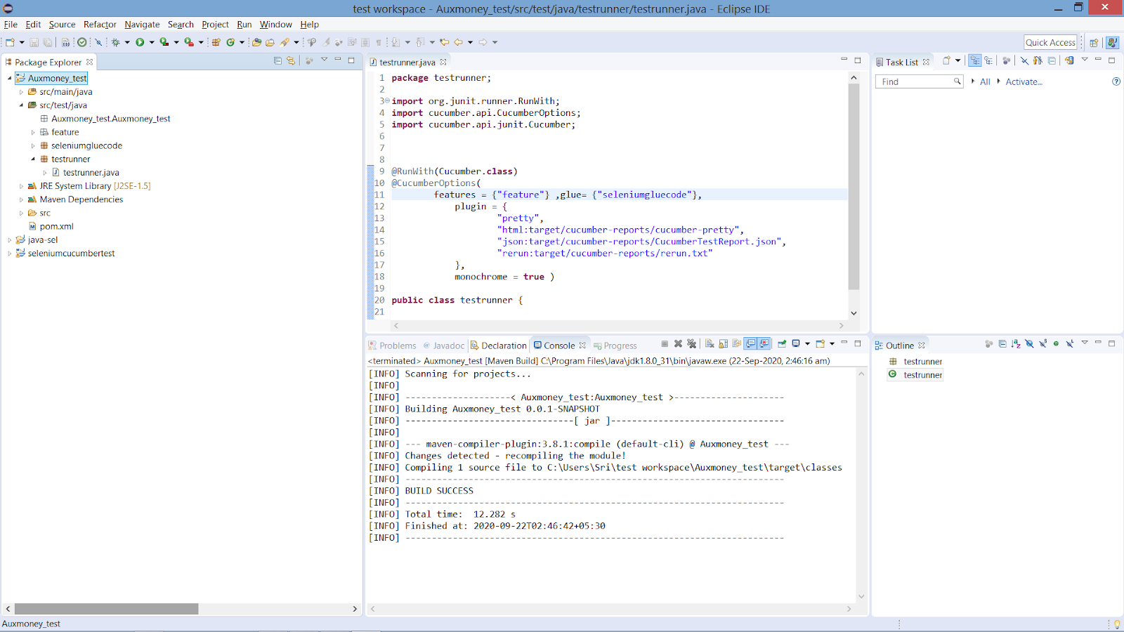

1. Click on you test runner and ´Run As´  Junit test

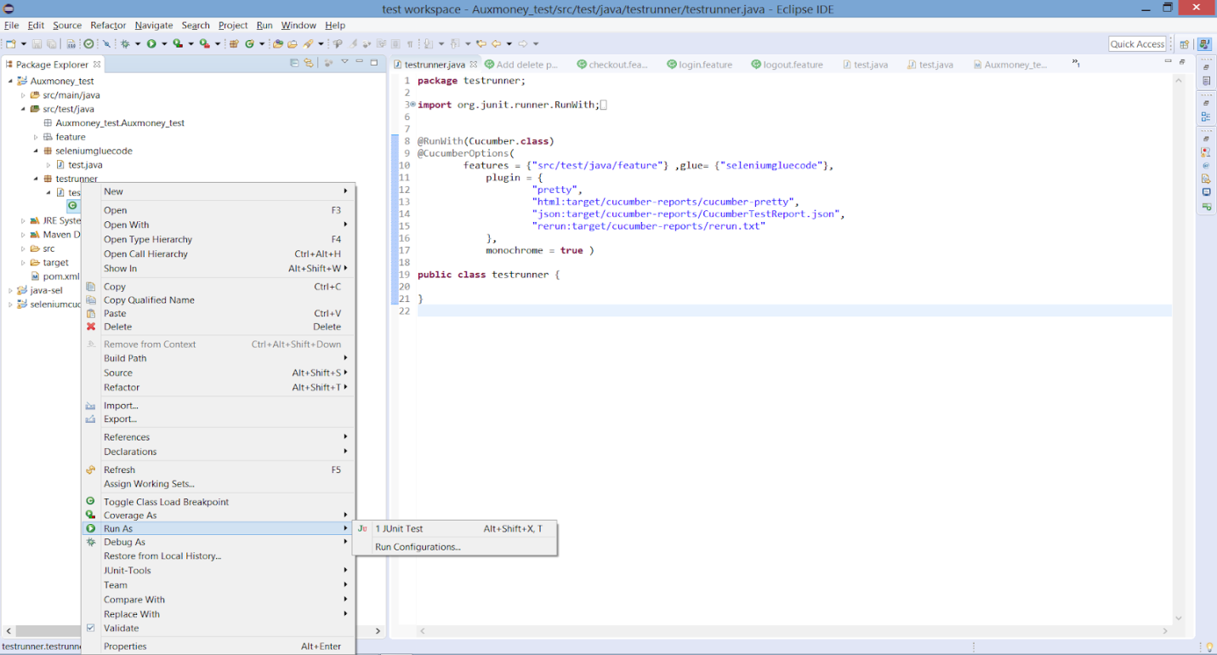

1. Check results on console.

