FML ASSIGNMENT 4

Sri Chandana

2023-11-19

# The necessary packages are loaded  
library(caret)

## Warning: package 'caret' was built under R version 4.3.2

## Loading required package: ggplot2

## Loading required package: lattice

#install.packages("factoextra")  
library(factoextra)

## Warning: package 'factoextra' was built under R version 4.3.2

## Welcome! Want to learn more? See two factoextra-related books at https://goo.gl/ve3WBa

library(dplyr)

## Warning: package 'dplyr' was built under R version 4.3.2

##   
## Attaching package: 'dplyr'

## The following objects are masked from 'package:stats':  
##   
## filter, lag

## The following objects are masked from 'package:base':  
##   
## intersect, setdiff, setequal, union

library(ggplot2)

library(tidyverse)

## Warning: package 'tidyverse' was built under R version 4.3.2

## Warning: package 'tidyr' was built under R version 4.3.2

## ── Attaching core tidyverse packages ──────────────────────── tidyverse 2.0.0 ──  
## ✔ forcats 1.0.0 ✔ stringr 1.5.0  
## ✔ lubridate 1.9.2 ✔ tibble 3.2.1  
## ✔ purrr 1.0.2 ✔ tidyr 1.3.0  
## ✔ readr 2.1.4   
## ── Conflicts ────────────────────────────────────────── tidyverse_conflicts() ──  
## ✖ dplyr::filter() masks stats::filter()  
## ✖ dplyr::lag() masks stats::lag()  
## ✖ purrr::lift() masks caret::lift()  
## ℹ Use the conflicted package (<http://conflicted.r-lib.org/>) to force all conflicts to become errors

#install.packages("cowplot")  
library(cowplot)

## Warning: package 'cowplot' was built under R version 4.3.2

##   
## Attaching package: 'cowplot'

## The following object is masked from 'package:lubridate':  
##   
## stamp

#install.packages("flexclust")  
library(flexclust)

## Warning: package 'flexclust' was built under R version 4.3.2

## Loading required package: grid

## Loading required package: modeltools

## Loading required package: stats4

#install.packages("cluster")  
library(cluster)

## Warning: package 'cluster' was built under R version 4.3.2

#install.packages("NbClust")  
library(NbClust)

# It imports the "Pharmaceuticals" dataset from the specified file path  
Pharmacy <- read.csv("C://Users//srich//OneDrive//Desktop//FML//DATASETS//Pharmaceuticals.csv")

# The "Pharmacy" dataset will be viewed  
view(Pharmacy)

# It displays the first few rows of the "Pharmacy" dataset  
head(Pharmacy)

## Symbol Name Market_Cap Beta PE_Ratio ROE ROA Asset_Turnover  
## 1 ABT Abbott Laboratories 68.44 0.32 24.7 26.4 11.8 0.7  
## 2 AGN Allergan, Inc. 7.58 0.41 82.5 12.9 5.5 0.9  
## 3 AHM Amersham plc 6.30 0.46 20.7 14.9 7.8 0.9  
## 4 AZN AstraZeneca PLC 67.63 0.52 21.5 27.4 15.4 0.9  
## 5 AVE Aventis 47.16 0.32 20.1 21.8 7.5 0.6  
## 6 BAY Bayer AG 16.90 1.11 27.9 3.9 1.4 0.6  
## Leverage Rev_Growth Net_Profit_Margin Median_Recommendation Location Exchange  
## 1 0.42 7.54 16.1 Moderate Buy US NYSE  
## 2 0.60 9.16 5.5 Moderate Buy CANADA NYSE  
## 3 0.27 7.05 11.2 Strong Buy UK NYSE  
## 4 0.00 15.00 18.0 Moderate Sell UK NYSE  
## 5 0.34 26.81 12.9 Moderate Buy FRANCE NYSE  
## 6 0.00 -3.17 2.6 Hold GERMANY NYSE

# It displays the summary statistics for the "Pharmacy" dataset  
summary(Pharmacy)

## Symbol Name Market_Cap Beta   
## Length:21 Length:21 Min. : 0.41 Min. :0.1800   
## Class :character Class :character 1st Qu.: 6.30 1st Qu.:0.3500   
## Mode :character Mode :character Median : 48.19 Median :0.4600   
## Mean : 57.65 Mean :0.5257   
## 3rd Qu.: 73.84 3rd Qu.:0.6500   
## Max. :199.47 Max. :1.1100   
## PE_Ratio ROE ROA Asset_Turnover Leverage   
## Min. : 3.60 Min. : 3.9 Min. : 1.40 Min. :0.3 Min. :0.0000   
## 1st Qu.:18.90 1st Qu.:14.9 1st Qu.: 5.70 1st Qu.:0.6 1st Qu.:0.1600   
## Median :21.50 Median :22.6 Median :11.20 Median :0.6 Median :0.3400   
## Mean :25.46 Mean :25.8 Mean :10.51 Mean :0.7 Mean :0.5857   
## 3rd Qu.:27.90 3rd Qu.:31.0 3rd Qu.:15.00 3rd Qu.:0.9 3rd Qu.:0.6000   
## Max. :82.50 Max. :62.9 Max. :20.30 Max. :1.1 Max. :3.5100   
## Rev_Growth Net_Profit_Margin Median_Recommendation Location   
## Min. :-3.17 Min. : 2.6 Length:21 Length:21   
## 1st Qu.: 6.38 1st Qu.:11.2 Class :character Class :character   
## Median : 9.37 Median :16.1 Mode :character Mode :character   
## Mean :13.37 Mean :15.7   
## 3rd Qu.:21.87 3rd Qu.:21.1   
## Max. :34.21 Max. :25.5   
## Exchange   
## Length:21   
## Class :character   
## Mode :character   
##   
##   
##

#a. Use only the numerical variables (1 to 9) to cluster the 21 firms. Justify the various choices made in conducting the cluster analysis, such as weights for different variables, the specific clustering algorithm(s) used, the number of clusters formed, and so on.  
  
# Calculates the column wise mean of missing values in the "Pharmacy" dataset  
colMeans(is.na(Pharmacy))

## Symbol Name Market_Cap   
## 0 0 0   
## Beta PE_Ratio ROE   
## 0 0 0   
## ROA Asset_Turnover Leverage   
## 0 0 0   
## Rev_Growth Net_Profit_Margin Median_Recommendation   
## 0 0 0   
## Location Exchange   
## 0 0

# Sets row names of "Pharmacy" to the values in the second column.  
row.names(Pharmacy) <- Pharmacy[,2]  
# Removes the second column from the "Pharmacy" dataset  
Pharmacy <- Pharmacy[,-2]  
# Removes the first column and columns 11 to 13 from the updated "Pharmacy" dataset  
Pharmacy.1 <- Pharmacy[,-c(1,11:13)]

# Checks the dimensions of the "Pharmacy" dataset  
dim(Pharmacy)

## [1] 21 13

# Standardizes the columns of "Pharmacy.1" using the scale function  
norm.Pharmacy.1 <- scale(Pharmacy.1)  
# Calculates the distance matrix based on the standardized data  
dist <- get_dist(norm.Pharmacy.1)  
# Visualizes the distance matrix using function  
fviz_dist(dist)

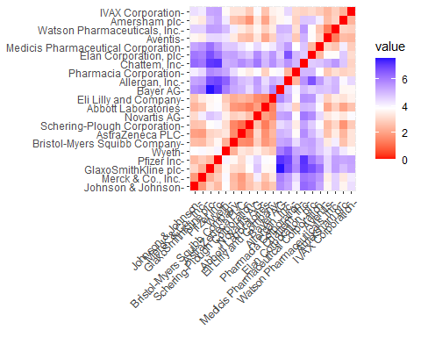

# The chart shows how the color intensity changes as we move across distances. As expected,the diagonal line representing the distance between two observations, has a value of zero.  
  
# For finding the best K Value: The Elbow chart and the Silhouette Method are effective ways to decide the number of clusters for a k-means model, especially when external factors don't guide the decision. The Elbow chart shows how increasing the number of clusters decreases overall cluster diversity. On the other hand, the Silhouette Method evaluates how well an objects cluster aligns with other clusters, helping us understand the cohesion within the clusters.

# Calculates Within Cluster Sum of Squares (WSS) for different numbers of clusters using the k-means algorithm  
WSS <- fviz_nbclust(norm.Pharmacy.1, kmeans, method = "wss")  
# Calculates Silhouette scores for different numbers of clusters using the k-means algorithm  
Sil <- fviz_nbclust(norm.Pharmacy.1, kmeans, method = "silhouette")  
# Displays the plots of WSS and Silhouette scores  
plot_grid(WSS, Sil)

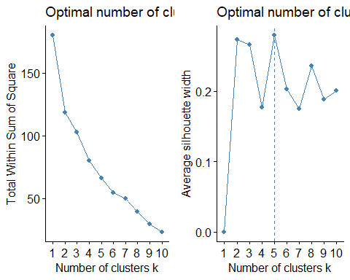

# The charts indicate different optimal values for k, the Elbow Method suggests k=2, while the Silhouette Method produces k=5. Despite this, I have decided to use k=5 for the k-means method in my analysis.

# Set the seed for reproducibility  
# Performs k-means clustering on the normalized "Pharmacy.1" data with 5 centers   
# Displays the cluster centers obtained from the k-means clustering  
set.seed(123)  
KMeans.Pharmacy.Opt <- kmeans(norm.Pharmacy.1, centers = 5, nstart = 50)  
KMeans.Pharmacy.Opt$centers

## Market_Cap Beta PE_Ratio ROE ROA Asset_Turnover  
## 1 -0.03142211 -0.4360989 -0.31724852 0.1950459 0.4083915 0.1729746  
## 2 -0.87051511 1.3409869 -0.05284434 -0.6184015 -1.1928478 -0.4612656  
## 3 -0.43925134 -0.4701800 2.70002464 -0.8349525 -0.9234951 0.2306328  
## 4 1.69558112 -0.1780563 -0.19845823 1.2349879 1.3503431 1.1531640  
## 5 -0.76022489 0.2796041 -0.47742380 -0.7438022 -0.8107428 -1.2684804  
## Leverage Rev_Growth Net_Profit_Margin  
## 1 -0.27449312 -0.7041516 0.556954446  
## 2 1.36644699 -0.6912914 -1.320000179  
## 3 -0.14170336 -0.1168459 -1.416514761  
## 4 -0.46807818 0.4671788 0.591242521  
## 5 0.06308085 1.5180158 -0.006893899

# Display the size of each cluster  
KMeans.Pharmacy.Opt$size

## [1] 8 3 2 4 4

# Display the within-cluster sum of squares  
KMeans.Pharmacy.Opt$withinss

## [1] 21.879320 15.595925 2.803505 9.284424 12.791257

# Visualize the k-means clusters using a scatter plot  
fviz_cluster(KMeans.Pharmacy.Opt, data = norm.Pharmacy.1)

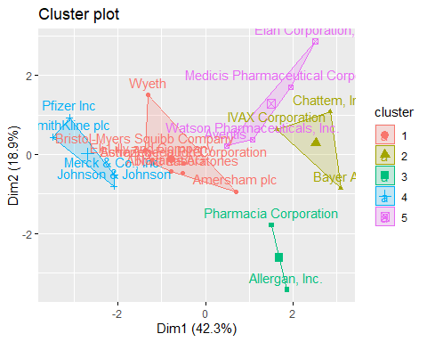

# Using the dataset,we identified five clusters based on their proximity to core points. Cluster 4 stands out for its high Market Capital, while Cluster 2 is notable for its high Beta.   
# On the other hand, Cluster 5 is characterized by a low Asset Turnover.Examining the size of each cluster, Cluster 1 has the most enterprises, while Cluster 3 consists of only two.   
# The within-cluster sum of squared distances provides insights into data dispersion: Cluster 1 (21.9) is less homogeneous than Cluster 3 (2.8).Visualizing the algorithm's results allows us to see the distinct groups the data has been divided into.

#b. Interpret the clusters with respect to the numerical variables used in forming the clusters.  
  
# Set the seed for reproducibility  
# Performs k-means clustering on the normalized "Pharmacy.1" data with 3 clusters  
# Displays the cluster centers  
  
set.seed(123)  
KMeans.Pharmacy <- kmeans(norm.Pharmacy.1, centers = 3, nstart = 50)  
KMeans.Pharmacy$centers

## Market_Cap Beta PE_Ratio ROE ROA Asset_Turnover  
## 1 -0.6125361 0.2698666 1.3143935 -0.9609057 -1.0174553 0.2306328  
## 2 0.6733825 -0.3586419 -0.2763512 0.6565978 0.8344159 0.4612656  
## 3 -0.8261772 0.4775991 -0.3696184 -0.5631589 -0.8514589 -0.9994088  
## Leverage Rev_Growth Net_Profit_Margin  
## 1 -0.3592866 -0.5757385 -1.3784169  
## 2 -0.3331068 -0.2902163 0.6823310  
## 3 0.8502201 0.9158889 -0.3319956

# Displays the sizes of each cluster obtained from the k-means clustering.  
KMeans.Pharmacy$size

## [1] 4 11 6

# Displays the within-cluster sum of squares for each cluster  
KMeans.Pharmacy$withinss

## [1] 20.54199 43.30886 32.14336

# Visualize the k-means clusters using a scatter plot  
fviz_cluster(KMeans.Pharmacy, data = norm.Pharmacy.1)

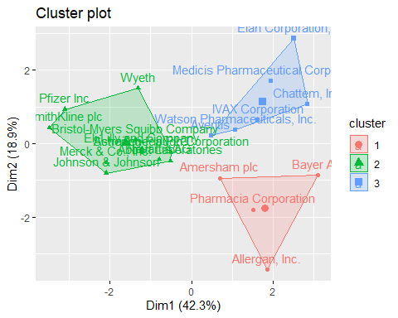

clusplot(norm.Pharmacy.1,KMeans.Pharmacy$cluster,color = TRUE,shade =TRUE, labels=2,lines=0)

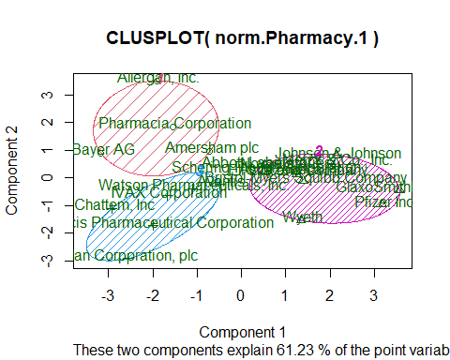

#c. Is there a pattern in the clusters with respect to the numerical variables (10 to 12)?  
  
# To explore patterns in the data for the last three categorical variables—Median Recommendation, Location, and Stock Exchange—I decided to use bar charts. These charts provide a visual representation of how firms are distributed among different clusters, allowing for a clearer understanding of trends in the data.  
  
Pharmacy.2 <- Pharmacy%>% select(c(11,12,13)) %>%   
 mutate(Cluster = KMeans.Pharmacy$cluster)  
Med_Recom <- ggplot(Pharmacy.2, mapping = aes(factor(Cluster), fill=Median_Recommendation)) +  
 geom_bar(position = 'dodge') +  
 labs(x='Clusters', y='Frequence')  
Loc <- ggplot(Pharmacy.2, mapping = aes(factor(Cluster), fill=Location)) +  
 geom_bar(position = 'dodge') +   
 labs(x='Clusters', y='Frequence')  
Ex <- ggplot(Pharmacy.2, mapping = aes(factor(Cluster), fill=Exchange)) +  
 geom_bar(position = 'dodge') +   
 labs(x='Clusters', y='Frequence')  
plot_grid(Med_Recom, Loc, Ex)

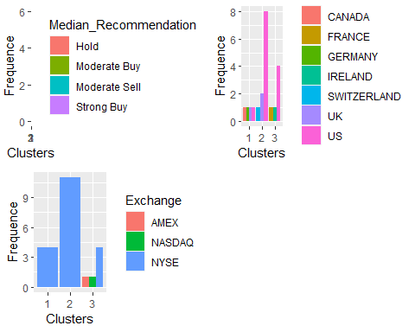

# The chart makes it clear that most companies in cluster 3 are from the United States, and all of them suggest holding their shares.They're exclusively traded on the New York Stock Exchange. For cluster 2, we've selected stocks with a "Moderate Buy" recommendation, and only two companies are from different exchanges (AMEX and NASDAQ). Cluster 1 reveals that the four firms come from four different countries, yet all their stocks are traded on the NYSE.

#d. Provide an appropriate name for each cluster using any or all of the variables in the dataset.  
  
#1) Cluster 1 - Global Giants: These companies are considered "overvalued international firms" because they operate globally, are listed on the NYSE, have low Net Profit Margins, and high Price/Earnings ratios.Despite their high market value, it's not well-supported by their current earnings. To sustain their stock prices, they need to invest and increase earnings to meet investor expectations.  
#2) Cluster 2 - Growth Prospects: This group is labeled as "growing and leveraged firms" due to "Moderate buy" evaluations, low asset turnover, low ROA, high leverage, and expected revenue growth.Even though they currently lack profitability and carry significant debt, investors see potential in their future growth, making them highly valued.  
#3) Cluster 3 - Stable US Companies: Companies in this cluster are characterized as "mature US firms" since they are based in the US, listed on the NYSE, and have "Hold" ratings.They are considered stable and mature, indicating a more conservative investment approach compared to the other clusters.