**SUMMER INTERNSHIP FINAL REPORT**

INTERNSHIP REPORT

Human Resources Internship at ScieGen Pharmaceuticals India Pvt. Ltd.

Submitted to the School of Management, Mahindra University

Internship Period: 15th June,2024 – 31st July,2024

Submitted by: Sricharan Gajavelli

SM22UBBD115

Date of Submission: 15TH August,2024

**Acknowledgement:**

I would like to take this opportunity to thank all those who were part of my internship journey, each one of you has had lasted a very positive impact on my journey and helped me grow with each experience. My heartfelt thanks go to my mentor from Mahindra University Mr Sanjay Singh. I also thank Mahindra University for paving the path to a summer internship at ScieGen Pharmaceuticals India Pvt. Ltd.

I am profoundly grateful for the invaluable guidance and mentorship provided by my esteemed mentors at ScieGen Pharmaceuticals India, their encouragement has motivated me to consistently strive for excellence in my work. Their thoughtful feedback at every stage of the project significantly enriched my learning experience and contributed to my professional growth.

Furthermore, I extend my heartfelt appreciation to my colleagues at ScieGen Pharmaceuticals India, whose collaborative spirit and knowledge-sharing created an exceptionally conducive learning environment. Their camaraderie and willingness to offer assistance enhanced my understanding of various marketing concepts and allowed for a holistic learning journey.

**Self-Certification:**

I, Sricharan Gajavelli, hereby declare that the contents of this internship report accurately reflect my internship experience at ScieGen Pharmaceuticals India and that the work presented herein is entirely my own, and I have properly cited and referenced any sources or contributions from others.

**Introduction**

During my internship as an IT recruiter at ScieGen Pharmaceuticals, I gained hands-on experience in the fast-paced field of Information Technology recruitment. This experience sparked my interest in systematic recruitment strategies, engaging with potential candidates, and collaborating with company representatives. My responsibilities included resume screening, conducting interviews, performing background checks, and maintaining staffing records. These tasks provided me with valuable insights into effective recruitment practices and significantly enhanced my communication and analytical skills. This report will outline the key responsibilities I undertook during my internship and highlight the significant learning outcomes that have contributed to my professional growth and readiness for a career in IT recruitment.

**Internship Objective:**

My primary goal for the IT recruitment internship is to gain a comprehensive understanding of the entire recruitment cycle, from job postings and candidate sourcing to resume screening, interviewing, and hiring. Mastering these processes will enable me to contribute effectively to a streamlined recruitment cycle that ensures the right talent is brought into the organization.

Central to my development will be mastering key tools and platforms, such as LinkedIn and job boards, to identify, engage, and nurture potential candidates. I plan to explore various sourcing strategies, engage in social and professional networking, and build a broad candidate pool. This approach will help me select the right candidates quickly and efficiently, thereby enhancing the overall recruitment process.

For example, reviewing CVs and conducting initial interviews will become more manageable as I gain experience. I will focus on effective resume screening to identify the most qualified candidates and conduct first contacts, telephone interviews, or virtual meetings to assess their qualifications, skills, and cultural fit for the company. Understanding different interview techniques will also help me ensure a better match between candidates and roles.

Another crucial area of focus is database management. I aim to develop skills in maintaining and updating candidate databases, ensuring that all information is accurate, current, and well-organized. Using applicant tracking systems and other database tools will help manage candidate information, track recruitment metrics, and generate reports. Effective database management is vital for making informed hiring decisions and ensuring the success of the recruitment operation.

Improving my communication skills will be a key focus, as I interact with candidates, hiring managers, and recruitment team members. Effective communication involves clearly explaining job requirements, providing constructive feedback, and managing candidate expectations throughout the recruitment process. Building positive relationships and delivering a professional recruitment experience will be essential.

Market research is another important aspect of my internship. I will study current trends in the IT job market and understand the demand for various technical skills and job roles. This knowledge will help me make informed recommendations and develop competitive recruitment strategies to attract top talent.

Additionally, I will deepen my understanding of general IT roles such as software developers, system administrators, data analysts, and cyber security professionals. Gaining familiarity with technical skills and qualifications in these areas will boost my confidence and effectiveness when working with such profiles, ultimately enhancing my contribution to the recruitment team.

**Company Profile:**

**Company Profile: ScieGen Pharmaceuticals India Pvt. Ltd.**

ScieGen was founded in 2009 with the goal of providing patients with high quality generic medicines at affordable costs. Since then, They have grown exponentially, filing over 75 ANDA’s and manufacturing products that treat a variety of therapeutic categories. They continue to increase their product line through our development, manufacturing, marketing, and distribution of generic drugs. Their aim is to provide patients with the highest quality and cost effective generic medicines.

**Detailed Description of Internship Role:**

As an IT Recruiter at ScieGen Pharmaceuticals, my responsibilities included assessing staffing needs by evaluating the scope of work and required skills, developing systematic recruitment strategies to effectively identify top candidates, and screening resumes and applications to align candidates with company requirements. I conducted interviews with candidates, coordinated interviews between candidates and the company, and served as the communication link between both parties. Additionally, I managed background checks to ensure candidate suitability for positions and tracked staffing information to enhance performance and provide valuable insights to clients.

**Detailed Description of Internship Role:**

**TASK 1: Creating Systematic Recruitment Strategies**

During the initial phase of my internship, I learned about "systematic recruitment strategies," which are crucial for efficiently finding the best candidates. This involves developing a structured approach to sourcing, engaging, and evaluating candidates. Key strategies include using job boards (such as Naukri and LinkedIn), leveraging social media, encouraging employee referrals, and partnering with educational institutions. Additionally, recruitment software and applicant tracking systems are employed to streamline the hiring process and ensure access to a diverse candidate pool.

**TASK 2: Screening Resumes and Applications**

Once I grasped the concept of systematic recruitment strategies, I moved on to the task of "screening resumes and applications." This critical responsibility involves reviewing numerous candidate profiles to identify those who best meet the company's requirements. The process includes tagging and sorting applications based on criteria such as experience, education, and skills. This helps in narrowing down the pool of applicants to those most likely to succeed in the role.

**TASK 3: Performing Candidate Interviews**

In the task of "performing candidate interviews," I developed a comprehensive understanding of how IT recruiters conduct interviews. This process involves assessing each candidate's potential and aspirations through both behavioural and technical questions. Interviews provide an opportunity to clarify any uncertainties from the resume and gauge the candidate’s enthusiasm and long-term career goals, ensuring a good fit for both the role and company culture.

**TASK 4: Coordinating Company Interviews**

I also learned the importance of "coordinating company interviews," which involves managing the logistics of scheduling interviews between candidates and company representatives. This task includes setting up interview times, preparing candidates for what to expect, and following up with both parties post-interview to collect feedback, ensuring a smooth and efficient process.

**TASK 5: Acting as a Communication Channel**

The task of "acting as a communication channel" significantly enhanced my communication skills. As IT recruiters, we facilitate effective communication between candidates and companies. This includes providing timely updates on application status, ensuring companies have all necessary candidate information, negotiating offers, addressing concerns, and maintaining positive relationships throughout the hiring process.

**TASK 6: Managing Background Checks**

"Managing background checks" is a vital task that ensures the suitability of candidates. This involves verifying the accuracy of a candidate’s resume, including their employment history, education, and any criminal record. Conducting these checks helps mitigate risks and ensures that candidates are reliable and trustworthy.

**TASK 7: Tracking Staffing Information**

Finally, I learned about "tracking staffing information," which involves collecting and storing data about candidates and the recruitment process. This data is used to analyze trends, measure the effectiveness of recruitment strategies, and identify areas for improvement. By maintaining accurate records, recruiters can provide valuable insights to clients and continuously enhance their recruitment practices.

**Learning Outcomes from These Tasks:**

1. **Systematic Strategies in Recruitment Development:**
   * Gained insight into developing structured approaches for sourcing, engaging, and evaluating candidates.
   * Learned to effectively use various platforms such as LinkedIn, social media, employee referrals, and partnerships with educational institutions to attract applicants.
2. **Screening Resumes and Applications:**
   * Acquired expertise in filtering, tagging, and sorting candidate profiles based on experience, education, and skills.
   * Developed the ability to efficiently identify the most suitable candidates for the company's needs.
3. **Conducting Candidate Interviews:**
   * Gained a detailed understanding of the interview process, including how to evaluate a candidate's potential, aspirations, and fit with the role and company culture.
4. **Coordinating Company Interviews:**
   * Learned to manage the logistics of the interview process, including scheduling, preparing candidates, and following up to gather feedback for a smooth and efficient experience.
5. **Acting as a Communication Channel:**
   * Improved communication skills by effectively facilitating interactions between candidates and companies.
   * Learned to provide timely updates, address concerns, and maintain positive relationships throughout the hiring process.
6. **Managing Background Checks:**
   * Acquired knowledge in conducting background and reference checks to verify the accuracy of candidate resumes and ensure their reliability.
   * Understood the importance of mitigating risks by confirming employment history, educational qualifications, and checking for any criminal records.
7. **Tracking Staffing Information:**
   * Developed skills in capturing and organizing data related to candidates and the recruitment process.
   * Learned to analyse trends, assess the effectiveness of recruitment strategies, and provide feedback for continuous improvement.

**Specific Projects Completed**

During my internship at ScieGen Pharmaceuticals, I had the opportunity to develop a robust set of technical skills that significantly enhanced my HR expertise. One key skill I acquired was the ability to analyse recruitment data to identify trends, measure the effectiveness of recruitment strategies, and generate insightful reports for on-going improvement. I also created a structured approach to sourcing and engaging candidates by utilizing job boards such as Naukri and LinkedIn.

In addition, I took on the challenge of refining our resume and application screening process. I developed user-friendly templates and criteria, which streamlined the tagging and sorting of candidate profiles based on critical factors like experience, education, and skills. I also implemented a communication plan to keep candidates informed about their application status with timely updates, ensuring a positive experience throughout the hiring process.

Furthermore, I coordinated and conducted background checks to verify candidates' employment history, educational qualifications, and criminal records. I ensured compliance with all legal requirements and maintained confidentiality, thereby providing peace of mind for both the company and candidates.

**Technical Skills Gained**

1. **Excel – Data Analysis:**
   * I enhanced my Excel skills by analysing recruitment data, including metrics on candidate sourcing effectiveness, time-to-hire, and application trends. I organized candidate information into specified formats and communicated the details to the relevant stakeholders.
2. **PowerPoint – Presentations:**
   * I improved my ability to create impactful PowerPoint presentations to convey recruitment strategies, progress, and outcomes to the team and stakeholders. I learned to design slides that effectively communicate key information and insights, boosting stakeholder engagement and comprehension.
3. **Job Board and Online Platform Navigation:**
   * I mastered the use of job boards such as Naukri and LinkedIn for sourcing candidates and screening their resumes. I became adept at navigating these platforms to efficiently find and sort potential candidates.
4. **Online Collaboration Tools:**
   * I utilized tools like Zoom, Microsoft Teams, and Google Meet for conducting virtual interviews and meetings. I also learned how to troubleshoot common technical issues that may arise during virtual interactions.

**Soft Skills Gained**

1. **Communication Skills:**

* Engaged in clear and effective communication with candidates, hiring managers, and team members.
* Enhanced my ability to articulate job requirements and convey company culture to candidates.

2. **Positive Attitude:**

* Maintained a positive outlook and consistently strived to perform at my best. The supportive environment, where team members encouraged each other after completing tasks, positively influenced my attitude and work ethic.

3. **Interpersonal Skills:**

* Built and sustained positive relationships with candidates and internal stakeholders.
* Improved my ability to connect with individuals from diverse backgrounds.

4. **Problem-Solving Skills:**

* Addressed challenges in the recruitment process, such as sourcing suitable candidates for hard-to-fill positions.
* Developed solutions to attract and retain top talent.

6. **Understanding Professionalism:**

* Gained an understanding of office dynamics and target-based work from my first experience working in an IT company.

7. **Time Management:**

* Effectively managed multiple tasks throughout the day, ensuring timely completion of responsibilities.

**Challenges faced and overcame**

1. **Consistency:**

* Maintaining consistent effort and giving my best every day was quite challenging, but I continually pushed myself. The welcoming nature of my colleagues helped me stay motivated.

2. **Finding Qualified Candidates:**

* Identifying and attracting suitable candidates for specialized IT roles was demanding, but I successfully employed advanced sourcing techniques to overcome this challenge.

3. **Adapting to the Corporate Environment:**

* Adjusting to the professional expectations and culture of the corporate world required effort. However, with the support of my colleagues, I observed, learned from their feedback, and gradually adapted to the office dynamics and professional standards.

4. **Balancing Multiple Responsibilities:**

* Juggling multiple recruitment processes while meeting deadlines was a significant challenge. I enhanced my time management skills by prioritizing tasks, creating a detailed schedule, and using organizational tools to track progress.

**Conclusion**

In conclusion, my internship at ScieGen Pharmaceuticals Limited has been an enriching experience, providing me with valuable insights, skill development, and personal growth. Throughout my time with the company, I have gained a deep understanding of the recruitment process, which has equipped me with a diverse range of technical and soft skills that will serve as a strong foundation for my future endeavours.

I am profoundly grateful for the guidance and mentorship from my mentors at ScieGen Pharmaceuticals Limited, whose expertise has significantly enhanced my understanding of the HR field. Their insightful feedback throughout my tasks has been crucial in shaping my learning journey. I would also like to extend my heartfelt thanks to my colleagues for their support and collaboration.

In closing, I sincerely appreciate everyone who contributed to making this internship a remarkable chapter in my professional development. With renewed purpose and enthusiasm, I look forward to the opportunities and challenges that lie ahead, confident in the skills and knowledge I have gained during my time at ScieGen Pharmaceuticals Limited.

**Sricharan Gajavelli**

**Human Resources Intern,**

**ScieGen Pharmaceuticals India Pvt. Ltd.**

Top of Form

Bottom of Form

**CERTIFICATE OF COMPLETION**

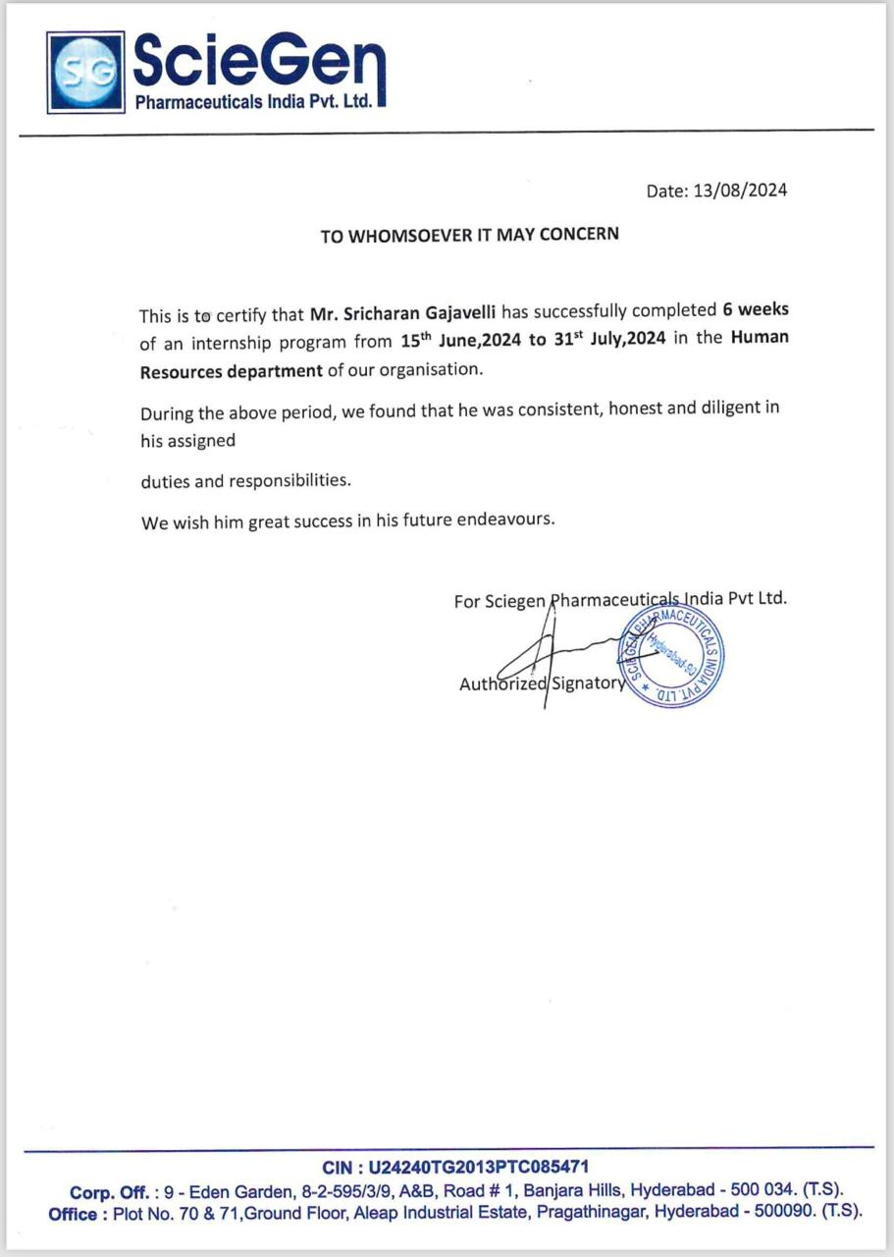

Top of Form

Bottom of Form