# Product Management Intern - Assignment

# Why I Chose This

When I first explored Flam, what stood out to me was how creatively powerful it could be — but I also imagined how intimidating it might feel for a brand-new user. Between the spatial gestures, 3D tools, and camera-based interactions, it's easy to get lost before getting excited.

And then it hit me — what if your first experience on Flam wasn’t alone?

That’s where this idea comes from: **Flam Co-Pilot** — a small but powerful shift that makes your first AR experience social, guided, and fun.

# The Problem

## First-time users drop off too early.

* AR feels new and different — which is great, *unless you’re unsure what to do*.
* Without a clear, fun way to get started, people lose interest before the magic happens.

## AR is still a mostly solo experience.

* Even on social platforms, most AR creation is single-player.
* There’s no easy way to “jam” or learn AR together with a friend — which limits creative confidence and shareability.

**The Idea: *Flam Co-Pilot***

A real-time collaborative mode where a friend, creator, or even AI assistant can guide you through your first AR creation — right inside your space.

Whether it’s placing your first object, learning a gesture, or remixing someone’s scene, you’re never figuring it out alone.

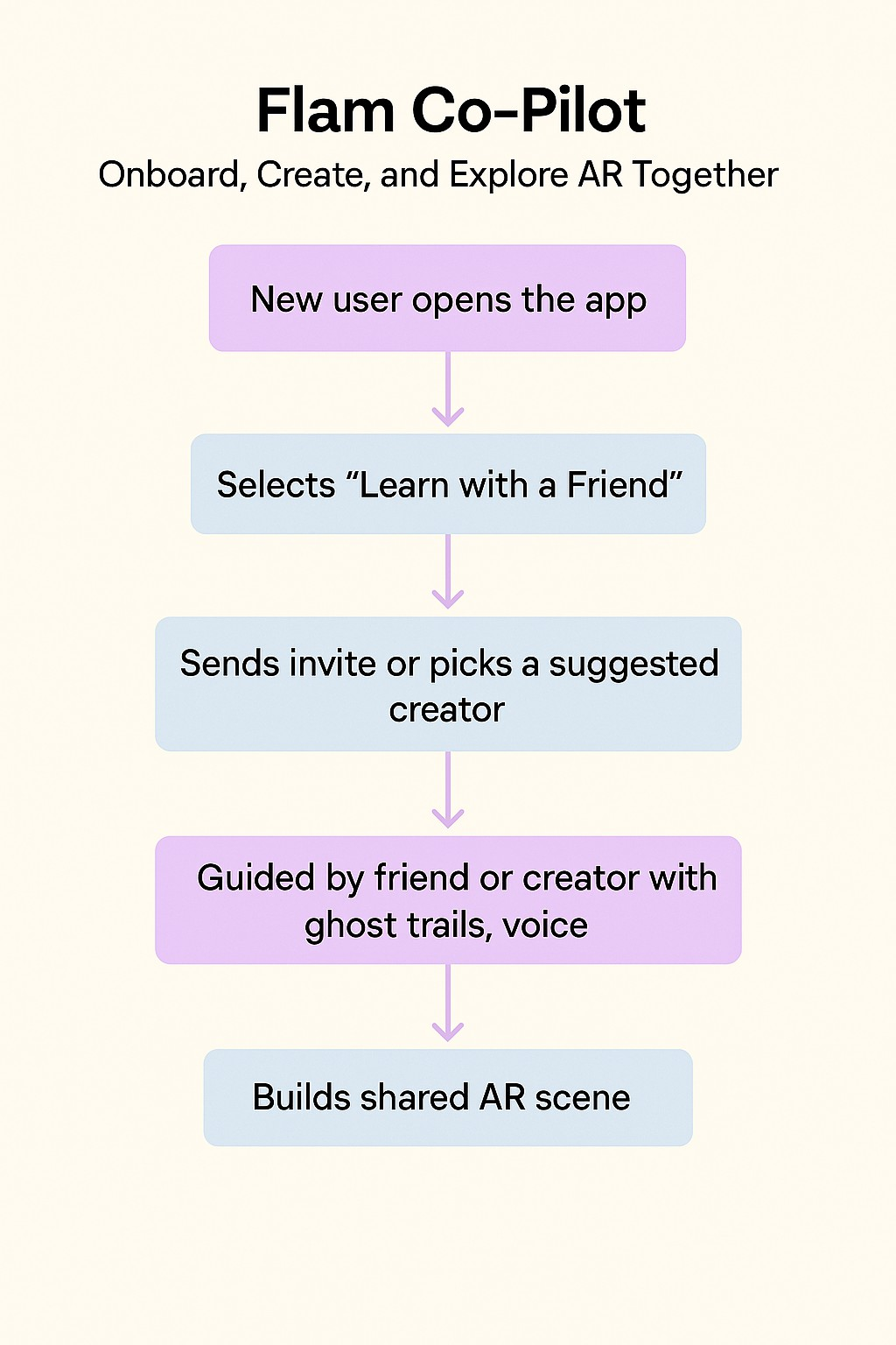

# How It Works

* **Start with a Friend:** On opening the app, new users can choose “Learn with a Friend.”
* **Invite or Match:** Invite someone you know or get matched with a verified Flam creator.
* **Live Co-Pilot Session:** The Co-Pilot joins, and you see ghost trails of their hand movements, hear them explain what to try, and build something together in real-time.
* **Replay Option:** The session is recorded so users can replay it or share it with others.
* **Bonus:** In future versions, the Co-Pilot could even be an AI creator assistant.

# Key Features

* **Ghost Trails & Tips:** See what your Co-Pilot does (object placements, swipes, gestures).
* **Dual Creation:** Both users can interact with the AR scene at once.
* **Voice & Visual Sync:** Natural voice + visual cue pairing for clear guidance.

**Replay & Remix:** Save or share the session — or build on it later.

# Why This Could Work (Realistically)

* **Faster Moments:** Instead of guessing, new users get the joy of doing something cool in the first few minutes.
* **Social Stickiness:** People are way more likely to return if they co-create something with someone.
* **Creator-Led Growth:** Flam creators can become mini-onboarders, helping scale trust and engagement.

# Success Metrics I’d Track :

|  |  |  |
| --- | --- | --- |
| **Metric** | **Why It Matters** | **Target Uplift** |
| First Session Completion | Shows onboarding clarity | +30% |
| Day 1 to Day 7 Retention | Indicates emotional hook | +20% |
| Invites Sent | Organic network effects | +15% |
| Scenes Created & Shared | Engagement + creative output | +25% |

**What It Needs (Tech Overview)**

* **Gesture Capture** – Already used in AR, just reused for ghost trails.
* **Voice + AR Sync Layer** – Like light WebRTC for spatial chat.
* **Session Logging Engine** – Tracks gestures, voice, and objects for replay.
* **Permissions + Privacy Controls** – Let users limit who can Co-Pilot.

# Imagine This...

You open Flam for the first time. You’re not greeted by a tutorial video or a wall of text. Instead, your friend shows up in your AR space.

They wave. “Try placing a portal here,” they say, as a trail appears on your floor. You follow. You build. You laugh. You get it.

That’s the kind of first session that makes people stay.

# What I’d Love to Add (If Time Permitted)

* Quick sketches/mockups (can share if you'd like)
* User research interviews with new users
* Creator feedback loop for Co-Pilot mode

**Demo UI :**

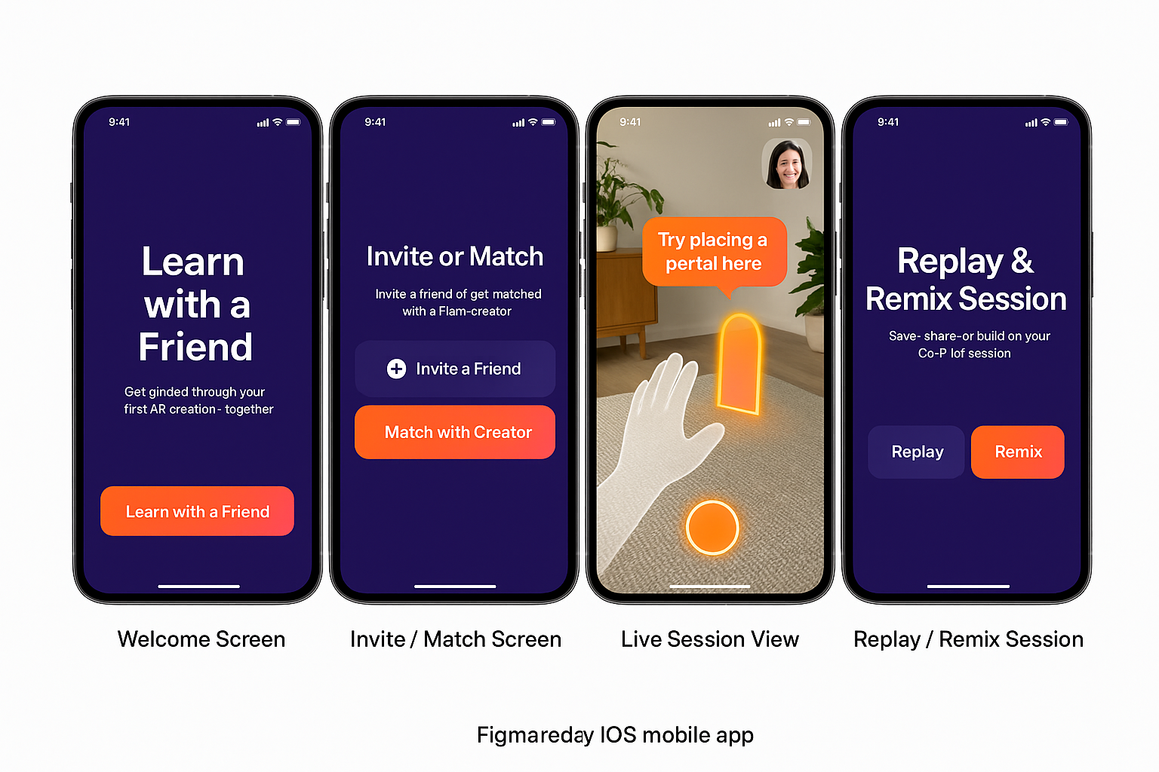

# Final Thoughts

I truly believe Flam is building something that feels like the future of social media — but more playful and meaningful. With Co-Pilot, we remove the friction that keeps people from seeing that.