K-means

**Code:**

**A<-read.csv("D:/Accelometer.csv")**

**View(A)**

**km<-kmeans(A,3)**

**> km**

**> plot(A("X","Y")], col=km$cluster)**

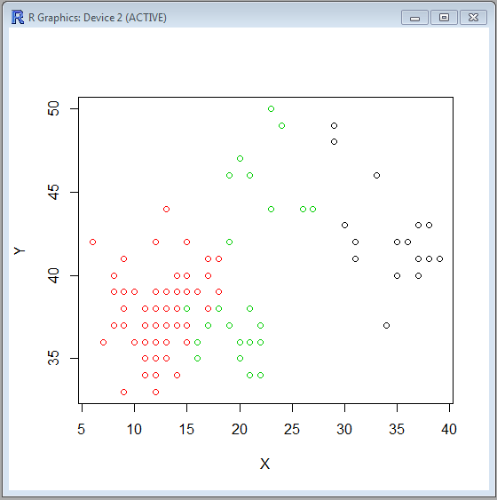

**> plot(A("X","Z")], col=km$cluster)**

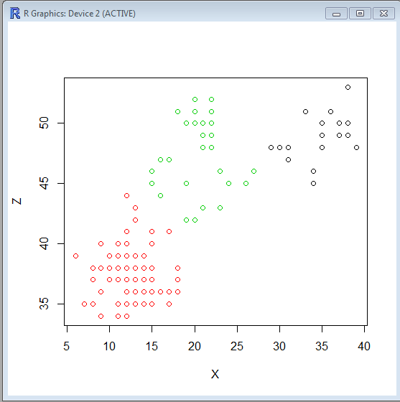

**> plot(A("X","Z")], col=km$cluster)**

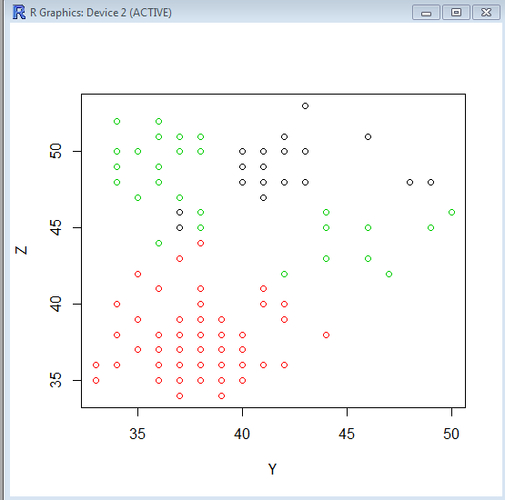

**Hierarchical Clustering**

**Code:**

**> d<-dist(as.matrix(A))**

**> hc<-hclust(d)**

**> plot(hc)**

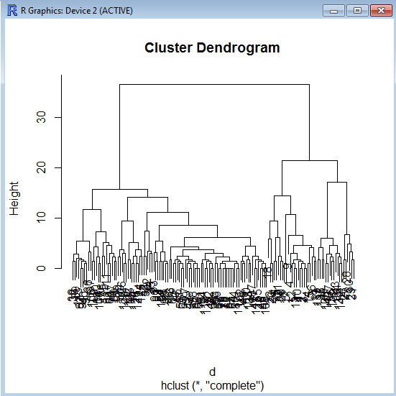

**Expected Maxmization:**

**Code:**

**> mc<-Mclust(A[,1:3],G=3)**

**> plot(mc,what=c("classification"),dimens=c(1,2,3))**

**> plot(mc,what=c("classification"),dimens=c(1,2))**

**> plot(mc,what=c("classification"),dimens=c(2,3))**

**> plot(mc,what=c("classification"),dimens=c(1,3))**

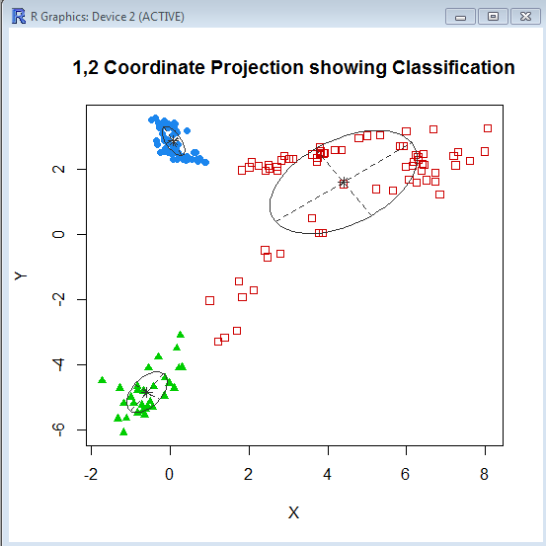

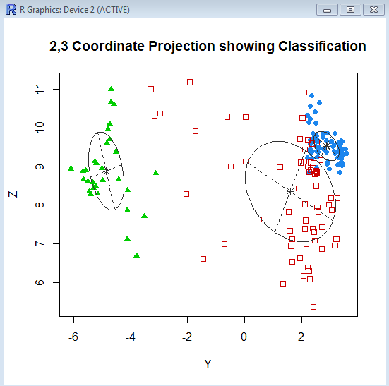

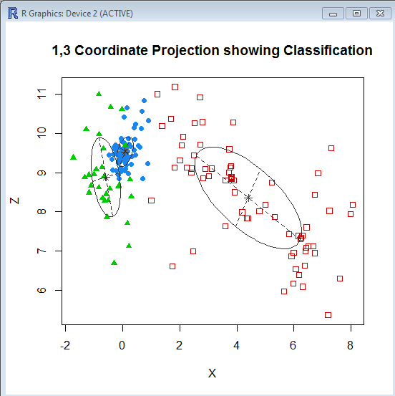

**K-Medians**

Code:

> cl1=kcca(A,k=3)

> image(cl1)

> points(A)

> barplot(cl1)

> cl2=kcca(A,k=3,family=kccaFamily("kmedians"),control=list(initcent="kmeanspp"))

> image(cl2)

> points(A)

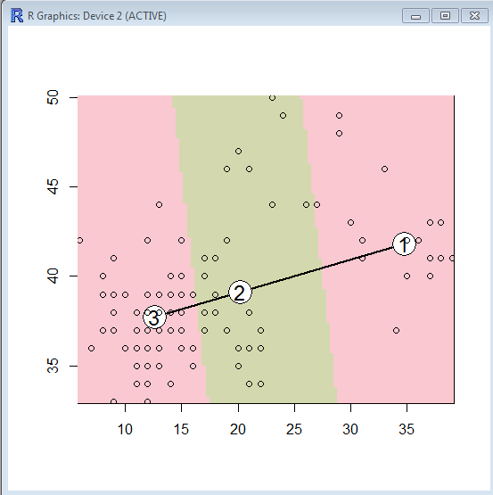

Barplot

