CS 5542 Big Data Applications and Analytics

LAB ASSIGNMENT #4

* Sricharan Pamuru(20)

2. Smartphone/Watch Application

An application was developed using the AlchemyApi and would list the basic taxonomy and image details when it is provided to the application. The uniform resource locator (URL) is used and respective information is analyzed.

The picture is provided.

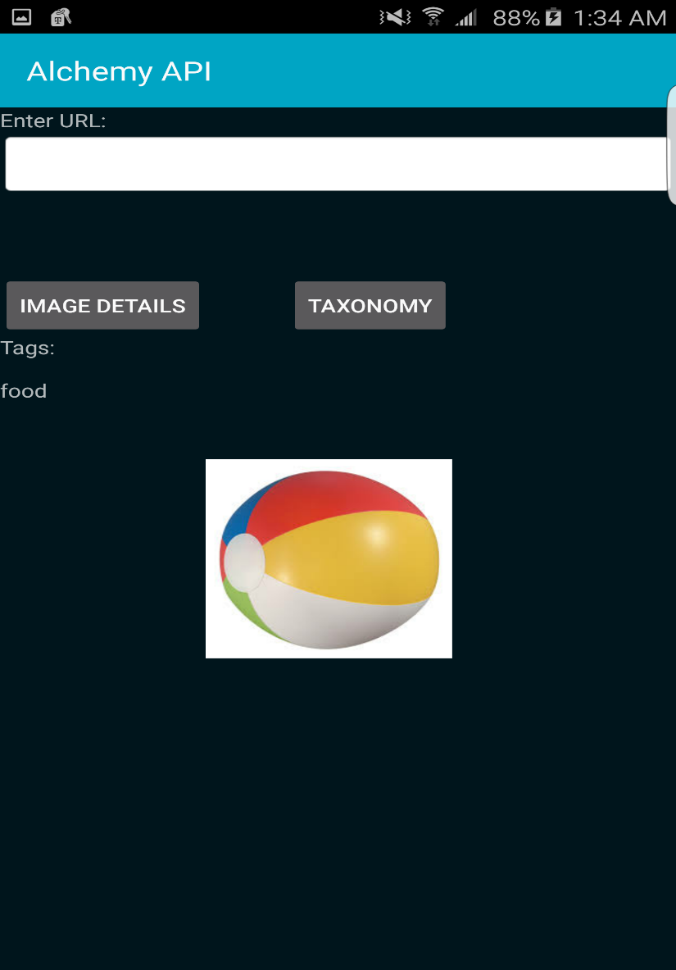

Details regarding the picture is obtained from the application.

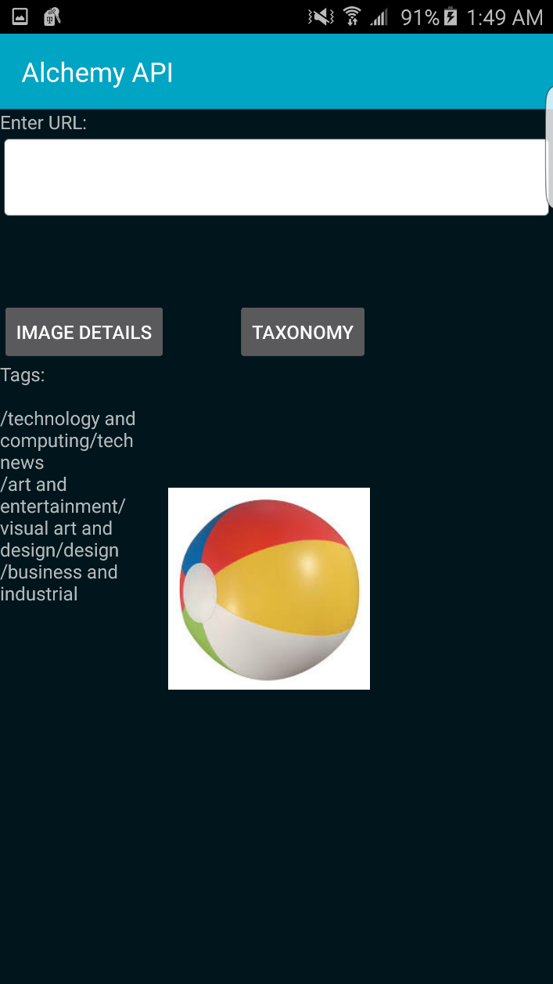

Image identification by the AlchemyApi

