CS 5542 Big Data Applications and Analytics

LAB ASSIGNMENT #4

* Sricharan Pamuru(20)

1. Hadoop MapReduce Algorithm

FileZilla is used to load both the jar file as well as input file.

C:\Users\Cheecha\Desktop\cheecha\Mutual Friends\3.PNG

C:\Users\Cheecha\Desktop\cheecha\Mutual Friends\2.PNG

Server is logged into by using Putty

The files are listed and the directory is entered into

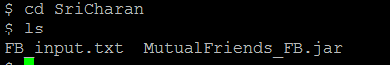

The Hadoop MapReduce program is run.

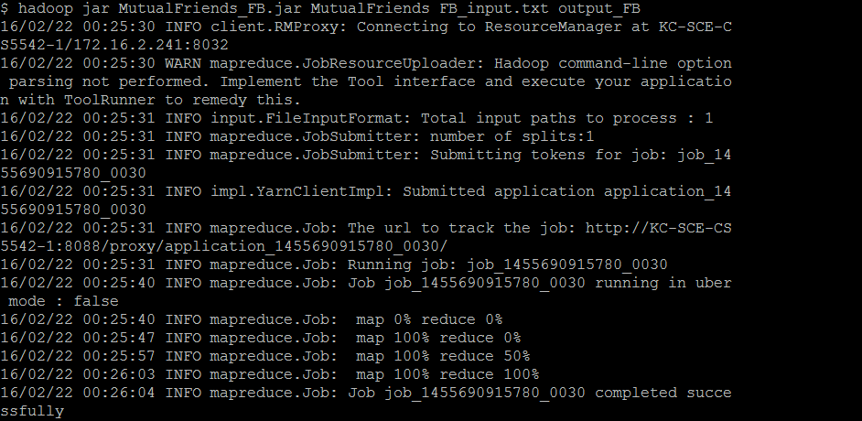

The output is shown by using the code executed.

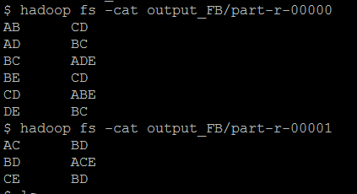

Therefore, the output of the Hadoop program is used to show mutual friends on Facebook for the given example.