## Function

Function is a self contained program for a block of code that perform some specific and well defined task. eg: printf,scanf,etc.

#### Advantages of function

Faster program Development

Reduces program complexity

Introduces “Reuseability” to blocks of code

Debugging becomes easier

#### Disadvantages of Function

The syntax must be same while declaring & calling the function, any mismatch results in complexity while Debugging. Eg:

Code:

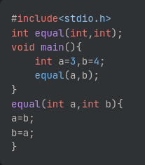

Output:

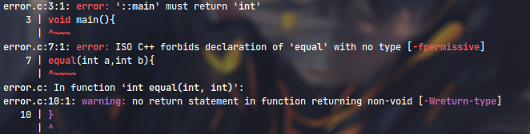

## Types of Function

## Library Function or Inbuilt Function

They are predefined function.

They can be used by including header files like stdio.h,conio.h,stdlib.h.

They are *usr/include* directory in a Linux System. Eg:

Code:

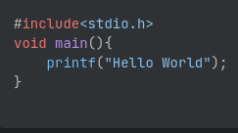

Output:

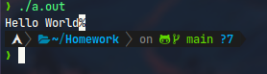

## User defined Function

It is declared,defined & used by this user.

It contains the following types of components:-

1. Declaration
2. Calling
3. Definition
4. Returning Statement

## Types of User-Defined Function

The following are the types of user defined function on the basis of “aguments” & “return types”.

Note:

The following example is used as the base for all upcomming programs; As such, each of them inspite of various diiference in systax, the output remains same.

**Example:**

**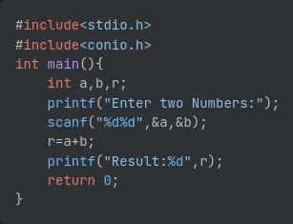**

**Output:**

**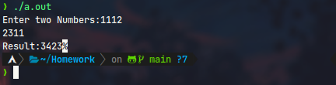**

#### Comments

Line Count(10)

A simple program to add two number and find the product.

### 1: Function with no return value and without argument

#### Screenshot 2023-01-20 at 18-35-49 Sridal_Homework Just some school work about functions in C

#### Comments

* Line Count(14)
* It is Easiest to write since systax is really similae to a code without function.
* Very similar to Example function.
* Additional definition for the function you are about to use is required.

### 2: Function with return value and without arguments

#### Screenshot 2023-01-20 at 18-36-04 Sridal_Homework Just some school work about functions in C

#### Comments

* Line Count(16)
* Harder to write since the code progresses procedurally from line 58 to 61 & 52 to 54.
* Additional definition about the function you are about to use is required.

### 3: Function without return value and with arguments

#### Screenshot 2023-01-20 at 18-36-22 Sridal_Homework Just some school work about functions in CComments

* Line Count(16)
* Easier to write than “2:”; Since, code is somewhat procedural.
* Additional definition about the function you are about to use is required along with definition for the “data types” you are about to use.

### 4: Function with return value with arguments

#### Screenshot 2023-01-20 at 18-36-40 Sridal_Homework Just some school work about functions in C

#### Comments

* Line Count(16)
* Somewhat easier to write and easier to understand as computation being separated to a different code block.
* Additional definition about the function you are about to use is required along with definition for the “data types” you are about to use.