Salesforce Day-3
Day 3 – Validation Rules, Flows & Triggers
Name: Kaligotla Sri Datta Sai Vithal
Roll No: 23PA1A4551

Objective
The objective of Day 3 was to understand Salesforce automation using Validation Rules, Record-Triggered Flows, and Apex Triggers. The main focus was learning how to choose the right automation tool based on different business requirements and implementing automation in the Placement Management System.

Topics Covered
- Validation Rules
- Flow Builder
- Record-Triggered Flow
- Before Save Flow
- After Save Flow
- Apex Trigger Basics
- Flow vs Trigger
- Order of Execution (Basics)

Concepts Learned

Validation Rule
Validation Rules are used to stop users from saving invalid data. They only validate the data and display an error message if the condition is not met.
Example: Student CGPA should be greater than or equal to the minimum CGPA required for a job.

Flow
Flow is Salesforce's declarative automation tool. It allows us to automate business processes without writing Apex code.
Some common uses are:
- Updating fields
- Creating records
- Sending emails
- Updating related records

Apex Trigger
Triggers are written using Apex and are used when business logic becomes too complex for Flow.
Triggers are useful for:
- Complex calculations
- Bulk record processing
- Advanced business logic

Business Scenario
The Placement Cell wanted to automate the application process.
Requirements:
1. Automatically fill the Application Date.
2. Send an email when a student applies.
3. Prevent duplicate applications.
4. Reject students with low CGPA.
5. Create an Offer Letter when the student is selected.

Objects Used
The following custom objects were used:
- Student
- Job
- Application
- Offer Letter

Fields Added
Student
- Student Name
- Email
- CGPA
- Department
Job
- Job Name
- Company
- Minimum CGPA
- Closing Date
Application
- Student (Lookup)
- Job (Lookup)
- Application Date
- Status
Offer Letter
- Application (Lookup)
- Offer Date
- Status

Task 1 – Before Save Record-Triggered Flow
Purpose
Automatically populate the Application Date whenever a new Application record is created.
Configuration
- Flow Type: Record-Triggered Flow
- Object: Application
- Trigger: Record Created
- Optimization: Fast Field Updates (Before Save)
Logic
Application Date = $Flow.CurrentDate
Result
Whenever a new Application record was created, Salesforce automatically filled today's date in the Application Date field.
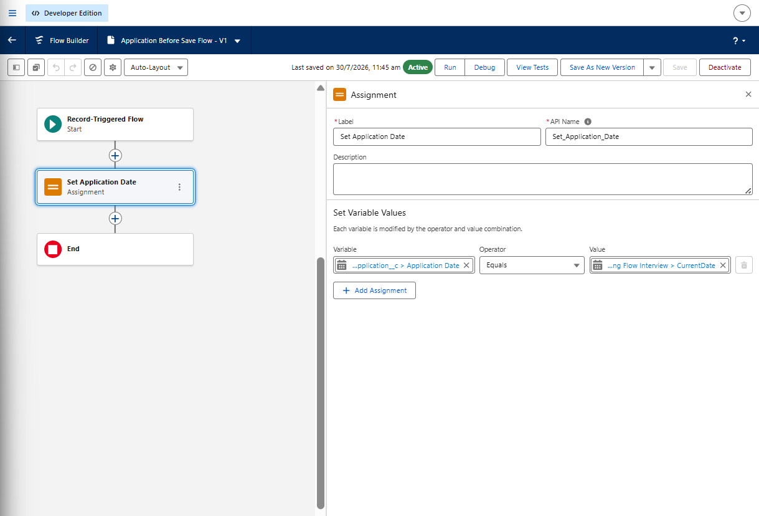
Flow Canvas — Assignment element setting Application Date
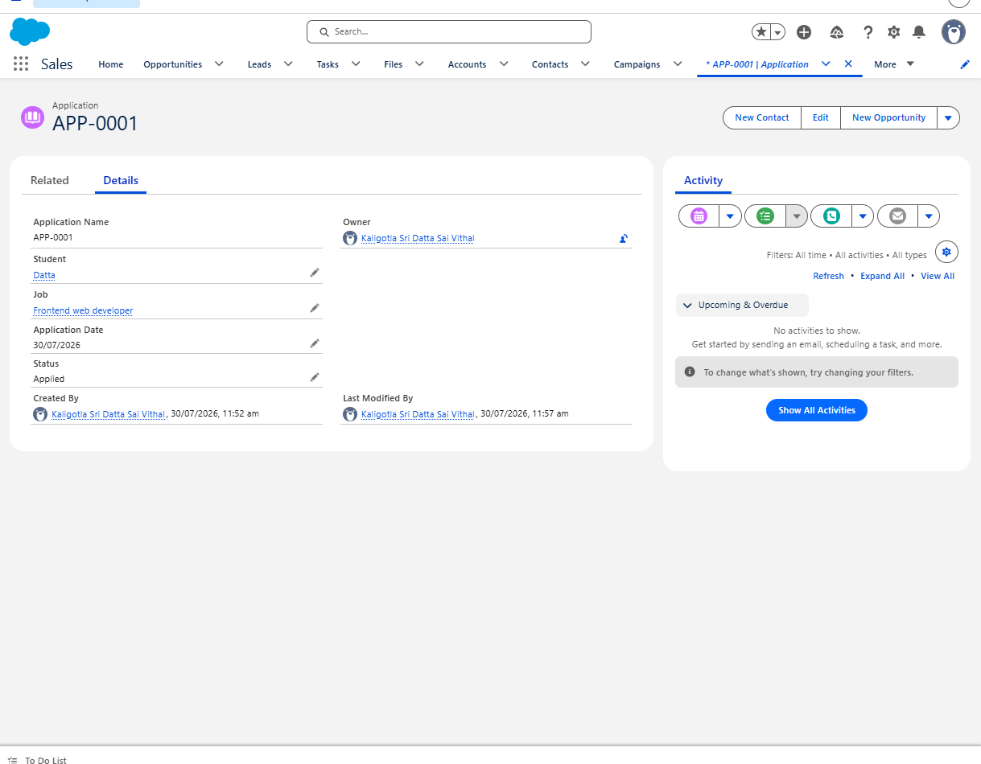
Application record showing the auto-filled Application Date

Task 2 – After Save Record-Triggered Flow
Purpose
Send an email notification whenever a new Application record is created.
Configuration
- Flow Type: Record-Triggered Flow
- Object: Application
- Trigger: Record Created
- Optimization: Actions and Related Records (After Save)
Email Details
Recipient: Placement Officer (used my email for testing)
Subject: New Application Submitted
Email Body
Hello Placement Officer,
A new application has been submitted.
Student: {!$Record.Student__r.Name}
Job: {!$Record.Job__r.Name}
Status: {!$Record.Status__c}
Please log in to Salesforce to review the application.
Regards,
Salesforce Automation
Result
Whenever a new Application record was created, an email notification was automatically sent.
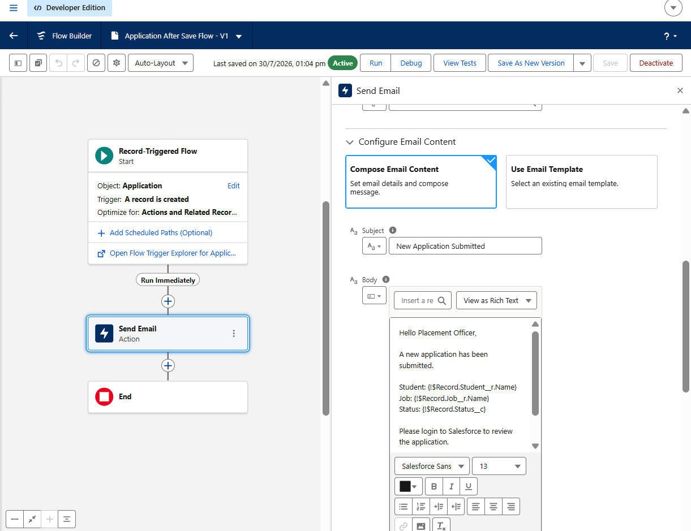
Email Action — Send Email configuration in the After Save Flow

Validation Rules Created
Created Validation Rules for:
1. Student CGPA must meet the minimum CGPA required for the Job.
2. Application Date should not be after the Job Closing Date.
3. Required fields should not be left blank.

Validation Rule Setup
Rule Name: Validate_Application_Details
Object: Job Application
Validation Formula:
OR(
Student_CGPA__c < Job_Minimum_CGPA__c,
Application_Date__c > Job_Closing_Date__c,
ISBLANK(Student_Name__c),
ISBLANK(Job__c)
)

Error Message:
Application cannot be submitted.
Please ensure:
• Student CGPA meets the minimum requirement.
• Application Date is on or before the Job Closing Date.
• All mandatory fields are filled.

Error Location:
Top of Page

Validation Error
Student Name: Rahul Sharma
Job: Software Developer Intern
Student CGPA: 6.5
Minimum CGPA Required: 7.5
Application Date: 25-Jul-2026
Job Closing Date: 20-Jul-2026
System Error Message:
Error: Application cannot be saved.

• Student CGPA must be greater than or equal to the Job's minimum CGPA.
• Application Date cannot be after the Job Closing Date.
• Please complete all mandatory fields before submitting.

Flow vs Trigger
Requirement | Tool Used | Reason
Auto-fill Application Date | Flow | Simple field update
Send Email | Flow | Built-in email action
Reject Low CGPA | Validation Rule | Prevent invalid data
Prevent Duplicate Application | Validation Rule | Stop duplicate records
Complex Business Logic | Trigger | When Flow is not enough

Testing
I tested the automation by creating new Application records.
Test 1
Created a new Application without entering the Application Date.
Result: Application Date was automatically populated.
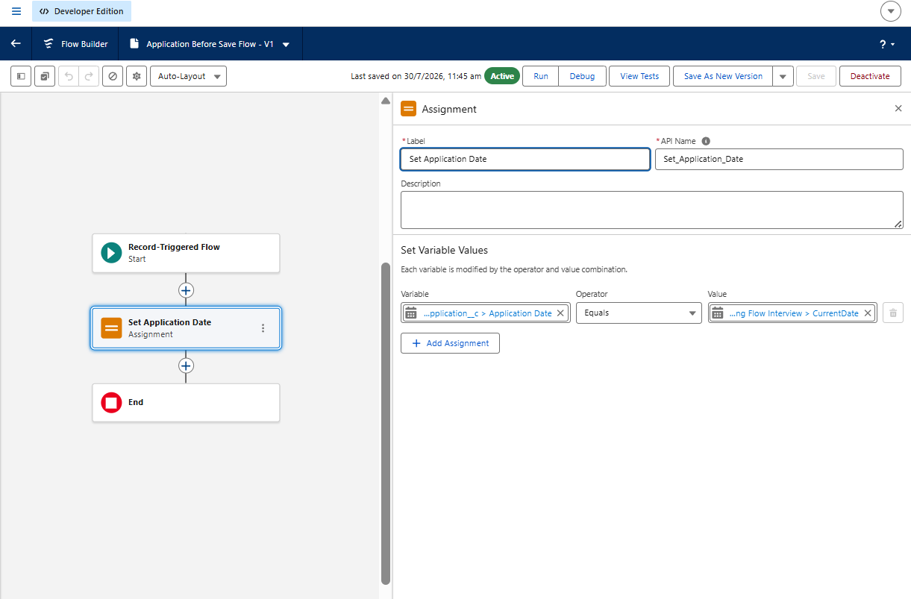
Flow active and running after Test 1
Test 2
Created another Application record.
Result: An email notification was sent automatically.

Application record confirming Test 2
Test 3
Verified that both Flows were active and executed successfully.

Send Email flow confirmed active for Test 3

Challenges Faced
- Initially tried using the Run button to test a Record-Triggered Flow.
- Learned that Record-Triggered Flows only execute when a record is created, updated, or deleted.
- Understood the difference between Before Save and After Save Flows.
- Learned how to use related record fields inside the Send Email action.

Key Learnings
- Understood when to use Validation Rules, Flows, and Triggers.
- Learned to build Record-Triggered Flows.
- Learned to use Assignment and Send Email actions.
- Understood the difference between Before Save and After Save Flows.
- Gained confidence in choosing the correct automation tool for different business requirements.

Conclusion
Day 3 helped me understand Salesforce automation in a practical way. I learned how to automate business processes using Record-Triggered Flows, validate data using Validation Rules, and identify situations where Apex Triggers are required. I also implemented automation in the Placement Management System and tested the flows successfully.

