**HARDWARE SIZING APPLICATION**

# Scenario:

The IT department for the Areteans is tired of sizing hardware requirements for the numerous PRPC applications the business wishes to implement.

# Requirements:

They have decided to build an application that will:

* Allow users to enter basic information about the application they wish to build
* Use a rules engine to determine the most appropriate hardware
* Allow users to decide if they wish to purchase the hardware
* Send the order to the fulfillment team if the user decides to purchase the hardware.
* Manage the Risk Mitigation process While the initial implementation will be for the IT Department, it is envisioned that this application will be used within other departments after the initial deployment, with minor specialization

## Actors:

* Initiator – Initiates the original hardware request. They will be responsible for entering basic inputs related to the application they wish to build.
* IT Specialist – Manages the rules that determine the hardware and also manually selects hardware that cannot automatically be determined by the rules engine.
* Fulfillment User – Member of the Fulfillment team who processes the requests from a workbasket.
* RMP – To handle risk mitigation process.
* IT Manager – Can update the Risk Mitigation rules, and runs reports.
* Application Structure: Framework
* Organization: ARETEANS
* Division: IT
* Unit: Unit
* Application Name: Hardware Sizing

## Work Class:

ARET ARET-FW

ARET-FW-HARDWARE

ARET-FW-HARDWARE-WORK

ARET-FW-HARDWARE-WORK-HARDWAREREQUIREMENT ARET-FW-HARDWARE-WORK-RISKMITIGATION

## Data Class:

ARET

ARET-FW-HARDWARE

ARET-FW-HARDWARE-DATA

ARET-FW-HARDWARE-DATA-APPLICATIONDETAILS ARET-FW-HARDWARE-DATA-INVOICEMASTER ARET-FW-HARDWARE-DATA-KEYFEATURES

ARET-FW-HARDWARE-DATA-SCORE MASTER

## Workgroups:

## Risk Mitigation

Fulfillment Team

**Operators**

Initiator@hardware

ITSpecialist@HW RMP1@HW

RMP2@HW

ITManagers@HW

FTManagerHW

FTMember1@HW

**Access Groups:**

Hardware:Authors

Hardware:Initiators

Hardware:Specialist

Hardware:RMP

Hardware:Fulfillment

## Case Life Cycle Design:

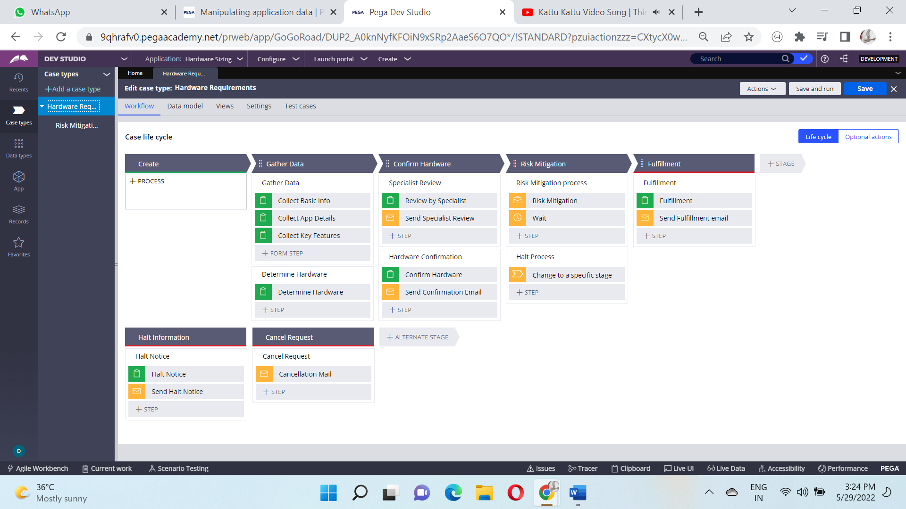**Hardware Requirement:**

## Risk Mitigation Process:

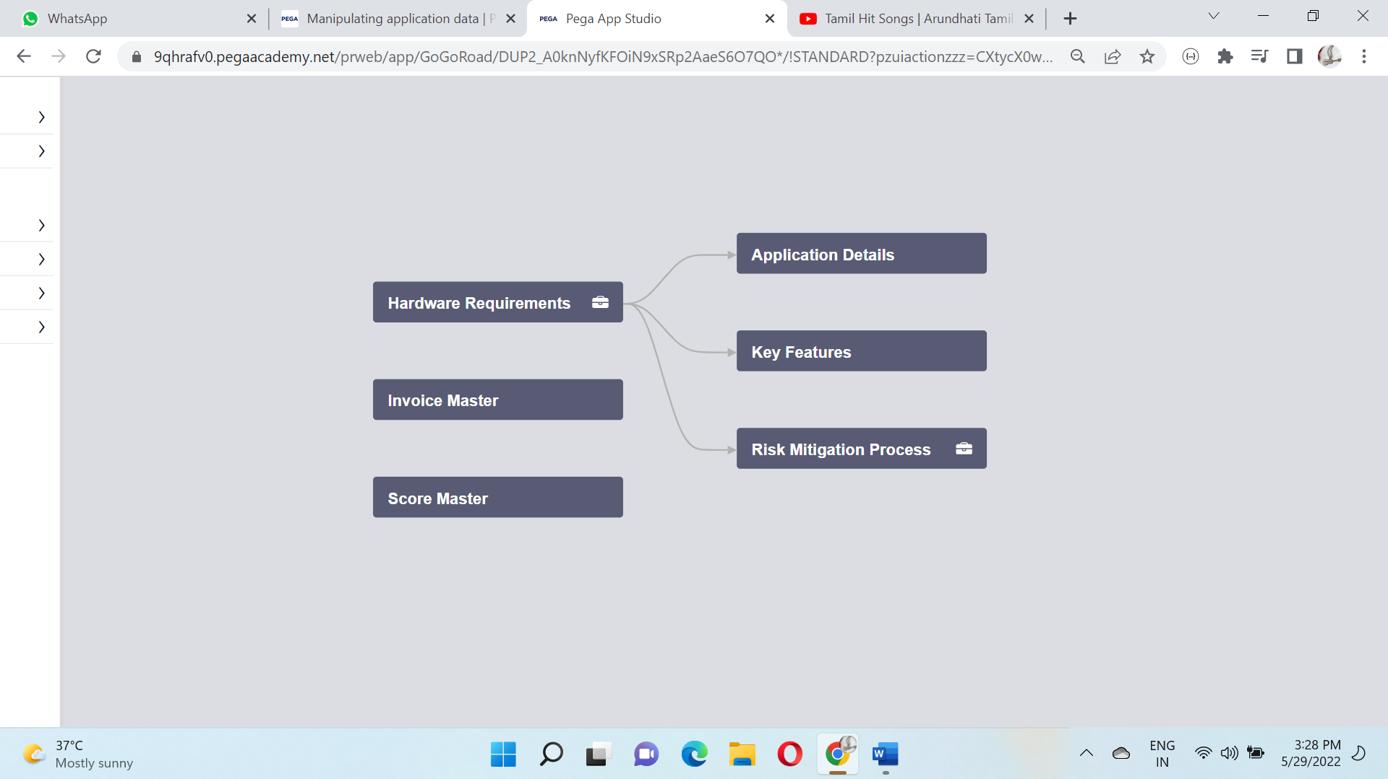**Data Model Design:**

## Process design:

**Gather Data:**

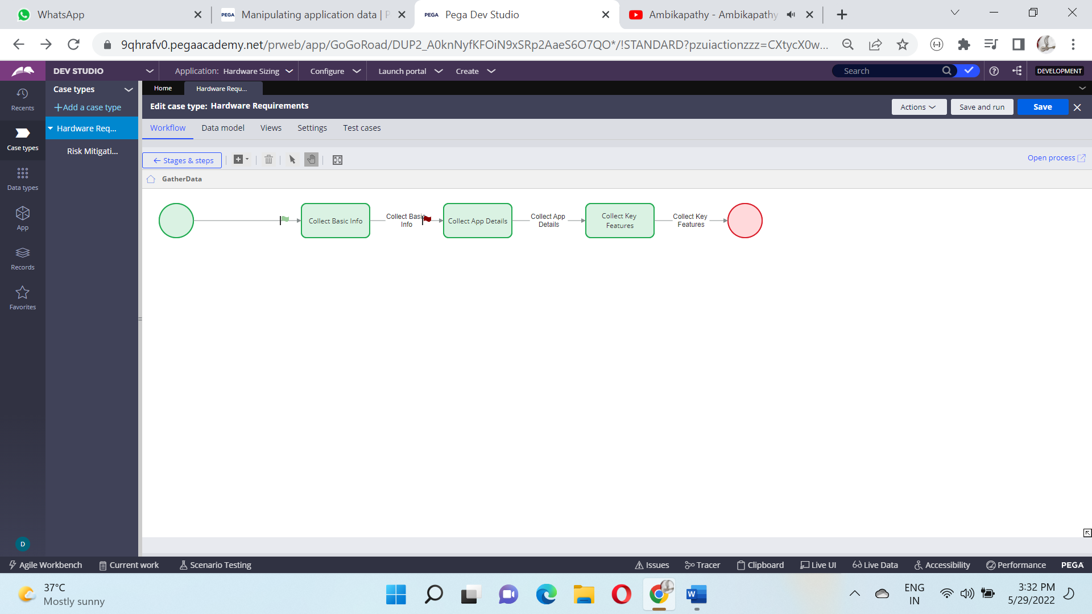

## Determine Hardware:

## 

## Specialist Confirmation:

## 

**Confirm Hardware:**

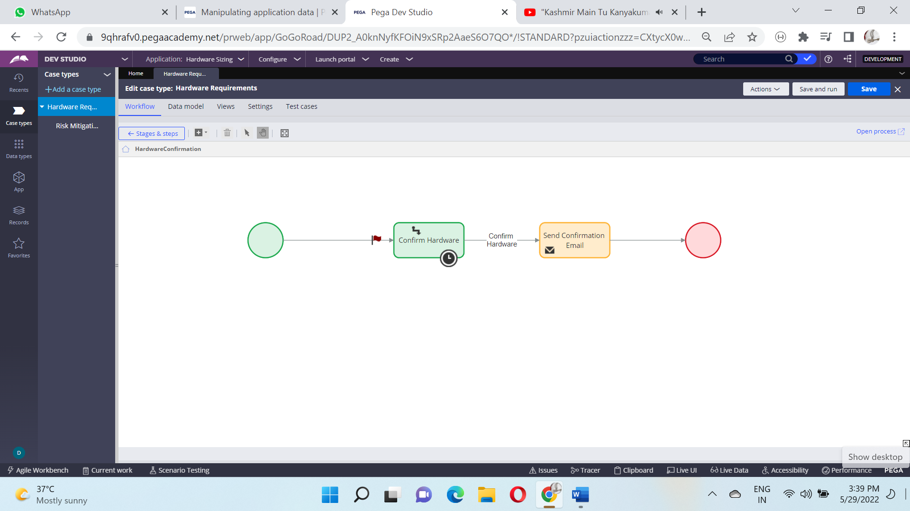

## Risk Mitigation:

**Fulfillment:**

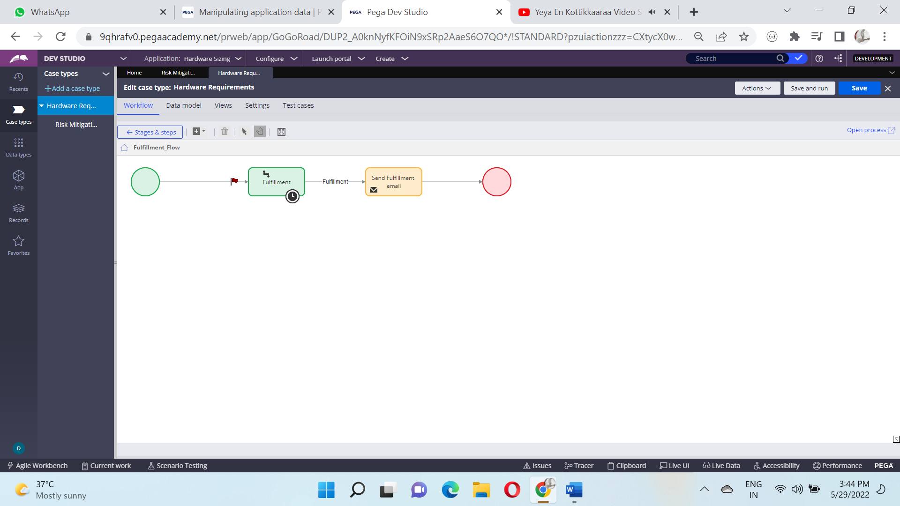

## Reports:

Hardware Fulfillment Fulfillment Request Range

**Portals:**

Initiator Managers ITManagers

## Initiator Portal:

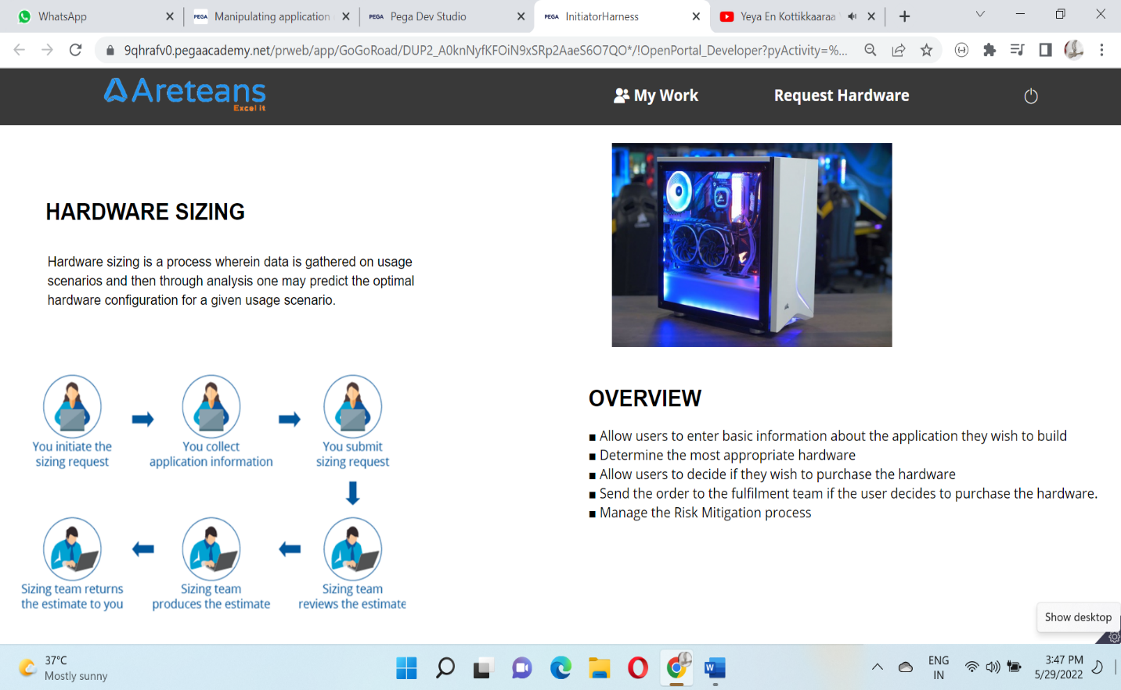

**Managers:**

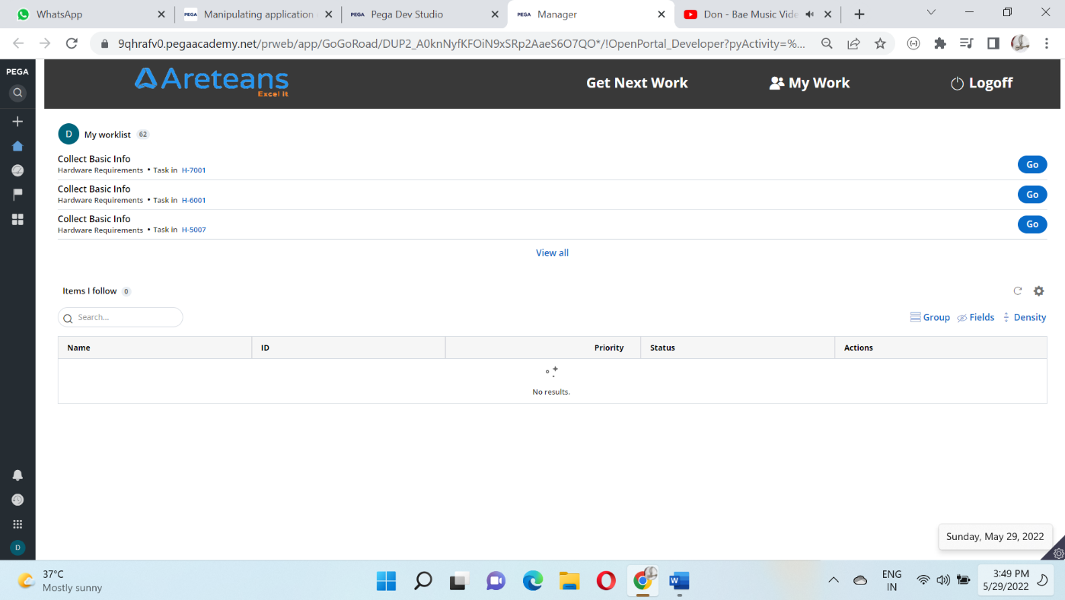

## ITManagers:

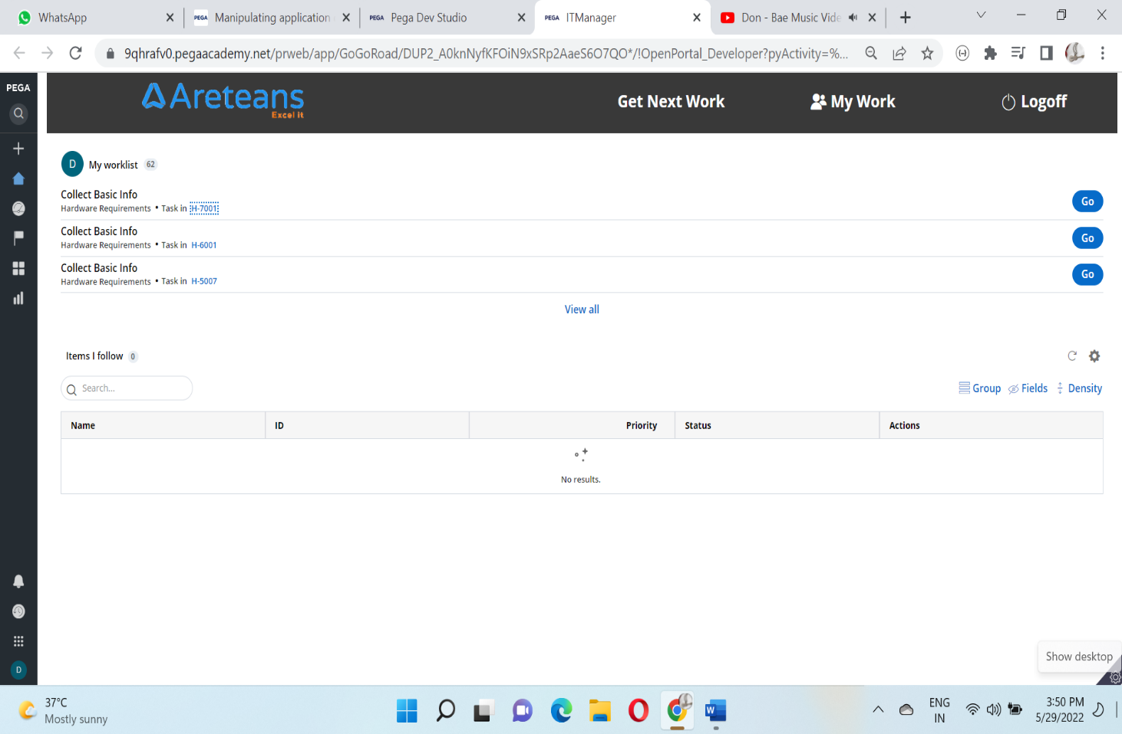

**Personas and Channels:**

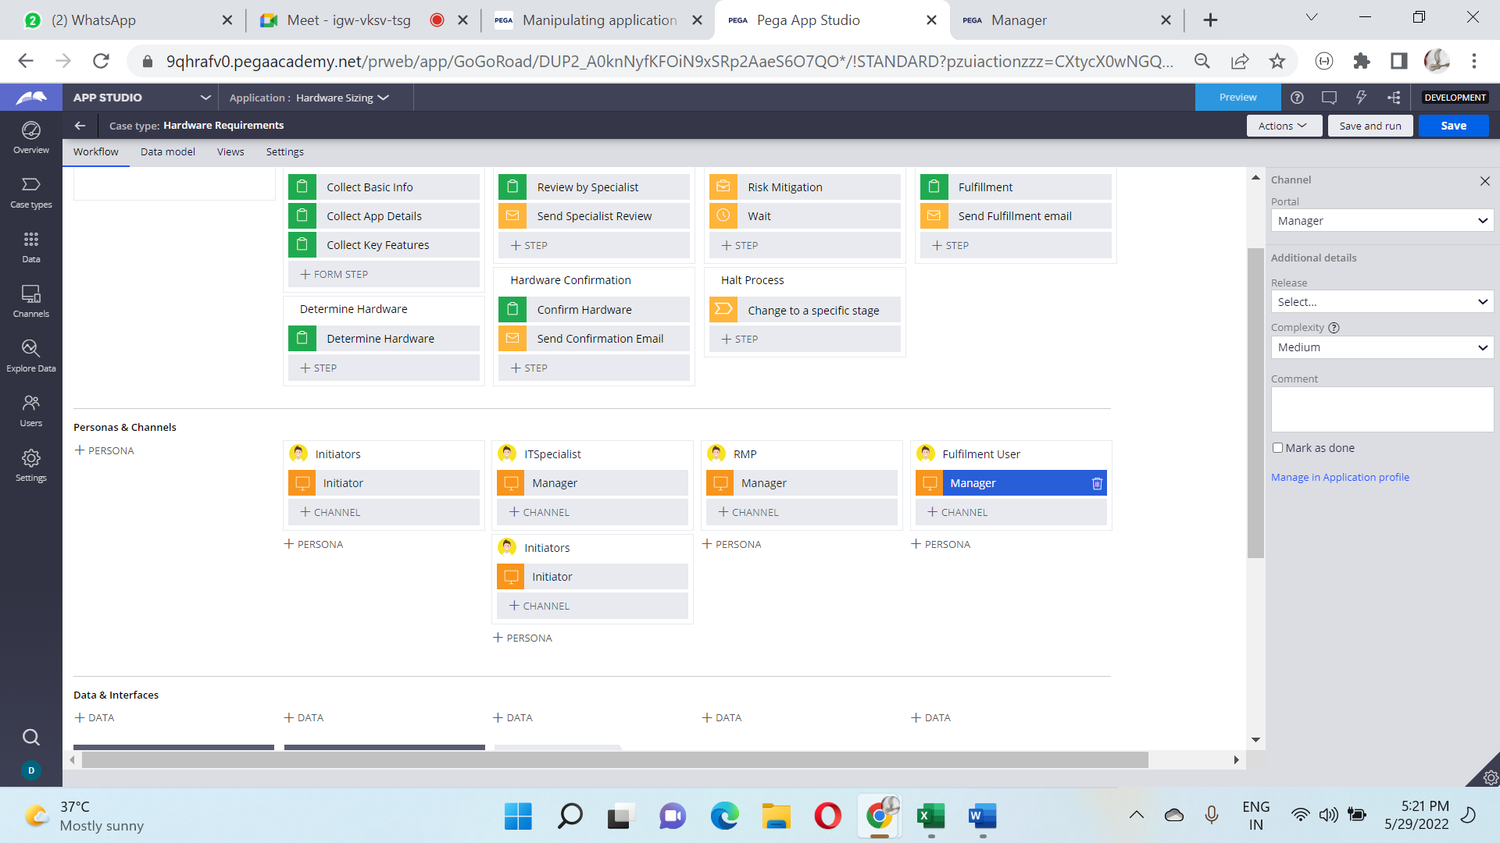

## Data and Interfaces:

