**Conclusion about crowdfunding:**

a)

We can see from above Category stats that Theatre has most successful and failed outcome compared to other categories.

b)

From above Launch date outcome chart, we can see that maximum successful outcome was in the month of June and July.

c)

From Goal Outcome chart, we can see that there is 100% success which falls in the goal range of 15000 to 19999, 20000 to 24999 and 30000 to 34999.

2. Few **limitations of dataset** is we could have given more info about factors behind successful outcome, age group and other factors that affect success.

3.We can calculate mean, median and standard deviation and can plot histogram chart to evaluate successful and unsuccessful campaign.

**Bonus Statistical Analysis:**

1. For the number of backers of successful and unsuccessful campaigns the Median summarizes the data more meaningfully because from below histogram we can see that data is not distributed normally.
2. Variability in Histogram is higher in Successful campaigns because the taller bar in Successful campaign Histogram is more spread out away from the mean.

|  |  |
| --- | --- |
| Successful _Campaign | |
| Mean | 851.1469 |
| Median | 201 |
| Minimum | 16 |
| Maximum | 7295 |
| Variance | 1606217 |
| Standard Deviation | 1267.366 |

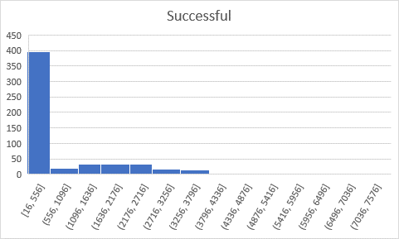

|  |  |
| --- | --- |
| Unsuccessful Campaign | |
| Mean | 585.6154 |
| Median | 114.5 |
| Minimum | 0 |
| Maximum | 6080 |
| Variance | 924113.5 |
| Standard Deviation | 961.3082 |

