

Final Project Report
Online Learning Engagement and Student Performance Analysis
Date | 21-sep-2026
Team ID | MCA(Master of Computer Application)
Project Name | Online Learning Engagement and Student Performance Analysis
Maximum Marks | 4 Marks

1. Introduction
1.1. Project Overview
This project analyzes student engagement and academic performance on an online learning platform. It combines SQL-based exploratory analysis with an interactive Power BI dashboard to help instructors and coordinators identify at-risk students early, understand the factors driving dropout, and make data-driven decisions to improve retention and outcomes.
1.2. Objectives
- Evaluate overall student engagement and academic performance using a consolidated set of KPIs.
- Identify the key factors that contribute to student dropout and course completion.
- Compare performance and engagement trends across region, gender, prior education, and risk level.
- Build an interactive Power BI dashboard and report that stakeholders can explore without needing to write SQL.

2. Project Initialization and Planning Phase
2.1. Define Problem Statement
The Customer Problem Statement framework (I am / I’m trying to / But / Because / Which makes me feel) was used to frame the problem from two stakeholder perspectives:
PS | I am (Customer) | I’m trying to | But | Because | Which makes me feel
PS-1 | An academic administrator overseeing an online learning program | understand which students are actively engaged and performing well versus those at risk of failing or dropping out | there is no consolidated, real-time view of student engagement (clicks) and performance (scores) across the platform | the data is scattered across spreadsheets and not visualized in a way that highlights patterns or flags at-risk students | overwhelmed and reactive, unable to intervene until it is too late
PS-2 | a program coordinator responsible for reducing student dropout rates | identify which factors most affect student dropout and pass rates | I cannot easily compare performance and engagement trends across student segments (region, gender, education level, risk level) | there is no interactive dashboard, only raw data that requires manual filtering and analysis to interpret | frustrated and limited in my ability to make timely, data-driven decisions to support students

2.2. Project Proposal (Proposed Solution)
Objective
To build an interactive Power BI dashboard, backed by SQL-based analysis, that consolidates student engagement and performance data so instructors and coordinators can identify at-risk students early and make data-driven decisions.
Scope
Covers data collection and cleaning, SQL-based exploratory data analysis, Power BI data modeling and DAX measure creation, KPI and chart visualizations, an interactive multi-page dashboard with slicers, and a final report with insights. Does not cover building a new learning platform, real-time data streaming, or predictive modeling.
Approach
Use SQL to explore and aggregate the raw dataset (total students, pass/dropout counts, engagement/performance/risk-level breakdowns, click-band and regional analysis). Load the cleaned dataset into Power BI, build DAX measures for core KPIs, and design an interactive dashboard combining KPI cards, bar/line/donut/pie charts, and an AI-powered decomposition tree.
Key Features
- Six interactive slicers (Gender, Engagement Level, Region, Performance Level, Risk Level, Final Result) for real-time cross-filtering.
- An AI-powered decomposition tree for root-cause drill-down into dropout factors.
- A single consolidated KPI view across the whole student population.
- A documented, reusable SQL + Power BI workflow.
Resource Requirements
Resource Type | Details
Hardware | Standard laptop/desktop, Intel i5 or higher (no GPU required); 8 GB RAM minimum (16 GB recommended); 5 GB free disk space.
Software | Power BI Desktop (data modeling and visualization); DAX and Power Query M language; MySQL Workbench; Git/GitHub for version control.
Data | online_education_dataset.csv — approx. 32,593 student records with demographic, engagement, and performance fields.

2.3. Initial Project Planning
The work was organized into 4 sprints covering 8 functional requirements (epics) and 16 user stories:
Sprint | Functional Requirement (Epic) | User Stories | Story Points
Sprint-1 | Problem Understanding & Data Collection | 2 | 5
Sprint-1 | Database Setup & SQL Analysis | 3 | 6
Sprint-2 | Power BI Data Preparation | 2 | 4
Sprint-2 | Data Visualization | 2 | 6
Sprint-3 | Dashboard Development | 2 | 5
Sprint-3 | Report Development | 1 | 2
Sprint-4 | Performance Testing & Optimization | 2 | 2
Sprint-4 | Project Documentation & Demonstration | 2 | 3

3. Data Collection and Preprocessing Phase
3.1. Data Collection Plan and Raw Data Sources Identified
Student engagement and performance data was sourced from the online learning platform's exported records, covering demographics, activity (clicks), academic scores, and outcome flags for each student. The primary raw data source is a single consolidated student dataset (online_education_dataset), loaded both as a CSV file for Power BI and into a MySQL table for SQL-based exploratory analysis.
Source Name | Description | Format | Size | Access
online_education_dataset | Student-level dataset (~32,593 records) with demographics, engagement, performance, and outcome fields (pass flag, dropout flag, final result). | CSV | ~5 MB | Project dataset

3.2. Data Quality Report
Profiling the raw dataset surfaced the following issues, which were resolved before the data was used for analysis:
Data Quality Issue | Severity | Resolution Plan
avg_score missing for 5,866 of 32,593 rows (~18%), mostly Withdrawn/Fail students. | High | Excluded blanks from AVG()/AVERAGE() aggregations rather than imputing a score.
total_clicks, engagement_level, risk_level missing for the same 2,852 rows, correlated with Withdrawn/Fail outcomes. | High | Treated missing clicks as “no recorded engagement” (0); labeled missing categories as “Unknown.”
performance_level missing for 5,898 rows (~18%). | Moderate | Recalculated where possible from avg_score; remaining nulls labeled “Unknown.”
imd_band missing for 1,111 rows (~3.4%). | Low | Replaced blanks with an explicit “Not Provided” category.
1,356 fully duplicate rows found in the raw dataset. | Moderate | Removed via Power Query “Remove Duplicates” / SQL SELECT DISTINCT.
3,808 student IDs appear in more than one row. | Moderate | Confirmed as separate course attempts; retained and documented.
risk_level uses inconsistent labels (“Low Risk” and “Safe” both appear). | Low | Standardized via Power Query Replace Values (“Safe” → “Low Risk”).
avg_score initially detected as Text in Power BI, breaking the AVERAGE() measure. | High | Explicitly set column type to Decimal Number in Power Query before creating measures.

3.3. Data Exploration and Preprocessing
- Data Cleaning: removed 1,356 duplicate rows; standardized inconsistent risk_level labels; labeled missing categorical values as “Unknown” or “Not Provided” instead of deleting rows.
- Data Transformation: filtered and sorted in Power Query; added a calculated click-band column (0–500, 500–1000, 1000–2000, 2000–3000, 3000+) mirroring the SQL CASE-based banding.
- Data Type Conversion: fixed avg_score (Text → Decimal Number); confirmed total_clicks, pass_flag, dropout_flag, id_student as numeric types.
- Data Modeling: single flat table (online_education_dataset), so no cross-table relationships were required; 5 DAX measures created directly on this table.
- Save Processed Data: transformations persisted in the Power BI data model (dataset.pbix) via “Close & Apply”; cleaned table also loaded into MySQL (online_education_db) for SQL reuse.

4. Data Visualization
4.1. Framing Business Questions
- What is the overall pass rate and dropout rate among students?
- How does student engagement level relate to average academic score?
- Which regions have the highest number of students and the highest average score?
- What proportion of students fall into each dropout risk level?
- How does platform engagement (total clicks) relate to average score across click ranges?
- What is the distribution of final outcomes (Pass, Fail, Withdrawn, Distinction)?
- Which factors contribute most to student dropout?
- How does average score vary by students' highest prior education level?
- How do dropout rates differ between male and female students?
4.2. Developing Visualizations
A total of 9 unique visualization types were created in Power BI to explore the business questions above and were combined across an interactive dashboard and two report pages:
- 5 KPI cards — Total Students, Dropout Rate, Average Score, Average Clicks, Pass Rate.

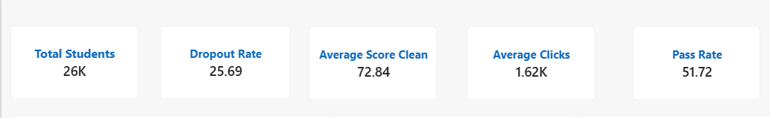

- Horizontal bar charts — comparing metrics across region, education level, and gender.
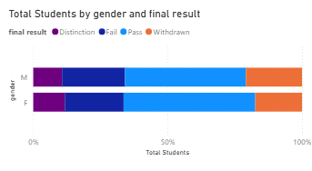

- A line chart — tracking average score across engagement (click-band) ranges.
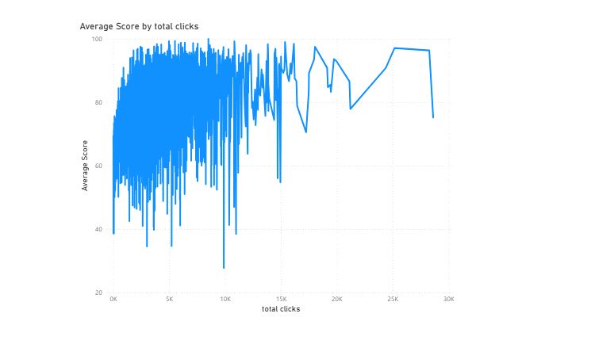

- A pie chart — showing the breakdown of final result categories.
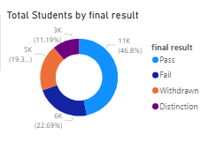

- An AI-powered Decomposition Tree — for root-cause drill-down into dropout factors

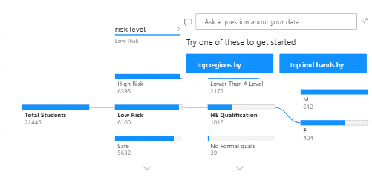.

5. Dashboard
5.1. Dashboard Design Screenshot with Insights
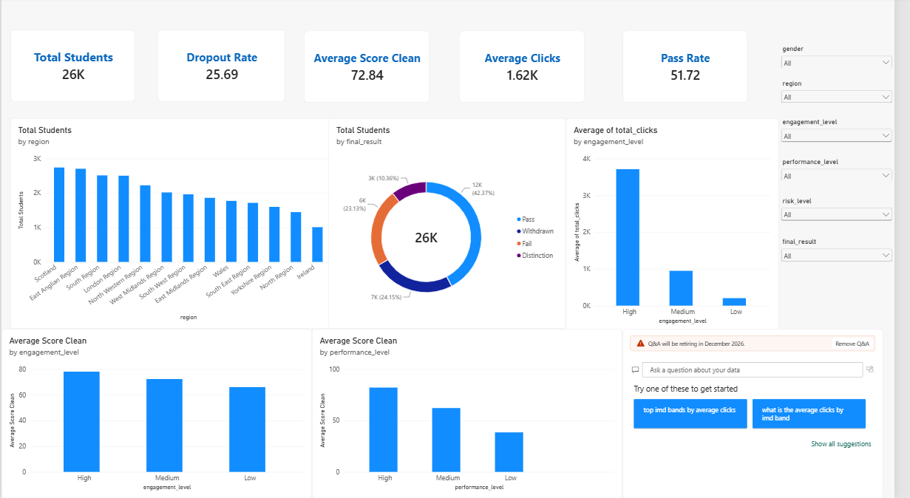

Key outcomes from the dashboard:
- Total Student Enrollment: the dataset covers 28,785 unique students (32,593 total enrollment records), reflecting the scale of activity captured on the platform.
- Dropout and Pass Rates: overall, 31.16% of students dropped out, while 47.20% passed the course, highlighting a substantial at-risk population that needs earlier intervention.
- Engagement Drives Performance: students with High engagement scored an average of 78.10, versus just 66.05 for Low-engagement students — a gap of more than 12 points.
- Engagement Reduces Dropout: dropout rate falls sharply as engagement rises — 43.61% for Low-engagement students compared with only 11.90% for High-engagement students.
- Risk Level Spread: students are spread almost evenly across risk bands, with Very High Risk students making up 25.04% of the population.

6. Report
6.1. Report Design Screenshot with Insights
Report Page 1:

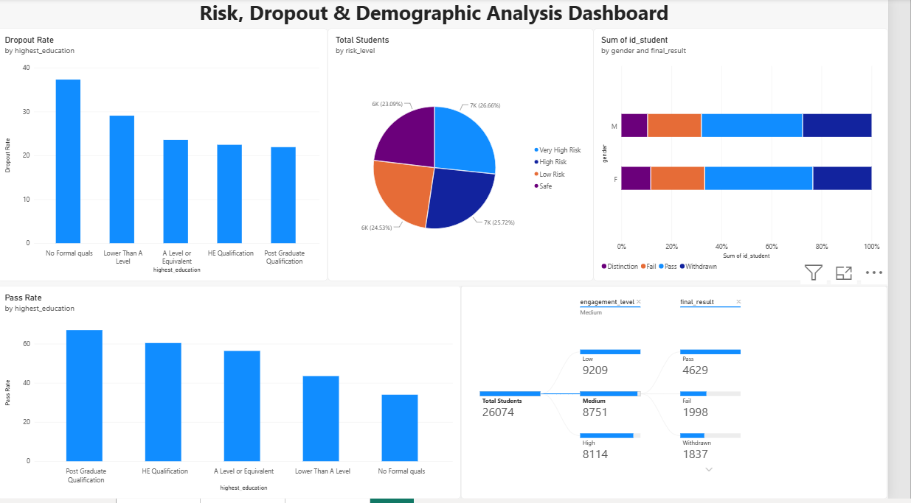

- Gender Distribution: the platform has more male students enrolled (17,875) compared to female students (14,718).
- Engagement vs. Score Trend: as total clicks rise from the 0–500 band to the 3000+ band, average score climbs steadily from 66.20 to 80.17.
- Regional Disparities: the North Western Region has the highest dropout rate (35.58%), followed by West Midlands (35.36%) and East Midlands (34.76%).
- Prior Education and Dropout: dropout rate falls sharply as performance level rises (42.46% for Low performers vs. 15.48% for High); students with a Post Graduate Qualification average 81.94 in score vs. 66.10 for those with no formal qualifications.

Report Page 2: Factors Affecting Dropout (Decomposition Tree)

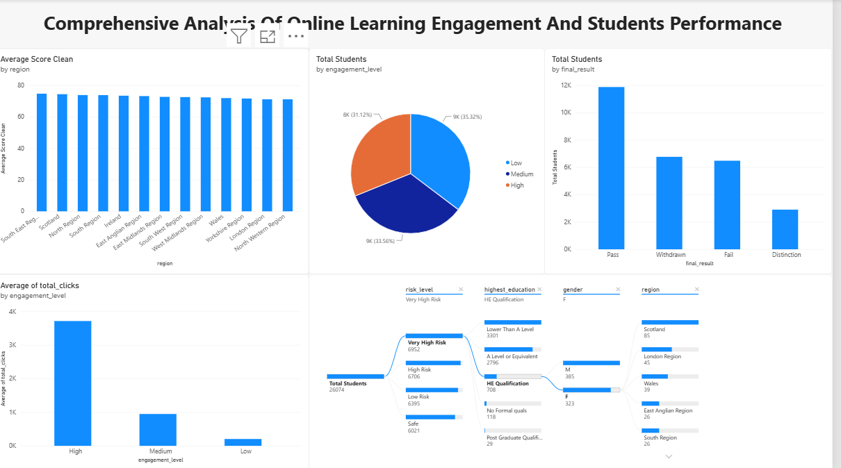

- Root Cause — Engagement Level: of 10,156 total dropouts, 4,328 (42.6%) come from Low-engagement students — the single strongest driver of dropout.
- Secondary Split — Risk Level: within the Low-engagement branch, 3,591 of 4,328 dropouts (83%) are classified as Very High Risk.
- Regional Overlay: within this Low-engagement, Very-High-Risk segment, London, East Anglian, and North Western regions show the largest concentrations.

7. Performance Testing
7.1. Utilization of Data Filters
Six interactive slicers let users dynamically filter every KPI and visual on the dashboard:
- Gender
- Engagement Level
- Region
- Performance Level
- Risk Level
- Final Result
7.2. No. of Calculation Columns/Measures
5 DAX measures were created on the online_education_dataset table:
- Total Students = DISTINCTCOUNT('online_education_dataset'[id_student])
- Dropout Rate = DIVIDE(CALCULATE(COUNTROWS(...), dropout_flag = 1), [Total Students]) * 100
- Average Score = AVERAGE('online_education_dataset'[avg_score])
- Average Clicks = AVERAGE('online_education_dataset'[total_clicks])
- Pass Rate = DIVIDE(CALCULATE(COUNTROWS(...), pass_flag = 1), [Total Students]) * 100
Plus 1 calculated column (click_band) added during Power Query transformation — 6 calculation items in total.
7.3. No. of Visualizations
9 distinct visualization types were built across the dashboard and report pages: 5 KPI cards, 1 horizontal bar chart type (reused across 3 comparisons), 1 line chart, 1 donut chart, 1 pie chart, and 1 AI-powered decomposition tree.
8. Conclusion / Observation
The analysis confirms a consistent, compounding relationship between platform engagement, academic performance, and dropout: students with higher engagement (measured by total clicks) achieve meaningfully higher average scores and are far less likely to drop out. Risk level and region further refine this picture, with specific regions and Very-High-Risk students accounting for a disproportionate share of dropouts. The interactive Power BI dashboard makes these patterns visible in real time, replacing manual, one-off SQL queries with a self-service tool that instructors and coordinators can use to identify at-risk students early and prioritize intervention.
9. Future Scope
- Connect the dashboard to a live LMS data feed for real-time (rather than periodic) updates.
- Add a predictive model to generate an early-warning dropout risk score for each student, beyond the current descriptive risk_level field.
- Automate alerts to instructors when a student's engagement or score crosses a risk threshold.
- Extend the analysis across multiple academic years to study longer-term trends and cohort effects.
- Publish the report to Power BI Service with row-level security so each region's coordinators see only their own students.
10. Appendix
10.1. Source Code
SQL exploratory analysis queries are provided in ameesha.sql, covering total students, average score/clicks, pass and dropout analysis, engagement/performance/risk-level breakdowns, click-band analysis, dropout analysis by engagement and performance level, regional analysis, and educational background analysis.
create database online_education_db;
use online_education_db;
-- Total Number of Students
SELECT COUNT(DISTINCT id_student) AS total_students FROM online_education_dataset;
-- Average Student Score
SELECT ROUND(AVG(avg_score), 2) AS average_student_score FROM online_education_dataset;
-- Average Total Clicks
SELECT ROUND(AVG(total_clicks), 2) AS average_total_clicks FROM online_education_dataset;
-- Pass and Dropout Analysis
SELECT SUM(CASE WHEN pass_flag = 1 THEN 1 ELSE 0 END) AS students_passed, SUM(CASE WHEN dropout_flag = 1 THEN 1 ELSE 0 END) AS students_dropped_out FROM online_education_dataset;
-- Engagement Level Analysis
SELECT engagement_level, COUNT(DISTINCT id_student) AS total_students FROM online_education_dataset GROUP BY engagement_level ORDER BY total_students DESC;
-- Performance Level Analysis
SELECT performance_level, COUNT(DISTINCT id_student) AS total_students, ROUND(AVG(avg_score), 2) AS average_score FROM online_education_dataset GROUP BY performance_level ORDER BY average_score DESC;
-- Risk Level Analysis
SELECT risk_level, COUNT(DISTINCT id_student) AS total_students FROM online_education_dataset GROUP BY risk_level ORDER BY total_students DESC;
-- Engagement vs. Performance
SELECT engagement_level, ROUND(AVG(avg_score), 2) AS average_score, COUNT(DISTINCT id_student) AS total_students FROM online_education_dataset GROUP BY engagement_level ORDER BY average_score DESC;
-- Total Clicks vs. Average Score
SELECT CASE WHEN total_clicks < 500 THEN '0 - 500' WHEN total_clicks < 1000 THEN '500 - 1000' WHEN total_clicks < 2000 THEN '1000 - 2000' WHEN total_clicks < 3000 THEN '2000 - 3000' ELSE '3000+' END AS click_band, COUNT(DISTINCT id_student) AS total_students, ROUND(AVG(avg_score), 2) AS average_score FROM online_education_dataset GROUP BY click_band ORDER BY average_score DESC;
-- Dropout Analysis by Engagement Level
SELECT
engagement_level,
COUNT(DISTINCT id_student) AS total_students,
SUM(CASE WHEN dropout_flag = 1 THEN 1 ELSE 0 END) AS dropout_students,
ROUND(
100.0 * SUM(CASE WHEN dropout_flag = 1 THEN 1 ELSE 0 END)
/ COUNT(*),
2
) AS dropout_rate
FROM online_education_dataset
GROUP BY engagement_level
ORDER BY dropout_rate DESC;
SELECT
engagement_level,
COUNT(DISTINCT id_student) AS total_students,
SUM(CASE WHEN dropout_flag = 1 THEN 1 ELSE 0 END) AS dropout_students,
ROUND(
100.0 * SUM(CASE WHEN dropout_flag = 1 THEN 1 ELSE 0 END)
/ COUNT(*),
2
) AS dropout_rate
FROM online_education_dataset
GROUP BY engagement_level
ORDER BY dropout_rate DESC;
SELECT
engagement_level,
COUNT(DISTINCT id_student) AS total_students,
SUM(CASE WHEN dropout_flag = 1 THEN 1 ELSE 0 END) AS dropout_students,
ROUND(
100.0 * SUM(CASE WHEN dropout_flag = 1 THEN 1 ELSE 0 END)
/ COUNT(*),
2
) AS dropout_rate
FROM online_education_dataset
GROUP BY engagement_level
ORDER BY dropout_rate DESC;
-- performance vs dropout
SELECT
performance_level,
COUNT(DISTINCT id_student) AS total_students,
SUM(CASE WHEN dropout_flag = 1 THEN 1 ELSE 0 END) AS dropout_students,
ROUND(
100.0 * SUM(CASE WHEN dropout_flag = 1 THEN 1 ELSE 0 END) / COUNT(*),
2
) AS dropout_rate
FROM online_education_dataset
GROUP BY performance_level
ORDER BY dropout_rate DESC;
-- Regional Analysis
SELECT
region,
COUNT(DISTINCT id_student) AS total_students,
ROUND(AVG(avg_score), 2) AS average_score,
ROUND(AVG(total_clicks), 2) AS average_clicks
FROM online_education_dataset
GROUP BY region
ORDER BY total_students DESC;
-- educational background analysis
SELECT
highest_education,
COUNT(DISTINCT id_student) AS total_students,
ROUND(AVG(avg_score), 2) AS average_score,
ROUND(AVG(total_clicks), 2) AS average_clicks
FROM online_education_dataset
GROUP BY highest_education
ORDER BY average_score DESC;
10.2. GitHub & Project Demo Link
GitHub repository:
https://github.com/SrideviTammsetty/Comprehensive-analysis-of-online-learning-students-performance

Project demo / walkthrough:
https://drive.google.com/file/d/1Ryrj1s7xSDj8trDQgCqOJq5HT1FV5e2R/view?usp=drive_link

