Dashboard Design

Date | 21-sep-2026
Team ID | MCA(Master of Computer Application)
Project Name | Online Learning Engagement and Student Performance Analysis
Maximum Marks | 4 Marks

Creating an effective dashboard involves thoughtful design to ensure that the presented information is clear, relevant, and easily understandable for the intended audience. Here are some key principles and best practices for dashboard design
Activity 1: Interactive and visually appealing dashboards
Creating interactive and visually appealing dashboards involves a combination of thoughtful design, effective use of visual elements, and the incorporation of interactive features. Here are some tips to help you design dashboards that are both visually appealing and engaging for users so take care of below points
- Clear and Intuitive Layout — KPI cards (Total Students, Dropout Rate, Average Score, Average Clicks, Pass Rate) sit at the top of the page, with supporting charts and the decomposition tree below, guiding the eye from headline metrics to detailed analysis.
- Use Appropriate Visualizations — bar charts compare metrics across region and education level, a donut/pie chart shows proportional breakdowns of risk level and final result, a line chart tracks score trends across click bands, and a decomposition tree supports root-cause drill-down into dropout.
- Colour and Theming — a consistent palette distinguishes positive outcomes (Pass, Low Risk) from negative ones (Dropout, High Risk), against a neutral background that keeps the KPI cards and chart data the visual focus.
- Interactive Filters and Slicers — six slicers (Gender, Engagement Level, Region, Performance Level, Risk Level, Final Result) let users cross-filter every KPI and chart on the page in real time.
- Drill-Down Capabilities — the AI-powered decomposition tree lets users expand Dropout Rate by engagement level, performance level, and region to explore root causes interactively.
- Responsive Design — visuals and cards are sized and aligned in a grid layout that remains readable across different screen sizes when the report is viewed in Power BI Service.
- Custom Visuals and Icons — the decomposition tree is used as an AI-powered custom visual, and KPI cards use concise labels to keep the header row scannable at a glance.
- Use of Infographics — KPI cards act as at-a-glance infographic elements, condensing Total Students, Dropout Rate, Average Score, Average Clicks, and Pass Rate into single-number visuals.

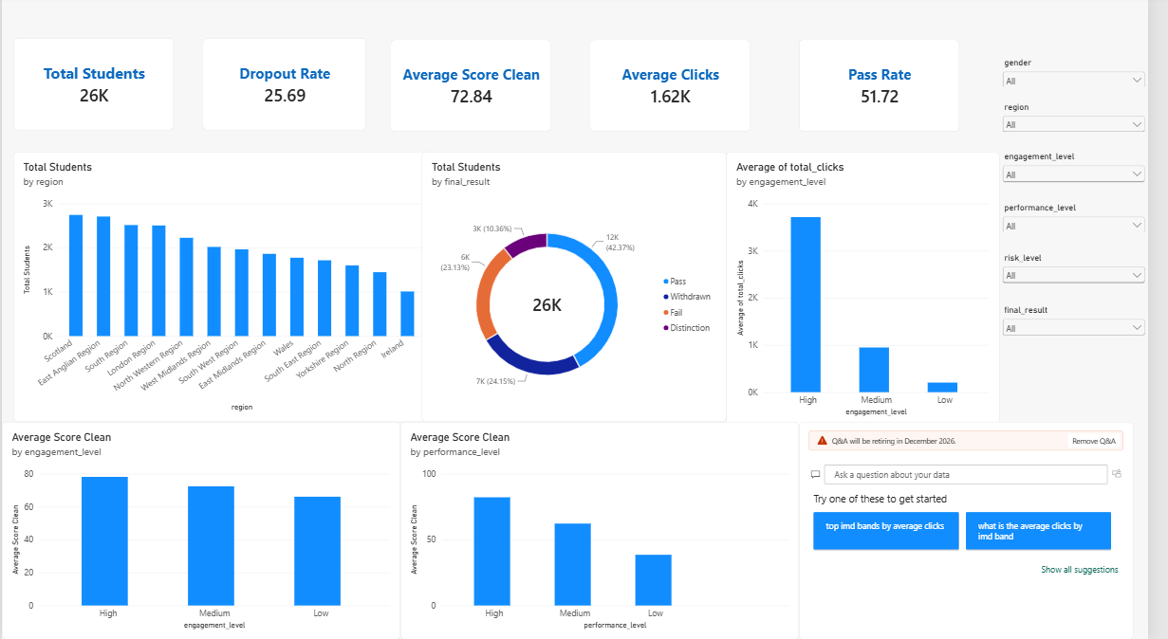

Here are five key outcomes derived from the Online Learning Engagement and Student Performance Analysis dashboard:
- Total Student Enrollment: The dataset covers 28,785 unique students (32,593 total enrollment records), reflecting the scale of activity captured on the platform.
- Dropout and Pass Rates: Overall, 31.16% of students dropped out, while 47.20% passed the course, highlighting a substantial at-risk population that needs earlier intervention.
- Engagement Drives Performance: Students with High engagement scored an average of 78.10, versus just 66.05 for Low-engagement students — a gap of more than 12 points on average score.
- Engagement Reduces Dropout: Dropout rate falls sharply as engagement rises — 43.61% for Low-engagement students compared with only 11.90% for High-engagement students.
- Risk Level Spread: Students are spread almost evenly across risk bands, with Very High Risk students making up 25.04% of the population — underscoring the need for proactive, dashboard-driven intervention.

