SRIDHAR S

23ISR055

LangGraphChatbotwithLangfuseMonitoring

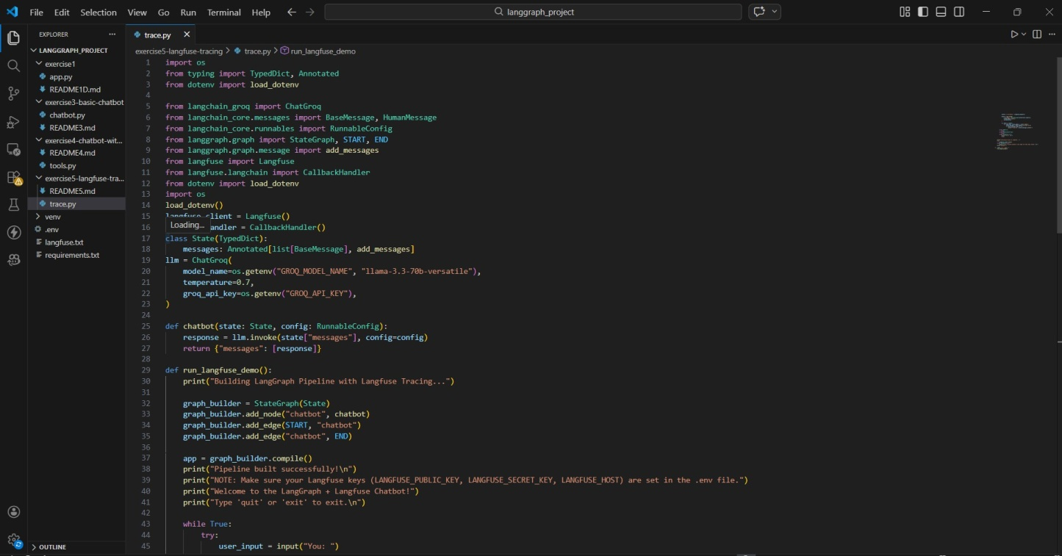
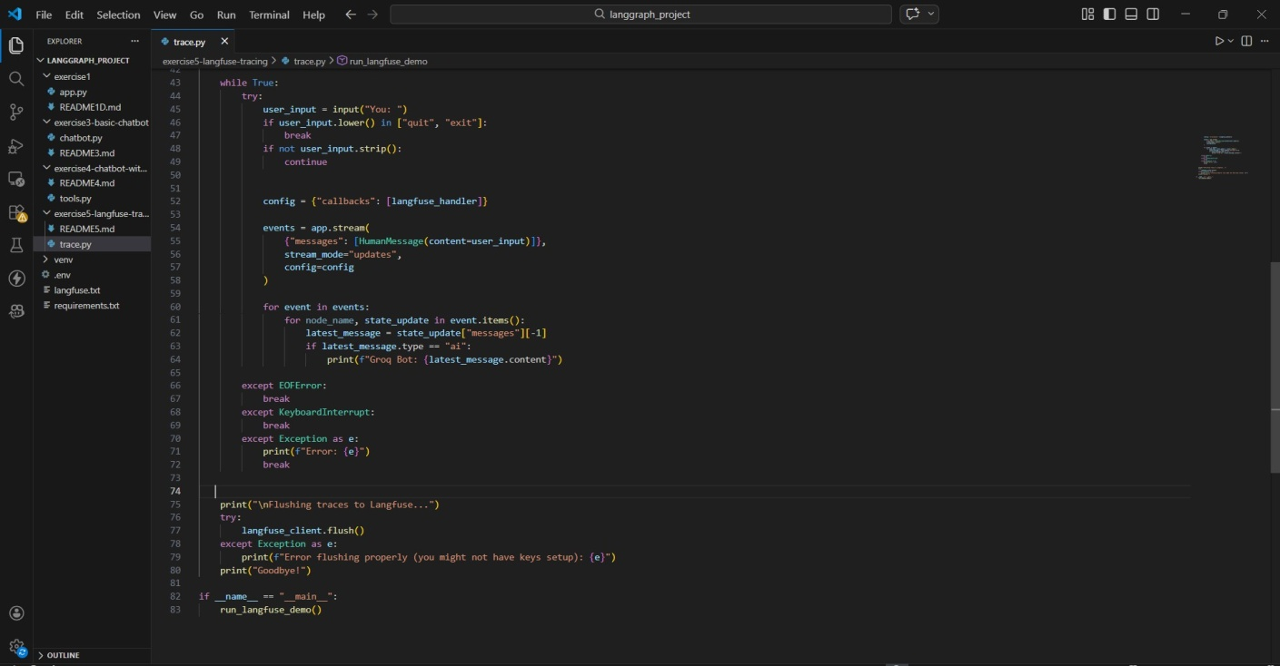

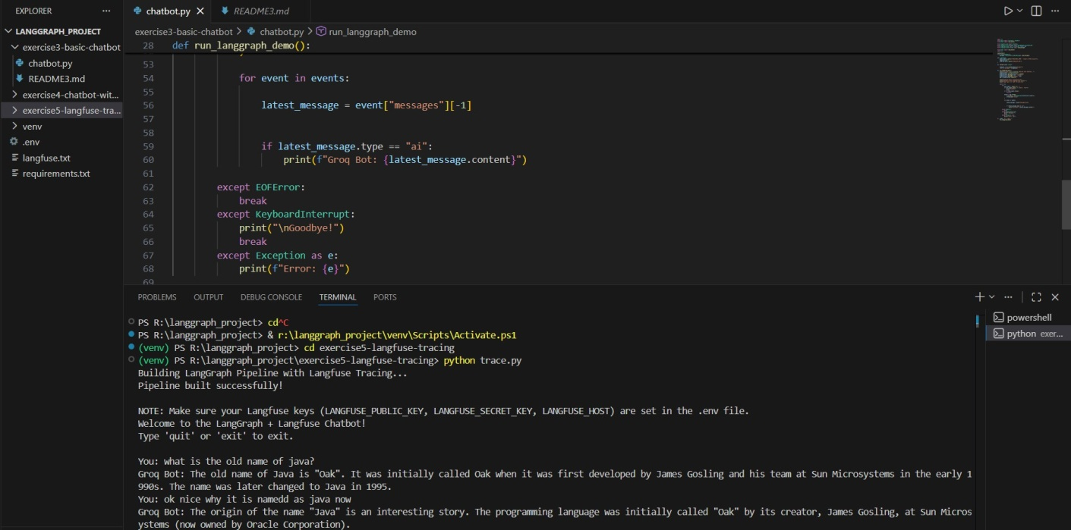

LangfuseOrganizationDashboard
Thisscreenshowsthecreatedorganizationandprojectusedformonitoringthechatbot.
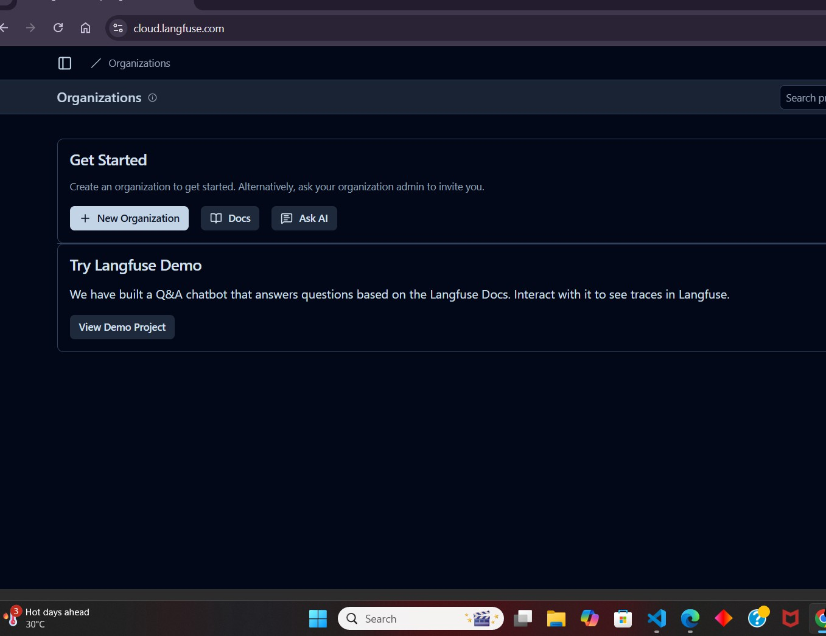

LangfuseProjectDashboard
Theprojectdashboardshowsinformationabouttraces,modelcost,andtokenusage. Key observations:
- Totaltracestracked:3
- Modelused:llama-3.3-70b-versatile
- Tokenusagerecorded
- Costmonitoringavailable
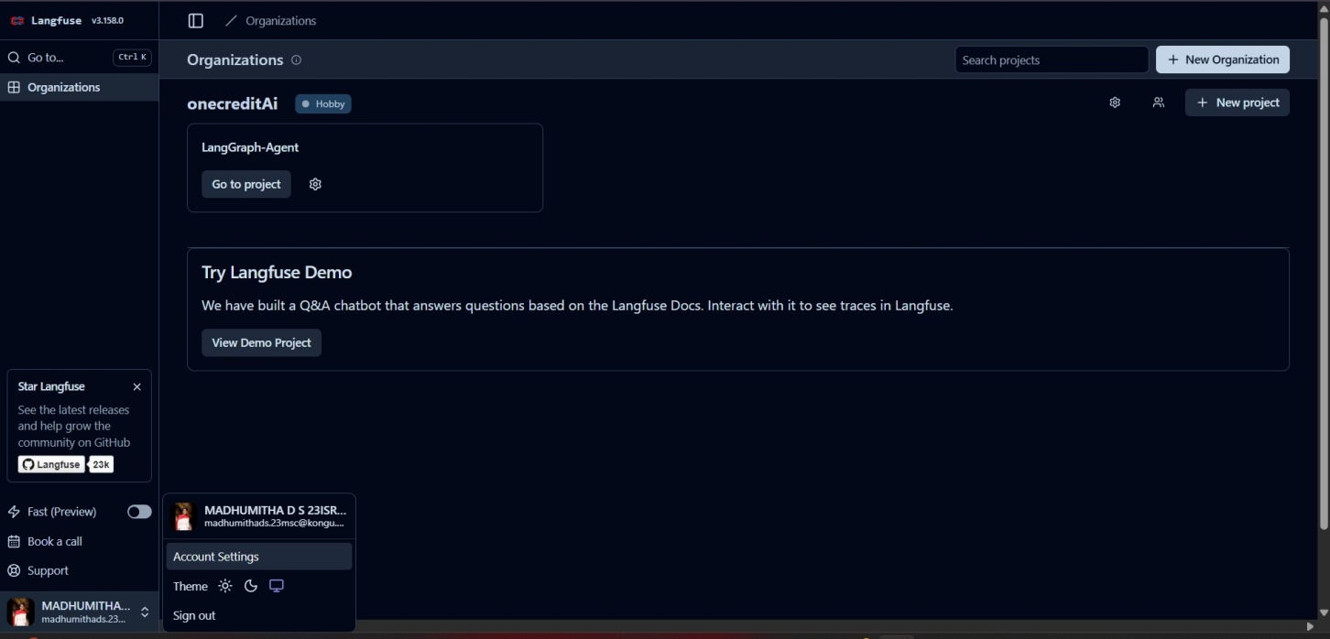

TraceAnalytics
Thetraceanalyticssectionshowsthenumberofchatbotexecutionsovertime. The graph displays:
- Tracecount
- Executiontimestamps
- Systemperformance

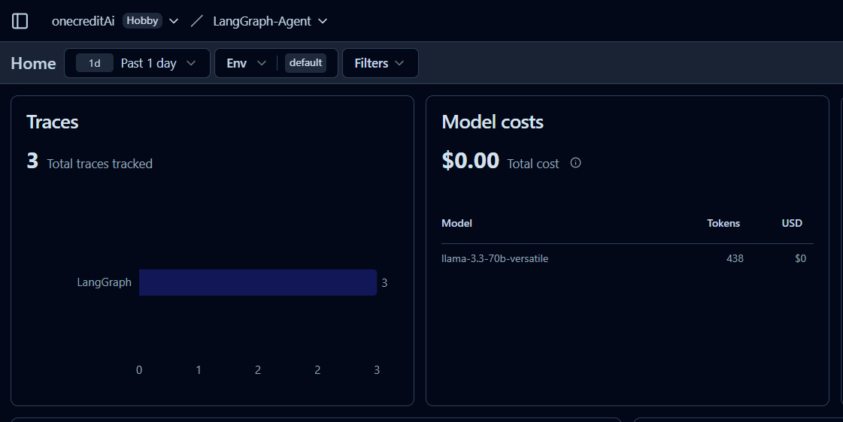
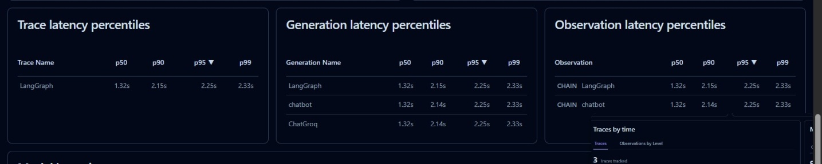

KeyFeaturesDemonstrated
Thisexercisedemonstrates:

- LLMtracingandobservability
- AIworkflowmonitoring
- Performanceanalytics
- Tokenusagetracking

MonitoringtoolslikeLangfuseareimportantwhendeployingproductionAIsystems.

