Early Detection of Alzheimer's disease Using Cognitive Features A Voting-Based Ensemble Machine Learning Approach

In propose paper author employing novel concept to detect Alzheimer disease and this novel concept contains combination of Cognitive Features selection and Voting-Based Ensemble ML algorithm. As cognitive features selection author employing Neighbourhood Component Analysis and Correlation-based Filtration (NCA-F) to identify key cognitive features from a dataset.

Key features extracted from dataset will be input Ensemble voting classifier by combining multiple algorithms called KNN, Random Forest, ADABOOST, XGBOOST, Naïve Bayes, Logistic Regression and Decision Tree. Propose Ensemble algorithm performance is compared with Non-Ensemble algorithm and propose algorithms manages to obtain an accuracy of over 93% and non-ensemble algorithm achieved 83%.

To train and test above algorithms we have used Alzheimer disease dataset which can be download from below URL

<https://www.kaggle.com/datasets/rabieelkharoua/alzheimers-disease-dataset>

After training algorithms using above dataset and then evaluate performance on test data with the help accuracy, precision, recall and FSCORE.

To implement this project we have designed following modules

1. New user Signup: using this module user can sign up with the application
2. User Login: using this module user can login to system
3. Load Alzheimer Dataset: after login user can use this module to upload dataset to application
4. Cognitive Features: this module will clean dataset by replacing missing values with mean and then normalize all features and then apply Cognitive algorithm to select features. All selected features will be split into train and test where application using 80% dataset features for training and 20% for testing
5. Run Voting-Based Ensemble ML: 80% training data will be input to existing and propose algorithms to train a model and this model will be applied on 20% test data to calculate prediction accuracy
6. Predict Disease: using this module user can upload test data and then application will extract cognitive features from test data and input to ensemble voting algorithm to predict weather test data contains Alzheimer disease or not.

SCREEN SHOTS

To run project double click on ‘run.bat’ file to get below page

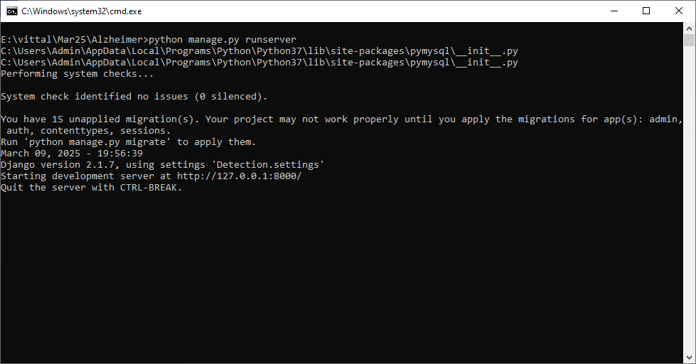

In above screen python server started and now open browser and enter URL as <http://127.0.0.1:8000/index.html> and then press enter key to get below page



In above screen click on ‘New User Sign up’ link to get below page

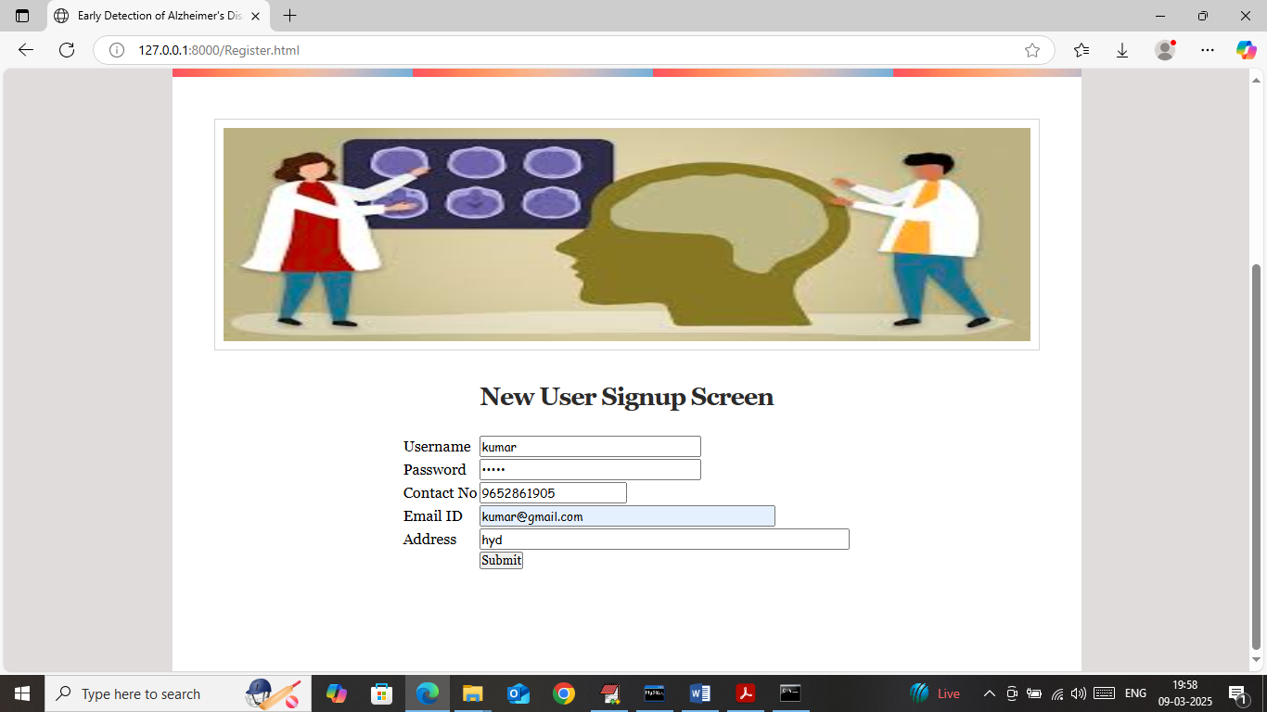

In above screen user is entering sign up details and then press button to get below page

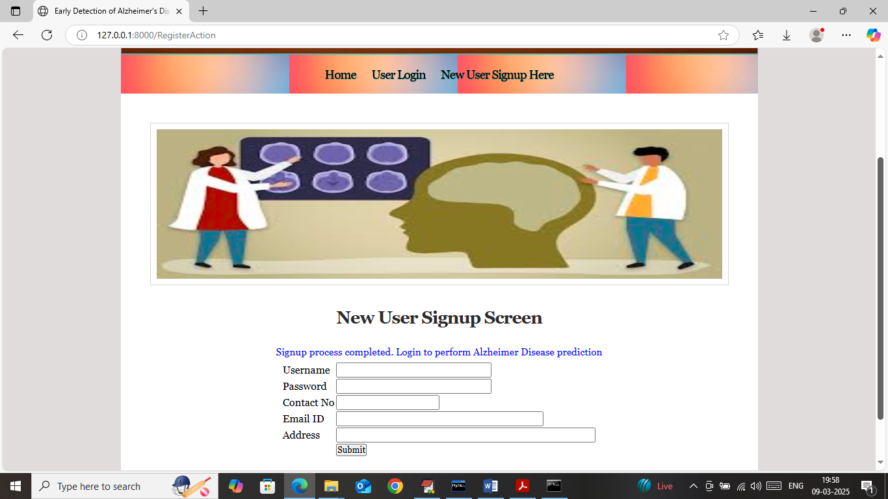

In above screen sign up completed and now click on ‘User Login’ link to get below page



In above screen user is login and after login will get below page



In above screen click on ‘Load Alzheimer Dataset’ link to load dataset and then will get below page

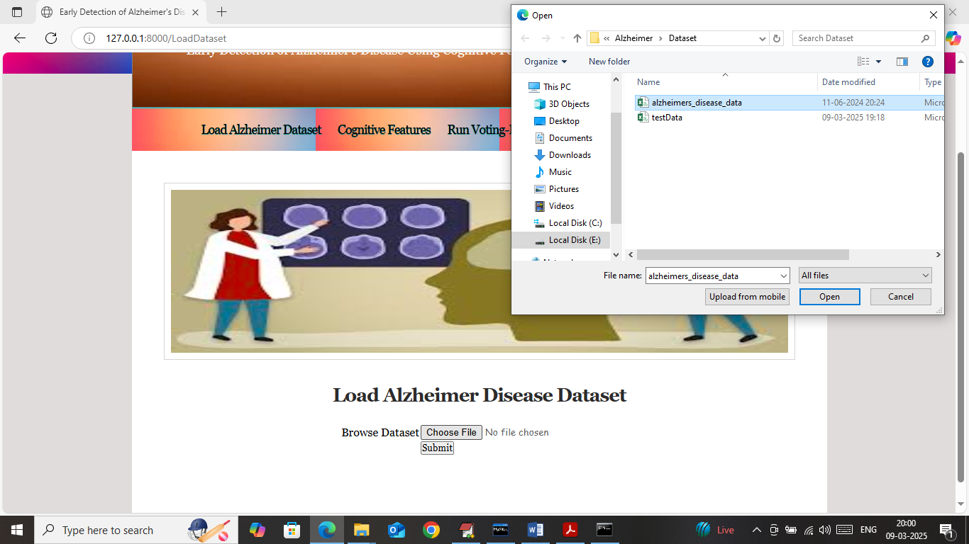

In above screen selecting and uploading ‘Alzheimer Disease’ dataset and then click on ‘Open and submit’ button to load dataset and then will get below page

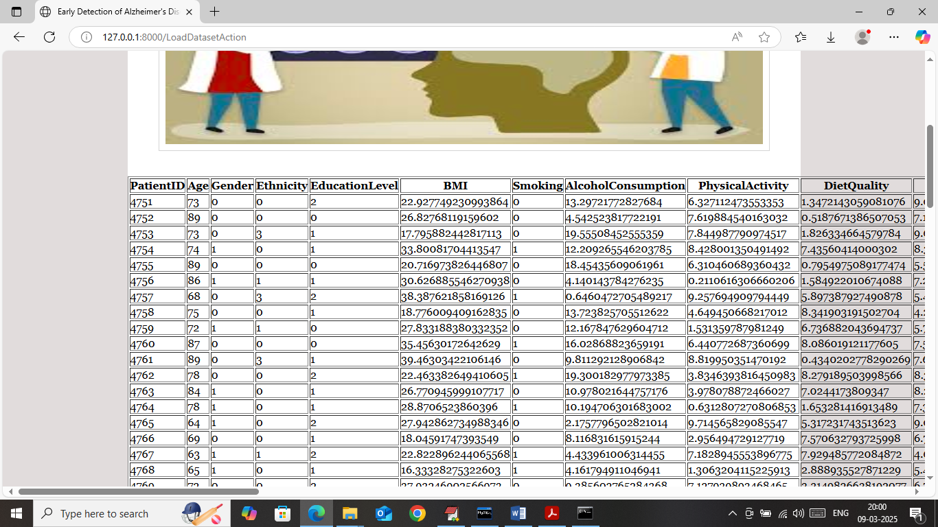

In above screen dataset loaded and now click on ‘Cognitive Features Selection’ button to select features and then will get below page

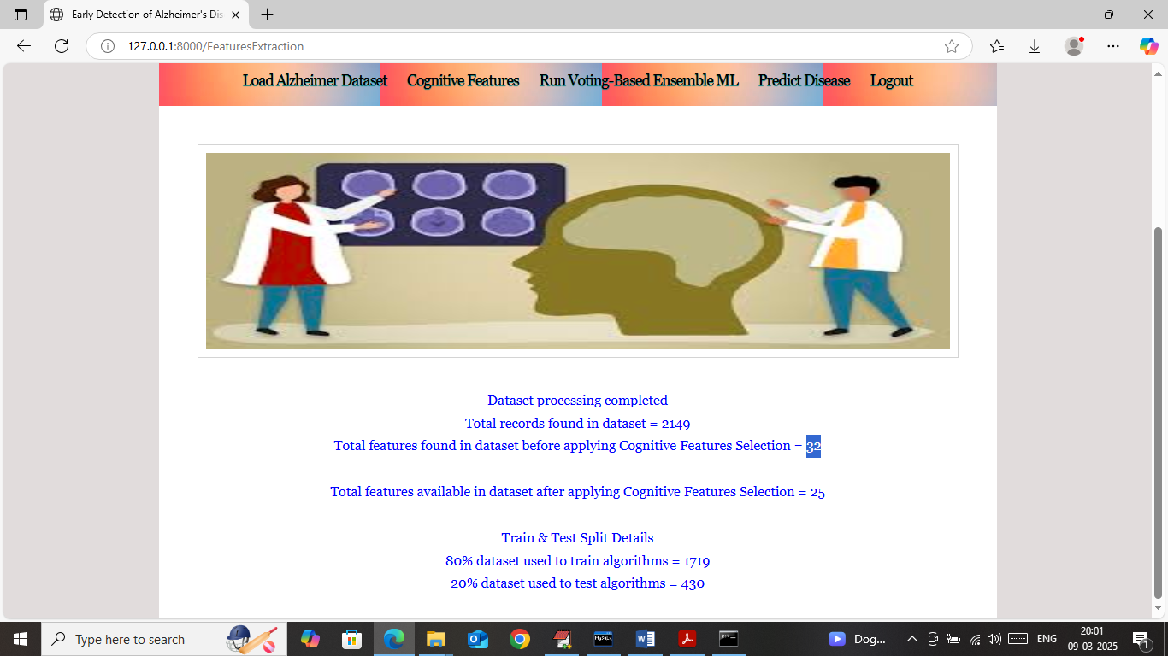

In above screen in first line can see number of records available in dataset and in 2nd line can see number of features available in dataset and in 3rd line can see Cognitive algorithm identify 25 key features out of 32 features and then in last lines can see train and test data size. Now click on ‘Run Voting-Based Ensemble ML’ link to train algorithms and then will get below page

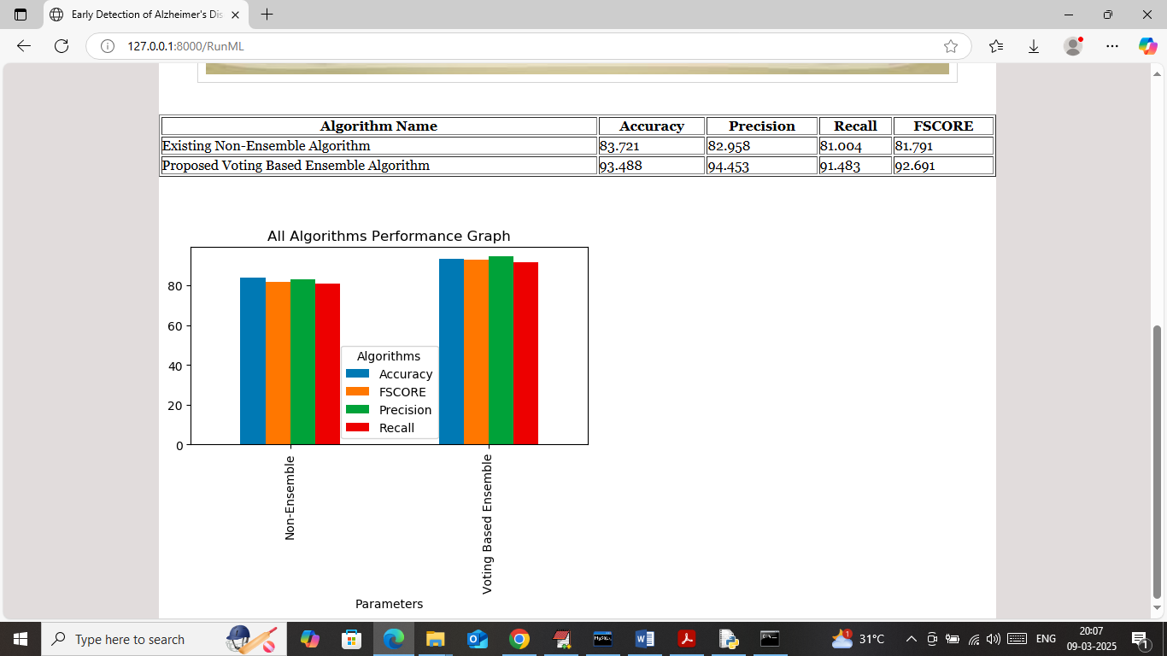

In above screen in table format can see both ‘non-ensemble and voting-based ensemble’ algorithms performance where propose Ensemble got 93% accuracy and non-ensemble got 83% accuracy. In above screen showing other metrics like precision, recall and FSCORE. In graph also showing both algorithm performance where x-axis represents algorithm names and y-axis represents accuracy and other metrics in different colour bars. In both algorithms propose ensemble got high accuracy. Now click on ‘Predict Disease’ link to get below page

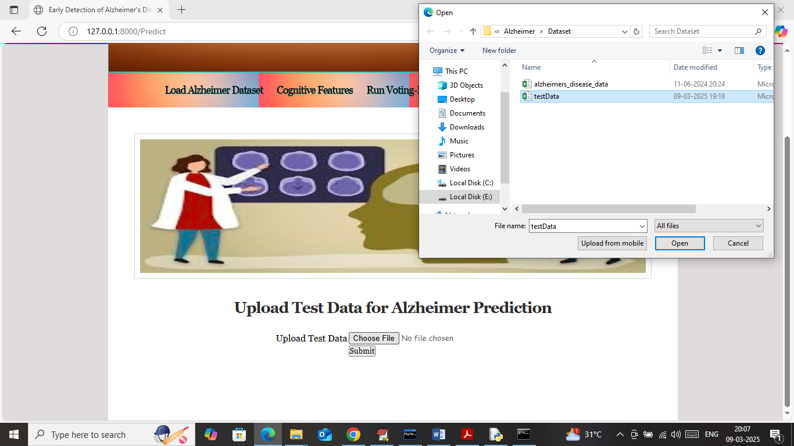

In above screen selecting and uploading test data file and then click on buttons to get below page

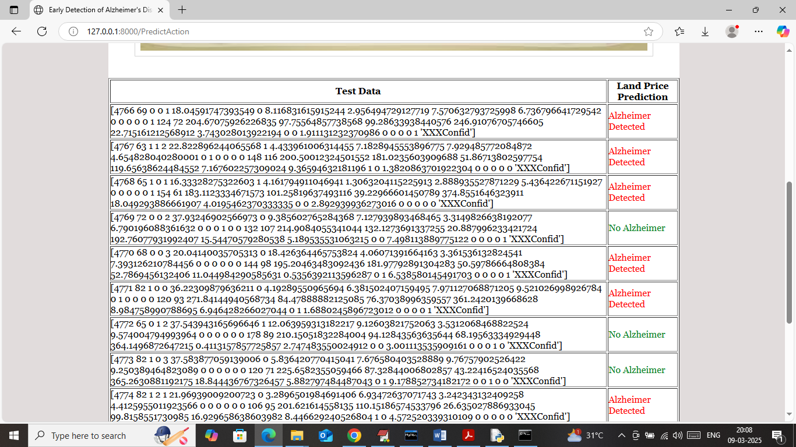

In above screen in first column can see TEST data values and in second column can see predicted output weather test data contains ‘Alzheimer or No Alzheimer’.