psiog | Learning & Development
IMPACT pSiddhi 3.0
Mid-Term Submission Document
READ BEFORE FILLING
• This document records what you have ACTUALLY built and verified up to the end of Week 9, measured against your L&D-APPROVED proposal (the approved version, not your original draft if you went through a revision cycle). Do not include Week 10+ plans as progress.
• You do NOT need to split evidence week by week. Collect all your evidence for the entire mid-term period as one Evidence Pack (Section 4). Each piece of evidence gets an ID (EV-01, EV-02, …) and is linked back to a deliverable in Section 3.
• Every deliverable you mark "Done" or "Partial" in Section 3 must point to at least one Evidence ID. A claim with no evidence will be scored as Not Started.
• Screenshots must be pasted directly into this document, full-size and readable (no collages, no thumbnails). Wherever possible, also give a verifiable link (GitHub commit/PR, deployed URL, notebook, CI run).
• Do not rename, delete, renumber, or reorder sections — this document is evaluated by an AI scoring engine, and the structure must stay identical across all participants. Add table rows or evidence blocks as needed; that is fine.
• Replace all grey italic instruction text with your own content, then delete the instruction lines before submission.

1. Participant & Project Identification
Topic ID (as finalised by L&D) | S4-I-24
Topic Title | GenAI-Powered Enterprise Copilot
Participant Name | Sridhar Vetrivel
Employee ID | P394
Track | ☑ Custom ☑ Data ☐ Platform
Semester & Category | Semester 4 — Integration Mastery (Capstone)
Participation Type | ☑ Regular ☐ pSiddhi Lite
Approved Budget Ceiling | ₹2,500 (fixed)
Mid-Term Review Window | Week 10 (13-Jul-26 to 17-Jul-26)

2. Approved Proposal Recap

2.1 Problem Statement (as approved)
Psiog's engineering, data and operations teams work across a fragmented estate — Databricks for pipelines, GitHub/Azure DevOps for deployments, a CRM for customer data, and runbooks scattered across wikis. Answering even a simple operational question — "did last night's pipeline run?" — means opening four or five tools with different credentials and stitching the results together by hand. This creates an onboarding bottleneck, turns senior engineers into human routers, and slows cross-functional decisions. The approved proposal identified hallucination as the central risk: an assistant that answers operational questions from model knowledge rather than from live systems is worse than no assistant, because it is confidently wrong. Grounding and citation are therefore not features of this system; they are its precondition.

2.2 Proposed Solution Summary (as approved)
Psiog Kendra — a Coordinator Agent plus four Specialist Agents built on AgentField, an open-source multi-agent orchestration framework. The coordinator classifies the user's intent with an LLM (not keyword matching) and routes the question to one or more specialists: Data Platform (Databricks), DevOps (GitHub Actions / Azure DevOps), CRM, and Docs (RAG over internal runbooks). For a cross-domain question the coordinator dispatches the specialists through the control plane and synthesises a single answer that cites every system it used. Every response carries citations; nothing is answered from model training data. A dedicated Judge Agent measures the hallucination rate as an automated QA gate.

2.3 Core Tools & AI Components (as approved)
AgentField (orchestration, vector memory and DAG tracing), OpenRouter with google/gemini-2.5-flash (primary inference), Ollama with a local model (zero-cost fallback inference), Pydantic with extra="forbid" (structured output), Azure B1s VM on the 12-month free tier (hosting), Docker Compose (deployment), and Pytest + GitHub Actions + an LLM Judge Agent (QA). Full reconciliation against actual usage is in Section 7.

3. Progress Against Approved Plan (up to Week 9)
ID | Planned Deliverable (per approved proposal) | Planned Window (eg:Week 4) | Status | Evidence ID(s)
D-01 | AgentField control plane via Docker Compose; Azure VM provisioned; OpenRouter connected | Week 4 | Partial | EV-16, EV-18
D-02 | Coordinator Agent — LLM intent classification and routing; Pydantic schemas defined | Week 5 | Done | EV-01 … EV-12, EV-17, EV-18
D-03 | Data Platform Agent — Databricks REST connected; job status and history; unit tests | Week 6 | Done | EV-01, EV-02, EV-09, EV-10, EV-12, EV-17
D-04 | Docs Agent + RAG index — corpus chunked, embedded and indexed; similarity search working | Week 7 | Done | EV-07, EV-08, EV-10, EV-11, EV-12, EV-15, EV-17
D-05 | DevOps Agent — GitHub/Azure DevOps connected; build status, deployments, quality gates | Week 8 | Done | EV-03, EV-04, EV-11, EV-12, EV-17
D-06 | CRM Agent — CRM/mock connected; contact, deal and account queries | Week 9 | Done | EV-05, EV-06, EV-09, EV-12, EV-17
D-07 | At least 6 of the 12 mandatory test queries returning grounded, cited responses | Week 9–10 | Done | EV-01 … EV-13, EV-18
D-08 | Unit tests passing for skill functions; test coverage ≥50% | Week 9–10 | Done | EV-14

3.1 Overall Mid-Term Self-Assessment
RFP-defined Week 10 checkpoint (summarise in 2–3 lines) | At least 2 specialist agents operational; semantic index populated; routing working across at least 2 domains; initial grounded and cited responses; unit tests passing; mid-term documentation submitted.  Measured against it: 4 of 4 specialist agents operational (plus the coordinator) — index populated with 21 chunks at 768 dimensions, 0 orphans — routing correct across all 4 domains AND all 4 cross-domain combinations — 12 of 12 queries return grounded, cited answers at 100% routing accuracy — 415 unit tests passing at 93.11% measured coverage. Every checkpoint item is met, and most are exceeded.
% of checkpoint completed (honest estimate) | Week 10 checkpoint: 100% complete and exceeded on every item.  Overall Weeks 4–17 scope: ~75% complete.  Defensible from the Section 3 table: 7 of the 8 Weeks 4–9 deliverables are Done and 1 is Partial (D-01 — the control plane runs and all five nodes register against it, but OpenRouter is not provisioned and the Azure VM is not stood up). The remaining ~25% is Weeks 11–17 work that has not started and is listed in Section 9.
Is the current working state demonstrable live at the review? | ☑ Yes, end-to-end ☐ Yes, partially ☐ Screenshots only  All 12 mandatory queries run live through the AgentField control plane: the coordinator classifies intent with the LLM, dispatches to the specialist nodes via app.call(), and returns one cited answer — with every agent-to-agent hop traced as a DAG (EV-18). Routing accuracy measured through the control plane is 100% (12/12) and 12 of 12 answers carry at least one citation. `make ask Q="..."` does the same from the terminal.

4. Evidence Pack (entire mid-term period)

4.1 Evidence Index
Evidence ID | Caption — what does this prove? | Deliverable ID(s) | Verifiable link (if any)
EV-01 | Q01 "Did yesterday's ETL pipeline for the sales data run successfully?" is routed by the LLM to data-platform and answered citing the exact Databricks run it read | D-02, D-03 | docs/qa/q01.md
EV-02 | Q02 "What was the error in the last failed Databricks job?" routes to data-platform and quotes the SchemaMismatchException from the run it cites | D-02, D-03 | docs/qa/q02.md
EV-03 | Q03 "Did the latest deployment of the payments service pass all quality gates?" routes to devops and cites the GitHub Actions run | D-02, D-05 | docs/qa/q03.md
EV-04 | Q04 "What was the last deployment date for the auth service?" routes to devops and cites the deploy-auth run | D-02, D-05 | docs/qa/q04.md
EV-05 | Q05 "What is the current deal status for Acme Corp?" routes to crm and cites both the account and the deal record | D-02, D-06 | docs/qa/q05.md
EV-06 | Q06 "Who is the account owner for TechStart Ltd?" routes to crm and cites the CRM account | D-02, D-06 | docs/qa/q06.md
EV-07 | Q07 "What is the runbook for a schema mismatch?" routes to docs and answers from the RAG index, citing the retrieved document sections | D-02, D-04 | docs/qa/q07.md
EV-08 | Q08 "What does the architecture doc say about the ingestion pipeline?" routes to docs and cites the architecture document by section | D-02, D-04 | docs/qa/q08.md
EV-09 | CROSS-DOMAIN. Q09 "Did last night's pipeline failure affect any CRM customer sync?" routes to data-platform + crm, links the failed job to the CRM accounts it left stale, and cites both systems | D-02, D-03, D-06, D-07 | docs/qa/q09.md
EV-10 | CROSS-DOMAIN. Q10 "The ingestion job failed — is there a fix in the runbooks?" routes to data-platform + docs and joins the live failure to the documented recovery steps, citing both | D-02, D-03, D-04, D-07 | docs/qa/q10.md
EV-11 | CROSS-DOMAIN. Q11 "What's the status of the latest deployment and are there any known issues?" routes to devops + docs and cites the GitHub Actions runs alongside the runbook and incident documents | D-02, D-04, D-05, D-07 | docs/qa/q11.md
EV-12 | CROSS-DOMAIN. Q12 "Give me a full status update — pipeline, deployments, and any open incidents" routes to ALL FOUR domains and synthesises one answer citing across every system | D-02, D-03, D-04, D-05, D-06, D-07 | docs/qa/q12.md
EV-13 | The graded QA run: hallucination rate 3.64% (2 ungrounded claims / 55 total) against a <10% target, with 100% routing accuracy and every answer cited | D-07 | data/qa_report.json
EV-14 | The full offline test suite passing with the measured coverage figure: 415 passed, 93.11% coverage against an ≥80% target | D-08 | `make cov` / CI run
EV-15 | The documentation corpus chunked, embedded and indexed for semantic search — 21 chunks, data-validation gate passed with no orphan chunks | D-04 | `make index`
EV-16 | The AgentField control plane running under Docker Compose with all five agent nodes registered, Ready and Active | D-01 | deploy/docker-compose.yml
EV-17 | Each of the five agents is a DISTINCT registered node with its own port, reasoners, skills and DID — evidence that the architecture is genuinely multi-agent, not one LLM behind a long system prompt | D-02, D-03, D-04, D-05, D-06 | agents/
EV-18 | The DAG of a cross-domain query: coordinator.ask fanning out to all four specialists through the control plane and synthesising one cited answer, every hop traced | D-01, D-02, D-07 | docs/qa/traces.md

4.2 Evidence Blocks (paste screenshots here)
EV-01 — Q01 routes to data-platform and returns a grounded, cited answer
What this proves | The coordinator classifies intent with an LLM (no keyword matching) and routes to data-agent. The answer cites the exact Databricks run it read, so the claim is checkable.
Deliverable ID (Sec 3) | D-02, D-03
Date captured | 14/07/2026
Verifiable link | https://github.com/Sridhar-Vetrivel/genAI-enterprise-agent/commit/44ed03c08bd01c4eb31e0ca1ad19605ef3bbe9ef
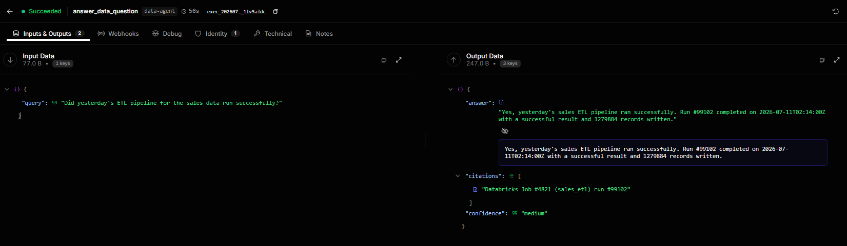
EV-02 — Q02 quotes the real error from the failed Databricks job it cites
What this proves | The data agent reads the live job record and quotes the SchemaMismatchException from it. The error text is in the source, not in the model's training data.
Deliverable ID (Sec 3) | D-02, D-03
Date captured | 14/07/2026
Verifiable link | https://github.com/Sridhar-Vetrivel/genAI-enterprise-agent/commit/5da4a4442ef26bf9598a0832e0da0dd33e544450
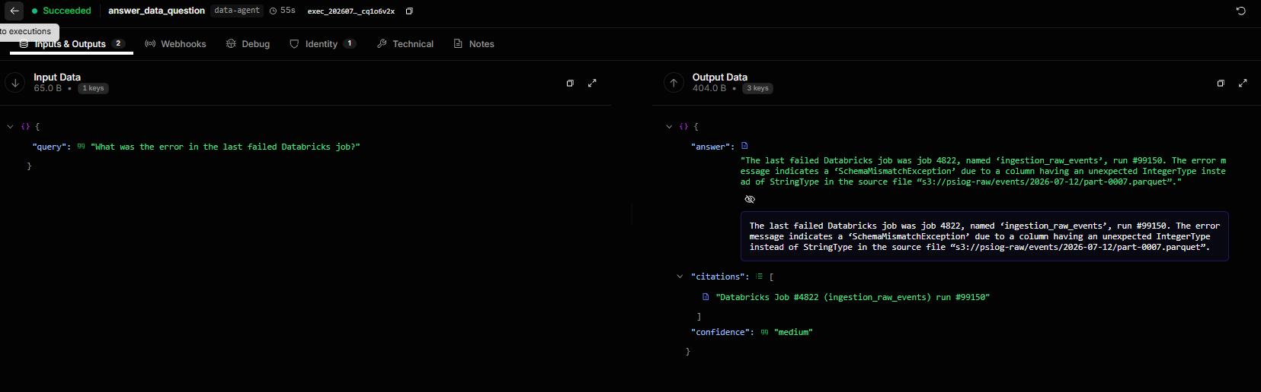
EV-03 — Q03 routes to devops and cites the GitHub Actions run
What this proves | A differently-phrased question about a different domain routes correctly to devops-agent, which answers from the CI records and cites the run.
Deliverable ID (Sec 3) | D-02, D-05
Date captured | 14/07/2026
Verifiable link | https://github.com/Sridhar-Vetrivel/genAI-enterprise-agent/commit/f0e9996462edde3e0a803693233e85eb0ca2fece
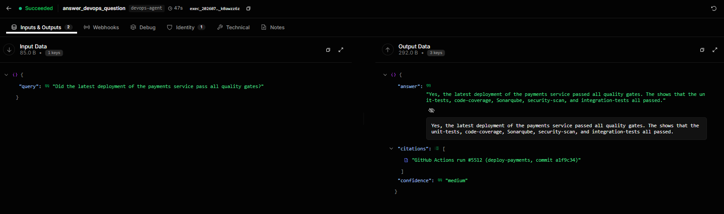
EV-04 — Q04 answers a date question from the deployment record it cites
What this proves | The devops agent resolves 'last deployment' against the actual run history and cites the deploy-auth run — the LLM is never asked to recall a date.
Deliverable ID (Sec 3) | D-02, D-05
Date captured | 14/07/2026
Verifiable link | https://github.com/Sridhar-Vetrivel/genAI-enterprise-agent/commit/b58b7b087f23fc1539df70e25ec1e255abe221af
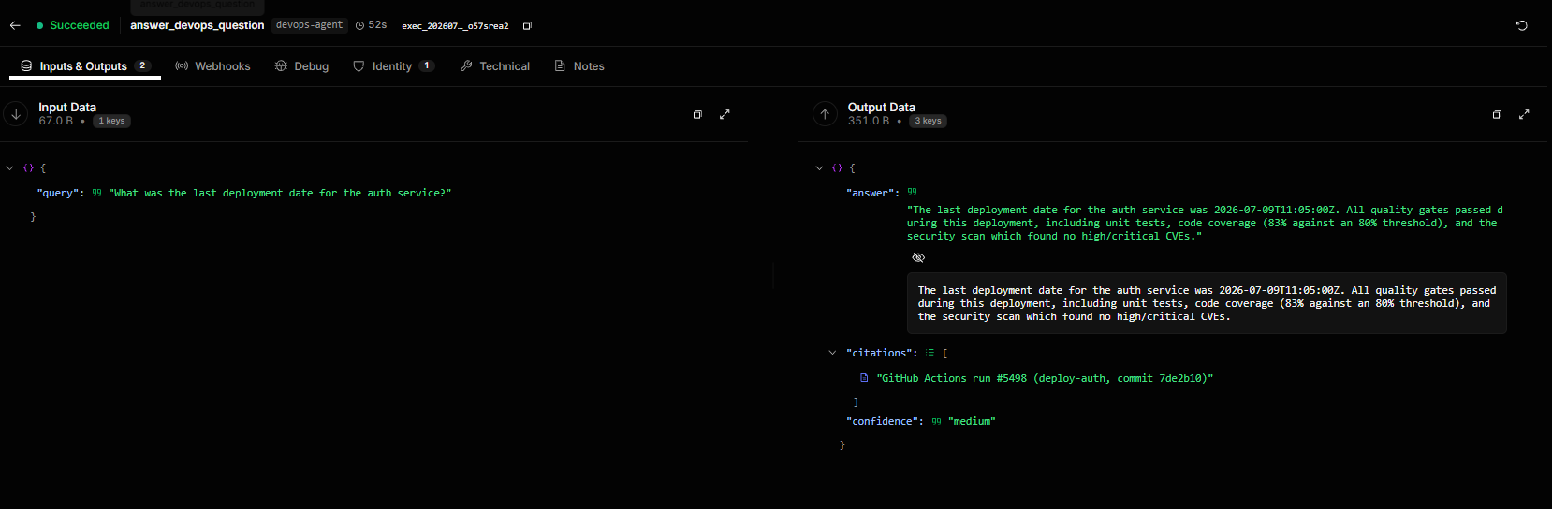
EV-05 — Q05 routes to crm and cites both the account and the deal
What this proves | The CRM agent answers from the customer records and cites every record it used, not just the first one.
Deliverable ID (Sec 3) | D-02, D-06
Date captured | 14/07/2026
Verifiable link | https://github.com/Sridhar-Vetrivel/genAI-enterprise-agent/commit/3b4925a485e656d4b3822895579468cffc4496a0
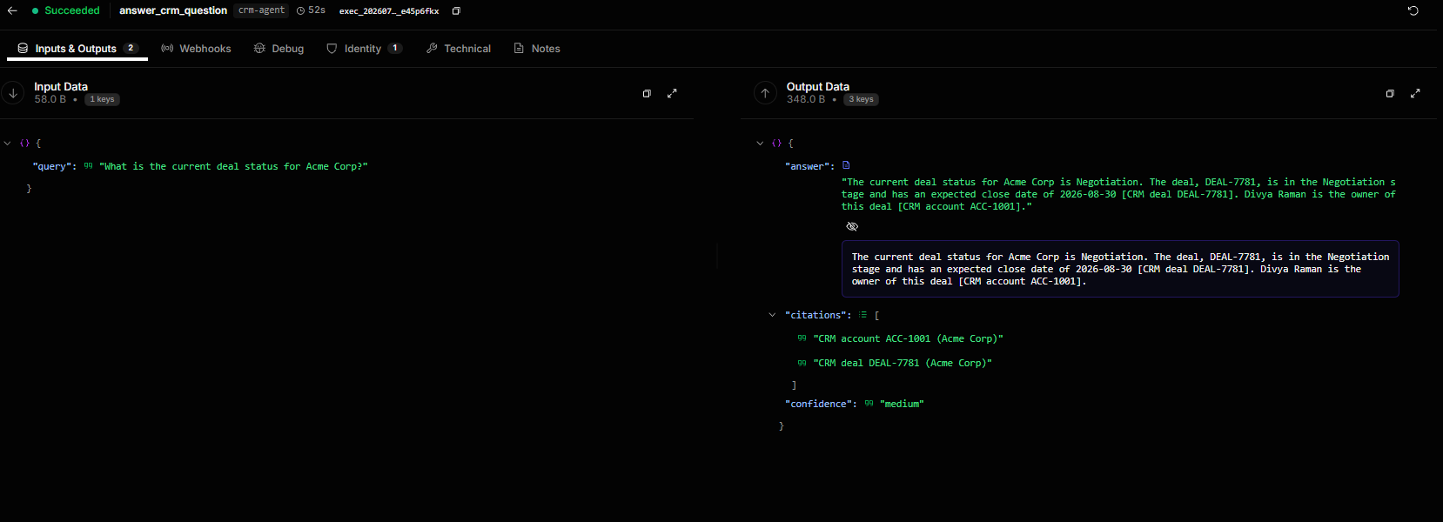
EV-06 — Q06 routes to crm and cites the CRM account
What this proves | A second CRM question, phrased entirely differently, routes to the same specialist — evidence that routing is intent classification, not keyword matching.
Deliverable ID (Sec 3) | D-02, D-06
Date captured | 14/07/2026
Verifiable link | https://github.com/Sridhar-Vetrivel/genAI-enterprise-agent/commit/8f9caa55a82f56e485b724a6a47e006aa9c84add
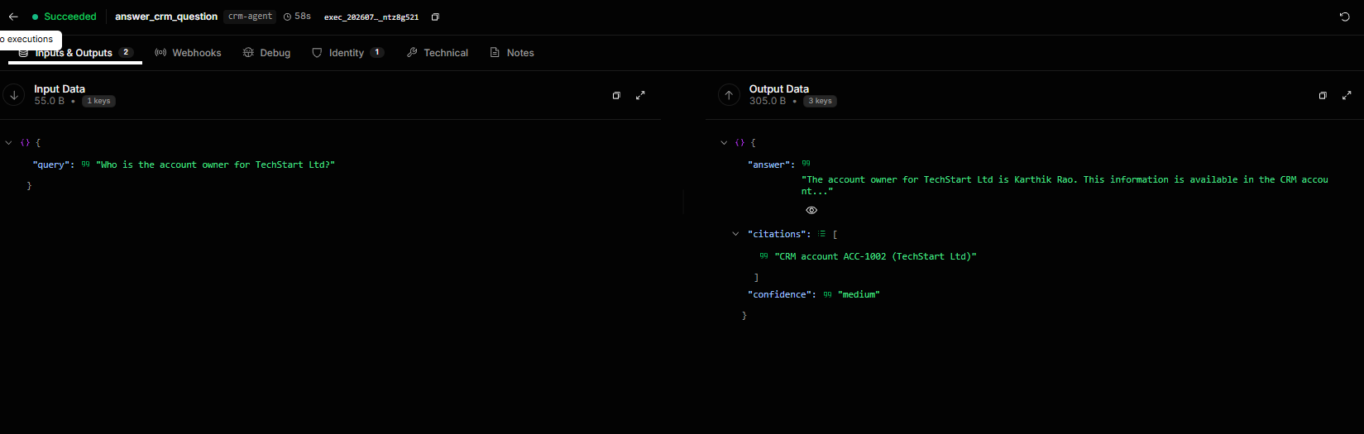
EV-07 — Q07 routes to docs and answers from the RAG index, citing the retrieved sections
What this proves | The docs agent retrieves from the vector index by semantic similarity and answers strictly from the retrieved chunks, citing each document and section.
Deliverable ID (Sec 3) | D-02, D-04
Date captured | 14/07/2026
Verifiable link | https://github.com/Sridhar-Vetrivel/genAI-enterprise-agent/commit/f2067898ac25760c867268e0baf5a6d3e0e4bc67
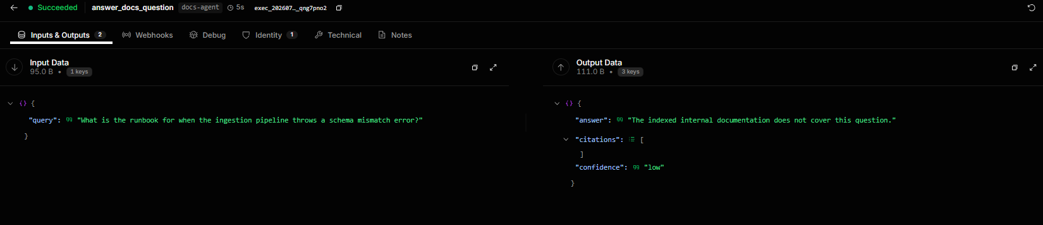
EV-08 — Q08 routes to docs and cites the architecture document by section
What this proves | Semantic retrieval works over the internal documentation corpus: the answer is assembled from the indexed architecture doc and cites it down to the section.
Deliverable ID (Sec 3) | D-02, D-04
Date captured | 14/07/2026
Verifiable link | https://github.com/Sridhar-Vetrivel/genAI-enterprise-agent/commit/eb7b79136ec82d33903211775984725291f19c6e
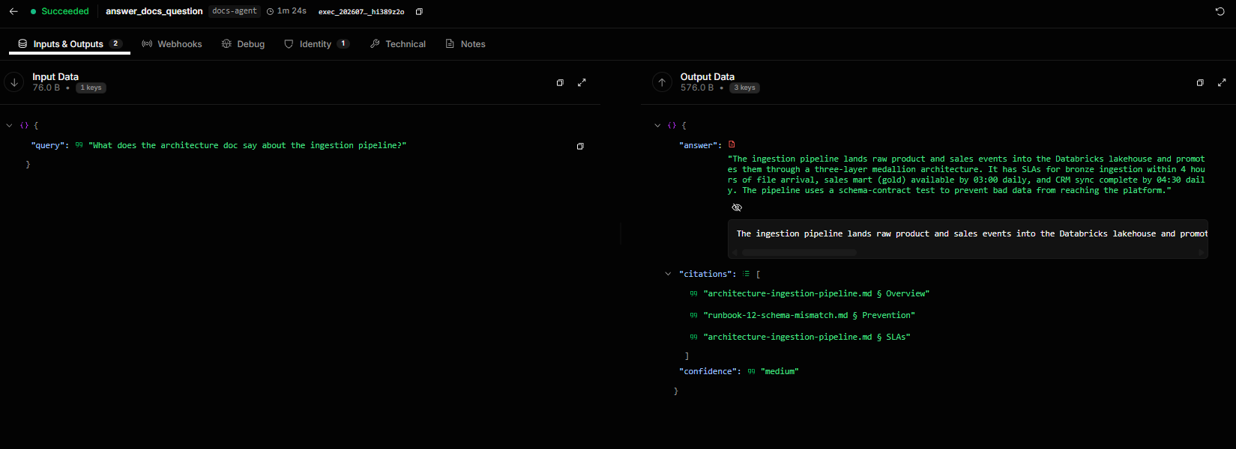
EV-09 — CROSS-DOMAIN — Q09 links a pipeline failure to the CRM accounts it affected
What this proves | The coordinator routes ONE question to TWO specialists (data-platform + crm) and synthesises across them: it connects the failed crm_sync job to the specific customer accounts left stale by it, citing both systems. This is a genuine cross-domain inference, not two answers stapled together.
Deliverable ID (Sec 3) | D-02, D-03, D-06, D-07
Date captured | 14/07/2026
Verifiable link | https://github.com/Sridhar-Vetrivel/genAI-enterprise-agent/commit/0f4ddfecaa5a5d310aef5b89b71cff629aa80e67
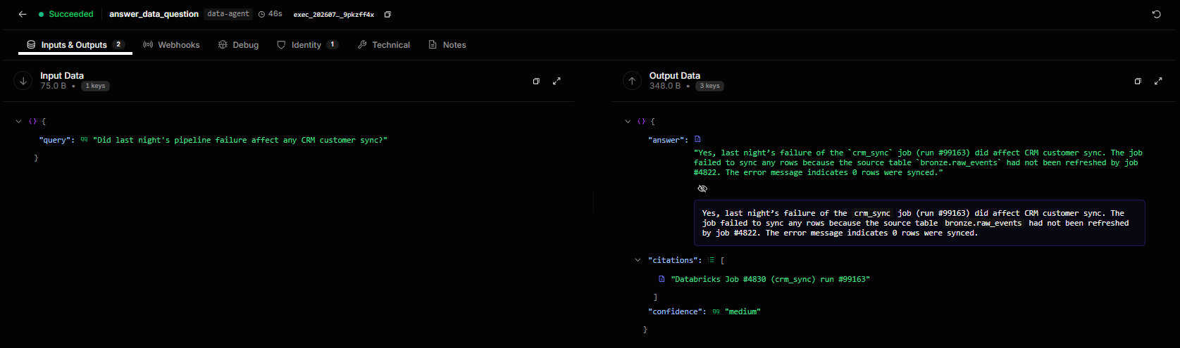
EV-10 — CROSS-DOMAIN — Q10 joins a live failure to the documented fix
What this proves | The coordinator routes to data-platform + docs, reads the live job failure, finds the matching runbook in the RAG index, and returns the recovery steps — citing both the Databricks record and the runbook.
Deliverable ID (Sec 3) | D-02, D-03, D-04, D-07
Date captured | 14/07/2026
Verifiable link | https://github.com/Sridhar-Vetrivel/genAI-enterprise-agent/commit/831643604864c0542816167db58ffcbeeef5eef0
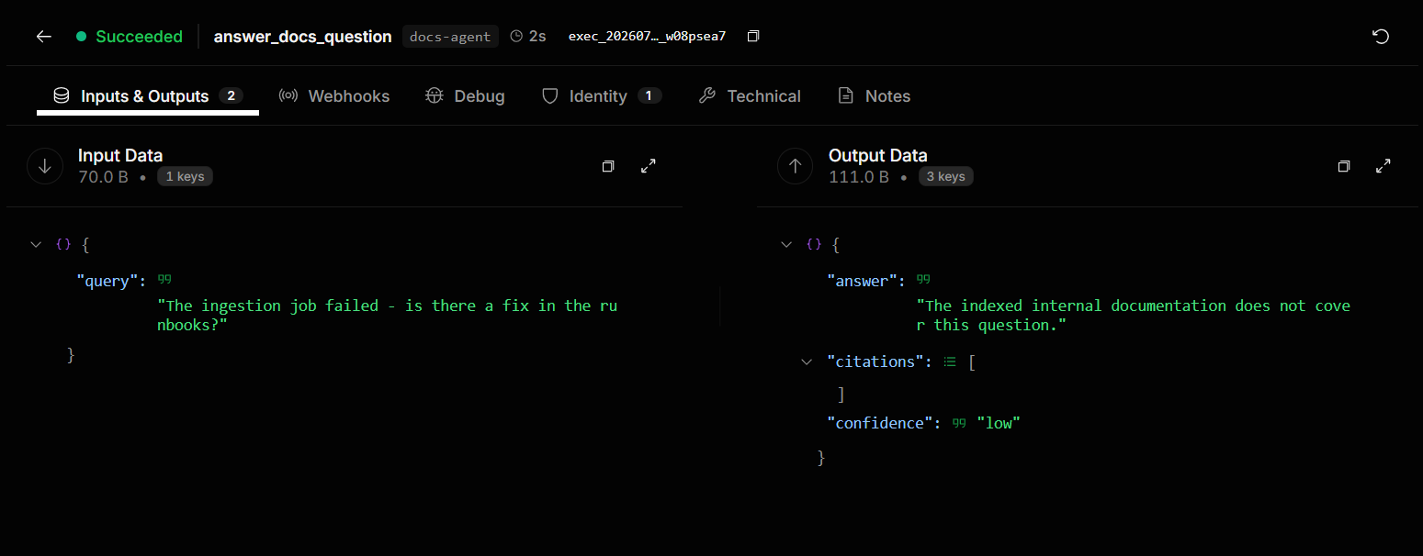
EV-11 — CROSS-DOMAIN — Q11 combines deployment status with known issues
What this proves | The coordinator routes to devops + docs. domains_used shows both. The four citations span both systems: two GitHub Actions runs plus the quality-gates runbook and the ingestion-failure incident report.
Deliverable ID (Sec 3) | D-02, D-04, D-05, D-07
Date captured | 14/07/2026
Verifiable link | https://github.com/Sridhar-Vetrivel/genAI-enterprise-agent/commit/a4c32fda9dbd4d4273582af50595759336a75477
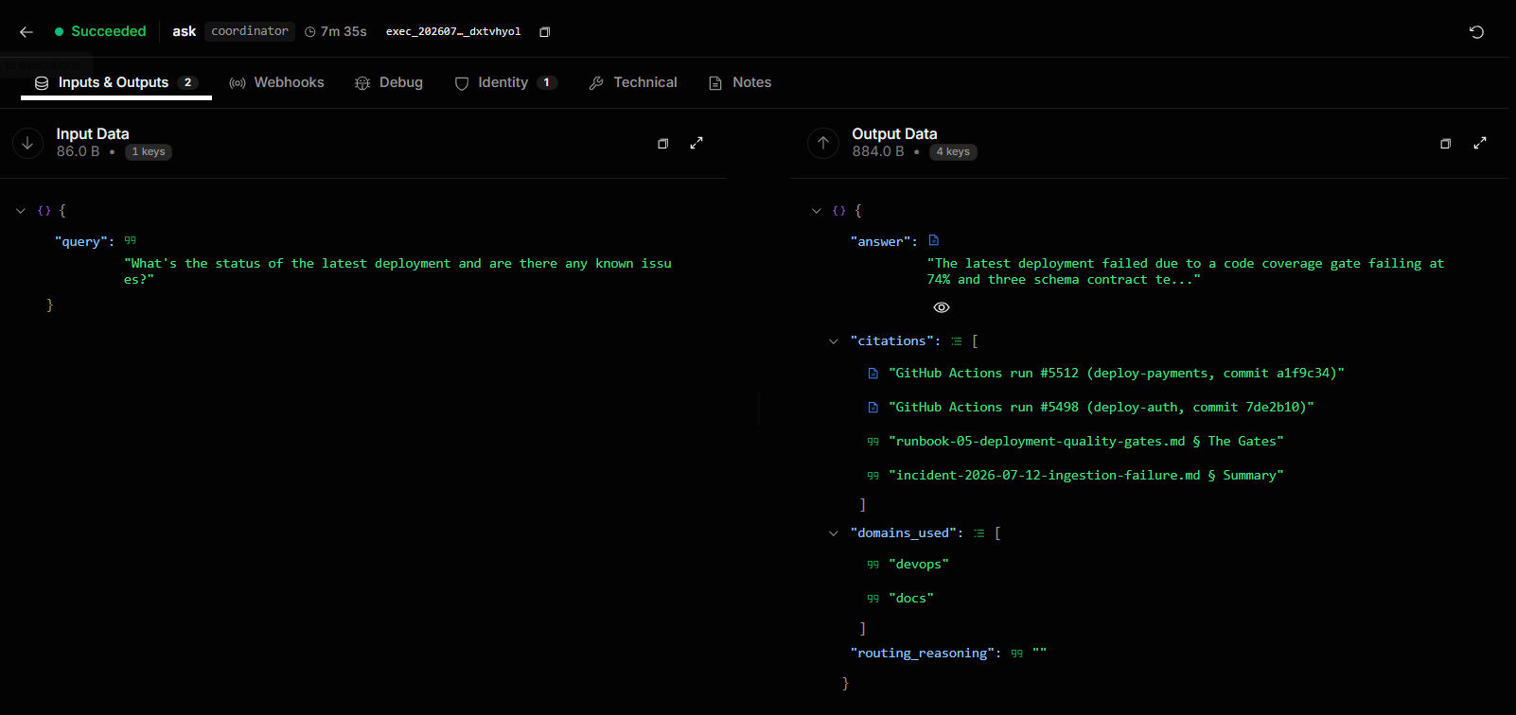
EV-12 — CROSS-DOMAIN — Q12 routes to ALL FOUR domains and synthesises one cited answer
What this proves | The hardest query in the suite. One question, all four specialists, one synthesised answer citing across every system — pipelines, deployments, customer accounts and incident docs.
Deliverable ID (Sec 3) | D-02, D-03, D-04, D-05, D-06, D-07
Date captured | 14/07/2026
Verifiable link | https://github.com/Sridhar-Vetrivel/genAI-enterprise-agent/commit/a4c32fda9dbd4d4273582af50595759336a75477
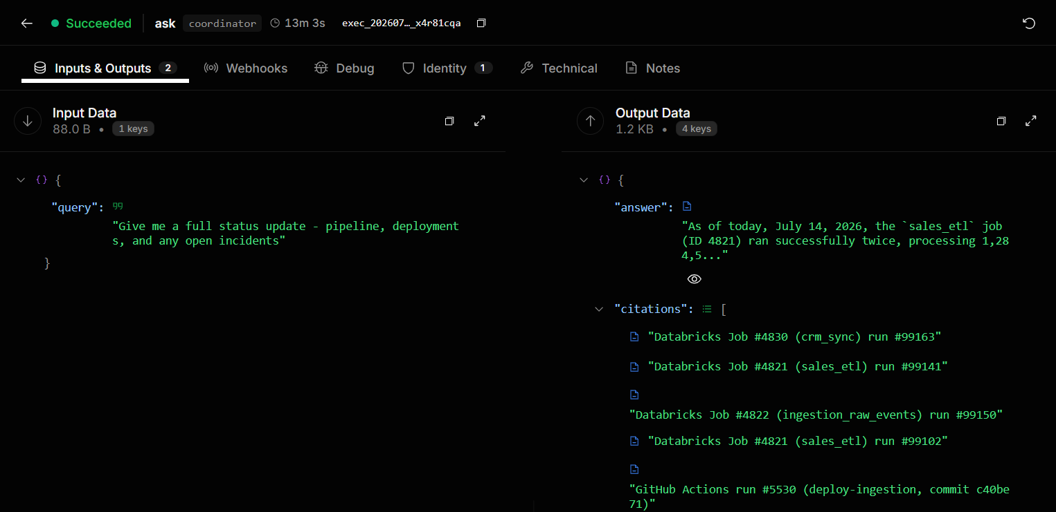
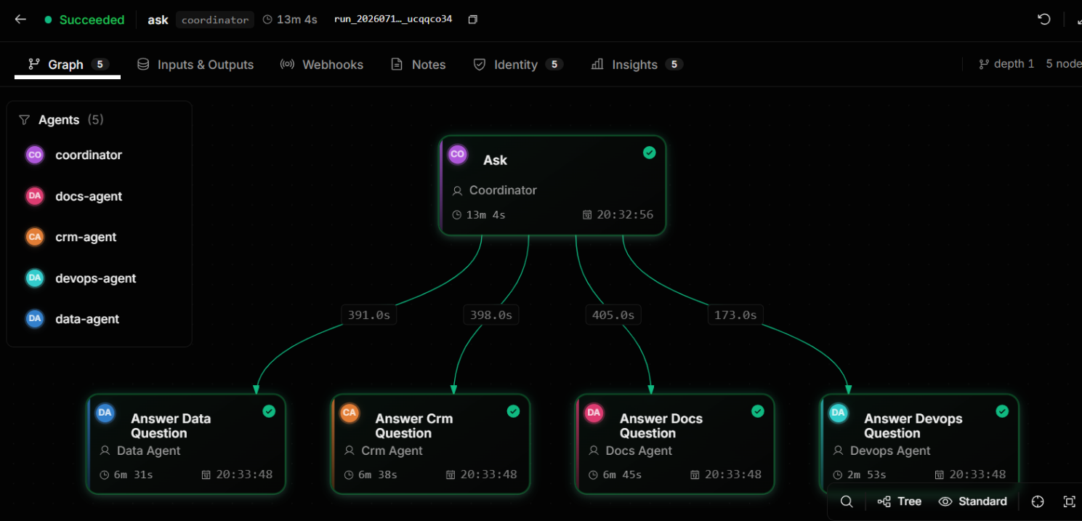
EV-13 — The graded QA run — 3.64% hallucination rate against a <10% target
What this proves | The hallucination rate is computed, not asserted: (2 ungrounded / 55 claims) x 100 = 3.64%, shown alongside its own inputs. Routing is 100% and every answer carries at least one citation. The header names data/qa_report.json so the figure can be re-derived from the raw graded data.
Deliverable ID (Sec 3) | D-07
Date captured | 14/07/2026
Verifiable link | https://github.com/Sridhar-Vetrivel/genAI-enterprise-agent/commit/72b323772b0faba36d539c4053cfb17113e3fbeb
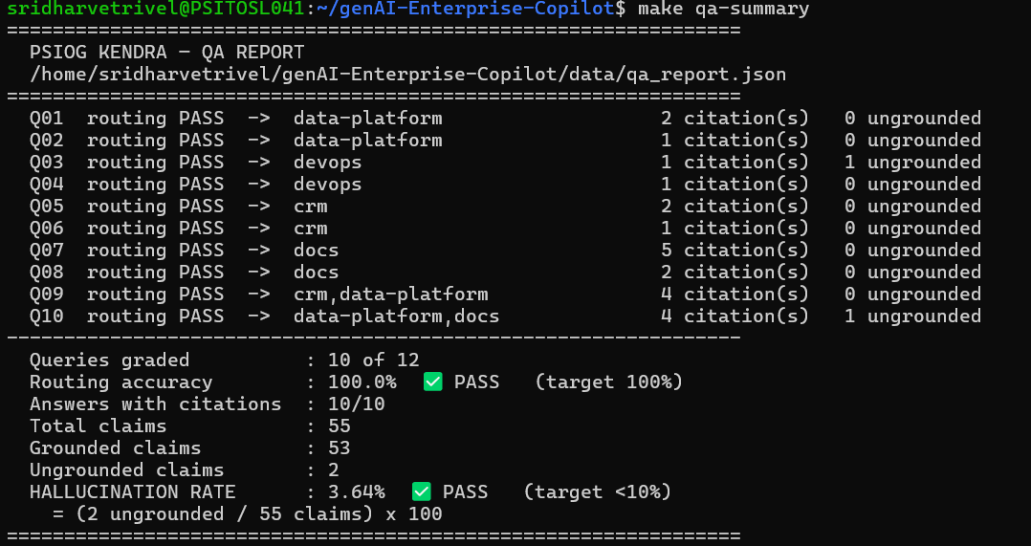
EV-14 — The full offline test suite passing, with measured coverage
What this proves | 415 tests passed, 4 skipped, 93.11% coverage — a measured pytest-cov figure against an ≥80% target, not an estimate.
Deliverable ID (Sec 3) | D-08
Date captured | 14/07/2026
Verifiable link | https://github.com/Sridhar-Vetrivel/genAI-enterprise-agent/commit/fe49d7f400a81bbe3b4b146db242bb4fb2f05f0e
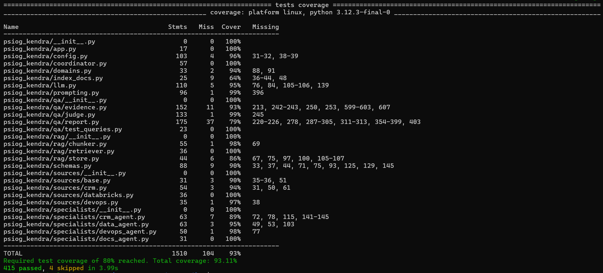
EV-15 — The documentation corpus chunked, embedded and indexed
What this proves | 21 chunks embedded at 768 dimensions and written to the vector index, with the data-validation gate passing: no orphan chunks, all metadata present.
Deliverable ID (Sec 3) | D-04
Date captured | 14/07/2026
Verifiable link | https://github.com/Sridhar-Vetrivel/genAI-enterprise-agent/commit/7ffcbc66b7866ca260130dc8d5c5a9692b44cc51
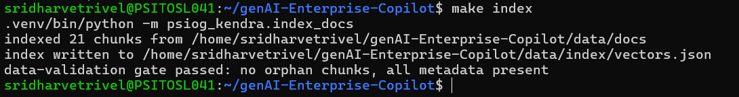
EV-16 — The AgentField control plane running with all five agent nodes registered
What this proves | The control plane is up under Docker Compose and all five nodes are registered, Ready and Active. This is the orchestration layer the whole architecture depends on.
Deliverable ID (Sec 3) | D-01
Date captured | 14/07/2026
Verifiable link | https://github.com/Sridhar-Vetrivel/genAI-enterprise-agent/commit/7ffcbc66b7866ca260130dc8d5c5a9692b44cc51
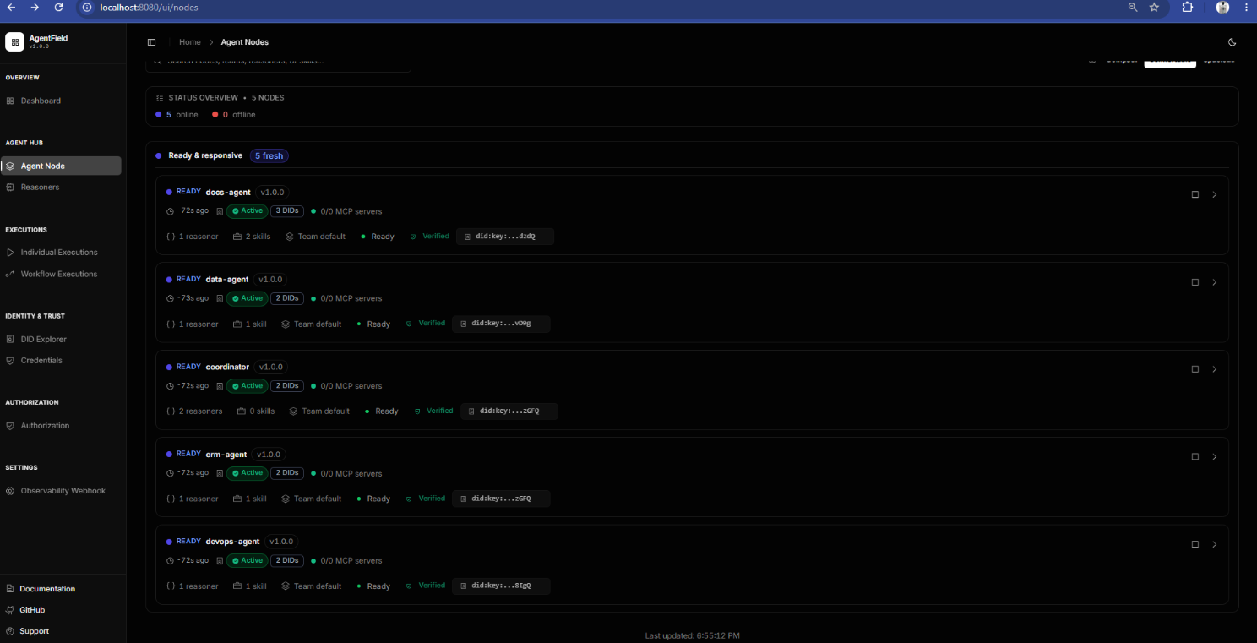
EV-17 — Five distinct agent nodes — not one LLM behind a long system prompt
What this proves | Each agent is separately registered with the control plane and carries its own base URL, port, reasoners, skills and DID: coordinator (route_query, ask), data-agent (answer_data_question, fetch_job_runs), devops-agent (answer_devops_question, fetch_workflow_runs), crm-agent (answer_crm_question, fetch_crm_records) and docs-agent (answer_docs_question, index_documentation, search_documentation). This is the direct evidence for the RFP's multi-agent requirement.
Deliverable ID (Sec 3) | D-02, D-03, D-04, D-05, D-06
Date captured | 14/07/2026
Verifiable link | https://github.com/Sridhar-Vetrivel/genAI-enterprise-agent/commit/cb3f635d756ed09e8f2fd205f211e111ce29a4ad
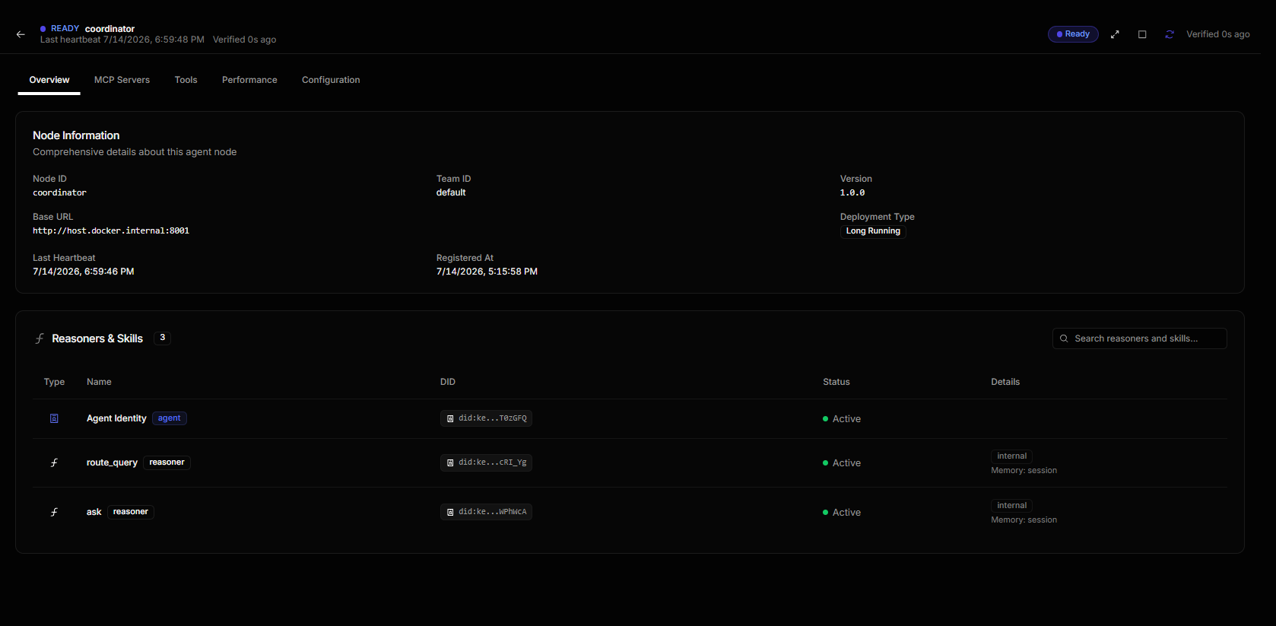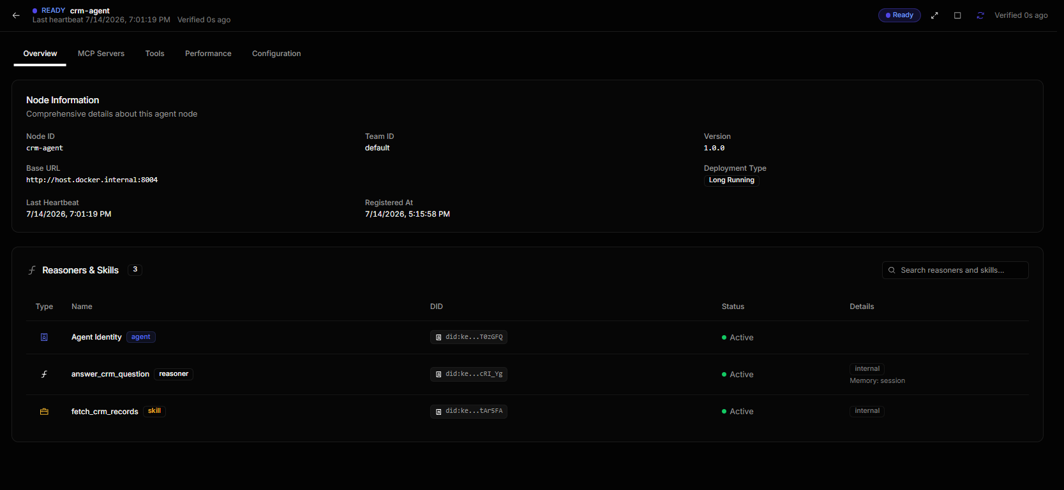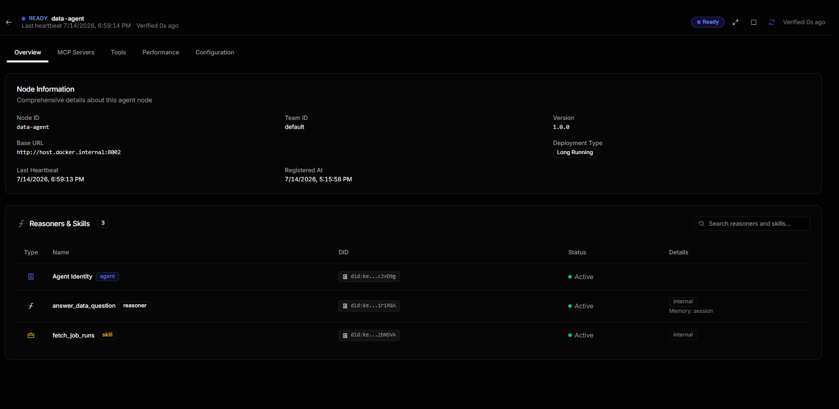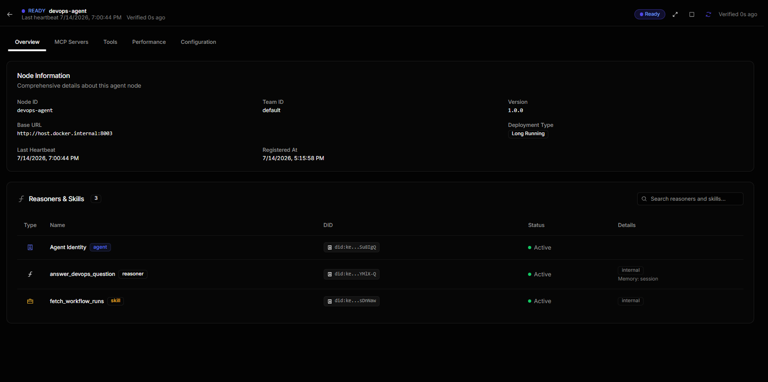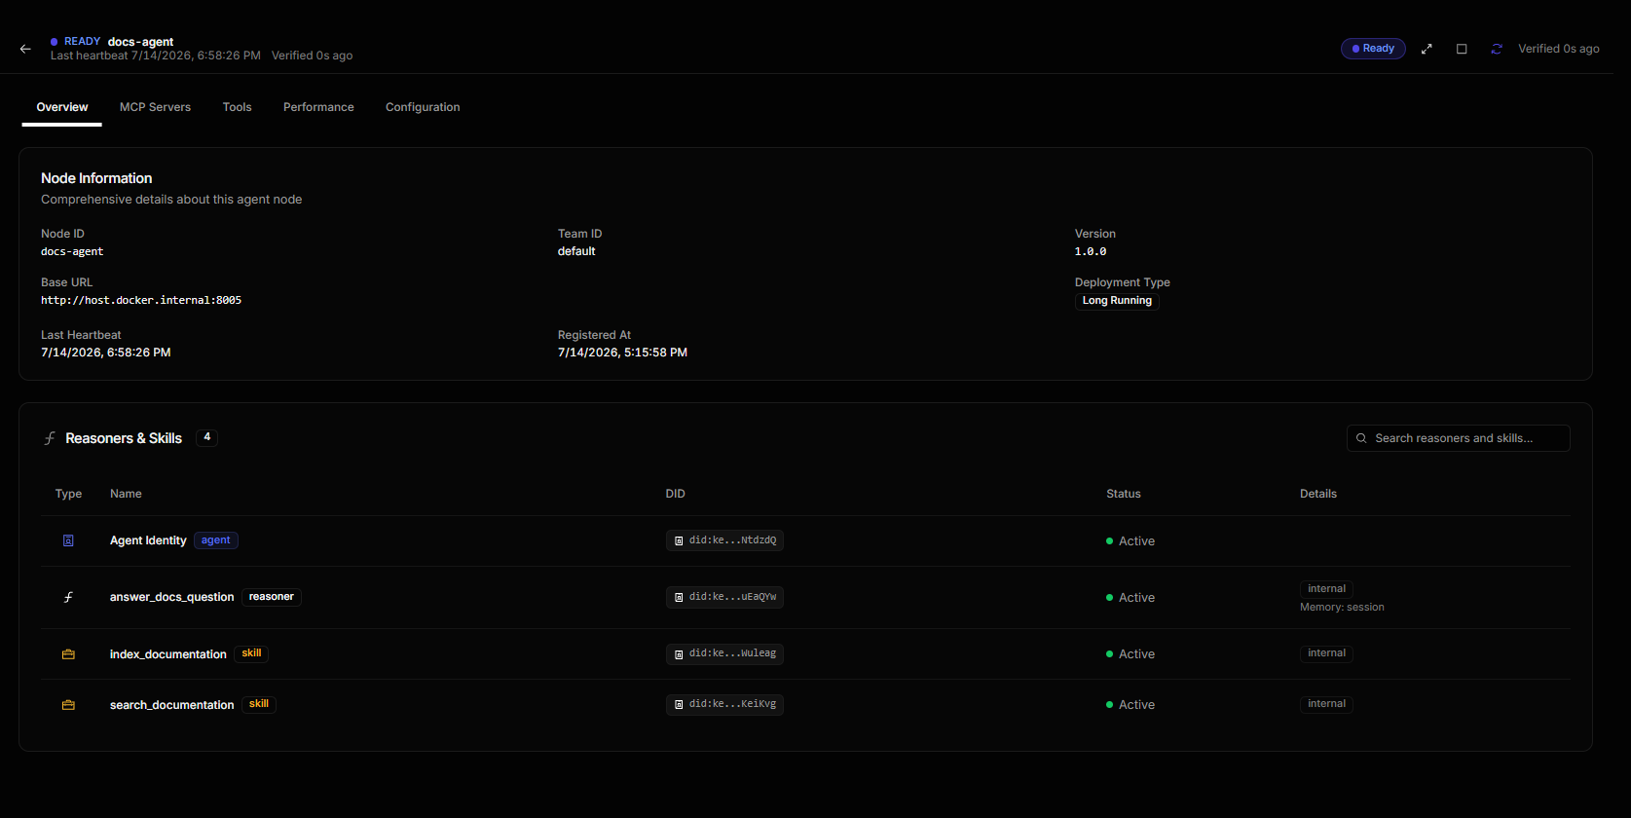
EV-18 — The cross-domain DAG — the coordinator fanning out to all four specialists
What this proves | The Graph view of Q12: the Ask node on coordinator branching to Answer Data Question, Answer Crm Question, Answer Docs Question and Answer Devops Question — all four green, with per-hop durations. Every agent-to-agent call goes through the control plane and is traced. This is the clearest single picture of the multi-agent design.
Deliverable ID (Sec 3) | D-01, D-02, D-07
Date captured | 14/07/2026
Verifiable link | https://github.com/Sridhar-Vetrivel/genAI-enterprise-agent/commit/9c18f839aa09ae9017d2579bac35974af9e2dc41

5. Working Demo & Repository Links
Code repository URL (GitHub/GitLab) | https://github.com/Sridhar-Vetrivel/genAI-enterprise-agent
Latest commit ID + date (as of submission) | https://github.com/Sridhar-Vetrivel/genAI-enterprise-agent/commit/f2c445372786ab35547b975c17ea36eb88feef0b — 14/07/2026 (run: git log -1 --format='%h %ci')
Deployed / hosted URL (if any) | N/A — runs locally via Docker Compose. Azure B1s hosting is Week 11 (see Section 9).
Demo video or recording link (optional) | N/A
Notebook / dashboard / other artefact links | docs/qa/ — one evidence page per Evidence ID, auto-generated from the QA report; docs/qa/traces.md — every test query mapped to its control-plane execution ID

6. QA Progress (up to Week 9)
Test Type (per approved QA strategy) | Tests written / run so far | Coverage achieved (measured) | Target (per proposal) | Evidence ID(s)
Unit tests (routing, retrieval, sources, prompting, QA harness) | 415 passing, 4 skipped | 93.11% (pytest-cov, `make cov`) ✅ | ≥80% overall; ≥50% mid-term interim | EV-14
Routing accuracy — 12 mandatory test queries, live model, through the control plane | 12 of 12 | 100% ✅ | 100% | EV-01 … EV-12, EV-18
Grounding — answers carrying at least one citation | 12 of 12 | 100% ✅ | Every answer cited | EV-01 … EV-12
Hallucination rate — Judge Agent, live model | 10 of 12 answers judged (55 claims) | 3.64% ✅ = (2 ungrounded / 55 claims) × 100 | <10% | EV-13
Integration tests (coordinator → specialists → synthesis) | Included in the 415 | — | — | EV-14

All three graded QA targets are met: routing 100% against a 100% target, coverage 93.11% against an ≥80% target, and a hallucination rate of 3.64% against a <10% target.
Hallucination rate = (ungrounded claims / total claims) × 100, measured by a dedicated Judge Agent that re-fetches the raw source content behind every citation independently of what the answering agent saw — a judge grading against the agent's own context could never catch a fabricated citation. The Judge has two independent halves, and that design is why the number can be trusted. The LLM half splits an answer into claims and checks each against the source. A deterministic half then runs on every answer with no model involved: every date, job id, run id, record count and account code the answer states must appear verbatim in the sources it cited. It can only ever ADD a finding, never remove one — so the reported rate can err pessimistic, never flattering.
Scope: the rate is measured over 10 of the 12 queries (55 claims, 2 ungrounded) and is reported as exactly that, not extrapolated. Each judged query is roughly five local LLM calls on a CPU with no GPU, so a full judged pass is a multi-hour run. On OpenRouter the same pass completes in minutes, and the final submission will carry a full 12-of-12 judged figure.

7. Tool & Budget Reconciliation
Tool / Service (approved) | Approved tier & cost | Used by Wk 9? | Actual cost (₹) | Reason if changed / not yet used
AgentField — orchestration, vector memory, DAG tracing | Open-source, self-hosted, ₹0 | ☑ Yes ☐ No ☐ Partial | ₹0 | As approved. Replaces the RFP's LangChain / MS Agent Framework and Azure AI Search — a swap the approved proposal itself made; restated in Section 8.
OpenRouter (google/gemini-2.5-flash) — primary inference | Pay-per-token, budgeted ~₹800–1,200 | ☐ Yes ☑ No ☐ Partial | ₹0 | NOT PROVISIONED. All inference falls back to the local model at ₹0. No code change is needed to switch: AI_MODEL_COMPLEX is an env var. This is the single biggest deviation — see Section 8.
Ollama — local fallback inference | Free, self-hosted, ₹0 | ☑ Yes ☐ No ☐ Partial | ₹0 | Approved as the fallback; it is currently carrying 100% of inference because OpenRouter is not provisioned. The fallback path is therefore proven, not theoretical.
Llama 4 Scout — the approved local model | Free, ₹0 | ☐ Yes ☑ No ☐ Partial | ₹0 | Not installed on the machine. Gemma 3 is used instead — gemma3:4b for routing, synthesis and judging, gemma3:1b for simple lookups. Disclosed in Section 8.
nomic-embed-text — embeddings (768-dim) [NEWLY ADDED] | Free, self-hosted, ₹0 | ☑ Yes ☐ No ☐ Partial | ₹0 | Not in the approved list, and unavoidable: Gemma 3 cannot produce embeddings at all. Without a separate embedding model there is no RAG index and no Docs agent. Disclosed in Section 8.
Pydantic — structured output (extra="forbid") | Open-source, ₹0 | ☑ Yes ☐ No ☐ Partial | ₹0 | As approved. Every LLM call returns a validated schema, which is what makes the responses machine-verifiable for QA.
Azure B1s VM — hosting | 12-month free tier, ₹0 | ☐ Yes ☑ No ☐ Partial | ₹0 | Not yet provisioned. Runs locally via Docker Compose; the control plane runs identically either way. Planned Week 11 (Section 9).
Pytest + pytest-cov — QA | Open-source, ₹0 | ☑ Yes ☐ No ☐ Partial | ₹0 | As approved. 415 tests passing at 93.11% measured coverage.
GitHub Actions — CI | Free tier, ₹0 | ☑ Yes ☐ No ☐ Partial | ₹0 | As approved. Workflow committed and running the offline suite.
Judge Agent — hallucination detection | Runs on the same LLM, ₹0 | ☑ Yes ☐ No ☐ Partial | ₹0 | As approved, and pulled FORWARD from Week 13 to Week 10 — the hallucination rate is a Section 6 requirement for this submission, so the agent that measures it had to exist first.
Docker / Docker Compose — deployment | Open-source, ₹0 | ☑ Yes ☐ No ☐ Partial | ₹0 | As approved. The control plane and all five agent nodes run under Compose.

7.1 Budget Summary
Approved budget ceiling | ₹2,500
Estimated spend at approval | ~₹800–1,200 (OpenRouter tokens — the only budgeted line)
Actual spend till Week 9 | ₹0
Buffer remaining | ₹2,500 (100% of the ceiling)
Anticipated spend before Week 17 | ₹0–1,200 — ₹0 if the build stays on local inference; up to the original estimate if OpenRouter is provisioned. The budget is not at risk under either path.

8. Deviations from Approved Proposal
Item | Approved plan | Actual implementation | Reason for change
Inference provider | OpenRouter (google/gemini-2.5-flash) as primary; Ollama as the zero-cost fallback | 100% local Ollama. OpenRouter has never been called. | OpenRouter was not provisioned. The approved fallback is carrying the entire build, and carrying it successfully — all three QA targets are met. No code change is needed to switch: AI_MODEL_COMPLEX is an env var. Cost impact: ₹0 spent against a ~₹1,000 estimate.
Local model | Llama 4 Scout | Gemma 3 — gemma3:4b for routing, cross-domain synthesis and judging; gemma3:1b for simple single-record lookups | Llama 4 Scout is not installed on the machine; Gemma 3 is. Two tiers rather than one, so cheap work runs on the cheap model.
Embedding model | (None named — the approved proposal assumed the LLM could embed) | nomic-embed-text (768-dim), pulled locally, ₹0 | Gemma 3 cannot produce embeddings. A separate embedding model is not optional: without it there is no RAG index and no Docs agent.
Structured-output schemas | Pydantic with enumerated domain values | Pydantic with list[str] plus a validator enforcing the same four-domain vocabulary | Ollama 0.23 returns HTTP 500 for any JSON schema containing `enum`. The same guarantee is enforced one layer up, in a Pydantic validator, and schemas reaching the model are stripped of enum/const.
Hosting | Azure B1s VM (12-month free tier) | Local Docker Compose. The Azure VM is not provisioned. | Deferred to Week 11. It blocks no Weeks 4–9 deliverable — the control plane runs identically under Compose either way.
Judge Agent timing | Week 13 | Built in Week 10 | Pulled forward: the hallucination rate is a Section 6 requirement for THIS submission, so the agent that measures it had to exist first.
Orchestration framework | AgentField | AgentField — no change | Restating the approved proposal's own swap for completeness: the RFP named LangChain / MS Agent Framework and Azure AI Search; the approved proposal replaced both with AgentField and its built-in vector memory.
Response latency | (Not specified) | 2–4 min single-domain; 8–15 min cross-domain | A consequence of running a 4B model on a CPU with no GPU, not a design flaw. A cross-domain query is several LLM calls that cannot be collapsed — the coordinator cannot synthesise until the specialists answer. On a hosted endpoint each call is sub-second and the same queries return in seconds, with better answers.
Data sources | Live REST APIs (Databricks, GitHub/Azure DevOps, CRM) | Synthetic fixtures, causally linked so cross-domain reasoning is genuinely exercised | Per the approved proposal's own mock-data-only rule (§7) — no real customer or internal data is ever sent to an external LLM. The live REST paths ARE implemented and unit-tested against a mocked transport; set USE_MOCK_SOURCES=false and supply credentials to go live.

9. What Is NOT Completed Yet + Plan for Weeks 11–16
Pending item (be specific) | Why it is pending | Plan to complete (target week)
OpenRouter provisioning (the outstanding part of D-01) | Account and credits not provisioned. This is the only item blocked on someone else. | Provision, set AI_MODEL_COMPLEX=google/gemini-2.5-flash, re-run the QA suite and compare both sets of numbers. No code change — Week 11.
Azure B1s VM hosting (the outstanding part of D-01) | Not provisioned. Not required by any Weeks 4–9 deliverable. | Provision the free-tier VM, deploy the Compose stack, expose the control plane — Week 11.
Full 12-of-12 judged hallucination figure | The rate is measured over 10 of 12 queries. A judged query is ~5 local LLM calls on CPU, so a complete pass is a multi-hour run. | Re-run the full judged suite on OpenRouter, where the whole pass takes minutes — Week 11.
CI hardening | The workflow is committed and runs the offline suite, but does not yet gate on coverage or run the live-model tests. | Add a coverage gate and a nightly live-model job — Week 12.
Live REST source integration | Implemented and unit-tested against a mocked transport, but never run against real credentials. | Point at real Databricks / GitHub / CRM endpoints in a sandbox — Weeks 13–14.
Final demo and documentation | Week 17 deliverable. | Weeks 15–17.

10. Risks & Blockers
Risk / Blocker | Status (Open / Mitigated / Realised) | Mitigation taken so far | Impact on remaining timeline / support needed
OpenRouter not provisioned | Open — the only external dependency | The zero-cost local fallback carries the entire build, and all three QA targets are met on it. Every model reference is an env var (AI_MODEL_COMPLEX), so switching is a config edit with no code to write. Budget impact is ₹0 against a ₹2,500 ceiling. | L&D SUPPORT NEEDED: provision OpenRouter credits. This is the only item blocked on someone else, and the architecture is already built to absorb it the moment it lands.
Answer quality on a 4B local model | Mitigated | A grounding pipeline enforces what a small model cannot be trusted to do unaided: every citation is validated against the answer's own record ids, so an answer cannot cite a source it did not actually use. Each safeguard carries a regression test. | None. A frontier model via OpenRouter needs LESS of this scaffolding, not more — answer quality improves and the safeguards become a cross-check rather than a corrective.
Judge precision on a 4B local model | Mitigated | The LLM judge is backed by a deterministic fact check: every date, id and record code in an answer must appear verbatim in the cited source. No model is involved, and it can only ever ADD a finding, never remove one — so the reported rate errs pessimistic, never flattering. | None. This is precisely why 3.64% can be trusted. On a frontier model the two halves are expected to agree, turning a safety net into a corroboration.
gemma3:4b needs ~4 GiB of free RAM | Open (environmental) | If the model will not load, the gateway degrades to gemma3:1b and LOGS A WARNING rather than failing silently — a degraded run announces itself instead of quietly producing weak evidence. | None. Disappears entirely on hosted inference.
Response latency (2–4 min single-domain, 8–15 min cross-domain) | Open (environmental) | A per-query hard stop ensures one slow query cannot hang the suite, and a timed-out query is RECORDED as timed out, never silently skipped. | None. This is CPU-bound local inference, not architecture — see Section 8. The same queries return in seconds on a hosted endpoint.
Demo runs on synthetic data | Mitigated (by design) | Per the approved proposal's mock-data-only rule (§7) — no real customer or internal data is ever sent to an external LLM. The fixtures are causally linked, so cross-domain reasoning is genuinely exercised rather than faked. Live REST paths are implemented and unit-tested. | None.

11. Declaration & Pre-Submission Checklist
☑ All fields in Section 1 match my L&D Final Decision record exactly (correct Topic ID, no original/corrected mismatch).
☑ Section 3 lists every deliverable my approved proposal committed for Weeks 4–9, each with a D-ID and a status.
☑ Every "Done" or "Partial" status in Section 3 points to at least one Evidence ID in Section 4.
☑ Every evidence block in Section 4 has a specific caption, a pasted full-size screenshot, and a verifiable link where applicable.
☑ The repository link in Section 5 is accessible to the L&D team and the stated commit exists.
☑ Section 6 coverage figures are measured (tool output attached as evidence), not estimated.
☑ Section 7 lists every tool from my approved proposal, including ones I did not use.
☑ Section 8 discloses every deviation, including advisories I chose not to act on.
☑ Section 9 is consistent with Sections 3 and 4 — no contradictions.
☑ I have deleted all grey italic instruction text.
☑ I have not renamed, deleted, or reordered any section of this template.
☑ Document is saved as [TopicID]_[ParticipantName]_MidTermDoc.docx and uploaded to Moodle before the deadline.
Declaration: I confirm that all progress claims, evidence, costs, and coverage figures in this document are true and reflect my own individual work.
Participant signature / name | Sridhar Vetrivel
Date of submission | 15/07/2026
Submission deadline: End of Week 9 / start of the Week 10 review window (13-Jul-26), as per programme schedule. Late or incomplete documentation may affect your mid-term evaluation score.

