File Management:

Create, rename, or delete multiple files based on a pattern or criteria.

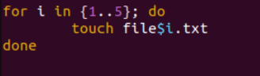

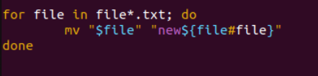

rm *.txt (delete all .txt files in directory)

Organize files into a specific directory structure.



Back up or archive important files.



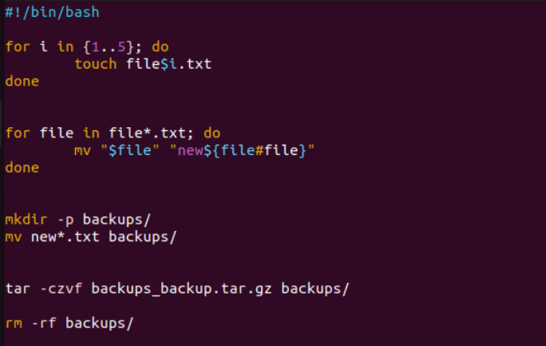

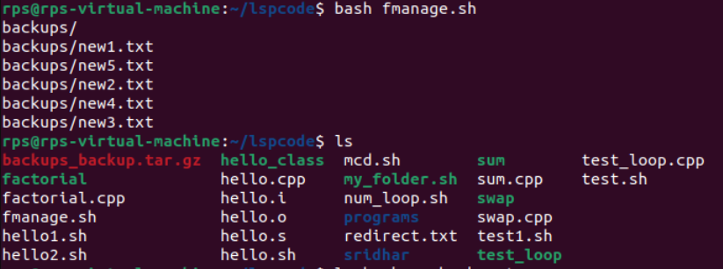

Text Processing:

Search and replace text within a group of files.

for file in *.txt; do

sed -i 's/foo/bar/g' "$file"

done

Extract specific information from log files or data sets.

grep "ERROR" *.log

Format text files in a particular way

Add a header to all .txt files

for file in *.txt; do

sed -i '1i This is the header' "$file"

done

Align columns to space separated file

awk '{ printf "%-10s %-10s\n", $1, $2 }' file.txt

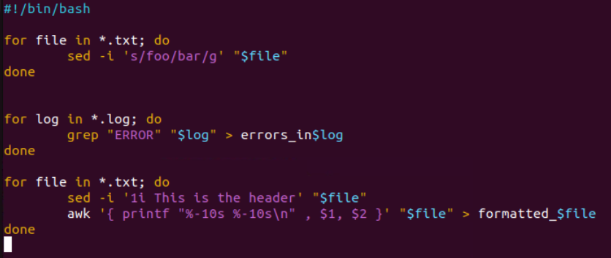

Output a text file

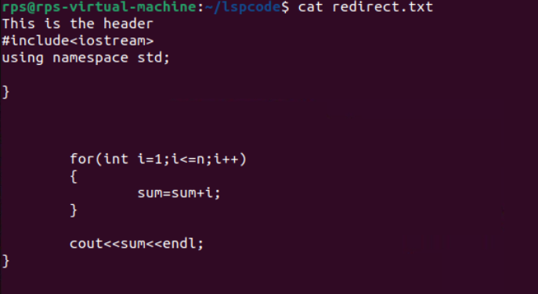

Command $? –is to check if the command is executed successfully

echo $? Prints the value 0 if it is executed successfully

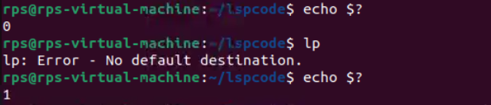

Script to check successful command on random

File name success_failure.sh

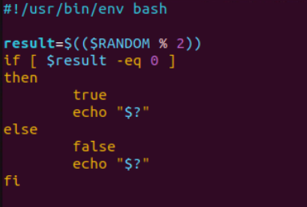

Output

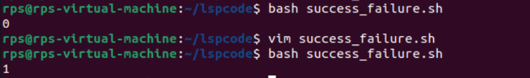

Exercise: Write a shell script called file_checker.sh that checks if a file exists or not. The script take in a file name as an argument and try to run cat on that file. The script should then check the exit code of the cat command to determine if the file exists or not. If the file exists, the script should print File exists!. If the file does not exist, the script should print File does not exist!.

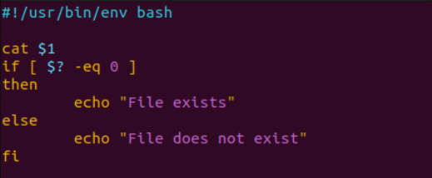

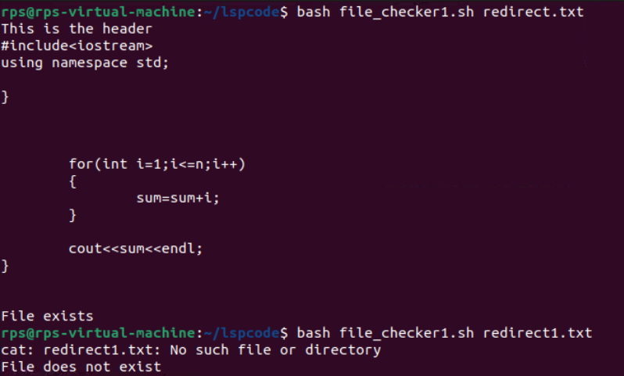

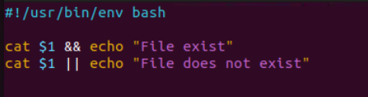

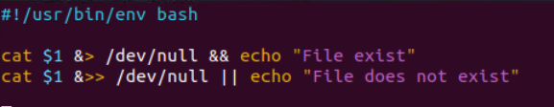



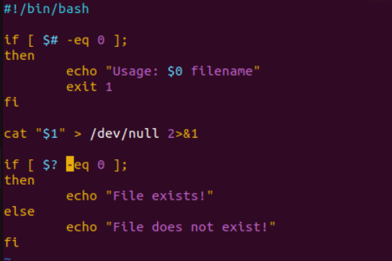

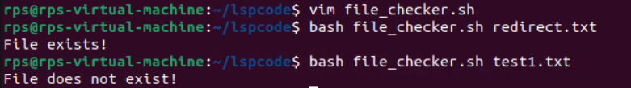

$$ is the PID of the current process.

$? is the return code of the last executed command.

$# is the number of arguments in $*

$* is the list of arguments passed to the current process

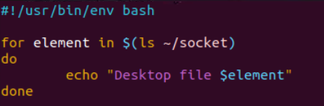

Write a shell script called

timely_greeting.sh that greets you based on the current time. The script should call the date command, extract the current hour (look into using %H) and then print the following greeting based on the time.

If it is between 5AM (05:00) and 12PM (12:00): Good morning!

If it is between 12PM (12:00) and 6PM (18:00): Good afternoon!

If it is between 6PM (18:00) and 5AM (5:00): Good night!

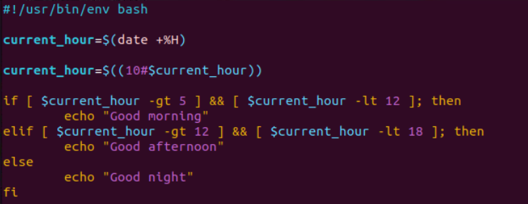



Calculator script

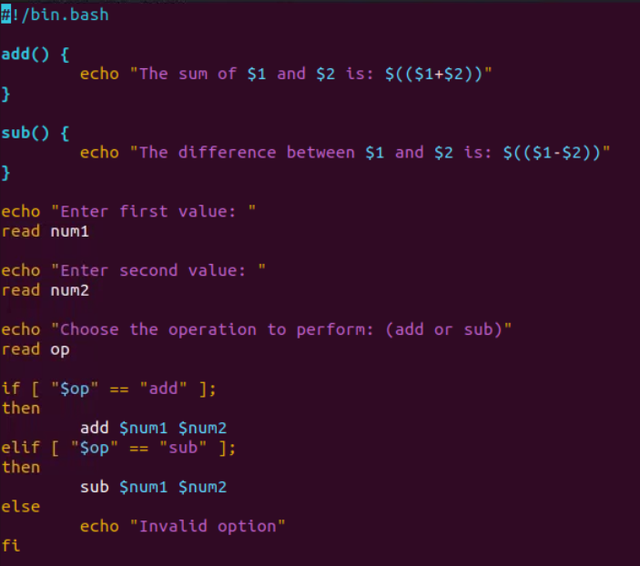

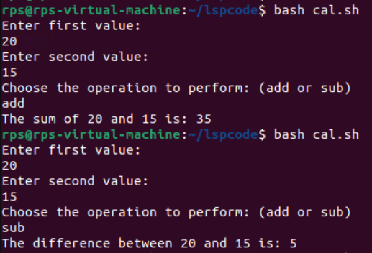

Extend the script to include multiplication and division operations, and handle division by zero appropriately.

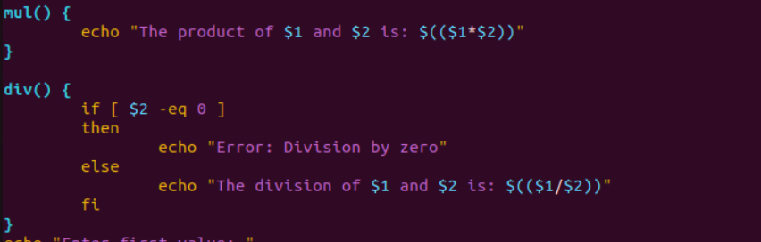

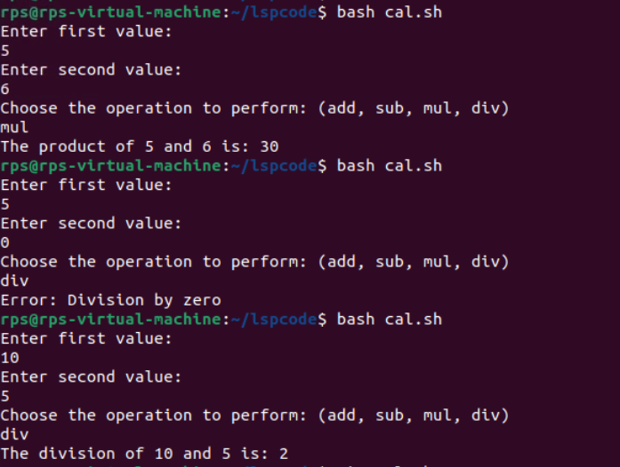

Title: Create, Write, and Read Files Using Shell Script

Objective:

Develop a shell script that can create a file, write user-provided content into the file, and then read and display the content of the file.

