Basic Signal Handling

Simple Signal Handler: Write a C++ program that handles the SIGINT signal (Ctrl+C) gracefully by printing a custom message before exiting.

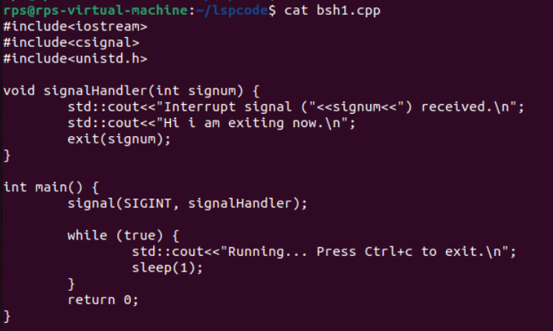

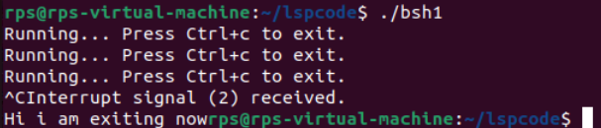

Multiple Signal Handling: Create a program that handles both SIGINT and SIGTERM signals, printing a different message for each.

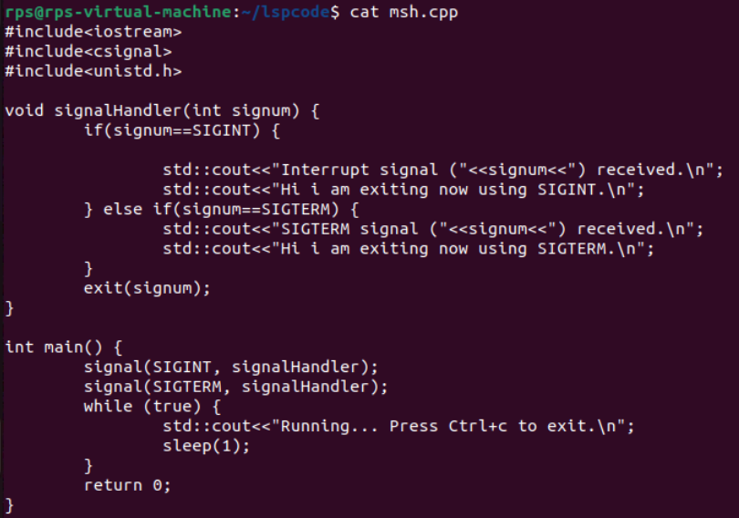

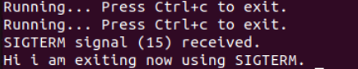

Ignoring Signals: Develop a program that ignores the SIGTERM signal and continues execution even after it's sent.

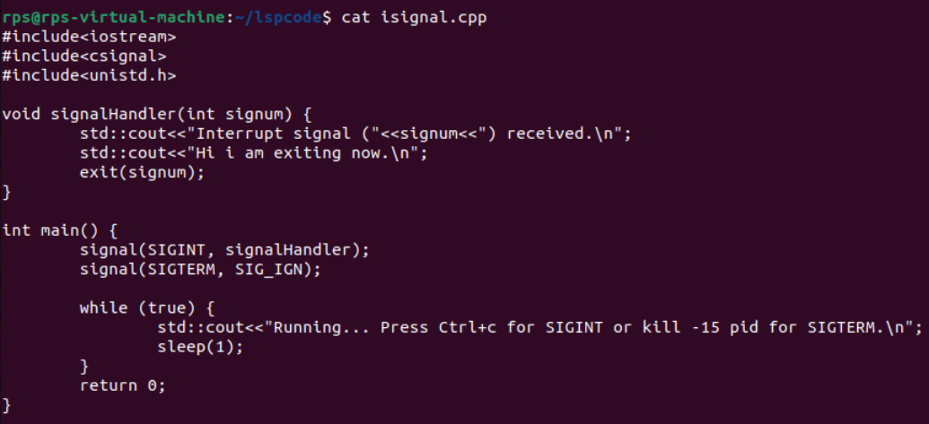

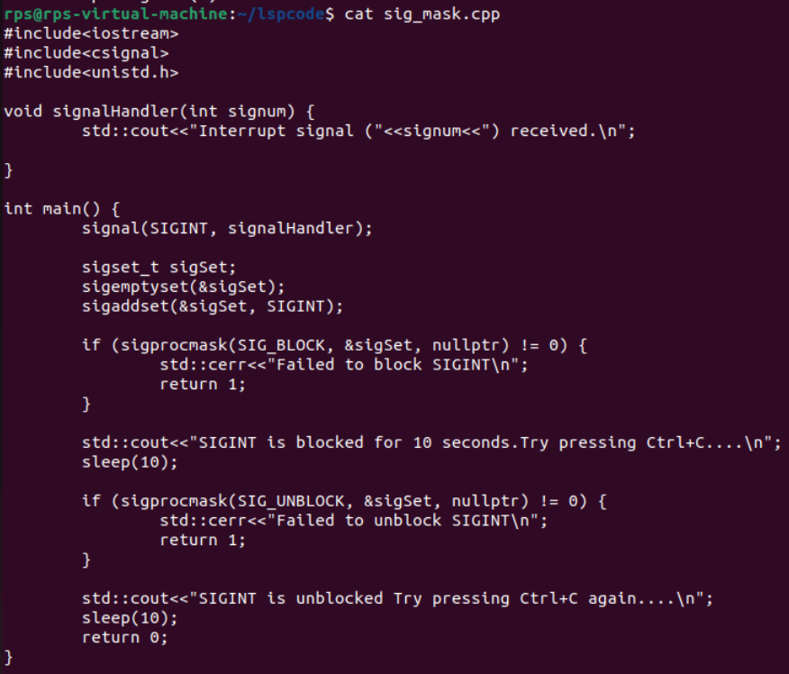

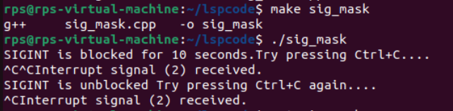

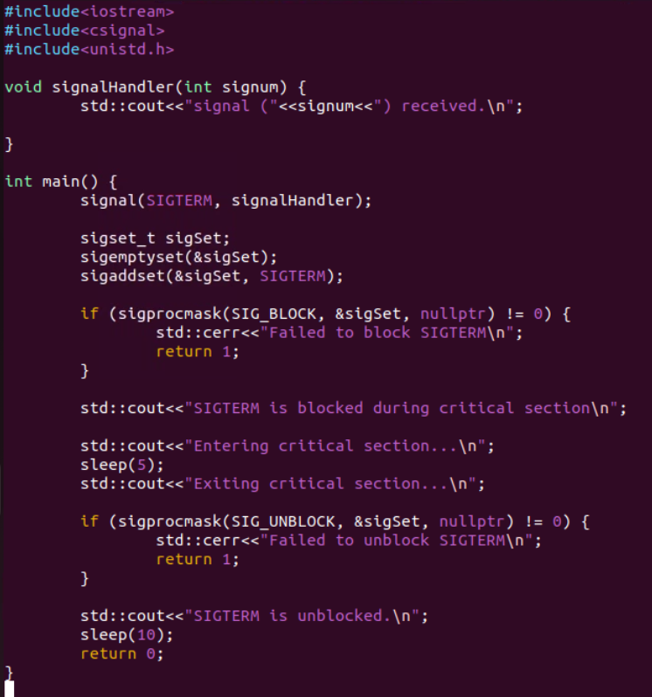

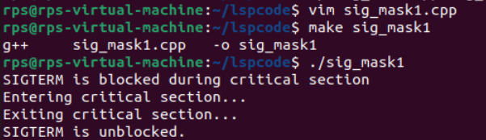

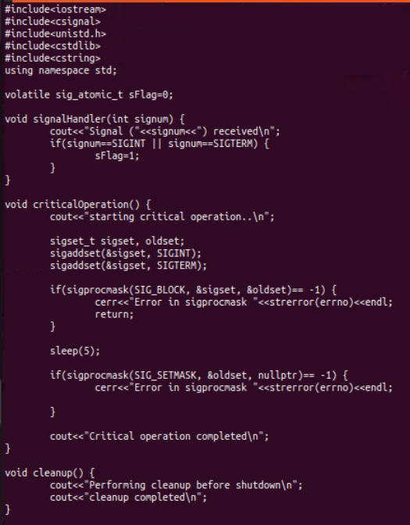

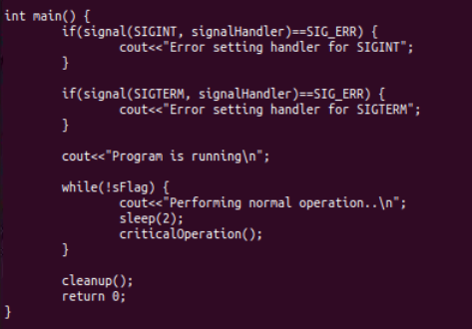

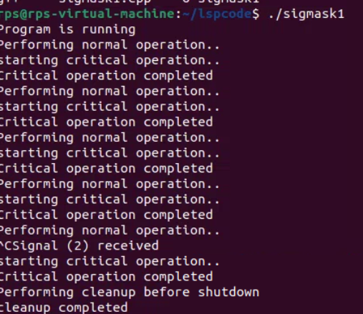

Signal file handler

