Sridhar M_WiproTraining(3)_Satinnder

**DAY 1**

Differences between Dual Core and Quad Core Processors:

|  |  |
| --- | --- |
| **Dual Core** | **Quad Core** |
| It consists of 2 cores, each designated to perform a specific task. | It consists of 4 cores which give the ability to perform multiple jobs concurrently. |
| The clock speed and computation capability are slower than Quad-core. | It is much faster than dual-core systems and computational efficiency is high. |
| Parallel processing capability is not available in these processors. | It has 4 cores which give it the capability of parallel computing. |
| The hardware of these processors does not get heated as they produce little heat. | Heat ejection is high and due to this, these processors make the hardware gets heated. |
| Resource-efficient as it uses less power as compared to Quad-core systems. | Resource utilization is more as compared to dual-core because the number of cores is more. |
| The graphic support of the dual-core system is weak and it cannot run heavy graphics. | The graphic support of the quad-core system is high and it is used to run heavy graphics. |

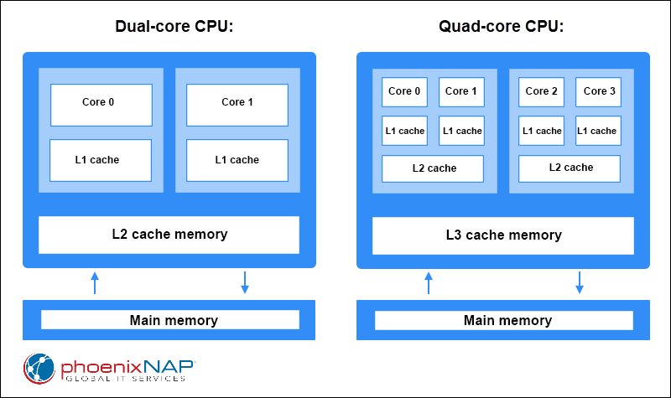

Differences between i5 and i7 Processors:

|  |  |
| --- | --- |
| **i5** | **i7** |
| Typically, i5 processors are equipped with four to six cores and lack hyper-threading, resulting in four to six threads. | i7 processors usually boast six to eight cores and support hyper-threading, effectively doubling the number of threads (twelve to sixteen threads). |
| i5 processors tend to have slightly lower base and boost clock speeds compared to i7 processors. | i7 processors generally feature higher base and boost clock speeds, providing faster performance especially in demanding applications. |
| i5 processors typically come with a smaller cache size compared to i7 processors, impacting the speed of data access. | i7 processors usually have a larger cache size, allowing for quicker data retrieval and improved overall performance. |
| i5 processors are more budget-friendly compared to i7 processors, making them an attractive option for users seeking a balance of performance and affordability. | i7 processors come at a higher price point due to their increased performance capabilities and additional features. |
| i5 processors are well-suited for mainstream users, light gamers, and those engaged in moderate multitasking and content creation. | i7 processors are designed for power users and professionals involved in resource-intensive tasks like video editing, 3D modeling and heavy multitasking. |

**DAY 2**

**IP classes**

1. **1-127**
2. **128-191**
3. **192-223**
4. **224-239**
5. **240-255**

**Class A**

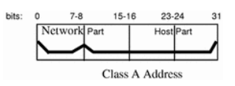

**Class B**

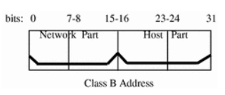

**Class C**

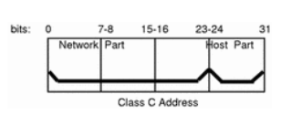

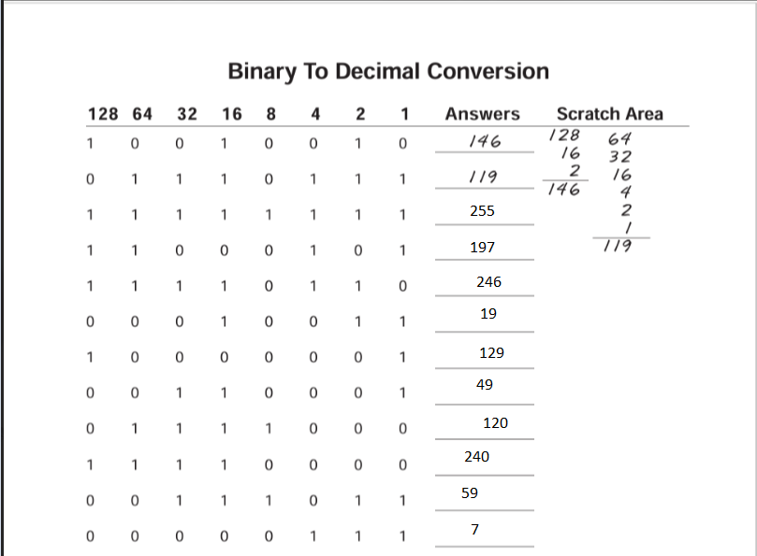

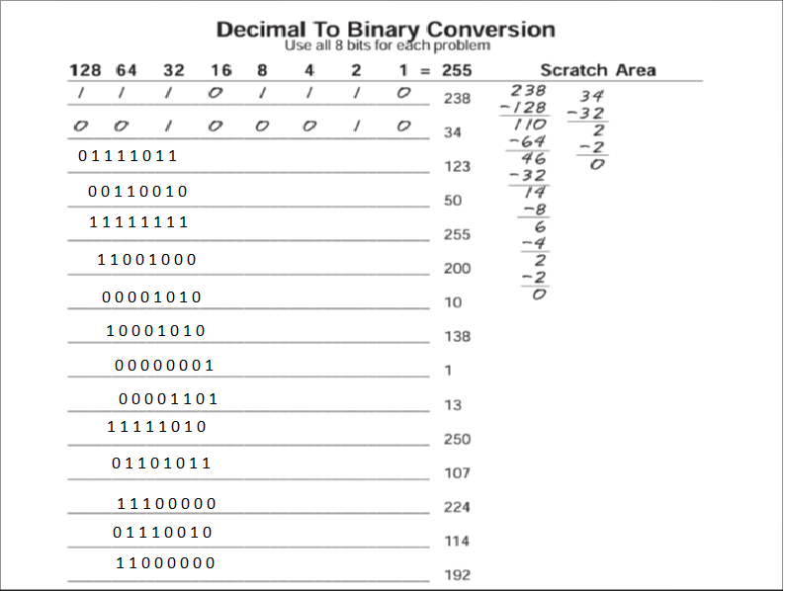

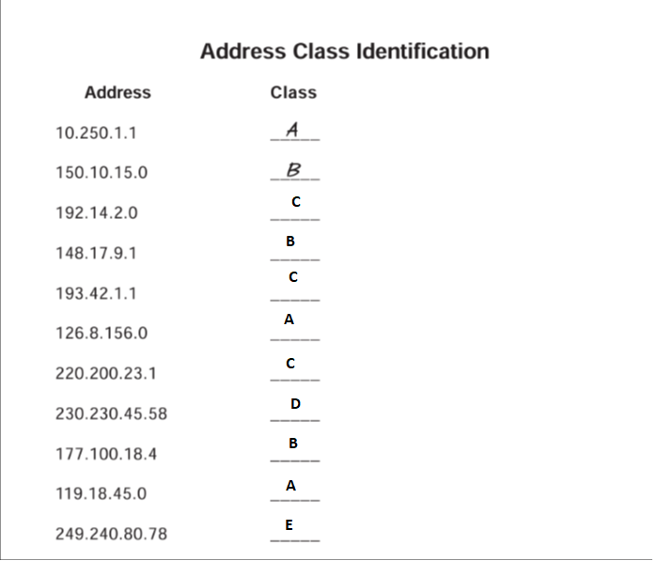

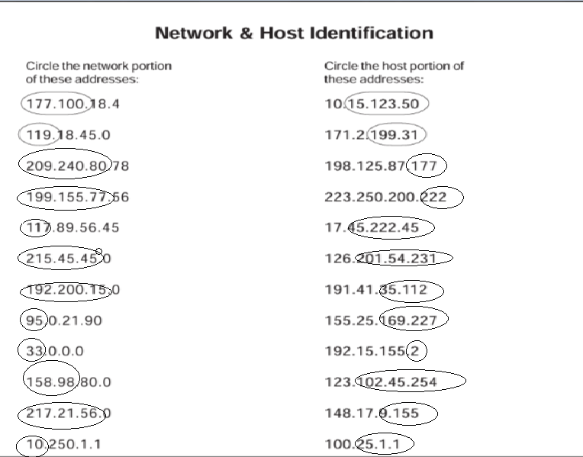

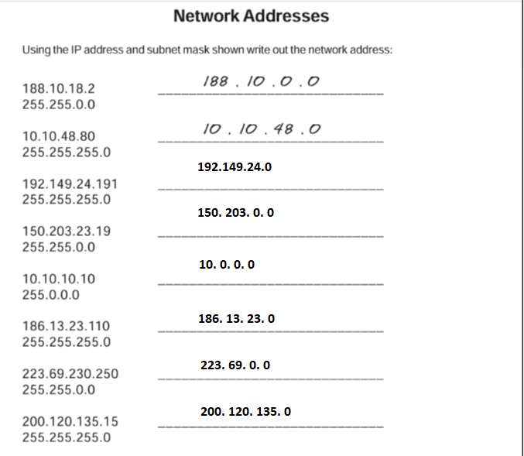

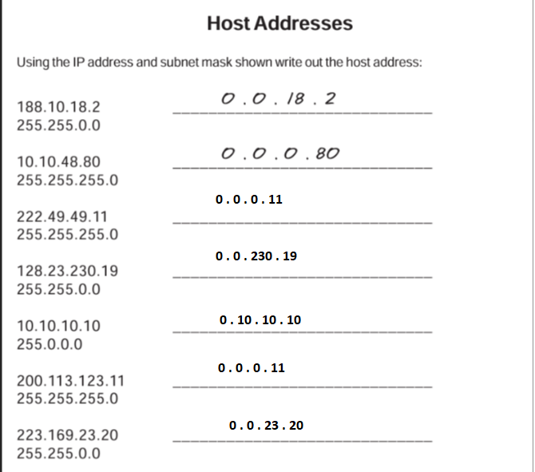

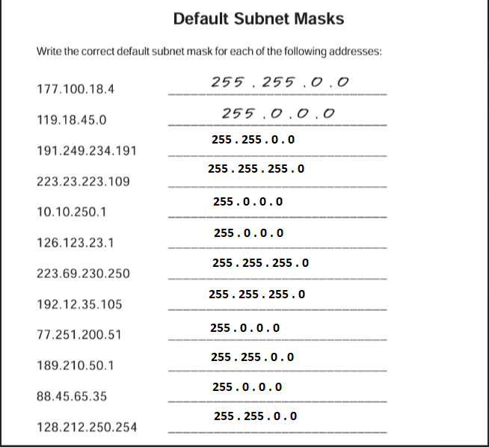

**DAY 3**

**LAB ACTIVITY**

1. **Router to Router, Router to Switch, Router to PC, PC to Switch**

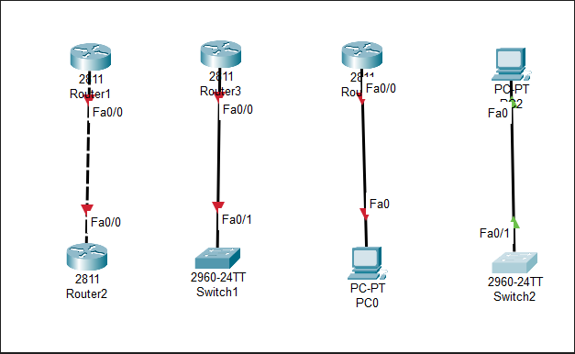

1. **PC-Router-PC**

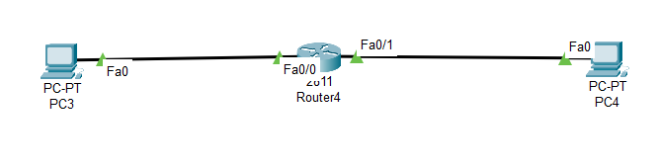

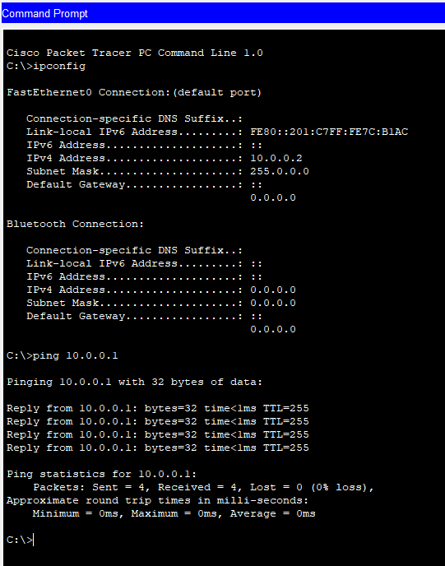

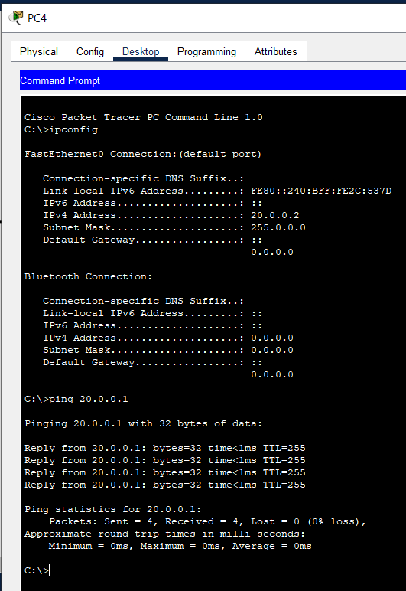

**3.**

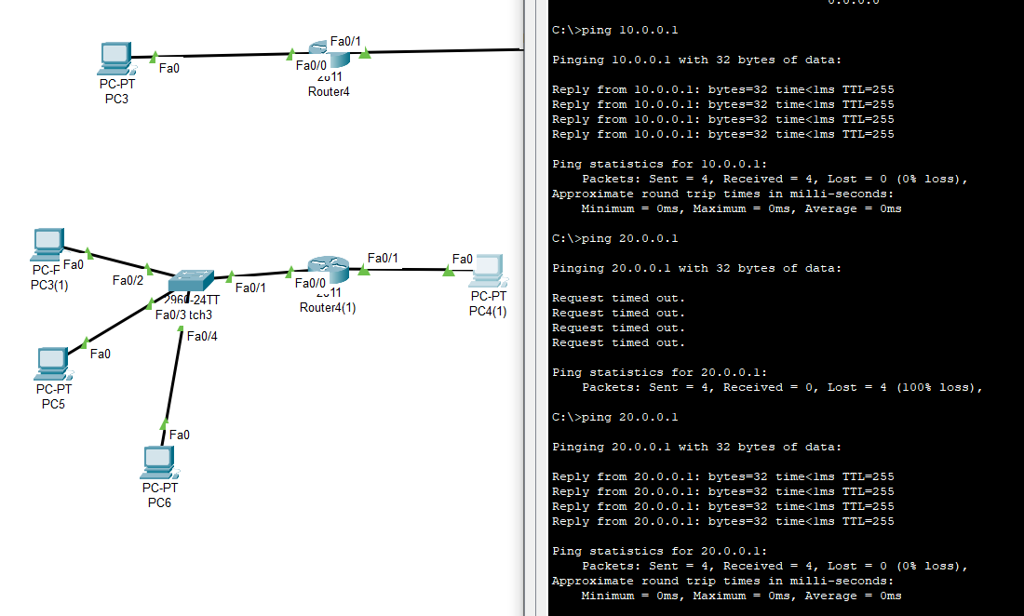

**4.**

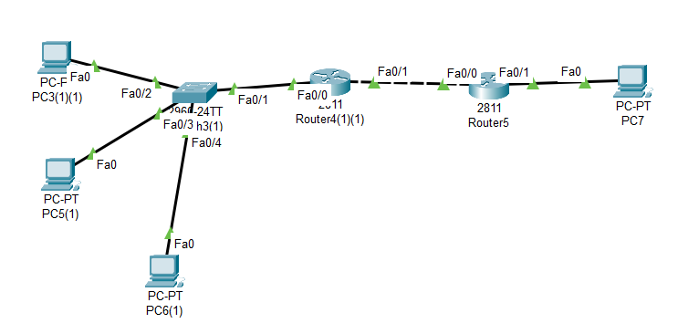

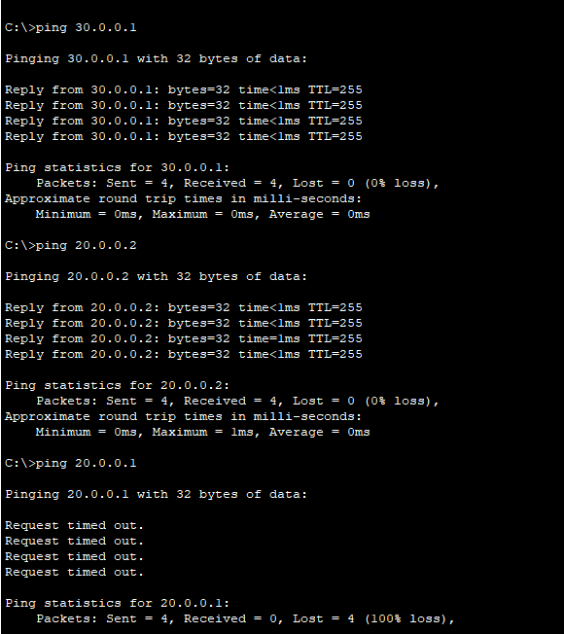

**DAY 4**

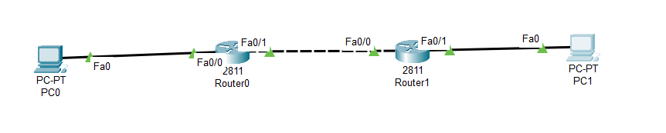

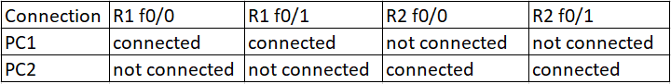

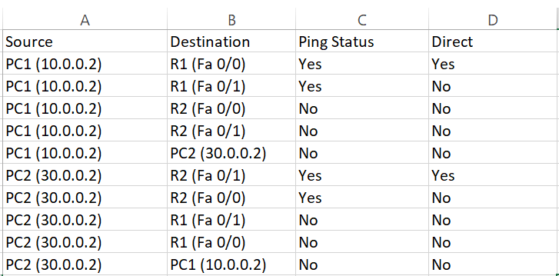



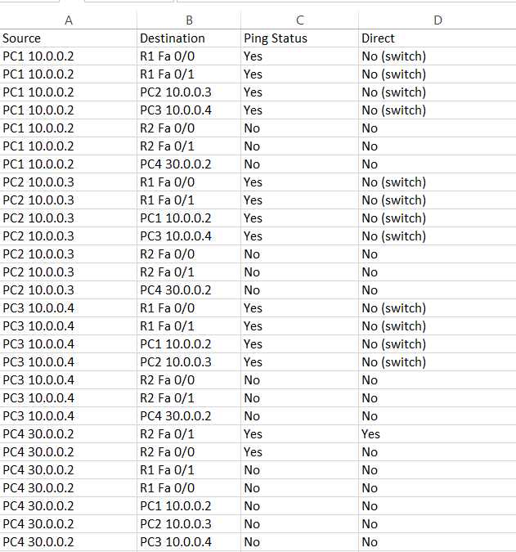

**Static Routing**

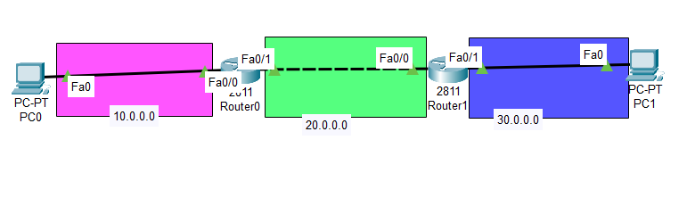

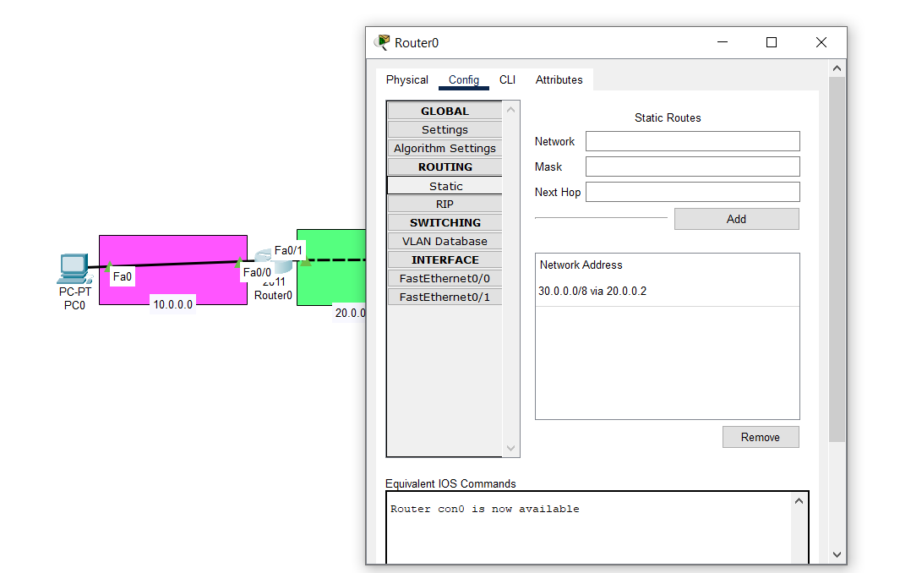

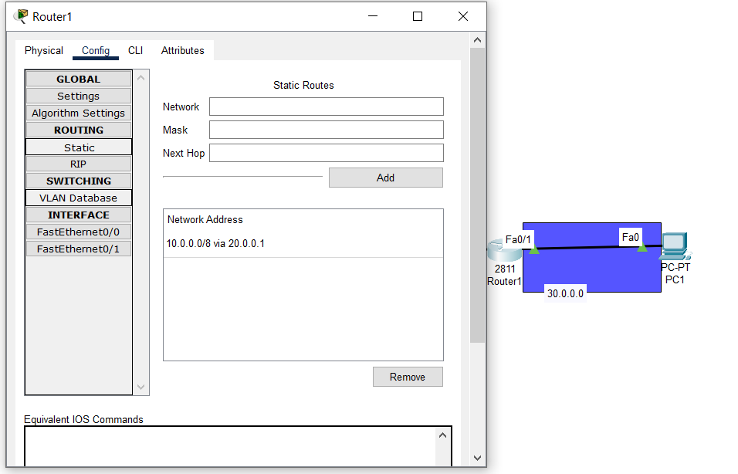

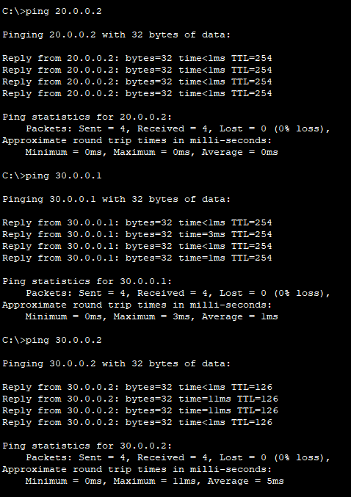

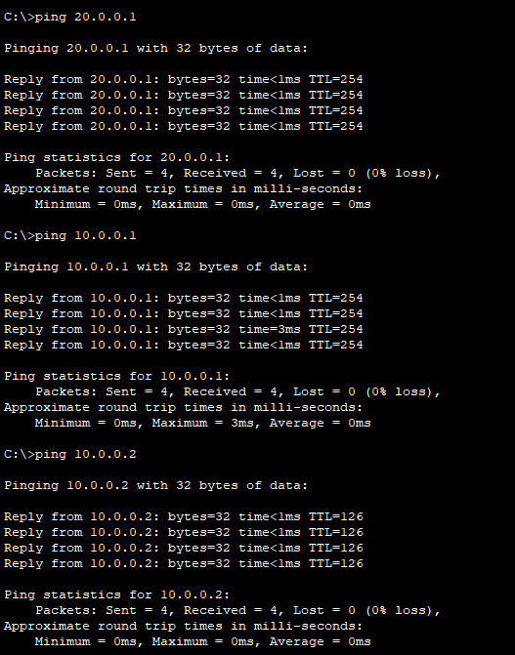

**DAY 5**

**OSI- Open System Interconnection**

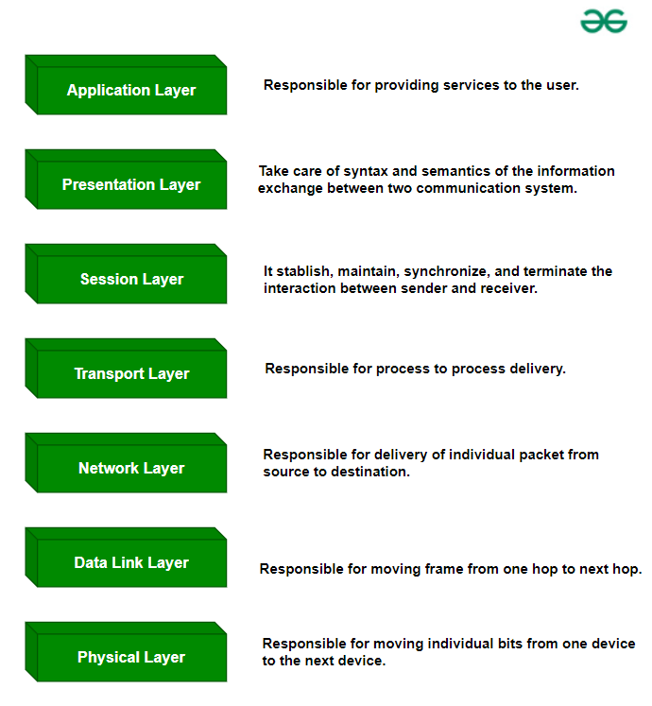

**OSI Layers Services**

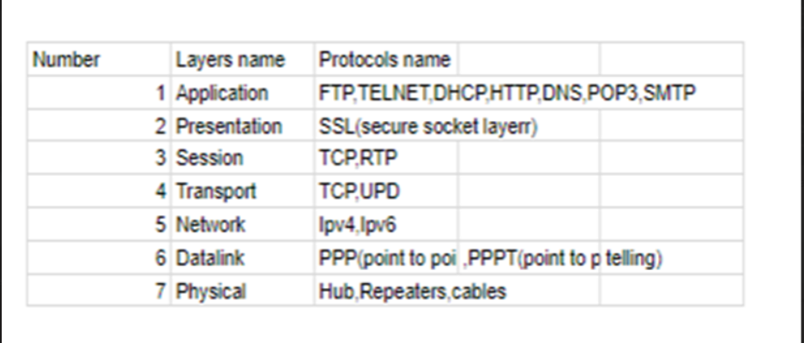

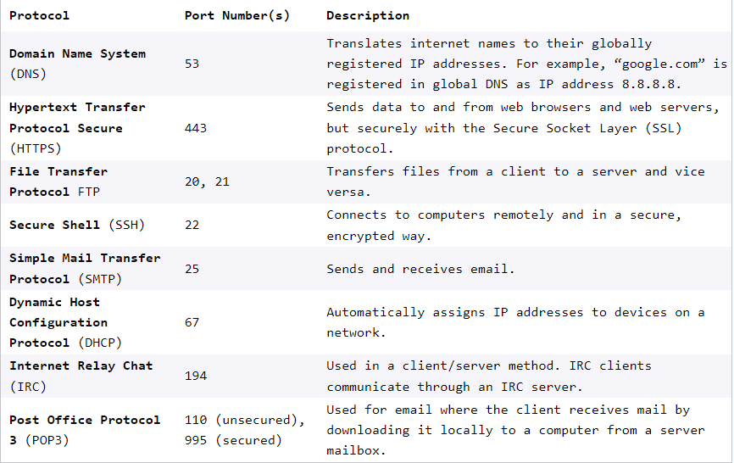

**TCP/IP - Transmission Control Protocol/Internet Protocol**

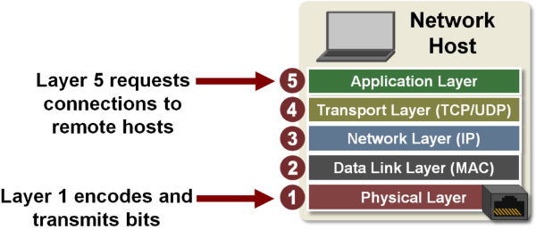

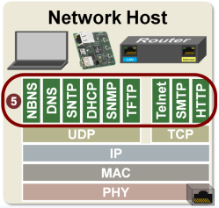

**OSI VS TCP/IP**

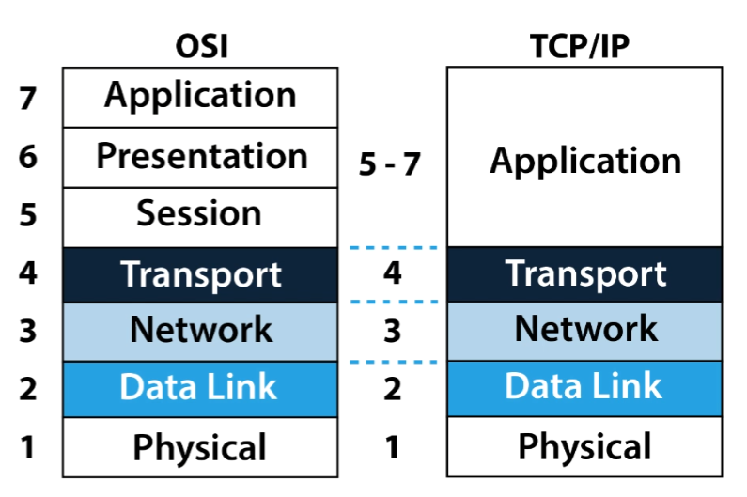

| **TCP/IP** | **OSI** |
| --- | --- |
| TCP refers to Transmission Control Protocol. | OSI refers to Open Systems Interconnection. |
| TCP/IP uses both the session and presentation layer in the application layer itself. | OSI uses different session and presentation layers. |
| TCP/IP follows connectionless a horizontal approach. | OSI follows a vertical approach. |
| The Transport layer in TCP/IP does not provide assurance delivery of packets. | In the OSI model, the transport layer provides assurance delivery of packets. |
| Protocols cannot be replaced easily in TCP/IP model. | While in the OSI model, Protocols are better covered and are easy to replace with the technology change. |
| TCP/IP model network layer only provides connectionless (IP) services. The transport layer (TCP) provides connections. | Connectionless and connection-oriented services are provided by the network layer in the OSI model. |

interface FastEthernet0/0

ip address 10.0.0.1 255.0.0.0

ip nat inside

duplex auto

speed auto

!

interface FastEthernet0/1

ip address 20.0.0.1 255.0.0.0

ip nat outside

duplex auto

speed auto

!

interface Vlan1

no ip address

shutdown

!

ip nat inside source list 1 interface FastEthernet0/1 overload

ip classless

ip route 30.0.0.0 255.0.0.0 20.0.0.2

!

ip flow-export version 9

!

!

access-list 1 permit 10.0.0.0 0.255.255.255

**NAT**

**Network Address Translation**

