**National Institute of Technology Silchar**

****

**WEB DEVELPOMENT**

An Industrial Training and Summer Intern Report

In partial fulfillment of Summer Internship for the award of the degree of

**Bachelor of Technology in Department of Electronics and Communication Engineering**

Submitted By: Guided By: *Guru Naga Satya Sridhar* *Mr. Rahul Kumar Singh* *Scholar Id:1914159 Senior Software Developer*

*7th Semester BOLT-IOT.*

*ECE-B Section*

**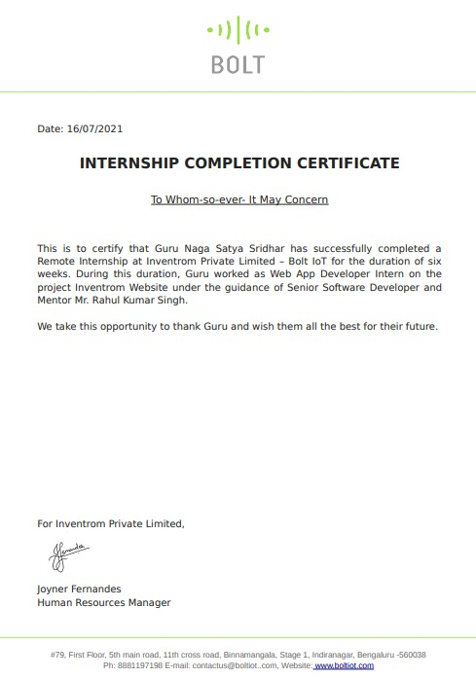**

**INDEX**

**CONTENTS**  **PAGE NO**

1.Declaration 4

2.Introduction 5-6

3.Literature Review 6-8

4.Methodology 9-13

5.Results 14-16

6.Conclusion 16

7.References 16

1. **DECLARATION:-**

It is hereby declared that this report represents the work done by me while

being an intern at BOLT IOT, and the work being depicted is strictly a property

of the organization, and is mostly based solely on the ideas of the individuals

and correspondents of the organization.

It however, needs to be emphasized that the work-style, the solution to the

problem statements presented during the internship and the manner of

implementation belong primarily to me, while also adhering to all the

principles of academic honesty and integrity alongside the NDA policies of the

organisation.

**Guru Naga Satya Sridhar (1914159)**

****

**2)INTRODUCTION:-**

**WEB DEVELOPMENT** refers to the building, creating, and maintaining of websites. It includes aspects such as web design, web publishing, web programming, and database management. It is the creation of an application that works over the internet i.e. websites. In other words, **WEB DEVELOPMENT** refers in general to the tasks associated with developing websites for hosting via internet. The web development process includes web design, web content development, client-side/server-side scripting and network security configuration, among other tasks. **WEB DEVELOPMENT** is also known as website development, while the professionals that maintain a website are called web developers or (more commonly) web dev’s.

Web development ranges from creating plain text pages to complex web-based applications, social network applications and electronic business applications. Web developers, or ‘dev’s’, do this by using a variety of coding languages. The languages they use depends on the types of tasks they are preforming and the platforms on which they are working, The Web development hierarchy is as follows:

* **Client-side Coding:** It is the program that runs on the client machine (browser) and deals with the user interface/display and any other processing that can happen on client machine like reading/writing cookies. Programming languages for server-side programming are HTML, CSS, Java script, and AJAX etc.
* **Server-side Coding:**  It is the program that runs on server dealing with the generation of content of web page. Programming languages for server-side programming are, C++, Python and Java etc.
* **Database technology:** Ittake information and store, organize, and process it in a way that enables users to easily and intuitively go back and find details they are searching for. Database technologies come in all shapes and sizes, from complex to simple, large to small. Some examples of popular database software or DBMSs include MySQL, Microsoft Access, Microsoft SQL Server, FileMaker Pro, Oracle Database, etc.

**2.1)TYPES OF WEB DEVELOPMENT:-**

* **Front-end Development:** Front-end web development is known as client-side web development. It is a procedure of designing the user interface of the website with front-end technologies like HTML, CSS, and JavaScript.
* [**Backend Development**](https://www.geeksforgeeks.org/which-one-is-most-demanding-back-end-web-framework-between-laravel-nodejs-and-django/)**:** Back-end development is also known as server-side web development. The responsibilities of back-end developers are writing code and building the logical parts of the entire website. It mainly focuses on back-end logic, databases, servers, and APIs.
* **Full-Stack Development::** Full-stack web development means the development of the front end and back end. The full-stack web developer should have knowledge of web design, web development, database, and website debugging.

**3)LITERATURE REVIEW:-**

**3.1)HTML:-**

HTML is an acronym which stands for **Hyper Text Markup Language** which is used for creating web pages and web applications. Hypertext defines the link between the web pages and markup language defines the text document within the tag that define the structure of web pages. A web page is a document which is commonly written in HTML and translated by a web browser. A web page can be identified by entering an URL. A Web page can be of the static or dynamic type. **With the help of HTML only, we can create static web pages.**

**3.1.1)Features of HTML:-**

1) It is a very **easy and simple language**. It can be easily understood and modified.

2) It is very easy to make an **effective presentation** with HTML because it has a lot of formatting tags.

3) It is a **markup language**, so it provides a flexible way to design web pages along with the text.

4) It facilitates the programmer to add **Graphics, Videos, and Sound** to the web pages which makes it more attractive and interactive.

5) HTML is a case-insensitive language, which means we can use tags either in lower-case or upper-case.

**3.2)CSS:-**

CSS stands for Cascading Style Sheets. It is a style sheet language which is used to describe the look and formatting of a document written in markup language. It provides an additional feature to HTML. It is generally used with HTML to change the style of web pages and user interfaces. It can also be used with any kind of XML documents including plain XML, SVG and XUL. CSS is used along with HTML and JavaScript in most websites to create user interfaces for web applications and user interfaces for many mobile applications.

**3.2.1)Use of CSS in HTML:-**

* **Solves a big problem:** Font, color, background style, element alignments, border, and size tags had to be duplicated on each web page before CSS. This was a lengthy procedure.
* **Saves a lot of time:** Because CSS style definitions are stored in external CSS files, updating only one file can modify the entire website.
* **Provide more attributes:** CSS gives more specific features for defining the look and feel of a website than simple HTML.
* **Pages load faster:** CSS doesn’t require you to write HTML tag attributes all of the time. A tag’s rule can be written once and applied to all instances of the tag. As a result, CSS uses less code, resulting in speedier download times.
* **Base for web development:** HTML and CSS is the basic skill that every web developer should know. It is the basic skill that is required for building a website.

**3.2.2)Types of CSS:-**

CSS is added to HTML pages to format the document according to information in the style sheet. There are three ways to insert CSS in HTML documents.

* **Inline:** Inline CSS contains the CSS property in the body section attached with the element known as inline CSS.
* **Internal or Embedded:** The CSS ruleset should be within the HTML file in the head section i.e. the CSS is embedded within the HTML file.
* **External:** External CSS contains a separate CSS file that contains only style property with the help of tag attributes.

**NOTE:** In my project I had used the **External CSS,** to style the Inventrom website.

**3.3)Java script:-**

JavaScript (js) is a light-weight object-oriented programming language which is used by several websites for scripting the webpages. It is an interpreted, full-fledged programming language that enables dynamic interactivity on websites when applied to an HTML document. It was introduced in the year 1995 for adding programs to the webpages in the Netscape Navigator browser. Since then, it has been adopted by all other graphical web browsers. With JavaScript, users can build modern web applications to interact directly without reloading the page every time. The traditional website uses js to provide several forms of interactivity and simplicity.

**3.3.1)Features of JavaScript:-**

* All popular web browsers support JavaScript as they provide built-in execution environments.
* JavaScript follows the syntax and structure of the C programming language. Thus, it is a structured programming language.
* It is a light-weighted and interpreted language.
* It is a case-sensitive language

**3.3.2)Types Of Java Script:-**

JavaScript can be added to your HTML file in two ways:

* **Internal JS:** We can add JavaScript directly to our HTML file by writing the code inside the <script> tag. The <script> tag can either be placed inside the <head> or the <body> **External JS:** We can write JavaScript code in other file having an extension .js and then link this file inside the <head> tag of the HTML file in which we want to add this code.

**4)METHODOLOGY:-**

There are different ways of creating websites. Two of the most common ways are:

1. **Use an online website builder** (requires no technical knowledge)
2. **Code your own website** (this is the more "technical" method)

**Use an online website builder ::**

The easiest way to create a website is by using a website builder. These are interactive, browser-based tools that will let you create a website using one of their off-the-shelf templates. These solutions typically feature drag-and-drop functionality, include templates for design, and don’t require you to have any coding knowledge.

This builder enables you to choose from many pre-styled blocks of content. For example, you can select a contact information block specifically styled for restaurant websites. Then, you can customize it with your own colors, fonts, imagery, and so on. Some of the website builders platforms are::

1. **[Wix](https://tech.co/go/wix" \t "_blank)  best overall website builder**
2. **[Squarespace](https://tech.co/go/squarespace" \t "_blank)  best for growing businesses**
3. **[GoDaddy](https://tech.co/go/godaddy" \t "_blank)  best for setting up a website quickly**
4. **[Zyro](https://tech.co/go/zyro" \t "_blank)  best for beginners**

**Code your own website ::**

If a person is technically inclined, then he can always build his/her own website from scratch using [Hypertext Markup Language (HTML)](https://www.w3schools.com/whatis/whatis_html.asp) and [Cascading Style Sheets (CSS)](https://www.w3schools.com/css/css_intro.asp). These are the foundational languages used to create most websites.

Using this method, user can develop the website on his/her own computer, using specialized software (such as HTML editor, graphics software, etc). Then when they are happy with the changes, user will upload it to the hosting provider (usually via [FTP](https://www.quackit.com/web_hosting/ftp.cfm)). At that stage, user changes are able to be viewed by your visitors.

**NOTE::**

In my project I had used the code your own website method to complete the project. Project assigned to me by the BOLT-IOT was to build an interactive and Responisve, **Inventrom Website**, as part of this project, I had to design a single page User Interface for the Inventrom ([www.inventrom.com](http://www.inventrom.com/)​) website using **HTML**, **CSS** and **JavaScript**.This site should have the following 6 components:

* + **Navigation Bar**
  + **Background image with Text section**
  + **About US section**
  + **Awards section**
  + **Contact**
  + **Footer**

**4.4)Syntax for HTML,CSS and JS:-**

**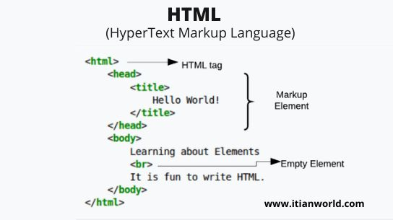 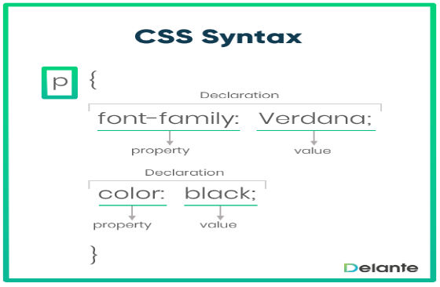**

**Syntax for HTML Syntax for CSS**

**Syntax for JS::**

<script type="text/javascript">

document.write("JavaScript is a simple language for javatpoint learners");

</script>

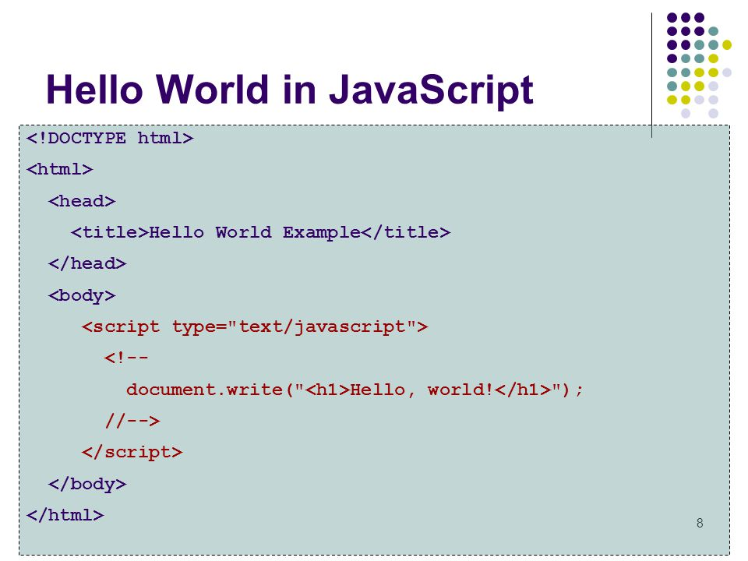

**HTML Code used for the project:**

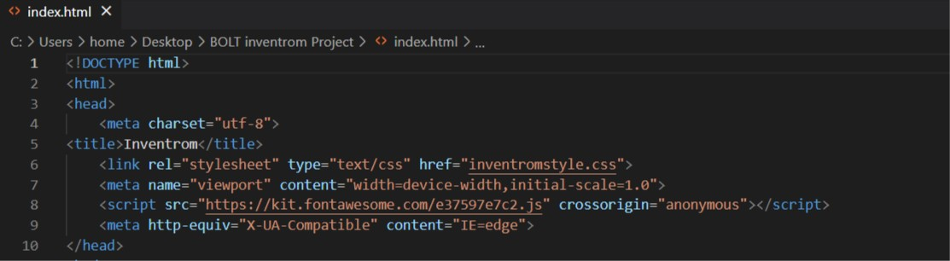The above code talks about head section which contains title,the links of CSS, JavaScript and other links.

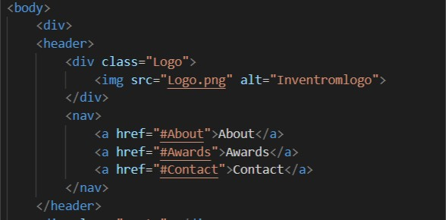This is a header section which is present in body and it contains navigation links.

(The HTML <a> tag defines a hyperlink and its syntax is <a href="url">link text</a> )

(The HTML <img> tag is used to embed an image in a web page.)

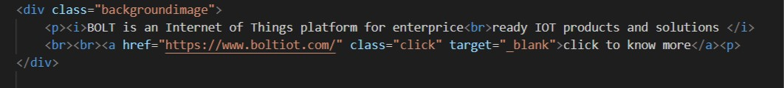

This is the Background image section which contains some hyperlinks also which is used to navigate to other webpage.

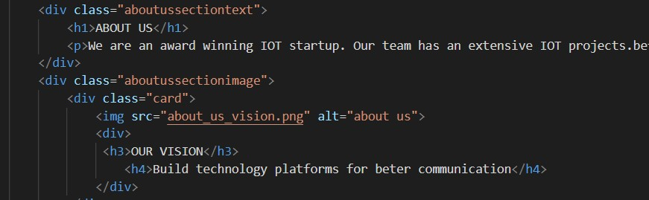This division is about section which talks about the company and theme of the company

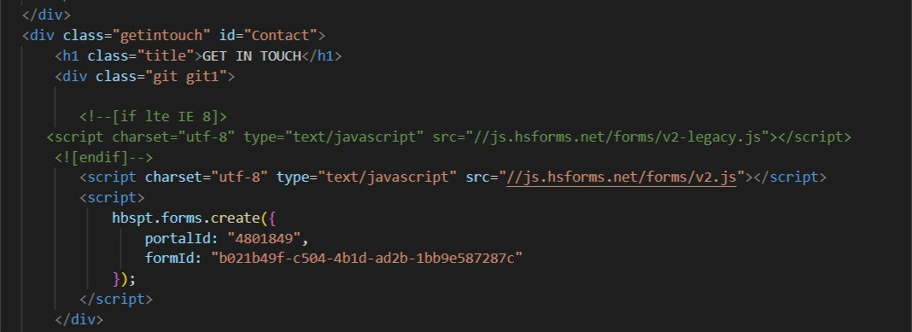This is JavaScript section it talks about what script we used and their hyperlinks and its functions we used.

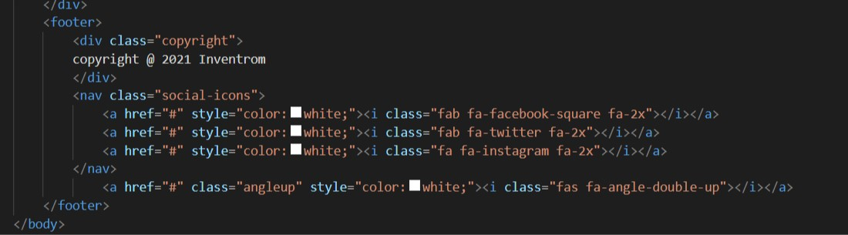This is the footer section which contains some hyperlinks within the same page and some CSS styles which belongs to the footer section.

**4.5)HOW DOES A WEBSITE WORKS:-**

When you enter something like [Google.com](http://www.google.com/" \t "_blank) the request goes to one of many special computers on the Internet known as *Domain Name Servers* **(DNS)**. All these requests are routed through various routers and switches. The domain name servers keep tables of machine names and their IP addresses, so when you type in [Google.com](http://www.google.com/" \t "_blank) it gets translated into a number, which identifies the computers that serve the Google Website to you.

When you want to view any page on the Web, you must initiate the activity by requesting a page using your browser. The browser asks a domain name server to translate the domain name you requested into an IP address. The browser then sends a request to that server for the page you want, using a standard called Hypertext Transfer Protocol or HTTP.

The server should constantly be connected to the Internet, ready to serve pages to visitors. When it receives a request, it looks for the requested document and returns it to the Web browser. When a request is made, the server usually logs the client's IP address, the document requested, and the date and time it was requested. This information varies server to server.

An average Web page actually requires the Web browser to request more than one file from the Web server and not just the HTML / XHTML page, but also any images, style sheets, and other resources used in the web page. Each of these files including the main page needs a URL to identify each item. Then each item is sent by the Web server to the Web browser and Web browser collects all this information and displays them in the form of Web page.

**5)RESULTS:-**

**5.1)Home Page:-**

**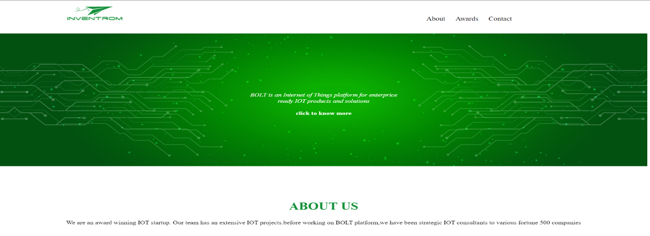**

This is the home page of A Inventrom Website containing the logo of the website, brief introduction of the website and the three short cuts of

* 1. About Us
  2. Awards
  3. Contact

**5.2)About Us:-**

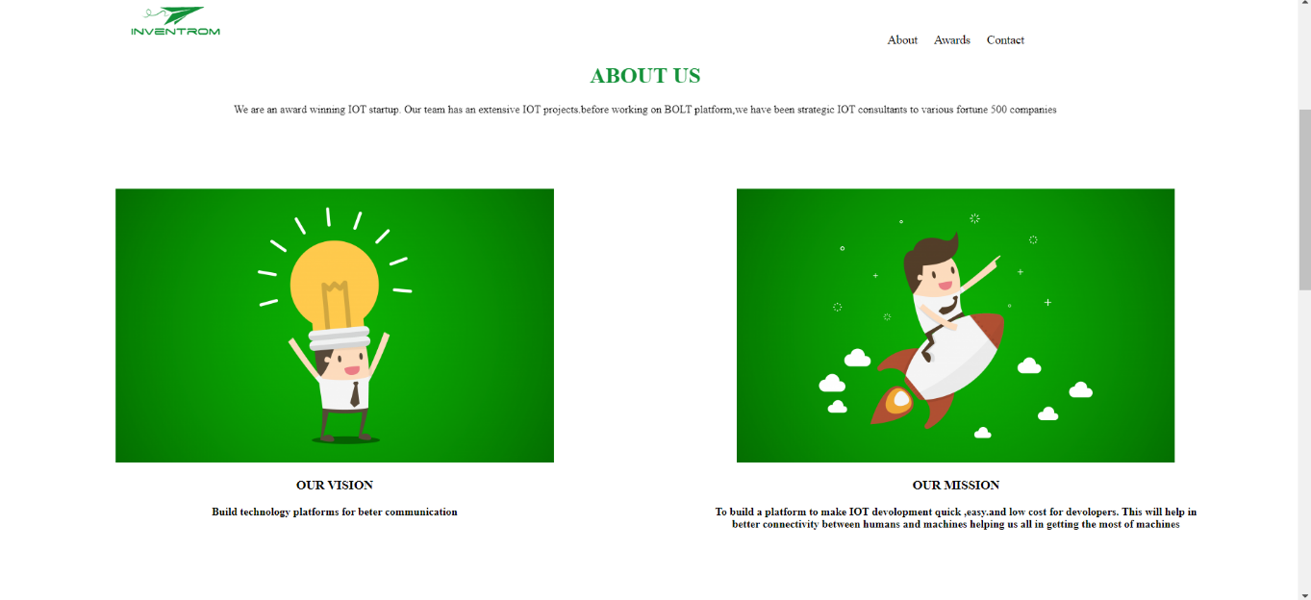

By clicling on the about us tag in the homepage we will be navigating to the About Us,

Where this will tells us the vision and mission of the inventrom website

**5.3)Award::**

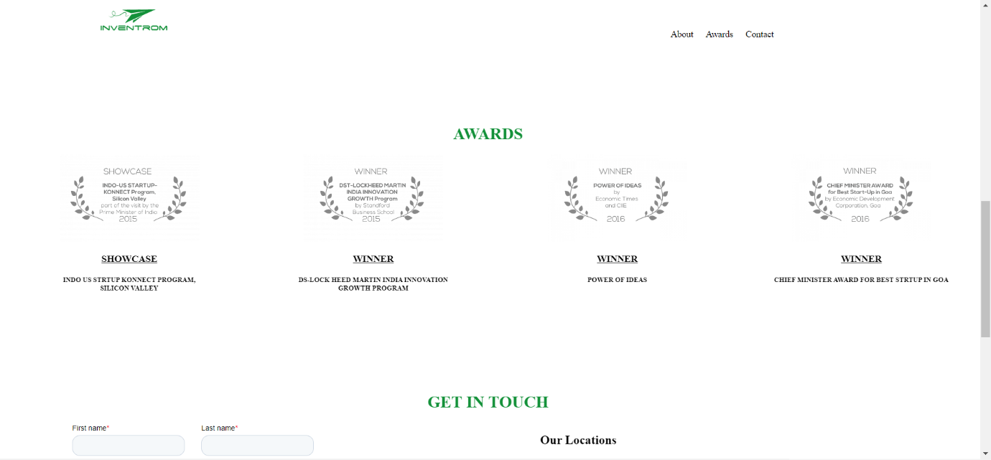

By clicling on the Awards tag in the homepage we will be navigating to the Awards,

Where this will provides the information regarding the awards acheivied by the inventrom website.

**5.4)Get In Touch and Footer:-**

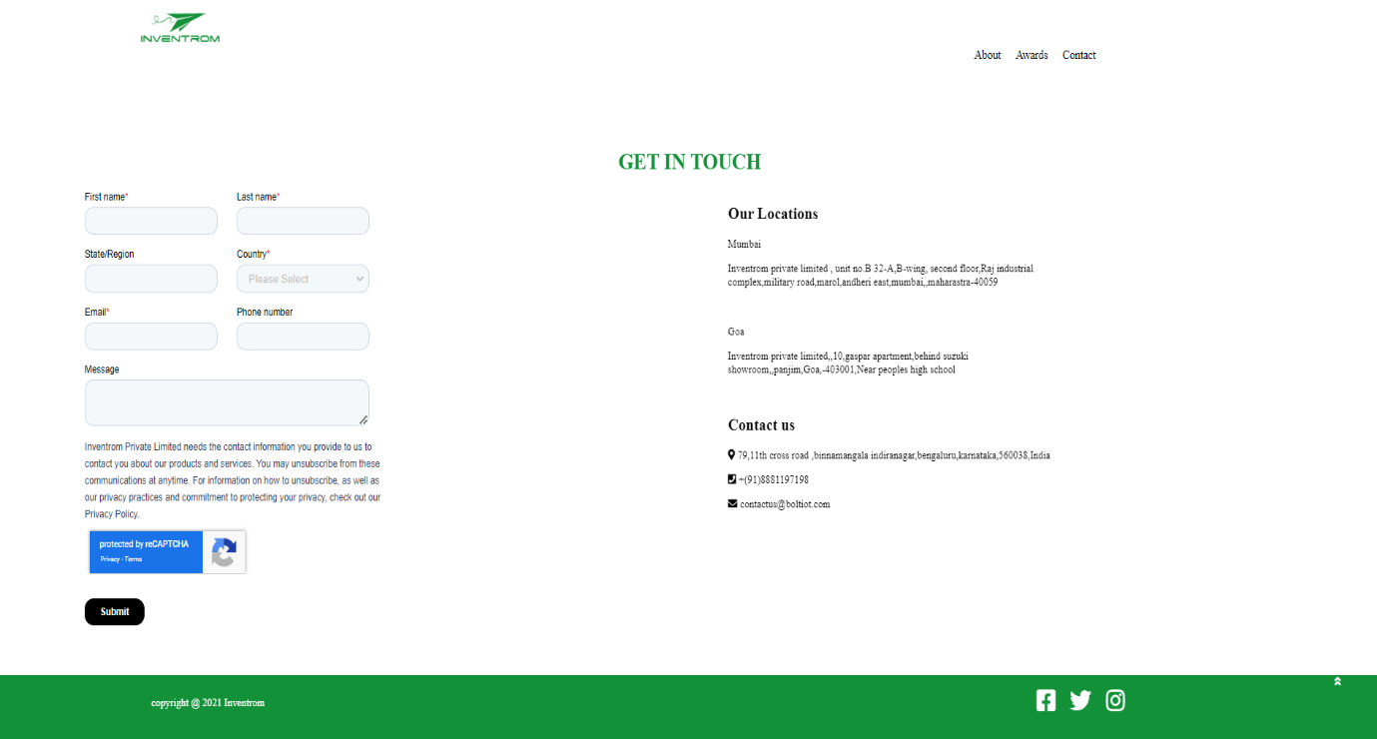

By clicling on the conatct tag in the homepage we will be navigating to the Get In Touch Session, Here we will be getting the offical address and contact number of the Inventrom Company and contact form will also be displayed to fill the details of user , so that the company can contact the user. Along with Get In Touch session we can aslo see the footer seesion which displays the copywrites of the company and the links to the social media platforms.

**5.5)Links for the Code and The Webiste:-**

* Link for the inventrom website done by me during my internship is::

https://style-retreat.hostatic.com/

* Githhub link for the code is :: https://github.com/SridharGNS/BOLTIOT.git

**6)Conclusion:-**

Thus the problem statements presented during the internship period were

successfully completed within the stipulated time. A proper documentation of

the development procedure was recorded, which included details about the

source code, use-cases and areas that would require extended monitoring and

maintenance.

A good page design is essential in today’s web development. A good design will lead to more number of visitors and that can lead to extension of business. To design an attractive and a good web page I have used CSS for styling and JavaSript for making the website reactive and HTML to display all the contents.

**7)REFERENCES:-**

**W3schools.com , BOLTIOT training lectures, Javatpoint**