FoundationDB – NoSQL

FoundationDB is a is a free and open-source multi-model distributed NoSQL developed by Apple Inc with a shared nothing Architecture. It is designed to handle large volumes of structured data across clusters of servers. The product was designed around a “core” database with additional features supplied in layers. The core database exposes an ordered key-value store with Transaction. The Transaction are able to read or write multiple keys stored on any machines in the cluster that support ACID property. FoundationDB is known for its strong ACID (Atomicity, Consistency, Isolation, Durability) properties and its ability to provide high performance and scalability.

Key Features of FoundationDB:

- Transactional Support: FoundationDB supports full ACID transactions, allowing for complex operations to be performed reliably and consistently across the database.
- Scalability: It is designed to scale horizontally by distributing data across multiple servers. This allows it to handle large datasets and high throughput.
- Multi-Model: FoundationDB supports multiple data models, including key-value, document, graph, and more, by providing a core layer that other models can be built on.
- High Performance: It is optimized for low-latency and high-throughput operations, making it suitable for applications requiring real-time data access.
- Fault Tolerance: The database is designed to be fault-tolerant, with built-in mechanisms for data replication and recovery.

Common use case of FoundationDB:

FoundationDB is versatile and can be used in various scenarios, especially where high performance, scalability, and strong consistency are required. Some common use cases include:

- Distributed Systems: Ideal for building large-scale distributed systems that require strong consistency and fault tolerance.
- Real-Time Applications: Suitable for real-time applications that need low-latency data access and updates.
- Financial Services: Used in environments where ACID transactions are crucial for maintaining data integrity, such as in banking and trading systems.
- IoT and Telemetry: Efficient for handling high-throughput data ingestion and querying in IoT and telemetry applications.
- Content Management: Useful for content management systems that need to store and retrieve diverse types of data with varying schemas.

Example of CRUD Operations in FoundationDB:
CRUD operations in FoundationDB can be implemented using Python:
- Create:
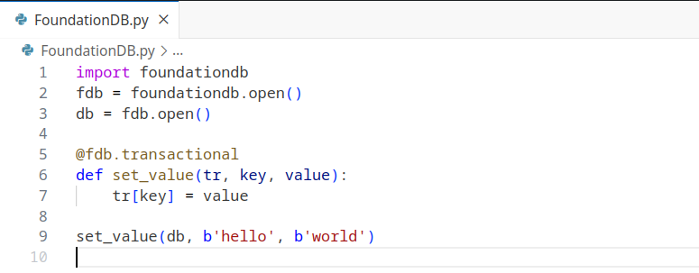

- Read:
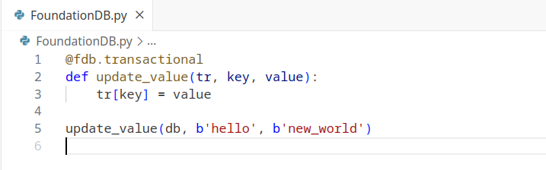

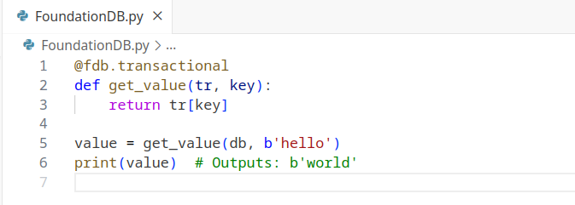
- Update:

- Delete:

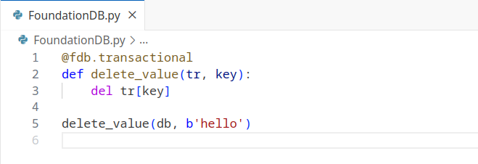

FoundationDB's strong transactional support and flexibility in data modeling make it a powerful choice for developers needing a robust, scalable database solution.

Advantages of FoundationDB:

- ACID Transactions: Provides full ACID compliance, ensuring reliable and consistent data operations.
- Scalability: Designed to scale horizontally across many servers, handling large volumes of data and high throughput.
- Flexibility: Supports multiple data models (key-value, document, graph, etc.) through a layered architecture, allowing developers to use the most suitable model for their application.
- Performance: Optimized for low-latency and high-throughput operations, making it suitable for real-time applications.
- Fault Tolerance: Built-in data replication and recovery mechanisms ensure high availability and durability.
- Layered Architecture: Allows for building custom layers to support various data models and abstractions, offering flexibility in application design.

Disadvantages of FoundationDB:
- Complexity: The layered architecture can introduce complexity in setting up and managing the database, especially for custom layers.
- Operational Overhead: Managing a distributed system requires careful planning and resources, which might be challenging for smaller teams or organizations.
- Limited Built-in Models: While it supports multiple data models through layers, FoundationDB natively only provides a key-value store, requiring additional effort to implement other models.
- Learning Curve: New users may face a steep learning curve due to the unique features and concepts of FoundationDB.
- Community and Support: Compared to more established databases, FoundationDB has a smaller community, which can impact the availability of third-party tools, libraries, and community support.
Summary:
FoundationDB is a powerful and flexible database that excels in scenarios requiring high performance, scalability, and strong transactional support. Its advantages include ACID transactions, scalability, flexibility, and fault tolerance, making it suitable for a wide range of applications. However, its complexity, operational overhead, and learning curve can be challenging, particularly for smaller teams or those new to distributed systems.

