**IFT 533: Project-Phase-2 Decision Making**

Aravindh Easwaran,

Sridhar Renangi,

Yogananda Reddy Murikinati,

Siva Ramakrishna Durga Sompalli

**Course:** Data Visualization & Reporting for IT

**Instructor name**: Dr Asmaa Elbadrawy

**Due date:** 11/19/2023

**Section 1: Used Visualization Tools**

**Tableau:**

We chose Tableau over Python and its related visualization libraries, such as Bokeh, when choosing visualization tools for our project. The reason we chose Tableau is because of its easy-to-use interface; it makes preparing data easier and makes it easier to create dashboards and visuals.

Tableau's strength is how easily it can handle a variety of data sources. For example, we are establishing a connection to our source of sales data, which is a CSV-formatted flat file that contains details about sales of pizza. We use Tableau to import this data source into our project with ease, leveraging features like those of an SQL server.

Tableau's drag-and-drop feature is one of its main benefits; it makes it simple to create a wide range of visualizations, such as scatter plots, heat maps, bar charts, and line charts. Without the need for a lot of scripting, this visual canvas enables an interactive and dynamic examination of data.

The project's focus on user-friendly data processing and visualization development led to the decision to utilize Tableau, even though Python and libraries like Bokeh are strong tools for data visualization. The criteria and objectives of our project are well-aligned with Tableau's capacity to offer a rapid and effective means of connecting to data sources, in addition to its user-friendly interface for creating a variety of representations.

**Section 2: Explanation of Required Data Pre-processing**

We are utilizing a CSV file, which can be easily loaded in Kaggle and utilized for visualization, thus no preprocessing of the data is needed. Fortunately, all of the tables have distinct headings, and the dataset is clean, devoid of null values. A seamless transition into the visualization phase is ensured by the dataset's observable numerical values.

On the other hand, we want to use Tableau for various calculated field operations in order to improve the analysis and visualization in this project. This is creating calculated fields and parameters using values taken straight out of the CSV file. These calculated fields will enable us to extract other data and insights that are important for our visualization's particular objectives.

**Section 3: List of Final Sets of Questions**

1. What was the total revenue generated during the specified period?
2. What pizza sales fluctuate on an hourly basis for the total pizza sold?
3. Which pizzas rank highest in terms of total orders, listing the top five?
4. What percentage of sales is attributed to pizza size?
5. What are the top 5 pizzas by revenue?
6. What are the bottom 5 pizzas by revenue?
7. How are pizza sales influenced by both pizza category and time variations?
8. What are the top 5 pizzas by total pizzas sold?
9. What are the bottom 5 pizzas by total pizzas sold?
10. What is the weekly trend for the number of orders?
11. What percentage of sales is attributed to each pizza category?
12. How many orders and pizzas were sold by each pizza category?

**Section 4: Dashboard Plot Drafts**

1. **What was the total revenue generated during the specified period?**

The total price is on the x-axis and the total revenue is on the y-axis of the visualization you sent. In other words, each order date's total revenue is represented by a point on the graph.

Below is a more thorough description of every axis:

* x-axis (SUM(Price in Total)): The total revenue earned on each order date is displayed on this axis. Dollars are used as the measurement unit.

We are visualizing additional plots representing total revenue, average total value, total pizza sold, total orders, and average pizza per order.

Color: purple

1. **What pizza sales fluctuate on an hourly basis for the total pizza sold?**

Plot: Stacked bar chart

The chart shows how hourly fluctuations in pizza sales occur, with the largest sales in the morning and the lowest sales at night, at about 23:00 pm. Over 6,776 pizzas are sold during the peak sales hour of 12 p.m. 9 am is the lowest sales hour, selling slightly more than 4 pizzas. Determining the right amount of employees, inventory, and marketing campaigns can all be done with this information. The X-axis represents order time and the y-axis total pizzas sold

**The pre-attentive attributes and colors used in the chart are:**

* Size: The highest sales bars are also the largest bars, which makes them even more noticeable.
* Colour: The highest sales bars are colored purple, which is a bright and contrasting color that stands out from the other bars.

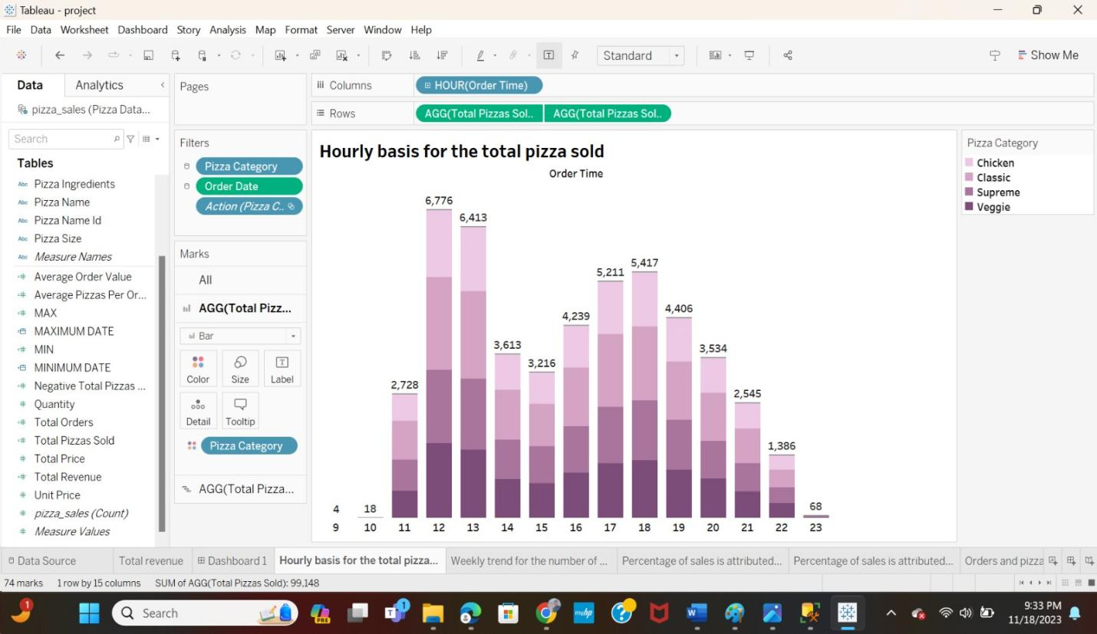

1. **Which pizzas rank highest in terms of total orders, listing the top five?**

Plot: Horizontal Bar Graph

This chart shows that the most popular pizzas are the Classic Deluxe Pizza, the Hawaiian Pizza, and the Pepperoni Pizza. These pizzas are all classic Flavors that are popular with a wide range of people. The Barbecue Chicken Pizza and the Thai Chicken Pizza are also popular, but they are not as popular as the top three pizzas.

The x-axis represents the total orders, and the y-axis represents the pizza name. The height of each bar represents the number of orders for that pizza.

**The pre-attentive attributes and colors used in the chart are:**

* Size: The taller bars represent the most popular pizzas, which are the Classic Deluxe Pizza, the Hawaiian Pizza, and the Pepperoni Pizza. The tall bar represents the classic deluxe pizza, which is 2329.
* Color: The bars are colored in different shades of Gray, which makes it easy to distinguish between the different pizzas.

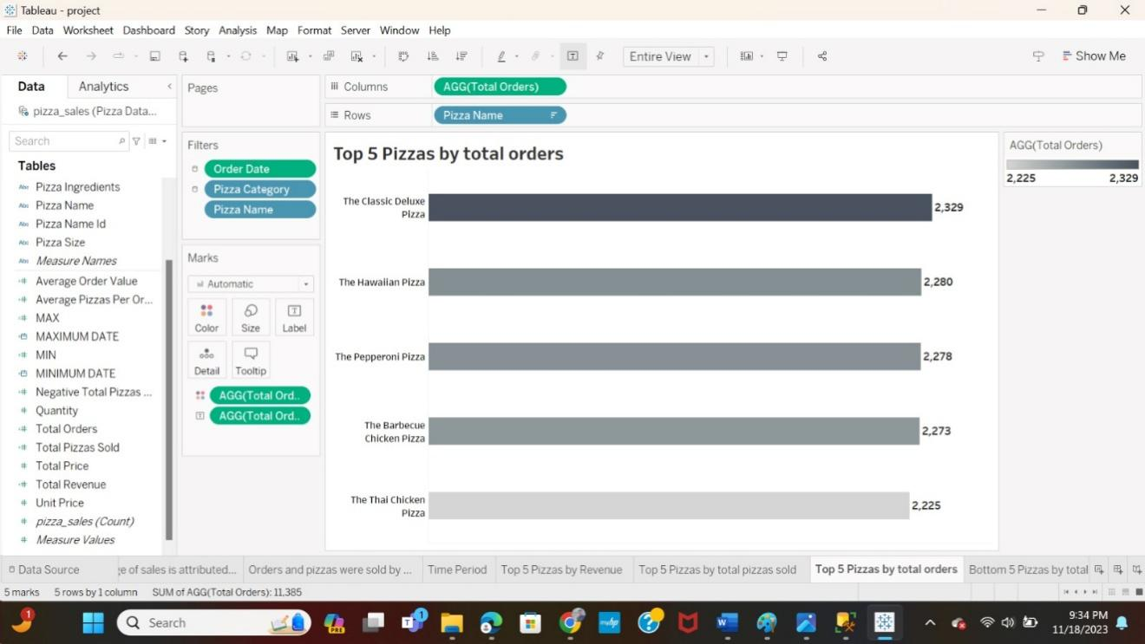

1. **What percentage of sales is attributed to pizza size?**

Plot: bar graph

The chart shows that the percentage of sales attributed to pizza size varies depending on the size of the pizza. Large pizzas account for the highest percentage of sales, followed by medium pizzas, small pizzas, and extra-large pizzas. Specifically, large pizzas account for 45.89 % of sales, medium pizzas account for 30.49% of sales, small pizzas account for 21.77% of sales, and extra-large pizzas account for 1.72 % of sales.

This chart is important because it shows the relative popularity of different pizza sizes. This information can be used to make decisions about inventory levels, staffing levels, and pricing.

The x-axis represents the measure values and total revenue, and the y-axis represents the pizza size, specifically the total revenue percentage of sales attributed to that size. The height of each bar represents the percentage of sales for that size.

**The pre-attentive attributes and colors used in the chart are:**

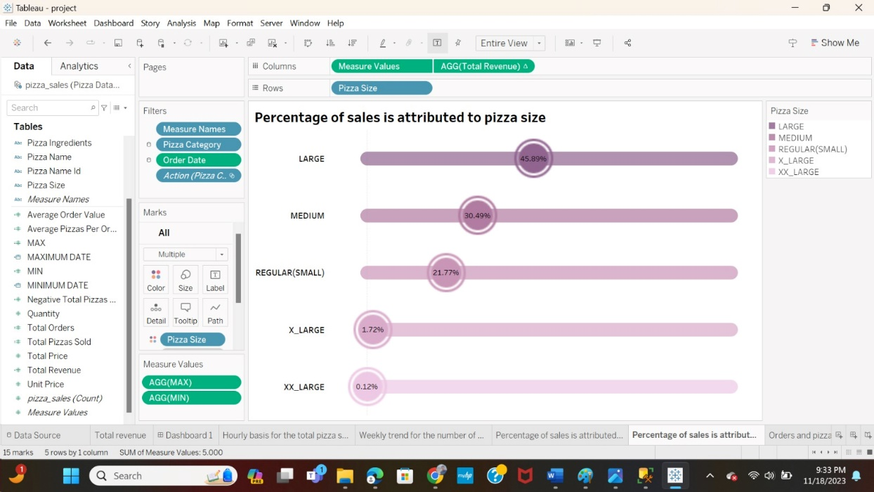

1. **What are the top 5 pizzas by revenue?**

Plot: Horizontal Bar Graph

The chart shows the top 5 pizzas by revenue. The x-axis represents the total revenue, while the y-axis represents the number of pizza names. The chart shows that the "The That Chicken" pizza is the top-selling pizza, generating $43,434K in revenue. The "The Barbecue" pizza is the second-best-selling pizza, generating $42,768K in revenue. The "The California" pizza is the third best-selling pizza, generating $41,410K in revenue. The "The Classic Deluxe" pizza is the fourth-best-selling pizza, generating $38,181K in revenue. The "The Spicy Italian" pizza is the fifth-best-selling pizza, generating $34,831K in revenue.

**The pre-attentive attributes and colors used in the chart are:**

* Length: The length of the bars represents the revenue of each pizza.
* Color: The color of the bars represents the ranking of each pizza by revenue, with the darkest purple bar representing the highest revenue and the lightest purple bar representing the lowest revenue.

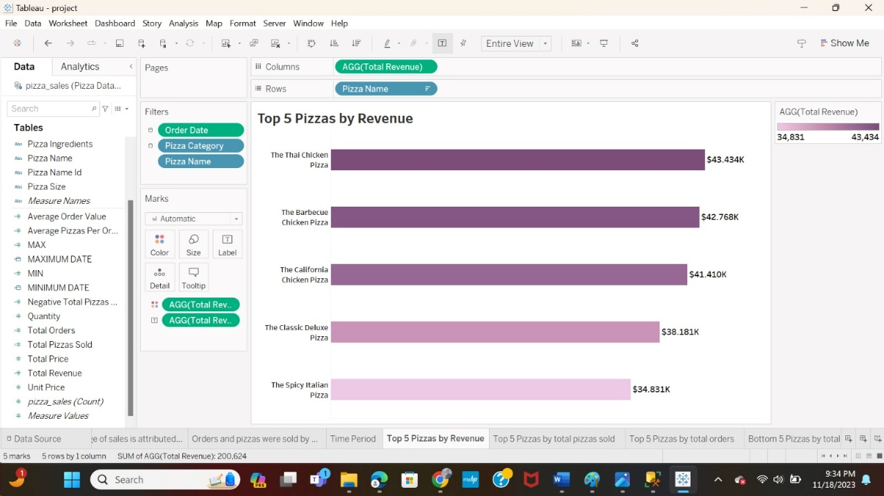

1. **What are the bottom 5 pizzas by revenue?**

Plot: Horizontal Bar Graph

The chart shows the bottom 5 pizzas by revenue. The x-axis represents the total revenue, while the y-axis represents the pizza name. The bars are colored in a gradient from dark purple to light purple, with the lightest purple representing the lowest revenue and the darkest representing the highest revenue.

**The pre-attentive attributes and colors used in the chart are:**

* Size: The size of the bars represents the revenue of each pizza.
* Orientation
* Color: The color of the bars represents the ranking of each pizza by revenue, with the lightest purple bar representing the lowest revenue and the darkest purple bar representing the highest revenue.

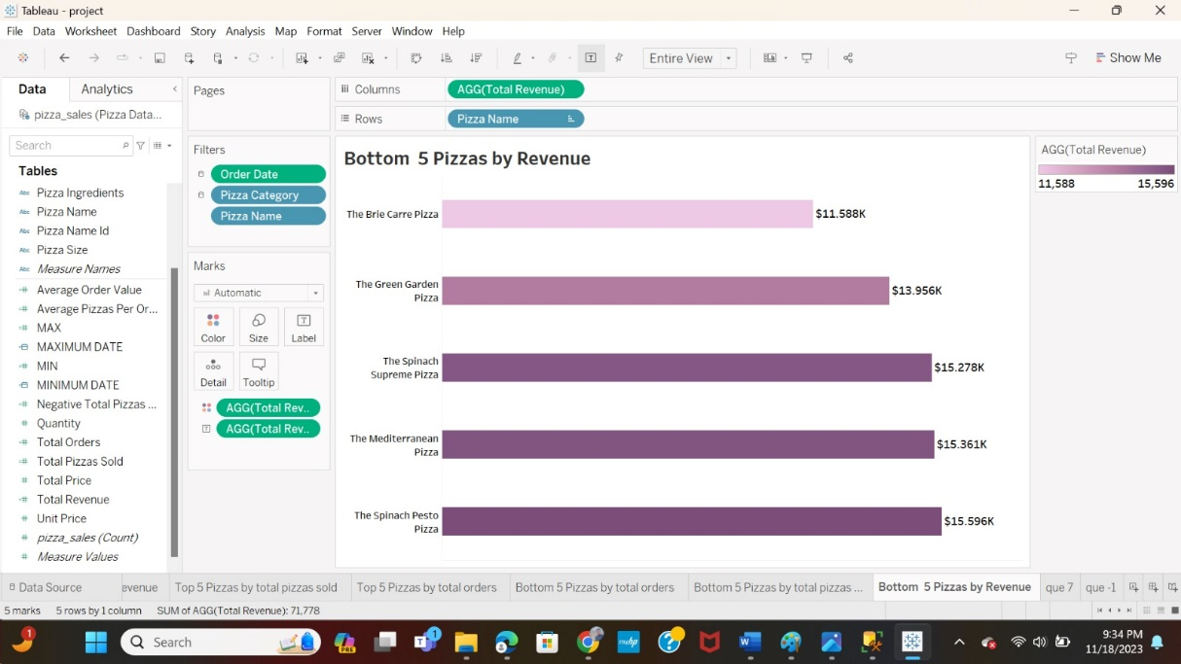

1. **How are pizza sales influenced by both pizza category and time variations?**

Plot: Area Chart

The Line or area chart illustrates the timing of pizza orders categorized by Pizza Type. On the x-axis, you find the order time, while for each pizza category, pizza sales are denoted along the y-axis. The vertical segments within the Line chart signify the number of pizzas sold for the corresponding time intervals.

**The pre-attentive attributes and colors used in the chart are:**

* Position and orientation

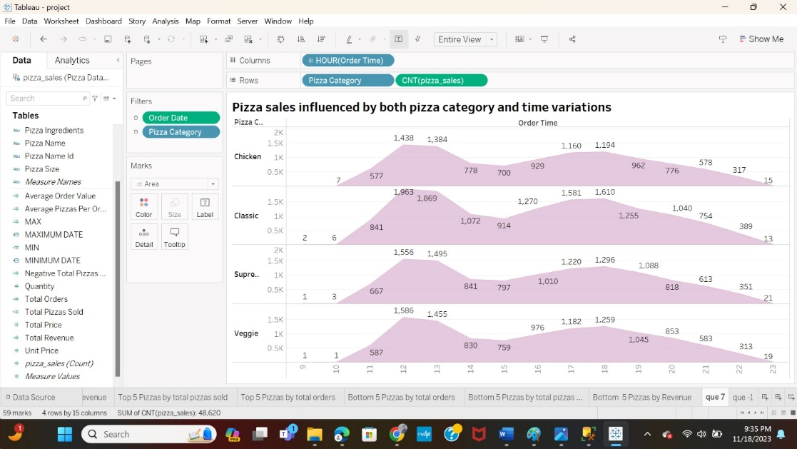

1. **What are the top 5 pizzas by total pizzas sold?**

Plot: Horizontal Bar Graph

The chart shows the top 5 pizzas by total pizzas sold. The x-axis represents the total pizza sold. The y-axis represents the total pizza name. The bars are colored in a gradient from blue to light blue, with the darkest blue representing the highest number of pizzas sold and the lightest blue representing the lowest number of pizzas sold.

**The pre-attentive attributes and colors used in the chart are:**

* Length: The size of the bars represents the number of pizzas sold, with the largest bar representing the highest number of pizzas sold and the smallest bar representing the lowest number of pizzas sold.
* Colour: The color of the bars represents the ranking of each pizza by number of pizzas sold, with the darkest blue bar representing the highest-ranking pizza and the lightest blue bar representing the lowest-ranking pizza.

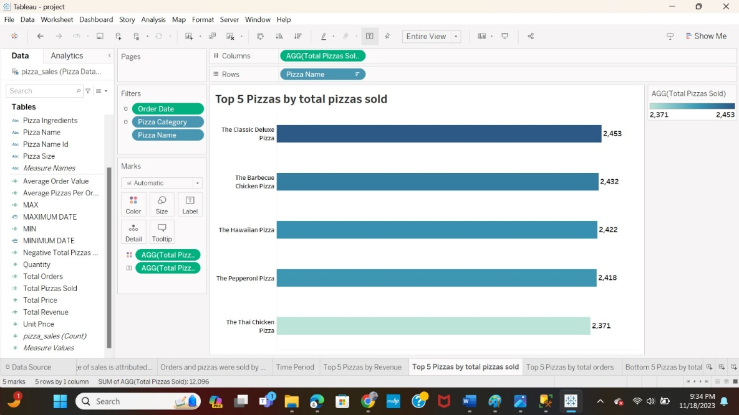

1. **What are the bottom 5 pizzas by total pizzas sold?**

Plot: Horizontal Bar Graph

The chart shows the bottom 5 pizzas by total pizzas sold. The y-axis represents the pizza's name, while the x-axis represents the total pizza sold.

**The pre-attentive attributes and colors used in the chart are:**

* Length
* Colour: dark blue, light gray
* Orientation

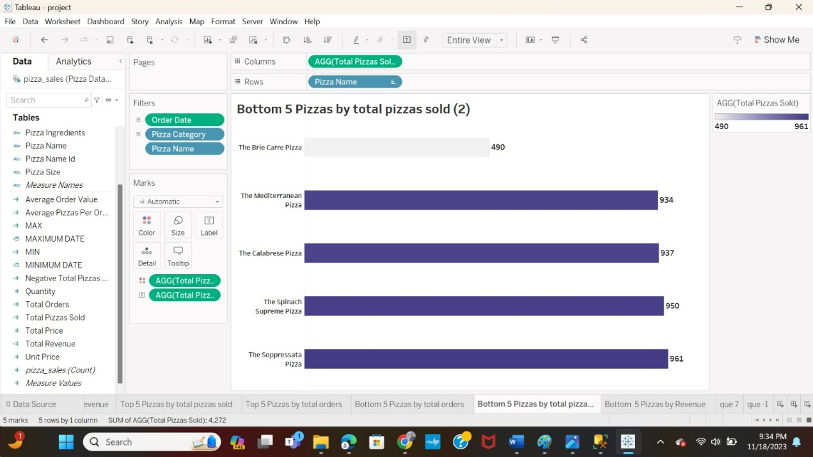

1. **What is the weekly trend for the number of orders?**

Plot: Line Chart

The line chart shows tracking the weekly trend for the number of orders. The x-axis represents the order date, while the y-axis represents the total orders.

**The pre-attentive attributes and colors used in the chart are:**

* Position
* Color: The line representing the trend is colored dark Gray, which is a visually salient colour.

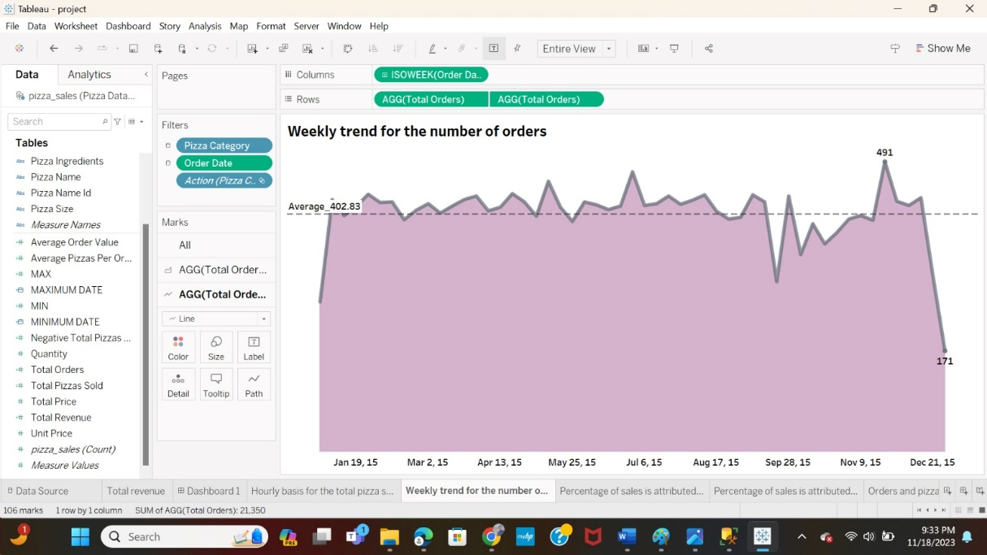

1. **What percentage of sales is attributed to each pizza category?**

Plot: Donut chart

The donut chart shows the percentage of sales attributed to each pizza category. The chart is divided into four slices, representing the four pizza categories: Chicken, Veggie, Classic, and Supreme.

* Slice: Pizza category
* Size of slice: Percentage of sales

**The pre-attentive attributes and colors used in the chart are:**

* Color: Each pizza category is represented by purple color intensity: These colors are visually salient and easy to distinguish from each other.
* Size: The size of each slice is proportional to the percentage of sales it represents. This makes it easy to see which pizza categories are the most popular.

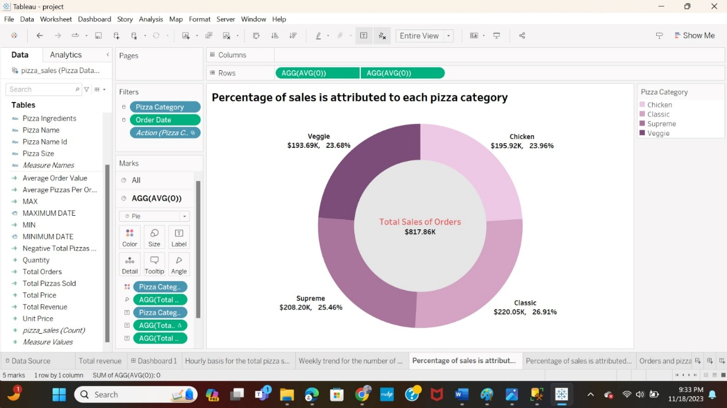

1. **How many orders and pizzas were sold by each pizza category?**

Plot: Stacked bar chart  
The image shows a stacked bar chart of the number of orders and pizzas sold by each pizza category. The x-axis represents the measure values, while the y-axis represents the pizza category. The bars are stacked, with the number of orders at the bottom and the number of pizzas sold at the top.

Which axis represents which and what:

* X-axis: measure values (stacked)
* Y-axis: pizza category

**The pre-attentive attributes and colours used in the chart are:**

* Color: Total pizzas orders and Total pizzas sold are represented by purple variation.
* Size: The length of each bar represents the total number of orders and pizzas sold for that pizza category. The width of each bar is the same, so the length of the bar is the only pre-attentive attribute that varies.

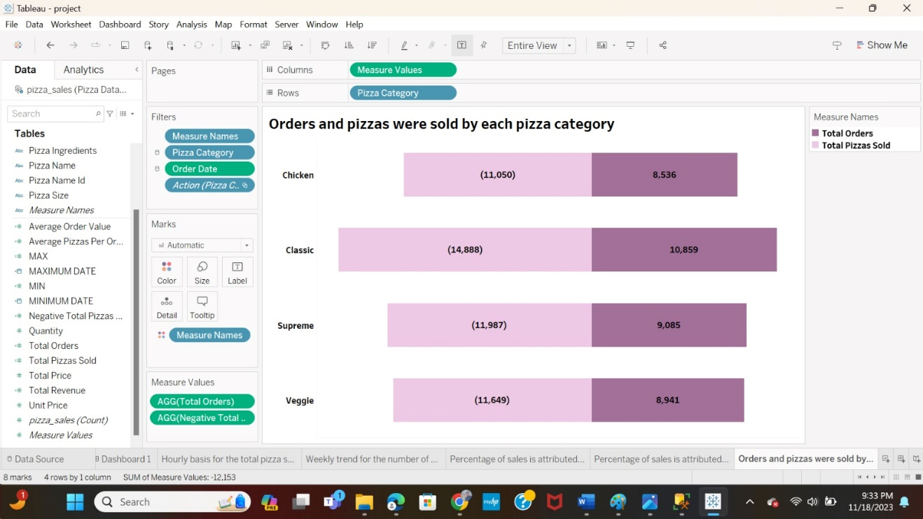

**Section 5: Dashboard Interactivity**

**5.1 Interactive Visualization Features**

We developed the Tableau dashboard with elements like filters, dynamic parameters, and calculated fields. These features allow users to explore and analyze pizza sales data in a comprehensive and user-focused manner across various scenarios.

Several calculated fields and filters are being used in this project, such as Minimum, Maximum, Total Revenue, Minimum Date, Maximum Date, Negative Total Pizza Sold, Average Pizza per Order, Total Pizza Sold, and Average Order Value, among others. And filters are classic, chicken, Veggie, supreme.

By giving users useful metrics and insights for a thorough grasp of the pizza sales data, these calculated fields improve the dashboard's analytical capabilities. Here some calculations filed are:

The calculation fields for the minimum and maximum values are utilized to determine the percentage of sales attributed to each pizza size

The calculation fields for the negative average total pizza sold are employed to analyze the number of orders and pizzas sold for each pizza category.

The calculation fields for the maximum date and minimum date are used to select the total dashboard maximum and minimum dates from the year 2015 for the pizza sale dashboard.

**5.2 Criteria for Examining Pizza Sales Filters and types:**

* This project's filters, which include large, small, medium, X-large, and XX-large pizza sizes, are based on pizza sizes.

**5.3 Enhanced Data Analysis through Tableau**

Analyzing Sales Trends - By leveraging the data grouping and analysis capabilities of Tableau we have successfully. Visualized the trends in pizza sales over a period. By analyzing the quantity of pizza sold over time, this analysis gives us insights into client preferences and the effects of seasonal influences on sales.

In-depth Analysis with Variable Ranges - The interactive features of our system allow for an exploration of sales data by accepting a range of values. For example, our filters can be adjusted in steps enabling an examination of sales data, across different time periods and categories.

**Section 6: Reference Links**

**Dataset link:**

*🍕🍽️ Pizza Restaurant Sales*. (2022, October 21). Kaggle. <https://www.kaggle.com/datasets/shilongzhuang/pizza-sales>

**Mural link:**

<https://app.mural.co/invitation/mural/phase14757/1699563089525?sender=u1a6332ed6ddde045bbc37154&key=c1965fb8-d49b-4a7f-9e4a-0adbe368ba37>