Sridhar_Sriram_HW10

## Lab 10.4, Lab 1 (PCA)

### Exploring the USArrests Dataset

states = row.names(USArrests)  
  
names(USArrests)

## [1] "Murder" "Assault" "UrbanPop" "Rape"

#### Using the apply function:

* Allows us to apply any given function onto a specified dataset
* Syntax is apply(<dataset>, <margin:1,2>,<function>)
  + **margin**:
    - **1**: applying to rows
    - **2**: applying to columns

apply(USArrests,2,mean)

## Murder Assault UrbanPop Rape   
## 7.788 170.760 65.540 21.232

apply(USArrests,2,var)

## Murder Assault UrbanPop Rape   
## 18.97047 6945.16571 209.51878 87.72916

#### Standardizing dataset to avoid overwhelming influence by the Assault data points (due to very high variance and very high mean)

prcomp –> PCA function in R

* Centers the variables to have a mean of 0

pr.out = prcomp(USArrests, scale = TRUE)  
  
names(pr.out)

## [1] "sdev" "rotation" "center" "scale" "x"

pr.out$center

## Murder Assault UrbanPop Rape   
## 7.788 170.760 65.540 21.232

pr.out$sdev

## [1] 1.5748783 0.9948694 0.5971291 0.4164494

pr.out$scale

## Murder Assault UrbanPop Rape   
## 4.355510 83.337661 14.474763 9.366385

The rotation matrix provides PCA loadings; each column has the respective PC loading vector

pr.out$rotation

## PC1 PC2 PC3 PC4  
## Murder -0.5358995 0.4181809 -0.3412327 0.64922780  
## Assault -0.5831836 0.1879856 -0.2681484 -0.74340748  
## UrbanPop -0.2781909 -0.8728062 -0.3780158 0.13387773  
## Rape -0.5434321 -0.1673186 0.8177779 0.08902432

We expect to see 4 Principal components because the rule of thumb is

* number of principal components = min(observations -1, variables)

dim(pr.out$x)

## [1] 50 4

** Plotting the first two principal components** :

biplot(pr.out,scale = 0)

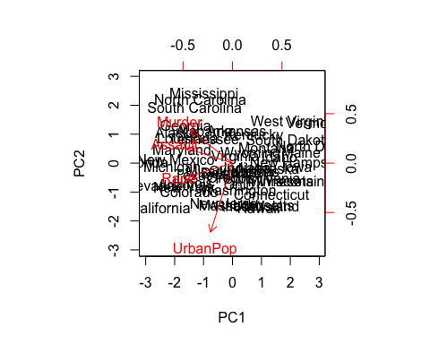

Fixing the problem of principal components being unique up to a sign change

pr.out$rotation = -pr.out$rotation  
pr.out$rotation

## PC1 PC2 PC3 PC4  
## Murder 0.5358995 -0.4181809 0.3412327 -0.64922780  
## Assault 0.5831836 -0.1879856 0.2681484 0.74340748  
## UrbanPop 0.2781909 0.8728062 0.3780158 -0.13387773  
## Rape 0.5434321 0.1673186 -0.8177779 -0.08902432

pr.out$x = -pr.out$x  
  
biplot(pr.out,scale = 0)

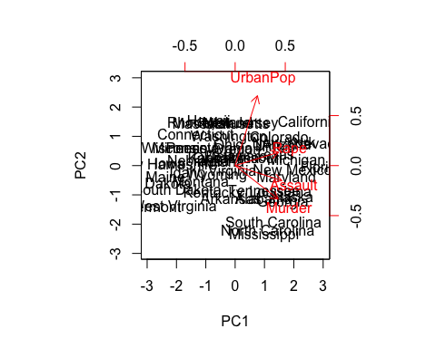

** Obtaining the variance related to each principal component**

pr.var = pr.out$sdev^2  
  
pr.var

## [1] 2.4802416 0.9897652 0.3565632 0.1734301

#### Variance explained by each principal component

variance.by.component = pr.var/sum(pr.var)  
variance.by.component

## [1] 0.62006039 0.24744129 0.08914080 0.04335752

#### Visualizing these effects

plot(variance.by.component,  
 xlab = "Principal Component",   
 ylab = "Proportion of Variance Explained",  
 ylim = c(0,1),  
 type = 'b')

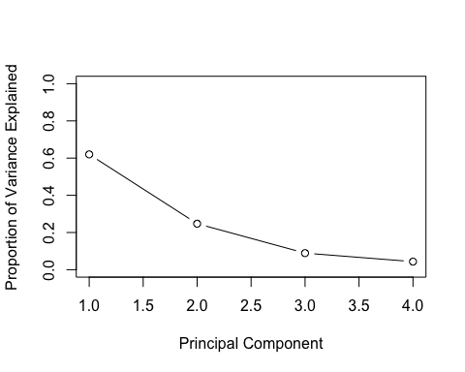

plot(cumsum(variance.by.component),   
 xlab = "Principal Component",   
 ylab = "Proportion of Variance Explained",  
 ylim = c(0,1),  
 type = 'b')

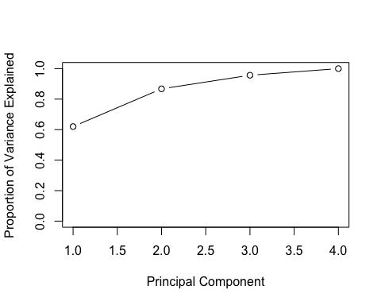

cumsum() calculates cumulative sums of elements in a numeric vector

a = c(1,2,8,-3)  
  
cumsum(a)

## [1] 1 3 11 8

## Lab 10.5.1, Lab 2 (K-means Clustering)

### Simulated 2-Cluster K-Means

set.seed(2)  
x = matrix(rnorm(50*2), ncol = 2)  
x[1:25,1] = x[1:25,1] + 3  
  
x[1:25,2] = x[1:25,2] - 4

#### Performing the clustering with K = 2

km.out = kmeans(x,2,nstart = 20)  
km.out

## K-means clustering with 2 clusters of sizes 25, 25  
##   
## Cluster means:  
## [,1] [,2]  
## 1 -0.1956978 -0.1848774  
## 2 3.3339737 -4.0761910  
##   
## Clustering vector:  
## [1] 2 2 2 2 2 2 2 2 2 2 2 2 2 2 2 2 2 2 2 2 2 2 2 2 2 1 1 1 1 1 1 1 1 1 1  
## [36] 1 1 1 1 1 1 1 1 1 1 1 1 1 1 1  
##   
## Within cluster sum of squares by cluster:  
## [1] 65.40068 63.20595  
## (between_SS / total_SS = 72.8 %)  
##   
## Available components:  
##   
## [1] "cluster" "centers" "totss" "withinss"   
## [5] "tot.withinss" "betweenss" "size" "iter"   
## [9] "ifault"

#### Plotting the kmeans clustering with colored distinction

plot(x,  
 col = (km.out$cluster+1),  
 main= "K-Means Clustering Results with K = 2",  
 ylab = "",  
 pch = 20,  
 cex = 2)

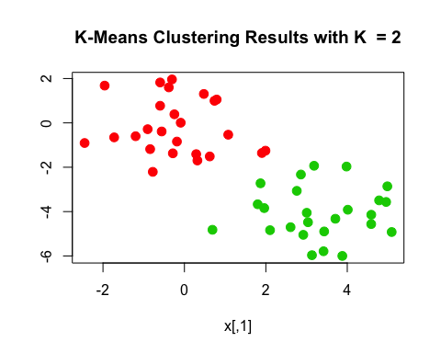

**FOR FUTURE APPLICATIONS:**

If we have clusters/components that are more than just 2 in number, then we can perform PCA and plot/visualize clusters relating to the first two most significant cluster

#### Same data, now with 3 clusters

set.seed(1234)  
  
km.out.3 = kmeans(x,3,nstart = 20)  
km.out.3

## K-means clustering with 3 clusters of sizes 17, 10, 23  
##   
## Cluster means:  
## [,1] [,2]  
## 1 3.7789567 -4.56200798  
## 2 2.3001545 -2.69622023  
## 3 -0.3820397 -0.08740753  
##   
## Clustering vector:  
## [1] 1 2 1 2 1 1 1 2 1 2 1 2 1 2 1 2 1 1 1 1 1 2 1 1 1 3 3 3 3 3 3 3 3 3 3  
## [36] 3 3 3 3 3 3 3 3 2 3 2 3 3 3 3  
##   
## Within cluster sum of squares by cluster:  
## [1] 25.74089 19.56137 52.67700  
## (between_SS / total_SS = 79.3 %)  
##   
## Available components:  
##   
## [1] "cluster" "centers" "totss" "withinss"   
## [5] "tot.withinss" "betweenss" "size" "iter"   
## [9] "ifault"

plot(x,  
 col = (km.out.3$cluster+1),  
 main= "K-Means Clustering Results with K = 3",  
 ylab = "",  
 pch = 20,  
 cex = 3)

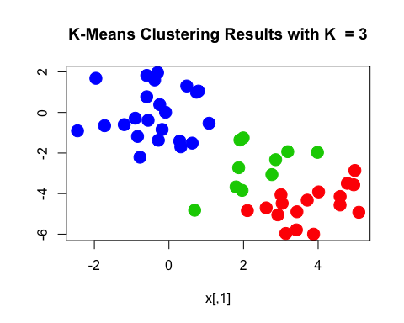

**Within kmeans**: nstart :

* parameter for multiple initial cluster assignments

** kmeans components: **

tot.withinss :

* Total within-cluster sum of squares –> minimize this!!!

withinss:

* individual within-cluster sum of squares

## Lab 10.5.2, Lab (hierarchial clustering)

### Using same data from previous lab (x)

#### Complete, average, single linkage

hc.complete = hclust(dist(x),method = "complete")  
  
hc.single = hclust(dist(x),method = "single")  
  
hc.average = hclust(dist(x),method = "average")

#### Plotting the associated dendrograms

par(mfrow = c(1,3))  
  
plot(hc.complete,  
 main = "Complete Linkage",  
 sub = "",  
 xlab = "",  
 cex = 0.9)  
  
plot(hc.average,  
 main = "Average Linkage",  
 sub = "",  
 xlab = "",  
 cex = 0.9)  
  
plot(hc.single,  
 main = "Single Linkage",  
 sub = "",  
 xlab = "",  
 cex = 0.9)

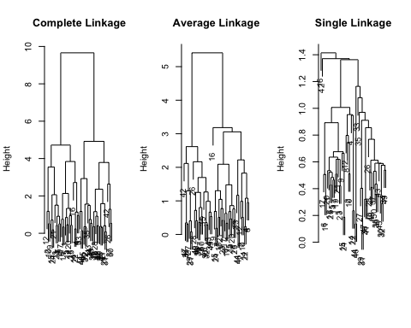

#### Determining cluster labels for each observation

cutree(hc.complete,2)

## [1] 1 1 1 1 1 1 1 1 1 1 1 1 1 1 1 1 1 1 1 1 1 1 1 1 1 2 2 2 2 2 2 2 2 2 2  
## [36] 2 2 2 2 2 2 2 2 2 2 2 2 2 2 2

cutree(hc.average,2)

## [1] 1 1 1 1 1 1 1 1 1 1 1 1 1 1 1 1 1 1 1 1 1 1 1 1 1 2 2 2 2 2 2 2 1 2 2  
## [36] 2 2 2 2 2 2 2 2 1 2 1 2 2 2 2

cutree(hc.single,2)

## [1] 1 1 1 1 1 1 1 1 1 1 1 1 1 1 1 2 1 1 1 1 1 1 1 1 1 1 1 1 1 1 1 1 1 1 1  
## [36] 1 1 1 1 1 1 1 1 1 1 1 1 1 1 1

The cutree using hc.single returns a list of 1s because single linkage identifies one point as belonging to its own cluster

** Fixing the above (using 4 clusters) **

cutree(hc.single, 4)

## [1] 1 1 1 1 1 1 1 1 1 1 1 1 1 1 1 2 1 1 1 1 1 1 1 1 1 3 3 3 3 3 3 3 3 3 3  
## [36] 3 3 3 3 3 3 4 3 3 3 3 3 3 3 3

#### Scaling before performing hierarchial clustering

scaled = scale(x)  
  
plot(hclust(dist(scaled), method = "complete"),  
 main = "Hierarchial Clustering with Scaled Features")

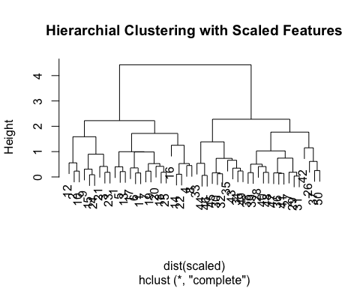

#### Correlation-based distance

x = matrix(rnorm(30*3),ncol = 3)  
  
dd = as.dist(1-cor(t(x)))  
  
plot(hclust(dd,method = "complete"),  
 main = "Complete Linkage w/ Correlation-Based Distance",  
 xlab = "",  
 sub = "")

