Sridhar Sriram Homework 9

## Lab 5.3.1: The Validation Set Approach

#### Splitting the Dataset

library(ISLR)  
set.seed(1)  
# of the 392 observations, randomly select 196  
train = sample(392, 196)

#### Fitting the linear regression w/ only the training set, then expanding for quadratic and cubed regression

lm.fit = lm(mpg~horsepower, data = Auto, subset = train)  
  
attach(Auto)  
mean((mpg-predict(lm.fit,Auto))[-train]^2)

## [1] 26.14142

lm.fit.squared = lm(mpg~poly(horsepower,2), data = Auto, subset = train)  
lm.fit.cubed = lm(mpg~poly(horsepower,3), data = Auto, subset = train)  
  
mean((mpg-predict(lm.fit.squared,Auto))[-train]^2)

## [1] 19.82259

mean((mpg-predict(lm.fit.cubed,Auto))[-train]^2)

## [1] 19.78252

#### Choosing a different training set

set.seed(2)  
train.2 = sample(392, 196)  
  
lm.2.fit = lm(mpg~horsepower, data = Auto, subset = train.2)  
mean((mpg-predict(lm.2.fit,Auto))[-train.2]^2)

## [1] 23.29559

lm.2.fit.squared = lm(mpg~poly(horsepower,2), data = Auto, subset = train.2)  
lm.2.fit.cubed = lm(mpg~poly(horsepower,3), data = Auto, subset = train.2)  
  
mean((mpg-predict(lm.2.fit.squared,Auto))[-train.2]^2)

## [1] 18.90124

mean((mpg-predict(lm.2.fit.cubed,Auto))[-train.2]^2)

## [1] 19.2574

* From this outcome we can tell that using a quadratic model is definitely better than linear regression model, although cubic is not obviously any more advantageous

## Lab 5.3.2 192-193: LOOCV

#### Showing the glm() without a specification of family type and lm() are the same

glm.fit = glm(mpg~horsepower, data = Auto)  
  
coef(glm.fit)

## (Intercept) horsepower   
## 39.9358610 -0.1578447

lm.fit.glmcopy = lm(mpg~horsepower, data = Auto)  
coef(lm.fit.glmcopy)

## (Intercept) horsepower   
## 39.9358610 -0.1578447

#### Opting to use glm() because of compatability with cv

The values found within the delta vector of our cv.err variable contain the results from our cross-validation

library(boot)  
glm.fit = glm(mpg~horsepower, data = Auto)  
cv.err = cv.glm(Auto, glm.fit)  
cv.err$delta

## [1] 24.23151 24.23114

#### Populating a vector with the associated regression

cv.error = rep(0,5)  
for ( i in 1:5){  
 glm.fit = glm(mpg~poly(horsepower,i),data = Auto)  
 cv.error[i] = cv.glm(Auto, glm.fit)$delta[1]  
}  
  
cv.error

## [1] 24.23151 19.24821 19.33498 19.42443 19.03321

## Chapter 5, exercise 5 A & B (198 - 199)

library(ISLR)  
attach(Default)  
set.seed(1234)  
  
glm.fit.regression <- glm(default~income*balance, family = "binomial")  
  
coef(glm.fit.regression)

## (Intercept) income balance income:balance   
## -1.091573e+01 1.599661e-06 5.265278e-03 1.193329e-08

summary(glm.fit.regression)$coef

## Estimate Std. Error z value Pr(>|z|)  
## (Intercept) -1.091573e+01 9.488860e-01 -11.50372889 1.263369e-30  
## income 1.599661e-06 2.682921e-05 0.05962384 9.524552e-01  
## balance 5.265278e-03 5.647706e-04 9.32286069 1.132450e-20  
## income:balance 1.193329e-08 1.638066e-08 0.72849895 4.663082e-01

attach(Default)

## The following objects are masked from Default (pos = 3):  
##   
## balance, default, income, student

set.seed(1354)  
  
train = sample(nrow(Default),nrow(Default)/2)  
  
glm.fit.train <- glm(default~income*balance, family = "binomial", subset=train)  
  
summary(glm.fit.train)$coef

## Estimate Std. Error z value Pr(>|z|)  
## (Intercept) -1.205962e+01 1.514935e+00 -7.9604843 1.713672e-15  
## income 9.749369e-06 4.240617e-05 0.2299045 8.181660e-01  
## balance 5.790184e-03 8.855269e-04 6.5386877 6.206095e-11  
## income:balance 1.027836e-08 2.544177e-08 0.4039957 6.862159e-01

glm.probability = predict(glm.fit.train, type = "response")  
  
glm.prediction = rep("No",length(train))  
  
glm.prediction[glm.probability > 0.5] = "Yes"

** Test error rate on the training set: **

classification.table.train <- table(glm.prediction,default[train])  
classification.table.train

##   
## glm.prediction No Yes  
## No 4814 103  
## Yes 19 64

cat("Error rate of: ",1 - (classification.table.train[1] + classification.table.train[4])/5000)

## Error rate of: 0.0244

** Test error rate on the training set: **

classification.table.val<- table(glm.prediction,default[-train])  
classification.table.val

##   
## glm.prediction No Yes  
## No 4753 164  
## Yes 81 2

cat("Error rate of: ",1 - (classification.table.val[1] + classification.table.val[4])/5000)

## Error rate of: 0.049

## Chapter 8, exercise 8 ( 333 - 334)

1. train, test sets

library(ISLR)  
attach(Carseats)  
set.seed(156)  
  
train.carseats = sample(nrow(Carseats),nrow(Carseats)/2)  
carseats.test=Carseats[-train.carseats ,"Sales"]

1. Regression Tree

library(tree)  
tree.carseats = tree(Sales~.,Carseats, subset=train.carseats)  
  
summary(tree.carseats)

##   
## Regression tree:  
## tree(formula = Sales ~ ., data = Carseats, subset = train.carseats)  
## Variables actually used in tree construction:  
## [1] "ShelveLoc" "Price" "Income" "Age" "Population"   
## [6] "Advertising" "CompPrice" "Education"   
## Number of terminal nodes: 17   
## Residual mean deviance: 2.063 = 377.6 / 183   
## Distribution of residuals:  
## Min. 1st Qu. Median Mean 3rd Qu. Max.   
## -3.447000 -1.078000 0.005739 0.000000 0.975900 4.146000

plot(tree.carseats)  
text(tree.carseats, pretty = 0)

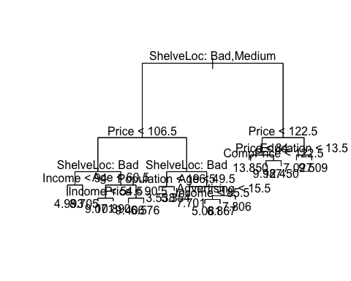

yhat=predict (tree.carseats ,newdata=Carseats[-train.carseats ,])  
cat("Obtained MSE of: ",mean((yhat -carseats.test)^2))

## Obtained MSE of: 5.124802

1. Cross-validation

cv.carseats = cv.tree(tree.carseats)  
cv.carseats

## $size  
## [1] 17 16 14 13 12 11 10 9 8 7 6 5 4 3 2 1  
##   
## $dev  
## [1] 986.4486 1005.3384 1071.7825 1071.7825 1044.5041 1056.8837 1016.5187  
## [8] 1016.5187 1130.7896 1132.1095 1147.8975 1147.8975 1159.1984 1193.6924  
## [15] 1270.0111 1662.9011  
##   
## $k  
## [1] -Inf 17.20778 22.26882 23.19946 27.52352 28.73494 31.15063  
## [8] 31.81033 51.53923 61.23975 73.71490 74.90618 83.52968 97.68064  
## [15] 190.89025 416.84938  
##   
## $method  
## [1] "deviance"  
##   
## attr(,"class")  
## [1] "prune" "tree.sequence"

plot(cv.carseats$size, cv.carseats$dev, type = 'b')

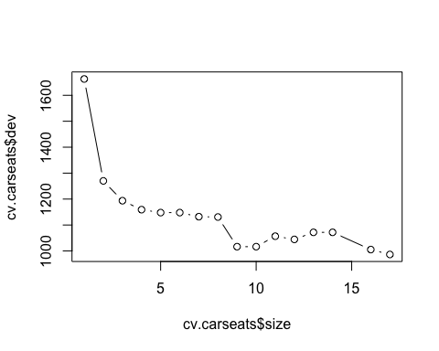

prune.carseats = prune.tree(tree.carseats,best=5)  
plot(prune.carseats)  
text(prune.carseats,pretty = 0)

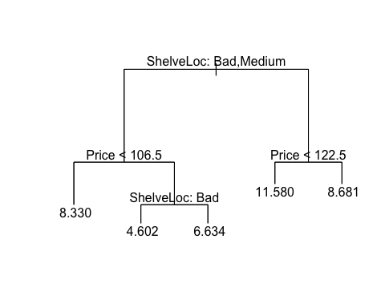

No, pruning does not improve the test MSE

1. Bagging

library(randomForest)

## randomForest 4.6-14

## Type rfNews() to see new features/changes/bug fixes.

set.seed(1)  
bag.car = randomForest(Sales~.,data = Carseats, subset = train.carseats, importance = TRUE)  
  
  
yhat.bag = predict(bag.car, newdata=Carseats[-train.carseats,])  
plot(yhat.bag, carseats.test)  
abline(0,1)

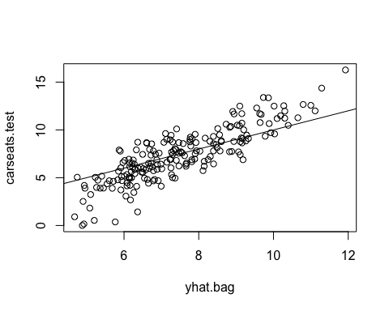

cat("Obtain test MSE of: ",mean((yhat.bag - carseats.test)^2))

## Obtain test MSE of: 2.804214

varImpPlot(bag.car)

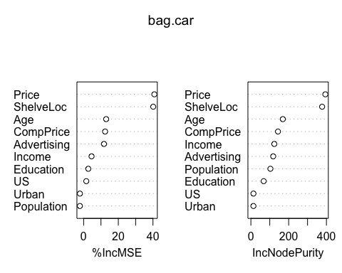

1. Random Forest

library(randomForest)  
set.seed(1)  
  
minMSE = 10000  
min.m = 0  
for( i in 1:11){  
 car.rf = randomForest(Sales~.,data = Carseats, subset = train.carseats, mtry = i,importance = TRUE)  
 yhat.rf = predict(car.rf, newdata=Carseats[-train.carseats,])  
 currentMSE = mean((yhat.rf - carseats.test)^2)  
 print(currentMSE)  
 if(currentMSE<minMSE){  
 minMSE = currentMSE  
 min.m = i  
 }  
}

## [1] 4.641856  
## [1] 3.293058  
## [1] 2.73729  
## [1] 2.605346  
## [1] 2.483848  
## [1] 2.404292  
## [1] 2.405813  
## [1] 2.404572  
## [1] 2.403962  
## [1] 2.401182

## Warning in randomForest.default(m, y, ...): invalid mtry: reset to within  
## valid range

## [1] 2.385646

min.m

## [1] 11

car.rf = randomForest(Sales~.,data = Carseats, subset = train.carseats, mtry = i,importance = TRUE)

## Warning in randomForest.default(m, y, ...): invalid mtry: reset to within  
## valid range

yhat.rf = predict(car.rf, newdata=Carseats[-train.carseats,])  
  
cat("Obtain test MSE of: ",mean((yhat.rf - carseats.test)^2))

## Obtain test MSE of: 2.376525

varImpPlot(bag.car)

