**Html5**

**HEAD section(meta):**

* This section describes about the webpage.

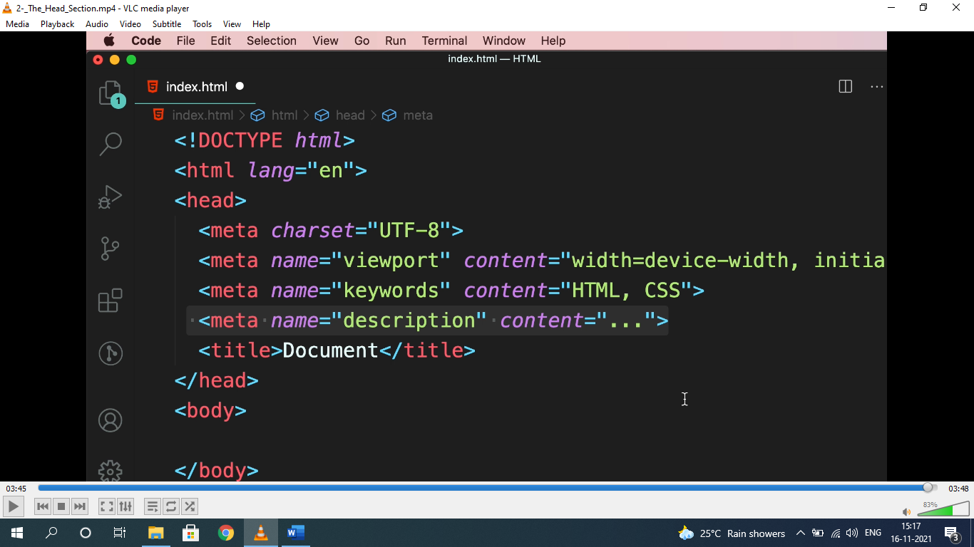ading

* Viewport=display size of device. Used to display content properly.

**<h1..h6>, <strong>, <em>:**

* Heading should be used in hierarchy.

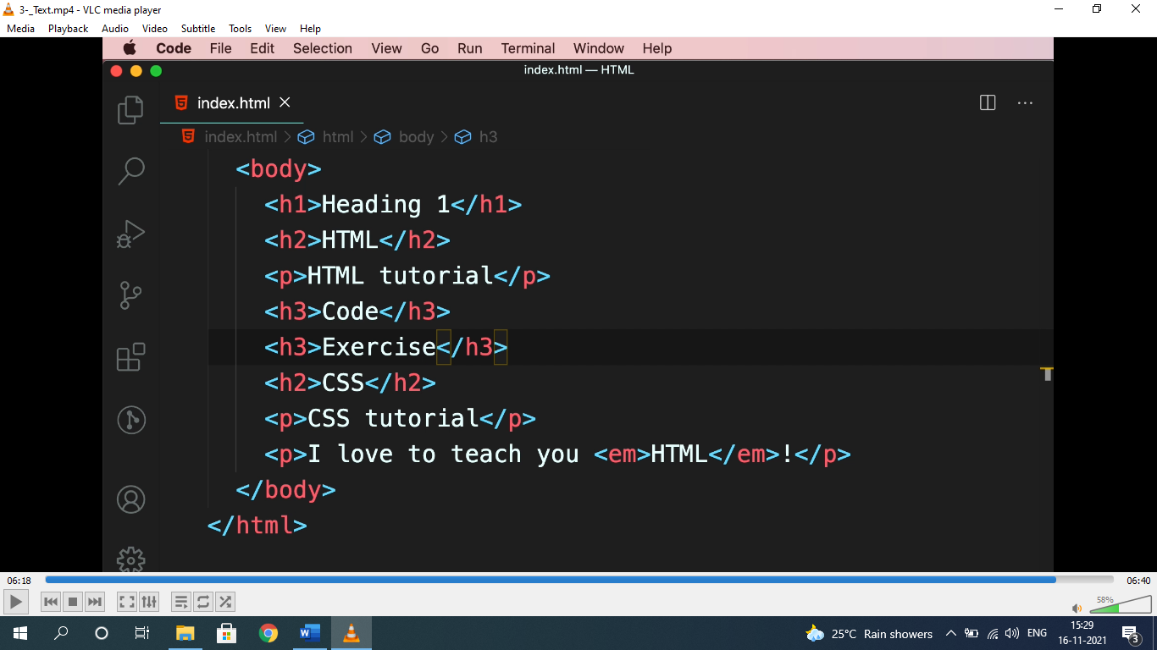

* <em> used for emphasizing and <strong> used for highlight.

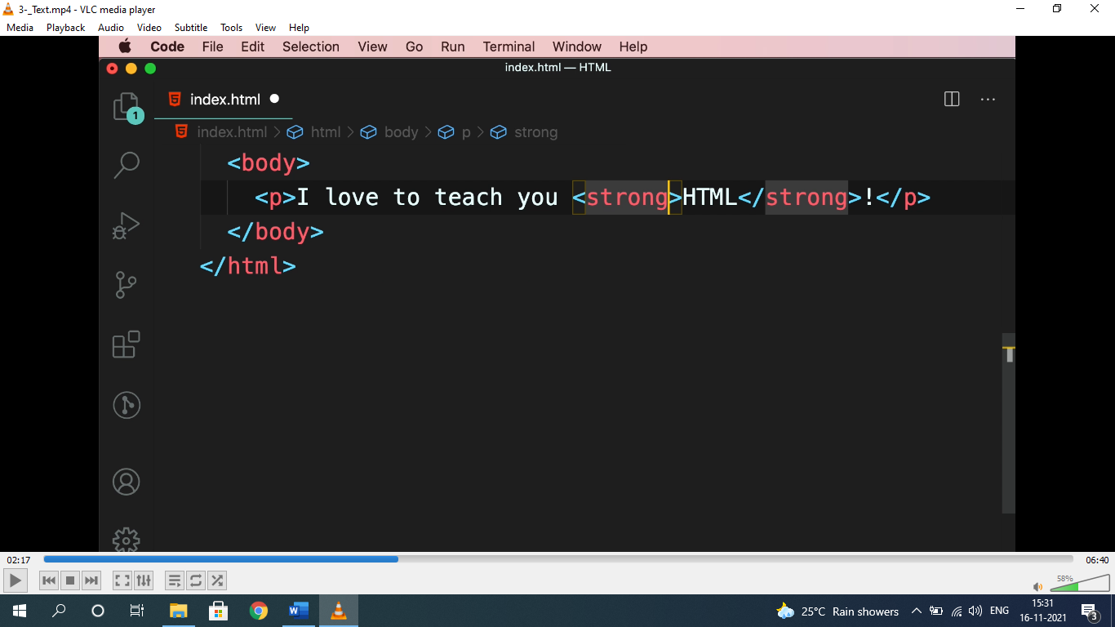

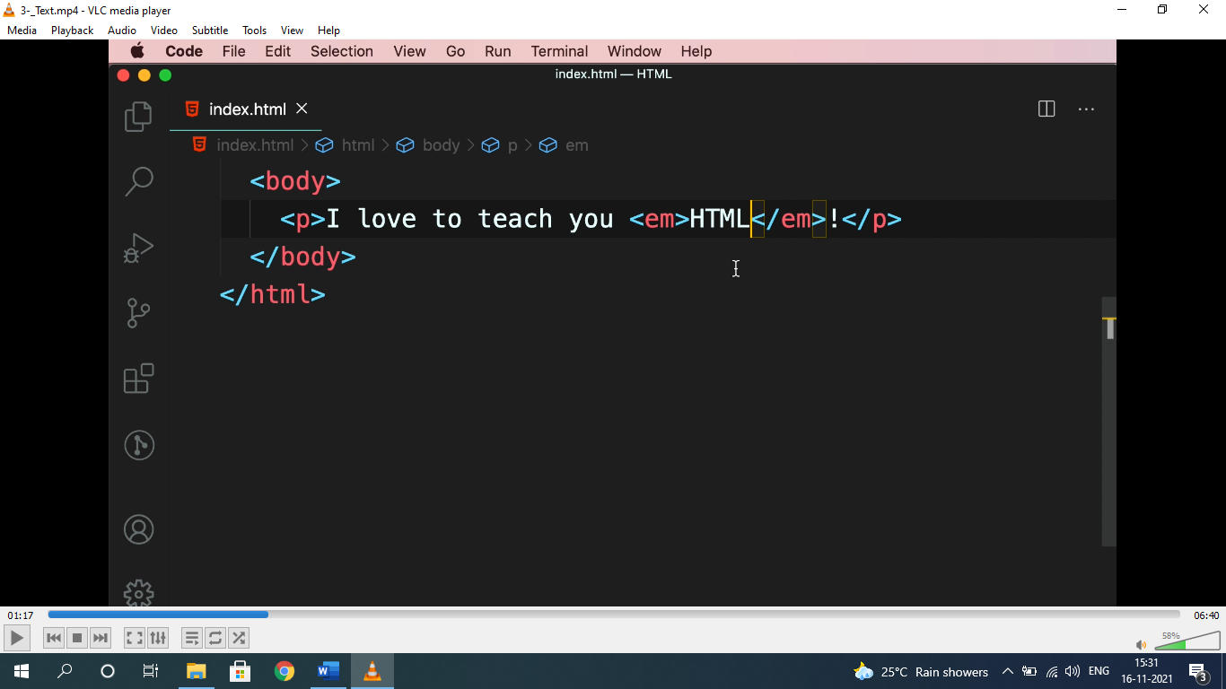

**ENTITIES(&;):**

* To represent elements, symbols as it is, it should be written within HTML entities i.e “&…;”.

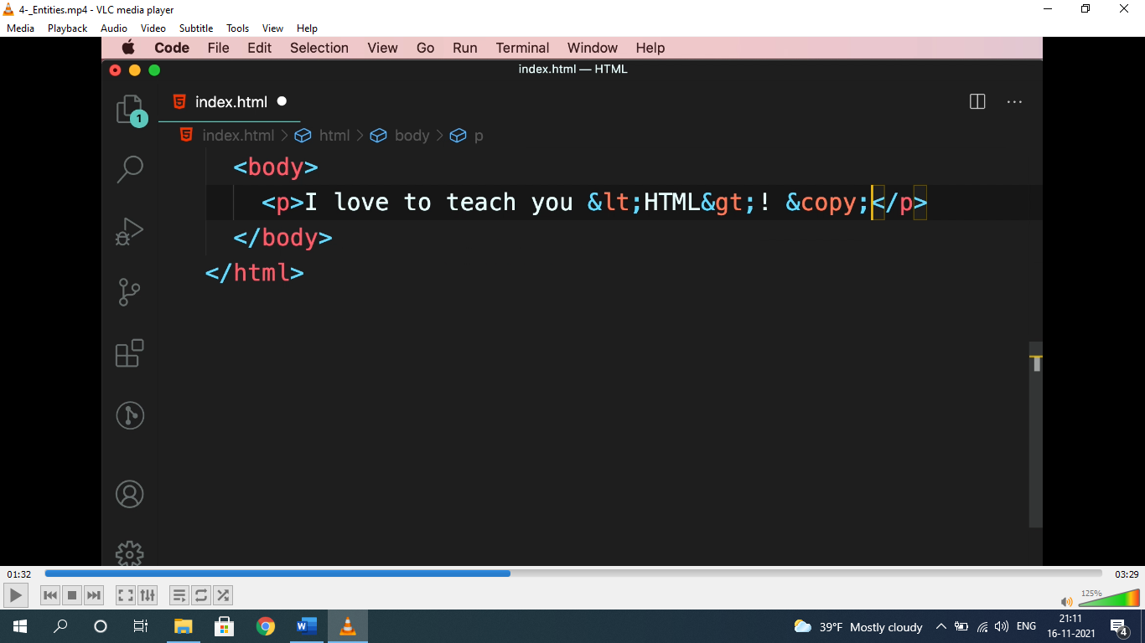

* For entities: ***search html entities in google.***

**HYPERLINK(href):-**

* used to navigate to links, images, download, pages etc.

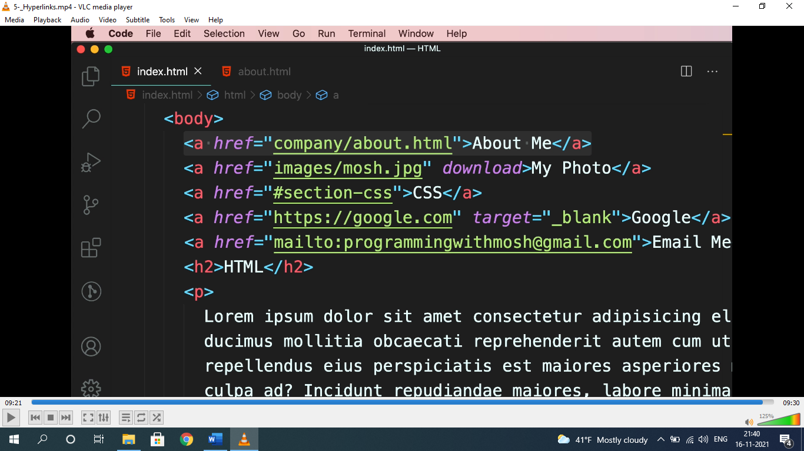

* “about me” is to navigate a page, “my photo” is to navigate to a photo with “download” attribute to download, CSS is to navigate to a ID “#section-css”. Google is to navigate to google home page.
* “**go to top**” can be done by assigning ID to “#”.

**IMAGES:**

* setting image hight and width without cropping or compressing “object-fit: cover” property is used.

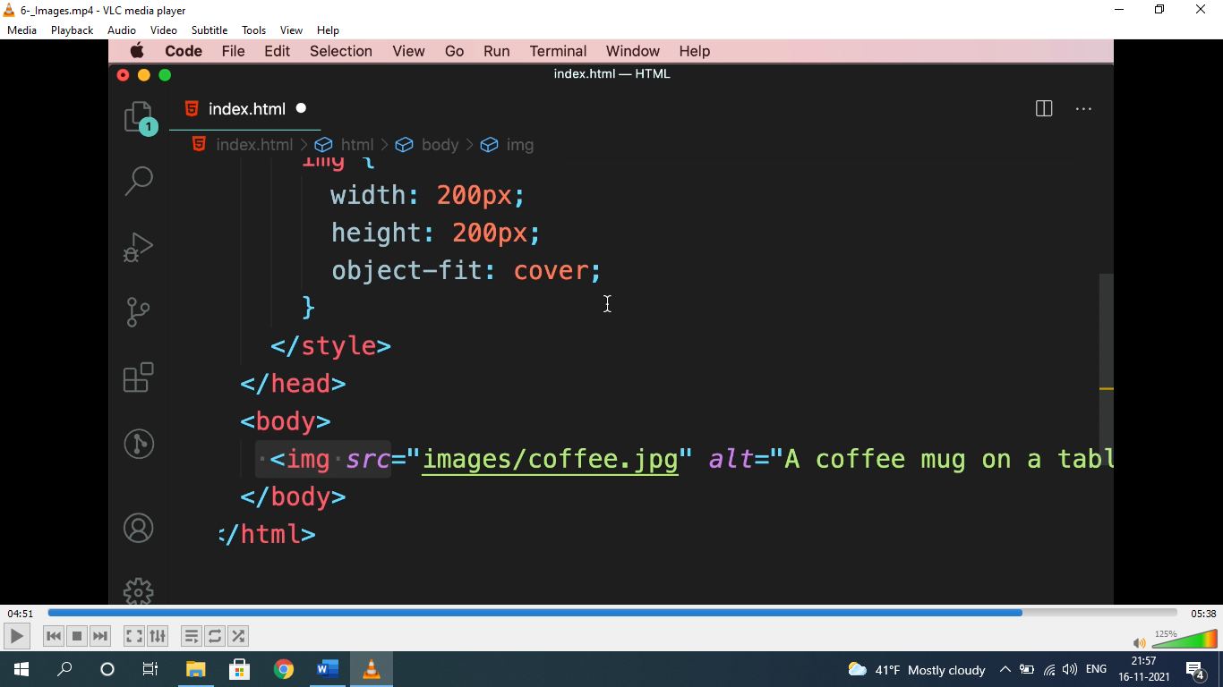

* for free images: ***unsplash.com***

**<video> & <audio>:**

* used to show video and audio.

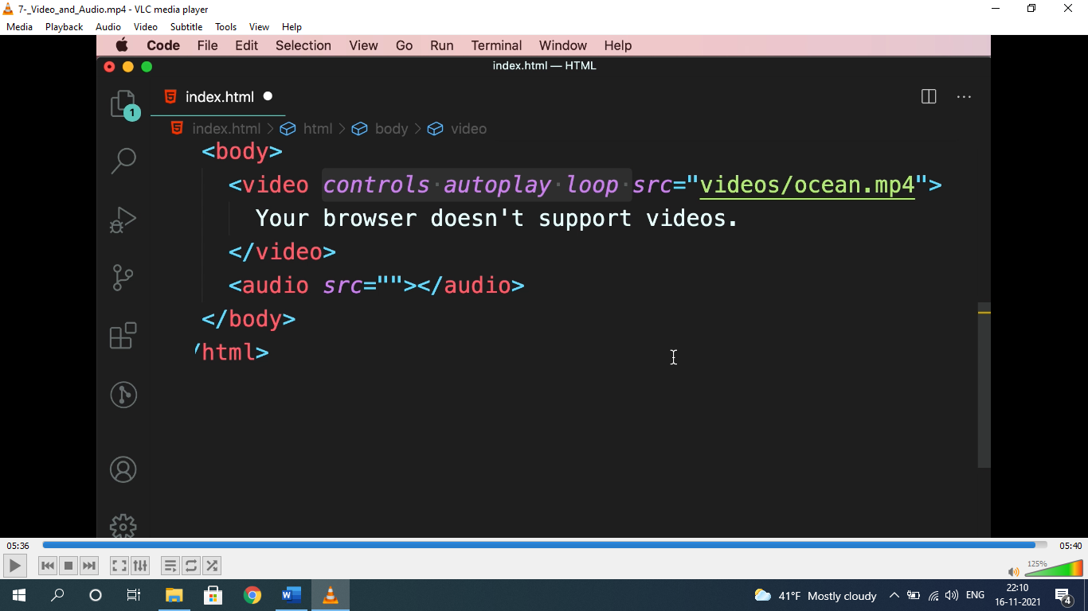

* “your browser doesn’t support videos” will only render when browser doesn’t support video.
* Attribute for video and audio are same.
* For free audio and videos: ***pexels.com***

**LISTS (<ul>, <ol>, <dl>);**

* Used to represent list, nav items etc.

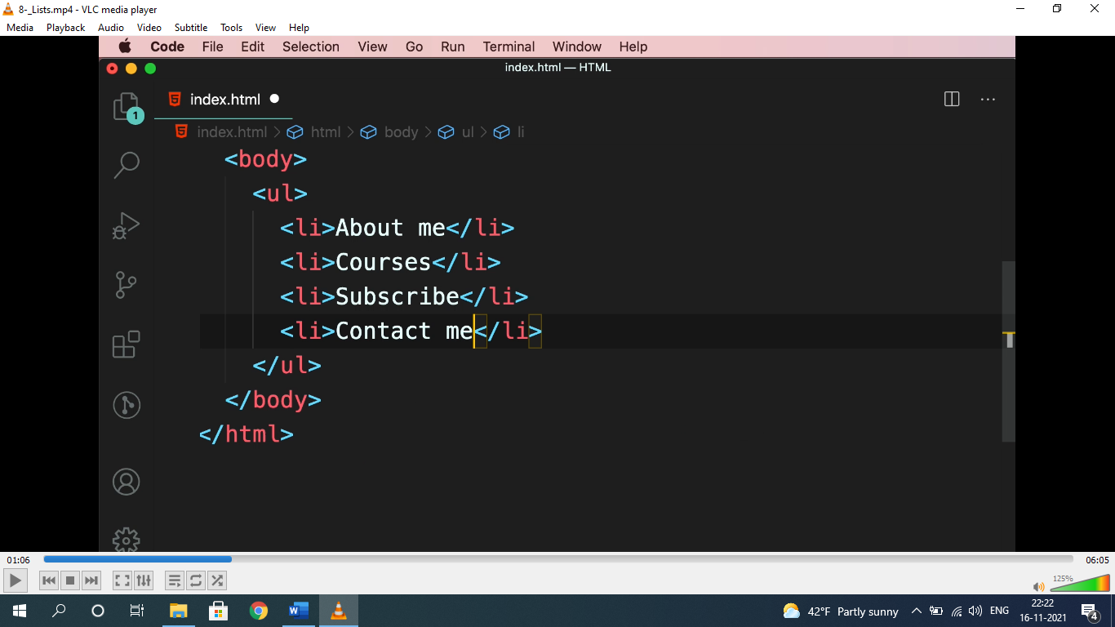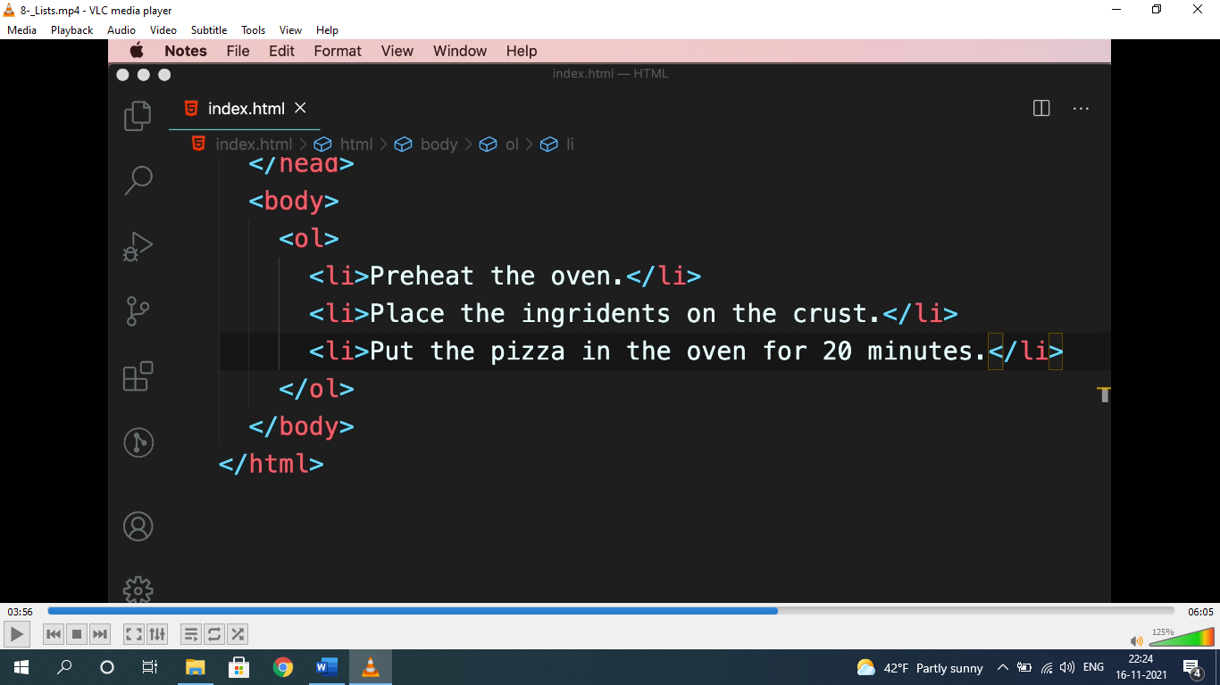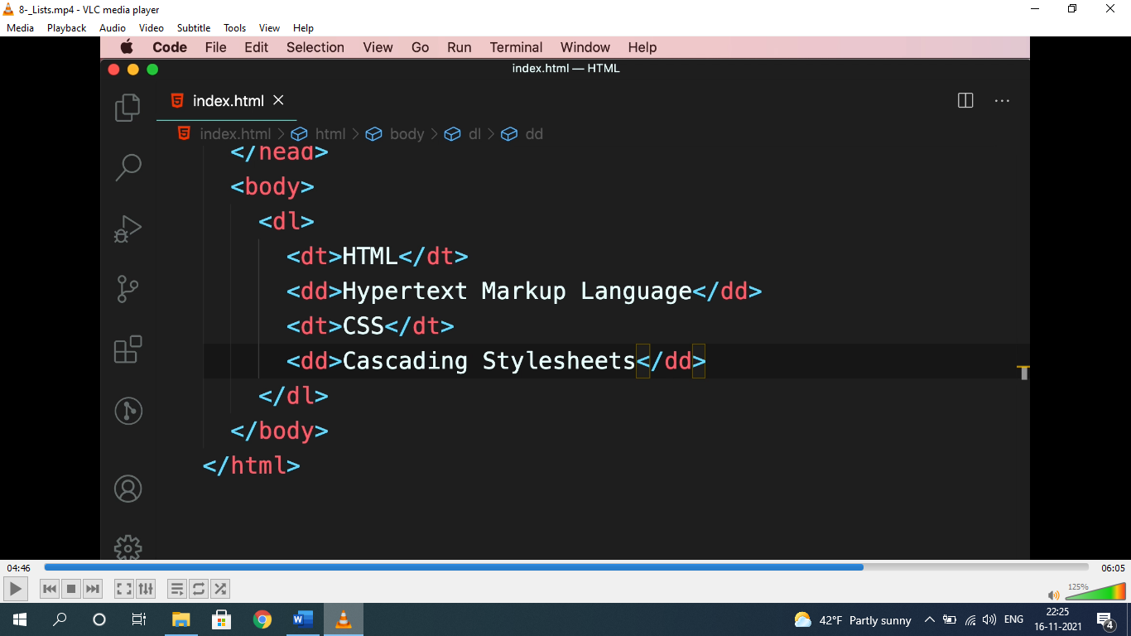

* dl= description list, dt= description term, dd= description details.