**TESTING**

**Form to test:**

import { render, screen } from '@testing-library/react';

import user from '@testing-library/user-event';

import UserForm from './UserForm';

test('it shows two inputs and a button', () => {

*// render the component*

  render(<UserForm />);

*// Manipulate the component or find an element in it*

*const* inputs = screen.getAllByRole('textbox');

*const* button = screen.getByRole('button');

*// Assertion - make sure the component is doing*

*// what we expect it to do*

  expect(inputs).toHaveLength(2);

  expect(button).toBeInTheDocument();

});

test('it calls onUserAdd when the form is submitted', () => {

*const* mock = jest.fn();

*// Try to render my component*

  render(<UserForm *onUserAdd*={mock} />);

*// Find the two inputs*

*const* nameInput = screen.getByRole('textbox', {

    name: /name/i,

  });

*const* emailInput = screen.getByRole('textbox', {

    name: /email/i,

  });

*// Simulate typing in a name*

  user.click(nameInput);

  user.keyboard('jane');

*// Simulate typing in an email*

  user.click(emailInput);

  user.keyboard('jane@jane.com');

*// Find the button*

*const* button = screen.getByRole('button');

*// Simulate clicking the button*

  user.click(button);

*// Assertion to make sure 'onUserAdd' gets called with email/name*

  expect(mock).toHaveBeenCalled();

  expect(mock).toHaveBeenCalledWith({ name: 'jane', email:'jane@jane.com' });

});

**Querying element using trsting playground”**

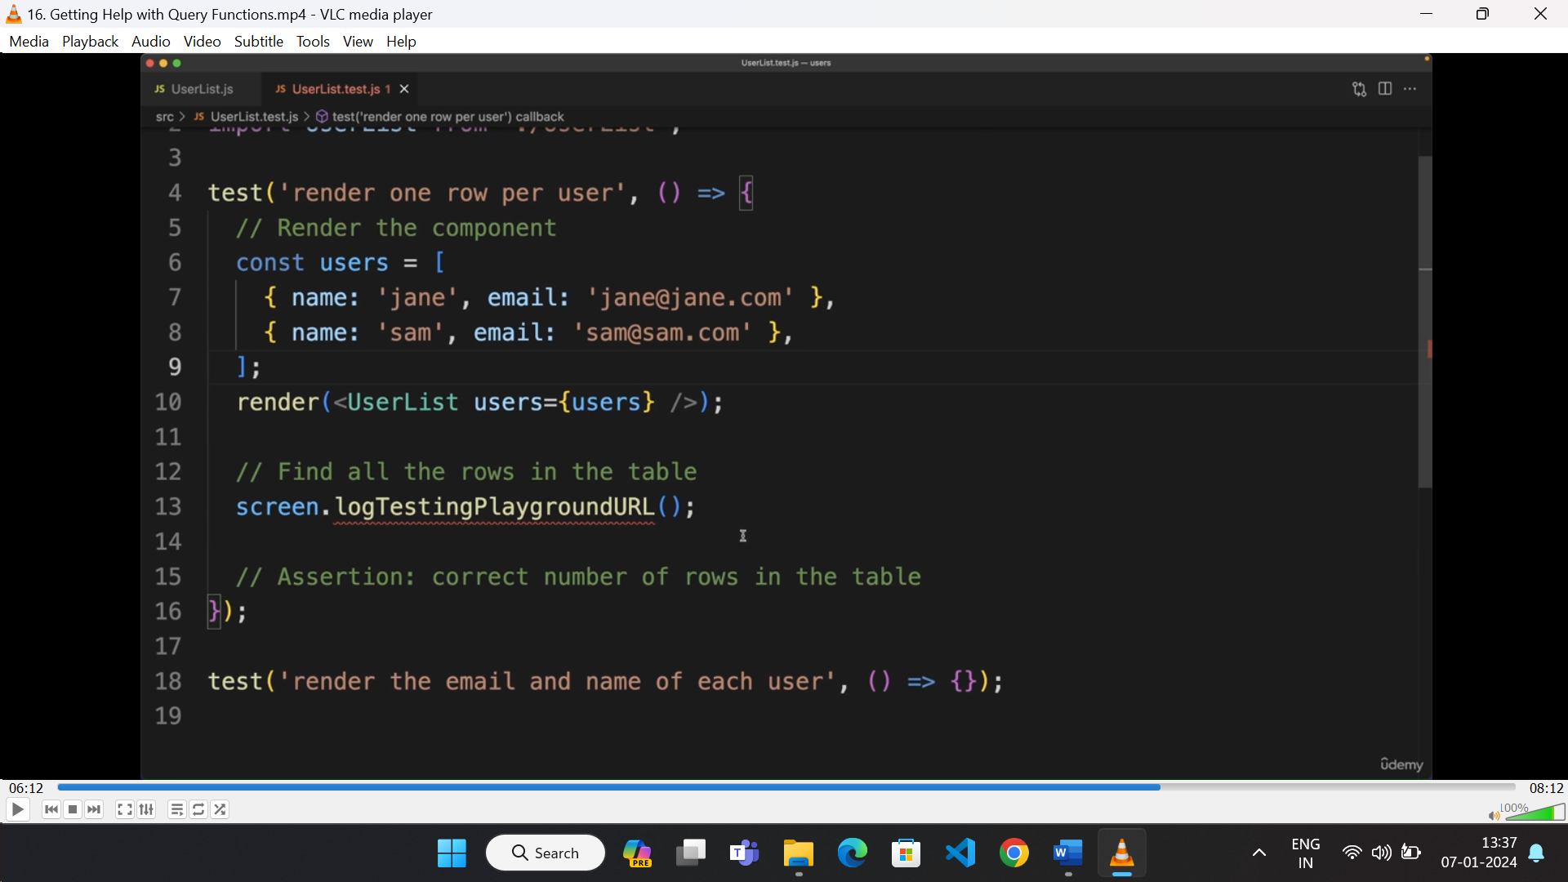

* It will log the component on the URL and hovering over the element, it displays how to get the element for testing.

**Quering element using “data=testid”:**

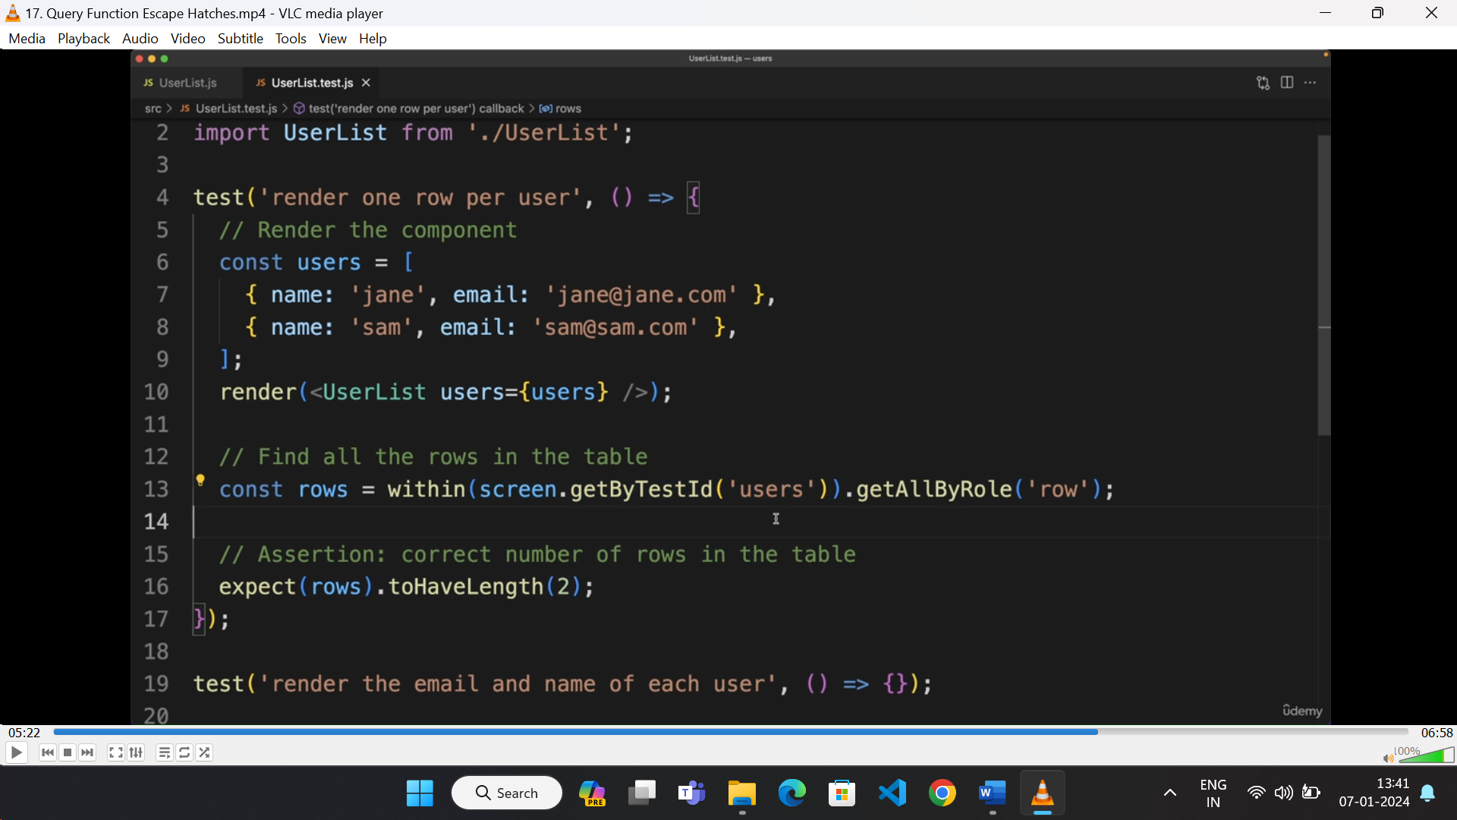

* Elements can be queried using “data-testid” to test functionality.
* Here checking the number of rows inside the element with the given testid.

**Querying elements from root container:**

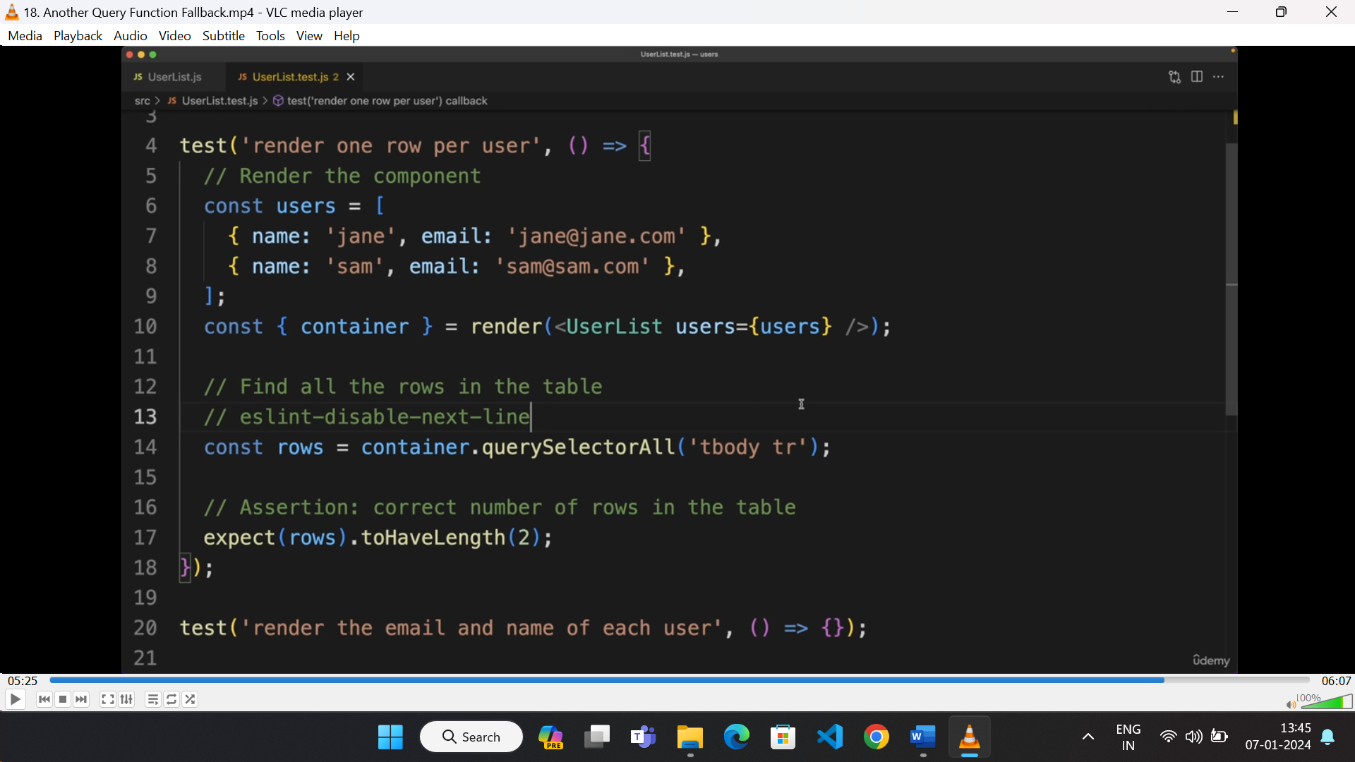

* Here we can get all html elements from the “container” object provided by the render function.
* “container.querySelector” or "container.querySelectorAll” used to get elements from testing DOM.
* Here we are getting all “<tr>” element from “<tbody>”.