Lab10_Matplotlib_ANP-C7281 and ANP-C7374

**Name : Sridhara j b**

**Id : AF0362612**

**1.Analyze the relationship between the size of houses (measured in square footage) and their selling prices in a particular neighborhood. You have collected data on various houses in that neighborhood.Create a scatter plot using the below data and share your conclusion/analysis.**

**Input: square_footage = np.array([1200, 1400, 1600, 1800, 2000, 2200, 2400, 2600, 2800, 3000]) selling_prices = np.array([250, 290, 315, 380, 410, 450, 500, 525, 570, 610])**

**Output:**

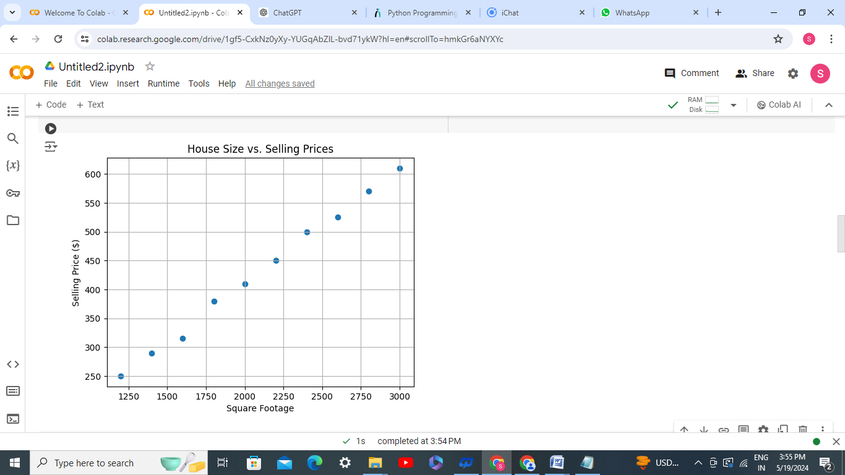

**PROGRAM :**

import numpy as np

import matplotlib.pyplot as plt

square_footage = np.array([1200, 1400, 1600, 1800, 2000, 2200, 2400, 2600, 2800, 3000])

selling_prices = np.array([250, 290, 315, 380, 410, 450, 500, 525, 570, 610])

plt.scatter(square_footage, selling_prices)

plt.title("House Size vs. Selling Prices")

plt.xlabel("Square Footage")

plt.ylabel("Selling Price ($)")

plt.grid(True)

plt.show()

**OUTPUT :**



**2. Create a pie chart to visualize the distribution of your monthly income by source. You have collected data on the various sources of your income, such as salary, freelance work, investments, and rental income. Share your conclusion/analysis.**

**Input: income_sources = ['Salary', 'Freelance', 'Investments', 'Rental', 'Other']**

**monthly_income = [5000, 1500, 1000, 600, 400]**

**Output**:

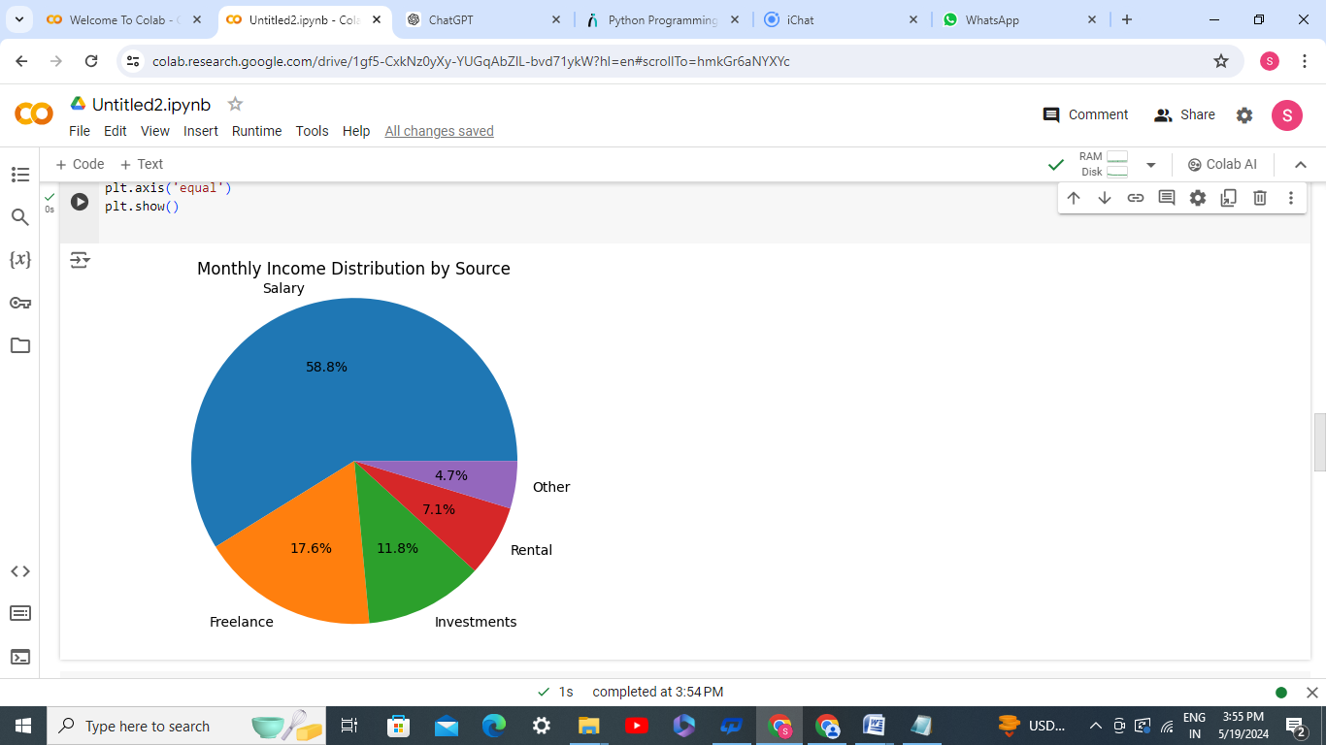

**PROGRAM :**

import matplotlib.pyplot as plt

income_sources = ['Salary', 'Freelance', 'Investments', 'Rental', 'Other']

monthly_income = [5000, 1500, 1000, 600, 400]

plt.pie(monthly_income, labels=income_sources, autopct='%1.1f%%')

plt.title('Monthly Income Distribution by Source')

plt.axis('equal')

plt.show()

**OUTPUT :**



**3. Suppose you're a sales manager for an e-commerce company, and you want to create a figure with subplots to compare the sales performance of different product categories over time. You have sales data for four product categories: Electronics, Clothing, Home & Garden, and Sports & Outdoors. Share your conclusion/analysis.**

**Input: months = np.arange(1, 13) electronics_sales = np.array([25000, 28000, 31000, 27000, 30000, 32000, 35000, 36000, 38000, 39000, 41000, 42000])**

**clothing_sales = np.array([15000, 16000, 17000, 18000, 19000, 20000, 21000, 22000, 23000, 24000, 25000, 26000])**

**home_garden_sales = np.array([18000, 19000, 20000, 21000, 22000, 23000, 24000, 25000, 26000, 27000, 28000, 29000])**

**sports_outdoors_sales = np.array([12000, 13000, 14000, 15000, 16000, 17000, 18000, 19000, 20000, 21000, 22000, 23000])**

**Output:**

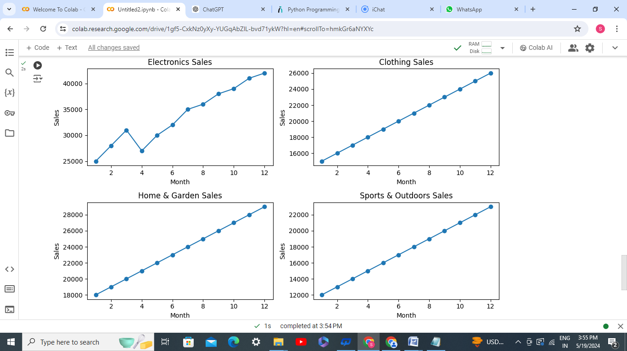

**PROGRAM :**

import numpy as np

import matplotlib.pyplot as plt

months = np.arange(1, 13)

electronics_sales = np.array([25000, 28000, 31000, 27000, 30000, 32000, 35000, 36000, 38000, 39000, 41000, 42000])

clothing_sales = np.array([15000, 16000, 17000, 18000, 19000, 20000, 21000, 22000, 23000, 24000, 25000, 26000])

home_garden_sales = np.array([18000, 19000, 20000, 21000, 22000, 23000, 24000, 25000, 26000, 27000, 28000, 29000])

sports_outdoors_sales = np.array([12000, 13000, 14000, 15000, 16000, 17000, 18000, 19000, 20000, 21000, 22000, 23000])

plt.figure(figsize=(10, 6))

plt.subplot(2, 2, 1)

plt.plot(months, electronics_sales, marker='o')

plt.title('Electronics Sales')

plt.xlabel('Month')

plt.ylabel('Sales')

plt.subplot(2, 2, 2)

plt.plot(months, clothing_sales, marker='o')

plt.title('Clothing Sales')

plt.xlabel('Month')

plt.ylabel('Sales')

plt.subplot(2, 2, 3)

plt.plot(months, home_garden_sales, marker='o')

plt.title('Home & Garden Sales')

plt.xlabel('Month')

plt.ylabel('Sales')

plt.subplot(2, 2, 4)

plt.plot(months, sports_outdoors_sales, marker='o')

plt.title('Sports & Outdoors Sales')

plt.xlabel('Month')

plt.ylabel('Sales')

plt.tight_layout()

plt.show()

**OUTPUT :**

