Validity Is Not Recovery:
Constrained Candidate Selection
for Molecular String Repair
Sridhara Syam Chandrabhotla$​^{1}$, KPK Lalitha Vitala$​^{2}$, S. Diwakar Bhagavathula$​^{3}$
$​^{1}$Independent Researcher, Bhimavaram, India
$​^{2}$Department of Electronics and Communications, Vishnu Institute of Technology, Bhimavaram, India
$​^{3}$Department of Chemistry, SRKR Engineering College, Bhimavaram, India
All authors contributed equally. Corresponding author: 11sridharasyam@gmail.com
lalitha.v@vishnu.edu.in diwakar.b@srkrec.edu.in
Abstract
Generative models for molecules routinely emit SMILES strings that no chemistry toolkit will parse, and a growing body of work aims to correct them. Validity, the fraction of repaired strings that parse, is the headline by which that work is claimed, even where identity metrics are reported too. We show validity is a weak proxy for whether the intended molecule is recovered, and that validity-only evaluation can substantially mis-rank recovery systems.
We build a leakage-controlled benchmark of 6,000 corrupted SMILES with known ground truth, drawn from a held-out molecule pool and corrupted with an operator mix calibrated to the error distribution of real generative-model failures. On it, a recent published corrector attains 86.6% validity but recovers the intended molecule for 1.2% of inputs: roughly 74 valid molecules per correct one. An unconstrained large-language-model repair loop shows the opposite profile (47.7% validity, 13.8% recovery), so the two systems are ordered one way by validity and the other by recovery.
We then show that invalid-SMILES recovery is better formulated as constrained candidate selection than as unconstrained sequence generation. A symbolic enumerator over single-token edits yields a candidate set containing the ground truth for 99.79% of items (median 50 candidates); the toolkit’s diagnosis prunes it losslessly; and a character-level chemical language model ranks what remains. The resulting system reaches 100.0% validity and 80.7% exact recovery, versus 59.4% for a supervised sequence-to-sequence corrector trained on 245,000 in-distribution repair pairs, which our method needs none of. The ranker is trained only on a disjoint molecule split, so the result is not pretraining contamination. The approach transfers to real generative-model output: 91.5% of 4,009 genuinely invalid strings sampled from a character-level generator admit a one-edit repair, and on corruptions of that generator’s own molecules recovery is 78.9%. On an external benchmark built with another group’s corruption code and molecule corpus, recovery among reachable items is 87.5%, and its output is always valid where it answers. Coverage collapses from 99.7% to 0.5% once two errors coincide, bounding the scope. Ranking confidence supports calibrated abstention: 46% of all inputs can be answered at 96.4% precision. We release the benchmark, code, and per-item outputs.
Keywords: SMILES; molecular string repair; generative models for molecules; evaluation methodology; chemical language models; benchmark; neuro-symbolic methods; selective prediction

Background
Molecular generative models emit molecules as strings, most often SMILES (Weininger 1988). A well-known failure mode is that a syntactically plausible string need not denote a molecule: ring-closure digits may be unbalanced, branches unclosed, valences violated, or an aromatic system un-kekulizable. Depending on architecture, between a few percent and a large minority of sampled strings fail to parse (Brown et al. 2019; Polykovskiy et al. 2020). Sampling temperature compounds this: the character-level generator we use throughout falls from 93.3% valid at $T=1.0$ to 85.3% at $T=1.2$ and 64.1% at $T=1.5$.
The dominant response has been prevention: constrained grammars (Kusner et al. 2017; Dai et al. 2018), or alternative string encodings such as SELFIES (Krenn et al. 2020), whose grammar makes every string decodable. A second and more recent response is correction: take the broken string and repair it. Correction is attractive because invalid strings are concentrated where the model is least certain, so discarding them throws away the model’s hardest cases. The premise deserves care, however: Skinnider (2024) shows that the ability to emit invalid strings is itself beneficial, acting as a self-corrective filter on low-likelihood samples, and that enforcing validity introduces structural bias. That argument tells against prevention rather than against correction, since a repaired string is recovered after the fact rather than forced during sampling. It does mean the case for repair rests on recovering the intended molecule, not merely on raising a validity count.
Validity is easy to compute, needs no ground truth, and is the number these systems are named and compared by. It is not the only number reported. Schoenmaker et al. (2023) measure a molecule reconstruction rate of 78% and observe that “fixed molecules do not necessarily represent the original molecule”; Tao et al. (2025) report exact match to the ground truth alongside validity; and Yoon and Lee (2026) argue the distinction directly. The gap between validity and identity is therefore known. What has not been established is how much it costs: whether validity is a mildly noisy proxy for recovery or a qualitatively different quantity that can order systems the wrong way round. This paper answers that question, and supplies the benchmark and metrics needed to ask it of any future system.

The problem with validity.
Consider a generative model that intended some molecule $m$ and emitted a corrupted string $\tilde{s}$. A corrector maps $\tilde{s}$ to some string $\hat{s}$. Validity asks only whether $\hat{s}$ parses. It is fully satisfied by a corrector that discards $\tilde{s}$ and returns benzene. Nothing in the metric rewards returning $m$. The concern is not hypothetical: methods that convert a broken string into a guaranteed-decodable representation achieve near-perfect validity precisely because the conversion is free to change the molecule.
What a practitioner wants is recovery: that $\hat{s}$ denotes $m$. This is measurable whenever ground truth is available, and it is the quantity we argue the field should report.

Contributions.
- A leakage-controlled recovery benchmark with known ground truth, built from a held-out molecule pool and calibrated to the empirical error mix of a real generative model (Section 4).
- A quantitative account of how far validity and recovery come apart, far enough to reverse the ordering of published systems. That validity is insufficient has been argued qualitatively (Yoon and Lee 2026); we measure the consequence (Section 6.1).
- A transfer of the bounded-edit constrained-selection formulation from syntax repair (Considine 2025) to molecular strings, instantiated with a chemistry toolkit’s diagnosis as the pruning constraint and a chemical language model as the prior: a six-stage system, EnumRank, attaining 100.0% validity and 80.7% exact recovery (Sections 5–6.4).
- A decomposition showing where recovery comes from: symbolic enumeration makes recovery possible (99.79% candidate coverage); the chemical prior makes it accurate (12.7% $→$ 80.7%).
- A comparison against a supervised corrector trained in-distribution on 245k repair pairs, which EnumRank beats without any repair supervision (Section 6.5).

Related work

Preventing invalid strings.
Grammar- and syntax-directed decoders constrain generation to a formal grammar (Kusner et al. 2017; Dai et al. 2018; Geng et al. 2023). SELFIES (Krenn et al. 2020, 2022) instead redesigns the string encoding so that every token sequence decodes to a molecule. These approaches eliminate invalidity by construction but change the generative model or its output space, and they do not help with strings already emitted by a deployed model.

Correcting invalid strings.
Closest to our setting are systems that repair broken SMILES directly. Sequence transduction models trained on synthetically corrupted SMILES learn to map invalid strings back to valid ones (Schoenmaker et al. 2023), which reports a 78% molecule reconstruction rate and 70.5% at one error per input. A more recent approach converts an invalid SMILES into SELFIES via grammar rules, obtaining essentially complete validity (Tao et al. 2025); it too reports exact match to the ground truth, and reasons about whether corrected strings recover the intended molecule. Neither work is validity-only. What neither does, and what this paper supplies, is a controlled setting in which validity and identity are measured side by side across systems, so that the two rankings can be compared directly.

Recovery rather than repair.
Concurrently with this work, Yoon and Lee (2026) argue that repairing a string is not the same as recovering the molecule it was meant to denote, and propose an agentic system that iteratively proposes and selects edits using a general-purpose LLM. We agree with their premise and adopt their terminology. Our work is complementary in three respects. First, their evaluation forces every system to 100% validity by falling back to SmiSelf, so validity-based and recovery-based rankings cannot be compared within their setup; quantifying that comparison is our starting point. Second, their candidate pool is produced by bounded stochastic LLM sampling with no soundness or completeness guarantee, whereas ours is a symbolic enumeration whose coverage of the answer we measure directly. Third, they evaluate on 140–194 real failures per backbone without a leakage analysis, a supervised baseline, or an abstention mechanism. Their independent finding that SmiSelf attains an exact match of 0.000 on their data corroborates the 1.2% we measure on ours.

Self-correction with language models.
A parallel literature has language models revise their own outputs given feedback, either self-generated (Madaan et al. 2023) or from an external verifier (Gou et al. 2024; Welleck et al. 2023). Applying this to SMILES is natural, since a chemistry toolkit is an exact verifier. We evaluate this family directly, and find it improves validity while degrading the identity of the recovered molecule, which is the central tension this paper quantifies.

Neuro-symbolic systems.
Our method belongs to the family that couples a symbolic component with a learned one (Garcez and Lamb 2023). The specific division of labour matters: rather than letting the neural component generate and the symbolic component merely check, the symbolic component defines a sound hypothesis space and the neural component only ranks within it. That division is not ours. Considine (2025) formulates bounded syntax repair as an intersection of a context-free language with a Levenshtein automaton, separating exact admissibility from probabilistic ranking, and argues that coverage must be measured because reranking cannot repair a retrieval failure. We adopt that formulation and ask what it takes to make it work for molecules, where the analogous machinery is unavailable: by our own measured error mix, kekulisation and valence violations account for 56.5% of real failures, and neither is context-free. Our soundness therefore comes from an oracle filter (RDKit parse and sanitise) rather than from a grammar, and the pruning constraint from that same toolkit’s diagnosis.

Problem formulation
Let $m$ be a molecule and $s=SMILES(m)$ a string denoting it. A corruption process produces $\tilde{s}≠s$ that fails to parse. A recovery system is a map $R(\tilde{s})=\hat{s}$. We evaluate $R$ with:
- Validity: $Pr[\hat{s}\text{ parses}]$. The standard metric.
- Exact recovery: $Pr[canon(\hat{s})=canon(s)]$, where $canon$ is RDKit canonicalisation (Landrum et al., n.d.). The quantity of interest.
- Tanimoto similarity of Morgan fingerprints (radius 2, 2048 bits) (Rogers and Hahn 2010), conditioned on validity: how close a non-exact recovery is.
- Scaffold match: equality of Bemis–Murcko scaffolds (Bemis and Murcko 1996), conditioned on validity.
- MCS fraction: size of the maximum common substructure as a fraction of the true molecule’s atoms, conditioned on validity.
We also report the ratio
$$V/R = \frac{\text{validity}}{\text{exact recovery}},$$
the number of valid molecules a system emits per molecule it actually recovers. A system with $V/R≈1$ is right whenever it answers; a system with large $V/R$ is mostly producing valid molecules that are not the requested ones.

A leakage-controlled recovery benchmark
Measuring recovery requires ground truth, which real generative-model failures do not come with. We therefore construct corruptions of known molecules, and take care that the construction neither leaks the answer nor drifts from realistic errors.

Error mix calibrated to real failures.
We first trained a character-level SMILES language model on the GuacaMol training split (Brown et al. 2019), sampled from it, and classified every invalid output with a two-stage RDKit diagnosis that separates parse failures from sanitisation failures. That measured distribution (kekulisation 45.2%, ring closure 31.3%, valence 11.3%, other syntax 5.4%, parentheses 3.7%, brackets 3.1%) is used as the target sampling mix for the corruption operators, so that the synthetic corruptions mirror the errors a real model makes. The mix actually realised in the benchmark is close but not identical (kekulisation 45.8%, ring 32.7%, valence 11.9%, other 5.6%, parentheses 3.6%, brackets 0.5%), because a corruption is accepted only when it yields a genuinely invalid string. Brackets are the one operator that materially under-delivers, because deleting a closing bracket usually leaves a string RDKit still parses, so that category is small ($n=19$ in the test split) and we draw no conclusions from it.

Construction.
Source molecules are drawn from the GuacaMol test split, which the generative model never saw. Each molecule is canonicalised, corrupted by a single-token operator sampled from the mix above, and verified to be genuinely invalid by RDKit; the observed error category is recorded, which agrees with the intended category for 99.6% of items. Duplicate source molecules are removed.

Splits and leakage control.
The benchmark contains 6,000 items, split into 1,800 development and 4,200 test. Every design decision in this paper (ranker choice, length normalisation, pruning rule) was made on the development split; the test split was scored once, at the end. We verified zero canonical-molecule overlap between all splits, and between the benchmark and the 245k-pair supervised-training corpus. Exactly one of the 4,200 test molecules also appears in the 1,272,851-molecule corpus used to train our generative model and ranker (0.02%); Section 6.11 shows that removing it changes every reported figure by at most 0.02 percentage points.
Critically, no component of any system we evaluate consults the ground truth. Enumeration uses only the corrupted string; pruning uses only the toolkit’s diagnosis of that string; ranking uses only a language-model likelihood; and the edit-distance selection rule used by the LLM baseline measures distance to the observed corrupted input, never to the answer.

Method: EnumRank
Our starting point is an observation about the structure of the problem. If a string became invalid through a small edit, the intended molecule is a small edit away, so rather than generating a repair, we can enumerate the repairs and choose among them. This turns an open-ended sequence-generation problem into a closed-set selection problem, with three consequences: validity becomes guaranteed rather than hoped for, the achievable ceiling becomes measurable, and the learned component is asked only for a preference, which is a much easier question than a string.
EnumRank has six stages.
RDKit is applied in two stages (parse, then sanitise), yielding an error category (ring, parenthesis, bracket, valence, kekulisation, other) and, where available, the offending atom indices mapped back to character positions.
All strings within one token edit of $\tilde{s}$ are generated: deletion at each position, substitution of each position by each token in a 50-token alphabet, and insertion of each token at each position.
Each candidate is parsed and sanitised; survivors are canonicalised and deduplicated by molecule. The surviving set is sound by construction: every member is a valid molecule.
The diagnosis constrains which edits could plausibly have caused the observed error: an unclosed ring is repaired by a ring-closure digit, an unbalanced branch by a parenthesis, and so on. Candidates whose edit is inconsistent with the diagnosis are removed. We select the tightest rule that is lossless on the development split.
Surviving candidates are scored by the log-likelihood of a chemical language model and sorted. Length normalisation is a per-ranker choice made on the development split: the two domain models use the mean per-character log-likelihood, the general-purpose LLM the summed log-likelihood (Section 6.4).
The top-ranked candidate is returned. The margin between the top two candidates is a confidence signal that supports abstention (Section 6.12).

Why a domain language model.
The ranker’s job is to express a chemical prior: among many valid molecules one edit apart, the intended one is the chemically ordinary one. We use the same character-level SMILES LSTM we trained as a generator. It is trained only on the GuacaMol training split, disjoint from the benchmark, which additionally makes it a contamination control: unlike a web-pretrained LLM, it cannot have memorised the test molecules from public databases.

Experiments
All results are on the 4,200-item test split unless stated otherwise. Confidence intervals are Wilson 95% intervals; system comparisons use exact paired McNemar tests with Bonferroni correction.

Experiment 1: is validity recovery?
Table 1 reports both metrics for every system. SmiSelf (Tao et al. 2025) attains 86.6% validity, and 1.2% exact recovery. Its $V/R$ ratio is 74.2: it emits about 74 valid molecules per molecule it actually recovers, because converting a broken string into a decodable representation is free to change the molecule. Its mean Tanimoto to the truth is 0.356 and its scaffold match rate 3.4%, so the outputs are not near-misses; they are different molecules.
The unconstrained LLM repair loop shows the opposite profile: 47.7% validity but 13.8% recovery. Ranked by validity, SmiSelf leads by 39 percentage points; ranked by recovery, the LLM loop leads by a factor of 12. Validity-only evaluation therefore does not merely compress the differences between these systems: it orders them the other way round. Figure 1 shows the full picture.
A useful control is the stock SELFIES round trip, which only ever returns strings that already parsed: its Tanimoto is exactly 1.000 and its $V/R$ exactly 1.0, confirming that these metrics do detect true recovery when it occurs.
Recovery on the held-out test split ($n=4,200$). Identity metrics are conditioned on producing a valid molecule. $V/R$ is valid outputs per correct recovery; 1.0 is ideal.
System | Validity | Exact rec. | Tanimoto | Scaffold | V/R
EnumRank (ours) | 100.0% | 80.7% | 0.937 | 84.7% | 1.2
Supervised seq2seq (in-dist., 245k) | 74.8% | 59.4% | 0.946 | 84.1% | 1.3
Enumerate + prune + general LLM | 100.0% | 50.2% | 0.805 | 57.9% | 2.0
Enumerate + shortest canonical | 100.0% | 23.1% | 0.683 | 28.5% | 4.3
Free LLM loop ($k=5$, min-edit) | 47.7% | 13.8% | 0.660 | 34.9% | 3.5
Enumerate + uniform | 100.0% | 13.6% | 0.629 | 19.7% | 7.3
SmiSelf (Tao et al. 2025) | 86.6% | 1.2% | 0.356 | 3.4% | 74.2
Rule-based repair | 11.8% | 0.0% | 0.503 | 0.8% | —
Stock SELFIES round trip (control) | 0.2% | 0.2% | 1.000 | 100.0% | 1.0
Identity (no repair) | 0.0% | 0.0% | — | — | —
Wilson 95% intervals on exact recovery are $[79.4,81.8]$ for EnumRank, $[57.9,60.9]$ for the supervised corrector, $[48.7,51.7]$ for general-LLM ranking, $[12.6,14.7]$ for uniform selection and $[0.9,1.5]$ for SmiSelf. No two of these intervals overlap, and the paired tests below are the stronger evidence in any case, since every system is scored on identical items.
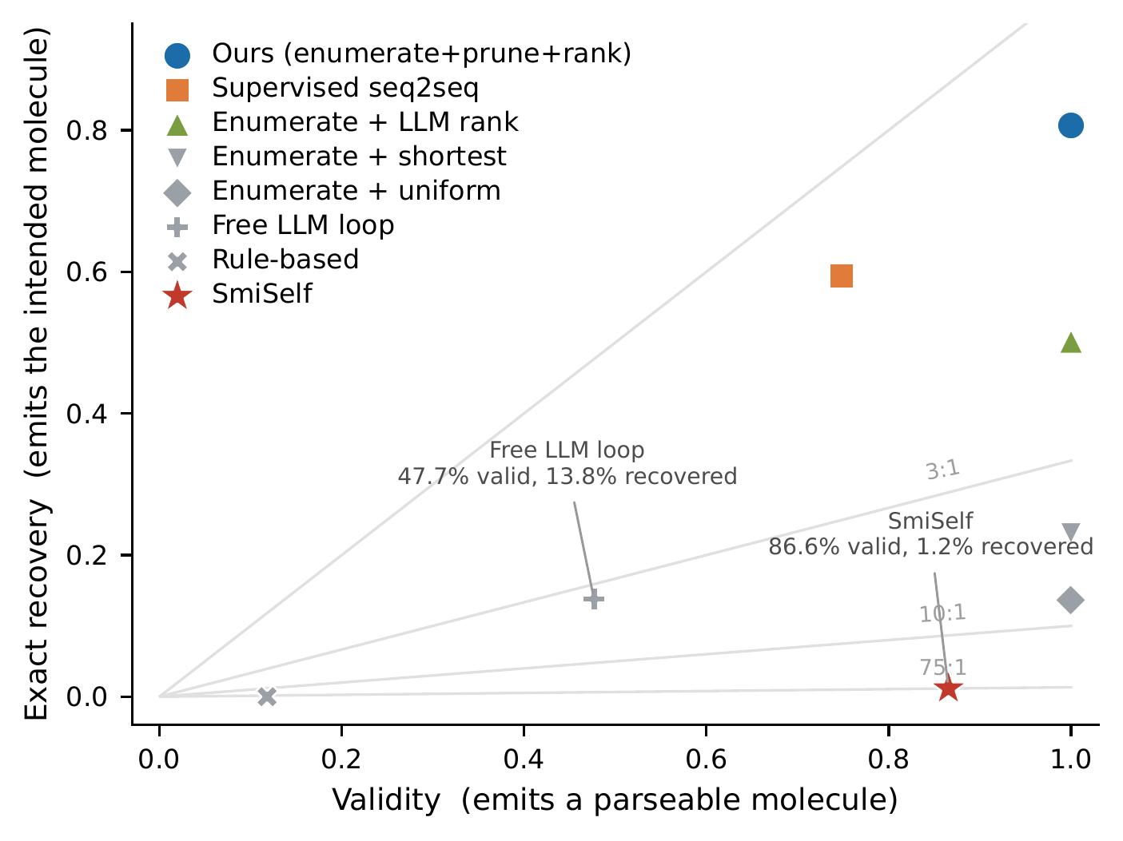
Validity and recovery are close to independent. Grey lines are contours of constant valid-outputs-per-correct-recovery. Two systems are annotated whose relative ordering depends entirely on which axis is read.

Experiment 2: can the candidate space contain the answer?
Enumerating all single-token edits and keeping those RDKit accepts yields a median of 50 candidate molecules per item (mean 75.9, 90th percentile 183). The ground-truth molecule is in that set for 99.79% of test items. The residual 0.21% is concentrated in bracket corruptions, where a deleted closing bracket sometimes cannot be repaired by a single token edit.
Two consequences follow. First, the task is essentially solvable within this hypothesis space, so any shortfall is a ranking failure, not a coverage failure. Second, a system that picks uniformly at random from the candidate set (with no learning whatsoever) achieves 12.7% expected exact recovery, which already exceeds every published system we evaluate. Figure 2 shows the distribution of candidate-set sizes and per-category coverage.
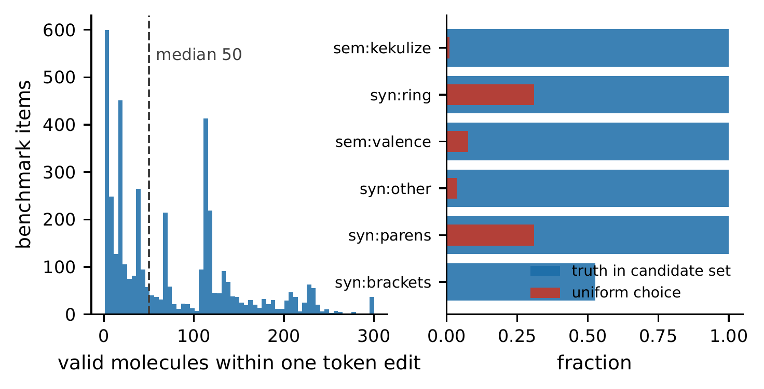
Left: number of valid molecules within one token edit. Right: per error category, the fraction of items whose candidate set contains the truth (blue) and the expected accuracy of uniform selection (red).

Experiment 3: does symbolic pruning help?
Using the RDKit diagnosis to discard edits inconsistent with the observed error reduces the median candidate set from 45 to 28 on the development split while leaving truth retention unchanged at 0.9978: the pruning is lossless. We selected the constraint by sweeping candidate rules on the development split and keeping the tightest lossless one; tightening kekulisation repairs to aromatic atoms alone, for instance, would shrink the median set to 27 but drop retention to 0.749, and was rejected.

Experiment 4: does ranking matter?
Holding the candidate set fixed and varying only the selection rule isolates the contribution of the prior (Figure 3):
Selection rule over the same candidate set | Exact recovery
Uniform at random | 13.6%
Shortest canonical SMILES | 23.1%
General LLM likelihood (Qwen2.5-14B (Qwen Team 2024), 14.7B params) | 50.2%
Domain Transformer LM likelihood (3.2M params) | 75.4%
Domain character-level LSTM likelihood (12.2M params) | 80.7%
Each language-model rung uses the length normalisation that won on the development split for that model, since the two families disagree about it: the general LLM scores 47.7% with summed and 39.3% with mean log-likelihood, while the character-level LSTM scores 80.3% with mean and 77.9% with summed. The table below therefore reports each ranker at its own dev-selected setting; using one rule for all of them would handicap whichever family it suited less.
The prior is worth 67 percentage points over uniform selection, and the gain tracks domain-specificity rather than scale. Both domain language models beat the general LLM by a wide margin while being thousands of times smaller: 75.4% for a 3.2M-parameter Transformer and 80.7% for the 12.2M-parameter character-level LSTM, against 50.2% for Qwen2.5-14B. Parameter count is not the operative variable, since the smaller of the two domain models still exceeds a model four thousand times its size. Their standing relative to each other is a separate question: Section 6.9 shows it depends on which generator produced the data being repaired, so the gap between them here should not be read as an architecture ranking. A model trained on SMILES places a sharper distribution over molecular strings than a general-purpose model whose tokeniser fragments them, and because both domain models see only a disjoint molecule split, their advantage cannot be explained by recall of test molecules from web pretraining.
The gain is largest exactly where the problem is hardest. Kekulisation errors are both the most frequent real failure (45.8% of the benchmark) and the most ambiguous (median 112 candidates even after pruning, 0.9% uniform accuracy); the domain prior lifts them to 67.5%, a factor of 74. Ring closures go from 31.0% to 93.1%, valence from 7.5% to 87.4% (Figure 4).
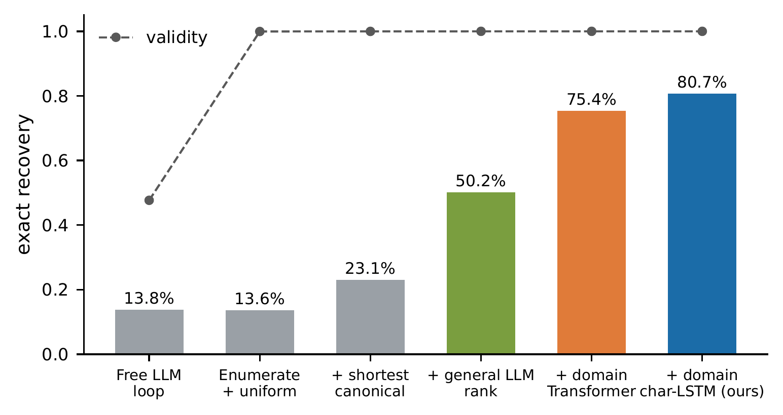
Exact recovery (bars) and validity (dashed) as the free-generation loop is replaced by enumeration and progressively better selection rules.
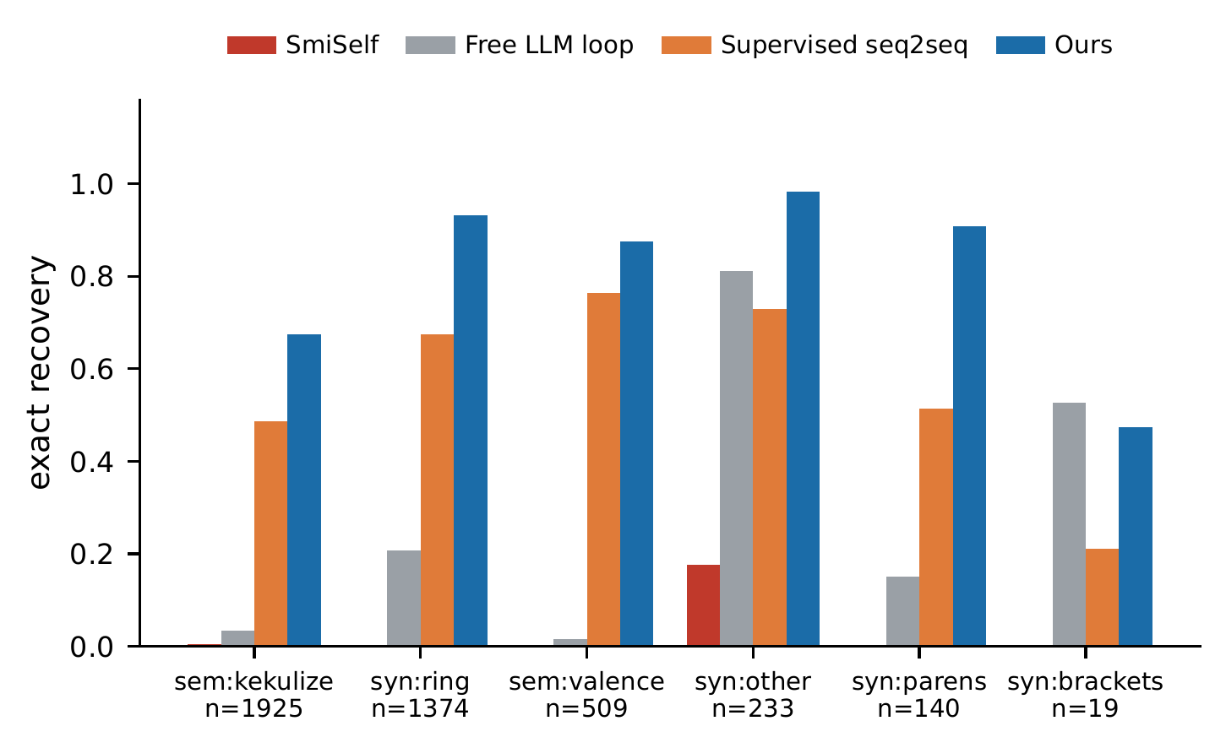
Exact recovery by error category.

Free generation is the wrong mechanism.
Our own earlier system is instructive as a negative result. Adding symbolic feedback and iteration to an LLM repair loop raises validity monotonically (23.4% $→$ 27.0% $→$ 37.4% $→$ 47.7%) but recovery saturates near 13.8%, and the iterative variants actually reduce Tanimoto (0.737 $→$ 0.660) and scaffold match (48.5% $→$ 34.9%). The loop buys validity by drifting away from the intended molecule. Constrained selection over the same problem reaches 100% validity and 80.7% recovery simultaneously, which is why we conclude that invalid-SMILES recovery is better formulated as constrained candidate selection than as unconstrained sequence generation.
Across three seeds the free loop varies by 0.15 percentage points (13.79/13.64/13.79%), far below the gaps between conditions.

Experiment 5: does it beat supervised correction?
The obvious alternative is to train a dedicated corrector. We took the transformer architecture of Schoenmaker et al. (2023) and retrained it from scratch on 245,000 corrupted/correct pairs generated from our own corruption distribution, so that it suffers no domain shift, using molecules disjoint from the benchmark. This baseline is given every advantage the setting allows.
It reaches 74.8% validity and 59.4% exact recovery, far better than the validity-oriented systems of Section 6.1 (SmiSelf at 1.2%, rule-based repair at 0.0%), confirming that in-distribution supervision on the right objective matters a great deal, and still 21 points below EnumRank (paired McNemar $+1210/−318$, $p_{\text{Bonf}}=1.1×{10}^{−121}$). The supervised corrector also inherits the generative failure mode: one output in four does not parse at all, whereas enumeration makes invalidity impossible.
EnumRank matches that result with no repair supervision, requiring only a chemistry toolkit, which practitioners already have, and a generative chemical language model, which in the intended deployment is the very model whose outputs are being repaired.

Experiment 6: does it transfer to real generator failures?
Our benchmark corrupts molecules deliberately, which invites the objection that real generative models might fail in ways the operators do not capture. To test that, we apply the pipeline to 4,009 genuinely invalid SMILES sampled from our character-level generator at $T=1.0$, and to a second benchmark built by corrupting the generator’s own valid outputs.

The one-edit hypothesis space holds on real failures.
Enumerating single-token repairs for the real failures yields a non-empty candidate set for 91.5% of them (median 72 candidates). The design assumption thus holds of real generator output and is not an artefact of how we built the benchmark. The remaining 8.5% carry more than one simultaneous error and are outside the current enumerator; we return them unchanged rather than guessing, which is the correct behaviour for a system that is asked to preserve identity.

Identity preservation without ground truth.
Exact recovery cannot be measured on real failures, since nobody knows which molecule the model intended, and that is precisely why the controlled benchmark exists. What can be measured is how much of the string a repair destroys. A method that rewrites most of the molecule cannot be preserving what the generator was reaching for, whatever its validity rate.
On 4,009 real generator failures | Yield | Repair size (tokens)
3-4 | (valid output) | median | mean
EnumRank (ours) | 91.5% | 1 | 1.00
SmiSelf (Tao et al. 2025) | 90.9% | 21 | 21.47
Repair size is the token edit distance from the broken string to the string the method emitted. Every EnumRank repair is a single token by construction. (Measured instead against the canonicalised output, our median rises to 2 and the mean to 9.8, but that reflects RDKit re-serialising the string rather than any further change to the molecule; we report the applied edit, which is the quantity of interest.)
SmiSelf converts a comparable fraction of real failures into valid molecules, but at a median token edit distance of 21: it re-encodes the string through SELFIES and emits a largely different molecule. On the controlled benchmark that difference is worth 1.2% against 80.7% exact recovery. Here the truth is unknown, so the 21-fold gap in intervention size is the only trace of the same effect we can observe.

Recovery on the generator’s own distribution.
To obtain ground truth on the distribution a real model actually produces, we corrupted 2,000 of the generator’s own valid outputs with the same operators. Because these molecules came from the generator, ground truth is available and exact recovery is measurable. The candidate set contains the truth for 99.7% of items (median 47 candidates) and uniform selection scores 12.5%, both close to the main benchmark. EnumRank recovers 78.9% exactly at 99.9% validity, against 80.7% on the GuacaMol-derived benchmark.
The method transfers to the distribution a real model produces, losing under two points. Note also that the ranker here is the very model that generated the molecules, so the prior is matched to the data: the deployment setting, but equally the configuration in which one would most expect an inflated result. Performance is slightly lower than on molecules the ranker has never seen, which argues that the chemical prior, rather than familiarity with these particular molecules, is doing the work.

Experiment 7: where does the one-edit assumption break?
Enumerating single-token edits is the assumption the method rests on, so we measure what it costs. Using the same held-out pool but excluding all 6,000 molecules of the main benchmark, we built matched benchmarks of 600 items at $k=1$, $2$ and $3$ simultaneous edits (realised mean token distance 1.10, 2.01, 3.29).
$k$ (simultaneous edits) | one-edit coverage | median candidates | empty sets
1 | 99.67% | 45 | 0/600
2 | 0.50% | 0 | 324/600
3 | 0.00% | 0 | 536/600
The enumerator does not degrade gracefully. It is near-complete at $k=1$ and of almost no use at $k=2$, which fixes the method’s scope boundary and makes the measurement in Section 6.6 load-bearing: 91.5% of real generator failures fall on the useful side of it. On the $k=1$ benchmark, whose molecules are disjoint from the main benchmark entirely, EnumRank recovers 80.0% exactly at 100% validity, replicating the 80.7% headline on fresh molecules.

Buying a second edit, and what it costs.
A complete two-edit enumeration is quadratic and infeasible. We therefore run a bounded search: level one enumerates one-edit neighbours; the invalid ones are ranked by a purely syntactic imbalance score (unclosed branches, odd ring-closure digits, bracket mismatch, none of which uses ground truth), and the best beam of them are expanded by a second edit under a per-item wall-clock budget.
Configuration | $n$​ | $k=2$ coverage | parses/item | s/item
one-edit only | 600 | 0.5% | $∼$5k | $∼$0.02
beam 60, 4 s budget | 40 | 5.0% | 28,063 | 4.42
beam 150, 15 s budget | 20 | 30.0% | 117,819 | 15.32
beam 400, 60 s budget | 12 | 58.3% | 437,774 | 60.32
Coverage rises monotonically and the budget binds at every setting (truncation on 100%, 100% and 92% of items respectively), so each figure is a lower bound for that compute level. What limits the search is compute rather than the ranking heuristic. The second edit is reachable, at roughly three orders of magnitude more work than the first. We report this as a cost curve and do not claim to solve the multi-edit case.

Experiment 8: an external benchmark, built by someone else
Both the corruption operators and the source molecules are ours, which leaves open whether the method is tuned to its own corruption process. We therefore built an independent benchmark using the corruption code released with UnCorrupt SMILES (Schoenmaker et al. 2023), at one error per molecule, applied to their molecule source (PAPYRUS, a bioactivity corpus). The operators, the fragment library and the molecules are all theirs; our ranker has never seen a PAPYRUS molecule, so the benchmark doubles as an out-of-distribution test of the chemical prior ($n=1,200$). This reconstructs the condition Schoenmaker et al. (2023) evaluate themselves, so their published figure is the natural reference point: 70.5% reconstruction at one error per input, and 78% for their translator overall. The comparison is indicative rather than like-for-like, since their model is trained on this corruption distribution and ours is not, their evaluation set is their own validation split, and the operator mix differs from the one we sample. It is nonetheless the closest direct point of contact between the two systems, and we report it rather than leave it to be inferred.
Their notion of “one error” is not one token: only 28.0% of items lie a single token from the intended molecule, the median is 5, the 90th percentile is 26, and 11.1% graft an entire fragment onto the molecule (in which case the intended target is the grafted molecule, and we score against it exactly as their own pipeline does). Spanning both sides of our scope boundary makes it a stress test rather than a like-for-like comparison.
EnumRank on the external benchmark ($n=1,200$)
truth reachable within one edit | 69.1%
items answered (non-empty candidate set) | 84.5%
validity $∣$ answered | 100.00%
recovery $∣$ answered | 71.5%
items abstained (empty candidate set) | 15.5%
overall validity | 84.5%
overall exact recovery | 60.4%
Tanimoto $∣$ valid | 0.888
scaffold match $∣$ valid | 77.4%
recovery $∣$ truth reachable | 87.5%
recovery $∣$ truth not reachable | 0.00%

How much of this benchmark is reachable at all.
String edit distance is the wrong axis here. Their permutation operator reorders tokens and their graft operator appends a whole fragment, both of which inflate string distance while leaving the required repair small, and canonicalisation inflates it further. We report reachability instead. The truth is reachable within one edit for 69.1% of items. Of the 371 that are not, a bounded two-edit search (beam 150, 15 s per item; probe of 120) reaches a further 5.0%, about 1.5 points, with the budget binding on every item, again a lower bound. Roughly 29% of this external benchmark lies beyond edit-bounded enumeration altogether. That is the limit of the approach: it is a precise repair mechanism, not a general molecule reconstructor.
Recovery conditioned on the truth being reachable is 87.5%, marginally higher than the corresponding figure on our own benchmark (80.7% of 99.8%, i.e. 80.9%), so the chemical prior transfers to an unseen molecule corpus with no loss we can detect. The two figures are close enough that we draw no conclusion from the direction of the difference. Two of the remaining entries are checks rather than results. Recovery conditioned on the truth not being reachable is exactly zero: the method cannot return a molecule it never enumerated. Validity conditioned on answering is exactly 100%, on data the system was never designed against. The 15.5% it declines are the multi-edit corruptions of Experiment 6.7, and declining them is the correct behaviour for a system whose purpose is to preserve identity.

Experiment 9: does the prior have to match the generator?
Our ranker is the generative model whose output is being repaired, which is the intended deployment but raises the question of how much of the performance comes from that match. To separate the two, we trained a second generator of a different family (a 3.2M-parameter decoder-only SMILES Transformer, trained on the same corpus and reusing the character vocabulary of the LSTM verbatim, so the comparison is architectural rather than a tokenisation artefact), and built a corruption benchmark from each generator’s own valid samples (2,000 items each, identical operators and seed). The two generators differ substantially in how often they fail: 93.3% of the LSTM’s samples parse, against 83.6% of the Transformer’s. Their failures are nonetheless equally reachable (candidate-set coverage 99.7% and 99.8%, median 47 and 44 candidates), so differences below are attributable to the ranker rather than to one benchmark being easier.
 | Ranker
2-3 Benchmark (corruptions of…) | char-LSTM (12.2M) | Transformer (3.2M)
LSTM’s own molecules | 78.9% | 73.1%
Transformer’s own molecules | 64.9% | 73.8%
GuacaMol test (neither generator’s) | 80.7% | 75.4%
The diagonal dominates. Each ranker recovers best on the benchmark built from its own generator’s molecules, the LSTM ahead by 5.8 points on LSTM-derived corruptions and the Transformer ahead by 8.8 points on Transformer-derived ones; averaged over the two, a matched prior is worth 7.3 points (76.3% against 69.0%).
What the table shows is an interaction rather than an ordering. It supports the deployment we assume, namely repairing a generator’s output with that generator, whose prior is calibrated to the region of chemical space where it is producing broken strings. It also accounts for the five-point gap between the two domain models in Section 6.4, which is not evidence that recurrent architectures rank better: that benchmark simply happens not to be Transformer-derived, and on Transformer-derived data the ordering reverses. The cost of a mismatch is bounded, since even the worse off-diagonal cell (64.9%) remains above the general-LLM ranker (50.2%) and far above the validity-oriented corrector evaluated here (1.2%), so a mismatched domain prior degrades recovery without destroying it.
Validity is 99.9% or above in all four cells, as it must be, since enumeration guarantees it regardless of which model does the ranking.

Statistical significance
All differences in Table 1 are significant under exact paired McNemar tests with Bonferroni correction ($m=6$):
Comparison (exact recovery) | wins/losses | $p_{\text{Bonf}}$​
EnumRank vs. SmiSelf | $+3344/−5$​ | $<{10}^{−300}$​
EnumRank vs. shortest canonical | $+2453/−34$​ | $<{10}^{−300}$​
EnumRank vs. general-LLM ranking | $+1427/−146$​ | $1.7×{10}^{−263}$​
EnumRank vs. supervised seq2seq | $+1210/−318$​ | $1.1×{10}^{−121}$​
Supervised seq2seq vs. SmiSelf | $+2460/−13$​ | $<{10}^{−300}$​
Supervised seq2seq vs. LLM ranking | $+996/−607$​ | $1.2×{10}^{−21}$​

Contamination check
Exactly one test molecule occurs in the corpus used to train the generator and ranker. Removing it and recomputing every headline number changes EnumRank by $−0.005$ percentage points (80.67% $→$ 80.66%); across all systems the largest change is 0.02 points. Training-set contamination does not explain these results.

Calibrated abstention
Because recovery is not perfect, a deployable system should know when it is unsure. The gap between the top-ranked and second-ranked candidate log-likelihood is a confidence signal that never consults ground truth. Sorting test items by it yields the risk–coverage curve in Figure 5. The signal is defined for the 3,881 items (92.4%) whose pruned candidate set holds more than one molecule; the remaining 319 admit a single candidate and involve no ranking decision. Among those 3,881, answering the most confident 50% gives 96.4% precision, the most confident 30% gives 99.2%, and the most confident 20% gives 99.7%. The 50% operating point is 1,940 molecules, or 46% of the full test split.
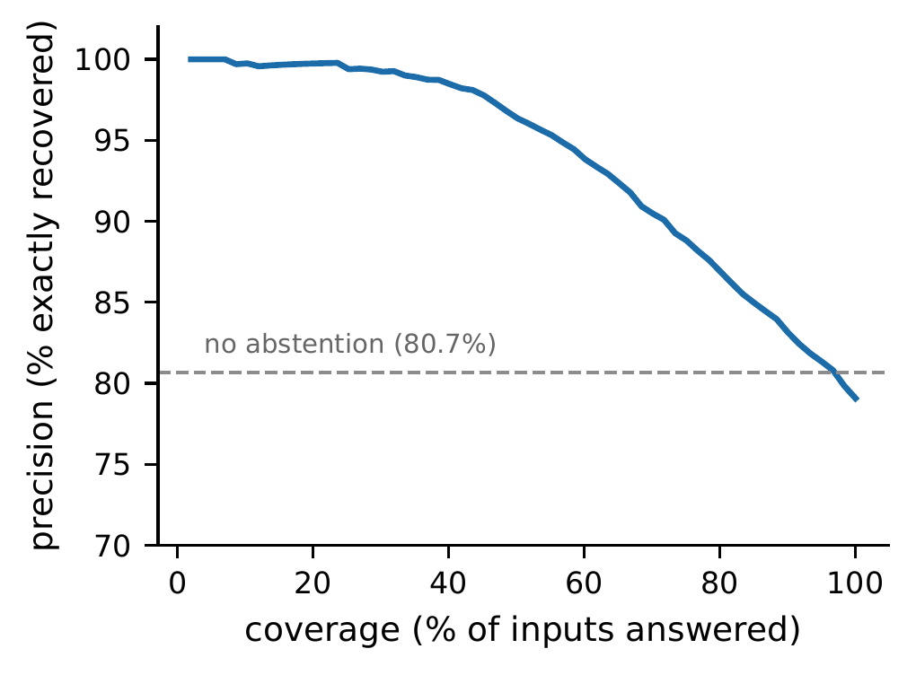
Risk–coverage curve for EnumRank, over the 3,881 test items for which the ranking margin is defined. Answering the most confident half of them (46% of the full test split) gives 96.4% precision.

Discussion

What the field should report.
We do not argue that validity is meaningless: a system that emits unparseable strings is useless. We argue that validity is insufficient, and that reporting it alone permits a system to look excellent while recovering almost nothing. The $V/R$ ratio is a cheap diagnostic: any corrector whose ratio is far from 1 is mostly manufacturing molecules rather than recovering them. Recovery metrics require ground truth, which is exactly what a benchmark like ours supplies.

Where the difficulty actually lives.
The decomposition is clean. Symbolic enumeration makes recovery possible : it delivers a sound candidate set containing the answer 99.79% of the time. The chemical prior makes recovery accurate, converting 12.7% into 80.7%. Neither half suffices alone: enumeration without a prior is barely better than published methods, and a prior without enumeration (the free LLM loop) sacrifices validity and drifts off the intended molecule.

Limitations.
Our benchmark applies single-token corruptions. This matches the modal real failure, and Section 6.6 shows that 91.5% of real generator failures admit a one-edit repair, but the remaining 8.5% carry multiple simultaneous errors and are outside the current enumerator. Section 6.7 quantifies that boundary rather than assuming it: coverage falls from 99.7% at one edit to 0.5% at two and 0.0% at three, and a bounded two-edit search recovers much of the $k=2$ case (58.3% coverage) only at roughly three orders of magnitude more compute. Bracket corruptions expose a further ceiling of the one-edit hypothesis space (52.6% coverage on that category, $n=19$). Finally, our ranker is the generator itself, which is the intended deployment; Section 6.6 indicates this does not inflate results and Section 6.8 shows the prior transfers undegraded to a molecule corpus it never saw, but the cost of a deliberately adversarial mismatch remains uncharacterised.

Conclusion
Validity has served as the default metric for SMILES correction. We find that it can substantially mis-rank systems: a published corrector attains 86.6% validity while recovering the intended molecule for 1.2% of inputs, and is ordered ahead of a system that recovers twelve times as many molecules. Once recovery is measured directly, the problem changes shape. It is better posed as constrained selection than as generation: enumerate the repairs a chemistry toolkit will accept, prune them with the toolkit’s own diagnosis, and let a chemical language model choose. That system recovers the intended molecule for 80.7% of held-out corrupted strings at 100% validity, beats a supervised corrector trained on 245k in-distribution repair pairs, and supports abstention at 96.4% precision over 46% of its inputs.

Declarations

Availability of data and materials.
The recovery benchmark (6,000 corrupted SMILES with ground truth, split into development and test), the multi-edit and external benchmarks, all per-item system outputs, and the code reproducing every table and figure are available at https://github.com/Sridharasyamch/validity-is-not-recovery. The trained generators and the supervised-corrector baseline are published as release assets in the same repository. The enumerated candidate sets and the 245,000-pair supervised-training corpus are omitted for size and regenerate deterministically from the released code. Source molecules are from the public GuacaMol/ChEMBL corpus. The code is released under the MIT licence. Baseline weights for the supervised corrector were trained by us; SmiSelf was run from its authors’ released implementation.

Ethics approval and consent to participate.
Not applicable. This work involves no human participants, human data, or animals.

Consent for publication.
Not applicable.

Competing interests.
The authors declare no competing interests.

Funding.
Not applicable.

Authors’ contributions.
All authors contributed equally to this work. They jointly conceived the study, designed the benchmark and evaluation protocol, developed and implemented the method, analysed the results, and wrote and approved the manuscript.

Acknowledgements.
Not applicable.
Bemis, Guy W, and Mark A Murcko. 1996. “The Properties of Known Drugs. 1. Molecular Frameworks.” Journal of Medicinal Chemistry 39 (15): 2887–93.
Brown, Nathan, Marco Fiscato, Marwin HS Segler, and Alain C Vaucher. 2019. “GuacaMol: Benchmarking Models for de Novo Molecular Design.” Journal of Chemical Information and Modeling 59 (3): 1096–108.
Considine, Breandan. 2025. “Syntax Repair as Language Intersection.” arXiv Preprint arXiv:2507.11873.
Dai, Hanjun, Yingtao Tian, Bo Dai, Steven Skiena, and Le Song. 2018. “Syntax-Directed Variational Autoencoder for Structured Data.” International Conference on Learning Representations (ICLR).
Garcez, Artur d’Avila, and Luís C Lamb. 2023. “Neurosymbolic AI: The 3rd Wave.” Artificial Intelligence Review 56: 12387–406.
Geng, Saibo, Martin Josifoski, Maxime Peyrard, and Robert West. 2023. “Grammar-Constrained Decoding for Structured NLP Tasks Without Finetuning.” Proceedings of EMNLP.
Gou, Zhibin, Zhihong Shao, Yeyun Gong, et al. 2024. “CRITIC: Large Language Models Can Self-Correct with Tool-Interactive Critiquing.” International Conference on Learning Representations (ICLR).
Krenn, Mario, Qianxiang Ai, Senja Barthel, et al. 2022. “SELFIES and the Future of Molecular String Representations.” Patterns 3 (10): 100588.
Krenn, Mario, Florian Häse, AkshatKumar Nigam, Pascal Friederich, and Alán Aspuru-Guzik. 2020. “Self-Referencing Embedded Strings (SELFIES): A 100% Robust Molecular String Representation.” Machine Learning: Science and Technology 1 (4): 045024.
Kusner, Matt J, Brooks Paige, and José Miguel Hernández-Lobato. 2017. “Grammar Variational Autoencoder.” International Conference on Machine Learning (ICML), 1945–54.
Landrum, Greg et al. n.d. RDKit: Open-Source Cheminformatics. Https://www.rdkit.org.
Madaan, Aman, Niket Tandon, Prakhar Gupta, et al. 2023. “Self-Refine: Iterative Refinement with Self-Feedback.” Advances in Neural Information Processing Systems (NeurIPS).
Polykovskiy, Daniil, Alexander Zhebrak, Benjamin Sanchez-Lengeling, et al. 2020. “Molecular Sets (MOSES): A Benchmarking Platform for Molecular Generation Models.” Frontiers in Pharmacology 11: 565644.
Qwen Team. 2024. Qwen2.5 Technical Report. Alibaba Group.
Rogers, David, and Mathew Hahn. 2010. “Extended-Connectivity Fingerprints.” Journal of Chemical Information and Modeling 50 (5): 742–54.
Schoenmaker, Linde, Olivier J. M. Béquignon, Willem Jespers, and Gerard J. P. van Westen. 2023. “UnCorrupt SMILES: A Novel Approach to de Novo Design.” Journal of Cheminformatics 15 (1): 22. https://doi.org/10.1186/s13321-023-00696-x.
Skinnider, Michael A. 2024. “Invalid SMILES Are Beneficial Rather Than Detrimental to Chemical Language Models.” Nature Machine Intelligence 6 (4): 437–48. https://doi.org/10.1038/s42256-024-00821-x.
Tao, Wen, Jing Tang, Alvin Chan, et al. 2025. “How to Make Large Language Models Generate 100% Valid Molecules?” Proceedings of the 2025 Conference on Empirical Methods in Natural Language Processing (EMNLP) (Suzhou, China), 26565–80. https://doi.org/10.18653/v1/2025.emnlp-main.1350.
Weininger, David. 1988. “SMILES, a Chemical Language and Information System. 1. Introduction to Methodology and Encoding Rules.” Journal of Chemical Information and Computer Sciences 28 (1): 31–36.
Welleck, Sean, Ximing Lu, Peter West, et al. 2023. “Generating Sequences by Learning to Self-Correct.” International Conference on Learning Representations (ICLR).
Yoon, Suwan, and Changhee Lee. 2026. “Agentic Molecular Recovery via Molecule-Aware Exploration.” arXiv Preprint arXiv:2606.05847.

