**Phase 3: Development Part 1 (website traffic analysis)**

**Define Objectives**:

Begin by clearly defining the objectives of your analysis. What specific insights are you looking to gain from website traffic data? Common objectives might include understanding user behavior, optimizing content, identifying traffic sources, or tracking performance over time.

**Data Source**:

You mentioned that you have a data source for website traffic. Ensure you have access to this data source, whether it's from Google Analytics, a web server log, or any other tracking tool.

**Data Loading**:

To load data into IBM Cognos, follow these steps:

* Open IBM Cognos and create a new project or workspace for your analysis.
* Import your website traffic data into the project. This typically involves connecting to your data source, whether it's a database, file, or API. Ensure you have the necessary permissions and access to the data.

**Data Cleaning and Preprocessing**:

Data cleaning and preprocessing are essential to ensure the accuracy and consistency of your analysis. Perform the following tasks:

* **Data Validation**: Check for missing or incorrect data. Are all the required fields present? Do data points fall within expected ranges?
* **Data Transformation**: Convert data types if needed. For example, convert date and time fields to the appropriate format, and ensure numerical values are in the correct format.
* **Handle Missing Data**: Decide how to handle missing data. You can either impute missing values or remove data points with missing information, depending on the nature and impact of missing data on your analysis.
* **Duplicate Removal**: Remove duplicate entries if any.
* **Data Aggregation**: If your dataset contains granular data, you may want to aggregate it to a more useful level. For example, you can aggregate daily page views into monthly views or summarize data by traffic source.
* **Outlier Detection**: Identify and handle outliers that could skew your analysis.
* **Data Integration**: If you have data from multiple sources, ensure that the datasets are integrated correctly.

**Data Exploration**:

Before diving into visualization, explore your data to understand its characteristics and relationships. IBM Cognos provides various tools and options for data exploration, including the ability to run descriptive statistics, create data distributions, and identify correlations.

**Visualization**:

Once your data is prepared and you have a good understanding of it, start building visualizations in IBM Cognos. You can create various types of charts, graphs, and dashboards to represent the website traffic data effectively. Popular visualizations for website traffic analysis include line charts for time-series data, pie charts to show traffic sources, and heatmaps to visualize user behavior.

**Dashboard Creation**:

Assemble the visualizations into dashboards or reports to provide a comprehensive view of the website's performance. Dashboards make it easy to track key performance indicators (KPIs) and provide a holistic view of the data.

**Analysis and Insights**:

Analyze the visualizations to extract insights. For example, you might identify trends, popular content, traffic patterns, and conversion rates. These insights can inform your decision-making and help you optimize your website.

**Regular Updates**:

Website traffic analysis should be an ongoing process. Set up regular data updates to ensure that your analysis reflects the latest traffic patterns.

**Documentation and Communication**:

Document your analysis process, findings, and the insights gained. Communicate the results with relevant stakeholders in your organization. Remember to follow best practices in data analysis, and keep data security and privacy in mind, especially if your data contains sensitive information. Building a successful website traffic analysis project requires a combination of data skills, domain knowledge, and effective data visualization.

**Visualization:**

In this part you will begin building your project by loading and preprocessing the dataset. Start building the website traffic analysis using IBM Cognos for visualization

Define the objectives of the analysis and load website traffic data from the source shared.

Process and clean the collected data to ensure its accuracy and consistency. 

**Dataset Link:**[**https://www.kaggle.com/datasets/bobnau/daily-website-visitors**](https://www.kaggle.com/datasets/bobnau/daily-website-visitors)

**Time Series Line Chart**:

Objective: Analyze trends and patterns in daily website visitors over time.

Use a line chart to visualize daily, weekly, or monthly trends.

Insights: Identify seasonality, long-term growth or decline, and anomalies in traffic.

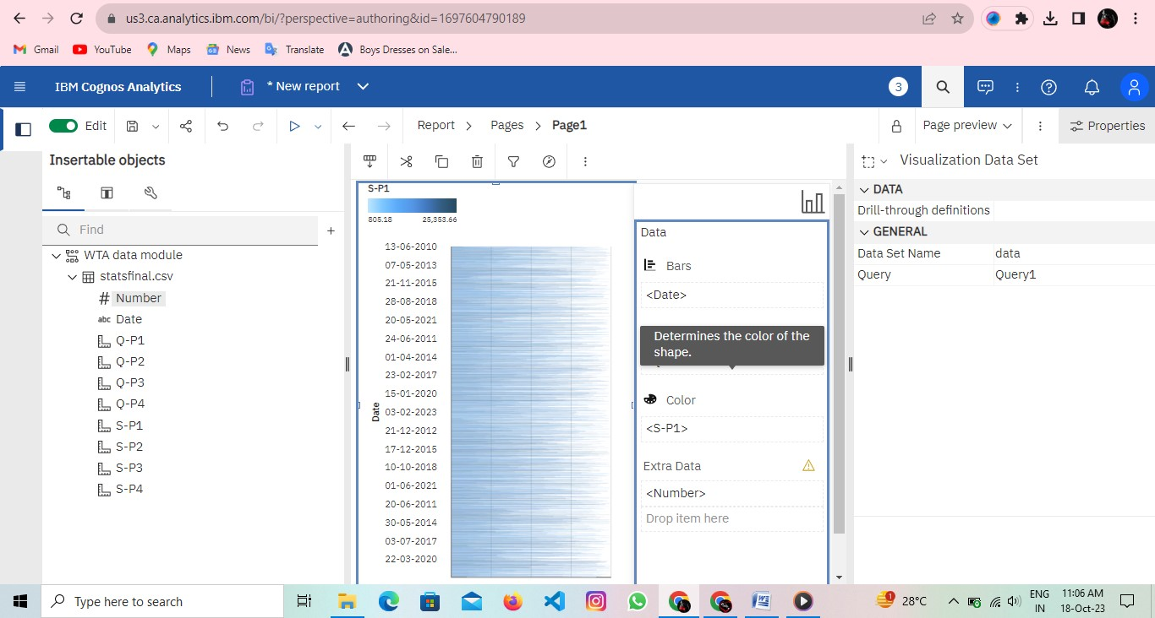

**Bar Chart**:

Objective: Compare website traffic metrics across different categories or time periods.

Use bar charts to compare metrics like page views, bounce rates, or conversions across various dimensions (e.g., traffic sources, devices, or months).

Insights: Identify the most popular traffic sources, best-performing content, or the impact of marketing campaigns.

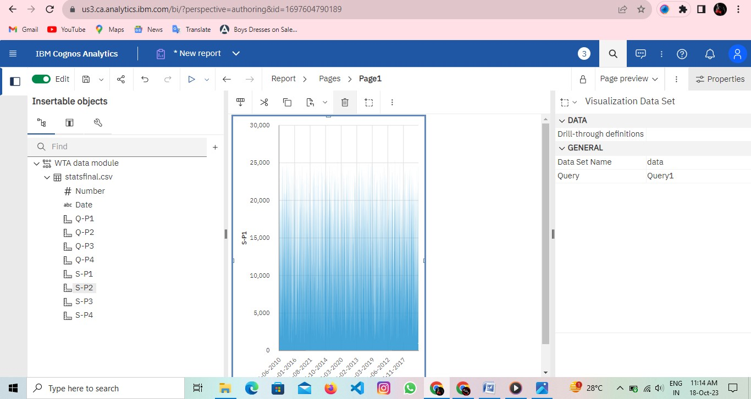

**Pie Chart**:

Objective: Show the composition of website traffic sources or categories.

Use pie charts to visualize the distribution of traffic sources (e.g., direct, organic, referral) or different content categories.

Insights: Understand the relative importance of each traffic source or content category.