SENTIMENT ANALYSIS ON TWITTER DATA
WeIntern – Week 1 Task 2
Domain: Data Science & Analytics
1. Project Overview
This project performs sentiment analysis on Twitter data to classify tweets as Positive, Neutral, or Negative. The workflow includes data inspection, cleaning, text preprocessing, sentiment visualization, TF-IDF feature extraction, Logistic Regression classification, and model evaluation.
2. Objective
- Clean and preprocess tweet text for sentiment classification.
- Remove irrelevant records, missing text, duplicate records, and empty processed tweets.
- Visualize the distribution of sentiment classes.
- Convert tweet text into numerical features using TF-IDF.
- Build a sentiment classifier using Logistic Regression.
- Evaluate the classifier using accuracy, precision, recall, F1-score, and a confusion matrix.
3. Dataset Description
A pre-collected Twitter sentiment dataset was used for this task. The dataset initially contained 74,682 records and four relevant columns: id, entity, sentiment, and text.
Attribute | Value
Initial records | 74,682
Initial columns | 4
Final records | 57,714
Final columns | 5
Training samples | 46,171
Testing samples | 11,543
Sentiment classes | Negative, Neutral, Positive
4. Data Inspection and Cleaning
The data was inspected for structure, missing values, duplicates, and sentiment labels. The Irrelevant sentiment class was removed because the task requires Positive, Neutral, and Negative classification.
- Initial dataset size: 74,682 rows × 4 columns.
- Duplicate rows identified: 2,700.
- Missing tweet text before cleaning: 686.
- Irrelevant sentiment records were removed.
- Rows with missing tweet text were removed.
- 1,405 tweets became empty after text preprocessing and were removed.
- Final dataset size: 57,714 rows × 5 columns.
- No missing values remained in sentiment or clean_text.
5. Sentiment Distribution
After cleaning, the dataset contained three sentiment classes. Negative tweets were the largest group, followed by Positive and Neutral tweets.
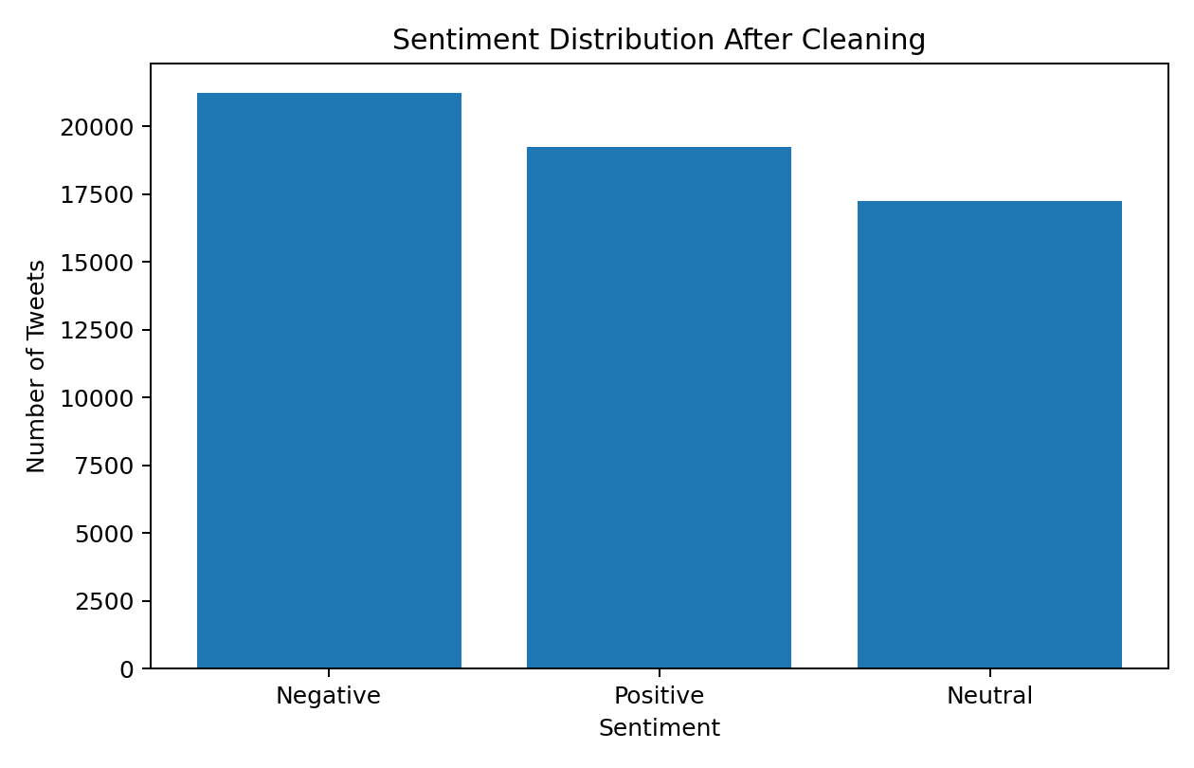
Sentiment | Number of Tweets
Negative | 21,245
Positive | 19,220
Neutral | 17,249
6. Text Preprocessing
The tweet text was cleaned before feature extraction using the following steps:
- Converted text to lowercase.
- Removed URLs and user mentions.
- Removed hashtag symbols while retaining hashtag words.
- Removed punctuation and special characters.
- Removed extra whitespace.
- Removed English stopwords using NLTK.
- Applied WordNet lemmatization.
- Removed tweets whose processed text became empty.
7. TF-IDF Feature Extraction
TF-IDF (Term Frequency–Inverse Document Frequency) was used to transform cleaned tweets into numerical features. The vectorizer used up to 10,000 features and included unigrams and bigrams. It was fitted only on the training data and then applied to the test data.
- Maximum features: 10,000.
- N-gram range: 1–2.
- Minimum document frequency: 2.
- Maximum document frequency: 95%.
- Training TF-IDF shape: 46,171 × 10,000.
- Testing TF-IDF shape: 11,543 × 10,000.
8. Train-Test Split
The cleaned data was divided into training and testing sets using an 80:20 split with stratification to preserve the sentiment distribution.
9. Machine Learning Model
Logistic Regression was used as the sentiment classification model. It was trained on 46,171 TF-IDF transformed tweets and evaluated on 11,543 unseen test tweets.
10. Model Performance
Metric | Score
Accuracy | 79.23%
Weighted Precision | 79.17%
Weighted Recall | 79.23%
Weighted F1-Score | 79.16%

Class-wise performance:
Sentiment | Precision | Recall | F1-Score | Support
Negative | 0.81 | 0.84 | 0.82 | 4,249
Neutral | 0.77 | 0.72 | 0.75 | 3,450
Positive | 0.79 | 0.80 | 0.80 | 3,844

11. Confusion Matrix
The confusion matrix shows correct predictions on the diagonal and misclassifications outside the diagonal.
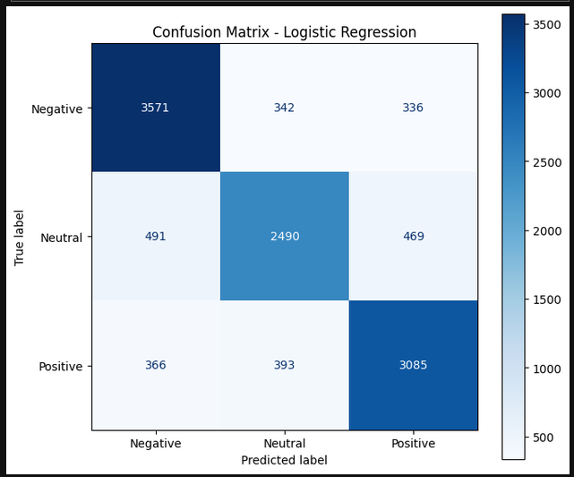
Actual \ Predicted | Negative | Neutral | Positive
Negative | 3571 | 342 | 336
Neutral | 491 | 2490 | 469
Positive | 366 | 393 | 3085
The model correctly classified 3,571 Negative, 2,490 Neutral, and 3,085 Positive tweets. Neutral tweets were comparatively difficult, with 491 Neutral tweets predicted as Negative and 469 predicted as Positive.
12. Key Findings
The final cleaned dataset contained 57,714 tweets across three sentiment classes.
- Negative sentiment was the largest class with 21,245 tweets.
- TF-IDF with unigrams and bigrams produced 10,000 features.
- Logistic Regression achieved 79.23% test accuracy.
- The weighted F1-score was 79.16%.
- Negative sentiment achieved the highest class-level F1-score of 0.82.
- Neutral sentiment was the most difficult class, with an F1-score of 0.75.
- The confusion matrix shows that Neutral tweets were frequently confused with both Negative and Positive classes.
13. Task Challenges Satisfied
- Clean and preprocess tweet text by removing stopwords, punctuation, URLs, mentions, and other noise.
- Visualize the distribution of sentiment classes.
- Use a simple machine-learning model for sentiment classification.
- Evaluate the model using standard classification metrics and a confusion matrix.
14. Technologies Used
- Python
- Pandas
- NumPy
- Matplotlib
- Seaborn
- NLTK
- Scikit-learn
- Jupyter Notebook
15. Conclusion
The project successfully implemented an end-to-end Twitter sentiment analysis pipeline. The data was cleaned and preprocessed, sentiment classes were visualized, and tweet text was transformed into TF-IDF features. Logistic Regression achieved 79.23% accuracy with a weighted F1-score of 79.16%. The results demonstrate that traditional machine-learning with TF-IDF can provide effective sentiment classification, while Neutral tweets remain comparatively harder to distinguish from Positive and Negative tweets.

