CUSTOMER SEGMENTATION USING CLUSTERING
WeIntern – Week 2 Task 3 | Data Science & Analytics
1. Project Overview
This project applies K-Means clustering to segment customers based on Age, Annual Income, and Spending Score. The objective is to identify groups of customers with similar characteristics and purchasing behavior.
2. Dataset Description
The Mall Customers dataset contains 200 customer records and 5 columns: CustomerID, Gender, Age, Annual Income (k$), and Spending Score (1-100).
Dataset Property | Result
Dataset size | 200 rows × 5 columns
Missing values | 0
Duplicate rows | 0
Female customers | 112
Male customers | 88
3. Features Used for Clustering
CustomerID was excluded because it is an identifier. Gender was not used as a clustering feature. The model used the following numerical features:
- Age
- Annual Income (k$)
- Spending Score (1-100)
4. Challenge 1 – Scaling and Normalizing Features
StandardScaler was applied to the three numerical clustering features. After scaling, their means were approximately 0 and standard deviations approximately 1. This prevents differences in feature scale from dominating the K-Means distance calculations.
5. Challenge 2 – Choosing the Optimal K
The Elbow Method was evaluated for K values from 2 through 10. The measured inertia values were:
K | Inertia | Selection
2 | 389.39
3 | 295.21
4 | 205.23
5 | 168.25
6 | 133.87 | Selected
7 | 117.01
8 | 103.87
9 | 93.09
10 | 82.39
K = 6 was selected for the final K-Means model based on the Elbow Method and the resulting segmentation structure.
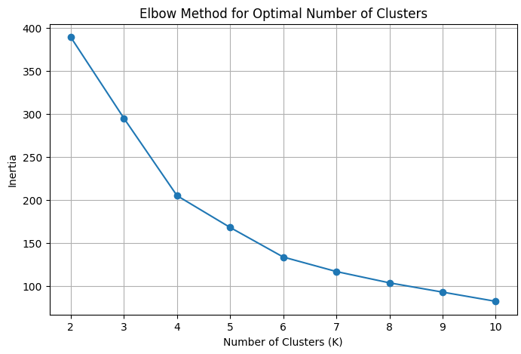
Figure 1. Elbow Method for Optimal Number of Clusters

6. K-Means Clustering
A K-Means model with 6 clusters was fitted on the standardized features. The resulting cluster labels were added to the original dataset as a new Cluster column.
7. Cluster Distribution
Cluster | Number of Customers
0 | 45
1 | 39
2 | 33
3 | 39
4 | 23
5 | 21
Figure 2. Number of Customers in Each Cluster
8. Challenge 3 – 2D Cluster Visualization
A 2D scatter plot was created using Annual Income and Spending Score. The visualization shows separation between customer groups with different income and spending behavior.
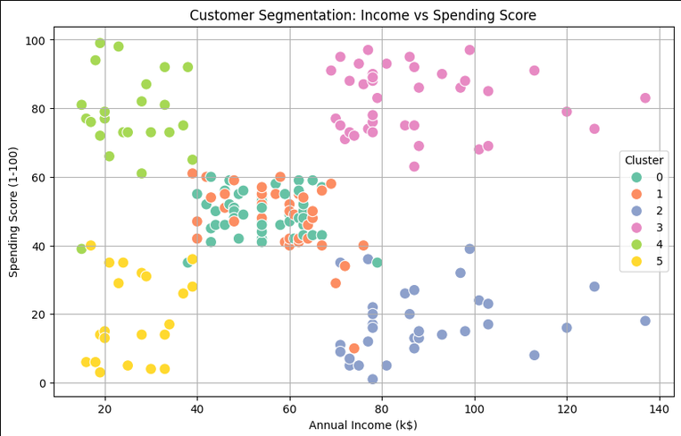
Figure 3. Customer Segmentation: Income vs Spending Score

9. 3D Customer Segmentation
A 3D visualization was created using Age, Annual Income, and Spending Score. This provides a broader view of the six customer segments using all three clustering features.
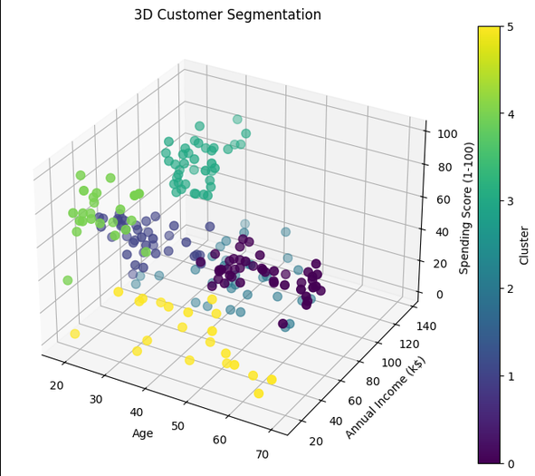
Figure 4. 3D Customer Segmentation
10. Cluster Profiles and Interpretation
Cluster | Customers | Avg Age | Avg Income (k$) | Avg Spending | Interpretation
0 | 45 | 56.33 | 54.27 | 49.07 | Older, average-income, average-spending customers
1 | 39 | 26.79 | 57.1 | 48.13 | Young, average-income, average-spending customers
2 | 33 | 41.94 | 88.94 | 16.97 | High-income, low-spending customers
3 | 39 | 32.69 | 86.54 | 82.13 | High-income, high-spending / premium customers
4 | 23 | 25.0 | 25.26 | 77.61 | Low-income, high-spending customers
5 | 21 | 45.52 | 26.29 | 19.38 | Low-income, low-spending customers
11. Key Findings
- Six distinct customer segments were identified using K-Means clustering.
- Cluster 3 represents high-income, high-spending customers and is the strongest premium customer segment.
- Cluster 2 contains high-income customers with relatively low spending, providing an opportunity for targeted engagement.
- Cluster 4 contains younger, lower-income customers with high spending scores.
- Cluster 5 represents lower-income, lower-spending customers.
- Clusters 0 and 1 have relatively average income and spending behavior but differ substantially in age.
12. Business Applications
- Targeted marketing campaigns
- Personalized promotions
- Premium customer retention
- Customer engagement strategies
- Identifying high-value customers
- Designing offers for low-spending customers
13. Conclusion
The project successfully used K-Means clustering to divide 200 customers into six meaningful groups. StandardScaler addressed feature-scale differences, the Elbow Method was used to select K = 6, and 2D and 3D visualizations were used to examine the resulting segments. The identified customer groups can support targeted marketing, premium-customer retention, and customer engagement strategies.
14. Technologies Used
- Python
- Pandas
- NumPy
- Scikit-learn
- Matplotlib
- Seaborn
- Jupyter Notebook

