Keyword :

* Reserved Words
* Can’t be used as variable,function and identifier
* Case sensitive

Code snippet to view all keywords :

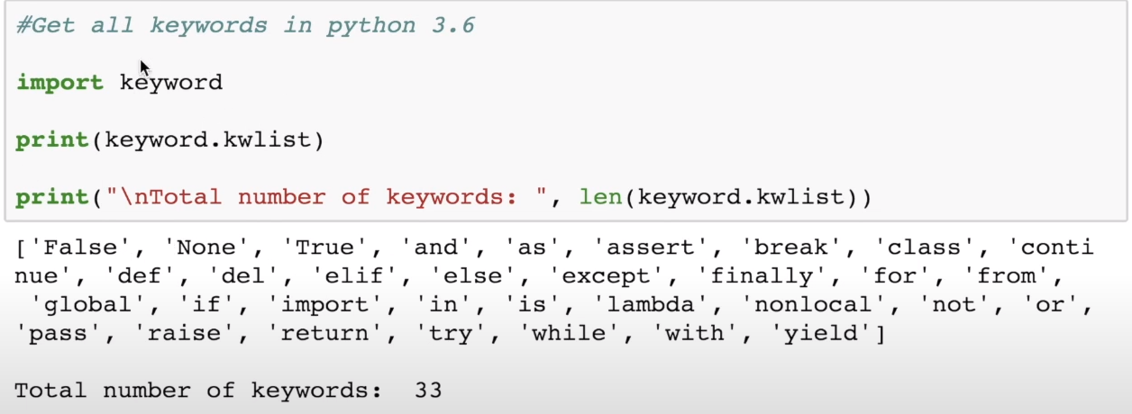

Identifier :

* Combination of alphabet, numbers and Underscore (_) .
* Cannot start with number. eg 1abc,2var etc
* But we can start with alphabet and underscore. Eg abc1, var2, _var.
* Keyword cannot be an identifier.

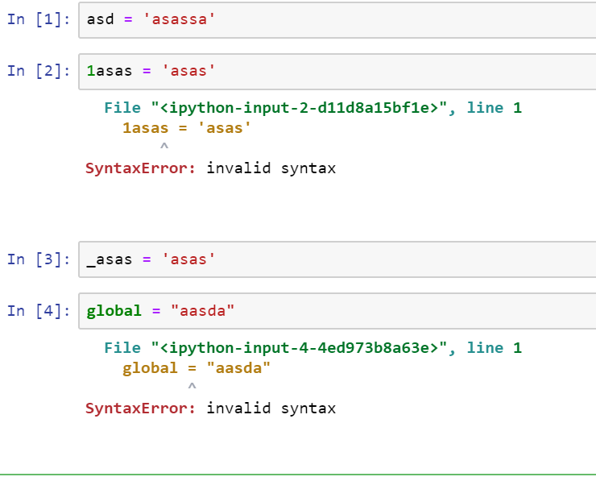

Comments :

* Single Comment(#) and Multi Line comment(‘’’- Triple (Single or Double Quotes))

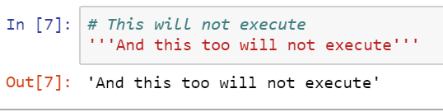

Python Indentation :

* Code Block
* Similar to braces {} in other lang
* Normally 4 Space indicates a block (Avoid using tab)

In the below code print is under for below which denotes by 4 whitespaces.

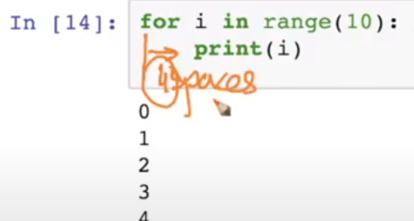

Python Statement :

* Single line statement
* Multiple line statement
* Semicolon used to denote end of line.

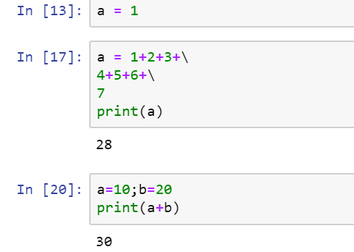

For muliple line statement we denotes by concat \ in end.

While Loop:

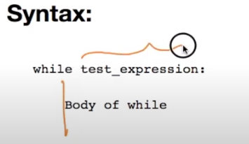

Sample code snippet

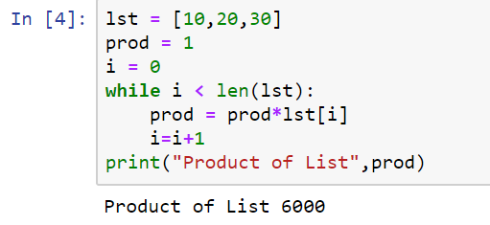

While loop with else :

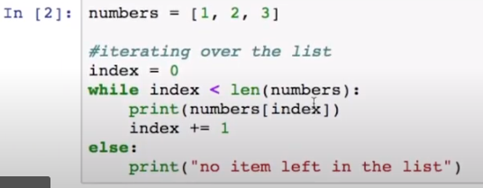

For loop :

In Sequence :

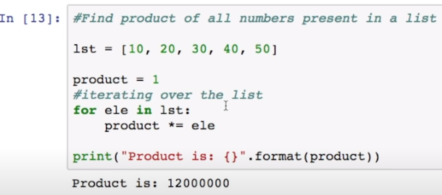

In Range() :

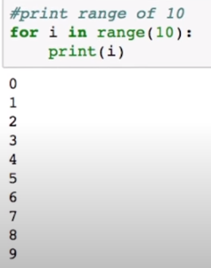

In Range with increment size specific:

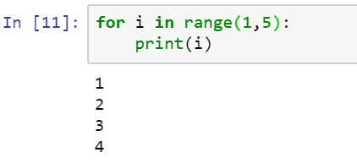

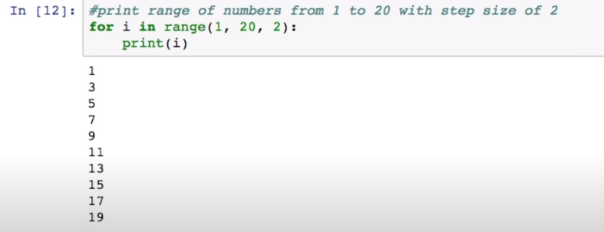

For loop with else :

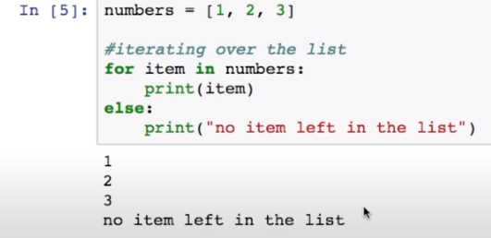

Break and Continue Keyword :

* Break keyword used to come out of loop(for,while) anytime.

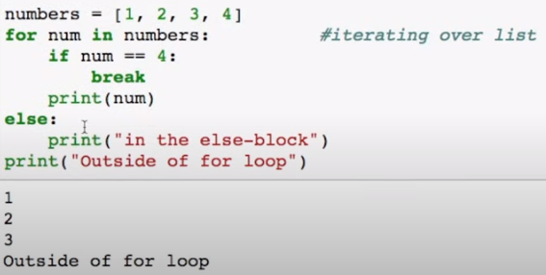

* In the above case, if num == 4 then loop will exit (for,else) which includes the else statement.

Conitnue keyword:

* Continue is used to skip the (after keyword continue) below lines of code in loop.
* It continues with next iteration.

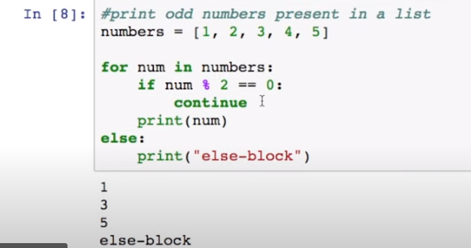

**List :**

* Mutable – we can change the elements anytime.
* Indexed, we can traverse through the list using index.
* We can store mixed datatypes.
* Syntax : [x,y,z]

**Notes path :** [**https://github.com/Sridharrr/Python/blob/master/List_AAIC_Notes.ipynb**](https://github.com/Sridharrr/Python/blob/master/List_AAIC_Notes.ipynb)

**Tuples :**

* Immutable – we can’t change the elements in tuples.
* Indexed, we can traverse through the list using index.
* We can store mixed datatypes.
* We can’t remove or edit the individual elements in tuple.
* Syntax : (x,y)

**Notes path :** [**https://github.com/Sridharrr/Python/blob/master/Tuples_AAIC_Notes.ipynb**](https://github.com/Sridharrr/Python/blob/master/Tuples_AAIC_Notes.ipynb)

**Sets :**

* Mutable – we can change the elements.
* Its stored in memory unordered, so we can’t use index.
* Sorted by default.
* It won’t allow duplicates.
* Sets are Mutable, while frozen sets are Immutable (So used as a Key in dict)
* Syntax : {}

**Notes path :** [**https://github.com/Sridharrr/Python/blob/master/Set_AAIC_Notes.ipynb**](https://github.com/Sridharrr/Python/blob/master/Set_AAIC_Notes.ipynb)

**Strings:**

* **Immutable - we can’t change a individual element in String.**
* **We can assign different value to the same String.**
* **We can use index to traverse the String.**
* **Syntax : ‘xyz’,”xyz”,’’’xyz’’’**