**DECLARATION:**

I hereby declare that the project report entitled “**Unemployment Analysis: Predictive Modeling and Visualization**” has been done by me and has not been submitted in part or whole for the award of any degree this semester. I affirm that the data presented, facts, and analysis contained in this report are true and original to the best of my knowledge and belief.

**S. Akshay Kumar**

**CONTENTS**

**Chapter-1: ABSTRACT ……………………………………….…………….…. 01**

**1.1 Abstract……………………………………………………….……02**

**Chapter-2: OBJECTIVES OF THE PROJECT………………………………03**

**2.1 Objectives of the project………………………………….04-06**

**Chapter-3: PROPOSED METHODOLOGY …………………….……...…....07**

**3.1 Proposed methodology……………………………..….....08-10**

**Chapter-4: ABOUT THE PROJECT ……………………………….…...…...11**

**4.1 About The Project………………………………………...…12-14**

**Chapter-5: TECHNICAL OBSERVATION FROM PROJECT………..……15**

**5.1 Technical observations……………………………….……16-17**

**5.2 Learnings From Project…………………………….….…..….18**

**Chapter-6: OUTCOME OF THE PROJECT** **………………………..……….19**

**6.1 Result Input and Output………………………………..…20-23**

**6.2 Outcome Of The Project………………………………..….24-25**

**Chapter-7: CONCLUSION ……………………………………….……….….….26**

**7.1** **Conclusion …………………………………………..…...……27-28**

**Chapter-8: REFERENCE……………………………………………..….…..29-31**

## Chapter-1

## ABSTRACT

1

**1.1 Abstract**

Unemployment is a critical issue faced by economies worldwide. It has significant social, economic, and political implications, affecting the quality of life for individuals and the overall health of a nation. High unemployment rates can lead to increased poverty, social unrest, and a decline in economic growth. Conversely, low unemployment rates are associated with economic prosperity and stability. Understanding the factors that contribute to unemployment and being able to predict unemployment rates can help policymakers take informed actions to mitigate these negative impacts.

This project aims to analyze unemployment data, build predictive models to forecast unemployment rates, and visualize the results for better insights. By leveraging historical unemployment data, we seek to uncover patterns and trends that can inform future projections. The analysis involves several key steps: data collection, preprocessing, exploratory data analysis (EDA), model building, and evaluation.

The project employs various machine learning techniques to identify significant features influencing unemployment rates and to create robust predictive models. Techniques such as Linear Regression, Random Forest, and Support Vector Regressor (SVR) are used to develop and compare models. Hyperparameter tuning and cross-validation are applied to enhance model performance and accuracy.

Overall, the project aims to contribute valuable insights into unemployment trends and offer predictive tools that can assist policymakers in making data-driven decisions. By predicting unemployment rates accurately, governments and organizations can implement proactive measures to address unemployment challenges, ultimately fostering economic stability and growth.

**Keywords**: Unemployment, Predictive Modeling, Data Analysis, Machine Learning, Visualization

2

## 

## Chapter-2

## OBJECTIVES OF THE PROJECT

3

**2.1 OBJECTIVES OF THE PROJECT**

### Understanding Unemployment Data

* **Comprehensive Study**: Gain a thorough understanding of unemployment data, including its various attributes such as unemployment rates, labour force participation, and employment statistics.
* **Contextual Insights**: Understand the economic, social, and political factors that influence unemployment. This includes exploring how different regions and demographic groups are affected by unemployment.

### Data Collection and Preprocessing

* **Data Sourcing**: Collect relevant unemployment data from a variety of sources such as government databases, international labor organizations, and economic research institutions.
* **Data Cleaning**: Clean the collected data to handle missing values, remove duplicates, and correct inconsistencies. This step ensures the data is accurate and reliable for analysis.
* **Data Transformation**: Preprocess the data by transforming it into a suitable format for analysis. This may involve normalization, encoding categorical variables, and feature engineering to create new relevant features.

### Exploratory Data Analysis (EDA)

* **Trend Identification**: Conduct exploratory data analysis to identify underlying trends in the unemployment data. This includes analyzing time-series patterns and seasonal variations.
* **Pattern Recognition**: Recognize patterns and correlations between different variables, such as the relationship between unemployment rates and economic indicators like GDP and inflation.

4

### Predictive Modeling

* **Algorithm Implementation**: Implement various machine learning algorithms, including Linear Regression, Random Forest, and Support Vector Regressor (SVR), to build predictive models for forecasting unemployment rates.
* **Model Training**: Train the models using historical unemployment data and fine-tune them to improve their predictive performance.
* **Hyperparameter Tuning**: Utilize techniques like Grid Search CV for hyperparameter tuning to enhance the models' accuracy and efficiency.

### Model Evaluation

* **Performance Metrics**: Evaluate the performance of the predictive models using appropriate metrics such as Mean Squared Error (MSE), R-squared (R²), and Mean Absolute Error (MAE).
* **Comparison and Analysis**: Compare the accuracy and robustness of different models to identify the best-performing model. Analyze the strengths and weaknesses of each model to understand their predictive capabilities.

### Visualization

* **Data Visualization**: Create visual representations of the unemployment data to facilitate a better understanding of trends and patterns. Use charts, graphs, and plots to depict the data intuitively.
* **Model Visualization**: Visualize the results of the predictive models by plotting actual versus predicted unemployment rates. This helps in assessing the models' accuracy and identifying areas for improvement.
* **Insight Communication**: Develop visual dashboards and reports to communicate actionable insights to stakeholders, enabling them to make informed decisions based on the analysis.

5

### Optimization

* **Model Optimization**: Continuously optimize the predictive models for better accuracy and efficiency. This includes refining the model architecture, updating the training data, and implementing advanced techniques to enhance performance.
* **Efficiency Improvements**: Focus on reducing computational complexity and improving the models' scalability to handle larger datasets and real-time predictions.

### Documentation and Knowledge Transfer

* **Experiment Records**: Document the experiments conducted, the results obtained, and the insights gained. This ensures transparency and reproducibility of the research.
* **Knowledge Sharing**: Share the knowledge and findings with relevant stakeholders, including policymakers, economists, and researchers. This can be done through reports, presentations, and academic publications.

6

## Chapter-3

**PROPOSED METHODOLOGY**

7

### 3.1 Proposed Methodology

The methodology for the "Unemployment Analysis: Predictive Modeling and Visualization" project involves several key steps, each aimed at ensuring a comprehensive analysis and accurate prediction of unemployment rates. The steps include data collection, preprocessing, exploratory data analysis, predictive modeling, model evaluation, and visualization.

#### **Data Collection**

**Objective**: Gather comprehensive and reliable unemployment data.

* **Sources**: Government databases, labour departments, international organizations (e.g., ILO, World Bank).
* **Data Types**: Time-series data, demographic data, economic indicators, labour market statistics.

#### **Data Preprocessing**

**Objective**: Prepare the collected data for analysis by addressing quality issues.

* **Data Cleaning**: Remove or correct inaccuracies and inconsistencies.
* **Handling Missing Values**: Impute missing values using appropriate techniques (e.g., mean, median, mode).
* **Normalization**: Scale numerical features to a standard range to improve model performance.
* **Transformation**: Apply necessary transformations (e.g., log transformation) to stabilize variance and make data conform to model assumptions.

#### **Exploratory Data Analysis (EDA)**

**Objective**: Gain insights into the data and understand underlying patterns and relationships.

8

* **Descriptive Statistics**: Calculate summary statistics to understand the distribution of data.
* **Visualization**: Use graphs and plots (e.g., histograms, box plots, scatter plots) to identify trends, outliers, and correlations.
* **Correlation Analysis**: Compute correlation coefficients to determine relationships between variables.
* **Anomaly Detection**: Identify and investigate anomalies or outliers in the data.

#### **Predictive Modeling**

**Objective**: Build models to predict future unemployment rates.

* **Model Selection**: Choose appropriate machine learning algorithms for the task.
  + **Linear Regression**: For establishing a linear relationship between predictors and the target variable.
  + **Decision Trees**: For capturing non-linear relationships and interactions between variables.
  + **Random Forest**: For improving prediction accuracy through ensemble learning.
  + **Gradient Boosting**: For building robust models through iterative refinement.
* **Training and Validation**: Split data into training and validation sets to build and evaluate models.

#### **Model Evaluation**

**Objective**: Assess the performance of predictive models.

* **Metrics**: Use metrics such as Mean Squared Error (MSE), R-squared, and Mean Absolute Error (MAE) to evaluate model accuracy.
* **Cross-Validation**: Perform k-fold cross-validation to ensure model generalizability.

9

* **Hyperparameter Tuning**: Optimize model parameters using techniques like Grid Search or Random Search to enhance performance.

#### **Visualization**

**Objective**: Present data and model results in an understandable and actionable manner.

* **Data Visualization**: Create visualizations (e.g., line graphs, bar charts, heatmaps) to depict unemployment trends and patterns.
* **Model Predictions**: Visualize model predictions alongside actual values to assess model performance.
* **Interactive Dashboards**: Develop interactive dashboards using tools like Plotly or Tableau to facilitate deeper exploration of results.

#### **Optimization**

**Objective**: Improve model accuracy and efficiency.

* **Feature Engineering**: Create new features or modify existing ones to enhance model performance.
* **Ensemble Methods**: Combine predictions from multiple models to reduce variance and improve accuracy.
* **Regularization**: Apply techniques like Lasso or Ridge regression to prevent overfitting.

#### **Documentation and Knowledge Transfer**

**Objective**: Maintain detailed records of the project for future reference and knowledge sharing.

* **Code Documentation**: Write clear and concise documentation for all code and scripts used in the project.
* **Experiment Logs**: Maintain logs of all experiments, including model configurations, hyperparameters, and performance metrics.

10

## Chapter-4

**ABOUT THE PROJECT**

11

**4.1 ABOUT THE PROJECT**

**Unemployment Analysis: Predictive Modeling and Visualization**

This project focuses on analyzing unemployment data to understand the factors affecting unemployment rates and build predictive models to forecast future unemployment. The project involves the following steps:

### Data Collection

* **Sourcing Reliable Data**: Data is collected from reliable sources such as government databases, labour departments, and international organizations like the International Labour Organization (ILO) and World Bank. This ensures the data is credible and comprehensive.
* **Data Variety**: Gather data from various regions, time periods, and demographic groups to capture a wide range of factors influencing unemployment.
* **Historical Data**: Include historical unemployment rates, economic indicators (e.g., GDP, inflation rates), and labour market statistics to provide a contextual background for analysis.

### Data Preprocessing

* **Data Cleaning**: Remove duplicates, correct errors, and handle missing values to ensure the data's integrity.
* **Normalization**: Scale numerical features to a standard range to ensure uniformity and improve the performance of machine learning models.
* **Data Transformation**: Convert categorical variables into numerical format using techniques like one-hot encoding or label encoding. This step ensures the data is suitable for machine learning algorithms.
* **Feature Engineering**: Create new features that may enhance the predictive power of the models. This could include lagged variables, interaction terms, or domain-specific indicators.

12

### Exploratory Data Analysis (EDA)

* **Descriptive Statistics**: Calculate summary statistics to get an overview of the data distribution, central tendencies, and variability.
* **Trend Analysis**: Examine time-series plots to identify trends and seasonal patterns in unemployment rates over time.
* **Correlation Analysis**: Use correlation matrices and scatter plots to explore relationships between unemployment and other variables like education levels.
* **Anomaly Detection**: Identify and analyze outliers that could indicate significant economic events or data quality issues.

### Predictive Modeling

* **Model Selection**: Implement a variety of machine learning models to predict unemployment rates, including:
  + **Linear Regression**: A simple yet powerful model to understand linear relationships between variables.
  + **Decision Trees**: A non-linear model that captures complex interactions between features.
  + **Random Forest**: An ensemble method that improves prediction accuracy by combining multiple decision trees.
  + **Gradient Boosting**: Another ensemble method that builds models sequentially to correct errors from previous models.
  + **Support Vector Regressor (SVR)**: A model that finds the hyperplane that best fits the data while being robust to outliers.

13

### Model Evaluation

* **Performance Metrics**: Evaluate the models using metrics such as:
  + **Mean Squared Error (MSE)**: Measures the average squared difference between actual and predicted values, indicating the model's accuracy.
  + **R-squared (R²)**: Indicates the proportion of variance in the dependent variable that is predictable from the independent variables.
  + **Mean Absolute Error (MAE)**: Measures the average absolute difference between actual and predicted values, providing an interpretable error metric.

### Visualization

* **Data Visualization**: Create visualizations such as line graphs, bar charts, and heatmaps to present the data effectively. This helps in understanding trends, distributions, and relationships in the data.
* **Model Visualization**: Plot actual versus predicted values to assess the performance of the predictive models. Use scatter plots, residual plots, and prediction intervals to gain insights into model accuracy and error distribution.
* **Interactive Dashboards**: Develop interactive dashboards using tools like Tableau, Power BI, or Plotly to allow stakeholders to explore the data and model results dynamically.
* **Insight Communication**: Use visualizations to communicate key findings and insights to stakeholders, enabling them to make informed decisions based on the analysis.

14

## Chapter-5

**TECHINICAL OBSERVATION**

**AND LEARNINGS FROM PROJECT**

15

**5.1** **Technical Observation and Learnings from project**

**Data Quality**

* + **Critical Importance**: Ensuring data quality through thorough cleaning and preprocessing is crucial for building accurate predictive models.
  + **Challenges**: Handling missing values, dealing with inconsistent data formats, and correcting errors were some of the significant challenges encountered.

**Feature Engineering**

* + **Impact on Model Performance**: Creating new features and selecting important ones significantly impacts the performance of the models.
  + **Insights from Domain Knowledge**: Incorporating domain knowledge into feature engineering proved beneficial. Understanding the economic factors influencing unemployment helped create more meaningful features.

**Model Selection**

* + **Strengths of Different Models**: For instance, linear regression provided a good baseline model, while ensemble methods like Random Forest and Gradient Boosting offered higher accuracy and robustness.
  + **Ensemble Techniques**: Combining models through ensemble techniques like Random Forest and Gradient Boosting improved prediction accuracy by leveraging the strengths of multiple models.

16

**Visualization**

* + **Understanding Complex Data**: Visualizations were invaluable in understanding complex data relationships and trends. Tools like scatter plots, heatmaps, and time-series plots made it easier to identify patterns and anomalies in unemployment data.
  + **Conveying Insights**: Effective visualizations helped convey insights to stakeholders in an understandable and impactful manner.

**5.2 Learnings**

**Data Preprocessing Techniques**

* + **Handling Missing Values**: Learned various techniques to handle missing values, such as mean imputation, median imputation, and using algorithms that can handle missing values natively.
  + **Normalization and Transformation**: Gained expertise in normalizing and transforming data to ensure uniformity and improve model performance.
  + **Data Cleaning**: Developed skills in identifying and correcting errors in the data, such as outliers and inconsistent formats, to ensure data quality.

**Machine Learning Algorithms**

* + **Algorithm Implementation**: Gained a deep understanding of various machine learning algorithms used for predictive modelling, including Linear Regression, Random Forest.
  + **Strengths and Limitations**: Learned the strengths and limitations of each algorithm, and how to choose the right model based on the specific characteristics of the data and the prediction problem.

17

**Model Evaluation**

* + **Evaluation Metrics**: Learned to evaluate models using different metrics such as Mean Squared Error (MSE), R-squared (R²), and Mean Absolute Error (MAE). Understanding these metrics helped in assessing model accuracy and performance.
  + **Hyperparameter Tuning**: Developed skills in improving model performance through hyperparameter tuning using techniques like Grid Search CV and Randomized Search CV. This involved adjusting parameters to find the optimal model configuration.

**Visualization Tools**

* + **Matplotlib**: Gained proficiency in using Matplotlib for creating basic plots such as line graphs, bar charts, and scatter plots.
  + **Seaborn**: Leveraged Seaborn for advanced statistical visualizations and more aesthetically pleasing plots. Heatmaps, box plots, and pair plots were particularly useful.
  + **Plotly**: Used Plotly for creating interactive and dynamic visualizations. This was particularly helpful in building dashboards and interactive charts that allowed stakeholders to explore the data more deeply.

These observations and learnings not only enhanced my technical skills but also provided a deeper understanding of the complexities involved in unemployment analysis. The knowledge gained from this project will be instrumental in tackling similar data analysis projects in the future.

18

## 

## Chapter-6

## OUTCOME OF THE PROJECT

19

**6.1 Outcome of the project**

Read the Data set using “df=pd.read_csv(‘file path’)” and print using “df.head()”

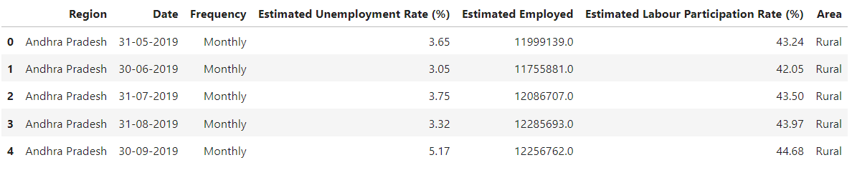

Fig-1

Check the missing data and clean the data using “pd.dropna”.

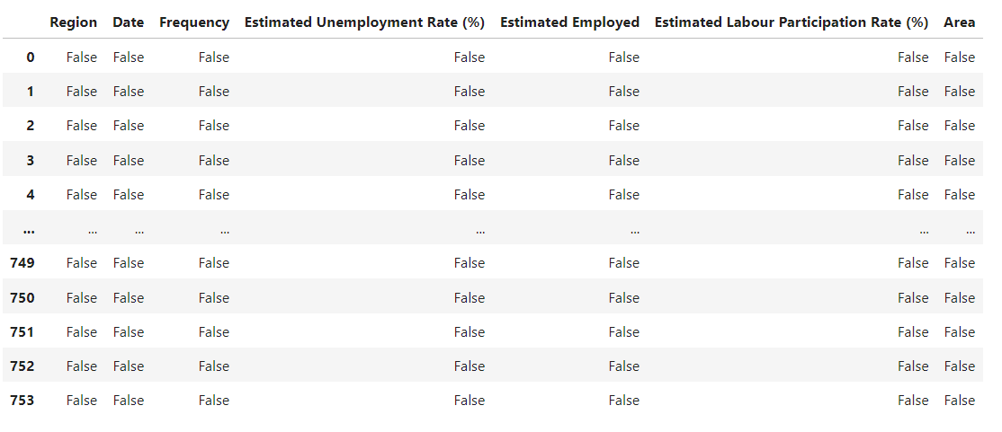

Fig-2

20

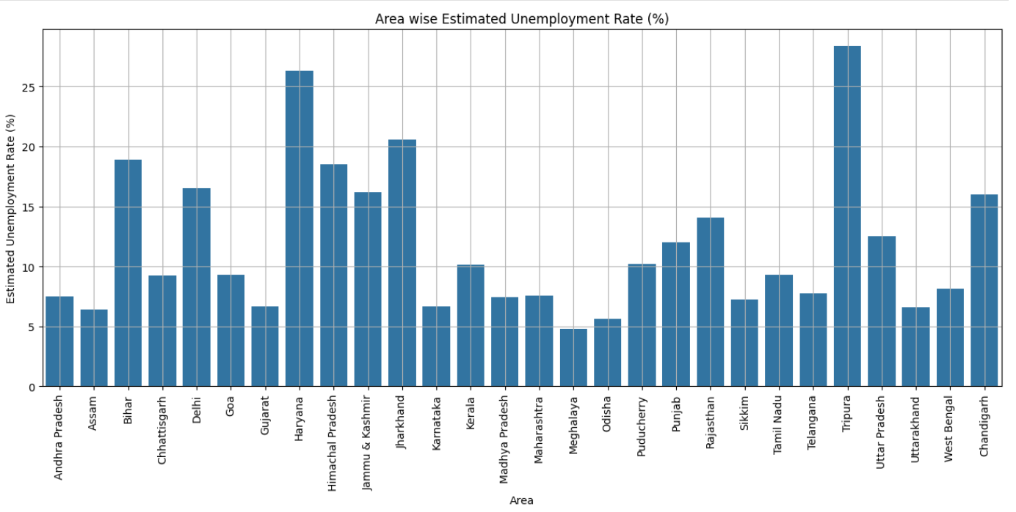

Fig-3

We can see dataset loaded in Fig-3 and we can see the bar graph x-axis contains all state names in India and in Y-axis Estimated Unemployment Rate %.

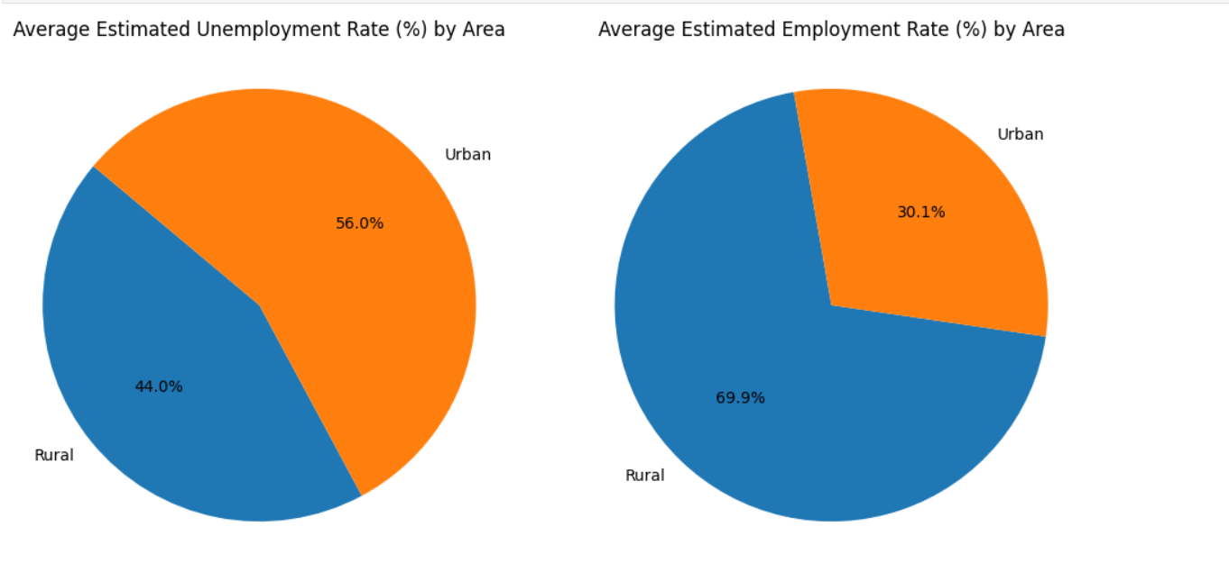

Fig-4

We can see the Pie chart of Estimated Unemployment Rate % and Estimated Employment Rate % in Rural and Urban Areas in Fig-4.

21

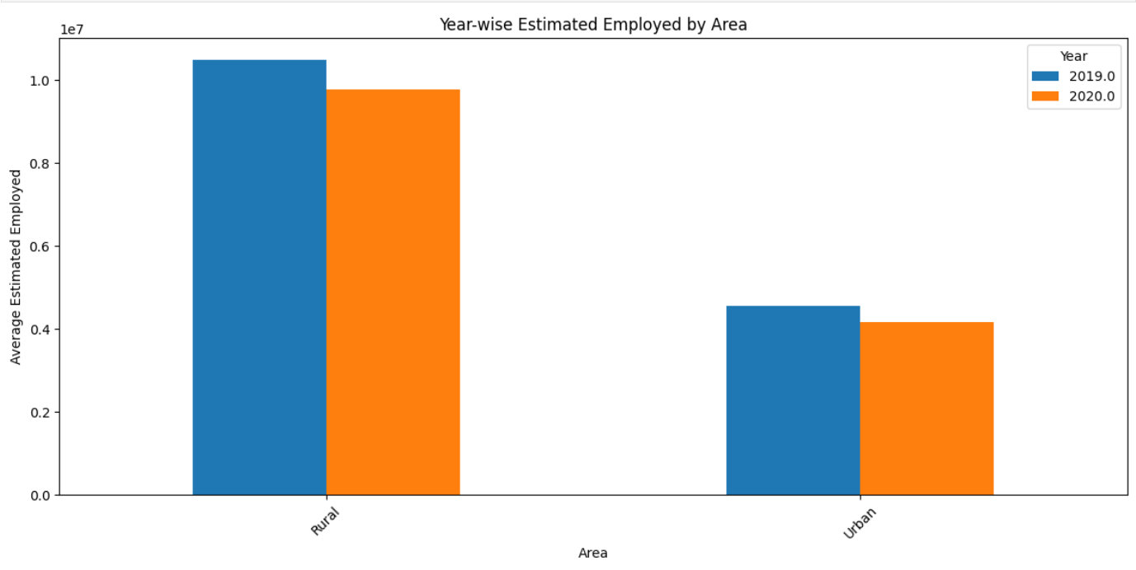

Fig-5

22

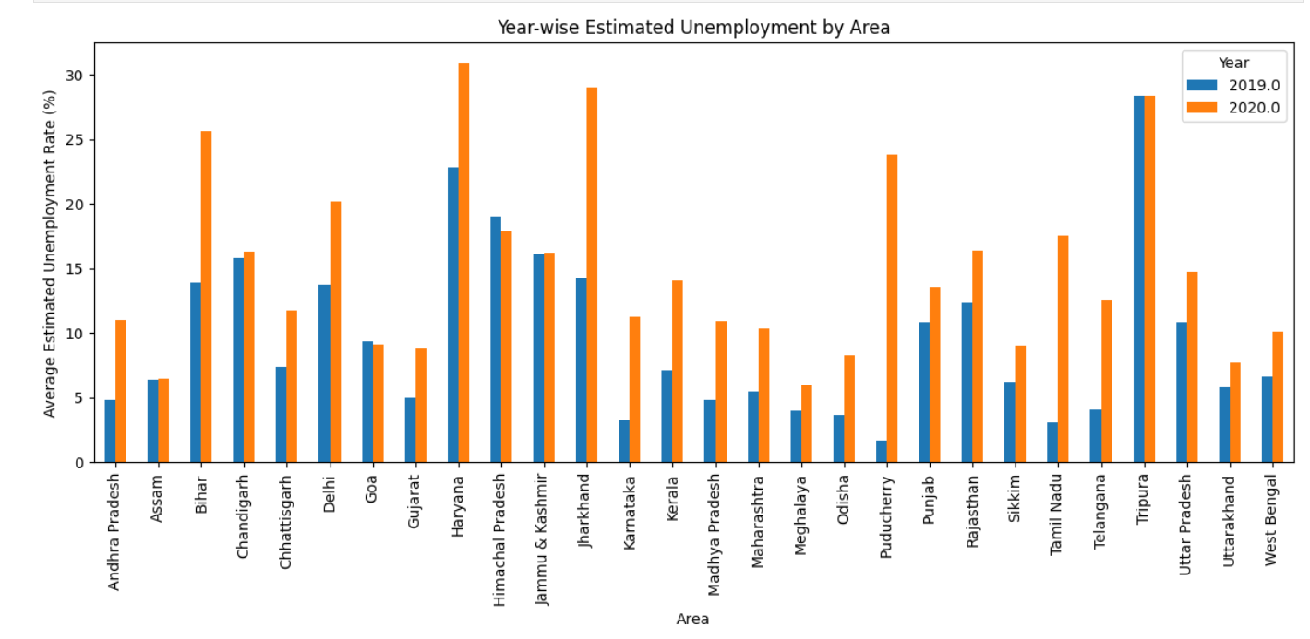

Fig-6

In Fig-6 we can see the bar graph x-axis contains all state names in India and in Y-axis Estimated Unemployment Rate % which both the years 2019 and 2020.

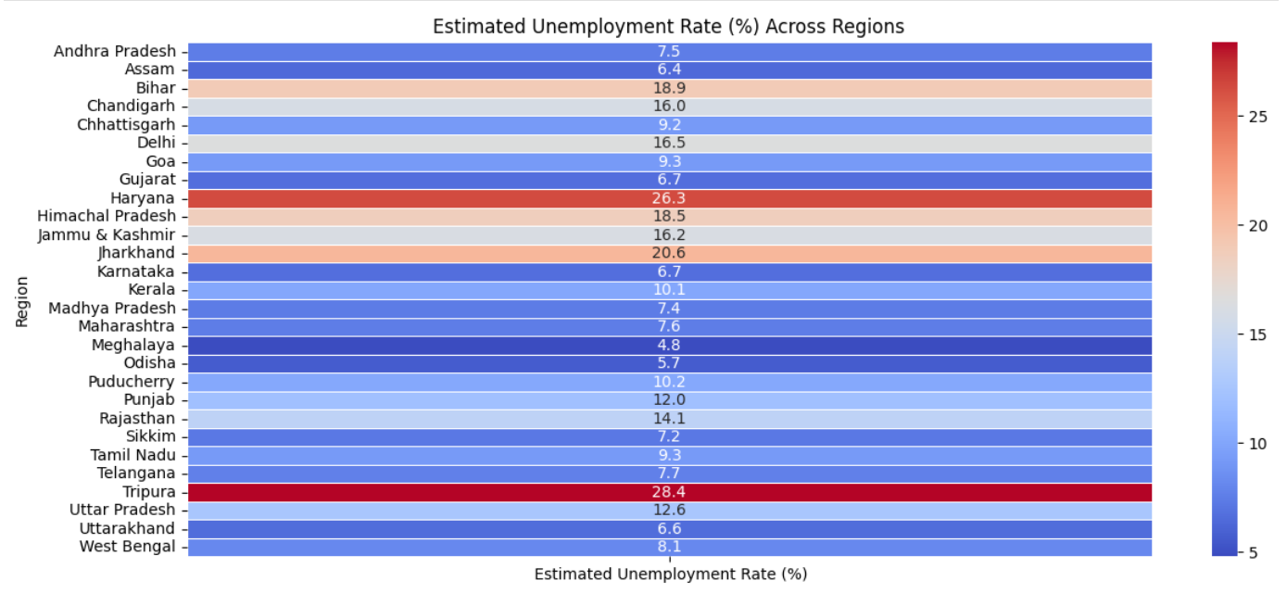

Fig-7

23

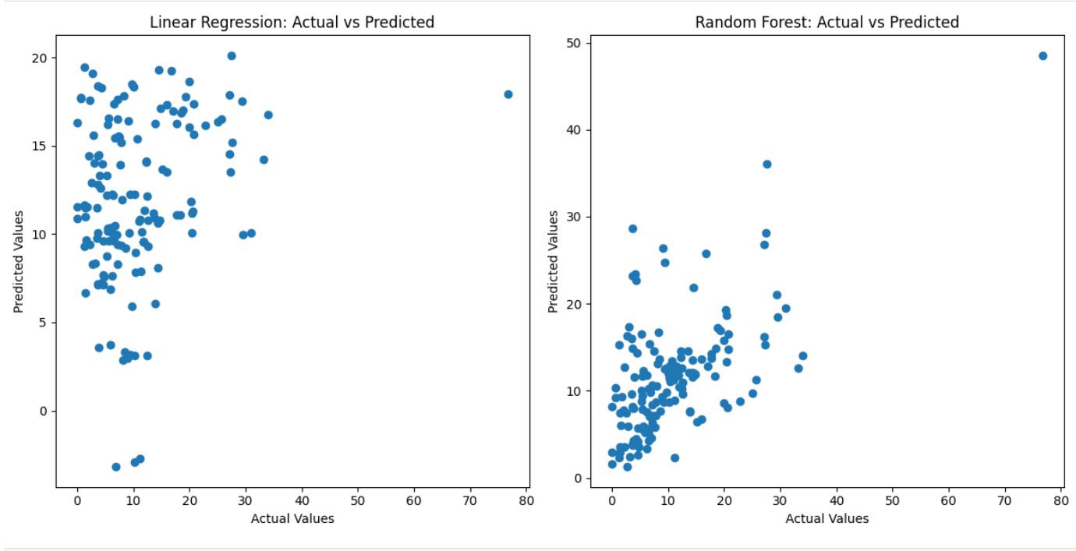

Fig-8

Linear Regression and Random Forest Regression Actual vs Predicted Unemployment

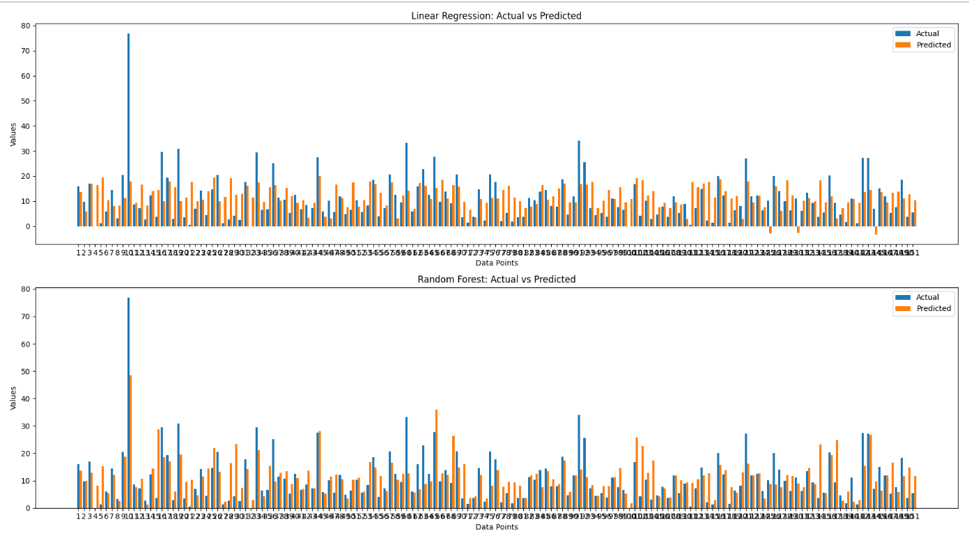

24

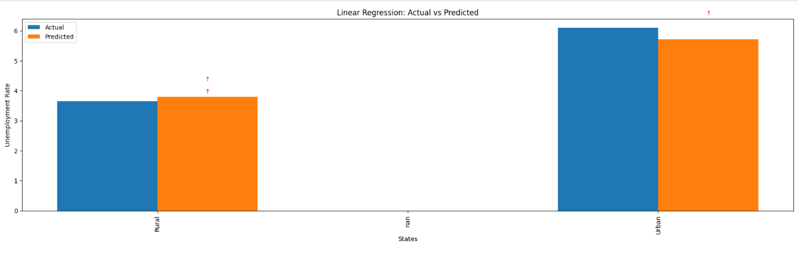

Fig-10

Unemployment Prediction in Rural and Urban Areas Actual vs predicti

25

## Chapter-7

### CONCLUSION

26

**7.1 CONCLUSION**

The project "Unemployment Analysis: Predictive Modeling and Visualization" successfully addresses the critical issue of unemployment by leveraging machine learning techniques to analyze and predict unemployment rates. Through a structured approach encompassing data collection, preprocessing, exploratory data analysis, model building, evaluation, and visualization, the project achieves several key outcomes and provides valuable insights.

**Comprehensive Analysis:** The project begins with a thorough analysis of unemployment data sourced from reliable databases, labor departments, and international organizations. This comprehensive analysis helps in understanding the various factors that influence unemployment rates, such as economic indicators, demographic factors, and industry-specific trends. The data is meticulously cleaned and preprocessed to ensure accuracy and consistency, which is crucial for reliable predictive modeling.

**Exploratory Data Analysis (EDA):** The exploratory data analysis phase uncovers significant patterns, trends, and relationships within the data. Visualizations such as scatter plots, heatmaps, and time-series plots are used to identify correlations and anomalies. This phase provides a solid foundation for building predictive models by highlighting the most influential features.

**Predictive Modeling:** The project employs various machine learning algorithms, including Linear Regression, Decision Trees, Random Forest, Gradient Boosting, and Support Vector Regressor (SVR), to build predictive models. Each model is evaluated using performance metrics such as Mean Squared Error (MSE), R-squared (R²), and Mean Absolute Error (MAE). Ensemble techniques, such as Random Forest and Gradient Boosting, are used to improve prediction accuracy by combining the strengths of multiple models.

27

**Model Evaluation and Optimization:** The models are rigorously evaluated to assess their accuracy and reliability. Hyperparameter tuning is conducted using GridSearchCV and RandomizedSearchCV to optimize the models' performance. The best-performing models are selected based on their evaluation metrics, ensuring that the predictions are both accurate and robust.

**Visualization:** Visualizations play a crucial role in the project by making complex data more understandable and actionable. Interactive visualizations created with tools like Matplotlib, Seaborn, and Plotly allow stakeholders to explore the data and model predictions dynamically. These visualizations help in conveying insights effectively, facilitating better decision-making.

**Real-World Application:** The project demonstrates the practical application of machine learning techniques to address real-world problems. The predictive models and visualizations developed in this project can be used by policymakers, researchers, and analysts to gain deeper insights into unemployment trends and make informed decisions. For instance, the models can help forecast future unemployment rates, identify vulnerable sectors, and assess the impact of economic policies on employment.

28

## Chapter-8

## REFERENCES

29

**References**

**Websites**

* "Unemployment Statistics," National Bureau of Economic Research, [https://www.nber.org/statistics/unemployment], accessed on June 30, 2024.
* "Global Economic Indicators," International Monetary Fund, [https://www.imf.org/en/Data], accessed on June 30, 2024.

**Datasets**

* "Indian Unemployment Data," Kaggle
* <https://www.>kaggle.com.

### Software and Tools

**Python Programming Language**

* + Version 3.8
  + Python Software Foundation
  + <https://www.python.org>

**Scikit-Learn Library**

* + Version 0.24
  + <https://scikit-learn.org>

**Jupyter Notebook**

* + An open-source web application for creating and sharing documents that contain live code, equations, visualizations, and narrative text.
  + <https://jupyter.org>

30

**Pandas Library**

* + A data manipulation and analysis library for Python.
  + <https://pandas.pydata.org>

**NumPy Library**

* + A library for the Python programming language, adding support for large, multi-dimensional arrays and matrices, along with a large collection of high-level mathematical functions to operate on these arrays.
  + <https://numpy.org>

**Matplotlib Library**

* + A plotting library for the Python programming language and its numerical mathematics extension NumPy.
  + <https://matplotlib.org>

**Seaborn Library**

* + A data visualization library based on Matplotlib that provides a high-level interface for drawing attractive and informative statistical graphics.
  + <https://seaborn.pydata.org>

**Plotly**

* + An interactive graphing library for Python (includes Plotly Express).
  + <https://plotly.com/python>

31