

Functional Safety Concept Lane Assistance

**Document Version: 1.0**

**Released on 2018-05-25**



# Document history

|  |  |  |  |
| --- | --- | --- | --- |
| Date | Version | Editor | Description |
| 25-05-2018 | 1.0 | Srigandhan | First Submission |
|  |  |  |  |
|  |  |  |  |
|  |  |  |  |
|  |  |  |  |

# Table of Contents

Document history

Table of Contents

Purpose of the Functional Safety Concept

Inputs to the Functional Safety Analysis

Safety goals from the Hazard Analysis and Risk Assessment

Preliminary Architecture

Description of architecture elements

Functional Safety Concept

Functional Safety Analysis

Functional Safety Requirements

Refinement of the System Architecture

Allocation of Functional Safety Requirements to Architecture Elements

Warning and Degradation Concept

# Purpose of the Functional Safety Concept

The purpose of Functional Safety Concept document is to identify system high level requirements and allocate them to different parts of the item architecture without getting into much of the technical details. And thus prove that the system actually meets all the requirements to be functionally safe.

# Inputs to the Functional Safety Concept

## Safety goals from the Hazard Analysis and Risk Assessment

|  |  |
| --- | --- |
| **ID** | **Safety Goal** |
| Safety_Goal_01 | The oscillating steering torque from the LDW function shall be limited. |
| Safety_Goal_02 | LKA function shall be time limited and the additional steering torque shall end after a given timer interval so that the driver cannot misuse the system for autonomous driving. |
| Safety_Goal_03 | The LDW function shall be turned off when driving on off road condition. |
| Safety_Goal_04 | The Lane Keeping Assistance function shall be deactivated when the camera sensor stop working. |

## Preliminary Architecture

The following figure shows the Lane Assistance item architecture:

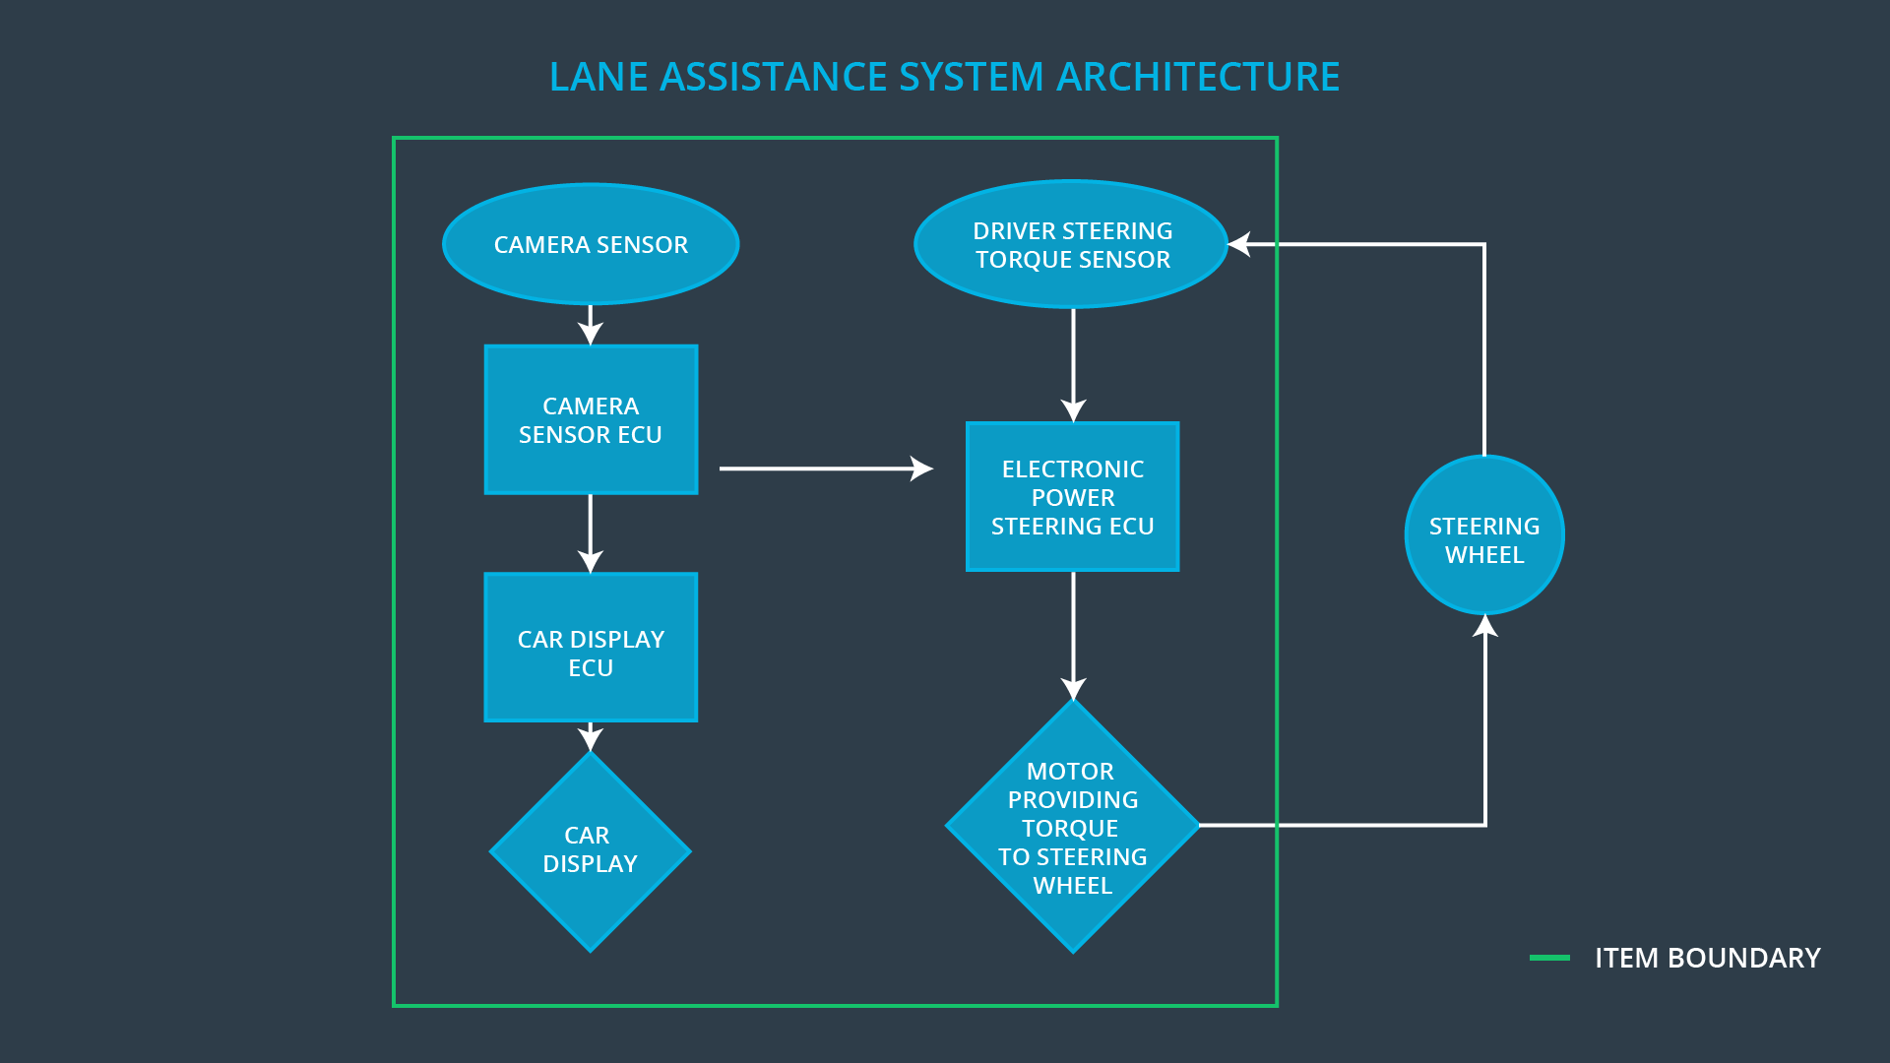

### Description of architecture elements

|  |  |
| --- | --- |
| **Element** | **Description** |
| Camera Sensor | Capture road images and provide them to the Camera Sensor ECU. |
| Camera Sensor ECU | Analyze provided images to calculate the car position on the road respect to the road lanes. |
| Car Display | Provide feedback to the driver displaying warnings and the Lane Departure Assistance status. |
| Car Display ECU | Drive the Car Display component to show the Lane Keeping Assistance warning and Lane Departure Assistance status. |
| Driver Steering Torque Sensor | Measure the torque applied to the steering wheel by the driver. |
| Electronic Power Steering ECU | Use the information received from the Driver Steering Torque Sensor and the torque requested by the Lane Keeping Assistance and Lane Warning and request the necessary torque to be applied by the Motor actuator. |
| Motor | Applies the torque indicated by the Electronic Power Steering ECU to the steering wheel. |

# Functional Safety Concept

The functional safety concept consists of:

* Functional safety analysis
* Functional safety requirements
* Functional safety architecture
* Warning and degradation concept

## Functional Safety Analysis

|  |  |  |  |
| --- | --- | --- | --- |
| **Malfunction ID** | **Main Function of the Item Related to Safety Goal Violations** | **Guidewords (NO, WRONG, EARLY, LATE, MORE, LESS)** | **Resulting Malfunction** |
| Malfunction_01 | Lane Departure Warning (LDW) function shall apply an oscillating steering torque to provide the driver a haptic feedback | MORE | The lane departure warning function applies an oscillating torque with very high torque amplitude (above limit) |
| Malfunction_02 | Lane Departure Warning (LDW) function shall apply an oscillating steering torque to provide the driver a haptic feedback | MORE | The lane departure warning function applies an oscillating torque with very high torque frequency (above limit) |
| Malfunction_03 | Lane Keeping Assistance (LKA) function shall apply the steering torque when active in order to stay in ego lane | NO | The lane keeping assistance function is not limited in time duration which leads to misuse as an autonomous driving function. |
| Malfunction_04 | The Lane Keeping Assistance function shall be deactivated when the camera sensor stop working. | WRONG | The Lane Keeping Assistance start acting randomly when the camera sensor is not working. |

## Functional Safety Requirements

Lane Departure Warning (LDW) Requirements:

|  |  |  |  |  |
| --- | --- | --- | --- | --- |
| **ID** | **Functional Safety Requirement** | **ASIL** | **Fault Tolerant Time Interval** | **Safe State** |
| Functional  Safety  Requirement  01-01 | The lane keeping item shall ensure that the lane departure oscillating torque *amplitude* is below Max_Torque_Amplitude | C | 50 ms | Lane Assistant functionality off |
| Functional  Safety  Requirement  01-02 | The lane keeping item shall ensure that the lane departure oscillating torque *frequency* is below Max_Torque_Frequency | C | 50 ms | Lane Assistant functionality off |
| Functional Safety Requirement  01-03 | The Lane Departure Warning function shall be deactivated when the camera sensor stop working. | C | 10 ms | Function is deactivated. |

Lane Departure Warning (LDW) Verification and Validation Acceptance Criteria:

|  |  |  |
| --- | --- | --- |
| **ID** | **Validation Acceptance**  **Criteria and Method** | **Verification Acceptance**  **Criteria and Method** |
| Functional  Safety  Requirement  01-01 | Validate Max_Torque_Amplitude chosen is high enough to be detected by a driver while low enough not to cause loss of steering | Verify the system does turn off if the Lane Departure Warning exceeded Max_Torque_Amplitude. |
| Functional  Safety  Requirement  01-02 | Validate Max_Torque_Frequency chosen is adequate to be detected by the driver and not cause the loss of steering. | Verify the system does turn off if the Lane Departure Warning exceeded Max_Torque_Frequency. |
| Functional Safety Requirement 01-03 | Validate Lane Departure Warning is off when the camera sensor is not working. | Verify the Lane Departure Warning is never on when the camera sensor is not working. |

Lane Keeping Assistance (LKA) Requirements:

|  |  |  |  |  |
| --- | --- | --- | --- | --- |
| **ID** | **Functional Safety Requirement** | **ASIL** | **Fault Tolerant Time Interval** | **Safe State** |
| Functional  Safety  Requirement  02-01 | The electronic power steering ECU shall ensure that the lane keeping assistance torque is applied for only Max_Duration | B | 500 ms | Turn Off System |
| Functional  Safety  Requirement  02-01 | The electronic power steering ECU shall be deactivated​ ​when​ ​the​ ​electronic​ ​power steering​ ​ECU​ ​detects​ ​the​ ​camera sensor​ ​is​ ​not​ ​working. | B | 50 ms | Turn Off System |

Lane Keeping Assistance (LKA) Verification and Validation Acceptance Criteria:

|  |  |  |
| --- | --- | --- |
| **ID** | **Validation Acceptance**  **Criteria and Method** | **Verification Acceptance**  **Criteria and Method** |
| Functional  Safety  Requirement  02-01 | Validate that the value chosen for Max_Duration dissuades drivers from taking their hands off the wheel. | Verify that the system does turn off within a fault tolerant time interval, if the lane keeping assistance ever exceeds Max_Duration |
| Functional  Safety  Requirement  02-02 | Validate​ ​that Lane​ ​Keeping assistance​ ​shall​ ​be​ ​deactivated when​ ​the​ ​camera​ ​sensor​ ​stop working. | Verify that the system does turn off within a fault tolerant time interval, if the camera sensor stopped working. |

## Refinement of the System Architecture

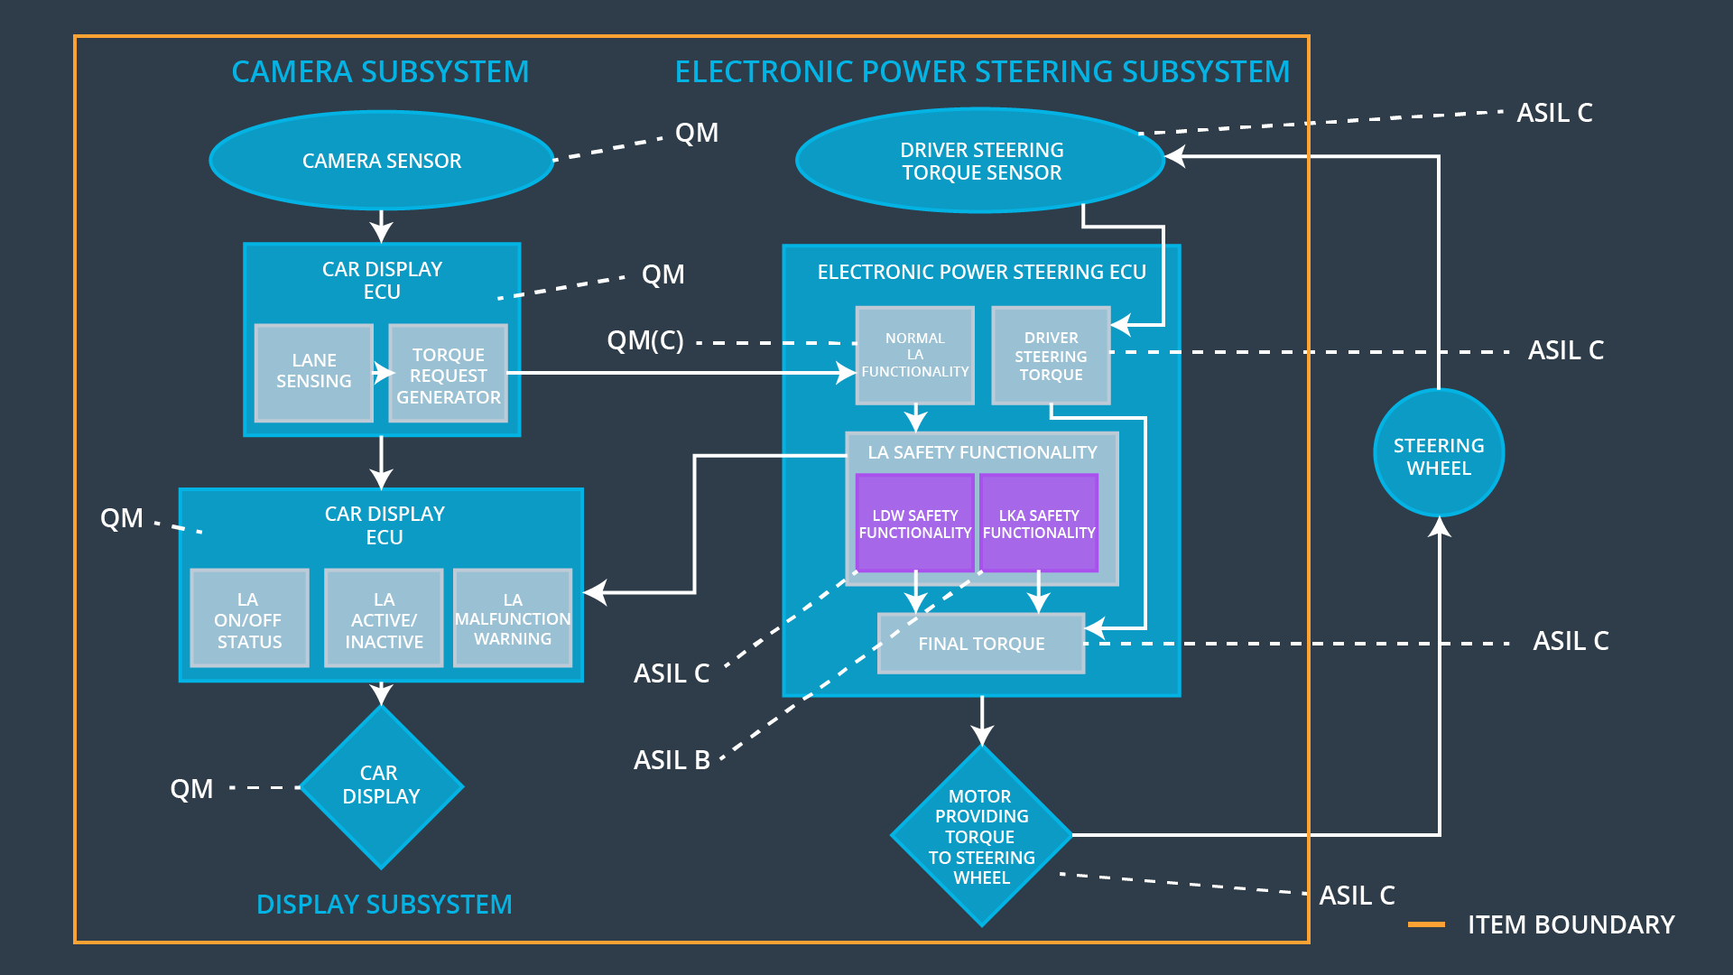

## Allocation of Functional Safety Requirements to Architecture Elements

|  |  |  |  |  |
| --- | --- | --- | --- | --- |
| **ID** | **Functional Safety Requirement** | **Electronic Power Steering ECU** | **Camera ECU** | **Car Display ECU** |
| Functional  Safety  Requirement  01-01 | The Lane Departure Warning item shall ensure that the lane departure oscillating torque amplitude is below Max_Torque_Amplitude. | **X** |  |  |
| Functional  Safety  Requirement  01-02 | The Lane Departure Warning item shall ensure that the lane departure oscillating torque frequency is below Max_Torque_Frequency. | **X** |  |  |
| Functional Safety Requirement 01-03 | The Lane Departure Warning function shall be deactivated when the camera sensor stop working. | **X** |  |  |
| Functional  Safety  Requirement  02-01 | The electronic power steering ECU shall ensure that the lane keeping assistance torque is applied for only Max_Duration | **X** |  |  |
| Functional  Safety  Requirement  02-02 | The electronic power steering ECU shall be deactivated​ ​when​ ​the​ ​electronic​ ​power steering​ ​ECU​ ​detects​ ​the​ ​camera sensor​ ​is​ ​not​ ​working. | **X** |  |  |

## Warning and Degradation Concept

|  |  |  |  |  |
| --- | --- | --- | --- | --- |
| **ID** | **Degradation Mode** | **Trigger for Degradation Mode** | **Safe State invoked?** | **Driver Warning** |
| WDC-01 | Turn off LDW functionality | Malfunction_01,  Malfunction_02 | Yes | Turn on warning light of the LDW functionality |
| WDC-02 | Turn off LKA functionality | Malfunction_03,  Malfunction_04 | Yes | Turn on warning light of the LKA functionality |