Tree Augmented Naïve Bayesian Classifier with Feature Selection for fMRI Data
Aabid Shariff Ahmet Bakan
aas44@pitt.edu ahb12@pitt.edu
Abstract
Functional Magnetic Resonance Imaging of brain produces a vast amount of data that could help in understanding cognitive processes. In order to achieve this, the problem is cast as a classification problem. Here, we implement Tree Augmented Naïve Bayes to increase the accuracy of previously implemented Naïve Bayes. We also use activity based feature selection and Principal Component Analysis to reduce the dimensionality of data and increase accuracy. We have shown that TAN classifier performs better than NB classifier. Also, we have modified the activity based feature selection method and we have shown that there is a significant improvement in the classification accuracy.

Introduction
Functional Magnetic Resonance Imaging (fMRI) is a powerful technique that is known to represent neural activity in brain indirectly. Figure 1 illustrates fMRI data with an instantaneous image of a slice of the brain and change in activity in a volume of the brain. Although this data does not provide us single neuron resolution of neural activity, many studies have reported the use of this data to identify cognition. These kind of studies are important in the understanding of cognitive processes, medical diagnostics (e.g. in Alzheimer’s disease), etc. The basis of these studies is the existence of anatomically distinct regions in the brain for distinct functions carried out by the brain that reflect a particular cognitive process. We can now use classification methods to understand the mapping of brain activity to cognition. fMRI data has been very useful to implement as an input to classification algorithms. Some problems with fMRI data are that they are high dimensional, noisy and sparse. This project aims at implementing Tree Augmented Naïve Bayes Classifier to increase the accuracy of prediction compared to naïve Bayes classifier while addressing above issues associated with data.
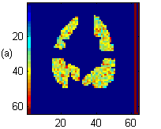 | 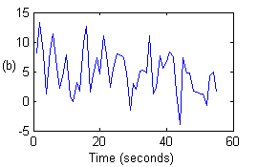
Figure 1: fMRI data from subject 05710: (a) Image of a slice of brain and (b) time change of activity in a voxel.

Related Work
Recent work has trained several methods to classify the cognitive states of brain of a human subject by using fMRI data (Mitchell, 2004). The tasks defined in the study were classification of states looking at a sentence versus looking at a picture, reading an ambiguous sentence versus reading an non-ambiguous sentence, and viewing a word describing one of several categories,. The study has made use of Naïve Bayes classifier (NB), Support Vector Machines (SVM), and k-Nearest Neighbor (kNN) machine learning methods. The group has also applied four different types of feature selection methods in accordance with the nature of the data. These methods were based on the cognitive state discriminative ability of voxels, activity of voxels at given cognitive state, activity of voxels categorized by Regions of Interest in the brain, and mean of active voxels for each region of interest. In the first type of classification problems, discriminating between looking at a picture or a sentence, highest prediction accuracy at 89% was achieved by SVM when feature selection was performed.
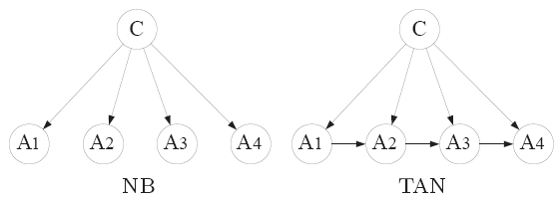
Figure 2: Structure of the classifiers used in this study. C is the class variable, A’s are features, and arrows indicate dependence among variables.

In the above study, NB classifier performed with 82% accuracy when feature selection was performed. This simple classifier makes independence assumptions among all features of the data given the class variable. So, as one would expect that forsaking some of the irrelevant independence assumptions between some of the features may improve the accuracy of the learner. One method aiming at reducing the number of such unwarranted independent assumptions is Tree Augmented Naïve Bayes (TAN) classifier described by Friedman et al. The structure and relations between class variable and features in NB and TAN models are shown in Figure 2. The procedure described in Friedman et al.’s work is based on Chow and Liu’s method to find dependence relations among variables so to be able to factorize a joint probability distribution among these variables. The authors perform experiments on 25 different cases and show that the method provides higher accuracy than Naïve Bayes classifier in two out of three cases.
Construct-TAN procedure, described by Friedman et al. and others, to learn a TAN classifier has time and space complexity of the order O(n²N), where n is the number of features and N is number of examples. Later, Meila and Shi et al. have modified the algorithm independently to decrease computational cost based on some assumptions and requirements in the data. Meila’s improvement accelerated the algorithm reducing the time complexity to O[s²Nlog(s²N/n)], where s is a constant related to sparsity of data and s << n. So, as it becomes obvious, the acceleration in the algorithm takes advantage of sparsity in feature vectors of examples which can be illustrated with well known text classification problem. The more recent study of Shi et al. reduced the space complexity of the algorithm based on Meila’s work. In all these studies, use of TAN is described for discrete data. Yang et al. has studied discretization methods for naïve Bayes classifier. This is still a field of current research, since performance of methods vary with the type of data. Most recently, Perez et al. have reported TAN for continuous and normally distributed data, which is the one we have chosen to use in this study due to nature of the fMRI data.

Methods
Before describing the methods we will point the main issue arising with this classifier and data combination. The fMRI data has dimensionality of the order 10⁵. The computational cost of applying this algorithm to fMRI data naturally requires considering efficient computation. Since we cannot take advantage of later algorithmic improvements in Construct-TAN method, we are going to consider feature selection. We will first describe procedures to select relevant features, than continue with describing the implementation of the algorithms.

Feature Selection
Since the fMRI data is high dimensional and noisy we require feature selection methods to reduce the computational time and also to reduce errors in the training.

Activity Based
One of the feature selection methods used here is the activity test method. The goal of feature selection is to discriminate the target classes. A method to do this is the discriminative method which distinguishes one class from another. But the activity test method which distinguishes classes from the zero signal class has been shown earlier to work better on fMRI data. The activity test method can be summarized as follows:
- Consider a voxel across all examples belonging to a particular class.
- Perform a t-statistic on this voxel’s fMRI acitivity and compare with the voxel’s activity in fixation periods.
- Repeat steps 1 and 2 for different voxels of the same class.
- Select the desired number of voxels with the greatest t-statistic.
- Start from step 1 for a new class.

Principal Component Analysis (PCA)
Principal component analysis is a method of unsupervised dimension reduction. Traditionally, PCA applies a linear transformation that transforms the data to a new coordinate system. This coordinate system is chosen such that the first coordinate is the projection where the data has the greatest variance. The subsequent components are chosen in a similar manner. In the fMRI dataset, we would like to pick the voxels that show the greatest variance in differing conditions. Hence, it seems intuitive to use PCA technique to pick the voxels that show large variations so that classification can be made easier and often more accurate. The algorithm for PCA is as follows
1. Calculate the covariance matrix for all the voxels across 80 trials.
2. Perform eigenvalue decomposition on this matrix.
3. Sort the vectors based on the eigenvalues and map these vectors back to the original data with the required number of features (voxels).

Active Voxel Time Averaging (AVTA)
In this project, we have also used a modified activity based dimensionality reduction method. Cognitive processes are discriminated based on a series of instantaneous activity measurements of voxels. If a voxel is playing a role in a cognitive process, signal obtained from it will be different from its inactive state and inactive states of other voxels, i.e. in different ROIs. Hence, assuming average activity will display same distinct behavior; activity of a voxel for a particular cognitive process can be averaged over stimulation period and used as a feature in classification.
Although this assumption is not ideal, the intuition behind this method is that, the value of a voxel at particular region simply indicates the amount of blood supply, in turn indicating the amount of activation in that region. As long as the cognitive process is ongoing, the region should be active to a particular level. Hence, we can average the activity level over 8 second time interval for each voxel to considerably reduce the dimension of the data.

Classifiers and Training
In this study, we have utilized naïve Bayes and Tree Augmented Naïve Bayes classifiers. This sub-section describes the implementation of these methods.

Tree Augmented Naïve Bayes (TAN)
Construct-TAN procedure is described here as a blend of Friedman et al’s and Perez et al.’s work. The procedure uses conditional mutual information between two features given the class variable which is described as follows for continuous data assumed to be normally distributed:
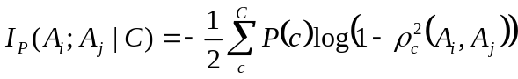 (1)
and 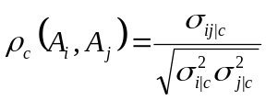
A_{i} and A_{j} are sets of feature variables, C is the set of class variable, and 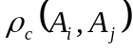 is the correlation coefficient between A_{i} and A_{j}. Corresponding lower case letters represent assigned values to these variables. This function measures the information provided by A_{i} and A_{j} for each other when the class variable is given.
The Construct-TAN procedure:
- Compute 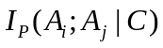 between each pair of attributes, 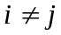, into a symmetric matrix.
- Using Kruskal’s algorithm implementation in MatlabBGL, build a maximum weighted spanning tree from the above symmetric matrix (Gleich, 2006) and
- Transform the resulted undirected tree to a directed one by choosing a root variable and setting the direction of all edges to be outward from it.
- Construct a TAN model by adding a vertex labeled by C and adding an arc from C to each A_{i}.
Above procedure is proved to build a TAN tree, B_{T}, that maximizes the log-likelihood function, LL(B_{T}|D), and has time complexity O(n²N). Log-likelihood function can be written as:
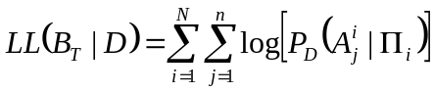 (2)
Where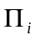 is the set of parents of the attribute A_{i}.

Naïve Bayes (NB)
Naïve Bayes classifier is implemented along with TAN algorithm. NB classifier parameters were obtained from the intermediate estimates for TAN classifier, which uses class conditioned means and variances to calculate parameters conditioned on both class and another feature.

Classification
Class of an example is decided by calculating posterior probabilities of classes using Bayes rule. This is described for both classifiers.

NB classifier
In NB classifier, class variable maximizing equation (3) is assigned to a given example. Required parameters, prior class probabilities, mean, and variance for features, are calculated distinctly for each class.
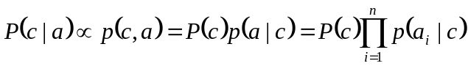 (3)

TAN classifier
In TAN classifier, mean and variance of a feature depends on its parents, class variable and one other feature. Argument to be maximized and calculation of these parameters are given in equation (4).
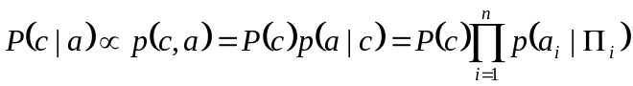 (4)
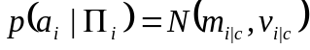, 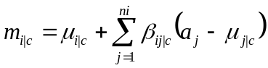 ,
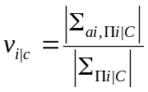 , and 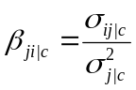

Experiments and Results
Naïve Bayes and Tree Augmented Naïve Bayes classifiers are trained over six subjects using three different methods to reduce dimension of the data. Average accuracy over all subjects is displayed in Table 1. Classifiers are compared in more detail for each feature selection method and details of individual experiments are discussed in the following sub-sections.
The data displayed in Table 1 is obtained by cross-validation analysis (CV). Specifically, for AVTA leave-one-out CV was used. For activity based and PCA methods 40, 40, 20, 20, 20, 20, and 10-fold CV was applied. The number of the folds decreased due to the increasing dimensionality of data and TAN computational resource requirements.
Table 1: Average performance of BN and TAN
 | Activity |  | PCA |  | AVTA
Voxels | BN | TAN | BN | TAN | BN | TAN
10 | 71.46±2.2 | 72.50±2.0 | 57.71±2.3 | 60.83±2.5 | 63.33±2.0 | 70.63±2.0
20 | 76.67±2.0 | 76.46±1.9 | 60.63±2.3 | 66.67±2.3 | 64.17±2.1 | 71.04±1.9
30 | 74.38±2.4 | 78.75±2.0 | 63.33±2.3 | 68.33±2.3 | 66.67±2.0 | 77.71±1.8
60 | 77.71±2.3 | 80.21±2.0 | 65.42±3.0 | 70.63±2.8 | 70.83±1.9 | 84.38±1.6
120 | 75.75±2.6 | 80.50±2.1 | 71.35±3.0 | 75.26±2.6 | 75.42±1.9 | 83.54±1.7
240 | 77.75±2.5 | 79.25±2.2 | 71.88±3.4 | 72.29±2.7 | 78.96±1.8 | 86.67±1.6
480 | 69.64±3.4 | 75.77±2.6 | 74.42±3.5 | 70.93±2.8 | 81.25±1.8 | 87.50±1.5
960 | - | - | - | - | 82.29±1.8 | 85.63±1.7
1920 | - | - | - | - | 82.71±1.7 | 86.25±1.6
3000 | - | - | - | - | 80.63±1.8 | 85.21±1.6
all | - | - | - | - | 76.12±2.1 | 87.31±1.7

Activity based feature selection
We have used feature selection method based on activity of voxels as described by Mitchell et al. The experiments were performed up to 480 voxels due to the enormous memory requirements of TAN method. The results are plotted in Figure 3 in the range of accuracy from 60% to 90% to emphasize the trend in accuracy with increasing number of voxels. TAN has slightly improved the performance of NB in 6 out of 7 different runs for different number of voxels.
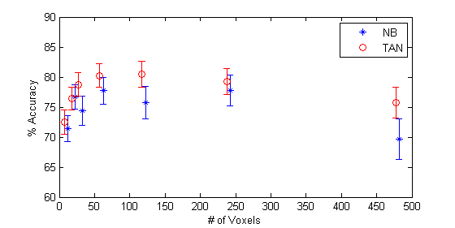
Figure 3: Average accuracy of BN and TAN classifiers.

Principal Component Analysis
Principal component analysis performed less accurate than activity based feature selection methods. However, TAN performed marginally better than NB, shown in Table 1.

Active Voxel Time Averaging
In this feature selection method, first active voxels are selected and their activities were averaged. Experiments were performed up to all voxels of all subjects, since averaged activity significantly reduces the number of dimensions. The results are plotted in Figure 4 in the range of accuracy from 60% to 90% to emphasize the trend in accuracy with increasing number of voxels. TAN has performed better than NB in all runs for different number of voxels.
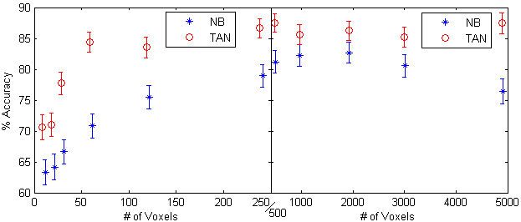
Figure 4: Average accuracy of BN and TAN classifiers.

Conclusion
In this study we have implemented and compared two classifiers and three feature selection methods. The goal was to be able to apply algorithms that can produce useful information from a high dimensional and noisy datasets such as fMRI data. In particular, the aim is to improve Naïve Bayes classifier by removing some of the unwarranted independence relations among features and hence we extend NB structure shown in Figure 1 by implementing the Tree Augmented Naïve Bayes. In all the experiments, TAN classifier has performed better than NB classifier after the feature selection methods were applied. The increase in the average accuracy was approximately 3%. As suggested by Friedman et al., this increase in accuracy may be attributed to the ability of TAN to identify related features in the data (voxels, in fMRI data) and set dependence relations between them.
Among feature selection methods, the activity based methods performed much better than PCA method. We notice that ranking voxels based on variance is not appropriate for fMRI data. This is probably because PCA being an unsupervised method does not use the fact that the data is labeled (sentence vs picture).
Interestingly, averaging the time series data of the individual active voxels has significantly improved the accuracy of the classification. Our results indicate that we get up to 87.5% accuracy with the active voxel time averaging method of dimensionality reduction. Although it is apparent that with averaging we lose information (time resolution of data) and might decrease the accuracy of classifier, we have shown that in fact averaging improves the accuracy significantly. A possible reason is that, on averaging, the noise cancels itself and is eliminated from the data.
We have improved the classification accuracy by implementing a modified version of a previously studied classification method and modifying a feature selection method. We hope that better algorithms and improved feature selection methods will be able to improve classification and consequently identification of cognitive states of brain.

Acknowledgements
We thank Dr. Mitchell and Dr. Xing for providing project idea and fMRI data, Mr. Rustandi for answering our questions and pointing key papers to us, and Mr. Gleich for generously sharing his code on MATLAB Central.

References
[1] Mitchell, T.M., Hutchinson, R., Niculescu, R.S., Pereira, F. & Wang, X. (2004) Learning to Decode Cognitive States from Brain Images. Machine Learning 57:145-175.
[2] Chow, C.K., Liu, C.N., (1968) Aproximating Discrete Probability Distributions with Dependence Trees. IEEE Transactions on Information Theory 19.3:462-467.
[3] Friedman, N., Geiger, D., Goldszmidt, M. (1997) Bayesian Network Classifiers. Machine Learning 29:131-163.
[4] Meila, M. (1999) An accerelated Chow and Liu algorithm: fitting tree distributions to high-dimensional sparse data. MIT Artificial Intelligence Laboratory 57:145-175.
[5] Shi, H., Huang, H. (2002) Learning Tree-Augmented Naive Bayesian Network by Reduced Space Requirements.Proceedings of the First International Conference on Machine Learning by Cybernetics 3:1232-1236.
[6] Yang, Y., Webb, G.I. (2002) A Comparative Study of Discretization Methods for Naïve-Bayes Classifier In Proceedings of PKAW 2002
[7] Perez, A., Larranaga, P., Inza, I. (2006) Supervised classification with conditional Gaussian networks: Increasing the structure complexity from naïve Bayes Preprintsubmitted to Elsevier Science
[8] Gleich, D. (2006) MatlabBGL http://www.mathworks.com/matlabcentral/fileexchange/ loadFile.do?objectId=10922

