LEARN PYTHON WITH ME IN 100 DAYS

**DAY 1**

Today we will learn printing, commenting, debugging, string manipulation, and variables.

And today’s project is going to generate a band name

And the idea is that let’s say that your friend was starting a new band, a rock band or a classical band and they are struggling to come up with a good name.

So we will help our friends and send them a band generator program.

Ex: -

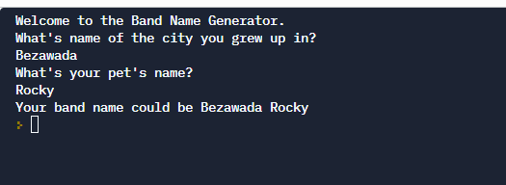

In this process, we will learn about printing, inputting, commenting, name errors, syntax errors, string manipulation, variables, and a whole lot more.

After a few days, I will show you how to install and set up pycharm, the most popular Python local editor.

In the meantime, we will be using **Replit** a browser-based code editor. This has a number of advantages:

1. We can get up and running immediately, with less time wasted on setup and troubleshooting, and more time learning to code.

2. It's accessible anywhere, any computer/iPad/phone that's connected to the internet can be used to code.

3. Your code and progress are saved, and ready for you to review and revisit at any time.

4. It's free.

If you already have PyCharm or another code editor installed, feel free to use it. we need to learn to use many tools, and the more you know the better.

Print() function

You have the keyword print followed by a set of parenthesis, and then inside the parenthesis, we can tell what we want. And once you’ve inserted that, then when this line of code gets executed by the computer, it’ll know to simply that print or output the thing that you’ve placed in between the parenthesis

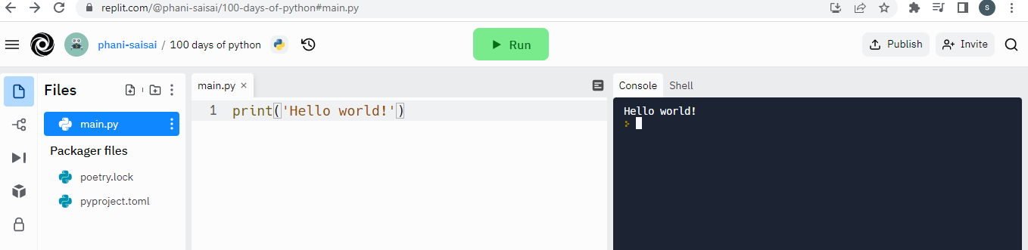

We have written in between the double quotes. And the reason why I have done this is so that I can tell the computer that this bit here in between the double quotes is not code. It’s not like print where it is supposed to do something. That is just some text that I’ve made up that I want to print out.

And these piece of text in the programming language is known as **strings**.

And the double quotes do is they basically show the beginning and the end of that string of characters.

Let’s see what will happen if we didn’t close the quotation,

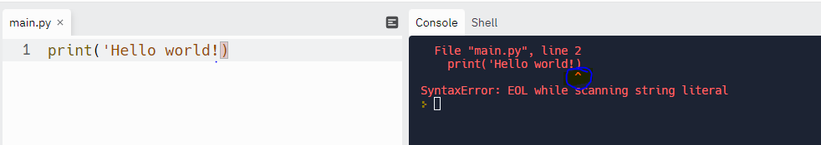

In the console, it is clearly mentioned that something is missing with the arrow symbol.

I have practiced print function in coding rooms

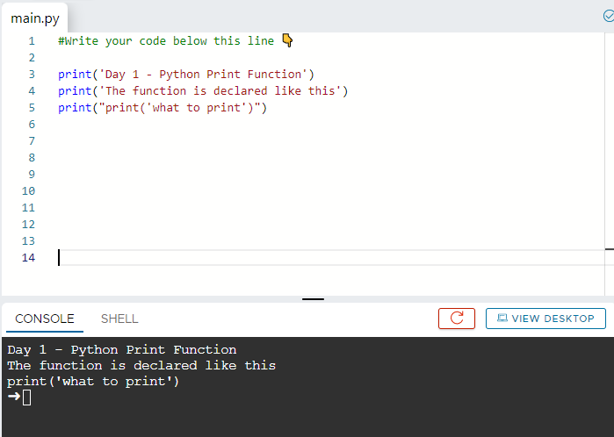

When we want to use double quotes inside another set of double quotes commonly you’ll see people switch to single quotes instead like I have done to come to the output

**String manipulation Code intelligence**

Line code that has been executed,

I’ve got hello world printed on two separate lines, separated by this pink “ \n “ and character, which gets replaced by a new line

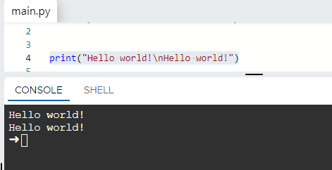

So by using the single print statement and creating some new lines with the “\n”

One of the other things we can do with the strings is we can concatenate them, What this means is we combine different strings so that they will be added to the end of other strings. Here’s an example

I can simply combine the string using the ‘+’ sign

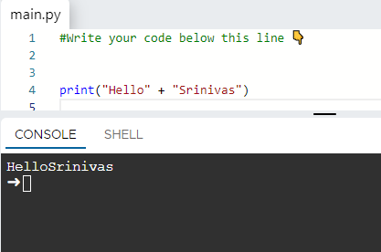

You can see the “Hello” & “Srinivas” got combined into one. And there is no space in between because we don’t have a space character anywhere here

For to get space between these two strings, simply add another string between these two

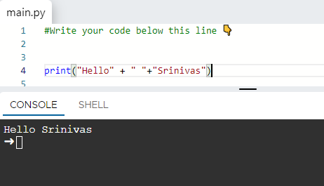

Now we can see space between them.

If we think of strings as a string of connected characters, then string concatenation is taking those separate strings of characters and merging them into one.

So in python programming spaces are really important

There should not be any spaces or any tabs that you’ve inserted in front of the line of code. We will get mentioned below attached error

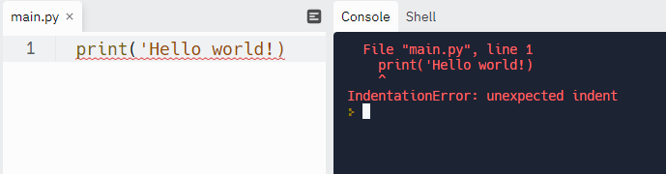

**The python input function**

We use the input function

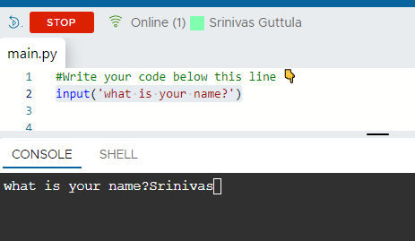

And the piece of data (Srinivas) has now been passed back into my code and it now it replaces the part of the code (what is your name?)

So I am passing data from ‘console’ to ‘main.py’

If we write print instead of ‘input’

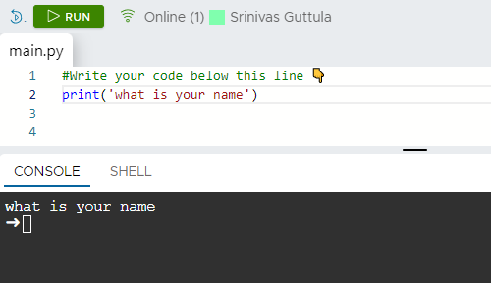

The code execution ends and we have got an arrow

If we use instead of print, we won’t get that

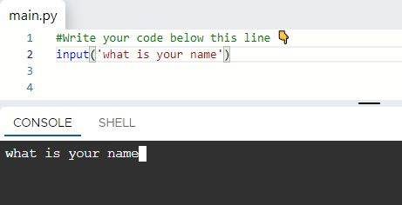

It just blinks, my program is actually paused right now in order for the user to provide input and it’s only when I have given the input and hit enter

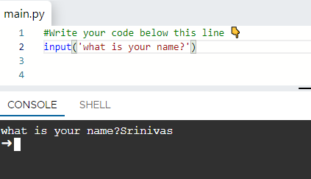

Then the program ends.

The ‘input’ function looks pretty much identical to the print function, it’s just got the word input. And inside the parentheses, instead of adding what text will be printed, we’re adding the prompt for the user to give them a hint as to what kind of data we want. And then when you run this code, it will print out of the prompt, but then there will be a cursor. In some places, you’ll see it like flashing or it will be a solid cursor ready for the user to type in some piece of data.

If I use both ‘print’ and ‘input’ functions at a time then

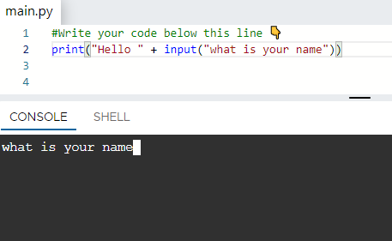

I need to give the answer to this and the output will go to the question and print along with it as mentioned below. That means it got concatenated with the word, hello and the entire thing got printed down here.

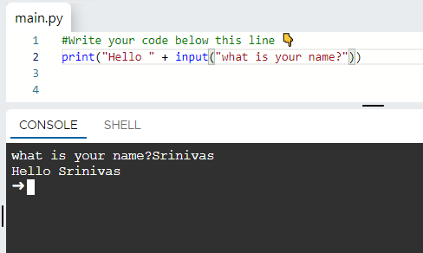

For to get the length of that string , Use the length function

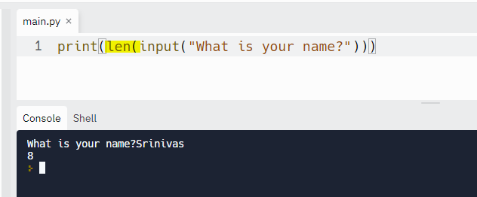

**PYTHON VARIABLES: -**

We get to know how to use the input function previously

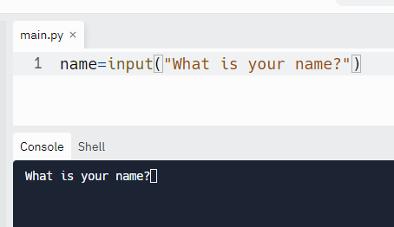

In the mentioned above image ‘input’ to this prompt to a variable called the **‘name’**.

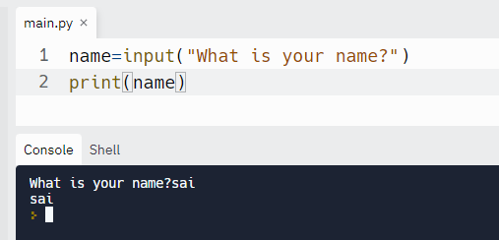

So by using this variable ‘name’ we can use this at any point in my code. Just by referring to the name that’s attached to this value

So it’s almost like we’ve saved the data from this action to a ‘**name’.**

So as the name variable suggests it’s something that can be changed or can be varied

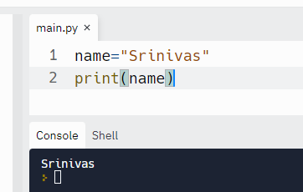

Here in the above example ‘name’ =Srinivas

And when I run print(name)

o/p:- Srinivas

So that’s what gets printed inside the console because we are now referring to the piece of data with the variable name.

**Naming the variables**

Make your code readable, & name of the variable must be one single unit.

If we are separating the words in python, we use underscore.

If we want to use numbers in the name of the variable, we can for example length1

Numbers should not be at the beginning of the variable; we can’t say 1length or 2length.

And there are certain privileged words that we use, for example, the names of our functions like ‘print’ &’ input’. So don’t use these ‘print’ and ‘input’ keywords as variables.

By using all the concepts what we have learned today we are generating the band name

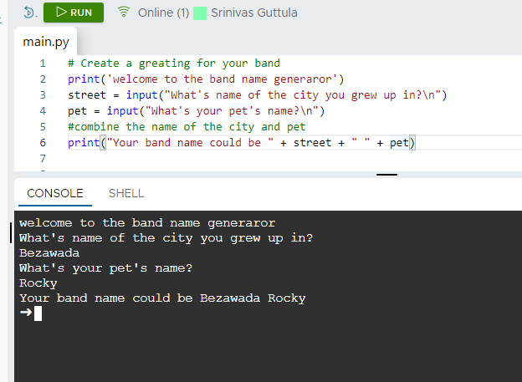

In the mentioned program we are using “\n" because to get the cursor to blink in the next line so that our program looks lot better